Summer 2025
Heet Patel
Param Katrodia
Afra Alam
Ryan Aoude
<Project Name>

Software Requirements Specification
<Group Name> | Group #

Executive Summary

Background

Description

Company Value Add

End-User Value Add

Scope

What is Included

What is Not Included

Justification

Table of Contents
Executive Summary 1
Background 1
Description 1
Company Value Add 1
End-User Value Add 1
Scope 1
What is Included 1
What is Not Included 1
Justification 1
Section 1 4
1.1 Document Authors 4
1.2 Document Revision History 4
1.3 Document Purpose 5
1.4 Audience 6
1.5 Group Agreement 6
Team – Group 6 6
Project Title - Grazer 6
Project Time Frame – 2025 Sept 02 to 2025 Dec 21 6
Team Members 6
Team Leadership 6
Team Functions/Roles 6
Team Meetings – Wednesday at 2:00PM and Saturday at 2:00PM 6
Team Problems 6
Team Commitment 6
Section 2 7
2.1 Project Proposal 7
2.1.1 Project Background 7
2.1.2 Problem Statement 14
2.1.3 Product Vision 14
2.2 Stakeholders and Users 14
2.3 Project Scope 15
2.4 System Risks 15
2.5 Operating Environment 15
2.6 Functional Requirements 15
2.7 Nonfunctional Requirements 15
2.8 UI/UX Interface Mock-ups 15
Section 3 16
3.1 Data Flow Diagrams 16
3.2 User Stories and related Use Case Scenarios 16
3.3 Activity Diagrams 16
3.4 Business Rules 16
Section 4 – Domain Class 16
Section 5 – Database 17
Section 6 – Project Management 17
6.1 Work Breakdown Structure 17
6.2 Milestones & Acceptance Criteria 17
Section 7 – Product Backlog & Implementation Schedule 17
Section 8 - References 17
Section 9 – Client/Faculty Sign-off 17

Section 1

1.1 Document Authors

Heet Hiteshbhai Patel: - CEO, back-end lead, and co-founder.
- At Grazer, Heet is in charge of leadership, strategy, and overall vision. He guarantees the scalability, security, and dependability of the platform's fundamental infrastructure thanks to his extensive experience in back-end programming and systems integration. In his capacity as CEO, he is in charge of long-term growth planning, milestone delivery, and team coordination.
Param Jayesh Katrodia:- Chief Data Officer (CDO), and co-founder.
- Param Jayesh Katrodia, is an expert in data analytics, insights, and optimization. He is in charge of creating and implementing Grazer's business dashboards, trend analysis tools, and price-comparison logic. Additionally, he keeps an eye on KPIs to make sure that partner companies and customers are receiving correct, up-to-date information. Param connects data-driven business choices with technological execution.
Ryan Aoude: - Co-Founder, Chief Product Officer (CPO), and Front-End Lead.
- Ryan Aoude oversees product design, user interface, and user experience (UI/UX). He is in charge of the front-end platform development at Grazer, ensuring that it is intuitive, responsive, and user-friendly. Ryan sets the product roadmap, converts consumer requests into products, and ensures a smooth shopping experience for both end users and companies.
Afra Alam: -Co-Founder and Head of Quality and Operations (CQO).
- Afra Alam oversees quality assurance, processes, and compliance. She tests the product thoroughly to verify that it satisfies high usability, security, and reliability criteria. Afra also oversees team documentation, operational planning, and process improvement, ensuring that Grazer runs smoothly both as a platform and as a company.

1.2 Document Revision History

WEEK | DATE | Revisions
1 | 20-09-2025 | - Completed section 1 and 2.1
2 | 25-09-2025 | - Revised Problem statement and Product Vision
3 | 28-09-2025 | - Completed till section 2.3
4 | 05-10-2025 | - Completed till 2.7 and update the 2.1 till 2.4
5 | 10-10-2025 | - Mockup UI
6 | 11-10-2025 | Final edits made
7
8
9
11
12
13
14

1.3 Document Purpose

The objective of this document is to serve as the core business proposal and operational charter for Grazer, a startup dedicated to changing the way consumers and companies engage in the online purchasing ecosystem.
This paper is more than simply an academic requirement; it is a strategic plan outlining Grazer's vision, goals, and structure for implementation. It describes the difficulties Grazer is tackling, the novel solutions presented, and the distinct value we hope to provide to both consumers and enterprises. By collecting this information, the paper creates a clear narrative for stakeholders, investors, advisers, and the founding team.
Specifically, the document is intended to:
- Establish Vision and purpose: Clearly express Grazer's vision of building a transparent, efficient, and environmentally responsible e-commerce platform, as well as its purpose of empowering consumers and businesses.
- Align the Team: Ensure that all co-founders have a clear grasp of the project's goals, deliverables, and long-term strategy, reducing uncertainty and encouraging cooperation.
- Demonstrate Market Need: Highlight the global expansion of e-commerce, the growing problem of unsold inventory, and the difficulties of consumers who are unable to adequately compare costs.
- Showcase Innovation: Set Grazer apart from competitors by describing its focus on price transparency, data analytics, local business inclusion, and sustainability.
- Provide accountability: Serve as a living record of milestones, modifications, and agreements, ensuring that the team operates with accountability and traceability throughout the development process.
- Support Investor Readiness: Present Grazer as a serious enterprise with well-defined objectives, making this document appropriate for early investor or adviser evaluation.
- Guide Execution Across Semesters: Create a roadmap for how Grazer will progress from an idea to a functioning prototype and, eventually, to a scaled product across two semesters.
Ultimately, this document exists to guarantee that Grazer starts with clarity, alignment, and professionalism. It sets the tone for the startup's growth and expresses our dedication to creating a platform that is technically sound, user-friendly, and beneficial to both businesses and consumers.

1.4 Audience

- Founding Team
The founding team is the document's primary audience. For Grazer's co-founders, it acts as a thorough reference outlining the company's mission, duties, and expectations. It keeps each participant focused on the project's goals while holding them accountable for deliverables, deadlines, and overall startup success.
- Academic Supervisors and Evaluators
In the academic environment, this paper is also intended for teachers and assessors who will review the project. For them, it illustrates that Grazer is more than just a school project, but rather a competent and well-structured commercial venture. It demonstrates the team's capacity to adapt theoretical knowledge to actual entrepreneurship.
- Investors & Advisors
Potential investors and advisors are another important audience. For them, the plan communicates Grazer's market potential, competitive positioning, and long-term scalability. It enables stakeholders to analyze the team's commitment, the soundness of the business strategy, and the possibility for financial return or mentoring benefit.
- Strategic Partnerships and Businesses
Local stores, small enterprises, and e-commerce collaborators are also key audiences. The document demonstrates how Grazer can help them enhance exposure, attract more consumers, and increase sales through competitive pricing. For these partners, the proposal explains how joining the platform generates mutual benefit.
- Consumers and early adopters.
Consumers and early adopters remain a key audience, even though they are not actively participating in the plan currently. This document explains how Grazer will give them with more pricing transparency, convenience, and confidence in their buying experience. It also demonstrates how their engagement promotes sustainability by reducing unsold inventories and waste.

1.5 Group Agreement

Team – Group 6

Project Title - Grazer

Project Time Frame – 2025 Sept 02 to 2025 Dec 21

Team Members
- Heet Hiteshbhai Patel
- Param Jayesh Katrodia
- Ryan Aoude
- Afra Alam

Team Leadership
Leadership responsibility rests with Heet Hiteshbhai Patel, who will serve as Project Manager and CEO. He will coordinate schedules, monitor progress, and ensure that deadlines and deliverables are met. Leadership will also be shared in specialized domains, with each member holding authority in their respective roles.

Team Functions/Roles
Each team member has a defined role that contributes to the overall success of the project:
- Heet Patel: CEO, Project Manager, and Back-End Development Lead
- Param Katrodia: Chief Data Officer, responsible for data analytics, insights, and reporting
- Ryan Aoude: Chief Product Officer, responsible for product design, UI/UX, and front-end development
- Afra Alam: Head of Quality & Operations, ensuring testing, process compliance, and documentation

Team Meetings – Wednesday at 2:00PM and Saturday at 2:00PM

Team Problems
Conflicts, delays, or miscommunication will be addressed openly in meetings. Issues will first be discussed collaboratively within the team to find solutions. If consensus cannot be reached, the Project Manager will make the final decision. The team agrees that transparency, respect, and professionalism will guide all problem-solving efforts.

Team Commitment

The undersigned members agree to work together on the project until the end of the PRJ666 next Semester. They recognize that as a team and individually they are equally responsible for the quality of all deliverables.

Name | Date | Signature
Heet Patel | 17-09-2025 | HHP
Param Jayesh Katrodia | 17-09-2025 | PJK
Afra Alam | 17-09-2025 | AA
Ryan Aoude | 20-09-2025 | RA

Section 2

2.1 Project Proposal

2.1.1 Project Background

Name | What it Does / Main Features | Cons (Limitations) | Best Used For
KAYAK | - Searches many travel websites for flights, hotels, car rentals (KAYAK, 2024a).  - Price alerts / notifications when prices drop (KAYAK, 2024b).  - Flexible date/destination search (Google Play, 2024). | − Doesn’t always guarantee lowest price  − Forecasts not always accurate  − Customer service may involve third parties (KAYAK, 2024c) | Planning and booking travel, especially when flexible with dates or destination
Honey | - Finds and applies coupon codes automatically (Demore Wealth, 2023).  - Price watch list (Droplist) (Ramsey Solutions, 2024).  - Honey Gold rewards system (Permission.io, 2021). | − Coupon code success varies  − May miss codes  − Privacy concerns | Everyday online shopping across many categories
Capital One Shopping | - Finds and applies coupon codes (Demore Wealth, 2023).  - Price watch features (Wikipedia, 2024).  - Rewards/credits system (Wikipedia,  2024). | − Price comparisons sometimes imperfect  − Rewards small  − Mostly U.S.-centric | Retail purchases and coupon savings
Rakuten | - Offers cash-back on purchases (Ramsey Solutions, 2024).  - Provides coupons and deals (Ramsey Solutions, 2024).  - Browser extension and app. | − Cashback takes time  − Not all retailers participate  − Some coupon overlap issues | Larger purchases where cashback value is meaningful
RetailMeNot | - Aggregates coupons, promo codes for many stores (Ramsey Solutions, 2024).  - Offers seasonal / special-event codes.  - Provides both online and in-store coupon options | − Not all codes work  − Not always best available  − Limited travel retailer support | Browsing coupons before shopping (especially non-travel items)

2.1.2 Problem Statement

Shopping for clothes and accessories should feel exciting, but more often it turns into a frustrating guessing game. Prices swing from store to store, online discounts don’t always work, and delivery delays can take the thrill out of the purchase. Shoppers are left wondering: Should I buy this online, wait for a sale, or check if it’s available locally?
While platforms like Honey, Rakuten, or Capital One Shopping provide coupons and cashback, they fail to address the bigger challenge—clarity. Buyers don’t just want another promo code; they want to know if they’re making the right decision at the right place and time.
Meanwhile, local clothing boutiques and accessory shops—many of which offer competitive prices, unique selections, or immediate availability—struggle to get noticed online. Overshadowed by big retailers and fast-fashion platforms, these businesses miss out on reaching motivated customers nearby. The result? Shoppers overpay or wait unnecessarily, while local stores lose opportunities to connect with the very buyers in their community.

2.1.3 Project Vision

Our vision is to make shopping for clothing and accessories more local, transparent, and rewarding.
For customers: The platform compares prices across nearby stores and major retailers, giving shoppers a clear view of their best options. Instead of endlessly browsing websites or waiting for delivery, people can instantly see if that jacket or pair of shoes is available at a shop down the street—and at what price. This saves time, saves money, and puts buyers back in control of their choices.
For businesses: Local boutiques and accessory shops finally get the visibility they deserve. By showcasing their inventory alongside other local stores, they can fairly compete for attention and attract motivated customers in their own neighborhoods. This levels the playing field, drives more foot traffic into stores, and helps strengthen the local shopping economy

What Makes Our Product Stand Out:
Our platform doesn’t just compare prices—it transforms the way people shop. By combining transparency, intelligence, and local connection, we give shoppers confidence and control over every purchase decision.
• Unified shopping view: Instantly compare new and used options side by side, across local stores and major retailers—all in one place.
• Smart price insights: Our interactive price-trend charts show how prices have changed over time, helping shoppers decide whether to buy now or wait.
• Personalized alerts: Set custom notifications for when new or used items hit your ideal price, so you never miss a deal.
• Empowering local discovery: We put independent boutiques, and nearby sellers front and center, making it easy to find great items close to home.
• Clear, data-driven advice: Get real-time recommendations like “Buy now” or “Wait for Sale,” powered by market insights—not guesswork.

2.2 Stakeholders and Users

Internal Stakeholders

- Founding Team (Heet, Param, Ryan, Afra):
We’re the people building Grazer from the ground up. Each of us brings a different skill set—back-end, data, front-end, or operations—but our common role is to make sure the platform works, grows, and delivers on the vision. As co-founders, we’re both decision-makers and hands-on builders.
- Development Team (Future Members):
Down the line, we’ll need more engineers, data analysts, and QA testers to help scale. They will help us making clean documentation, efficient workflows, and making sure our tech stack stays strong as more users come in.

External Stakeholders and Users

- Smart Shoppers (Primary Users):
These are everyday people who want more than just discounts—they want confidence in their choices. Instead of endlessly jumping between websites, they come to Grazer to see new and second-hand options side by side. They care about whether it makes sense to pay full price for something brand new, or if a gently used option is the smarter buy. Features like trend charts, purchase advice (“Buy now” vs. “Wait”). Local seller listings give them the clarity they’ve been missing by showing real, nearby options alongside big-name retailers. Instead of overlooking small shops with great deals or unique second-hand finds, shoppers can finally compare everything in one place—new, used, and local—without guesswork. For them, Grazer isn’t just about saving money—it’s about shopping smarter.
- Local Independent Sellers:
Small shop owners and resellers who don’t have the marketing power of big retailers. For them, Grazer is a chance to be visible, connect with buyers, and compete on more than just advertising dollars.
- Investors and Advisors:
Early-stage VCs, or mentors who might support us financially or strategically. They’ll be looking at Grazer’s scalability, our ability to capture users, and the differentiation we bring compared to coupon-only or cashback-only platforms.

2.3 Project Scope
This software system will be a Web Application for an average person who shops online. This system will be designed to keep track of all the places where a product may be available for purchase as well as their prices, so that it is easy to compare the prices instead of the shopper having to go on multiple stores to check the prices. By having one place that checks different stores for them, this system will meet the shopper’s needs while remaining easy to understand and use.
More specifically, this system is designed to allow a shopper to check the price of a product that is offered by multiple local stores at once. The shopper can enter the name of a product and find results from different stores. The shopper will then be directed to the product listing on the store to purchase the product. The system will also provide a place for retailers to advertise competitive prices and sales.

2.4 System Risks
Systemic Risk Cases:
- Not all sellers have online stores that display the prices of their products, so the shopper may not be able to get the full price range of a product. It could be possible to have a function that lets consumers add the prices of products from other offline stores in the future and have them verify with a picture of the product and the price tag.
- There may be a lot of web traffic that crashes the system, so server updates may be required in the future as the project grows in scale.
- Shoppers may not see much benefit to the system, so there could be ways to incentivize them, such as exclusive coupons that they can use at a certain seller. The coupons may come from deals arranged with a seller.
- The system may not be able to keep track of all the products and stores a shopper can buy from due to database storage limits. It is important to manage the scale of the system and keep track of what the users are frequently looking for.

2.5 Operating Environment
This software system will be a Web Application that can be accessed via most browsers. To use the Web Application, the user must use have a device that has access to the internet and can use an internet browser that can display modern online stores. This includes a laptop, a desktop computer, a mobile phone and/or a tablet that came out in the last 10 to 15 years.

2.6 Functional Requirements

Persona 1: Sam – The Time-Pressed Professional (Consumer)

Sam is a 32-year-old marketing manager. Between work, travel, and social life, shopping is a necessary chore. He's used tools like Honey for coupon codes and Rakuten for cashback, but they only solve the online part of the problem. His real frustration is the disconnect between seeing something online and actually getting it in his hands without wasted trips.

Q1: "Tools like Honey find online coupons, but what's a shopping pain point they don't solve?"
A1: "They don't help me get things today. If I need a blazer for an event tomorrow, Honey can't tell me which local store has it in my size. I end up calling stores, being put on hold, or driving across town only to find they have a similar item but not the one I need. It's a total time-suck. I need a service that does for local inventory what Kayak does for flights—show me all my options with real-time availability."
Keywords: Same-Day Need, Verified Local Stock, Multi-Store Inventory Search

Feature 1 (Consolidated Local Stock Feed): A live-search platform that aggregates and verifies in-store inventory from partner retailers (big and small) into one interface. Shows exact stock levels (e.g., "Last One" or "4+ in Stock") and allows for a verified hold, preventing the "it was just sold" problem.

Q2: "Price tracking tools exist, but what makes you doubt their 'wait or buy' advice?"
A2: "Honey's Droplist tells me the price history on one website. But what about other sites? Or the cost of getting it used? Or the fact that a local boutique might have it for the same price without the shipping wait? I'm making a decision with incomplete data.“
Keywords: Cross-Platform Price History, Condition-Based Alternatives

Feature 2 (Price trend, comparing among nearby retailers): Shows new item across major retailers AND integrates quality-vetted, pre-owned options from platforms like The RealReal or local consignment shops. Provides a single price trend and a "Get It Now" vs. "Wait & Save" score based on comprehensive data.

Q3: "Rakuten gives you cashback, but what's the trade-off you hate?"
A3: "The trade-off is time. By that I mean it doesn't help me if I need the item immediately or want to try it on. I'd gladly forfeit a 5% cashback if I could be 100% sure my size is waiting for me at a store 10 minutes away, right now. Instant gratification and certainty are more valuable than a small, delayed rebate."
Keywords: Certainty Over Cashback, Instant Gratification, Try-Before-You-Buy Assurance

Feature 3 (Instant In-Store Reservation): A one-click "Reserve for Pickup" function that places a real-time, binding hold on an item at a local store, complete with a pickup-by deadline. This directly sacrifices the delayed benefit of cashback for the immediate value of guaranteed possession.

Persona 2: Tim – The Local Boutique Owner (Seller)

Profile: Tim is a 58-year-old boutique owner. He knows his customers love the in-store experience, but they can't discover him if they only search on Amazon or use Rakuten. He's tried Facebook ads, but they're expensive and don't reliably bring in local foot traffic. He needs a platform that treats his physical store as an asset, not a liability.

Q1: "You have a great in-store experience then how are online e-commerce business hurting your bottom line?
A1: "Because algorithms favor convenience over curation. A customer searching for a 'black cocktail dress' will be shown Amazon and Zara first—companies that pay for top placement. My shop, with a unique dress that's actually in stock and just a few blocks away, is invisible. I'm not selling a commodity; I'm selling a curated item with expert service, but Google and Instagram see me as just another advertiser."
Keywords: Local Curation Visibility, Local Discovery

Feature 1 (Local Discovery Feed): A platform where local sellers are prioritized for users searching with "near me" or "today" intent. Seller profiles highlight their curation expertise (e.g., "Specializes in Sustainable Denim") and are featured in a dedicated "Local Finds" feed, not buried in a global product search.

Q2: "Managing inventory on multiple platforms is hard. What's the main bottleneck?"
A2: "Double-selling. If I list a unique item on my Instagram, my website, and Etsy, I have to manually update everything the second it sells. I once had three people pay for the same vintage jacket because of a sync delay. I need a single, simple dashboard where I list something once, and it pushes to everywhere I sell, with automatic sold-out updates. My point-of-sale system should be the source of truth."
Keywords: Single-Source Inventory, POS Integration, Anti-Double-Sell Sync

Feature 2 (Centralized Inventory Hub): A seller dashboard that syncs directly with Tim's in-store POS system. When an item is sold or received in-store, all online listings (on the platform, his website, etc.) are updated in real-time. Listing new items can be done via bulk upload or simple barcode scan from his phone.

Q3: "What would make you trust that an online platform is worth the effort?"
A3: "Proof it drives real people through my door. I don't care about 'likes' or 'impressions.' I want to see: 'This listing was seen by 50 people in your zip code, and 3 of them clicked 'Get Directions'.' If I can see a direct link between my activity on the app and foot traffic in my store, I'm all in. Otherwise, it's just another time-wasting gadget."
Keywords: Foot-Traffic Analytics, Actionable Customer Insights

Feature 3 (Foot Traffic Analytics Dashboard): An analytics suite that shows Tim metrics tied to real-world actions: "Number of Directions Requests," "Number of Reserved Pickups," and "Redemption of In-Store-Only Promos." This moves beyond vague online metrics to prove the platform's value in driving his primary business.

2.7 Nonfunctional Requirements
The landing page supporting 100 users per hour must provide a 10-second or less response time on a Chromium-based browser, including the rendering of images and texts. Product search results must be displayed within 5 seconds for 90% of results under normal conditions. The system must be capable of ingesting streams of data at a rate of 1 million records per second minimum. For the redirection, the system should be able to send the user off-site within 10 seconds.

2.8 UI/UX Interface Mock-ups
Landing Page:
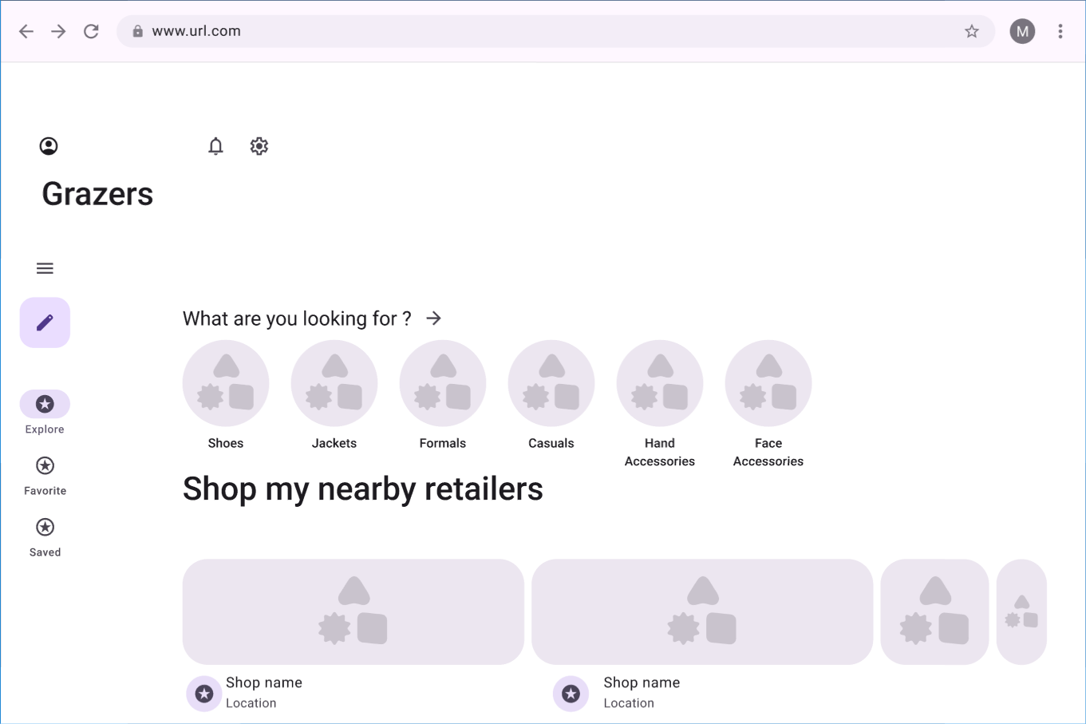
Selected Product Page:
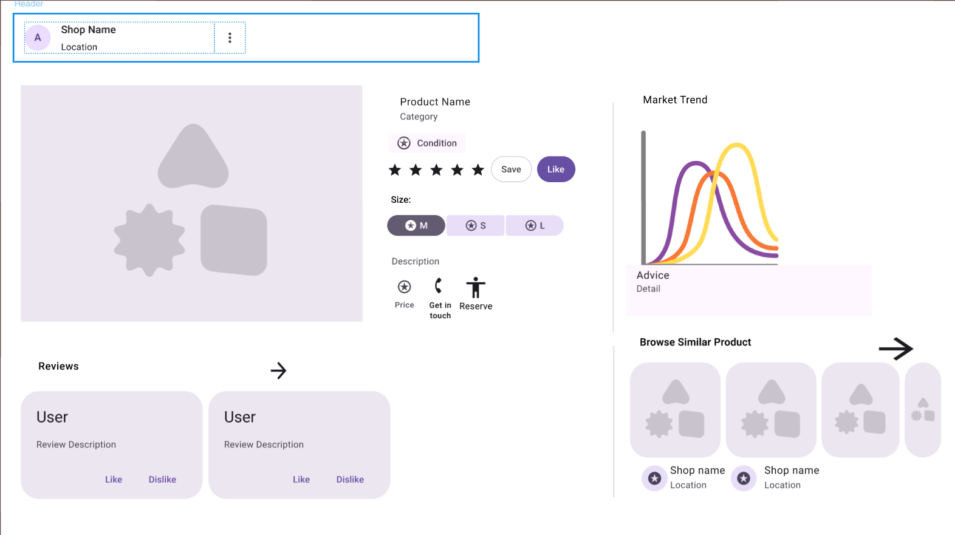
Owners’ Page:
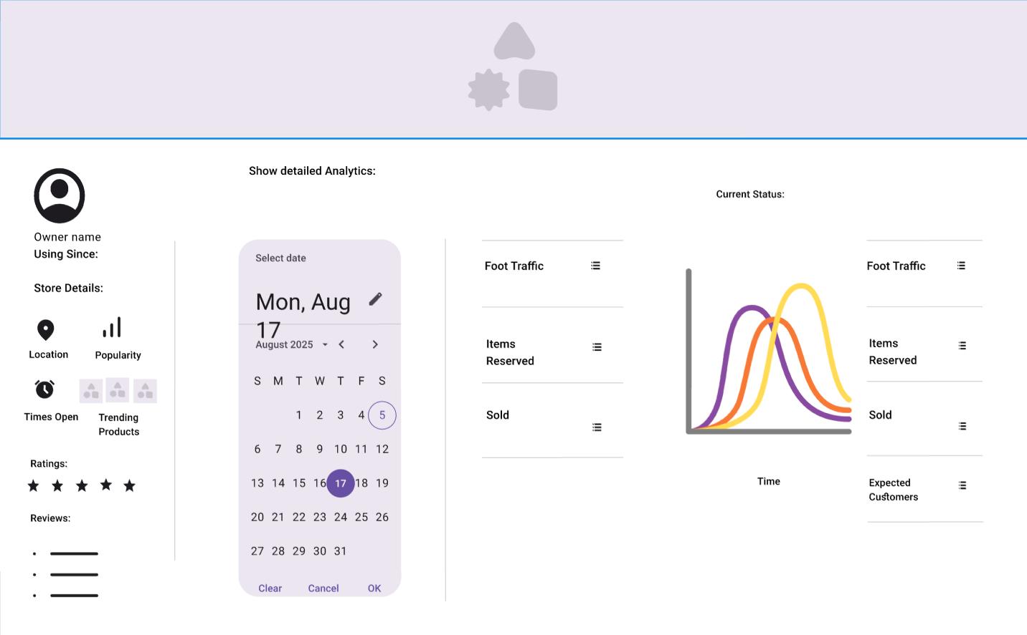
Sign/Sign-up Page:
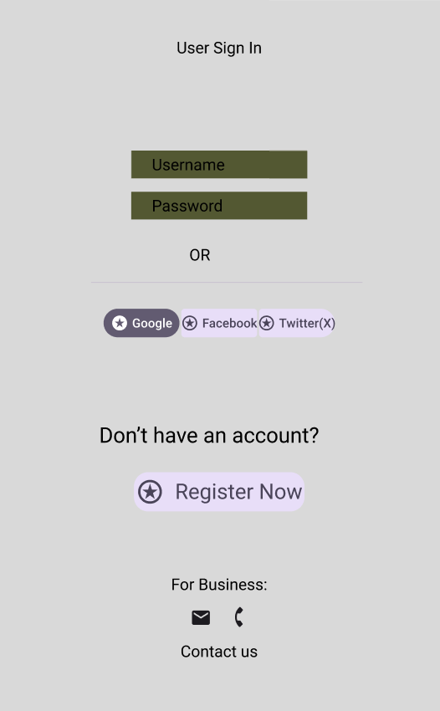
Users’ Page:
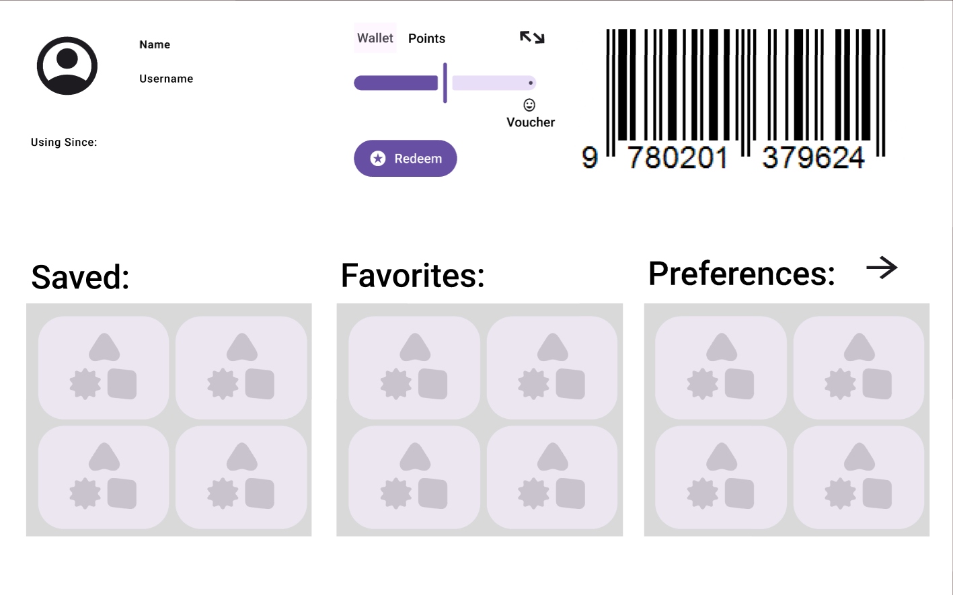

Section 3

3.1 Data Flow Diagrams

3.2 User Stories and related Use Case Scenarios

3.3 Activity Diagrams

3.4 Business Rules

Business Rule # | Description | Activity Diagram | Related UCS | UI  Mock-up
BR1 |  | AD1 | UC1 | UI 2.7.2
BR2 |  | AD2 | UC2 | UI 2.7.3
BR3 |  | AD3 | UC3 | UI 2.7.4
BR4 |  | AD3 | UC3 | UI 2.7.4
BR5 |  | AD5 | UC4 | UI 2.7.6
BR6 |  | AD6 | UC5 | UI 2.7.6
BR7 |  | AD7 | UC6 | UI 2.7.7
BR8 |  | AD8 | UC7 | UI 2.7.8
BR9 |  | AD8 | UC7 | UI 2.7.8
BR10 |  | AD8 | UC7 | UI 2.7.8
BR11 |  | AD8 | UC7 | UI 2.7.8
BR12 |  | AD8 | UC7 | UI 2.7.8
BR13 |  | AD9 | UC8 | UI 2.7.9
BR14 |  | AD9 | UC8 | UI 2.7.9
BR15 |  | AD9 | UC8 | UI 2.7.9
BR16 |  | AD9 | UC8 | UI 2.7.9
BR17 |  | AD10 | AD9 | UI 2.7.9
BR18 |  | AD10 | AD9 | UI 2.7.9
BR19 |  | AD10 | AD9 | UI 2.7.9
BR20 |  | AD11 | UC10 | UI 2.7.10
BR21 |  | AD11 | UC10 | UI 2.7.11
BR22 |  | AD11 | UC10 | UI 2.7.11
BR23 |  | AD12 | UC11 | UI 2.7.10
BR24 |  | AD13 | UC12 | UI 2.7.12

Section 4 – Domain Class

Section 5 – Database

Section 6 – Project Management

6.1 Work Breakdown Structure

6.2 Milestones & Acceptance Criteria

Section 7 – Product Backlog & Implementation Schedule

Section 8 - References

Section 9 – Client/Faculty Sign-off

