cran.r-project.org/bin/windows/base/ DOWNLOAD LINK RSTUDIO

- (a) Create a spreadsheet using Microsoft Excel that contains student marks information and calculate total and percentage. You may use the following labels and data :
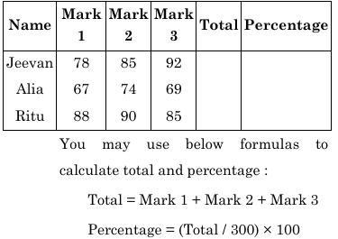
Kya karna hai
- Microsoft Excel open karo
- New Blank Workbook
- Ye headings likho (Row 1):
- Name | Mark1 | Mark2 | Mark3 | Total | Percentage
- Data fill karo:
- Jeevan 78 85 92
- Alia 67 74 69
- Ritu 88 90 85
Formula lagana
- Total column me (maan lo row 2):
- =B2+C2+D2
- Percentage column:
- =(E2/300)*100
Baaki rows me drag down kar do

B. What is Google drive ? List its features and explain how it facilitates file sharing and collaboration.
WHAT IS GOOGLE DRIVE
Google Drive is a cloud storage service developed by Google that allows users to store, manage, access, and share files online. It helps users save important data such as documents, spreadsheets, presentations, images, videos, and PDFs on Google servers instead of local computers. Since files are stored in the cloud, users can access their data anytime and from anywhere using internet-connected devices like computers, tablets, or smartphones. Google Drive also supports teamwork by allowing multiple users to work together on the same file in real time.

FEATURES OF GOOGLE DRIVE (TABLE FORMAT)
S. No. | Feature | Description
1 | Cloud Storage | Stores files online without using local storage
2 | Anywhere Access | Files can be accessed from any device with internet
3 | File Sharing | Easy sharing through email or shareable links
4 | Real-Time Collaboration | Multiple users can edit the same file simultaneously
5 | Version History | Tracks changes and allows recovery of older versions
6 | Auto Backup | Automatically saves and syncs files
7 | Security | Provides password protection and permission control
8 | Multiple File Support | Supports documents, images, videos, PDFs, etc.
9 | Google App Integration | Works with Docs, Sheets, and Slides
10 | Free & Paid Storage | Offers free storage with paid upgrade options

HOW GOOGLE DRIVE FACILITATES FILE SHARING
Google Drive simplifies file sharing by allowing users to share files and folders easily. Users can share files by entering email addresses or generating a shareable link. Google Drive provides permission controls such as Viewer, Commenter, and Editor, which help in maintaining data security. The owner can also revoke access anytime. This makes Google Drive suitable for academic, professional, and personal file sharing.

HOW GOOGLE DRIVE SUPPORTS COLLABORATION
Google Drive enables effective collaboration by allowing multiple users to work on the same document at the same time. Changes made by one user are instantly visible to others. The comment and suggestion features help users communicate directly within the document. The version history feature allows users to track changes and restore previous versions if required. This real-time collaboration improves teamwork, efficiency, and productivity.

ADVANTAGES OF GOOGLE DRIVE
Advantage | Explanation
Time Saving | Real-time updates reduce repeated work
Cost Effective | Free storage available
Easy to Use | Simple interface
Secure | Controlled access and data protection
Reliable | Data stored safely on Google servers

2. A data set of monthly electricity bills (in `) for 10 households is given : 2200; 1800; 2600; 2100; 2000; 1950; 2300; 1700; 2500; 2400
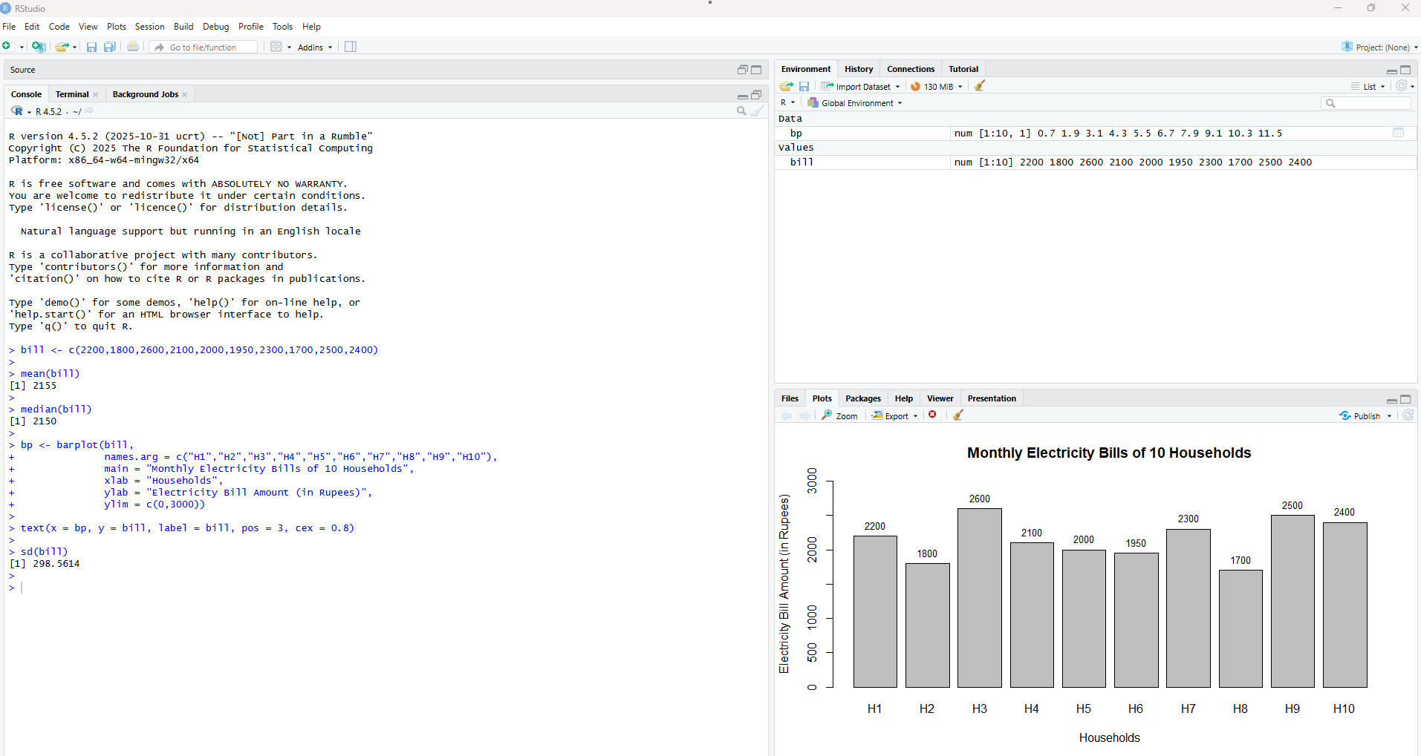

  - bill <- c(2200,1800,2600,2100,2000,1950,2300,1700,2500,2400) [ENTER]

2. mean(bill) [ENTER]
O/U [1] 2155

3. median(bill) [ENTER]
O/U [1] 2150

4. bp <- barplot(bill,
names.arg = c("H1","H2","H3","H4","H5","H6","H7","H8","H9","H10"),
main = "Monthly Electricity Bills of 10 Households",
xlab = "Households",
ylab = "Electricity Bill Amount (in Rupees)",
ylim = c(0,3000))

text(x = bp, y = bill, label = bill, pos = 3, cex = 0.8) [ENTER] – O/U CHART

5. sd(bill) [ENTER]

O/U [1] 298.5614

1.A Use Google Docs to create a formatted document resembling a research report. Include headings, bullet points numbered lists, tables and hyperlinks. Write a short report on “Benefits of Cloud Computing in Education”.
STEP 1 : Google Docs open karo
- Browser open karo
- Type karo: docs.google.com
- Blank Document select karo

STEP 2 : Title likho (Heading use karke)
- Text likho:
- Benefits of Cloud Computing in Education
- Select karo
- Heading 1 apply karo
Examiner ko dikhe ki tumhe formatting aati hai

STEP 3 : Introduction (Normal paragraph)
Likho:
Cloud computing plays an important role in modern education. It provides online access to learning resources, storage, and collaboration tools for students and teachers.

STEP 4 : Sub-heading + Bullet Points
- Sub-heading likho:
- Key Benefits
- Isko Heading 2 karo
Bullet points add karo:
- Easy access to study materials
- Cost effective learning solution
- Online collaboration
- Secure data storage
Bullet icon use karna zaroori hai

STEP 5 : Numbered List (Must)
Likho:
Major Advantages
Heading 2
Numbered list:
- Anywhere learning
- Reduced infrastructure cost
- Improved teamwork
- Automatic backup

STEP 6 : Table insert karo (Very Important)
Insert → Table → 2 × 3
Cloud Tool | Educational Use
Google Drive | File storage
Google Docs | Online documents
Table dekh ke examiner khush hota hai

STEP 7 : Hyperlink add karo
Text likho:
Google Cloud Education
Select karo → Ctrl + K
Paste link:
https://cloud.google.com/education
Ye prove karta hai tumhe hyperlink aata hai

STEP 8 : Conclusion likho
Cloud computing improves flexibility, accessibility, and collaboration in education. It supports digital learning and enhances the teaching-learning process.

(b) Explain the benefits of using Dropbox as a cloud storage solution. How can files be shared securely using Dropbox ? Include the steps with examples.
Dropbox is a popular cloud storage service that allows users to store files online and access them from anywhere using the internet. It is widely used for personal, educational, and professional purposes because of its simplicity and security.
Benefits of Dropbox
- Cloud Storage
Dropbox provides online storage space to save documents, images, videos, and other files securely.
- Access Anywhere
Files stored in Dropbox can be accessed from any device such as computer, tablet, or smartphone.
- Automatic Syncing
Files are automatically synced across all connected devices.
- File Backup and Recovery
Dropbox keeps backup of files and allows recovery of deleted files.
- Easy File Sharing
Files and folders can be shared easily using links or email.
- Security and Privacy
Dropbox uses encryption and permission control to protect data.

Secure File Sharing Using Dropbox
Dropbox allows secure file sharing by giving users full control over access permissions.
Steps to Share Files Securely in Dropbox
Step 1:
Login to your Dropbox account.
Step 2:
Upload the file or folder you want to share.
Step 3:
Click on the Share option next to the file.
Step 4:
Enter the email address of the person or generate a shareable link.
Step 5:
Set permissions:
- View only
- Edit
Step 6:
Enable security options such as password protection and link expiry date.

Example
A teacher uploads study material to Dropbox and shares a view-only password-protected link with students to ensure secure access.

2. Given the data set of exam scores : 72, 85, 91, 68, 77, 81, 95, 89, 73, 88 Write R program to perform the following tasks :
(a) Calculate the range and interquartile range (IQR).
(b) Create a box plot and interpret the distribution.
(c) Find the proportion of scores greater than 80.

scores <- c(72, 85, 91, 68, 77, 81, 95, 89, 73, 88) ENTER

range(scores) ENTER
O/U [1] 68 95
IQR(scores) ENTER
O/U [1] 14.75

boxplot(scores,
main = "Box Plot of Exam Scores",
ylab = "Scores",
col = "lightgray") ENTER O/U CHART

mean(scores > 80) ENTER
O/U [1] 0.6
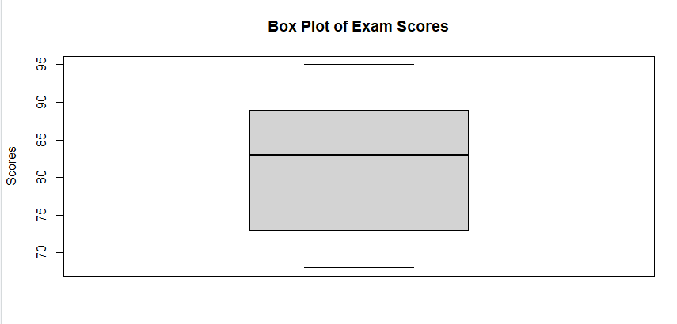

  - (a) Create a presentation using Google slides explaining the architecture of cloud computing. Include at least five slides with text, images and transitions.

STEP 1 : Google Slides kaise open kare
- Browser open karo
- Type karo: slides.google.com
- Blank presentation select karo

STEP 2 : SLIDE-BY-SLIDE KYA LIKHNA HAI

SLIDE 1 : TITLE SLIDE
Title (Heading):
Cloud Computing Architecture
Subtitle:
Overview of Cloud Computing Components
Layout: Title Slide

SLIDE 2 : INTRODUCTION
Heading:
Introduction to Cloud Computing
Bullet Points:
- Cloud computing delivers computing services over the internet
- It provides storage, servers, and applications online
- Users access services without managing infrastructure
Transition add karo: Fade

🔹 SLIDE 3 : CLOUD COMPUTING ARCHITECTURE
Heading:
Architecture of Cloud Computing
Bullet Points:
- Front End
- Back End
- Internet / Network

Image add karo:
Cloud computing architecture diagram
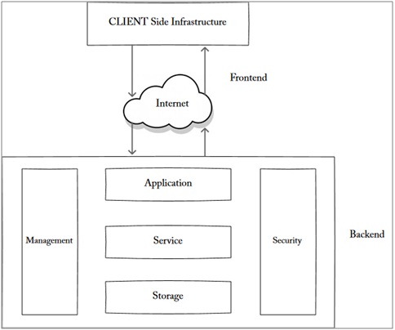
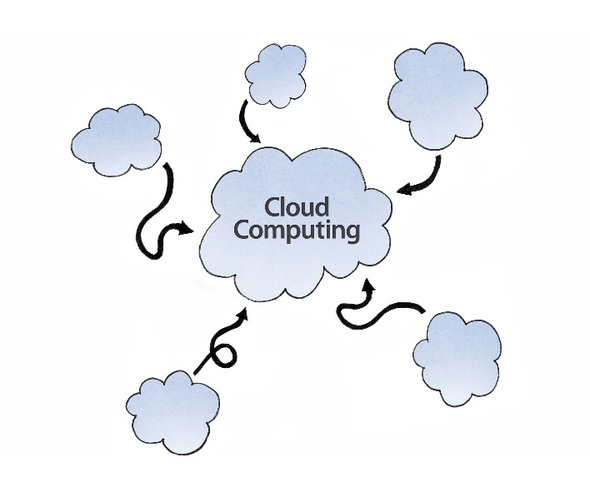

Transition: Slide from right

SLIDE 4 : FRONT END & BACK END
Heading:
Components of Cloud Architecture
Bullet Points:
- Front End: User interface, browser, client device
- Back End: Servers, databases, storage, virtual machines
- Middleware connects front end and back end
Transition: Fade

SLIDE 5 : BENEFITS OF CLOUD ARCHITECTURE
Heading:
Advantages of Cloud Architecture
Bullet Points:
- Scalability
- Cost efficiency
- High availability
- Data security
- Easy maintenance
Transition: Zoom / Fade

(OPTIONAL) SLIDE 6 : CONCLUSION
Heading:
Conclusion
Text:
Cloud computing architecture enables efficient resource sharing, scalability, and secure access to computing services over the internet.

STEP 3 : IMAGE KAISE ADD KARE
- Insert → Image → Search the web
- Type: cloud computing architecture
- Any one clear diagram select karo

STEP 4 : TRANSITION KAISE ADD KARE
- Slide select karo
- Click Transition
- Choose Fade / Slide / Zoom
- Apply

(b) What is Amazon Web Services (AWS) ? List at least five major services offered and briefly describe their use.
What is Amazon Web Services (AWS)?
Amazon Web Services (AWS) is a cloud computing platform provided by Amazon. It offers a wide range of on-demand computing services such as servers, storage, databases, networking, and software over the internet. AWS allows users to use IT resources without buying physical hardware, and services are charged on a pay-as-you-use basis. It is widely used by startups, enterprises, and educational institutions.

Major Services Offered by AWS
1. Amazon EC2 (Elastic Compute Cloud)
- Provides virtual servers in the cloud
- Used to run applications and websites
- Allows users to scale computing power easily

2. Amazon S3 (Simple Storage Service)
- Used for storing and retrieving data
- Supports files, images, videos, and backups
- Highly scalable and durable storage service

3. Amazon RDS (Relational Database Service)
- Provides managed database services
- Supports MySQL, PostgreSQL, Oracle, etc.
- Reduces database administration tasks

4. Amazon CloudFront
- Content Delivery Network (CDN) service
- Delivers content with low latency
- Used for faster website and media delivery

5. AWS Lambda
- Serverless computing service
- Runs code without managing servers
- Used for event-driven applications

2. A sample of daily temperature (in °C) recorded over 10 days is as follows : 30, 32, 28, 31, 33, 29, 34, 35, 30, 32 Write R program to perform the following tasks :
(a) Plot the line graph for daily temperatures.
(b) Calculate the moving average of the last 5 days.
(c) Identify days with temperature above the overall average.
temp <- c(30, 32, 28, 31, 33, 29, 34, 35, 30, 32)
days <- 1:10 ENTER

plot(days, temp,
type = "o",
main = "Daily Temperature Over 10 Days",
xlab = "Days",
ylab = "Temperature (°C)") ENTER CHART O/U

last5 <- temp[6:10]
moving_average <- mean(last5)
moving_average ENTER
O/U [1] 32

overall_avg <- mean(temp)
above_avg_days <- which(temp > overall_avg)
above_avg_days ENTER
O/U [1] 2 5 7 8 10
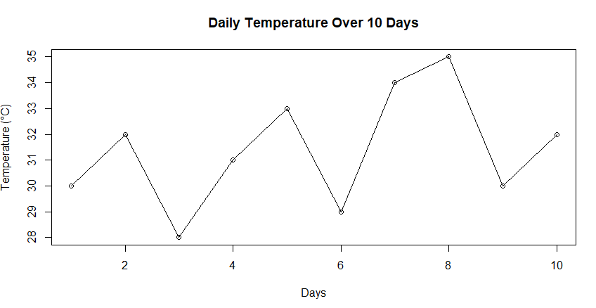
  - (a) Design a Google form for feedback collection after a Webinar. Include questions using different types like short answer, multiple choice, checkboxes and linear scale. Share it and collect responses.
STEP 1 : Google Form kaise create kare
- Browser open karo
- Type karo: forms.google.com
- Click on Blank Form
- Form ka title do
Form Title:
Webinar Feedback Form
Description:
Please provide your valuable feedback for the webinar.

STEP 2 : Questions add karo (IMPORTANT)
Question 1 – Short Answer
Question:
Name of the Participant
Question Type:
Short Answer

Question 2 – Multiple Choice
Question:
How would you rate the overall webinar?
Options:
- Excellent
- Good
- Average
- Poor
Question Type:
Multiple Choice

Question 3 – Checkboxes
Question:
Which topics did you find useful in the webinar?
Options:
- Introduction to topic
- Practical examples
- Case studies
- Question & Answer session
Question Type:
Checkboxes

Question 4 – Linear Scale
Question:
Rate the quality of the webinar content
Scale:
1 to 5
1 = Very Poor
5 = Excellent
Question Type:
Linear Scale

Question 5 – Short Answer (Optional)
Question:
Any suggestions for improvement?
Question Type:
Short Answer

STEP 3 : Form Settings (Optional but good for marks)
- Mark important questions as Required
- Enable Collect email addresses (optional)

STEP 4 : Form Share kaise kare
- Click Send button
- Choose sharing method:
  - Email
  - Link
- Copy link and share with participants

STEP 5 : Responses kaise collect kare
- Go to Responses tab
- View responses in:
  - Summary
  - Individual
- Click Create Spreadsheet to store responses

(b) Describe the concept of SaaS (Software as a Service). Give examples and mention advantages over traditional software models.
What is SaaS (Software as a Service)?
SaaS (Software as a Service) is a cloud computing model in which software applications are hosted on the service provider’s servers and made available to users over the internet. Users do not need to install, maintain, or update the software on their local systems. The software is accessed through a web browser, and payment is usually made on a subscription or pay-as-you-use basis.

Examples of SaaS
- Google Docs – Online document creation and editing
- Gmail – Email service
- Dropbox – File storage and sharing
- Salesforce – Customer relationship management
- Zoom – Online meetings and webinars

Advantages of SaaS over Traditional Software Models
1. No Installation Required
SaaS applications run on the cloud and do not require installation on individual computers.
2. Cost Effective
There is no need to purchase expensive licenses or hardware. Users pay only for what they use.
3. Automatic Updates
Software updates and maintenance are handled by the service provider.
4. Anywhere Accessibility
Users can access the software from anywhere using an internet connection.
5. Scalability
Resources can be increased or decreased easily based on user requirements.
6. Reduced Maintenance
No need for in-house IT staff to manage software.
Comparison with Traditional Software
Traditional Software | SaaS
Installed locally | Accessed via internet
High upfront cost | Subscription based
Manual updates | Automatic updates
Limited accessibility | Access from anywhere
2. Daily sales (in units) for a store in 10 days are recorded as : 150, 160, 145, 170, 155, 165, 158, 172, 169, 160 Write R program to perform the following tasks :
(a) Plot a histogram of daily sales.
(b) Compute and interpret the mode.
(c) Test whether the data is normally distributed using appropriate method in R.

sales <- c(150, 160, 145, 170, 155, 165, 158, 172, 169, 160) ENETR

hist(sales,
main = "Histogram of Daily Sales",
xlab = "Sales (Units)",
ylab = "Frequency") ENTER CHART

mode_value <- as.numeric(names(sort(table(sales), decreasing = TRUE)[1]))
mode_value ENTER
O/U [1] 160

shapiro.test(sales) ENTER

O/U Shapiro-Wilk normality test

data: sales
W = 0.95725, p-value = 0.7541
