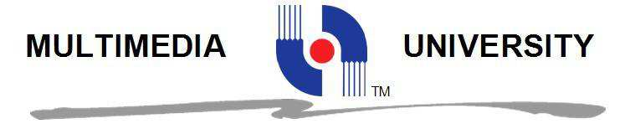

FACULTY OF COMPUTING AND INFORMATICS

TCP1101 PROGRAMMING FUNDAMENTALS

TRIMESTER 2 2018/2019

Assignment#2
Report

Lecture Section: TC 01
Tutorial Section: TT 02

INSTRUCTOR’S NAME:
- Mr Lee Kian Chin
- Dr Ng Kok Why

Student ID | Name | Email Address | Phone No.
1181302192 | Aiman Hans Bin Husin | aimanhans@protonmail.com | +6012-3701543

Assignment#2 Mark Sheet
TCP1101 Programming Fundamentals
Trimester 2, Session 2018/2019

To be filled by Examiner. This is for your reference only.

 | Max | Actual Marks
1. Report (10%)
a. Formatting and Style | 2
b. Language (Spelling, Grammar) | 2
c. Presentation Clarity | 2
b. Screenshots | 2
e. User Guide / Instructions to Use the Program | 2
2. Coding (50%)
a. Error Checking Features | 10
b. Good Coding Style (indentation, spacing, identifier naming etc.) | 10
c. Code Modularity (usage of functions) | 15
d. Code Efficiency and Strategy | 15
3. Program Execution (30%)
(If the program cannot be run, even if it can be compiled, 0 mark will be given for this section)
a. General Appearance of Program (display) | 6
b. Accuracy (program works and runs correctly) | 6
c. Usability (interaction with user, user-friendliness) | 6
d. Performs All Required Features | 6
e. Error-free During Runtime | 6
4. Additional Features (10%)
a. Additional special features or any other significant contributions | 10
TOTAL | 100

Introduction
Mars rover is a motor device that able to navigate through Mars. It can also perform many other things such as send an image, investigate, or gain the property of a specimen in Mars. The purpose of this program is to simulate the basic movement of a Mars rover by entering commands.
The main goal of the simulation is to collect every gold placed inside the map using the Mars rover. The user needs to input commands to control the Mars rover while making sure the rover does not move into a hole, or the mission will fail. To add into the difficulty, the user only given limited visibility to three boxes in front of the rover, which then makes it permanent once discovered.

User Manual
When first starting the program, you will be prompted with a welcome message and background story of the Mars rover. Then, you will be allowed to design the map by making the size based on inputted row and column, and the amount of gold you wanted. After that, you are shown the map to navigate the rover to the end goal.

Move forward:
- Input M.
- Rover will move by 1 block it is facing.
Turn right:
- Input R.
- Rover will change the direction it is facing by 90 ° clockwise on the same block.
Turn left:
- Input L.
- Rover will change the direction it is facing by 90° counterclockwise on the same block.
Quit simulation:
- Input Q.
- Current simulation will stop and you will be prompted with options.
Retry:
- Input Q.
- Current simulation will be stopped.
- Input Y.
- The program will restart.
Exit:
- Input Q.
- Current simulation will be stopped.
- Input N.
- The program will end.

Screenshots

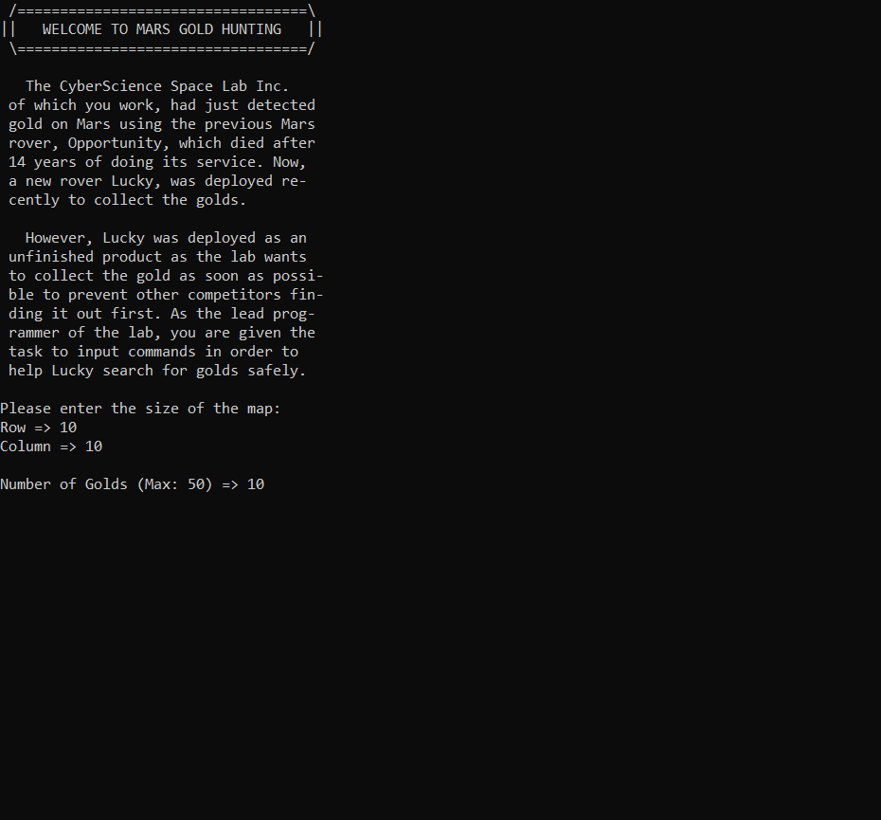

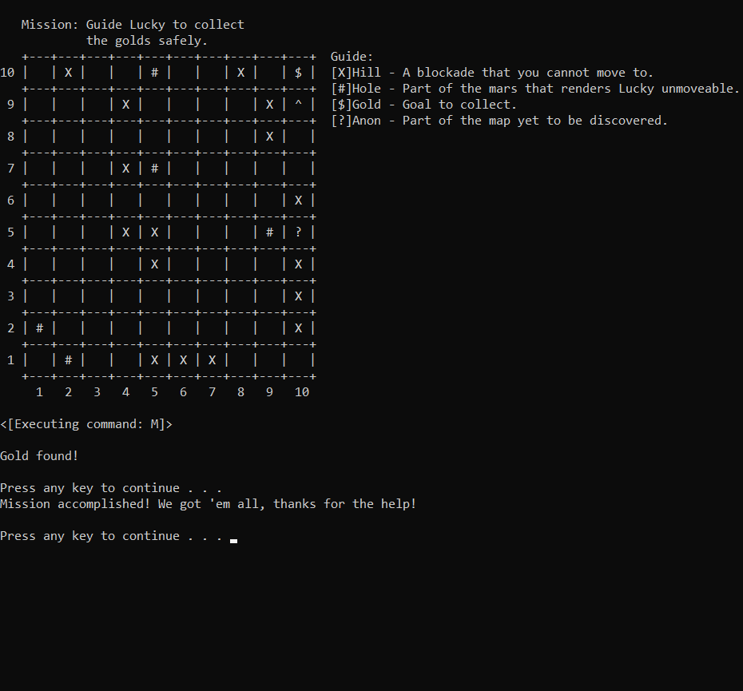
Assignment#02 Submission Declaration
TCP1101 Programming Fundamentals
Trimester 2, Session 2018/2019

To be Filled by Each Student

Name | Aiman Hans Bin Husin
ID | 1181302192
Lecture Section | TC01 |  | Tutorial Section |  | TT02
Names and IDs of students which I have discussed regarding this assignment
Number of hours I spent in doing this assignment |  |  |  | 12 hours

I hereby declare that this assignment represents the work done by myself. I declare that no part of my work has been copied from other persons or by means of professional assistance.

I hereby declare, and I fully understood that, if I have copied any parts from any other persons OR if any other persons have copied from my work, I will get a mark of ZERO and I am fully responsible to ensure this does not happen.

I also hereby declare that every works or materials/codes that I may have borrowed, copied or modified from other sources are properly acknowledged in the report and the sources are listed in the ACKNOWLEGEMENT or REFERENCES section. I will take full responsibility and understood that I will get a mark of ZERO if I failed to make proper acknowledgement.

I certify that any files submitted with this assignment have been virus-checked and is free from viruses.

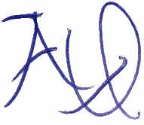
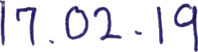

Signature: ……………................……… Date: .................................. ...................

Note: No work shall be accepted unless it is accompanied by this submission declaration with all sections completed and it has been signed and dated. Please scan the document and include this to the softcopy of your report. cs

