Android MQTT control and observer app setup

1. Download MQTT Dash from the Play Store.

<https://play.google.com/store/apps/details?id=net.routix.mqttdash&hl=en>

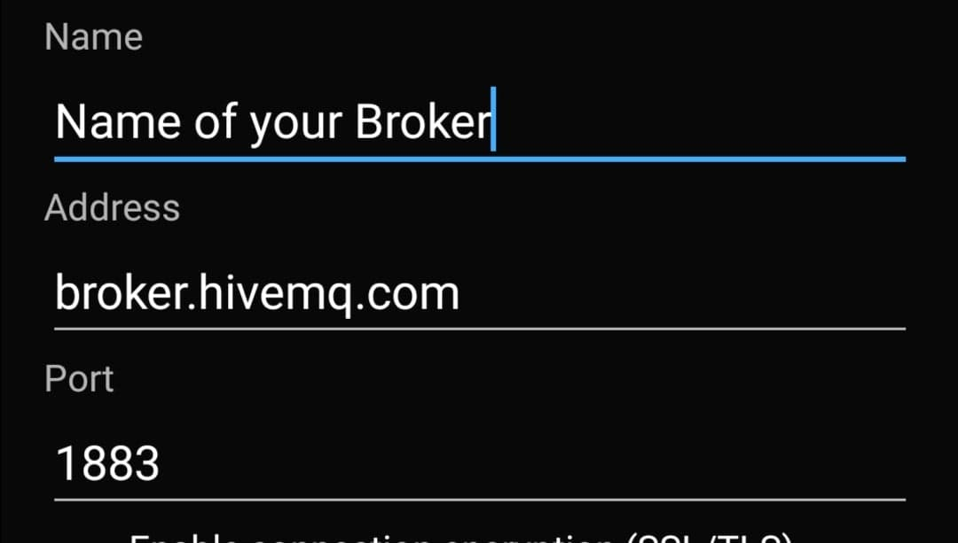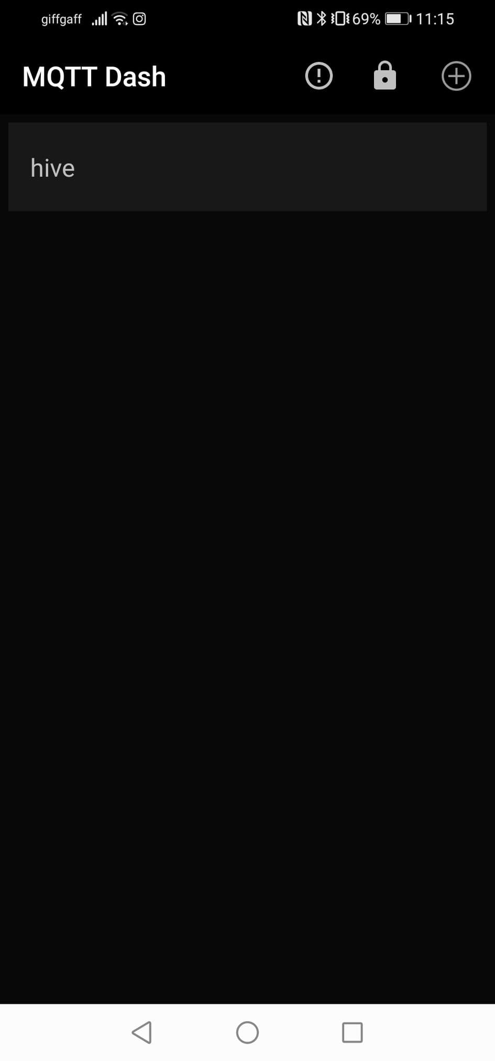Set up your broker by clicking on the plus sign in the top right corner and typing in your broker address and the needed port.

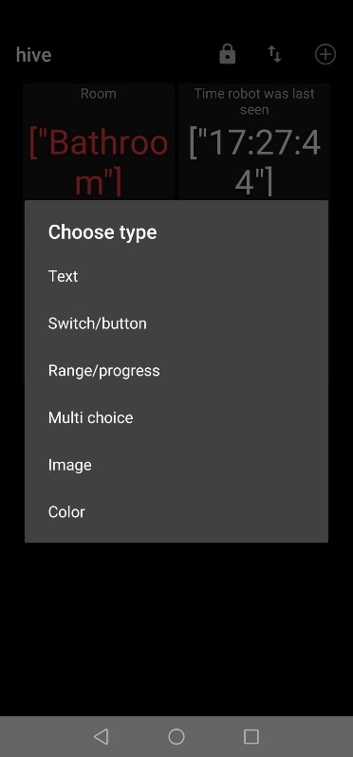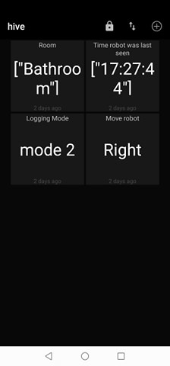Click on the broker you just created. First, we will set up the Location and Time monitoring modules. For this click on the plus sign on the top right corner and select “Text”

1. Name the module and fill out the Topic(sub) textbox with the topic the module should be subscribed to. In this applications case, the incoming payload is a JSON, so we need to make sure the module displays the right part of the json. For this we use the “$.level.value” format.

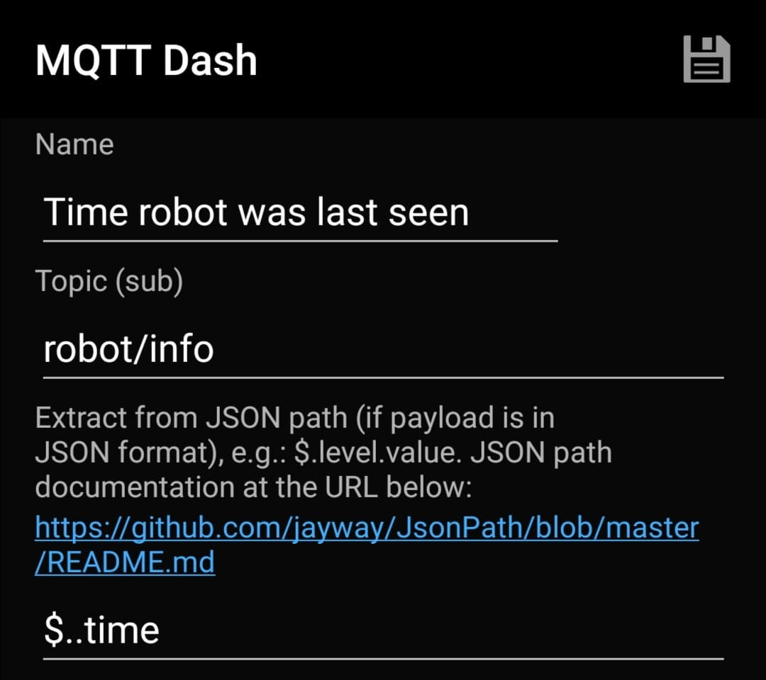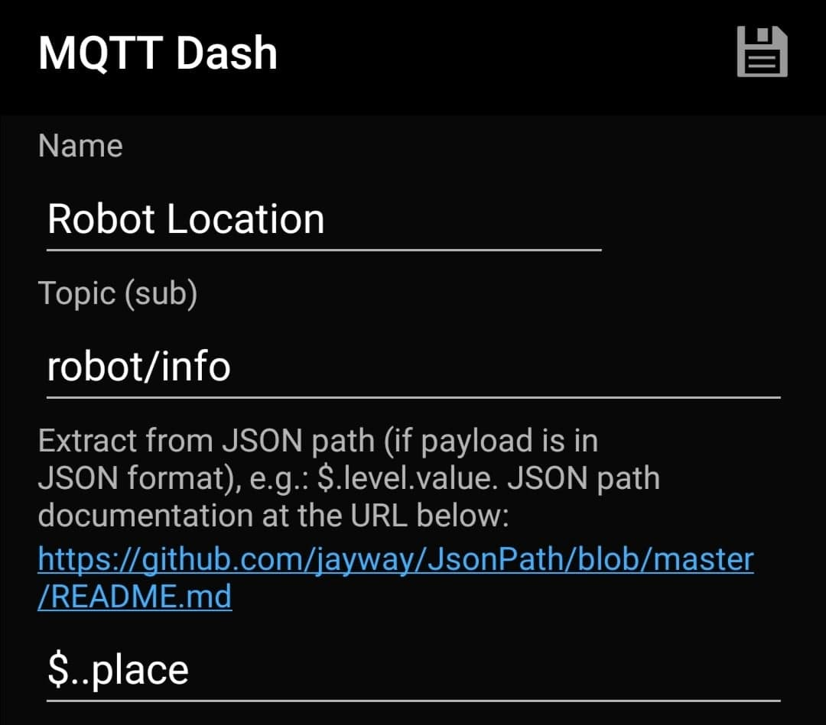

1. We will then create the Logging mode selector and the Robot movement direction Selector modules. For this we will create two “Multi choice” module.
2. We will give the modules a name and set up which topic they should publish to.

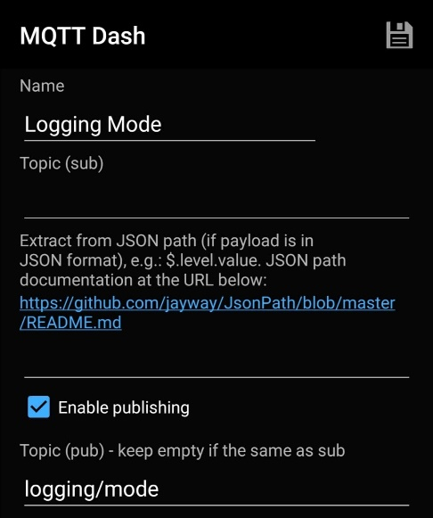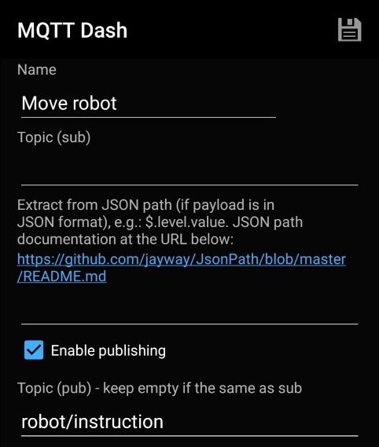

1. 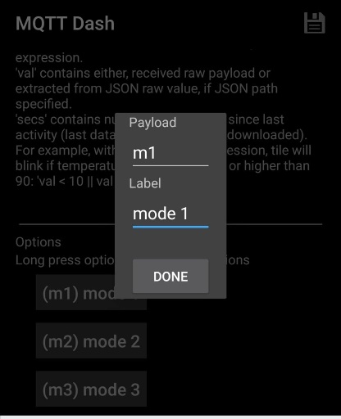We will then create the options that the user will be able to choose from. In the logging mode it will be the 3-logging mode and in the movement module it will be the four direction the robot is able to move. We do this by clicking “Add option” and fill out the displayed name of the option and the Payload it should send whenever its clicked.   
   The displayed text under the option indicates the payload and the label that needs to be inout for this application.

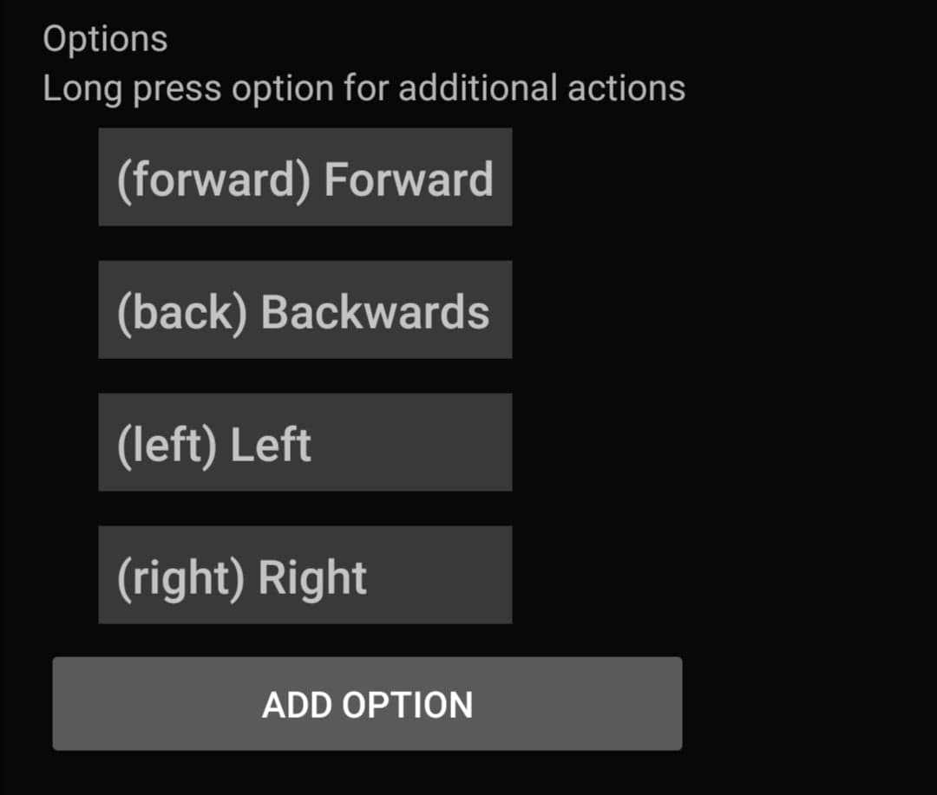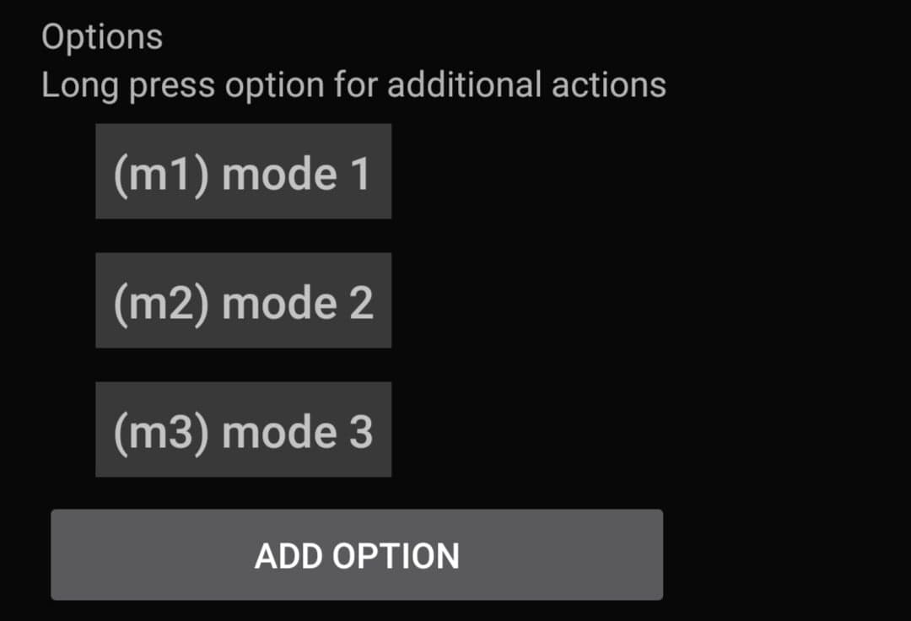

**PAYLOADS**

1. The setup is completed. The app will connect to the broker when the broker name in the main menu is clicked and the 4 modules are visible.