G4S1W6: 10th October 2026 Name: __________, Class: 4_____
Week 6- Remember what we did
- Describe the people. Use ‘She/he is…’, ‘She/he has…’ and at least 1 ‘She/ he (always)…’ sentence.


__________________________ __________________________
__________________________ __________________________
__________________________ __________________________


__________________________ __________________________
__________________________ __________________________
__________________________ __________________________

- What are the jobs below? What do they have to like? What are they good at?

Job: ______________
They like: _______________________
They have to be good at: ___________________________________

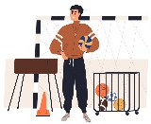
Job: ______________
They like: _______________________
They have to be good at: ___________________________________

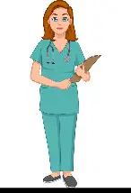
Job: ______________
They like: _______________________
They have to be good at: ___________________________________

- What are you doing next week? Write questions and your answers
What are you doing next week? I’m going to school next week
a- When _____________________________? ________________________________
b- Where _____________________________? ________________________________
c- How _______________________________? ________________________________
d- Why _______________________________? ________________________________

