G4S1W2: 10th October 2026 Name: __________, Class: 4_____
Week 6- Places and directions?
- What places in a town/ city can you see here?
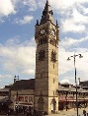
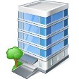
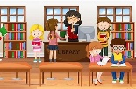
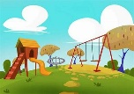
Opticians, jewellery shop, playground, office block, bakery, tourist information centre, library, clock tower

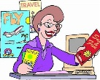
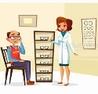
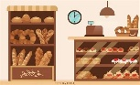
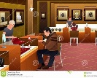
__________ ____________ ____________ ___________

__________ ____________ ____________ ___________
- What are the roads and the directions below?
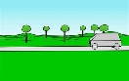
Go through, go up, go along, go round the bend, cross xxx, crossroad, T-junction, go down
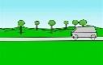
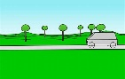

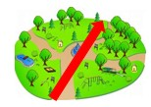
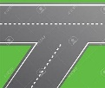
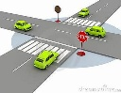
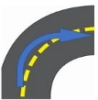
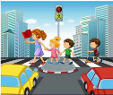
____________ ____________ ____________

___________ ____________ ___________ ___________ ____________

- Give directions from the star to book shop.








