G4S1W2: 25th September 2026 Name: __________, Class: 4_____
Week 4- What job should I have?
- What are the jobs below?


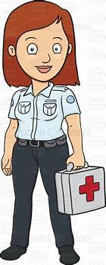

Scientist, designer/ architect, musician, nurse, Designer


__________ ____________ ____________ __________ ___________
- What do you need for each job below?


Like: _______________________________________
Good at: _______________________________________

Like: ________________________________________
Good at: _______________________________________

Like: ________________________________________
Good at: _______________________________________

Like: ________________________________________
Good at: _______________________________________

- Think of someone in your family. What is their job? What do they need to like/ be good at.
My ___________ (family member) is a _____________ (job). To be a ____________ (job), you have to like_______________________________. You have to be good at ____________________________. Every day, my ______________ (family member)
_____________________________ (what do they do?). She/ He often ___________ _______________________ (what do they do?) at the weekend. She/ He never ____ __________________________________ (what don’t they do?)

