Munich, 23. July 2019

Profile of Mr. Markus Hopf Dipl.-Ing. (FH)

Picture: | 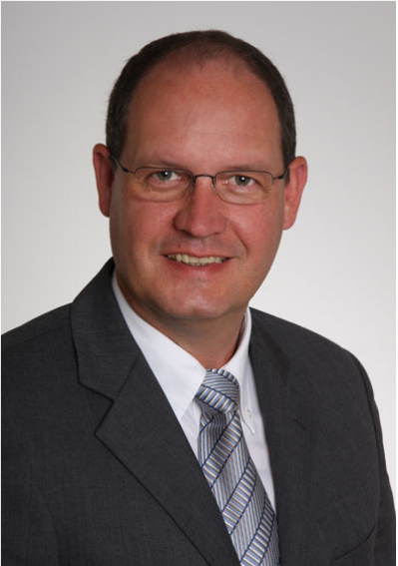
Overview: | - Dipl.-Ing. Computer Engineering (FH)  - Java EE Full Stack Developer  - Certified Professional Scrum Master PSM  - Certified Spring Professional  - Sun Certified Java Programmer  - Sun Enterprise Trainer  - Sun Certified Enterprise Architect  - OMG Certified UML Professional  - IBM Certified XML Professional
Skills: | - System – and Enterprise Consulting  - Java EE Full Stack Developer  - Microservice architecture  - Java, JavaScript, Typescript, Groovy, ES6, HTML5 und CSS  - Coordination of Projects  - Angular, ReactJs, Wicket, Web Development  - Spring, Hibernate  - NodeJs, npm  - Kubernetes, Docker  - Design and Analysis with UML  - Distributed multi-tier applications with JEE / J2EE  - REST API Webservices
Availability: | In 100% availability projects i can start not before 5. August 2019.
Location: | Munich or Remote.
Conditions: | 95 € per hour.
Address: | Dipl. Ing. (FH) Hopf, Markus  Klara-Ziegler-Bogen 53, D-81739 München  Mobil: +49 172 / 95 94 59 0  E-Mail: info@hopf-it.de  Homepage: www.hopf-it.de

