UTS SAFE WORK METHOD statement (SWMS)

- FACULTY/SUBJECT
Faculty/Subject title | 41013 Industrial Robotics
Subject supervisor/coordinator | Gavin Paul
SWMS prepared by | Jack Heffernan
- WORK ACTIVITY DESCRIPTION
Describe the work activity E.g. Operating, Handling, Using..  Include names of hazardous equipment, substances or materials used,  and any quantities and concentrations of substance(s) or reaction products. | Programming and operating a UR3e collaborative robot arm in the robotics lab to perform pick-and-place tasks for a robotic bartending demonstration. Motions are simulated in Python (Swift) first, including collision and joint limit checks, before a basic movement of the UR3e is run on the physical robot at reduced speed.  In terms of the virtual environment, hazards such as robot-to-robot collisions, collisions with the bar and objects, and a person entering the workcell are modelled and addressed in simulation using barriers, a light curtain, an E-stop and collision avoidance. Spillage and other bar factors are also taken into account.  The activity includes connecting and handling electrical connectors (UR controller, PLC and E-stop circuit), attaching the gripper end effector, and manual handling of equipment and props.
- HAZARDS: Choose those hazard types that will need to have control measures in Section 4
Work Environment  - Slip/Trip/Fall hazards  - Water/alcohol spills |  | Plant  - Noise  - Vibration  - Moving parts (Crushing,friction, cut, stab, shear hazards)  - Dropped or flung objects  - Collision within workspace  - Unexpected motion  - Parts being entangled with the robot |  | Chemical |  | Ergonomic/Manual Handling  - Working above shoulder or below knee height  - Poor workstation set up  - Repetitive or awkward movement
Electrical  - Plug in equipment  - High voltage  - Exposed wiring  - Exposed conductors |  | Radiation |  | Biological |  | Psychosocial  - Working in isolation  - Working with timeframes
- CONTROLS MEASURES: Choose those that apply for hazards identified
Eliminate/Isolate/Substitute / Engineering Controls  - Remove hazard  - Restrict access  - Regular maintenance of equipment  - Redesign of workspace / workflow  - Use plastic props instead of glass with liquid to stop shattering or spills in case of malfunction.  - Reduce speed.  - Simulate software joint limits. |  |  | Admin specific: Licenses/permits Work Methods  - Training Information or Instruction  - Licensing or certification of operators  - Test and tag electrical equipment  - Regular breaks  - Task rotation  - Work in pairs  - Have pre session checks of each component |  | Emergency Response Systems  - First aid kit  - Emergency Stop button  - Remote Communication Mechanism
Other controls not listed
- Tie back all loose hair and clothing.


- PPE REQUIRED (Tick those that apply)
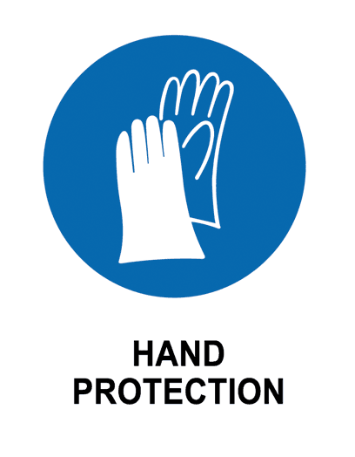

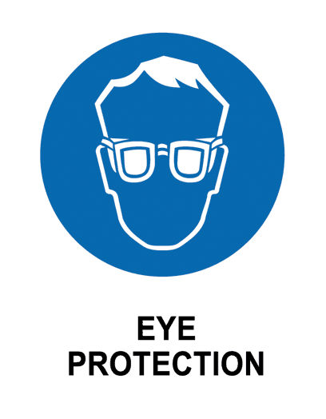
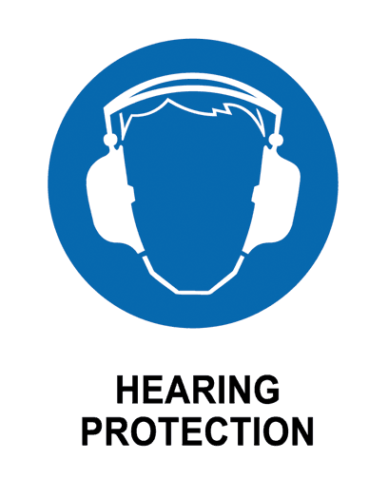
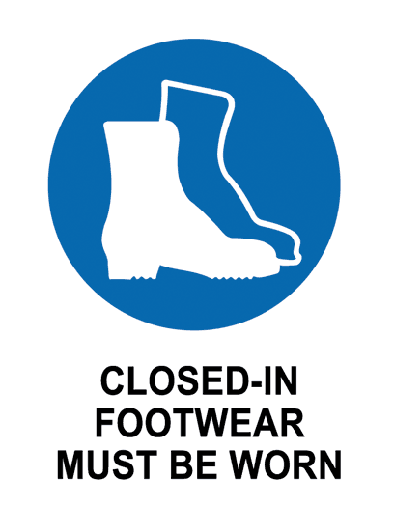
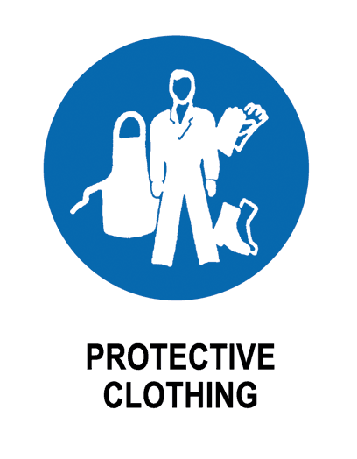
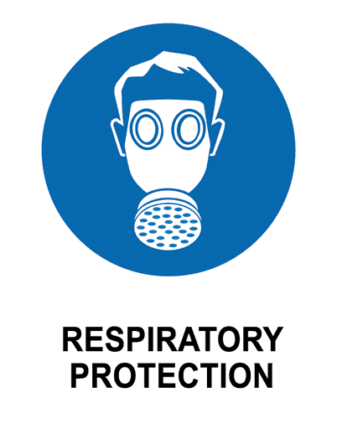
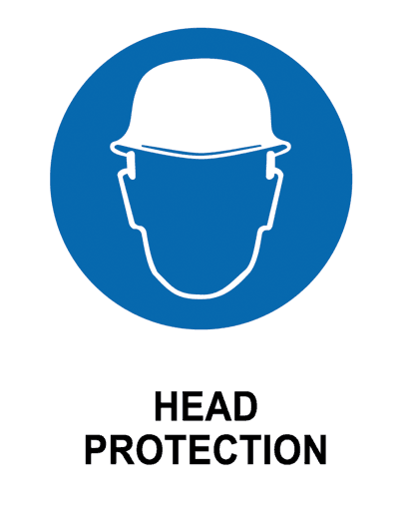

- EMERGENCY EQUIPMENT
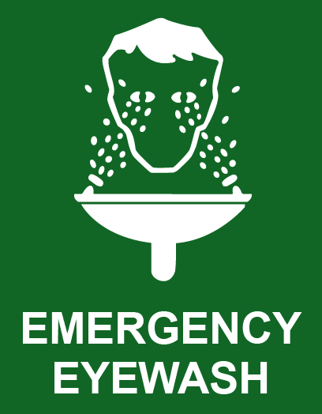
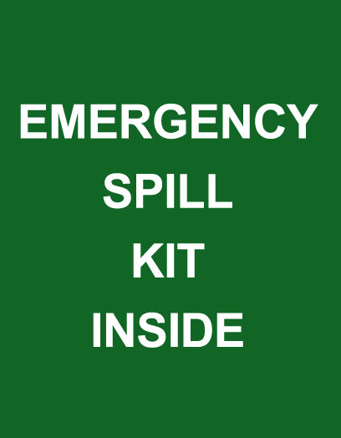
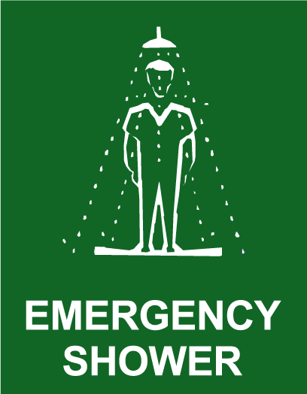

- work activity steps
before you start:

- Check E stop is working
- Closed in footwear is worn.
- Confirm workspace is clear
- Tie back long hair and wear safety glasses.
- Confirm payload is within safe bounds.
- Confirm that the electrical parts are plugged in safely.
- Virtually simulate the robot moving before starting.

steps in work activity:

- Power on the robot and confirm E stop is engaged
- Load and verify the program is correct
- Ensure Area is cleared and run program at reduced speed.
- Monitor movement and hold over e stop in case something happens
- Return robot to original position
- Pack up, power down and ensure workspace is left clean
- Log report, recording incidents if they occurred and store equipment safely.

emergency procedures:

- Press emergency button
- Notify security or dial 6 using the UTS internal phone

training required:
- Robot operation induction / lab safety brief
- E stop emergenct training

- sign off
prepared by:  NAME: JACK HEFFERNAN, JAMES WITCOMB, WILL RICHARDSON | Lab Supervisor  Name: Felipe Ulloa Gutierrez | Date: 24/09/2026  Review Date:

