UTS SAFE WORK METHOD statement (SWMS)

- FACULTY/SUBJECT
Faculty/Subject title | 41013 Industrial Robotics
Subject supervisor/coordinator | Gavin Paul
SWMS prepared by | Jack Heffernan, Will Richardson, James Witcombe
- WORK ACTIVITY DESCRIPTION
Describe the work activity E.g. Operating, Handling, Using..  Include names of hazardous equipment, substances or materials used,  and any quantities and concentrations of substance(s) or reaction products. | Real  Programming and operating a UR3e collaborative robot arm in the robotics lab to perform pick-and-place tasks for a robotic bartending demonstration.  The Real Robot demo is going to be a replica of the simulated motion of the UR3 where it is modelling the movement of picking up different bottles from a table. For the Real robot demo the Gripper and picking up bottles that can spill is not required to demonstrate the motion.  Sim  Motions are simulated in Python (Swift) first, including collision and joint limit checks, before a basic movement of the UR3e is run on the physical robot at reduced speed.  In terms of the virtual environment, hazards such as robot-to-robot collisions, collisions with the bar and objects, and a person entering the workcell are modelled and addressed in simulation using barriers, a light curtain, an E-stop and collision avoidance.  Spillage and other bar factors are also taken into account. An Arduino or Game Controller as an emergency stop button other than a keyboard.  The activity includes connecting and handling electrical connectors (UR controller, PLC and E-stop circuit), attaching the gripper end effector, and manual handling of equipment and props.
- HAZARDS: Choose those hazard types that will need to have control measures in Section 4
Work Environment  - Slip/Trip/Fall hazards  - Water/alcohol spills |  | Plant  - Noise  - Vibration  - Moving parts (Crushing,friction, cut, stab, shear hazards)  - Dropped or flung objects  - Collision within workspace  - Unexpected motion  - Parts being entangled with the robot |  | Chemical |  | Ergonomic/Manual Handling  - Working above shoulder or below knee height  - Poor workstation set up  - Repetitive or awkward movement
Electrical  - Plug in equipment  - High voltage  - Exposed wiring  - Exposed conductors |  | Radiation |  | Biological |  | Psychosocial  - Working in isolation  - Working with timeframes
- CONTROLS MEASURES: Choose those that apply for hazards identified
Eliminate/Isolate/Substitute / Engineering Controls  - Remove hazard  - Restrict access  - Regular maintenance of equipment  - Redesign of workspace / workflow  - Use plastic props instead of glass with liquid to stop shattering or spills in case of malfunction.  - Reduce speed.  - Simulate software joint limits. |  |  | Admin specific: Licenses/permits Work Methods  - Training Information or Instruction  - Licensing or certification of operators  - Test and tag electrical equipment  - Regular breaks  - Task rotation  - Work in pairs  - Have pre session checks of each component |  | Emergency Response Systems  - First aid kit  - Emergency Stop button  - Remote Communication Mechanism
Other controls not listed
- Tie back all loose hair and clothing.


- PPE REQUIRED (Tick those that apply)
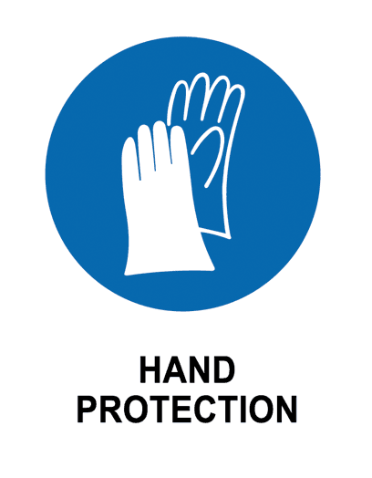


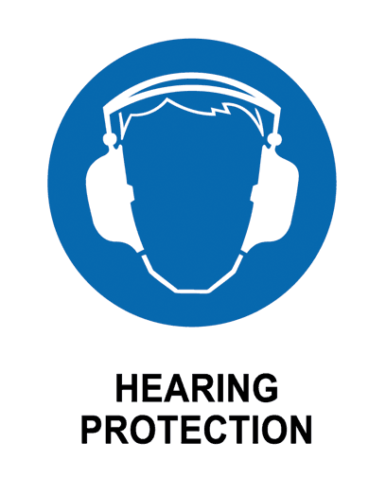
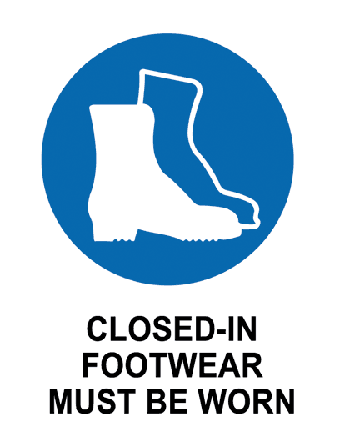
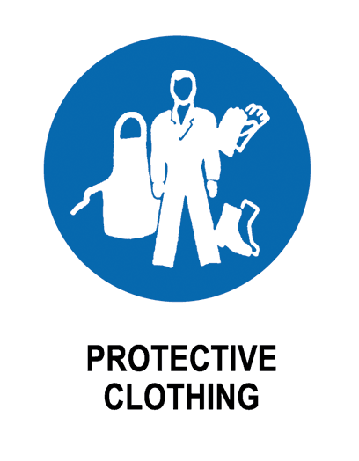
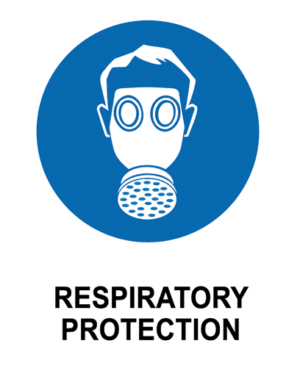
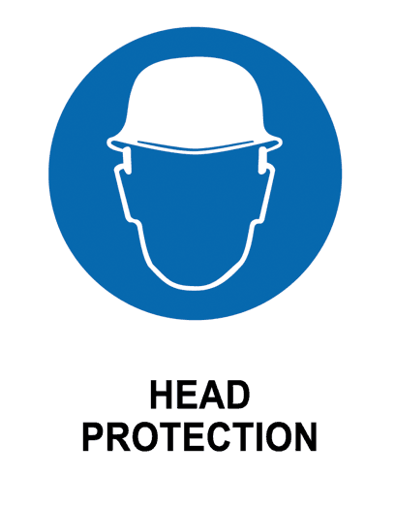

- EMERGENCY EQUIPMENT
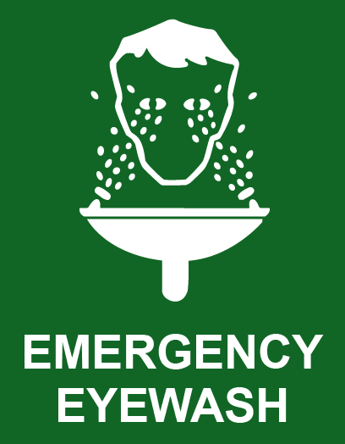
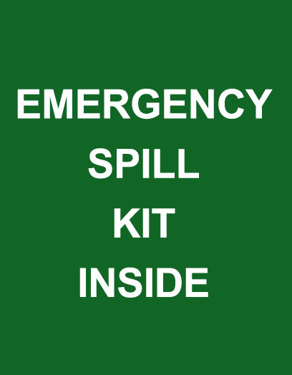
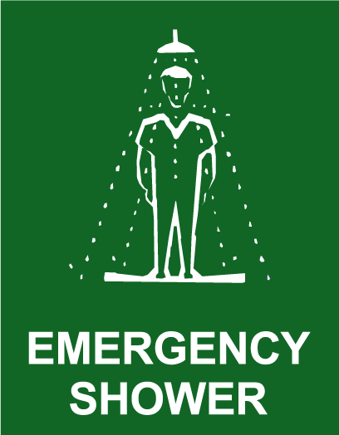

- work activity steps
before you start:

- Check E stop is working
- Closed in footwear is worn.
- Confirm workspace is clear
- Tie back long hair and wear safety glasses.
- Confirm payload is within safe bounds.
- Confirm that the electrical parts are plugged in safely.
- Virtually simulate the robot moving before starting.

steps in work activity:

- Power on the robot and confirm E stop is engaged
- Load and verify the program is correct
- Ensure Area is cleared and run program at reduced speed.
- Monitor movement and hold over e stop in case something happens
- Return robot to original position
- Pack up, power down and ensure workspace is left clean
- Log report, recording incidents if they occurred and store equipment safely.

emergency procedures:

- Press emergency button
- Notify security or dial 6 using the UTS internal phone

training required:
- Robot operation induction / lab safety brief
- E stop emergenct training

- sign off
prepared by:  NAME: JACK HEFFERNAN, JAMES WITCOMB, WILL RICHARDSON | Lab Supervisor  Name: Felipe Ulloa Gutierrez | Date: 24/09/2026  Review Date:

