1、MO SMS

5G 网络下发送SMS 空口信令和LTE下基本一致，没有什么变化

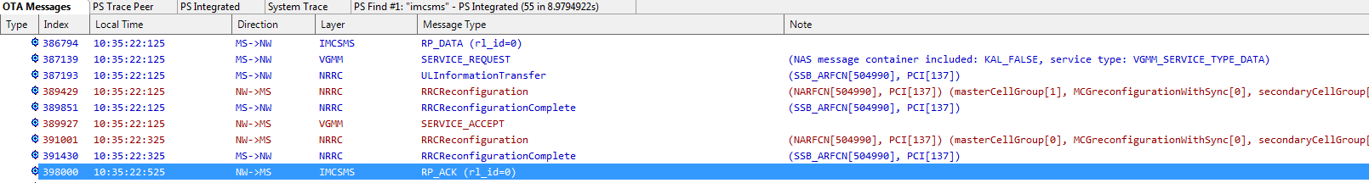

[MS->NW] [MO] IMCSMS__RP_DATA (rl_id=0)

[MS->NW] [MO] IMCSMS__RP_DATA (rl_id=0)
Peer Message
global_peer_msg_id = PROTOCOL_SECTION__NAS_SMS_RPDU (enum 405)
raw data = Buffer 0000 - 000F 00 53 00 08 91 68 31 08 20 01 05 f0 13 01 53 0b 0010 - 001F ff ff ff ff ff ff ff 00 08 06 ff ff ff ff ff ff
Message Content
GSM A-I/F RP - RP-DATA (MS to Network)
Message Type RP-DATA (MS to Network)
RP-Message Reference
RP-Message Reference: 0x53 (83)
RP-Originator Address
Length: 0
RP-Destination Address - (8613800210500)
Length: 8
1... .... = Extension: No Extension
.001 .... = Type of number: International Number (0x1)
.... 0001 = Numbering plan identification: ISDN/Telephony Numbering (ITU-T Rec. E.164 / ITU-T Rec. E.163) (0x1)
Called Party BCD Number: 8613800210500
RP-User Data
Length: 19
TPDU (not displayed)
GSM SMS TPDU (GSM 03.40) SMS-SUBMIT
0... .... = TP-RP: TP Reply Path parameter is not set in this SMS SUBMIT/DELIVER
.0.. .... = TP-UDHI: The TP UD field contains only the short message
..0. .... = TP-SRR: A status report is not requested
...0 0... = TP-VPF: TP-VP field not present (0)
.... .0.. = TP-RD: Instruct SC to accept duplicates
.... ..01 = TP-MTI: SMS-SUBMIT (1)
TP-MR: 83
TP-Destination-Address - () // 这里未解析出来，可能ELT工具问题
Length: 11 address digits
1... .... = Extension: No extension
.111 .... = Type of number: Reserved for extension (7)
.... 1111 = Numbering plan: Reserved for extension (15)
TP-DA Digits:
TP-PID: 0
00.. .... = Defines formatting for subsequent bits: 0x0
..0. .... = Telematic interworking: no telematic interworking, but SME-to-SME protocol
...0 0000 = The SM-AL protocol being used between the SME and the MS: 0
TP-DCS: 8
00.. .... = Coding Group Bits: General Data Coding indication (0)
..0. .... = Text: Not compressed
...0 .... = Message Class: Reserved, no message class
.... 10.. = Character Set: UCS2 (16 bit)/UTF-16 (0x2)
.... ..00 = Message Class: Class 0 (0x0)
TP-User-Data-Length: (6) depends on Data-Coding-Scheme
TP-User-Data
SMS text: _xffff__xffff__xffff_ // 这里未解析出来，可能ELT工具问题

TRACE_NAME, IMCSMS_MO_MS_TO_NW_PEER_MSG

[NW->MS] [MO] IMCSMS__RP_ACK (rl_id=0)
Peer Message
global_peer_msg_id = PROTOCOL_SECTION__NAS_SMS_RPDU (enum 405)
raw data = Buffer 0000 - 000F 03 53
Message Content
GSM A-I/F RP - RP-ACK (Network to MS)
Message Type RP-ACK (Network to MS)
RP-Message Reference
RP-Message Reference: 0x53 (83)

TRACE_NAME, IMCSMS_MO_NW_TO_MS_PEER_MSG

2、MT SMS

[NW->MS] [MT] IMCSMS__RP_DATA (rl_id=3)
Peer Message
global_peer_msg_id = PROTOCOL_SECTION__NAS_SMS_RPDU (enum 405)
raw data = Buffer 0000 - 000F 01 3a 08 91 68 31 08 20 01 05 f4 00 17 24 0b ff 0010 - 001F ff ff ff ff ff ff 00 08 12 80 50 01 63 34 23 04 0020 - 002F ff ff ff ff
Message Content
GSM A-I/F RP - RP-DATA (Network to MS)
Message Type RP-DATA (Network to MS)
RP-Message Reference
RP-Message Reference: 0x3a (58)
RP-Originator Address - (8613800210504)
Length: 8
1... .... = Extension: No Extension
.001 .... = Type of number: International Number (0x1)
.... 0001 = Numbering plan identification: ISDN/Telephony Numbering (ITU-T Rec. E.164 / ITU-T Rec. E.163) (0x1)
Called Party BCD Number: 8613800210504
RP-Destination Address
Length: 0
RP-User Data
Length: 23
TPDU (not displayed)
GSM SMS TPDU (GSM 03.40) SMS-DELIVER
0... .... = TP-RP: TP Reply Path parameter is not set in this SMS SUBMIT/DELIVER
.0.. .... = TP-UDHI: The TP UD field contains only the short message
..1. .... = TP-SRI: A status report shall be returned to the SME
.... 0... = TP-LP: The message has not been forwarded and is not a spawned message
.... .1.. = TP-MMS: No more messages are waiting for the MS in this SC
.... ..00 = TP-MTI: SMS-DELIVER (0)
TP-Originating-Address - ()
Length: 11 address digits
1... .... = Extension: No extension
.111 .... = Type of number: Reserved for extension (7)
.... 1111 = Numbering plan: Reserved for extension (15)
TP-OA Digits:
TP-PID: 0
00.. .... = Defines formatting for subsequent bits: 0x0
..0. .... = Telematic interworking: no telematic interworking, but SME-to-SME protocol
...0 0000 = The SM-AL protocol being used between the SME and the MS: 0
TP-DCS: 8
00.. .... = Coding Group Bits: General Data Coding indication (0)
..0. .... = Text: Not compressed
...0 .... = Message Class: Reserved, no message class
.... 10.. = Character Set: UCS2 (16 bit)/UTF-16 (0x2)
.... ..00 = Message Class: Class 0 (0x0)
TP-Service-Centre-Time-Stamp
Year: 21
Month: 8
Day: 5
Hour: 10
Minutes: 36
Seconds: 43
Timezone: GMT + 8 hours 0 minutes
TP-User-Data-Length: (4) depends on Data-Coding-Scheme
TP-User-Data
SMS text: _xffff__xffff_

TRACE_NAME, IMCSMS_MT_NW_TO_MS_PEER_MSG

[MS->NW] [MT] IMCSMS__RP_ACK (rl_id=3)
Peer Message
global_peer_msg_id = PROTOCOL_SECTION__NAS_SMS_RPDU (enum 405)
raw data = Buffer 0000 - 000F 02 3a 41 02 00 00
Message Content
GSM A-I/F RP - RP-ACK (MS to Network)
Message Type RP-ACK (MS to Network)
RP-Message Reference
RP-Message Reference: 0x3a (58)
RP-User Data
Element ID: 0x41
Length: 2
TPDU (not displayed)
GSM SMS TPDU (GSM 03.40) SMS-DELIVER REPORT
.0.. .... = TP-UDHI: The TP UD field contains only the short message
.... ..00 = TP-MTI: SMS-DELIVER REPORT (0)
TP-Parameter-Indicator: 0x00
0... .... = Extension: No extension
.000 0... = Reserved: 0
.... .0.. = TP-UDL: Not Present
.... ..0. = TP-DCS: Not Present
.... ...0 = TP-PID: Not Present

TRACE_NAME, IMCSMS_MT_MS_TO_NW_PEER_MSG

AP log:

08-05 10:36:44.206395 2306 2629 D RILJ : [UNSL]< UNSOL_RESPONSE_NEW_SMS [PHONE0]
08-05 10:36:44.314344 2306 2765 D RILJ : [5338]> SMS_ACKNOWLEDGE success = true cause = 0 [PHONE0]
08-05 10:36:44.315548 1538 1556 D RtcGsmSmsCtrl: [0] Stop MT SMS ack timer
08-05 10:36:44.316034 1538 1571 D RmcGsmSmsBase: [0] current sms_type = SMS_INBOUND_3GPP_CMT
08-05 10:36:44.625509 2306 3261 E OplusInboundSmsHandlerImpl: lastSmsPackage=com.android.mms

LTE AP log :

07-12 16:24:58.387670 2371 2831 D RILJ : [UNSL]< UNSOL_RESPONSE_NEW_SMS [PHONE0]
07-12 16:24:58.404641 2371 2849 D MtkGsmInboundSmsHandler-0: IdleState.processMessage: processing EVENT_NEW_SMS
07-12 16:24:58.407313 2371 2849 D MtkGsmInboundSmsHandler-0: DeliveringState.processMessage: processing EVENT_NEW_SMS
07-12 16:24:58.475794 2371 2849 D RILJ : [0345]> SMS_ACKNOWLEDGE success = true cause = 0 [PHONE0]
07-12 16:24:58.479133 1157 1165 D RtcGsmSmsCtrl: [0] Stop MT SMS ack timer
07-12 16:24:58.917834 2371 3175 D MtkGsmInboundSmsHandler-0: Delivering SMS to: com.google.android.apps.messaging com.google.android.apps.messaging.shared.receiver.SmsDeliverReceiver, id: 6432145444054230838

3、MO MMS

APP:

mainlog 搜索 MmsService

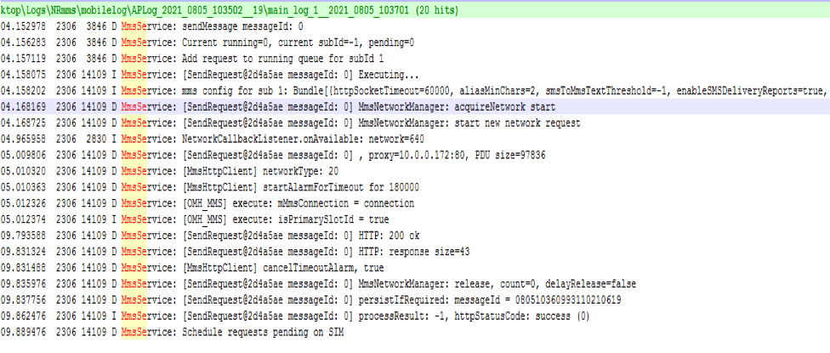

AP Radio log:

SETUP_DATA_CALL , 激活MMS APN，建立PDN连接：

08-05 10:36:04.232352 2306 3525 D RILJ : [5315]> SETUP_DATA_CALL,accessNetworkType=NGRAN,isRoaming=false,allowRoaming=false,DataProfile=1001/2/0/***/***/***/0/0/0/0/true/2/2/0/0/0/true/false,addresses=[],dnses=[] [PHONE0]
08-05 10:36:04.236563 1538 1573 I AT : [0] AT> AT+EAPNACT=1,"cmwap","mms",0 (RIL_CMD_READER_4 tid:523606539456)
08-05 10:36:04.240579 1538 1562 I AT : [0] AT< +EWIFIPDNACT: 0 (RIL_URC_READER, tid:523855985856)
08-05 10:36:04.240763 1538 1562 I AT : [0] AT< +EIWLPL: "notify","mms",2,2,2,"cellular" (RIL_URC_READER, tid:523855985856)
08-05 10:36:04.856781 2306 3525 D DataServiceCallback: onSetupDataCallComplete
08-05 10:36:04.856853 2306 2629 D RILJ : [5315]< SETUP_DATA_CALL DataCallResponse: { cause=0 retry=-1 cid=44802 linkStatus=2 protocolType=0 ifname=ccmni2 addresses=[10.5.17.182/32] dnses=[/211.136.150.86, /211.136.150.88] gateways=[/10.5.17.182] pcscf=[] mtu=1300 mtuV4=1300 mtuV6=1300} [PHONE0]

Net Log:

提交MMS 数据 ：

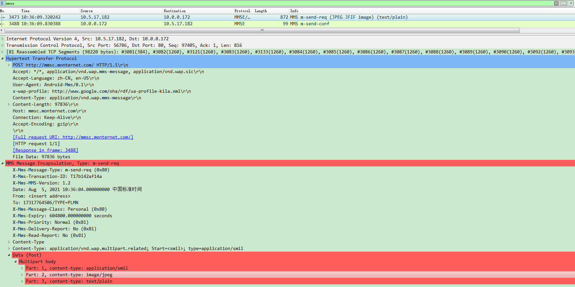

4、MT MMS

MMS WAP PUSH Notification：

[NW->MS] [MT] IMCSMS__RP_DATA (rl_id=3)
Message Content
GSM A-I/F RP - RP-DATA (Network to MS)
Message Type RP-DATA (Network to MS)
RP-Message Reference
RP-Message Reference: 0x22 (34)
RP-Originator Address - (8613800200500)
Length: 8
1... .... = Extension: No Extension
.001 .... = Type of number: International Number (0x1)
.... 0001 = Numbering plan identification: ISDN/Telephony Numbering (ITU-T Rec. E.164 / ITU-T Rec. E.163) (0x1)
Called Party BCD Number: 8613800200500
RP-Destination Address
Length: 0
RP-User Data
Length: 156
TPDU (not displayed)
GSM SMS TPDU (GSM 03.40) SMS-DELIVER
0... .... = TP-RP: TP Reply Path parameter is not set in this SMS SUBMIT/DELIVER
.1.. .... = TP-UDHI: The beginning of the TP UD field contains a Header in addition to the short message
..0. .... = TP-SRI: A status report shall not be returned to the SME
.... 0... = TP-LP: The message has not been forwarded and is not a spawned message
.... .1.. = TP-MMS: No more messages are waiting for the MS in this SC
.... ..00 = TP-MTI: SMS-DELIVER (0)
TP-Originating-Address - ()
Length: 12 address digits
1... .... = Extension: No extension
.111 .... = Type of number: Reserved for extension (7)
.... 1111 = Numbering plan: Reserved for extension (15)
TP-OA Digits:
TP-PID: 0
00.. .... = Defines formatting for subsequent bits: 0x0
..0. .... = Telematic interworking: no telematic interworking, but SME-to-SME protocol
...0 0000 = The SM-AL protocol being used between the SME and the MS: 0
TP-DCS: 4
00.. .... = Coding Group Bits: General Data Coding indication (0)
..0. .... = Text: Not compressed
...0 .... = Message Class: Reserved, no message class
.... 01.. = Character Set: 8 bit data (0x1)
.... ..00 = Message Class: Class 0 (0x0)
TP-Service-Centre-Time-Stamp
Year: 21
Month: 8
Day: 5
Hour: 10
Minutes: 38
Seconds: 36
Timezone: GMT + 8 hours 0 minutes
TP-User-Data-Length: (137) depends on Data-Coding-Scheme
TP-User-Data
User-Data Header
User Data Header Length: 6
IE: Application port addressing scheme, 16 bit address (SMS Control)
Information Element Identifier: 0x05
Length: 4
Destination port: UDP/TCP port numbers assigned by IANA without the need to refer to 3GPP (2948)
Originator port: UDP/TCP port numbers assigned by IANA without the need to refer to 3GPP (9200)
Wireless Session Protocol, Method: Unknown (0xff) (0xff)
Transaction ID: 0xff
PDU Type: Unknown (0xff) // 未能解析或数据加密

TRACE_NAME, IMCSMS_MT_NW_TO_MS_PEER_MSG

正常消息解析如下：

TP-User-Data
User-Data Header
User Data Header Length: 6
IE: Application port addressing scheme, 16 bit address (SMS Control)
Information Element Identifier: 0x05
Length: 4
Destination port: UDP/TCP port numbers assigned by IANA without the need to refer to 3GPP (2948)
Originator port: UDP/TCP port numbers assigned by IANA without the need to refer to 3GPP (9200)
Wireless Session Protocol, Method: Push (0x06), Content-Type: application/vnd.wap.mms-message
Transaction ID: 0x00
PDU Type: Push (0x06)
Headers Length: 3
Content-Type
.011 1110 = Header name: Content-Range (62)
Content-Type: application/vnd.wap.mms-message
Headers
Integer lookup: X-Wap-Application-Id
.010 1111 = Header name: X-Wap-Application-ID (47)
X-Wap-Application-Id: x-wap-application:mms.ua
[Expert Info (Error/Malformed): Malformed header]
[Malformed header]
[Severity level: Error]
[Group: Malformed]
MMS Message Encapsulation, Type: m-notification-ind
X-Mms-Message-Type: m-notification-ind (0x82)
X-Mms-Transaction-ID: 12EA8C1F189A0000ACB0000201
X-Mms-MMS-Version: 1.0
X-Mms-Message-Class: Personal (0x80)
X-Mms-Message-Size: 30720
X-Mms-Expiry: 431999.000000000 seconds
X-Mms-Content-Location: http://63.55.66.55/servlets/mms?message-id=
From: 7863017572/TYPE=PLMN

Net Log：

MMS 数据的下载：

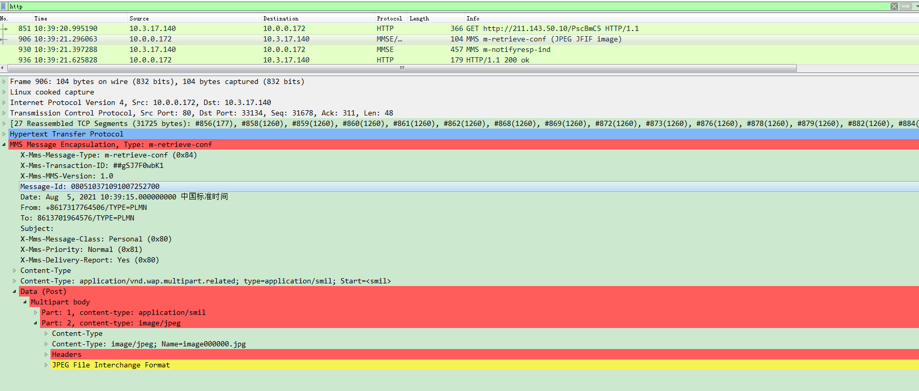

APP Log：

