Name: Sathwik S Hegde
USN: 4MT19CS138.

1) Pick 5 websites, find its IP address, give the class of IP address it belongs to.

1.
Website: facebook.com
IP address: 157.240.16.35
Class: B
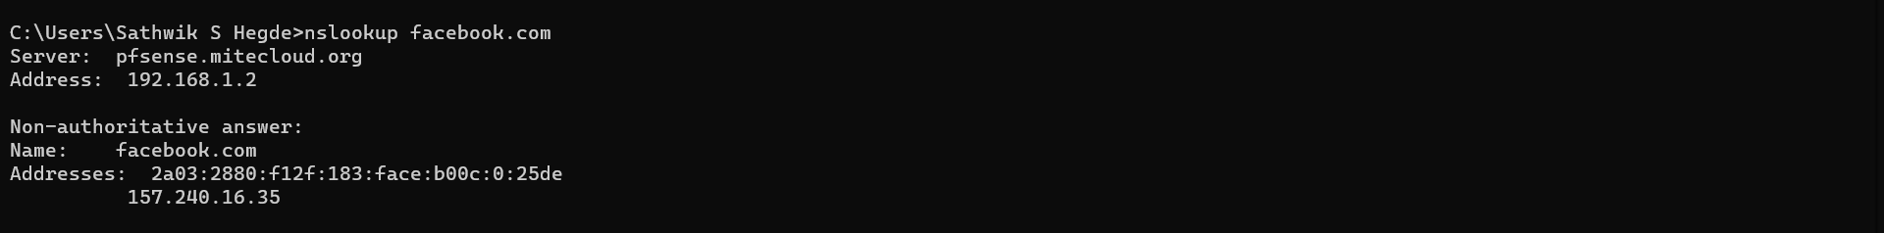

2.
Website: google.com
IP address: 172.217.31.206
Class: B

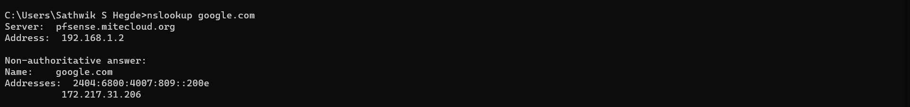

3.
Website: netflix.com
IP address: 54.73.148.110
Class: A

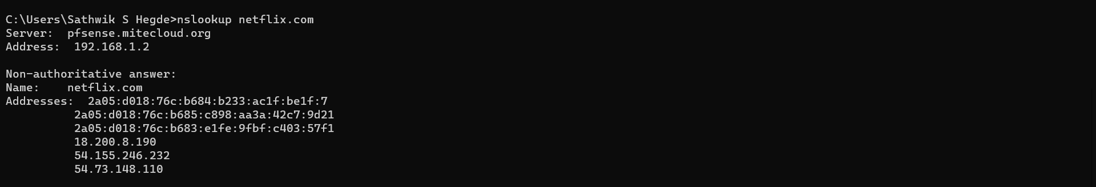

4.
Website: dlithe.com
IP address: 217.21.91.85
Class: C

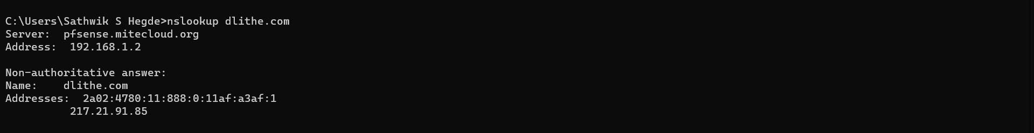

5.
Website: amazon.in
IP address: 52.95.116.115
Class: A

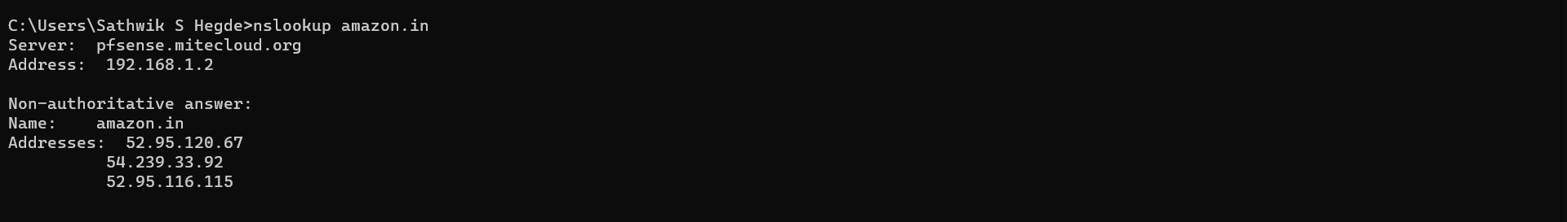

2) Check your laptop’s IP address and sub-net mask,define the network portion and host portion.

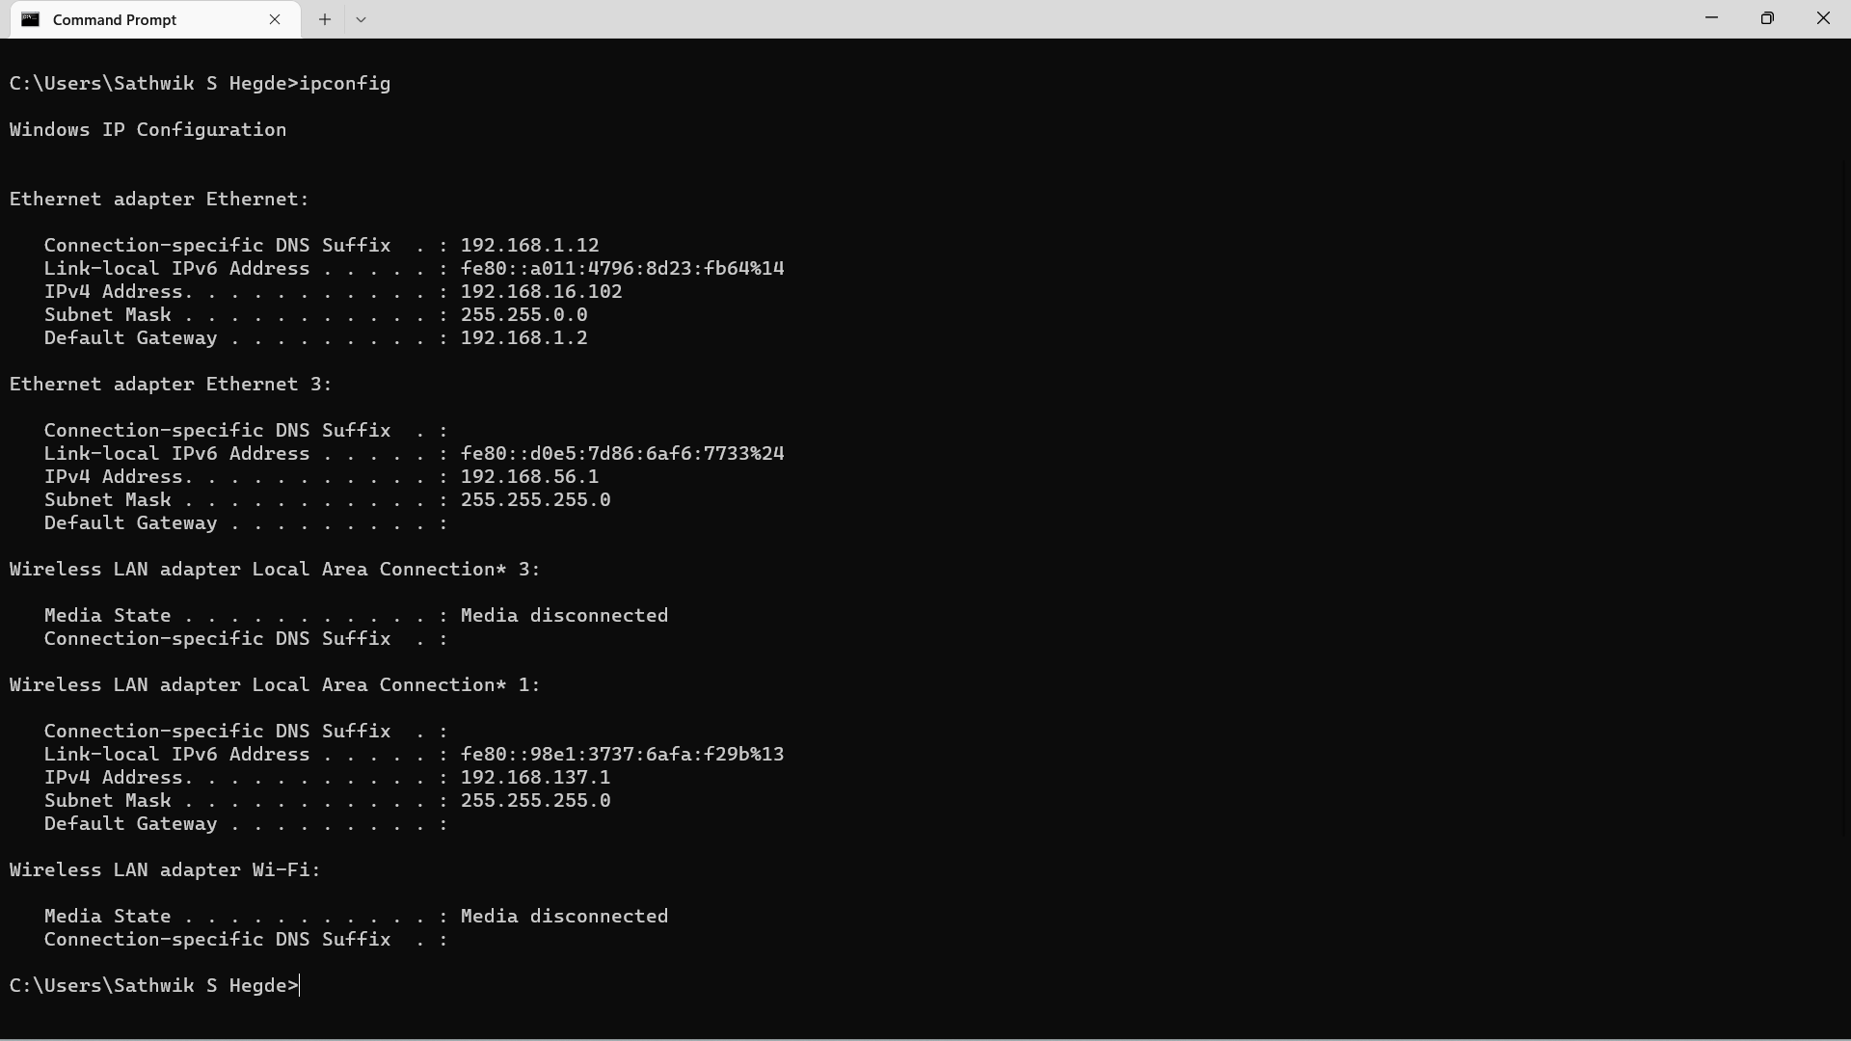

IP address of the laptop: 192.168.16.102
Subnet Mask: 255.255.0.0

Network portion: 192.168.16
Host portion: 102

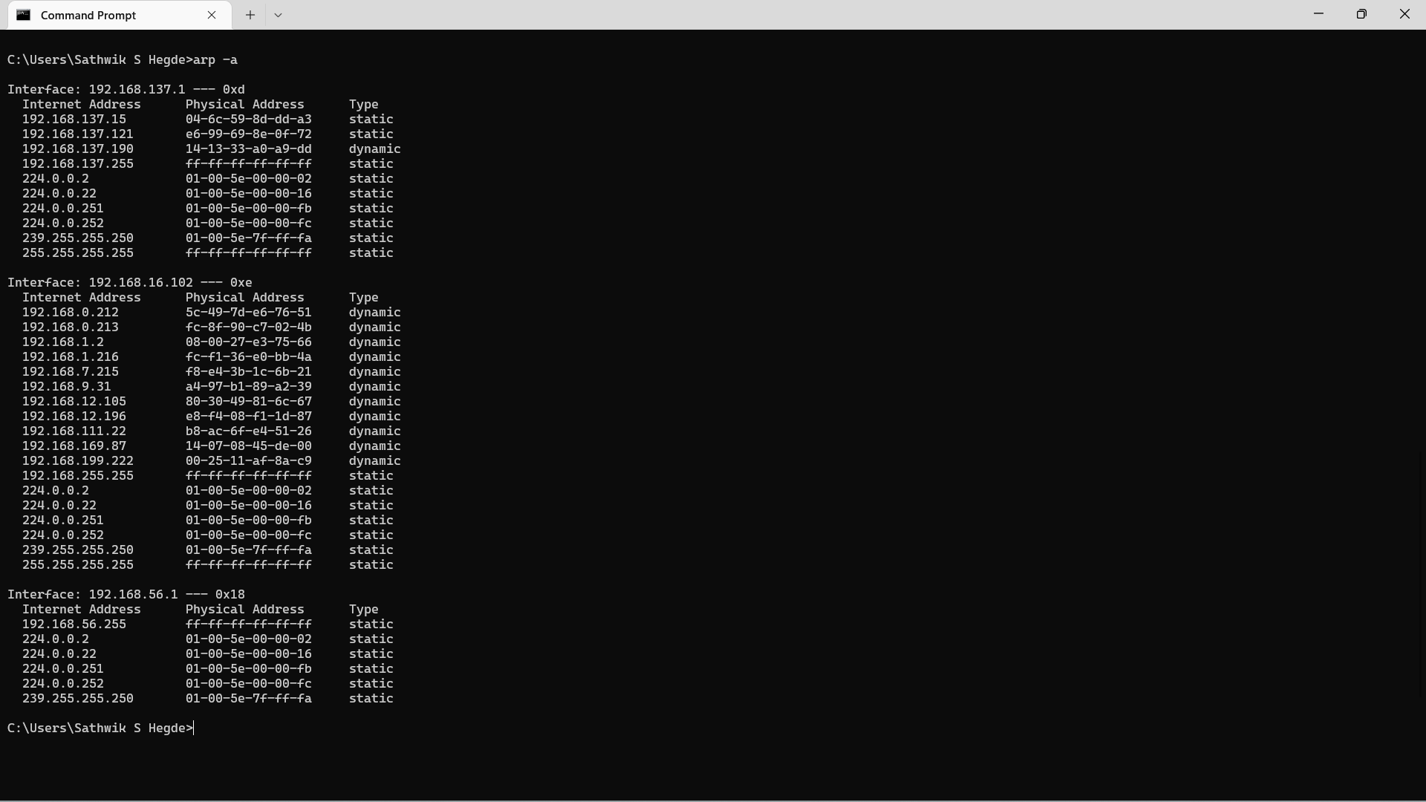
3)Check your arp cache and provide a screenshot of the entry.

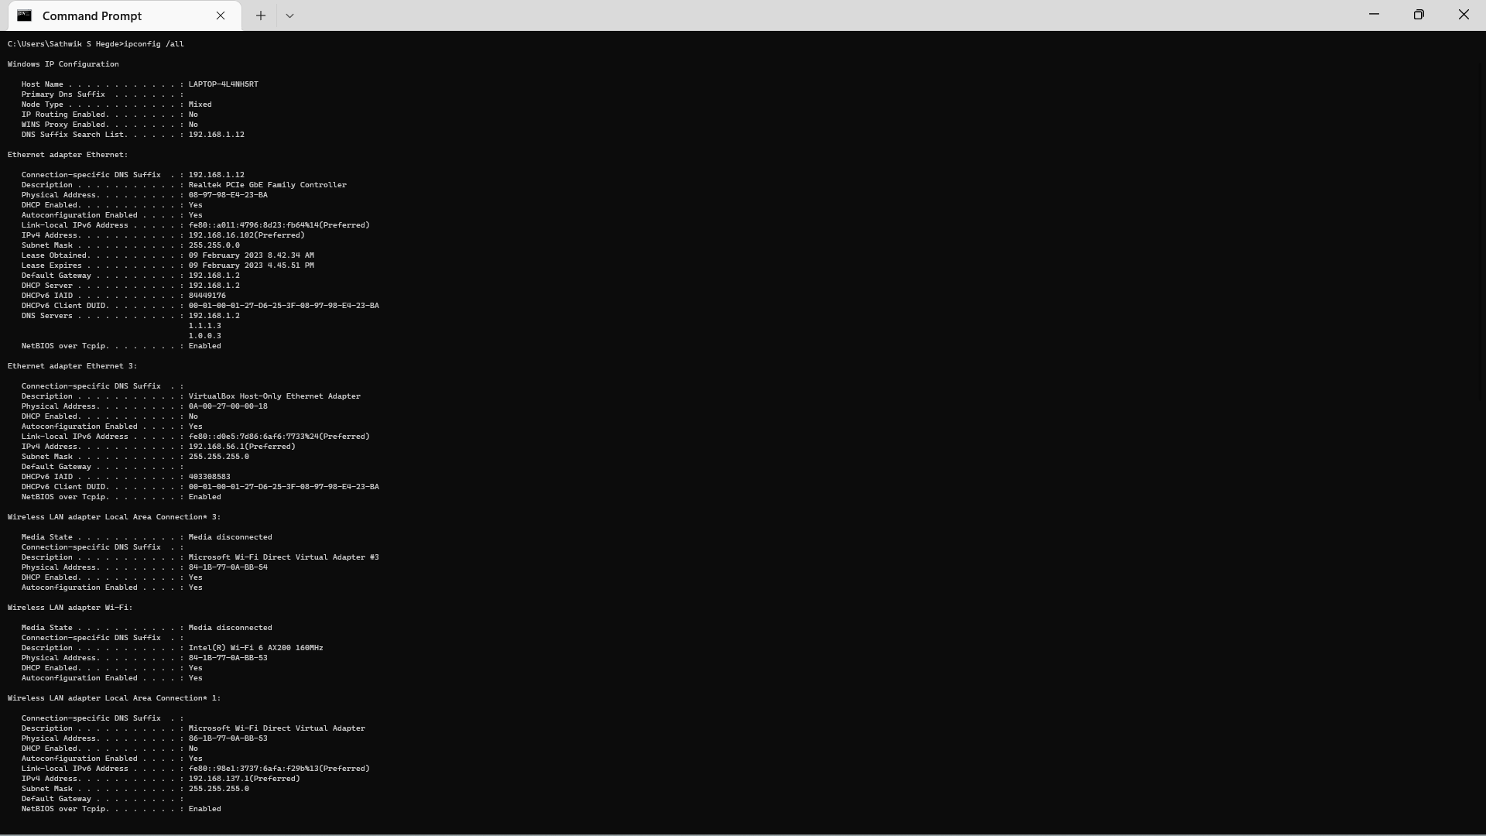
4)Identify your NIC’s MAC address and provide the screenshot

