**CAUSE FOR RECEIVING A ZERO / NOT RECEVING A SCORE**

1. When you go to the home page of your repository (remote repo), you will see this:

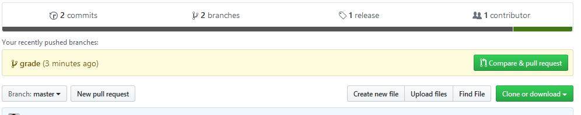

1. Click on the release tab:

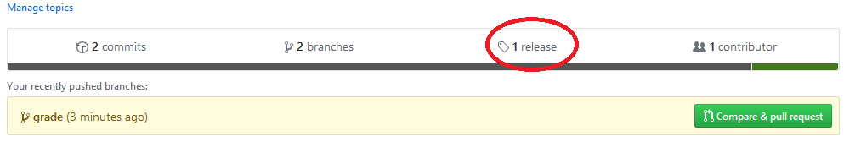

1. You will see a release details page:

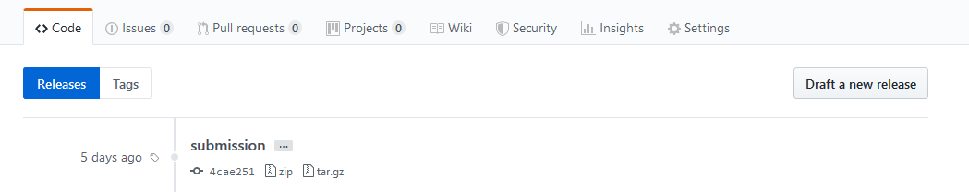

1. This shows all the releases (tags that you have applied and pushed to remote repo (using git push --tags) that you have made.
2. If you do not have an entry here you would have received ZERO. **(CASE 1)**
3. If you have multiple entries here and there is none with the name ‘submission’ (Case-sensitive, without quotes), you would have received ZERO. **(CASE 2).** 
   1. If you have multiple entries here and the one with name ‘submission’ is not at the top of the list, it means that your latest changes were not considered for grading. **(CASE 2.a)**
4. If you have one entry or multiple entries but the top entry is named ‘submission’ check the commit ID:

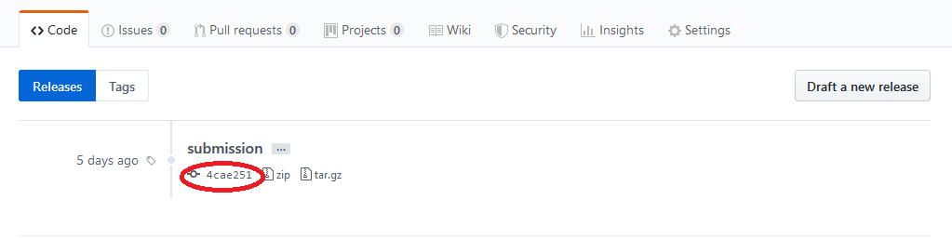

Let’s call this number **ID1**. Now come back to the home page of the remote repo. You should see the page shown in step 1.

1. Click on ‘commits’ tab.

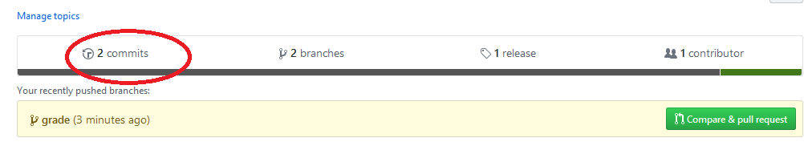

1. You will see the commits page as shown below:

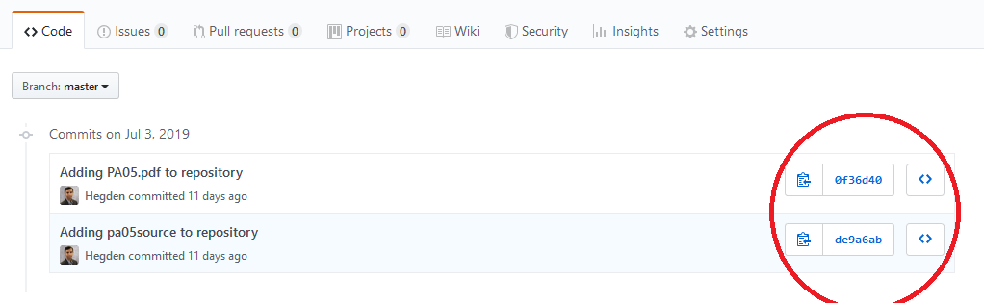

1. Check the commit IDs in the commit page (circled above). The commit ID associated with your release **(ID1)** must appear in this list. If not, you would have received ZERO. **(CASE 3)**

Correcting these errors:

CASE 1: You have to push your local changes to remote repository. Please follow the git submission instructions provided at <https://hegden.github.io/ece264/homeworks/ECE264PASubmitInstructions.pdf>

CASE 2 and 2.a: You have to overwrite the tags. Please read Section 2 (updating submission) in the git submission instructions provided at

<https://hegden.github.io/ece264/homeworks/ECE264PASubmitInstructions.pdf>

CASE 3: you would have forgotten to do ‘git push’ (Section 1, step 4) mentioned in the git submission instructions provided at <https://hegden.github.io/ece264/homeworks/ECE264PASubmitInstructions.pdf>

Please push all your local changes to remote, then overwrite the tags as mentioned in CASE 2/2.a

***After doing the above make sure that there are no more errors as seen in steps 7 to 10***

**UNDERSTANDING YOUR SCORE**

1. There is a separate branch called ‘grade’ created in your repository. You can go to the home page of this branch by clicking the ‘Branch’ button and selecting the ‘grade’ option under the ‘Branches’ tab as shown:

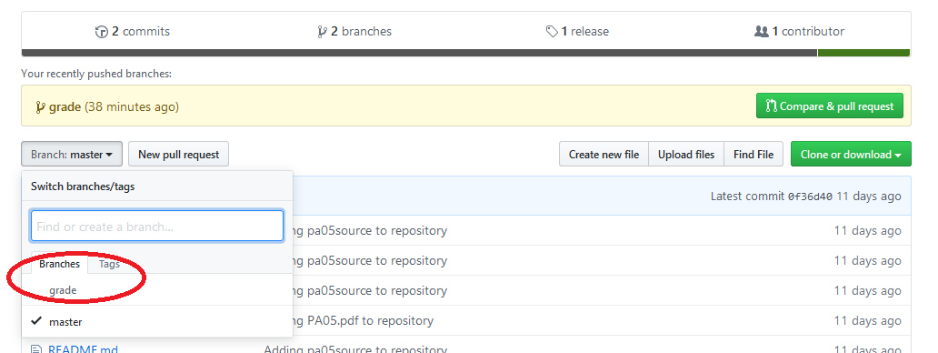

1. You will see two files grade.txt and output.txt here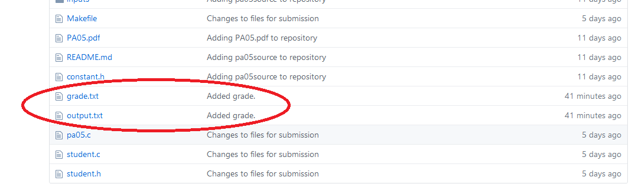

grade.txt tells your score. output.txt shows the details of how you got that score. This is basically the output of the grading script (which tests your submission on different criteria).

Before asking for any regrade request, please read and understand output.txt.

***For any questions on understanding contents of output.txt, please approach the TA.***