Readme
Titel EnergyMapper
Dato 27. februar 2020
Notat
Af JOLN

Git
https://github.com/Hegerstrand/energyMapper

Indstillinger

Add a trusted location
- Click File > Options.
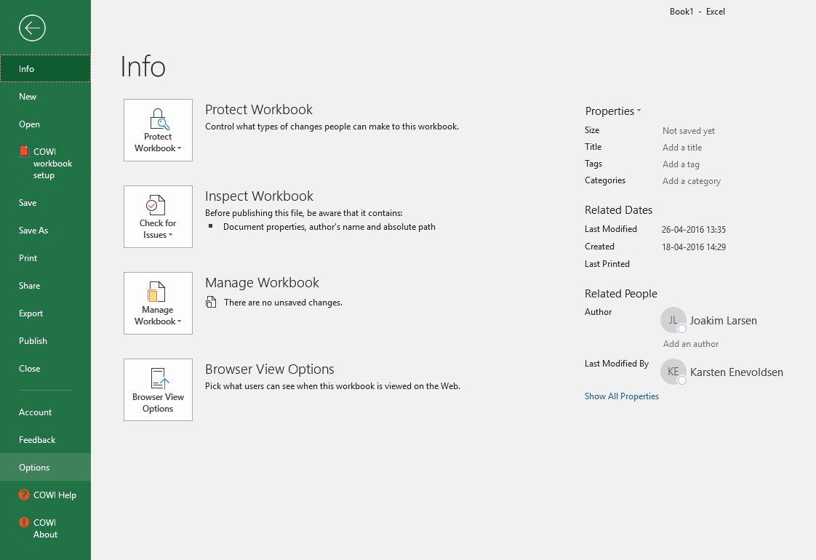
- Click Trust Center > Trust Center Settings > Trusted Locations.
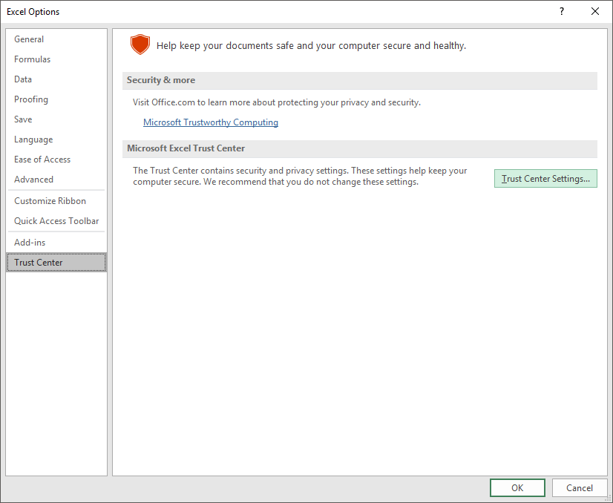
- Click Add new location.
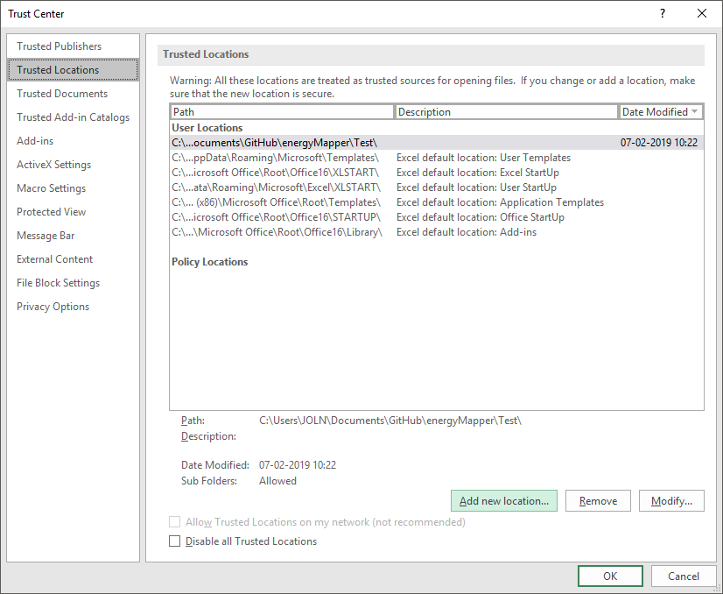
- Click Browse to find the folder, select a folder, and then click OK.
  - \energyMapper\Test

Filer

Kode

Brug

