Trevor Hegge
04/17/2025
CS-320
Software Testing Summary and Reflections Report
Summary
Unit Testing Approach
For Project One, I implemented a comprehensive unit testing approach for the contact, task, and appointment services. Each service required a distinct testing strategy while maintaining consistency in methodology.
For the Contact Service, I focused on validating the CRUD operations while enforcing field constraints. My tests verified that contact IDs couldn't exceed 10 characters, phone numbers had to be exactly 10 digits, and appropriate exceptions were thrown for validation failures. Similarly, for the Task Service, I ensured tasks could be properly created, retrieved, updated, and deleted while maintaining integrity constraints (task ID ≤ 10 characters, name ≤ 20 characters, description ≤ 50 characters). The Appointment Service required additional date validation to verify that appointments could not be created with past dates.
My testing approach aligned closely with the software requirements, as evidenced by test cases that directly mapped to specific requirements. For example, in the ContactTest class, testContactIDTooLong() directly verified the 10-character limit for contact IDs by attempting to create a contact with an 11-character ID and asserting that an appropriate exception was thrown. Similarly, testPhoneNotTenDigits() verified the requirement for exactly 10-digit phone numbers.
The effectiveness of my JUnit tests is demonstrated by their comprehensive coverage of normal cases, edge cases, and error scenarios. For example, in TaskServiceTest, I tested successful task creation with valid inputs, adding null tasks, and adding tasks with duplicate IDs. This approach ensured that the application behaved correctly under all circumstances, not just the "happy path" scenarios.
Experience Writing JUnit Tests
To ensure my code was technically sound, I followed test-driven development principles and used JUnit's assertion methods extensively. In ContactServiceTest, tests like testUpdateFirstName() verified that updating a contact's first name actually changed the stored value:
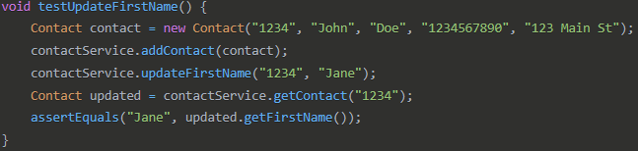
I also made extensive use of exception testing with assertThrows to verify error handling:
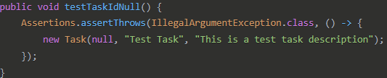
For efficiency, I utilized JUnit's @BeforeEach annotation to set up common test fixtures:
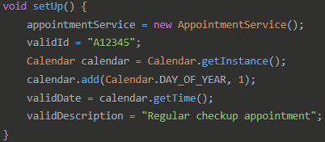
This approach eliminated redundant setup code and prevented test interdependencies. I also combined related assertions into single tests when they shared context, reducing the total test count while maintaining coverage.
Reflection
Testing Techniques
In this project, I employed several key testing techniques:
Unit Testing was my primary approach, isolating individual components and testing them separately. This allowed me to verify that each class functioned correctly on its own before integration.
Boundary Value Analysis was applied by testing at the edges of valid input ranges. For example, testing both valid 10-character IDs and invalid 11-character IDs:
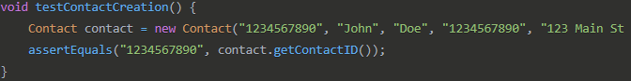
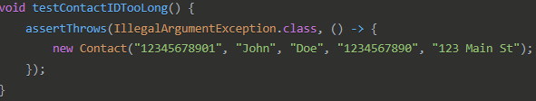
Equivalence Partitioning involved dividing inputs into valid and invalid categories and testing representatives from each, rather than exhaustively testing all possibilities.
Exception Testing: verified that the system responded appropriately to invalid inputs, as seen in tests like testDeleteNonExistentContact().
Other testing techniques not employed in this project include:
Integration Testing: I did not explicitly test interactions between components.
System Testing: I did not perform end-to-end testing of the entire application.
Performance Testing: I did not measure response times or system behavior under load.
Regression Testing: While my unit tests could serve as regression tests, I did not implement a specific regression strategy.
Security Testing: I did not test for security vulnerabilities.
Each technique has specific practical applications depending on the project context. Unit testing is essential for all projects as it helps identify issues early when they're less costly to fix. Integration testing becomes increasingly important as project size grows and components need to interact seamlessly. System testing is critical for user-facing applications to ensure the software meets user requirements. Performance testing is particularly important for high-traffic applications, and security testing is crucial for applications handling sensitive data.
Mindset
As a software tester, I employed a high degree of caution by constantly asking "what could go wrong?" rather than assuming the code would work as intended. For example, when testing the Appointment class, I created dynamic test cases for date validation that would remain valid regardless of when the tests were run:
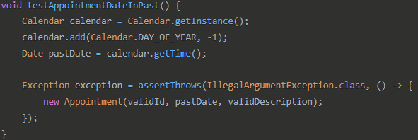
I also tested not just object creation but also modification, ensuring that setter methods enforced the same validation rules as constructors.
To limit bias in my testing, I deliberately wrote tests for failure cases and edge conditions, not just "happy path" scenarios. This helped counter the "confirmation bias" where testers tend to write tests that confirm their code works rather than trying to find flaws. For example, in ContactServiceTest, I tested adding null contacts and contacts with duplicate IDs, not just valid contacts.
If I were testing my own code, "familiarity bias" would be a significant concern, as I might have a mental model that could lead me to test only scenarios that fit that model. To counter this, I approached testing with a "stranger's mindset," pretending I had no prior knowledge of the implementation. In a professional environment, I would also seek peer reviews of my test cases and consider techniques like mutation testing.
Being disciplined in the commitment to quality is fundamentally important in software engineering. Cutting corners in code or testing leads to technical debt that compounds over time, resulting in higher costs and delayed releases. To avoid technical debt, I plan to maintain a test-first mentality, embrace continuous integration, refactor regularly, document thoroughly, and keep learning new testing techniques.
A specific example of my commitment to quality was testing exception messages, not just the presence of exceptions:
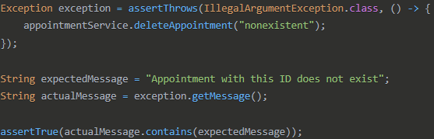
This extra step ensures that exceptions contain useful information for debugging and troubleshooting. By maintaining high-quality standards through thorough testing, I help ensure that our software is reliable, maintainable, and fit for purpose.

