Erinson Borrayo – 16004336

Category : A1:2017-Injection

reto: Login admin

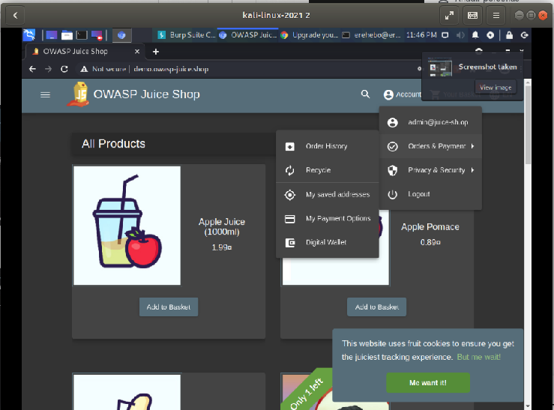

Category: A2:2017-Broken Authentication
reto: Reset jim’s Password

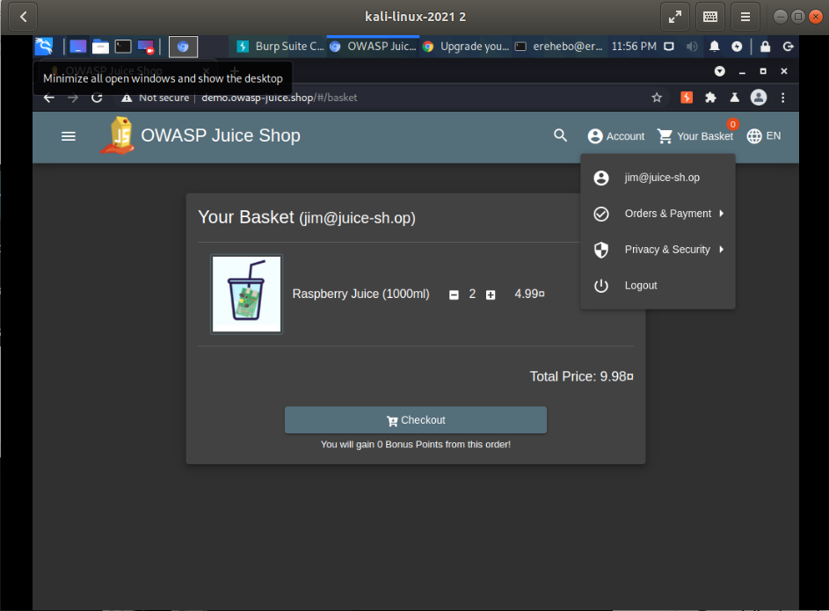

Category: A3:2017-Sensitve Data exposure
reto: Forgotten Developer Backup

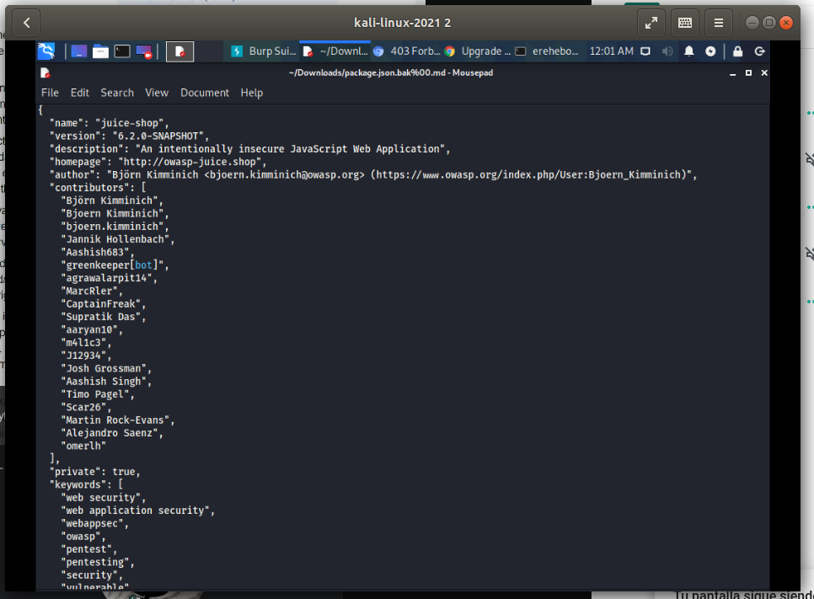

Category: A5-2017-Broken Access Control
reto: Admin section
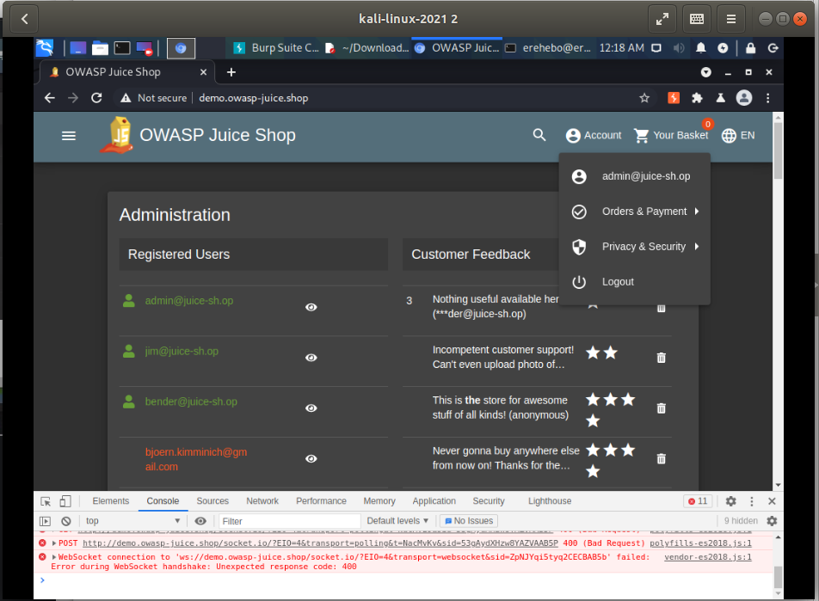

Category: A7:2017-Cross-site Scripting XSS,
reto: <iframe src="javascript:alert(`xss`)">

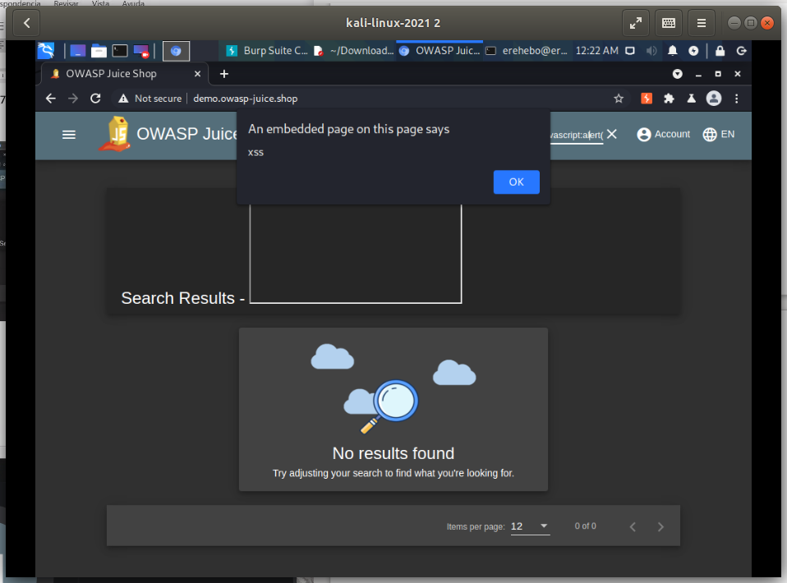

Category: Improper input validation
reto: Admin Registration

