**Title: {The Impact of Digital Transformation on Performance and the Cultural Industry: Challenges and Opportunities}**

PhD Leeds Doctoral College  
University of Leeds

By Heider Jeffer

June 19, 2024

# Introduction

The cultural industry, encompassing arts, entertainment, and heritage sectors, has undergone significant changes due to digital transformation. The infusion of digital technologies such as artificial intelligence (AI), big data, and the Internet of Things (IoT) has reshaped how cultural products are created, distributed, and consumed. This study focuses on evaluating the impact of digital transformation on performance within the cultural industry, identifying associated challenges, and exploring emerging opportunities.

# Problem Statement

While the potential benefits of digital transformation in the cultural industry are substantial, understanding its full impact on performance remains underexplored. This research addresses the problem of assessing how digital technologies affect the efficiency, effectiveness, and overall performance of cultural organizations. The challenge lies in quantifying these impacts and understanding the nuanced ways in which digital transformation influences cultural production and consumption.

# Possible Research questions

Research questions for the title "The Impact of Digital Transformation on Performance and the Cultural Industry: Challenges and Opportunities" could include:

**RQ 1. Impact on Performance:**

* How does digital transformation influence the operational efficiency and effectiveness of cultural institutions?
* What are the key performance metrics affected by digital transformation in the cultural industry?

**RQ 2. Cultural Industry Transformation:**

* How has digital transformation changed the production, distribution, and consumption patterns within the cultural industry?
* What are the emerging business models in the cultural sector due to digital transformation?

**RQ 3. Challenges of Digital Transformation:**

* What are the primary barriers or challenges cultural institutions face when adopting digital transformation initiatives?
* How do regulatory frameworks and intellectual property rights affect digital transformation in the cultural industry?

**RQ 4. Opportunities Created:**

* What new opportunities for revenue generation and audience engagement have emerged from digital transformation in the cultural sector?
* How does digital transformation enhance cultural diversity and accessibility globally?

**RQ 5. Impact on Cultural Heritage Preservation:**

* How does digital transformation influence the preservation and promotion of cultural heritage through technology?
* What are the ethical implications of digitizing cultural artifacts and traditions?

**RQ 6. Comparison across Different Cultural Domains:**

* How does the impact of digital transformation vary between different cultural domains (e.g., museums, performing arts, literature)?
* What lessons can be learned from successful digital transformation initiatives in different cultural sectors?

**RQ 7. User Experience and Engagement:**

* How does digital transformation enhance user experience and engagement with cultural content?
* What are the factors influencing digital engagement and participation in cultural activities?

**RQ 8 Future Trends and Predictions:**

* What are the anticipated future trends in digital transformation within the cultural industry?
* How might advancements in technology (e.g., AI, VR/AR) further influence the cultural sector?

These questions aim to explore various aspects of how digital transformation is shaping the cultural industry, identifying both challenges and opportunities brought about by technological advancements.

# Review of the Related Work

## What is Digital transformation?

* **The cultural** **industry:** also known as the creative industry, encompasses businesses and activities that produce, create, distribute, and commercialize creative content and cultural products [1] [2] [3].
* **Digital transformation (DT):** is the process by which an organization adopts and implements digital technology to create new or modify existing products, services, and operations by converting business processes into a digital format [4] [5] [6].

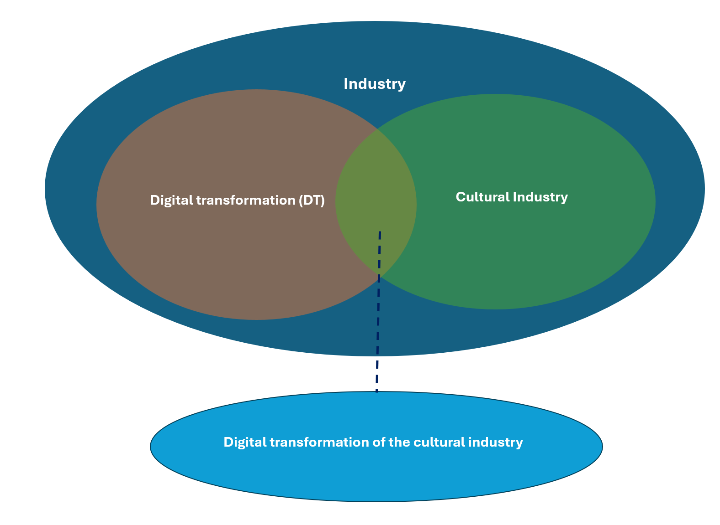

* T**he** **digital transformation of the** **cultural industry:** is cultural industry involves in the process by which organizations in this sector adopt and implement digital technology to create new or modify existing products, services, and operations by converting business processes into a digital format [J. Heider 2024].

## Finding studies

Digital transformation has become a significant topic of interest across various industries, including the financial service industry, oil and gas sector, automotive industry, and food retail industry.

* Study 1: Dehnert [7] highlights the importance of understanding how digital transformation dimensions are connected to firm performance, with contradictory findings in existing research.
* Study 2: Affonso et al [8] emphasize the need for innovation in the oil and gas industry, pointing out the risk-averse approach of traditional project management as a hindrance to progress.
* Study 3: Llopis-Albert et al [9] utilize fuzzy-set qualitative comparative analysis to analyze the impact of digital transformation on business performance models in the automotive industry.
* Study 4: In the context of the banking sector, Naimi-Sadigh et al [10] discuss the implementation of digital transformation to respond to disruptions and drive innovation in banking services.
* Study 5: Manjula et al [11] focus on digital technologies in the food retail industry, identifying challenges and opportunities in the digital transformation process.
* Study 6: Imran et al [12]  explore digital transformation in industrial organizations, aiming to identify key enablers and performance outcomes through data collected from leading industrial organizations.
* Study 7: Furthermore, Kumar et al. [13] propose a framework for assessing the social acceptability of Industry 4.0 technologies in digital manufacturing, highlighting the importance of considering social dimensions in technological advancements.
* Study 8: Ren et al. [14] shed light on the impact of digital transformation on renewable energy companies’ performance in China, emphasizing the role of digital transformation in advancing the development of renewable energy enterprises.
* Study 9: Zhao et al. [15] analyze the relationship between digital transformation strategy and ESG performance in large manufacturing enterprises, focusing on the mediating role of green innovation and sustainable development goals.
* Study 10: Overall, the literature review indicates a growing interest in understanding the impact of digital transformation on performance across various industries, highlighting both challenges and opportunities that come with embracing digital technologies (Sartal et al., [16].

The need for innovation, strategic alignment, and the identification of key enablers in the digital transformation process are recurring themes in the literature, emphasizing the importance of leveraging digital technologies to drive organizational success.

## Challenges

1. **Digital Divide**: The digital divide can hinder access to digital technologies and platforms, creating barriers for those who are less tech-savvy or have limited resources [17] [18].
2. **Copyright and Intellectual Property**: The use of digital technologies raises concerns about copyright and intellectual property, particularly in the context of digital assets and data management [19] [18].
3. **Preservation of Cultural Heritage**: The digitization of cultural heritage poses challenges related to preservation, conservation, and the long-term accessibility of digital artifacts [17] [20].
4. **Organizational Barriers**: The adoption of digital tools and processes can be hindered by organizational silos and a lack of understanding of the value of data [19].

## Opportunities

1. **New Forms of Cultural Expression**: Digital technologies have enabled new forms of artistic expression, such as AR/VR, and have opened up new channels for cultural consumption and engagement [17] [19].
2. **Increased Accessibility**: Digital platforms have increased access to art and culture, making it more inclusive and global [17] .
3. **Collaboration and Networking**: Digital tools facilitate global collaboration and networking among artists, institutions, and audiences [19] [20].
4. **Efficient Processes**: Digital transformation can streamline administrative processes, reducing errors and improving employee satisfaction [19].

## Strategies for Success

1. **Data Interoperability**: Ensuring data interoperability is crucial for seamless end-to-end processes and for addressing copyright and intellectual property concerns [18].
2. **Digital Literacy**: Developing digital literacy among artists, institutions, and audiences is essential for effective adoption and utilization of digital technologies [19] [18].
3. **Collaborative Ecosystems**: Fostering collaborative ecosystems between tech startups and creative sectors can facilitate knowledge exchange and innovation [18].
4. **Digital Sovereignty**: Establishing digital sovereignty through strategic policies and regulations can ensure the long-term sustainability and accessibility of digital cultural assets [21].

Overall, the impact of digital transformation on the cultural and creative industries is complex, presenting both challenges and opportunities. By understanding these dynamics and implementing effective strategies, the industry can harness the potential of digital technologies to enhance cultural expression, accessibility, and collaboration.

# Gap in Literature

Current literature lacks a holistic analysis of the relationship between digital transformation and performance metrics in the cultural industry. Most studies focus on individual aspects such as technology adoption or economic impacts, but few provide an integrated view that includes challenges and opportunities across the sector.

# Significance

Addressing this gap is crucial for policymakers, cultural managers, and stakeholders to make informed decisions that foster sustainable growth in the cultural sector. Understanding the impact of digital transformation on performance can guide strategic investments, enhance cultural policy frameworks, and support the development of adaptive strategies for cultural organizations.

# Methodology Preview

This research utilizes a mixed-methods approach, integrating quantitative analysis of performance data from cultural organizations with qualitative case studies and expert interviews. Data will be sourced from industry reports, financial records, and surveys, drawing on gray literature to offer a comprehensive overview.

*This study is designed to be exploratory. The overall data collection and analysis process is illustrated in the following UML diagram and explained in detail in the subsequent text.

## Data Collection

(Gray literature and Primary data collection)

**Step 1:** Define and refine search keywords for Google:

**Step 2:** Apply (Modified Search Keywords) in Google search engine:  
**Step 3:** Export [Search Results]  
**Step 4:** Apply inclusion/exclusion criteria to [Search Results Collection A]:  
To select the website relevant to our study.

## Data Analysis

Inclusion criteria and Exclusion criteria

- Developing a model to include/exclude (case studies).

- From Included Case Studies. This project will develop a model to extract the Challenges and Opportunities. factors that impact Digital Transformation on Performance and the Cultural Industry from the included case studies.

- Organizing those factors into identical groups

- Those factors reflect the failure and the success of The Impact of Digital Transformation on Performance and the Cultural Industry. Those factors answered the research questions that we addressed in this project

# Expected Results

# Outline of Contribution

The paper aims to contribute to the field by providing a detailed analysis of how digital transformation affects performance in the cultural industry. It will offer insights into the specific challenges faced by cultural organizations and highlight opportunities for leveraging digital technologies. The findings will inform policy recommendations and strategic planning for enhancing the sustainability and resilience of the cultural sector in the digital age.

# Bibliography

[1] “Culture | UNESCO.” Accessed: Jun. 19, 2024. [Online]. Available: https://www.unesco.org/en/culture

[2] P. O. of the E. Union, “CELEX1, Green Paper - Unlocking the potential of cultural and creative industries, /* COM/2010/0183 final */,” Apr. 2010, Accessed: Jun. 19, 2024. [Online]. Available: https://op.europa.eu/en/publication-detail/-/publication/1cb6f484-074b-4913-87b3-344ccf020eef/language-en

[3] D. Hesmondhalgh and A. C. Pratt, “Cultural industries and cultural policy,” *Int. J. Cult. Policy*, vol. 11, no. 1, pp. 1–13, Mar. 2005, doi: 10.1080/10286630500067598.

[4] “Digital transformation 1,” Shamiya Mirzagayeva, Heydar Aslanov. Accessed: Jun. 19, 2024. [Online]. Available: https://web.archive.org/web/20221112173332/https://metafizikajurnali.az/storage/images/site/files/Metafizika-20/Metafizika.Vol.5,No.4,Serial.20,pp.10-21.pdf

[5] G. Vial, “Understanding digital transformation: A review and a research agenda,” *J. Strateg. Inf. Syst.*, vol. 28, no. 2, pp. 118–144, Jun. 2019, doi: 10.1016/J.JSIS.2019.01.003.

[6] K. S. R. Warner and M. Wäger, “Building dynamic capabilities for digital transformation: An ongoing process of strategic renewal,” *Long Range Plann.*, vol. 52, no. 3, pp. 326–349, Jun. 2019, doi: 10.1016/J.LRP.2018.12.001.

[7] M. Dehnert, “Sustaining the current or pursuing the new: incumbent digital transformation strategies in the financial service industry A configurational perspective on firm performance”, doi: 10.1007/s40685-020-00136-8.

[8] I. D. Affonso *et al.*, “Digital Transformation as a Tool for FPSO Project Acceleration,” *Proc. Annu. Offshore Technol. Conf.*, vol. 2020-May, May 2020, doi: 10.4043/30480-MS.

[9] C. Llopis-Albert, F. Rubio, and F. Valero, “Impact of digital transformation on the automotive industry,” *Technol. Forecast. Soc. Change*, vol. 162, p. 120343, Jan. 2021, doi: 10.1016/J.TECHFORE.2020.120343.

[10] A. Naimi-Sadigh, T. Asgari, and M. Rabiei, “Digital Transformation in the Value Chain Disruption of Banking Services,” *J. Knowl. Econ.*, vol. 13, no. 2, pp. 1212–1242, Jun. 2022, doi: 10.1007/S13132-021-00759-0.

[11] S. Manjula, P. Balaji, and N. Deepa, “) Sazelin Arif, Universiti Teknikal Malaysia Melaka (UTeM), Malaysia. (3) Arjun Prasad Khanal,” *Nepal. Rev. Artic. Manjula al*, no. 1, pp. 88–101, 2021, doi: 10.9734/AJAEES/2021/v39i1130729.

[12] F. Imran, K. Shahzad, A. Butt, and J. Kantola, “Journal of Change Management Reframing Leadership and Organizational Practice Digital Transformation of Industrial Organizations: Toward an Integrated Framework,” 2021, doi: 10.1080/14697017.2021.1929406.

[13] A. Kumar, R. Agrawal, V. A. Wankhede, M. Sharma, and E. Mulat-weldemeskel, “A framework for assessing social acceptability of industry 4.0 technologies for the development of digital manufacturing,” *Technol. Forecast. Soc. Change*, vol. 174, p. 121217, Jan. 2022, doi: 10.1016/J.TECHFORE.2021.121217.

[14] Y. Ren, B. Li, and D. Liang, “Impact of digital transformation on renewable energy companies’ performance: Evidence from China,” *Front. Environ. Sci.*, vol. 10, Jan. 2023, doi: 10.3389/FENVS.2022.1105686.

[15] Q. ; Zhao *et al.*, “Analyzing the Relationship between Digital Transformation Strategy and ESG Performance in Large Manufacturing Enterprises: The Mediating Role of Green Innovation,” *Sustain. 2023, Vol. 15, Page 9998*, vol. 15, no. 13, p. 9998, Jun. 2023, doi: 10.3390/SU15139998.

[16] A. Sartal, R. Bellas, A. M. Mejías, and A. García-Collado, “The sustainable manufacturing concept, evolution and opportunities within Industry 4.0: A literature review,” *Adv. Mech. Eng.*, vol. 12, no. 5, May 2020, doi: 10.1177/1687814020925232/ASSET/IMAGES/LARGE/10.1177_1687814020925232-FIG2.JPEG.

[17] “Digital transformation in culture and art: Exploring the challenges, opportunities and implications in cultural studies | Research Journal in Advanced Humanities.” Accessed: Jun. 19, 2024. [Online]. Available: https://royalliteglobal.com/advanced-humanities/article/view/1236

[18] “Commission publishes two studies to map the challenges and opportunities for cultural and creative sectors in the digital decade | Shaping Europe’s digital future.” Accessed: Jun. 19, 2024. [Online]. Available: https://digital-strategy.ec.europa.eu/en/news/commission-publishes-two-studies-map-challenges-and-opportunities-cultural-and-creative-sectors

[19] “Digital Transformation of the Creative Industry.” Accessed: Jun. 19, 2024. [Online]. Available: https://www.valantic.com/en/industries/creative-industry/

[20] M. Massi, M. Vecco, and Y. Lin, *Digital transformation in the cultural and creative industries : production, consumption and entrepreneurship in the digital and sharing economy*. Accessed: Jun. 19, 2024. [Online]. Available: https://www.routledge.com/Digital-Transformation-in-the-Cultural-and-Creative-Industries-Production-Consumption-and-Entrepreneurship-in-the-Digital-and-Sharing-Economy/Massi-Vecco-Lin/p/book/9780367351168

[21] “DIGITAL TRANSFORMATION IN THE CULTURAL AND CREATIVE SECTORS AND INDUSTRIES - Executive Summary”.