

**E-CV1217**

**An Electronic Portfolio (Curriculum Vitae)**

**for Teenagers**

**The Design Document**

1

# Roadmap



* INTRODUCTION AND SCOPE OF THE PROJECT
* QUALITY REQUIREMENTS
* VIEwS

Requirements and Design of Software Systems

Design Document of E-CV1217 System 2

by Heider Jeffer and Marco Pomalo

# Introduction and Scope



* ESPECIALLY THOUGHT FOR SCHOOL DROPOUTS (EUROPEAN PROJECT FOR SCHOOL DROPOUTS).
* BASED ON THE REQUIREMENTS DOCUMENT.
* SYSTEM CONSIST OF 5 DIFFERENT COMPONENTS:
  + WEB APPLICATION SERvER + DATABASE SERvER
  + WEB APPLICATION
  + INTERNET BROwSER
  + HOME APPLICATION
  + MOBILE APPLICATION

Requirements and Design of Software Systems

Design Document of E-CV1217 System 3

by Heider Jeffer and Marco Pomalo

# Quality Requirements: Security



* THE DATA ARE PROTECTED AGAINST UNAUTHORIZED ACCESS.
* DATABASE AND FILES ARE ENCRYPTED wITH AES-256.
* THE ACCESS TO THE SERvER FROM THE INTERNET IS DENIED.
* THE HOME APPLICATION wORkS ONLY OFFLINE.
* THE MOBILE APPLICATION CAN wORk OFFLINE AND EvEN ONLINE ONLY IF CONNECTED TO THE SCHOOL NETwORk.

Requirements and Design of Software Systems

Design Document of E-CV1217 System 4

by Heider Jeffer and Marco Pomalo

# Quality Requirements: Usability



* ANIMATED ICONS SHOwING THE PURPOSE OF THE COMMAND.
* TOOLTIPS.
* SPECIFIC USABILITY PATTERNS ESPECIALLY FOR THE MOBILE APPLICATION.
* RECOGNITION BEFORE RECALL PRINCIPLE.

Requirements and Design of Software Systems

Design Document of E-CV1217 System 5

by Heider Jeffer and Marco Pomalo

# Views



* DESIGN AND ARCHITECTURAL PATTERNS.
  + CLIENT/SERvER
  + MVC (MODEL VIEw CONTROLLER)
* MODELS AND DIAGRAMS:
  + PHYSICAL vIEw ⇒ Hw COMPONENTS DIAGRAM
  + PROCESS VIEw ⇒ PROCESS DIAGRAM
  + LOGICAL vIEw ⇒ DATA MODELS, CLASS DIAG.
  + DEvELOPMENT VIEw ⇒ COMPONENTS DIAGRAM

Requirements and Design of Software Systems

Design Document of E-CV1217 System 6

by Heider Jeffer and Marco Pomalo

# Views: Physical View

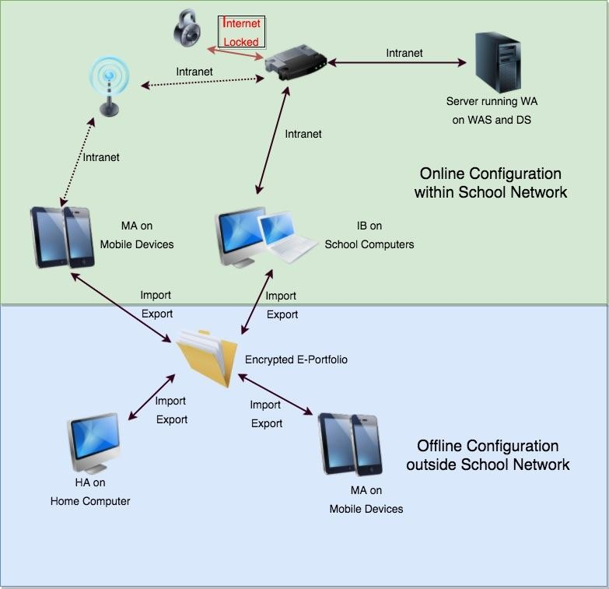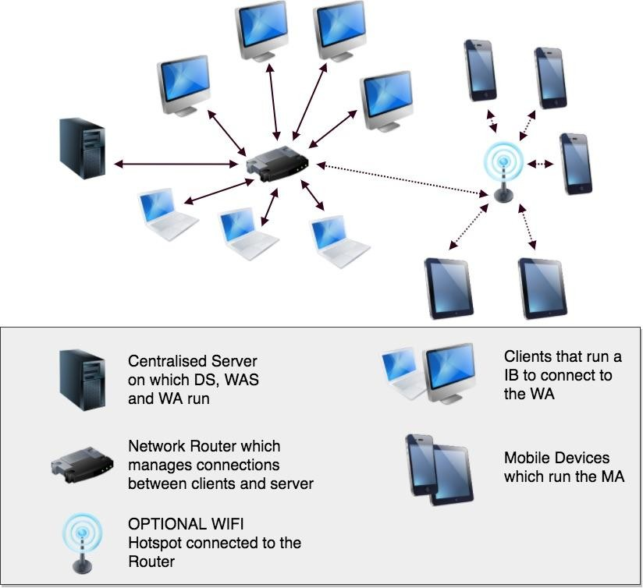

SCHOOL SYSTEM COMPLETE SYSTEM

Requirements and Design of Software Systems

Design Document of E-CV1217 System 7

by Heider Jeffer and Marco Pomalo

# Views: Process View

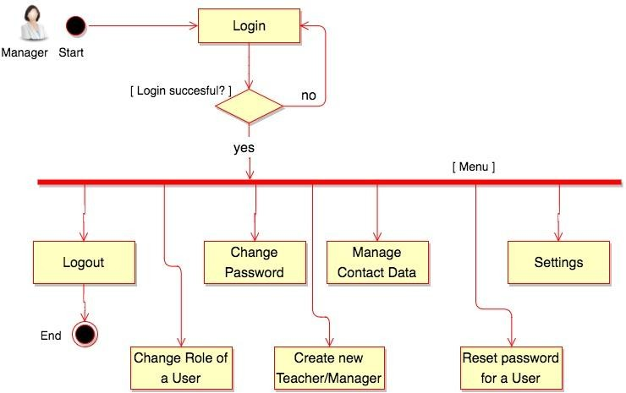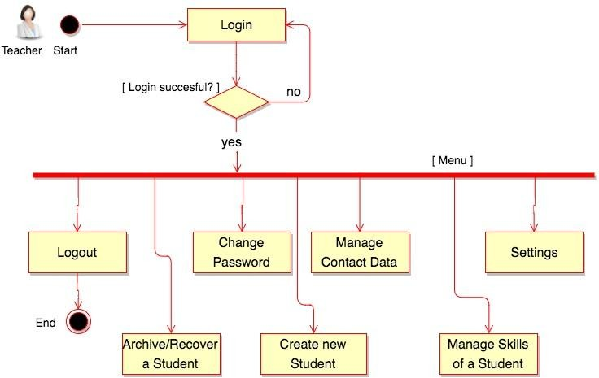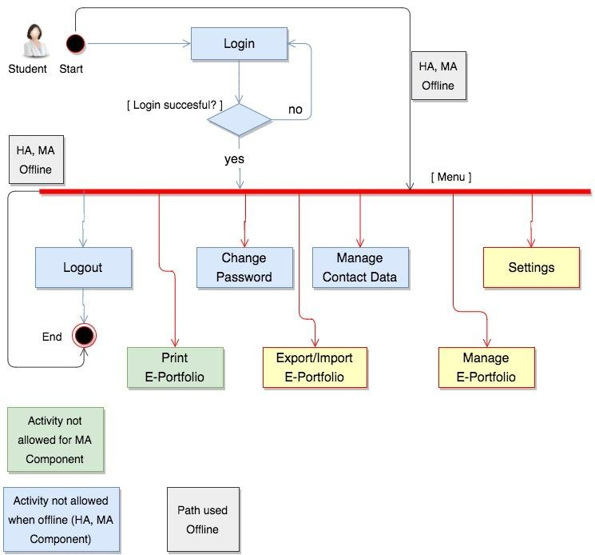

Requirements and Design of Software Systems

Design Document of E-CV1217 System 8

by Heider Jeffer and Marco Pomalo

# Views: Logical View

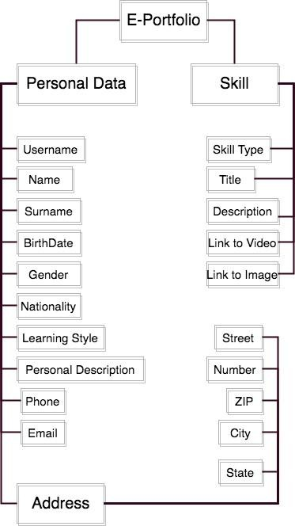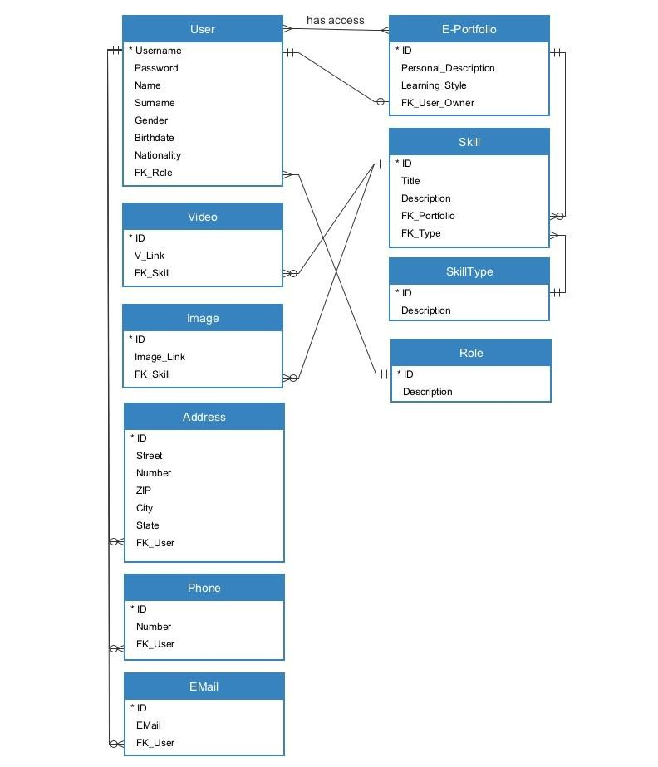

DATA MODEL: XML FILE

DATA MODEL: DATABASE

Requirements and Design of Software Systems

Design Document of E-CV1217 System 9

by Heider Jeffer and Marco Pomalo

# Views: Logical View

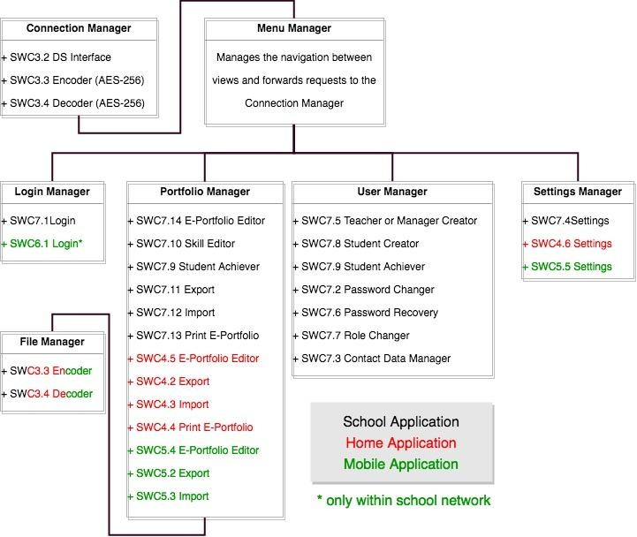

Requirements and Design of Software Systems

Design Document of E-CV1217 System 10

by Heider Jeffer and Marco Pomalo

# Views: Development View

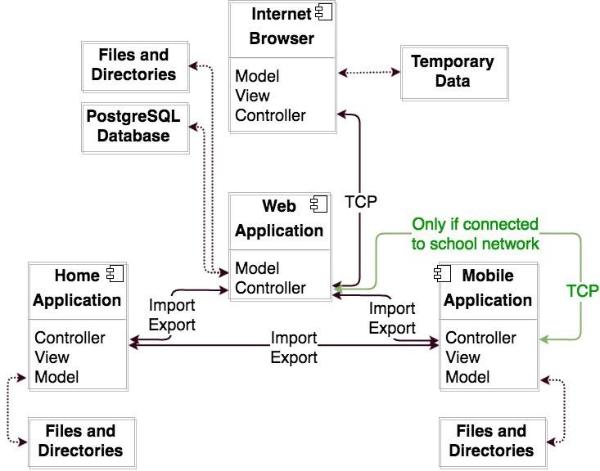

Requirements and Design of Software Systems

Design Document of E-CV1217 System 11

by Heider Jeffer and Marco Pomalo



Thank You

For Your Attention

12