# Design Thinking

Why is Design Thinking Important?

* It can help you or your team surface unmet needs of the people you are creating for.
* It reduces the risk associated with launching new ideas.
* It generates solutions that are revolutionary, not just incremental.
* It helps organizations learn faster.

Design thinking is a non-linear, iterative process that teams use to understand users, challenge assumptions, redefine problems and create innovative solutions to prototype and test

5 phases of Design Thinking

* Empathize
* Define
* Ideate
* Prototype
* Test.

3 Essential pillars of Design Thinking

* **Empathy** (inspiration)— Understanding the needs of those you’re designing for.
* **Ideation** — Generating a lot of ideas. Brainstorming is one technique, but there are many others.
* **Experimentation** (implementation)— Testing those ideas with prototyping.

Areas Where Design Thinking Can Apply

* Product design
* Service and experience design
* Business design
* Leadership
* Organizational change

**Modeller til Design Thinking (idekreation)**

D. School Modellen

* Består af 3 faser

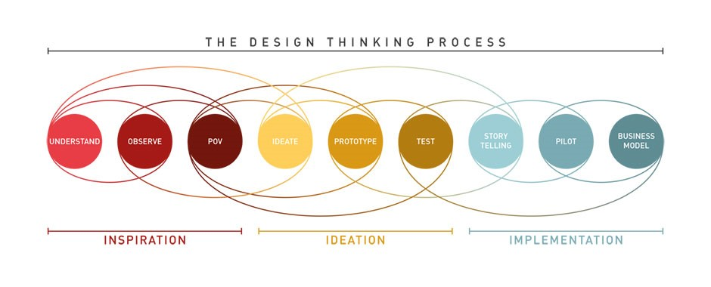Vi er også kort præsenteret for andre modeller, *Zurb Design Thinking Model*, *The Double Diamond Diagram by The Design Council, IBM Design Thinking Model, The Google Design Sprint Design*

The Five Why’s

Ask five times, and then you can start being able to trace back to solve the original problem.

Analogue Inspirations

Decision – Support

– Automatiseret

Automation – Algoritmer