Can R Notebooks help with reproducibility?

Av Ann Elisabeth Jacobsen og Heidi Marie Rolfsnes

September 2021

## Introduction

R Notebooks can be used to organize the methods that are used in a study or even the result. That will make it reproducibility. R Notebooks can help with reproducibility because the R Notebook also easily can be shared between colleagues or partners who works with the same articles or forexemple are sharing an analyse. It is actually a great tool for sharing an analyse or even a vizualtion. It can be used in many different fields. An Example is if there is need for a statistical analysis R would be to great tool to use.

In R there is a command that can run and reproducible document again from start to it is finished, which is very important for a reproducible document. In addition, it is easy to test the notebooks for reproducibility.

Barbara R.Jasny writes in an article that as new technologies produce more and different data to work with the knowledge (Jasny et al. 2011)

## Definition:

**“R notebook** is an R Markdown document with chunks that can be executed independently and interactively, with output visible immediately beneath the input” Grolemund (n.d.***(skrevet rett av og må fikses)***){.ul}

The terms reproducibility and replicability are used interchangeably in scientific circles. Some groups believe that reproducibility means repeating an investigation in an article using the same data, while replicability means doing it again, preferably with new data, but getting the same response. While other groups believe the opposite.

Regarding to K. Bollen et al. in the national Science Foundation the definitions for reproducibility, replicability and generalization is clear:

**Reproducibility** means that a researcher have the opportunity to use the result of a prior study and repeat the research with the same data and procedures that were used in the orginal study. For the find to be credible and informative that reproducibility is a minimum necessary condition. Bollen et al. (2015)

**Replicability** is when a researcher follows the same procedures as in an earlier study and manages to get the same result, but by collecting new data. Bollen et al. (2015)

**“Generalizability** refers to whether the result of a study apply in other context or populations that differ from the original one” ***skrevet rett av og må fikses*** Bollen et al. (2015)

### Picture

[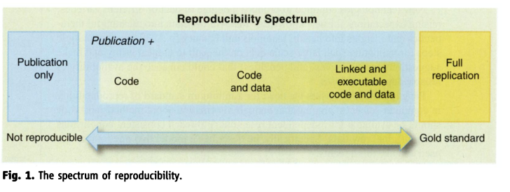](https://www.jstor.org/stable/pdf/41352177.pdf?refreqid=excelsior%3A4042fa72b0c4b5ce6ed25e118e92172a)

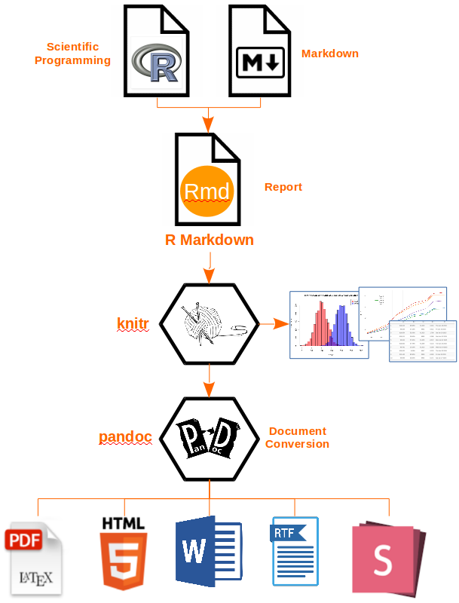

**Reproducibility**

If there is already a published article and there is a new scientist who wants to make an analyse using the same data from that article it will only be reproducibility if the new result is the same as in the already published article.

### Benefits

As we have written about before, we use reproducibility to repeat a research using the same data but with a separate twist.

Barbara R. Jasny et al. writes in an article that new technology is constantly emerging, and produces new data in different variants, which increases the expectations for new knowledge. (Jasny et al. 2011). By increasing the expectations of the data, we can also see an increase in the expectations for the content.

Although a test is reproducible, the quality may not be as good.

### Disadvantages

Steven N. Goodman et al. are writing in their article that reproducibility, replicability, reliability, robustness, and generalizability are used interchangeably in, for example, scientific environments. The terms seem to be a confusion in the literature and it can make it difficult to rely on a scientific result For their part, it is mostly for use in the biomedical field, but there is great faith that this could also solve other scientific areas.@goodman_what_2016

An example: Some groups believes reproducibility means repeating an investigation in an article using the same data, and replicability means doing it again, preferably with new data, but getting the same response. While other groups believe the opposite.

There is also another minus with reproducibility and that is that the result you have obtained can be built on by others who in turn can use it to develop new ideas or other methods. It may lead to further errors if the article was initially incorrect.

#### Solution

First of all, a solution could be that the scientific enviroment came together to create and definition to each of the different concepts reproducibility, replicability, reliability, robustness, and generalizability. It would have made the concepts easier to use and which in turn had given a common understanding of what was used at any given time. Steven N. Goodman et al. want to divide it into three different elements: methods reproducibility, results reproducibility, and inferential repro- ducibility. For their part, it is mostly for use in the biomedical field, but there is great faith that this could also solve other scientific areas.@goodman_what_2016

Bollen et al. says that scientists should document all the information in the procedures they use when collecting data - right down to the level of detail. It will make it easier and more effective for researchers who comes after using the same report and get the same results as the original researchers. It will not only reproduce reproducibility, but they will also be able to provide more information. @bollen_social_2015

#### Is there a perfect code?

Nick Barnes who works in the Climate Code Foundation writes in an article from 2010, that researchers don’t have to put so much emphasis on coding in their work, because the benefit of sharing raw data can be greater than writing a perfect code.

He further writes that if we share raw data that performs the job it is supposed to, the intention with the data is in place. So why not share it then.

He points out that in 2007 NASA released a software that wasn’t completely finished, but by releasing it before it was completely finished, they received held along the way so that it became both better and more user-friendly. Even if they got help, it didn’t mean that NASA had released a bad program or taht the result after they released the first version gave a slighty worse result. NASA took the change with them and made the software even better.

In Conclusion, he writes that researchers must work together to create space to release raw data, so that we can benefit from each other’s help to not always strive for perfectionism before we publish. But this is not something researchers nedd to do alone they also need help from the community around them (Barnes 2010).

#### Referances

Barnes, Nick. 2010. “Publish Your Computer Code: It Is Good Enough.” *Nature* 467 (7317): 753–53. <https://doi.org/10.1038/467753a>.

Bollen, Kenneth, John T. Cacioppo, Jon A. Krosnick, James L. Olds, and Robert M. Kaplan. 2015. “Social, Behavioral, and Economic Sciences Perspectives on Robust and Reliable Science.” Report of the Subcommittee on Replicability in Science Advisory Committee to the National Science Foundation Directorate for Social, Behavioral, and Economic Sciences. NSF.

Grolemund, Garrett, J. J. Allaire. n.d. *R Markdown: The Definitive Guide*. Accessed September 15, 2021. <https://bookdown.org/yihui/rmarkdown/>.

Jasny, Barbara R., Gilbert Chin, Lisa Chong, and Sacha Vignieri. 2011. “Again, and Again, and Again.” *Science* 334 (6060): 1225–25. <https://doi.org/10.1126/science.334.6060.1225>.