Proposal

Research proposal
Context
Dementia is a growing global health crisis, with 68% of the projected 140 million cases by 2050 expected in LMICs [1]. In rural Vietnam, individuals over 60 are disproportionately affected by Mild Cognitive Impairment (MCI) compared to their urban counterparts, highlighting a pressing need for targeted interventions [2]. MCI offers a critical two-to-three-year window where interventions can slow cognitive decline, making early treatment crucial [3]. Additionally, cardiovascular disease (CVD), a major risk factor for dementia [4], often goes undiagnosed in these rural areas [5]. Early interventions addressing both cognitive health and CVD have the potential to reduce the risk of developing dementia to prevent Alzheimer's progression, especially in regions with limited healthcare resources.
Objectives
The project's overall goal is to harness the collaboration's expertise to enable people at risk of dementia to benefit from technologies and monitoring that are culturally relevant and evidence-based. Specific objectives include:
- Develop BrainTrain, a cognitive training app specifically tailored for MCI patients in rural Vietnam.
- Design the app with a focus on accessibility and cultural appropriateness for older users with low technological proficiency and literacy.
- Integrate telemonitoring features for cardiovascular health, including blood pressure (BP) and electrocardiogram (ECG) monitoring, to address dementia risk factors.
Research Importances
The centralization of healthcare in urban Vietnam challenges rural populations' access to care. To bridge this gap, new infrastructures leveraging mobile technologies offer one solution. MCI and dementia are significant public health concerns in LMICs, and early interventions can delay Alzheimer’s onset, easing healthcare burdens and improving outcomes. With rising smartphone access [6], mobile-based interventions like BrainTrain offer scalable, cost-effective solutions suitable for these rural populations. Integrating CVDs monitoring, such as BP and ECG tracking, provides an opportunity to address cognitive and physical health. The project’s international collaboration between LMICs and high-income countries encourages knowledge sharing, enabling the development of adaptable interventions that are implementable across diverse settings.
Preliminary Research
We previously evaluated remote cognitive assessments of older Vietnamese adults using the MoCA-B and IQCODE. Development and analysis of the tool drew on the expertise of UK and US partners. Higher MCI and dementia rates were found in rural areas, with educational levels linked to cognitive function. These results indicate a need for developing non-verbal cognitive assessment methods for individuals with limited formal education.
We also designed cognitive games and tested them on 30 MCI patients. Participants were divided into high-and low-usage groups, with significant improvements observed in the high-usage group and an increase in MMSE scores (24.667 ± 1.989 to 27.400 ± 1.497). Patients' feedback reflected an average satisfaction score surpassing eight on a 10-point scale across all dimensions of the app. Since November 2023, we have recruited patients for the project and recently organized a community awareness program on Alzheimer’s at 175 Military Hospital. 157 MCI elderly patients have installed and used the BrainTrain app, with 91 of them still actively engaging with BrainTrain to date. These results demonstrate the potential of mobile-based cognitive training apps to enhance cognitive function in MCI patients.
We demonstrated the feasibility of tele-BP monitoring devices in managing CVDs among MCI elderly in Vietnam. Over three months, 64.5% of participants remained engaged, and clinical outcomes improved, with fewer out-of-range BP readings compared to the control group. These findings suggest that telemonitoring may play a pivotal role in managing CVDs, a significant risk factor for dementia. This collaboration will extend this work to test the efficacy of technology-driven initiatives to support the care of older rural populations at risk of dementia and or cardiovascular disease.
Methodology
Design and Procedure
Seventy participants aged +60, half women half men from urban and rural areas, will be recruited for the study. Inclusion and exclusion criteria are listed in Table 1.
Prior to the official intervention, in-depth interviews will ensure the BrainTrain app meets MCI patients’ needs. The intervention will consist of a three-month period with baseline, 1-month, and 3-month follow-ups (Fig. 1). During these check-ins, cognitive assessments, BP, ECG, and heart rate (HR) will be measured. Participants will be equipped with tele-BP monitoring and 3-lead ECG devices. Training will be provided for using the devices and the BrainTrain app at home. Collaborating clinicians will offer support during abnormal BP readings.
Cognitive app acceptability and validations
Pilot study: Building on the previous version of BrainTrain (Preliminary Fig. P2, P3) and related work from the first network grant, the app will be optimized for rural, low-literacy populations. Improvements include refining game difficulty, adding daily engagement features, and enhancing the interface for ease of use by elderly participants with low literacy. In-depth interviews with MCI patients before home-based interventions will explore the usefulness and validity of the app as a resource for health. The app will be adapted in line with findings prior to implementation.
Main study: In a three-month trial, participants will use BrainTrain for 25-30 minutes daily. Their data on daily usage, total training time, and cognitive performance will be tracked in a database. They will also complete a survey using a 5-point scale, adapted from the Mobile Application Rating Scale (MARS), to rate the app’s interface, user-friendliness, and engagement. Neuropsychological tests will assess cognitive changes before and after the intervention.
Cardiovascular health indicators assessment
BP, HR and ECG recordings will be taken during cognitive tasks, followed by 24-hour Holter ECG monitoring to capture heart rate variability (HRV) parameters. HRV analysis will be performed on both the resting 12-lead ECG 5-min, tele-ECG session during cognitive tasks and 24h ECG recordings. The data will be exported into the HRV analysis software from ITR company for analysis of both time-domain and frequency-domain HRV parameters.
Milestones and Timescales:
Table 2 outlines the tentative schedule and milestones. The project will start with an international hybrid conference for feedback on the app and telemonitoring and involve international partners in the implementation strategy. A one-month pilot study follows, with regular online progress meetings, to prepare for the main study. It concludes with a final conference in Vietnam to present findings and agree on future directions.

References
Please list any scientific references mentioned in your proposal
1. Nichols E, Steinmetz JD, Vollset SE, Fukutaki K, Chalek J, Abd-Allah F, et al. Estimation of the global prevalence of dementia in 2019 and forecasted prevalence in 2050: an analysis for the Global Burden of Disease Study 2019. The Lancet Public Health. 2022;7: e105–e125.
2. Nguyen TT-Q, Hoang CBD, Hoang Le MD, Anh Vo NT, Quang H, Nguyen CM, et al. Assessing cognitive decline in Vietnamese older adults using the Montreal Cognitive Assessment-Basic (MoCA-B) and Informant Questionnaire on Cognitive Decline in the Elderly (IQCODE) during the COVID-19 pandemic: A feasibility study. Clin Neuropsychol. 2023;37: 1043–1061.
3. Sex and Gender Differences in Neurological Disease. Academic Press; 2022.
4. Livingston G, Huntley J, Liu KY, Costafreda SG, Selbæk G, Alladi S, et al. Dementia prevention, intervention, and care: 2024 report of the Lancet standing Commission. Lancet. 2024;404: 572–628.
5. Thienemann F, Ntusi NAB, Battegay E, Mueller BU, Cheetham M. Multimorbidity and cardiovascular disease: a perspective on low- and middle-income countries. Cardiovasc Diagn Ther. 2020;10: 376–385.
6. Vittoradolfo T, De Benedictis A, De Micco F, Lettieri E. Equitable Digital Medicine and Home Health Care. Frontiers Media SA;

Tables and figures
Please upload any additional tables or figures to support your proposal (e.g. timeline, GANTT chart etc.), which must be presented only as tables or figures (with brief legends). No additional text is permitted.
Figure & Table - Google Docs

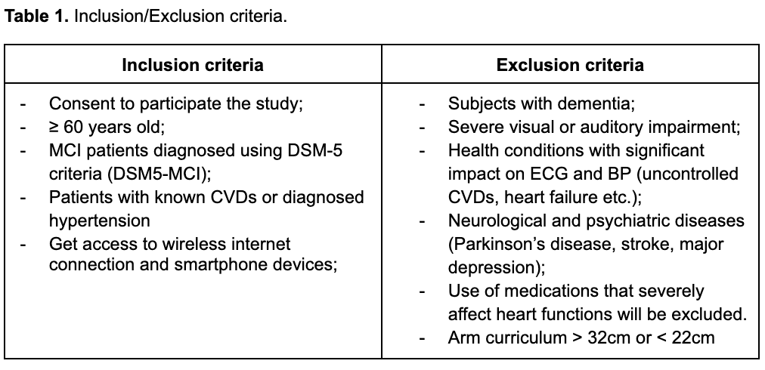

Figure 1. Experimental design diagram.
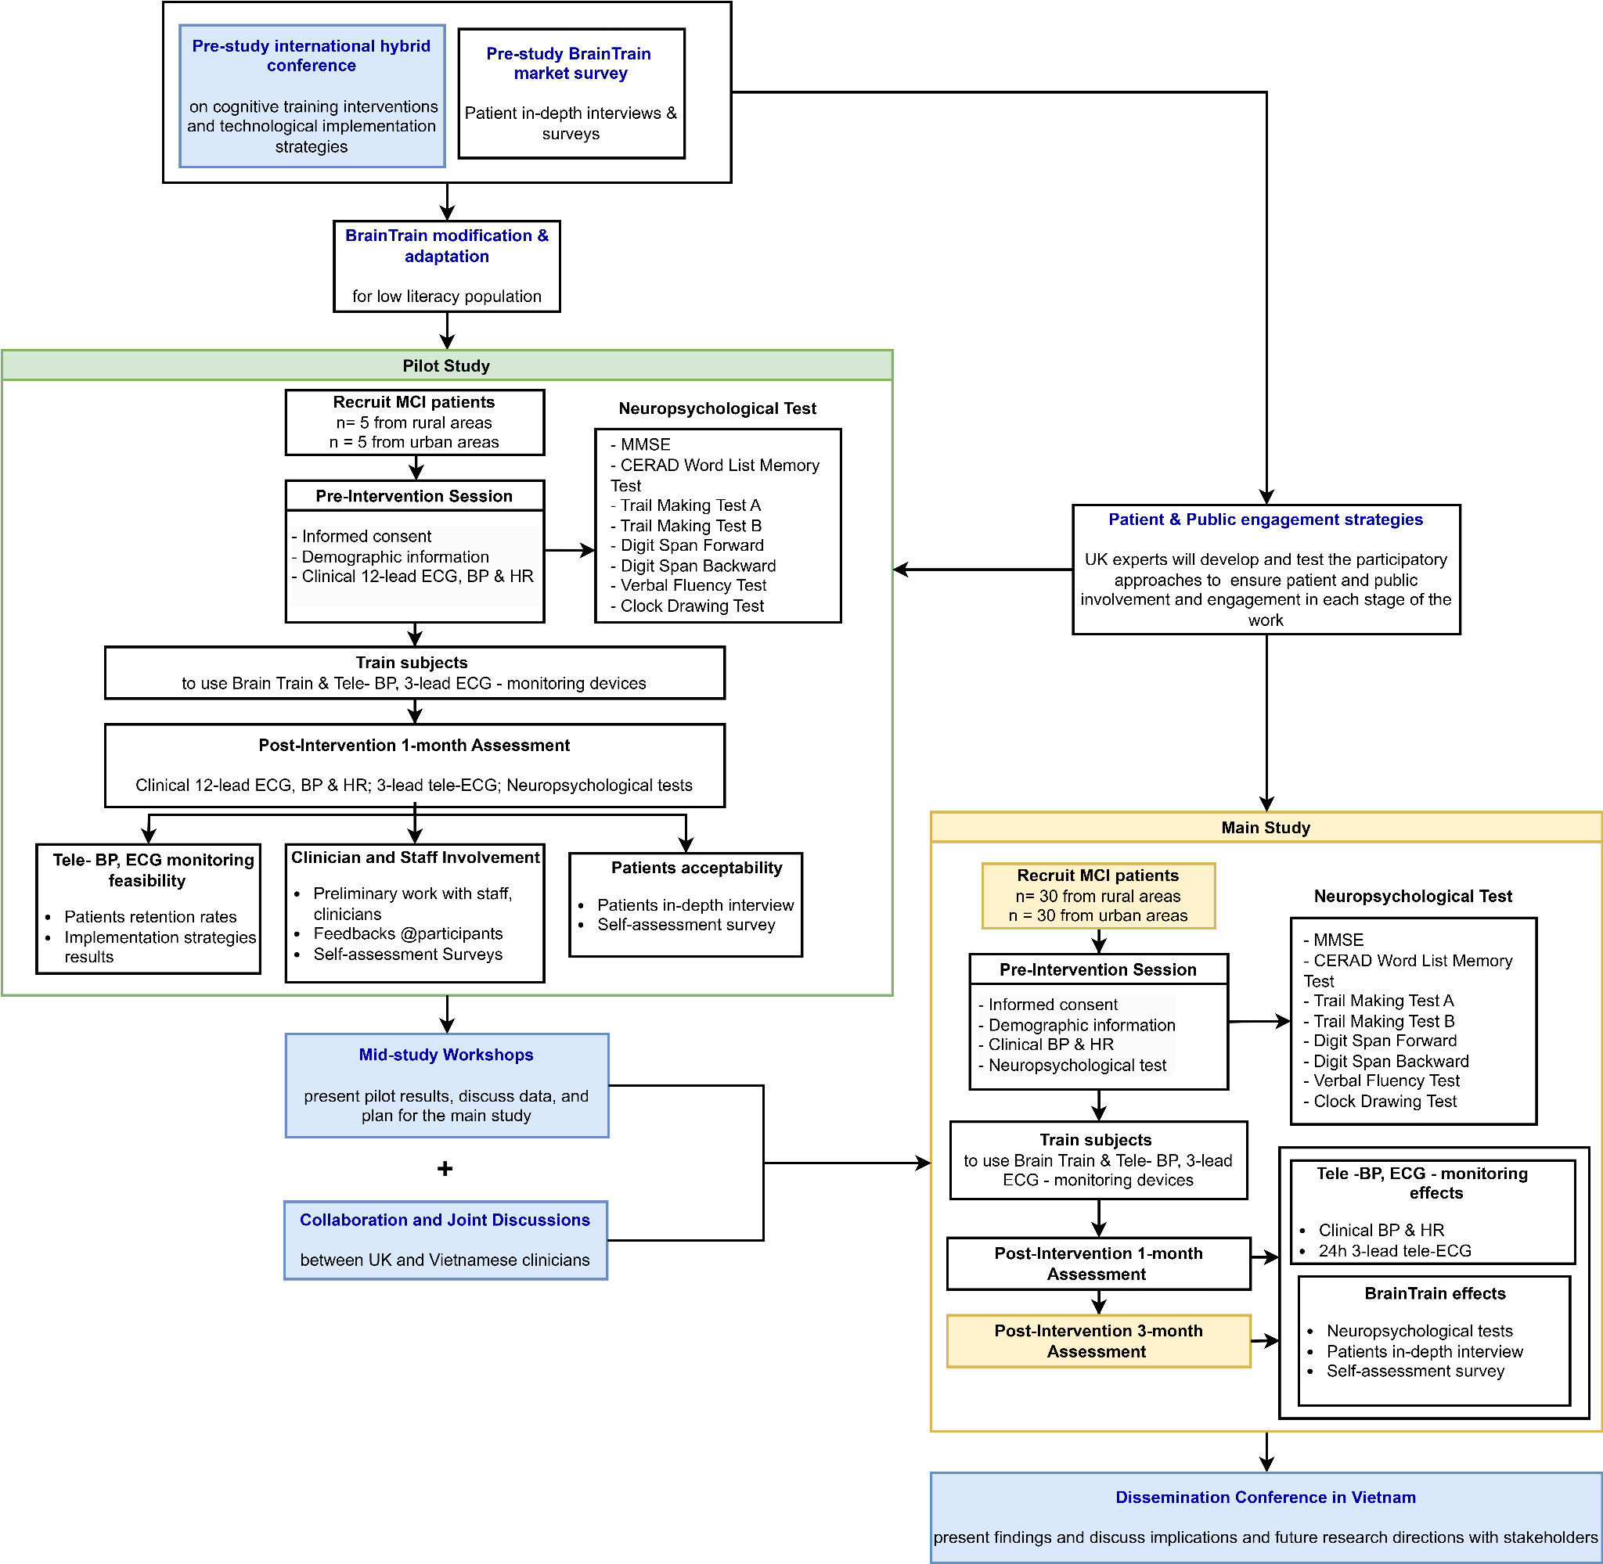

Table 2. Project Gantt Chart.
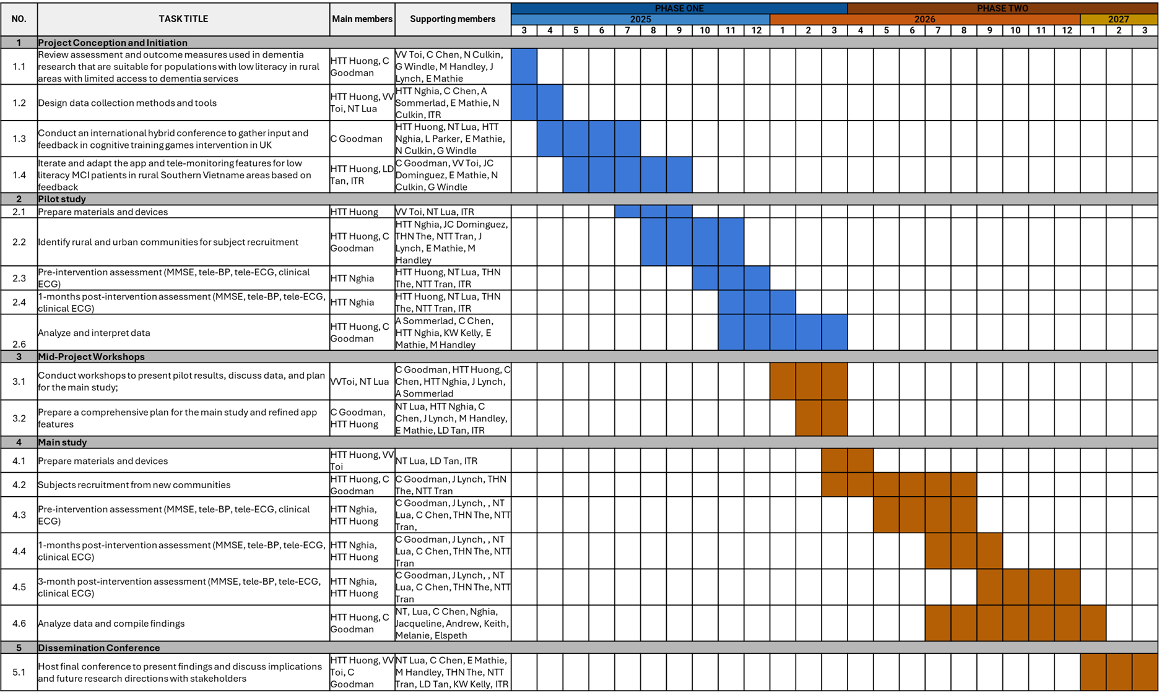

Preliminary data
Upload up to two A4 pages of prelim data in support of your research plan, which must be presented only as tables or figures (with brief legends). No additional text is permitted. Preliminary data - Google Docs

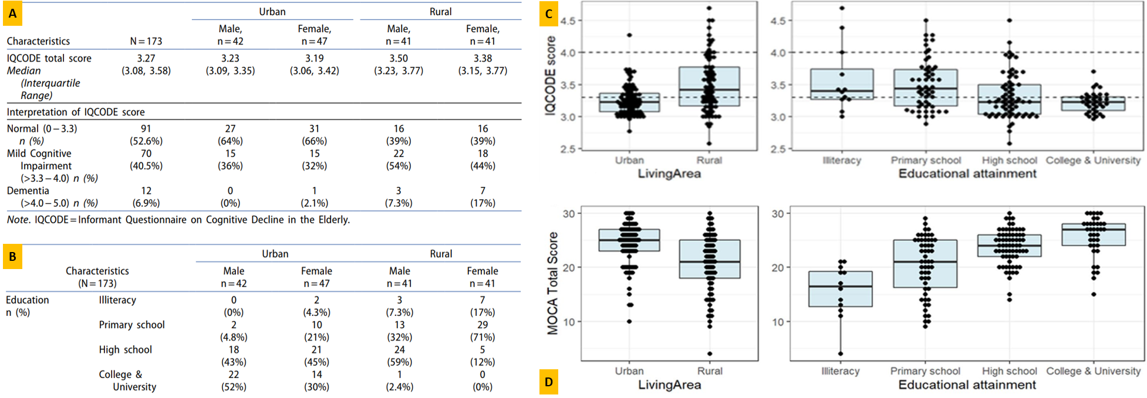
Figure P1. (A) The high prevalence of MCI and dementia in rural areas underscores the need for targeted interventions in underserved regions. (B) Urban participants tend to have higher educational attainment than rural patients, suggesting the need to optimise the app for low literacy to reach rural areas effectively. (C) Distribution of IQCODE scores by urban vs rural living area, and educational attainment (MCI: > 3.3-4.0; Dementia: > 4.0-5.0). (D) Distribution of MoCA-B scores by urban vs rural living area, and educational attainment.
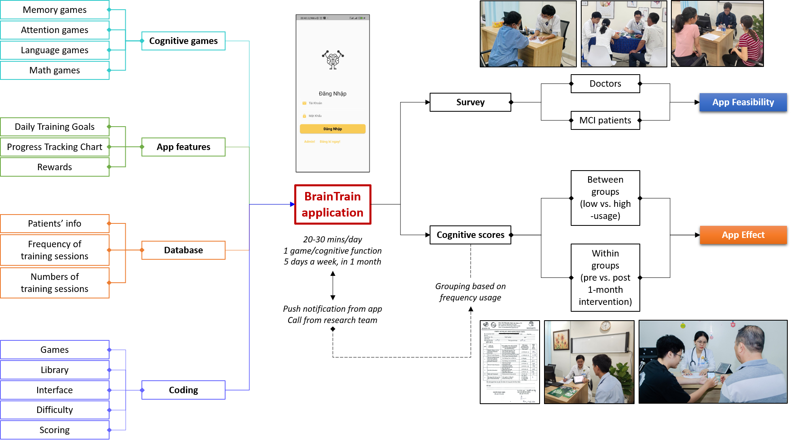Figure P2. The cognitive games in the BrainTrain application are designed to target four cognitive functions, including Memory, Attention, Language, and Math, along with features that help maintain user motivation. This study aims to explore the feasibility and effect of applying digital health tele-interventions for MCI patients in Vietnam.
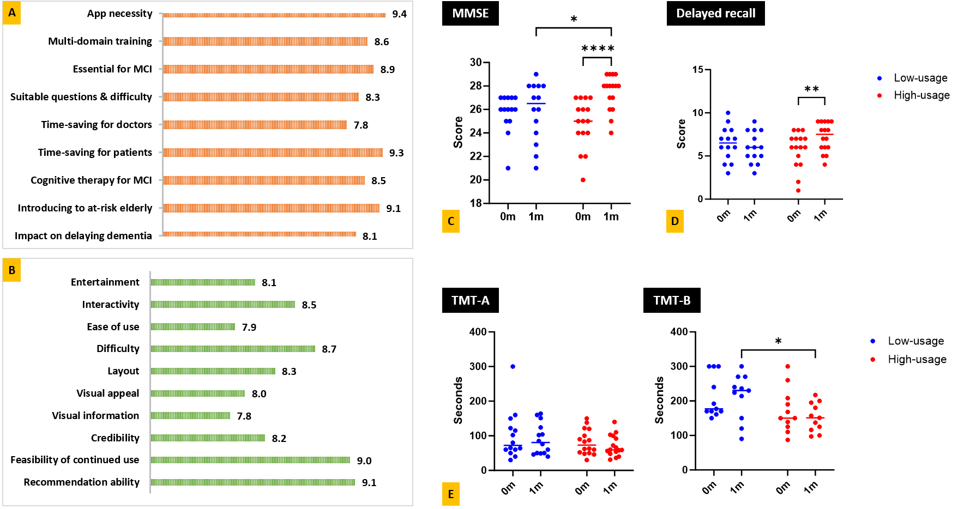
Figure P3. The mean scores on a 10-point scale from surveys assessing aspects of the BrainTrain app: (A) neurologists (n = 8) and (B) MCI patients (n = 30). (C) The change in Mini-Mental State Examination (MMSE) scores between pre and post-intervention demonstrated the app's effect. (D) The delayed recall test scores of the high-usage group showed improvement after 1-month. (E) A significant reduction in the time to complete the TMT-B test was observed between the two groups at one month.
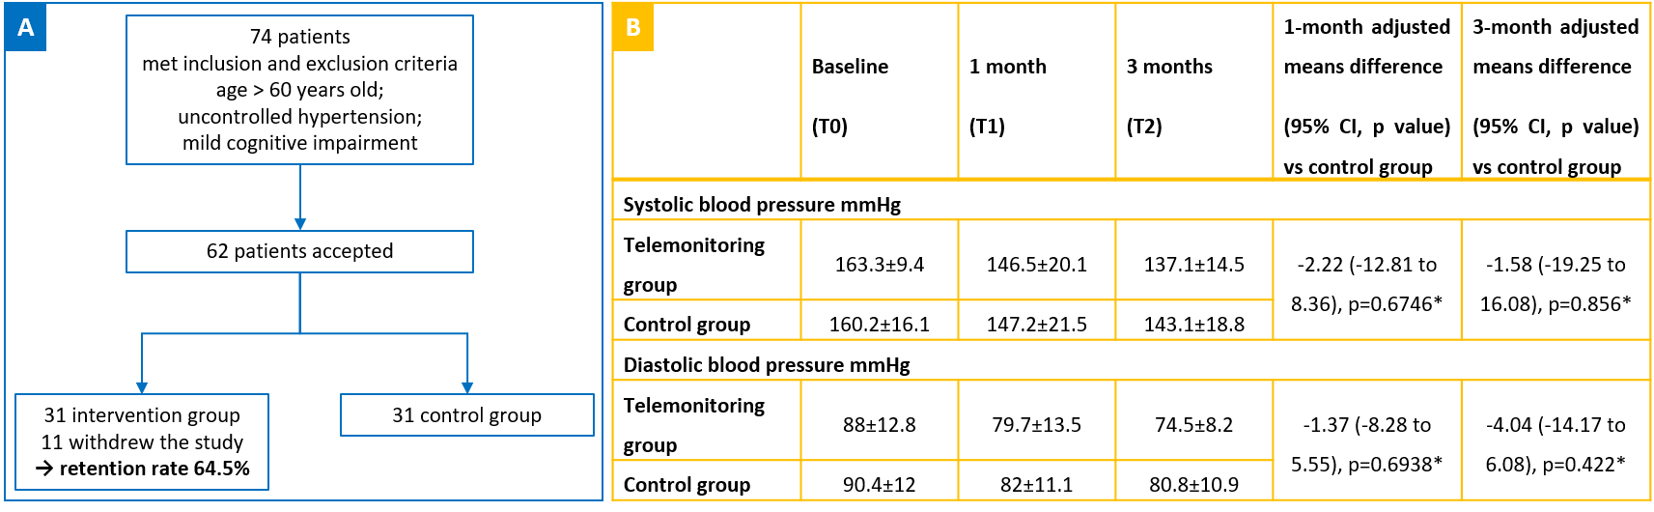
Figure P4. (A) High retention rates after three months demonstrate the feasibility of home BP telemonitoring in older Vietnamese patients with mild cognitive impairment and uncontrolled hypertension. (B) Blood pressure readings were collected and managed for three months, demonstrating that telemonitoring may improve blood pressure management over time.

Keywords
Please give up to six keywords that might be helpful in classifying your research
*Cognitive training games | *Mild cognitive impairment | ECG/BP remote monitoring
Cardiovascular risk factor | Rural populations | Telemedicine

Reviewers
Please suggest three potential reviewers for your application. Reviewers should not be based at your current or previous institution(s), nor at those of your collaborator(s). Co-authors in previous publications should also be excluded.

You are required to provide a contact email address for each suggested reviewer. You should only provide an email address that is publicly available, please do not provide the individual’s personal email address.

Your suggestions will be hidden from reviewers and Panel members.

Reviewer name | Institution | Email | I have not collaborated or published with them
Adelina Commas-Herrrera | London School of Economics and Political Science | A.Comas@lse.ac.uk
Mr. Lenny Shallcross | World Dementia Council | lenny.shallcross@WORLDDEMENTIACOUNCIL.COM
Prof. Reini Scherer | University of Essex | r.scherer@essex.ac.uk

Research environment
Describe any facilities or technical support that will be available to you

At the School of Biomedical Engineering IU-VNU HCMC, we will have access to various advanced biomedical engineering devices and strong technical support. Holter tele-blood pressure devices from Prof. Toi and his team will be utilized to measure the cardiovascular data. FDA-approved tele-ECG-monitoring devices from ITR, along with their development team, will help integrate signals, visualize data, and create algorithms to automatically calculate heart rate variability from raw ECG signals. Our experts from the UK will also support the development and testing of participatory approaches to ensure patient and public involvement and engagement in each stage of the work. Additionally, our collaboration with local neurologists, geriatricians, clinicians, and MCI patients in both rural and urban areas of Ho Chi Minh City will be facilitated by partnerships with Dr. Than, Dr. Nguyen, and Dr. Hoang. This combination of resources and expertise will ensure comprehensive technical support for the project’s success.

Lead Overseas Applicant

Summary of current research
Please provide an outline summary of your current research
After obtaining my Ph.D. in Neuroscience from Stanford University in 2018, I returned to Vietnam and established the Brain Health Lab at IU. With over 13 years of research experience in Neuroscience, my focus since 2018 has shifted to dementia, particularly early diagnosis and intervention for cognitive decline. My current work includes developing cognitive training for Mild Cognitive Impairment (MCI) patients and using EEG and AI for early Alzheimer's detection. I also investigate the heterogeneity in biomarkers and atrophy patterns in the MCI population and develop molecular detection of Alzheimer’s using p-Tau217 and cell-free RNA. Beyond dementia, my work involves building a Brain-Computer Interface for stroke rehabilitation and exploring AI potential in detecting brain tumors and migraines. Along with those studies, I lead projects to create the first Vietnamese databases of brain MRI and EEG data to enhance AI models and diagnostic accuracy. In mental health, my research also delves into the relationship between stress, emotions, and brain signal changes, along with evaluating the effects of Alpha music and Mindfulness-Based Stress Reduction (MBSR) in stress reduction. This work has fostered international collaborations with Emotiv Inc. (Australia), enhancing my research through state-of-the-art tools for neurodegenerative studies.

Career history
List all your qualifications and career history in reverse chronological order.
The depth of information you provide is up to you, but this will represent you under assessment and so it is worth including as much good evidence for your academic merit as possible.
CAREER POSITIONS
2018 - present
International University (IU)-Vietnam National Universities HCMC, Vietnam
School of Biomedical Engineering (BME)
Position: Chair, Department of Tissue Engineering and Regenerative Medicine (2020 - present)
Educational Quality Assurance Coordinator (2021 - present)
Lecturer (2018 - current)
Vice Chair, Bioethics Committee (2019 - 2021)
Research Coordinator (2019 - 2020)

2012 - 2015
Stanford University School of Medicine, Stanford, CA, US
Research Assistant
Psychiatry Department | 2014 - 2015
Department of Neurology and Neurological Sciences | 2012 - 2014

2011 - 2012
Oxford University Clinical Research Unit, Vietnam
Research Assistant

EDUCATION:
2021
EBRAINS & IBRO | Neuroscience (Brain Atlasing and Simulation Services)

2019
France - Vietnam training for neurologists | Neuroscience Certificate
University of Medicine and Pharmacy, Ho Chi Minh City, Vietnam | Diagnostic test standard and procedure at hospitals Certificate

2012 - 2018
Stanford University School of Medicine, Stanford, CA, US | PhD in Neuroscience

2014
The Marine Biological Laboratory, MA, US | Neurobiology Certificate

2007 - 2011
University of Science, VNU-HCMC, Vietnam | BSc in Medical Biotechnology

HONORS:
2024
Outstanding female intellectual of Ho Chi Minh City 2019-2024, Vietnam
Silver Medal in the “Design, manufacture, application” award, Vietnam

2023
Golden Globe Science and Technology Award, Vietnam
Women of the Future Awards Southeast Asia
Vietnamese Outstanding Young Face Award

2022
International Awards L'Oréal-UNESCO for Women in Science
Top 4 Social Business Creation, HEC Canada
UNLEASH HACKS: Mental Health Europe
Third Prize, National Technological Creation Contest, Vietnam

2021
Second Prize, Ho Chi Minh City Creative Awards
SUN* Award, Tech Planter Demo Day in Vietnam

2020
Early Career Award, International Brain Research Organization

RECENT FUNDINGS:

Funding Agency: Medical Research Council, United Kingdom
Title: Capacity Building and Computing Technologies for Healthcare: An Application in Transforming Mental Health Research and Services in Vietnam
Duration: 2024
Position: Main Investigator
Funding Amount: € 25,000

Funding Agency: Vietnam National University Ho Chi Minh City B Grant
Title: Design of a p-tau 217 protein quantitative immunosensor using carbon electrodes embedded with nanomaterials and targeted antibodies for application in detecting Alzheimer's disease
Duration: 2024 - 2026
Position: Principal Investigator
Funding Amount: € 26390.37

Funding Agency: Medical Research Council, United Kingdom
Title: Investigation and Implementation of Solutions for Challenges in Mental Issues of the Elderly in Vietnam by Networking with Advanced Countries
Duration: 2020 - 2021
Position: Main Investigator
Funding Amount: € 25,000/year

Funding Agency: Vietnam Alzheimer Network
Title: Toward a non-invasive blood test for Alzheimer's Disease
Duration: 2020 - 2022
Position: Principal Investigator
Funding Amount: € 10,000

List your five key and/or relevant publications
Provide details of authors, titles and references for up to five of your most relevant publications in refereed journals, in reverse chronological order. You should choose the most relevant to the application to support your case.

Please note: listing more than five publications will render this application ineligible. If you wish to include fewer than five publications, please enter 'N/A' in the remaining boxes.

Nguyen, M., Pham, B., Vo, T., & Ha, H. (2024). Revealing the heterogeneity of plasma protein and cognitive decline trajectory among Mild Cognitive Impairment patients by clustering of brain atrophy features. Brain Multiphysics, 6, 100093.
Do, T. T., Van Tran, L., Le, T. A., Le, T. M. T., Duong, L. A. H., Nguyen, T. H., ... & Ha, H. T. T. (2023, December). Stress Prediction Using Machine-Learning Techniques on Physiological Signals. In 2023 1st International Conference on Health Science and Technology (ICHST) (pp. 1-7). IEEE.
Nguyen, T. T. Q., Hoang, C. B. D., Hoang Le, M. D., Anh Vo, N. T., Quang, H., Nguyen, C. M., ... & Thanh Huong Ha, T. (2023). Assessing cognitive decline in Vietnamese older adults using the Montreal Cognitive Assessment-Basic (MoCA-B) and Informant Questionnaire on Cognitive Decline in the Elderly (IQCODE) during the COVID-19 pandemic: a feasibility study. The Clinical Neuropsychologist, 1-19.
Nguyen, Q. L., Nguyen, N. H. P., Le, A. P. H., Pham, B. H., Huynh, V. K., Cao, T. H. M., ... & Ha, H. T. T. (2024). Assessing the effect of the Trier social stress test (TSST) on psychological and physiological measurements of Vietnamese students. Vietnam Journal of Science, Technology and Engineering, 66(3), 105-113.
Phan, T. N. M., Nguyen, H. T., Huynh, T. N. M., Nguyen, T. H., Tran, T. N. Y., & Ha, H. T. T. (2022, December). Development and Commercialization of a Brain Training App Targeting the Vietnamese Elderly. In the International Conference on the Development of Biomedical Engineering in Vietnam (pp. 719-737). Cham: Springer Nature Switzerland.

Impact of COVID-19

Please briefly outline any issues you have experienced, which can be attributed to the COVID-19 pandemic and have directly impacted you and/or the following (500 words max):
- Research
- Publications
- Funding
- Research time
- Institutional support
- Other

You may wish to read the Academy's 'Top tips for factoring COVID-19 into grant applications' article for further advice on completing this statement.
As part of their statement, applicants are asked not to:
- name any third party individuals;
- identify the relationship with any third parties;
- otherwise include anything which might identify the third party.
The Academy encourages applicants to use phrases such as 'a close relative had COVID-19 and required significant support in order to recover' or ‘I had to carry out caring responsibilities in addition to my research and admin workload, which had an impact on the amount of time I could dedicate to my research’.

The COVID-19 pandemic has significantly impacted our research activities, affecting our ability to conduct research, secure funding, and manage research time. Despite these challenges, we have demonstrated resilience and adaptability, ensuring that we maintained progress and continued to contribute meaningfully to our field.
Research: The pandemic caused substantial delays due to lab closures and restricted facility access. Ongoing on-site experiments were halted, and new projects were postponed. Travel restrictions disrupted planned fieldwork, especially for the previous GCRF project. To adapt, we shifted to remote data collection and adjusted project scopes. Additionally, limited access to external computational resources prompted us to develop in-house expertise, allowing us to maintain momentum despite the constraints. This adaptability helped ensure that our research continued, albeit with some modifications.
Publications: Despite the challenges, our publication output increased during the pandemic. The restrictions for experimentation provided more focused time for writing and revising manuscripts. Though unable to attend in-person conferences, we leveraged virtual platforms to present findings and collaborate, ensuring that our research was still disseminated effectively. This period allowed us to pivot from fieldwork to writing, resulting in more published work than in a typical year.
Funding: Securing new funding was particularly difficult, as major funding bodies in Vietnam did not issue new calls. This situation forced us to optimize the use of existing grants, such as those from the GCRF and VAN. By carefully reallocating resources and adjusting project plans, we made the most of current funding to sustain ongoing research. Efficient management allowed us to navigate the funding shortfall without halting research activities.
Research Time: The pandemic significantly reduced research time due to increased personal responsibilities. Many team members took on caregiving duties, including supporting relatives who had COVID-19 and required substantial care. This reduced productivity and disrupted our usual work schedules. We implemented flexible work arrangements to achieve a better balance between caregiving and research. These adjustments helped us maintain focus on critical tasks, minimizing the overall impact on our research progress.
Institutional Support: During the pandemic, institutional support was reduced. Limited access to labs, libraries, and equipment, combined with remote working by administrative and technical staff, created barriers to efficiently managing research. However, by relying on internal resources and improving collaboration within our team, we mitigated the impact of these limitations and continued progressing on key research objectives.
Other Impacts: Losing in-person networking and collaboration opportunities impacted our ability to engage with peers. Nonetheless, we adapted by embracing virtual platforms, which allowed us to maintain connections and collaborate on projects. While not ideal, this new approach opened up opportunities for remote collaboration that had not been previously considered.
In summary, the COVID-19 pandemic presented numerous challenges to our research, but we adapted by optimizing resources, developing new competencies, and leveraging virtual tools. These strategies enabled us to continue conducting impactful research, increase publication output, and manage existing grants efficiently. We remain committed to sustaining our research through these adaptive practices in the evolving landscape.

Network

Contribution to network (core partners)
Please provide a brief description of the involvement of each core partner in the network, and how their expertise will directly contribute to the success of the project. (150 words max/person)

Core Partner | Contribution to network
Prof. Vo Van Toi | Prof. Vo Van Toi is the Former Chair of the School of Biomedical Engineering, Vice-Provost for Development of Life and Health Science, Engineering and Technology at the International University - VNU HCMC, and PI of the last GCRF Network Grant that laid the foundation for our current collaborations. He had helped to establish connections with Prof. Claire and partners in the UK, and with other institutions, companies in Vietnam. He is a leading figure in the biomedical engineering field in Vietnam, whose works include design and application of medical devices, and entrepreneurship for BME with a focus on telemedicine. He developed the tele-blood-pressure monitoring devices used in the previous GCRF Network Grant, which will continue to be implemented in our current proposal. He will also support the project design and deployment of the tele-BP devices and the organization of the seminars and conferences.
Dr. Chen Chen | Dr. Chen is a lecturer in Computer Vision at the University of Sheffield (UK) and a core member of the Insigneo Institute, specializing in artificial intelligence (AI) for healthcare. Prior to this, she was a postdoc at the University of Oxford and Imperial College London (UK). Her research interests lie in developing advanced AI models to exploit the value of multi-modal healthcare data, such as image, signal, text, etc. for advanced diagnosis and prognosis of cardiovascular diseases (CVDs). Currently, she focuses on developing AI models for paper ECG digitization and automatic interpretation for early diagnosis of CVDs, particularly in underserved areas with limited medical resources. For this proposal, she will be providing technical advice and support on the ECG data collection and model verification part.
Dr. Ngo Thi Lua | Dr. Lua Ngo is a lecturer and neuro-engineer specialized in artificial intelligence and healthcare at the School of Biomedical Engineering, IU - VNU HCMC. She develops AI models using biomedical data such as ECG, EEG, neuroimaging, etc. to detect and diagnose mental health disorders and other diseases. She was also our core partner in the previous GCRF Network Grants and had experience in ECG signal processing and remote monitoring. In this project, she will work with Dr. Chen and Prof. Toi to collect and analyze remote ECG and BP pressure in rural areas of Vietnam. In addition to her technical role, Dr. Lua will also play a crucial part in fostering collaboration and networking within Vietnam. She will be responsible for organizing site visits, meetings and conferences, and facilitating connections with other dementia experts in the country and region.
MD. MSc. Hoang Tien Trong Nghia | Dr. Nghia is the Head of the Neurology Department of the Military Hospital 175, HCMC, Vietnam. He has experience working in multiple research groups on neurological diseases across several countries, including Singapore, Korea, Australia and WHO. He also had his Master’s in Neurology and Peripheral Neuropathy at the University of Medicine and Pharmacy HCMC and Milan University, Italy. He will coordinate subject recruitments and collect medical data from hospital patients, and submit for ethical approval from the hospitals to work on human subjects and samples.
Impact Technical Resource | Impact Technical Resource is a leading Vietnamese technology firm specializing in medical technology and digital health solutions. Renowned for their expertise, they have successfully developed several FDA-approved wearable devices, clinically relevant sensors, and remote patient monitoring systems. These innovative technologies enable real-time diagnostic data collection and recording, providing invaluable insights for healthcare professionals. Given their proven track record, Impact Technical Resource will serve as a pivotal partner in our endeavor. They will supply tele-ECG monitoring tools and a robust platform capable of remotely visualizing and monitoring ECG signals from the Southern provinces of Vietnam. Moreover, they will seamlessly integrate these devices into a comprehensive system in close collaboration with Dr. Lua, Dr. Chen, and Professor Toi. This system will efficiently handle signal recording, transmission, processing, calculation of relevant HRV parameters, and the clear presentation of data for patient monitoring.

Contribution of collaborators
Please give a brief description of the involvement of the collaborators in the network and how their expertise will directly contribute to the project. (250 words max for 1 paragraph of all collaborators)

The project will benefit from the diverse expertise of its collaborators. Neurologists and geriatricians, including MDs Than, Nguyen, Hoang, and Prof. Dominguez, will provide critical clinical insights into MCI patients, particularly in LMIC settings, aiding in the streamlined implementation and evaluation of the intervention, and will be responsible for the screening and assessing cognitive conditions of the subjects. Dr. Sommerlad brings valuable experience in assessing dementia risk factors, cognitive training, and clinical expertise in risk assessment, contributing to the intervention’s design and evaluation. Dr. Lynch’s specialisation in technology adoption among older populations maximizes the intervention’s accessibility and effectiveness for the target group. Dr. Le, specializing in software development, will optimize the BrainTrain app’s user interface and management software, collaborating with ITR to enhance functionality and user experience. Dr. Melanie Handley, with her background in managing long-term conditions such as dementia, will offer patient-centered perspectives to enhance sustainable care strategies. Prof. Kelly’s research in neuroimmunophysiology will provide a deeper understanding of MCI mechanisms. Dr. Elspeth Mathie will focus on public involvement and engagement, promoting community collaboration. Prof. Culkin’s expertise in business management and entrepreneurship will support project execution, ensuring the long-term viability of the proposed solution. Dr. Greg Windle, as a social policy researcher focused on the health and well-being of inpatients with dementia, will assist in identifying and accessing potential MCI populations for intervention and policy implications. Ms. Lindsey Parker and MsCs. Nga will manage financial and project logistics, ensuring compliance with required documentation and tracking progress.

ODA compliance & Sustainable Development Goals
How do you expect the outcome of your proposed activities will promote the economic development and welfare of a country/countries on the DAC list? (250 words max)

SDG 3: Good Health and Well-being:
- Early intervention (BrainTrain app + health monitoring) delays cognitive decline, reducing dementia burden and healthcare costs.
- Improves mental and cardiovascular health, enhancing the quality of life for elderly in rural areas.
SDG 10: Reduced Inequalities:
- Accessible via smartphones, providing scalable, low-cost cognitive and health interventions in underserved, low-literacy populations.
- Reduces healthcare disparities in rural areas by offering equal access to interventions.

The proposed activities aim to reduce the prevalence of AD by targeting the MCI stage in rural populations of Vietnam, a country on the DAC list.
Employing a cognitive training app and telemonitoring of cardiovascular health, we address key risk factors associated with dementia. Early intervention mitigates the progression of AD, reducing the known risks of social exclusion. It facilitates the allocation of targeted health services and resources for marginalized groups, enabling older adults to continue contributing to family income and society. This supports economic sustainability by reducing the economic burden of caregiving duty, particularly for women who have to leave work to care for affected relatives.
The project also reduces inequalities between rural and urban populations by providing accessible healthcare technology tailored to low-literacy communities. It narrows the gap in healthcare access, ensuring that underserved rural populations benefit from culturally relevant and effective interventions. Incorporating cardiovascular risk management alongside cognitive training addresses both cognitive and physical health, offering a comprehensive approach to improving health outcomes.
In addition, the project contributes to job creation through the deployment of tele-monitoring systems and builds local capacity in healthcare technology. Knowledge transfer through international collaborations will equip local health workers and researchers with valuable skills, promoting sustainable healthcare solutions.
Overall, by reducing healthcare costs, increasing workforce participation, and promoting preventive care, this project aligns with Sustainable Development Goals (SDG) 3 (Good Health and Well-being) and SDG 10 (Reduced Inequalities), fostering economic development and welfare for marginalized populations.

Gender Equality
Using the UK Government’s guidance document on Gender Equality in Research and Innovation Official Development Assistance (ODA, and with particular reference to Annex 3 (page 37), please provide a gender equality statement.

This should outline how the design, implementation and impact of the activity will seek to reduce inequalities between persons of a different gender. It should acknowledge where there is the potential for direct or indirect impact on people of different genders. Furthermore, it should identify how the inclusion of all genders within a community can be enhanced, and issues of under-representation addressed. (400 words max)

Gender equality in healthcare is a critical issue, especially in the context of Alzheimer's disease, where significant disparities exist. These disparities are partly due to biological factors, such as hormonal changes post-menopause and underlying medical conditions like cardiovascular-induced Alzheimer's, which may accelerate neurodegeneration. The issue is further exacerbated by disparities in diagnosis and care for rural women, underscoring our research's aim to reduce gender inequality in healthcare, particularly in Alzheimer's disease research.
The lifetime risk of developing Alzheimer's at age 45 is twice as high for women (20%) compared to men (10%) (according to the Alzheimer's Association). Women's longer life expectancy and postmenopausal hormonal changes increase their risk. Hormonal changes also elevate the risk of conditions like heart disease, which is linked to dementia. Therefore, our proposed intervention integrates cardiovascular health management to address these interconnected risks, ensuring more personalized and early treatment options.
The issue of gender inequality in health is particularly pronounced in rural areas, where women face additional challenges such as low literacy rates, limited access to information, and insufficient healthcare. These barriers exacerbate their risk of dementia, especially as lower education levels limit participation in mentally stimulating activities. Rural hospitals, often lacking specialized professionals, contribute to delayed diagnoses and treatment, further disadvantaging women. Our research on an integrated intervention aims to address these gaps and reduce the burden on caregivers and society. Preliminary data from the pilot show that women experience symptoms earlier and participate more actively, highlighting their concern for dementia. Expanding access to this intervention could help protect their health more effectively, regardless of location.

Human tissues or subjects
Please give details on when you expect to obtain approval and any impacts on the work proposed (150 words) 148

In this proposal, we plan to conduct an interventional study on human subjects using only non-invasive methods. These include cognitive assessments (MMSE), blood pressure monitoring, and ECG readings. We have extensive experience with these interventions and have previously obtained approval from the internal review board for similar procedures. In our experience, these interventions have had no negative impact on the subjects' physical or mental health.
For this project, we will apply for ethical approval following the requirements of the Ethics Committees at Military Hospital 175 in Vietnam, which is the institution involved in the pilot BrainTrain study. The ethical assessment process typically takes around three months, so we plan to submit ethical approval from March to June 2025, ensuring approval is secured before the Pre-intervention assessment phase begins. Our team has successfully obtained ethical approval from this committee, which is particularly valuable due to the hospital's strong reputation.

Outputs management, sharing and subsidy control

Outputs management and sharing
To maintain research integrity, institutions and researchers must ensure research outputs are preserved so that results can be verified and data reused in the future. The Academy expects all award holders to maximize the availability of research outputs.

You should consider your approach for managing and sharing research outputs at the research proposal stage. The Academy will review those plans as part of the funding decision.

We do not have a set format for data management and sharing plans. You can structure your plan in a manner most appropriate to the proposed research. The information submitted in plans should focus specifically on how the outputs will be managed and shared, detailing the repositories where data will be deposited. However, in considering your approach for outputs management and sharing, you should consider the following questions as briefly and unambiguously as possible.
- What outputs will your research generate and what outputs will have value to other researchers?
- Where and when will you make the outputs available?
- If the research output is of high public interest, how will it be made accessible not only for those in the same or linked field, but also to a wider public audience?
- Specify whether any limits will be placed on the outputs to be shared, for example, for the purposes of safeguarding commercial interests, personal information, safety or security of the data.
- How will data and metadata be stored, backed up and preserved, to ensure their long-term value?
- What resources (to include financial and time) will you require to deliver your plan?
- Does your Institution have a data repository that is available to you?

Please provide an outputs management plan

Please read the scheme guidance notes, and outline your plans for the management of your research outputs in a way that will achieve the greatest health benefit, maximizing the availability of research data, software and materials with as few restrictions as possible. (300 words max)

With the rapid advances in data management and digitalization, this study will demonstrate how telehealth data can be linked to patient records in a secure, anonymized manner. This linkage will enable clinicians to receive timely feedback and help patients develop effective strategies for self-management. By integrating these digital health tools, the study will also explore new avenues for improving care coordination between healthcare providers and patients, facilitating real-time monitoring of Alzheimer’s disease risk management.
The research output includes the following events: an international hybrid conference to gather input and feedback in the UK, scheduled from April to July 2025; a mid-project workshop planned for January to March 2026; and an international conference to be hosted in Vietnam from January to March 2027. All project data will be saved in the private lab drive, which has a maximum capacity of 2TB, with 85% of the capacity currently available. The data collected during this project will be accessible after March 2027, once the project is completed. Any research group wishing to further analyze the dataset and make new contributions must request permission to access it. To address potential data loss due to unauthorized access, we always duplicate all files, store them in a locked folder, and only access the backup data if issues arise with the primary set.
Additionally, in collaboration with the Intellectual Property and Technology Transfer Center of Vietnam National University, Ho Chi Minh City (IPTC), all necessary intellectual property protections will be applied before data sharing. During the data collection process, we will also raise public awareness about Alzheimer's disease by educating the public on its progression and promoting mental health care.

Subsidy control
The UK subsidy control regime began on 4 January 2023. As part of this regime, the Academy is required to report to the UK Government on how award funding is being used when applications collaborating with commercial enterprises are awarded. The regime determines the lawfulness of monetary awards made using public sector resources when given to businesses and other organisations that are engaged in economic activity.

Please provide details of the applied research. (100 words max)

For this proposal, we are using the remote BP & ECG devices from Prof. Vo and the ITR company, Vietnam, along with the BrainTrain app developed in our lab. The Holter BP telemonitoring system has been successfully employed with MCI patients, while ECG telemonitoring devices from ITR have received FDA approval and are currently being distributed in international markets. The BrainTrain app has been rigorously validated by neurologists at 175 Military Hospital and has been in use by MCI patients in Ho Chi Minh City since November 2023.

Please outline how this grant would be used to strengthen research capacity and research excellence at both the Overseas Lead Organisation and the UK Administering Organisation.
(300 words).
Em viết theo kiểu nói sơ sơ về cái activities của grant mình
Rồi sau đó nói thông qua grant này thì build được các capacity về telemedicine, cognitive intervention đồ ntn, đào tạo nhân lực ra sao cho phía VN, cho phía bên UK
Về research excellent thì viết mấy cái lquan kiểu novelty của study và potential publication
Cô Hiệp

This grant project aims to tackle pressing healthcare challenges in rural areas, particularly in Vietnam, by utilizing advanced technology. The focus is on developing and deploying the BrainTrain app, which is designed to enhance cognitive function for individuals at risk of Mild Cognitive Impairment (MCI). Additionally, the integration of wearable devices will allow for the continuous monitoring of vital signs, such as ECG and blood pressure, which are critical in assessing cardiovascular health—a known risk factor for dementia. This combination of cognitive intervention and physiological monitoring provides a promising approach to early dementia risk detection.
The grant will play a significant role in building research and healthcare capacities in both Vietnam and the UK. In Vietnam, the introduction of telemedicine will enable remote monitoring and care for patients in underserved areas. For the UK, this initiative will offer valuable insights and data on implementing telemedicine in low-resource settings, further informing global health research efforts. The project also emphasizes the training of healthcare professionals in the country, ensuring they are equipped with the necessary skills to effectively use these technologies and apply cognitive interventions in patient care.

From a research perspective, this project is expected to make meaningful contributions by combining wearable health data with cognitive tasks to assess dementia risk. It stands out as one of the first efforts to apply this data-driven approach to rural populations in Vietnam. The outcomes are likely to result in impactful publications in fields such as neuroengineering, telemedicine, and cognitive health, with potential topics including the effectiveness of BrainTrain, early dementia risk prediction using wearable data, and the feasibility of telemedicine in low-resource environments.

This grant has the potential to foster new insights and approaches that will benefit both regions and support ongoing efforts in healthcare innovation.
This grant will enhance research capacity and excellence through a collaboration between the International University, Vietnam National University Ho Chi Minh City, and the administering organization from the UK, particularly the University of Hertfordshire. The project focuses on adapting and deploying telemedicine devices, such as remote BP and ECG monitors, along with the BrainTrain app, to improve patient monitoring and cognitive health in low-resource settings. These activities will build essential infrastructure and expertise for both partners. Training programs in Vietnam will equip local researchers and clinicians with the skills to use advanced digital health tools, while the UK team will gain insights into the unique healthcare challenges in LMICs. Cross-institutional training will foster knowledge exchange and strengthen long-term partnerships, building on the foundation of the GRCF Network and Network Strengthening grants. The project’s innovative approach, integrating telemedicine and cognitive interventions for MCI and dementia risk management, offers potential for high-impact publications and global relevance. With the support of a finance officer, proper resource allocation and financial oversight will ensure the project's sustainable success, contributing to the research capacities and excellence of both institutions involved.

