PSRUTI

Utilities for MIDI files of

YAMAHA Keyboards

Version 8.21

Content
1. Summary 3
2. The Main Window 4
3. Load and Save MIDI files 4
Load 4
Save 4
Save as... 4
Close 4
4. Converting and Optimizing MIDI files 5
Protocol of MIDI file characteristics 5
Converting Karaoke Files to Standard MIDI files 5
Optimizing and converting to the Yamaha format XG 5
Conversion to the Format GM (General MIDI) 6
5. Transpose MIDI files and edit the Key Signature 6
Transposing 6
Key Signature 8
6. Edit Tempo 8
7. Edit Volume 8
Controller 7: Main Volume 8
Master Volume 8
Change Volume by Velocity 9
8. Revoicing 9
Standard Revoicing 9
Selecting a voice with the voice browser 10
Selecting a voice by bank- and voicenames 11
Selecting a voice by bank- and voicenumber 11
Voicefile Revoicing 12
About Effect Blocks and Blocknumbers 13
The row "+Ctrl" 13
Notes 14
Revoicing with a Revoicefile template 14
Voicebank Calculator 15
9. Chords and Lyrics 15
Compute Chords 15
Quantize Chords 16
Normalize Chords 16
About Linefeeds and Newpages 16
Protocol Lyrics with Chords 16
The Chord Lyric Editor 17
Moving events 17
Changing and deleting events 17
Inserting events 18
Control by playing the MIDI file 18
Recording of lyrics 18
Shift Linefeeds and Newpages 19
Define Fill Lyrics 20
Insert Fill Lyrics 20
Not at lyrics: 20
Not in beats with lyrics 20
Not in measures with lyrics 21
Delete Fill Lyrics 21
Quantize Lyrics 22
Adjust Lyrics at Notes 22
Chords/Lyrics Import/Export 22
Export 22
Import 22
The structure of the textfile 22
Record Lyrics and Chords 25
10. Play MIDI files; record Lyrics and Chords 25
MIDI: Select the Soundgenerator 25
The Karaoke Window "Play" 25
The structure of a chord file 26
The structure of a lyric file 27
How do we perform the recording of chords and lyrics? 27
11. Controller and Effects 28
Controller 28
Effects 29
12. Velocity Compressor 29
13. Edit Drum- and SFX-Notes 30
Edit Drums/SFX (Dialog) 30
Edit Drums/SFX with a Drumfile template 30
14. Delete, copy and exchange Midi channels 31
15. Import and export SysEx 32
Export SysEx 32
Example 1: SysEx Protocol of the region before the notes 32
Example 2: SysEx Protocol of the notes area 33
Import SysEx 34
16. Delete and insert Count In 34
17. Miscellaneous 35
Expression <-> Main Volume 35
Songname, Componist, Lyricist, Copyright 35
Score 35
Score channel 35
Score Layout 35
Optimize Score Notes 36
Vocal Harmony (Vocoder) 36
1. Deleting Vocal Harmony and selecting, activating, deactivating a vocoder channel 36
2. Edit the Vocal Harmony in batch mode. 37
37
3. Lengthen the notes of a Vocoder channel 38
Quickstart 38
Delete Keyboard events 38
Delete short Notes 38
Delete MIDI Events 39
Quantize Notes 39
Change lengths of notes 39
Change Time 40
Insert Clicks 40
18. Preferences 41
Select the MIDI port of the soundgenerator 41
Select a suited Instrument Definition 41
Select a SysEditor XG effect data file 41
Define the form of Fill Lyrics 41
More Preferences 41
19. Addendum 43
Voicenames and Instrument Definition 43
PSRUTI with MIDI Files of other Manufacturers 43
Batch Processing 43
The file psruti.ini 44
21. Final remarks 44

1. Summary

With the YAMAHA Keyboards we can play Midi and Karaoke files of the formats GM (General MIDI) and YAMAHA XG (Extended General MIDI). Although the GM files may sound well, we obtain the best results only with XG and its extended file format XF.

PSRUTI (PSR Utility) is specialised for these file types. The program converts GM or GS files to XG and improves the internal structure of MIDI files. PSRUTI does not substitute a sequencer, but offers functions that are often used to tune MIDI files. In most case these actions are easier to perform with PSRUTI than with a sequencer.

PSRUTI works with source files (extension .mid) of MIDI Format 0 (SMF0), 1 (SMF1) and Karaoke files (extension .kar). Karaoke files (extension .kar or .mid) are converted to MIDI files that use standard meta lyric events.

YAMAHA style files (format SFF), that have got the extension .mid, are loaded, but the CASM parts and other style chunks are omitted. Files, that have been saved with the old Yamaha format XF, loose most of their data too. Loading such files, we get the warning "Some more data behind SMF tracks are ignored".

PSRUTI saves the new MIDI files in MIDI format 0 only and the files get the extension .mid. The destination will be created or overwritten. Some bugs in the source files (missing note offs and uncomplete RPN/NRPN) will be repaired. PSRUTI can be used to convert and repair a SMF1 or a Karaoke file to SMF0 by loading and saving the file without making any changes to it.

It is possible to select the same file as source and destination. Attention: The original source will be overwritten!

The actual state of changes can be played. It is not required to save the file before. The actual measure/beat number and the chords and lyrics of the file are displayed in a karaoke area in a similar way as with the keyboards.

With "Undo" we only get back to the state of the MIDI file before the last change.

With the button "Sprache wählen" or “Select Language” the language of the program can be switched to German or English.

To display the PSRUTI Help it is required to install the freeware Adobe Acrobat Reader.

System requirements: Windows 98 and later..

2. The Main Window

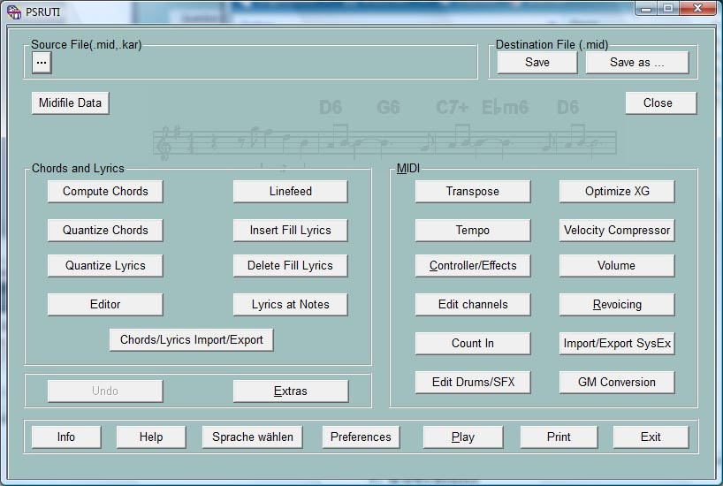

3. Load and Save MIDI files

Load

Usually the MIDI or Karaoke File is loaded with the button "..." (Source File).

When a PSRUTI icon is installed in the desktop, it is possible to drag the file with pushed left mouse button onto the icon and release the button (drag and drop). We also can drag the file into the open program window if no MIDI file is loaded before. If we drag more than one file onto the icon, PSRUTI will be opened with the first file and switches automatically with PSRUTI - Exit to the next file. The self-acting procedure can be aborted with a push at the close button "x".

Save

The button "Save" overwrites the source file without any warning.

Save as...

With "Save as ..." it is possible to save the file with another file name.

Close

This button closes the actual MIDI file without an implicite saving. The PSRUTI window remains open.

4. Converting and Optimizing MIDI files

Protocol of MIDI file characteristics

With the button "MIDI file Data" we get a protocol of global attributes of MIDI files.

Example:

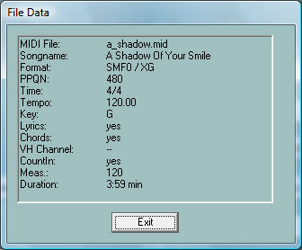

The function can be applied for single files and as batch job for all files of a folder. Do not load a MIDI file before, if batch is wanted. Activate "MIDI file Data", select a source folder and then a textfile. PSRUTI analyses all source files and fills the textfile with a protocol in table form. It is recommended to edit the layout afterwards with Windows Word or Excel.

Converting Karaoke Files to Standard MIDI files

Karaoke Files, extension .kar, are converted implicitely when the file is loaded. The Karaoke text events are converted by standard meta events Lyric, that can be displayed with Yamaha keyboards. Sometimes we find files with the extension .mid, where the internal representation of song text is like .kar files. In such case change the extension by .kar and load it with PSRUTI.

Optimizing and converting to the Yamaha format XG

Button "Optimize XG"

The MIDI file will be adapted to the YAMAHA Format XG and optimized. That means:

All manufacturer specific non XG SysEx are removed.

Channels without any note events are removed.

If needed, the SysEx "Turn General MIDI System On", followed by "XG On" are inserted. XG SysEx without any effect are deleted.

If missed, voice bank events (Controller 0 and 32) are inserted.

All MSB's of melody voice banks, with are not used by the YAMAHA Keyboards, are changed to zero. With drum kits (channel 10) the Drum XG bank 127/0 is used.

PSRUTI will not change following MSB's

0 XG Melody Voices
8 XG Mega and Articulation Voices
63 Custom Voices PSR 9000, Tyros
64 XG SFX
111 Custom Voices PSR-8000
120 GM2 Drum Kits, SFX Kits
121 GM2 Melody Voices
126 XG Drum Kits, SFX Kits
127 XG Drum Kits

The result may be, that some voices can be heard now, that did not have any sound before. It is recommended to revoice the file explicitely with PSRUTI Revoicing after these changes.

The MIDI events before the first note are checked and adjusted optimally. If required, all measures starting with the first note measure are shifted forward or backward. After this all initialisation events lie in measure 1 and the first note event start in measure 2. All needless MIDI events of the file are deleted.

All events of the MIDI file that follow the last note plus the time of four quarter notes are deleted. Here all MIDI files that do not stop playing after the last note are repaired.

"Optimize XG" is recommended to apply it with XG files too. We get smaller and better structured files. The sound of the file will not be influenced. The function is recommended as the first step before further changes with PSRUTI or sequencer software. Repeated appliance does not cause any problems.

The function "Optimize XG" can be applied for single files and as batch job for all files of a folder. Do not load a MIDI file before, if batch is wanted. Activate "Optimize XG" and select a source folder and then a destination folder. PSRUTI optimizes all source files and saves the new files with the original filename into the destination.

Conversion to the Format GM (General MIDI)

Button "GM Conversion"

MIDI files of all types are converted to the format GM. After conversion the files - special XG Files - can be played with the GM soundgenerators (soundcards or soundchips) at the PC. But we have to give consideration that Yamaha XG MIDI Files will loose the special high quality sound. The GM Conversion always must be the last action before saving the MIDI file because many other PSRUTI functions demolish the GM file structure.

It is not possible to convert MIDI Files with Mega Voices. Such files must be revoiced before with suited GM Voices of bank 0.

"GM Conversion" can be applied for single files and as batch job for all files of a folder. Do not load a MIDI file before, if batch is wanted. Activate "Optimize XG" and select a source folder and then a destination folder. PSRUTI optimizes all source files and saves the new files with the original filename into the destination.

5. Transpose MIDI files and edit the Key Signature

Button "Transpose"

Transposing

Here the notes values and if wanted, the chord events and key signatures of the MIDI source are transposed in a special way. It is possible to insert or change the key signature of the MIDI file.

Details:

A click at the button “Transpose” opens the dialog window.

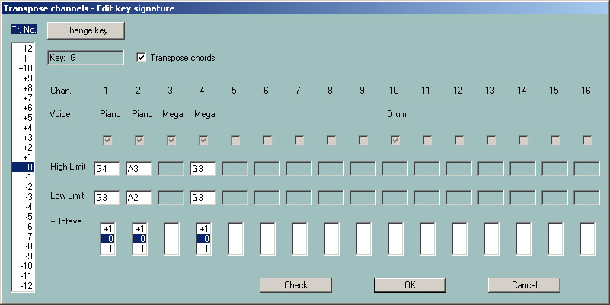
The list box on the left is used to specify the transpose numbers, i.e. the number of halftone steps of the transposition. Positive numbers generate higher and negative numbers lower notes. The number 0 will not transpose.

For MIDI files that have exact one key signature event, the actual key of the destination is displayed. With these MIDI files it is possible to transpose to a preferred key.

On the right side, we see line of boxes, one for each MIDI channel 1 – 16. A channel without any note are recognized by a grey mute box. These channels cannot be edited. In the second line the simplified names of the instruments (voices, patches) are protocolled. All Mega Voices get the name "Mega" and all Articulation Voices get the name "SArt". The voice of a channel where all notes have velocities less than 5 get the short name "VH". These channels often contain notes for Vocal Harmony (Vocoder) or special melody notes to be used in the Score display.

Mega voices can also be transposed: Only those note values are transposed which do not produce effect sounds. In the example, channel 4 causes effect sounds. For channels that do not contain any notes, the voicename is missing. It is not possible do transpose percussion channels (Drum and SFX) and special Megavoice channels that only contain effect notes - in the example channel 3 and channel 10.

The next boxes “High Limit” and “Low Limit” show the names of the uppermost and lowest note for each channel. This will be missed for percussion channels (drums) and megavoice-channels without any melody-note..

High and low limit will be adapted if the transpose number is changed.

The denotation of notes: The first character is the note itself, sometimes followed by “#” or “b”. The numbers at the end are octave numbers. C0 is the lowest key of the PSR-9000, C-2 is the lowest note allowed. Tuning events of the MIDI file have no influence on the limit boxes.

It is allowed to change the notes in the high and low limit boxes. New values can be checked with the button “Check”, bad notes are replaced. The boxes are checked with OK also. A click at transpose number 0 will initialize the limit boxes.

With the evaluation of transposing, the new note values are checked with the limits. If a value gets out of the limits, the note is transposed one octave higher or lower, otherwise the new value is accepted. With this method the melody of a channel is often changed, it should be used with subordinate channels only like bass or pads.

Using the “+Octave” boxes the melody of the channel notes remains unchanged. Here all the notes of a channel are decreased (-1) or increased (+1) by one octave. This method prevents the creation of sounds that are too low or too high.

It is possible to transpose Mega Voices also: The channel will be transposed only for note values that produce no effect sounds.

Transposing is performed with “OK” button and cancelled with the “Cancel” button.

Key Signature

Button "Change key"

With the button "Change key" it is possible to define a new key signature. PSRUTI tries, to find out the best key signature from the final notes of the file and diplays it. This proposal can be changed. If accepted, the MIDI file then gets the new key. PSRUTI suggests no key if there are no suitable notes or if the MIDI file has more than one key signature events in front of it.

6. Edit Tempo

Button "Tempo"

This function is used to change the tempo of a MIDI file. The displayed original value is the highest tempo used in the file. Changes for other values are computed by percentage.

It is possible to change the tempo by selecting a new value for the highest tempo or by percentage.
Tempo can be inserted as integer value like 120 or as decimal fraction like 81.22

7. Edit Volume

Controller 7: Main Volume

Button "Controller/Effects" - "Controller" - "7:Main Volume"

The change will be performed with a single MIDI channel or for the complete song. In the first case a new value between 0 and 127 must be entered, in the second case a percentage is needed.

Detailed informations are given in chapter "Controller".

Master Volume

Button "Volume" - "Master Volume"

This function allows to insert or change the Master Volume SysEx. In contrast to the controller 7 "Main Volume" here only one SysEx event changes the volume of all notes of the MIDI file. If this SysEx is not used with the file, the original volume is not changed, if a SysEx with the value 127 is inserted. Then we only can reduce the volume. If some Master Volume SysEx are already used at different times, the values will be changed proportionally.

The function can be applied for single files and as batch job for all files of a folder. Do not load a MIDI file before, if batch is wanted. Activate "Master Volume" and select a source and then a destination folder. PSRUTI changes all source files and saves the new files with the original filename into the destination.

Change Volume by Velocity

Button "Velocity Compressor"

Changing the velocity of all notes of a Midi channel influence the volume but also the character of the sound. Detailed informations are given in the chapter "Velocity Compressor".

8. Revoicing

Button "Revoicing"

This function (shortcut "R" or "r") is used to change the voices associated with MIDI channels. Revoicing of Mega Voices to normal voices is allowed: In this case PSRUTI deletes implicitely the critical notes that generate the Mega effects.

There are three different methods implemented: "Standard Revoicing", "Voicefile Revoicing" and "Revoicing from Revoicefile". Using "Standard Revoicing" or "Voicefile Revoicing" PSRUTI will edit only the first voice definition of each channel: It is only possible to change voice events before and inside the note area with Revoicing from Revoicefile".

Standard Revoicing

Button "Revoicing" - "Standard Revoicing"

All bank controller events and program change events are changed upto the first note of the channel. It has no impact on later voice changes. Effects, associated with the selected channel, remain unchanged. The sound of new voices can be tested.

If we have found an instrument definition file used with the sequencer Cakewalk / Sonar that supports our keyboard or synthesizer, we are able to select the new voices by a voice browser or by bank- and voicenames. Without this file, we have to select the voices by bank- and voicenumbers only.

The files yamaha_kbs.ins and tyros_kbds.ins on my homepage (www.heikoplate.de, Downloads, CW Insfiles) supports the keyboards PSR-8000, PSR-9000, 9000Pro, Tyros, Tyros 2, Tyros 3, Tyros 4, Tyros 5, PSR-S700 and PSR-S900. Instrument Definitions for some other keyboards can be found in the internet. Most of these are freeware.

With the button "Preferences" - "Instrument Definition" we load the suited instrument definition file and the appropriate instrument definition for the special keyboard model. Using the instrument definition we are able to select voices by its names and not by numbers. The selected instrument definition will be used as default with later starts of PSRUTI. It is also possible here to remove an already selected instrument definition from PSRUTI.

A click at the button "Standard Revoicing" opens the Revoicing window. For all channels with notes we read at Bank the actually used banknumber and at Voice the voicenumber. The boxes Bankname and Voicename are enabled only if we use an instrument definition. With the button "T" we can test the new voice: A short note sequence of the selected voice is played.

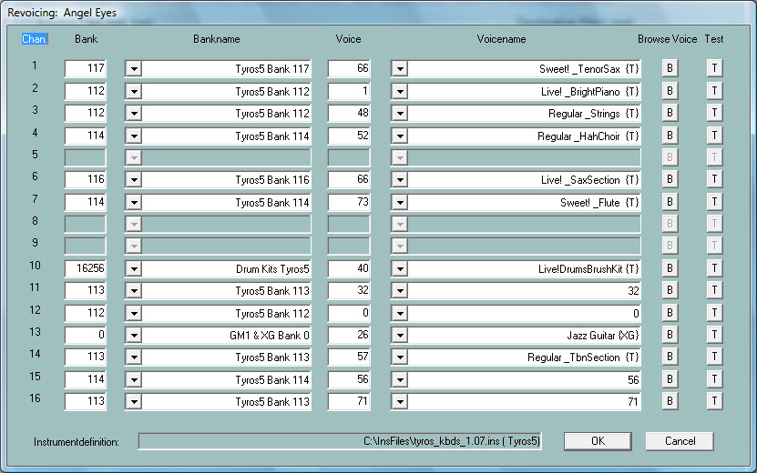

Selecting a voice with the voice browser

Only possible with a suitable instrument definition installed. The button (B) on the right side of the channel line opens the browser window.

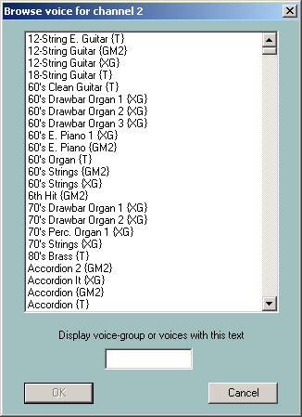

A long sorted list of all available voicenames is displayed. It is recommended to shorten the list with a search string, for example "Sax".
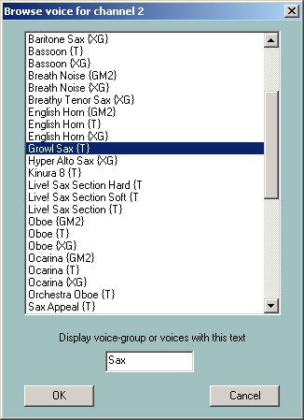

The list is now reduced to all voicenames that include the string Sax (or sax) or when there exist hided group strings as in the ins file tyros_kbds.ins. With a click at a voicename and OK, here GrowlSax{T}, this voice is assigned to the channel.

Selecting a voice by bank- and voicenames

Only possible with a suitable instrument definition. As before we get the following Revoicing Window:

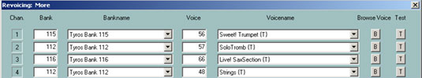

The voice can be changed by selecting a bank and a voicename. We are able to select the voice by numbers also.

Selecting a voice by bank- and voicenumber

A banknumber is defined by the formula "banknumber = 128*MSB+LSB" with the bank select values MSB and LSB of the voice list of the keyboard manuals (datalist).

With this definition we get for the standard panel voicebank MSB/LSB = 0/112 the banknumber 112, for the Mega Voice bank 1 of the Tyros MSB/LSB = 8/0 the banknumber 128*8+0 = 1024 and for the Drumkit bank MSB/LSB = 127/0 = 128*127+0 = 16256.

The voicenumbers (sometimes called MIDI program numbers or patch numbers) here start with 0 and not with 1 as in some other sequencers or in some keyboard datalists. Look at the datalist of the keyboard! If the number starts with 1 there, reduce it by 1 to get a correct PSRUTI number. We change a voice by filling the edit areas of Bank and Voice with the new numbers.

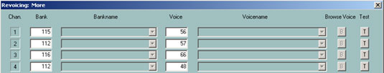

Voicefile Revoicing

Button "Revoicing" - "Voicefile Revoicing"

With this method not only the voicebank and the voicenumber are changed, but the voices will get some soundeffects too that are associated with the voice. We will get these effects only when playing or recording live with the keyboard. The effects are not inserted if we revoice with the Song Creator of the keyboard or with a sequencer.

PSRUTI gets its information about the effects from "Voicefiles" that are created by the keyboard with a voice copy. Because User Voices have the same structure as Voicefiles, we also can revoice with these files and therefore insert the user defined effects into MIDI files.

Conclusion: "Voicefile Revoicing" is not practicable if the keyboard does not allow to copy voices.

"Voicefile Revoicing" needs the copy of all keyboard preset voices in a PC folder. With the Tyros I will explain now how we can get such voice library for Tyros. The method for other keyboards is similar.

1. At the keyboard select any voice group, for example "Piano", and press "Up" then.
2. We can copy the voicefiles either on a floppy disk or onto the hard disk. If we prefer the hard disk, switch to "HD1" and create a new folder "TyrosVoices". Switch back to "Preset".
3. In the display the names of all voice groups are listed. Press "Copy", then "All" and then "OK".
4. Switch from "Preset" to "FD" or "HD1". With "HD1" select the folder "TyrosVoices". The display is empty now.
5. The copying process is started by pressing "Paste". The procedure will need nearly 15 minutes.
6. We now have to transport the voicefiles onto the PC. It is a simple procedure with the Music Finder USB connection but also easy with the floppy disk or a memory stick with other keyboard models. Create a PC folder "Tyros Voices" before. Now we can start the "Voicefile Revoicing" with PSRUTI. For example we will get the window:

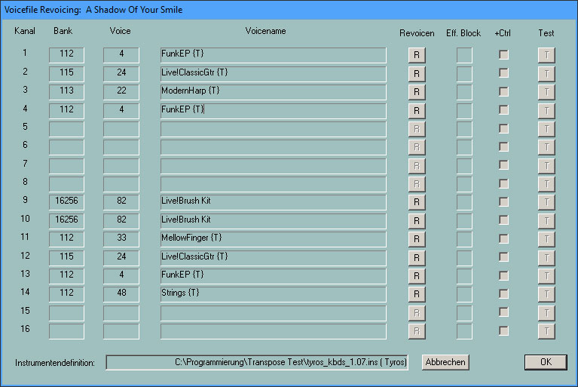

As with the method "Standard Revoicing" the voicenames are displayed only if we have loaded a suited instrument definition.
For revoicing, we have to push one of the buttons "R" and another window appears:

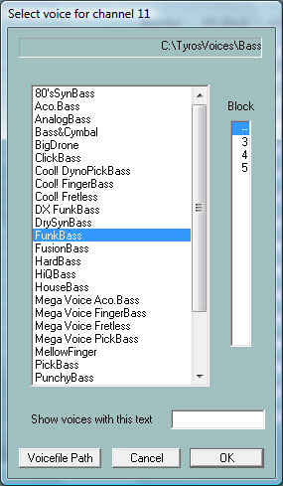

After selecting the voicefile path "TyrosVoices/Bass" all Preset Voices of "Bass" of the keyboard are listed. While PSRUTI derives the voicenames from the filenames, some names differ slightly from the original names. Now we have to select a voice and perhaps a blocknumber too.

About Effect Blocks and Blocknumbers

With YAMAHA keyboards so-called effect blocks can be used with voices. All voicefiles include voice specific Insertion effects that can be activated. Each of these effects needs its own effect block that is associated with a "Digital Signal Processor" (DSP) of the keyboard. There are not enough DSP's that each channel can get one: With Tyros we have five DSP's that we can use. In the MIDI file a DSP is adressed by an effect block number. If we have 5 DSP's, we only can use the numbers from 1 to 5. I recommend using an effect block for important melody voices only. There is no significant loss of quality when revoicing without an effect block.

The number of effect blocks is by default set to 5. This is not correct only for some keyboard models - look at the datalist of your keyboard. With the button "Preferences" - "More Preferences" we can set the number to another value. Here we also can define the effect block used for Vocal Harmony (Mic). For many PSRUTI functions it is important, to control and select the correct values.

The row "+Ctrl"

The voicefile defines itself some controller events like 91: Reverb Send Level or 71: Harmonic Content. With a hook at "+Ctrl" the original settings of the controllers are changed by the controllers of the voicefile; without hook the original controller settings remain. There is no recommendation that method may be better.

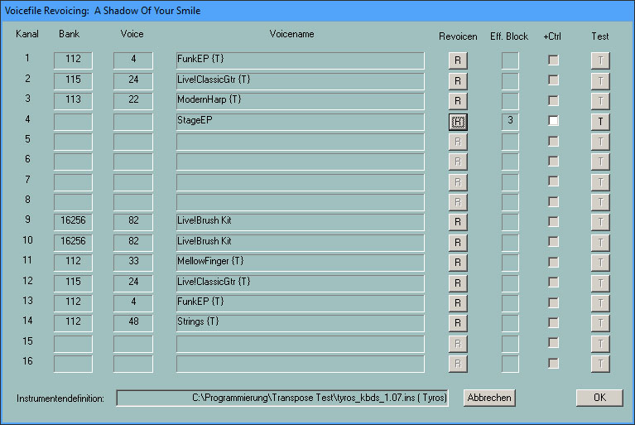

Here we have wanted to revoice channel 4 with notes by voicefiles to StageEP. O. We have spent an effect block for the channel 4. With the Button "T" we can test the new voice: A short note sequence of the selected voice is played. At this time the revoicing has not been started: It will be performed by pressing "OK".

Notes

If the original MIDI file has no explicite assignments of the system effect Reverb, the reverb type Hall 3 is set. The user has to select the intensity of this effect with the Controller 91: Reverb Send Level.

If the original MIDI file has no explicite assignments of the system effect Chorus, the chorus type Chorus 3 is set .The user has to select the intensity of this effect with the Controller 93: Chorus Send Level.

If the original MIDI file does not use a system effect Variation, a standard system variation effect will be inserted. The user has to define the intensity of this effect with the Controller 94: Variation Send Level. While these effects are not obstrusive, good values are 60. Listen to the sound. If you see that some channels have values greater than zero, it is not recommended to raise the values for other channels, because there may exist a special variation block in the file.

If a block number is set, we also get some DSP Insertion SysEx. The intensity of insertion effects are set with a SysEx Dry/Wet.

We can check and change the effect controller and Dry/Wet. Look at Controller/Effects – Effects.

Revoicing with a Revoicefile template

Button "Revoicing" - "Revoicing from Revoicefile"

With "Revoicing from Revoicefile" special voices of the whole MIDI file are changed. The user has to create a template text file, where the old and new voices are specified.

The structure of a short Revoicefile template (example):
==========================================
Revoicefile for two pianos
[start revoicelist]
#000-000-000 : #000-112-003 ; Aco Grand Piano : Honky Tonk
#000-000-001 : #000-113-002 ; Bright Aco Piano : CP80
[end list]
===================================

The voice specifications start after [start revoicelist] and end with [end list]. Text outside of these brackets are comments; also text behind the colon ';'.
A voice is identified by its values MSB, LSB and voice#. PSRUTI uses the denotation of the keyboards: "#<MSB>-<LSB>-<voice#>". On the left side of ':' we have the voice, that must be changed and on the right side the new voice. In the example all "Aco Grand Piano" Voices will be exchanged by "Honky Tonk" and all "Bright Aco Piano" by "CP80". Voice effects are not influenced.

Attention: PSRUTI counts voice numbers from 0 and not from 1. If the voicelist in the datalist counts from 1, the voice numbers must be reduced by 1.

"Revoicefile Revoicing" can be applied for single files and as batch job for all files of a folder. Do not load a MIDI file before, if batch is wanted. Activate the function and select a Revoicefile, a source and then a destination folder. PSRUTI revoices all source files and saves the new files with the original filename into the destination.

Voicebank Calculator

With the values of MSB and LSB wet get the voicebank number and reverse. The calulator may help to revoice if there is no instrument definition available.

9. Chords and Lyrics

Compute Chords

Button "Compute Chords"

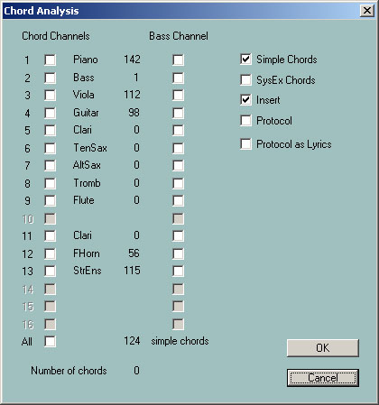

PSRUTI analyses the harmonies of the song by inspecting the notes of one or more channels separately or of all channels, creates a protocol file ("Protocol", look at "Import/Export Chords/Lyrics") or converts the sequence of harmonies to chord events and inserts these.

With chords, special events are inserted that allow to open the lyric display of the keyboards.

The new file will get some XF meta events or YAMAHA chord SysEx. With meta events, the file should not be edited by sequencer software that is not adapted for XF MIDI files. Such software often deletes the XF meta events but chord SysEx are not deleted by the sequencers. This problem can be solved with the function "Chords/Lyrics Import/Export": Export chords and lyrics before applying sequencers and import the chords and lyrics afterwards.

The visualisation of chords is supported with keyboards that are qualified for the YAMAHA MIDI file extension XF. At this time it is not possible to use keyboards from other manufacturers. Playing with PSRUTI, the chords are also displayed.

PSRUTI performs a harmony analysis for one or more selected channels that are tagged with voice names. Suited channels often are those with polyphone pads or guitar accompaniments. With the selection of a bass channel with bass notes at beats, bass chords chords, like C/A, are built. Sometimes we get more and better chords if we add a bass voice to the selection, that is not used as bass channel. If there are no channels to get good results, we will get no or bad chords. Often we get this situation with pure piano solo or with complex jazz harmonies. PSRUTI will not recognise chords from mono or dual played channels only.

If we select "all", the notes of all channels are analyzed simultaneously. With this method we often get a too large number of chords. If this happens, it may be suitable to apply the function "Quantisize Chords" or edit the chords with the "Chord Lyric Editor" (button Editor) afterwards.

The resulting chords are often very complex to be played with the keyboard. As default, the box “Simple Chords” is activated. Then PSRUTI will create simplified chords.

Quantize Chords

Button "Quantize Chords"

With the function "Compute Chords" we sometimes do not get the best time positions of the chords, because often the harmonies of the files cannot be found at the first beat of the measures. Using the function "Quantising Chords" we are able to improve the chord positions.

If we apply the function "Compute chords" using "all", we sometimes get a large number of chords. With "Quantize Chords" we get often a reduced number of chords. We are able to quantize in the following ways:

1. At the first beat of each measure
2. At the odd beats of each measure (1,3,..)
3. At each beat.

Normalize Chords

Button "Extras"(Shortcut E or e) - "Normalize Chords"

Recording MIDI files with style accompaniment at the keyboards insert sometimes strange chord events like Am/Am or G/F1+8. PSRUTI exchanges these with Am or G/F.

About Linefeeds and Newpages

Linefeeds and Newpages are special lyrics.

Linefeeds are used to start the following lyrics in a new line. PSRUTI denotes linefeed with the character „/“ but uses intern the character hex 0d.

Newpages produce page breaks. The lyric window will be cleared and the following lyric starts with the first line. PSRUTI denotes newpage with the character „<“ but uses intern the character hex 0a. Many keyboard models and also PSRUTI Play and Print do not perform newpages and uses linefeeds alternatively.
Linefeeds and newpages must be separated in single lyric events that are posited between away from song text lyrics.

Protocol Lyrics with Chords

Button "Print"

If there are lyrics and or chords in the MIDI file, it is possible to write both in a text file that can be printed immediately. The layout is similar with the structure of the Play Karaoke window. The text file can be formatted using text systems like Microsoft Word. To get the chords at the correct positions above the lyric lines, it is required to use a non proportional font like Courier or Lucida Console.

The function "Print" can be applied for single files and as batch job for all files of a folder. Do not load a MIDI file before, if batch is wanted. Activate "Print" and select a source and then a destination folder. PSRUTI prints all source files and saves the new files with the original filename as textfiles into the destination. Chord Lyric Editor

The Chord Lyric Editor

Key "Editor"

The Chord Lyric Editor allows you to clearly edit, delete and insert chords, lyrics, lyrics line changes "/" and page changes "<". Lyrics can be transferred to the MIDI file by means of a lyrics file created by the user.

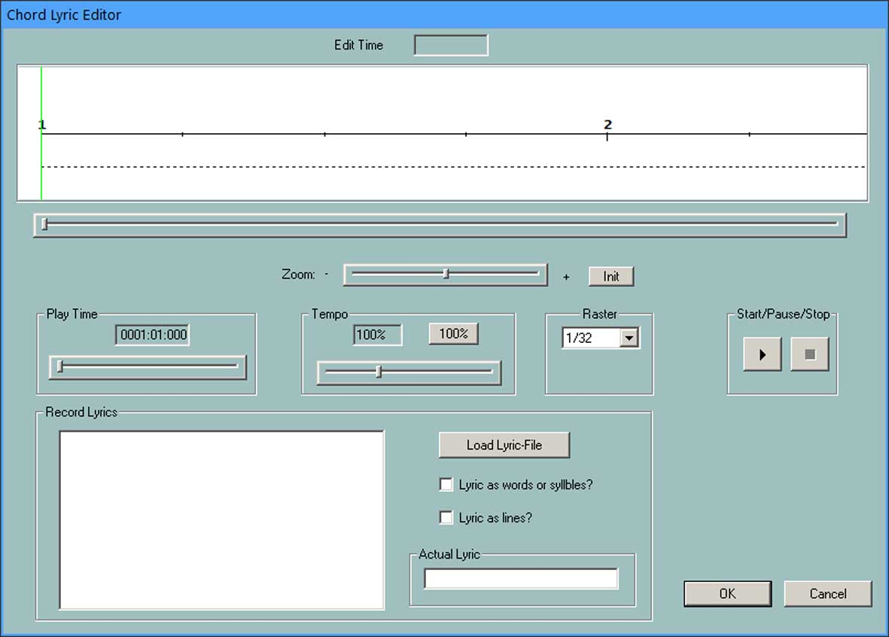

In the upper white highlighted editor area of the window a temporal section of the MIDI file is displayed. The number markings on the black song line are the bar numbers. Above them, the chords stored in the MIDI file are displayed in red. Below the song line the lyrics syllables are displayed in blue. Line and page changes, as far as they are not part of the lyrics themselves, appear below the lyrics.

The displayed section of the MIDI file can be moved with the scroll bar directly below the editor area or by turning the mouse wheel.

The zoom bar is used to change the size of the section. This is especially useful if lyric syllables in the file follow each other closely.

Moving events

By clicking with the left mouse button on a chord, lyrics syllable, line or page change and then dragging the mouse cursor while holding down the mouse button, the position of the event changes.
While moving, the reached time position is displayed at "Edit Time" as bar:beat:tick. With Grid, you can achieve that all events are placed on fixed note positions (1/4, 1/8, 1/16, 1/32) when moving in the bar. With "---" any time position is allowed.

Changing and deleting events

By clicking with the right mouse button on a chord, lyrics syllable, line break or new page a new window opens.
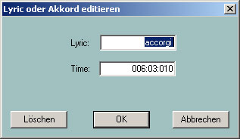
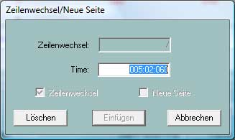
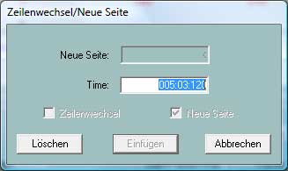

The lyrics or chord and the position of the event can be changed in the corresponding fields. When using chord text, make sure that the spelling is correct; see section "Reading in and out chords and lyrics". The input of bass note chords, e.g. G/F#, is allowed. Press the "Delete" key to remove the selected event. Line breaks and new pages can only be deleted here.

Inserting events

By clicking with the right mouse button on a position not occupied by an event, a chord, a lyrics syllable, a line break or a page break can be entered. The position of the mouse cursor is used to decide which type of event is to be entered.

Note: Page changes are not interpreted by all Yamaha keyboards. Also Play under PSRUTI does not consider page changes.

Control by playing the MIDI file

With the Start (black triangle) and Stop (black square) buttons, the MIDI file can be played at any time for control purposes. The playback position (play time) and the playback tempo can be set with the two scroll bars. During playback, pressing the pause button (two vertical lines) stops the playback. In this state, the events can be edited and the section in the editor window can also be changed.

Start and pause is also effected by pressing the space bar.

All changes made are only accepted by pressing the OK key.

Recording of lyrics

This function is performed in the Record Lyrics section. It allows the transfer of song lyrics stored in text files to the MIDI file. The lyrics are stored as lines, words or syllables.

The structure of the lyric files (examples)

======================
Down in the lowlands
Folk song

[start lyriclist]
Down in the lower lands,
That is a fine thing!
Down in the lower lands,
That is a fine thing!
Sloes in the upper lands,
Grapes in the lower lands.
Down in the lower lands,
That's where I want to be!
[end list]
======================

The form of this lyric file allows the lyrics to be stored word by word or line by line.

======================
Down in the lowlands
Folk song

[start lyriclist]
Down in the low-er lands,
That is a fine thing!
Down in the low-er lands,
That is a fine thing!
Sloes in the up-per lands,
Grapes in the low-er lands.
Down in the low-er lands,
That's where I want to be!
[end list]
======================

This form of the lyric file allows the lyrics to be stored by syllable.

The lyrics are read in from the area between [start lyriclist] and [end list]. The text outside is comment.

When playing on the keyboard and with the PSRUTI function Play, line changes of the lyric file lead to line breaks. Words in the lyric file are separated by spaces.

How does one proceed when recording lyrics?

The Midi file to be edited had already been loaded before. After loading the lyric file, by checking "Lyrics as words or syllables" or "Lyrics as lines" the lyrics are transferred line by line from the lyric file into the left window and at the same time the display of the lyrics for MIDI file as well as during later playback is prepared.

Inserting the lyrics into the Midi file:

By simultaneously pressing the Ctrl key and the left mouse button in the lyric area of the upper editor area (cursor below the horizontal time line), the current lyric appears in the input window (bottom right), the corresponding time position (bar:beat:tick) is displayed at the top. Without releasing the mouse button, the position can still be changed by moving the cursor. The lyric is only accepted and displayed in the upper window when you release the mouse button. The position can be moved later with the left mouse button (without Ctrl!).

With each "Ctrl+Click" on suitable positions in the Lyric section the lyrics are inserted one after the other.

To determine the desired positions of the lyrics, the midifile is played back at a low tempo (about 10%). The display of the playback window should be zoomed appropriately. The playback can be interrupted at any time to move wrongly positioned lyrics.

When inserting lyrics with the Lyrics Editor, the line breaks "/" are contained in the last lyrics of the lines. It is recommended to separate these line breaks from the actual lyrics afterwards using the PSRUTI function "Change line break". This is especially useful when storing the lyrics line by line. Unfavorable positions of the lyrics and line breaks can still be corrected afterwards with the Edtior.

Shift Linefeeds and Newpages

Button "Linefeed"

In the songtext (Lyrics) linefeeds and newpages are needed to get a good structured text in the keyboard display. At most keyboards it is recommended to extract linefeeds and newpages from the visable text in single events and to provide a distance for about 30 ticks from the preceding text.

"Shift by"
Linefeeds and newpages are posited the given number of ticks after the last lyric, but not more than the half distance to the next lyric.

"Shift at"
Linefeeds and newpages are shifted to a fixed tick position between two beats if possible.

Determine Lyrics Offset

With the Cuepoint meta event "$Lyrc:1:<offset>:L1" it is possible to determine how far ahead of the performance timing of the MIDI file the lyrics are displayed. To use this function we have to allow inserting the Cuepoints - look at "Preferences" - "Special Preferences". The number counts the ticks: 480 results a length of a quarter note. The default is 0. Playing with PSRUTI, the offset is ignored.

Define Fill Lyrics

Button "Preferences" - "Fill Lyrics"

Fill Lyrics are short character sequences that will be inserted at beat positions outside of the songtext lyrics.
Four types of Fill Lyrics are implemented: measure lyrics on measures (beat number 1), end lyrics on the last beat of measures, beat lyrics on other beats and linefeed lyrics to be inserted a number of ticks after the last beat of each measure. The defaults are

measure lyric: One point – two hyphens – one blank
beat lyric: Three hyphens – one blank
end lyric: Three hyphens
linefeed lyric: 30 ticks after the last beat of a measure

"Define Fill Lyrics" allows to change the design of the character sequences. The notation starts and ends by ".

The function inserts linefeeds some ticks after the last beat in all measures. The number of ticks is selected by setting a hook at "linefeed lyric" and by specifying a number. A tick number from 30 upto 120 is good in most cases.

If beat lyric and end lyric are set to "" both, we get Fill Lyrics at beat 1 only.

Attention: Some characters can not be displayed at the keyboard display.

It is possible to define three independant sets of measure lyrics, beat lyrics, end lyrics and linefeed lyrics that are saved and restored if wanted. To define the additional sets, we have to set a hook at User 1, User 2 or User 3.

The selection will be applied in this session and with all later starts of PSRUTI. The defaults are activated with the button "Default".

Insert Fill Lyrics

Button "Insert Fill Lyrics"

The short character sequences of Fill Lyrics are positioned at the beats and help the musician at the keyboard, to find the right moment for a new chord or the next syllable of the songtext..

In a MIDI file without any lyrics the Fill Lyrics are inserted beginning with measure 2 at each beat of the song. For songs with lyrics different methods can be selected:

Not at lyrics:
Fill Lyrics are inserted at all beats where no other lyrics exist.

Not in beats with lyrics
Fill Lyrics are inserted only if there are no lyrics between the actual and the next beat.

Not in measures with lyrics
The best method: Fill Lyrics are inserted if there are no lyrics in the surrounded measure.

The function can be applied for single files and as batch job for all files of a folder. Do not load a MIDI file before, if batch is wanted. Activate the function and select a source folder and then a destination folder. PSRUTI inserts fill lyrics into all source files and saves the new files with the original filenames into the destination.

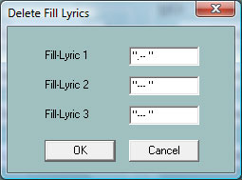
Delete Fill Lyrics

Fill Lyrics are constant character strings that are posited at beats.
At the three edit boxes it is possible to specify different strings of
Fill Lyrics, that are deleted with OK.
It is aquired to enclose the strings with double apostrophes as shown in de picture. Examples: "**" or "+ + + ". Double specifications are innocent..

Linefeeds that are connected with Fill-Lyric will also be deleted.

Quantize Lyrics

Button "Quantize Lyrics"

The lyrics of the MIDI file are shifted at positions of nearest quarter, eighth. eighth triole or sixteenth notes. It is recommended trying first with sixteenth notes to get the best result. With a hook at "Position at chords" lyrics with a short distance to the next chord are shifted at chord position.

Adjust Lyrics at Notes

Button "Lyrics at Notes"

This function allows to import the lyric syllables from a text file and attach each syllable or single word at the notes of a suited MIDI channel. The notes must be exactly those that are to be sung, the number of notes therefore is equal with the number of syllables. Otherwise we get a bad synchronisized song text.

The text file is structured as decribed in the chapter "Play"- "The structure of a lyric file".

Chords/Lyrics Import/Export

Button "Chords/Lyrics Import/Export"

This function works with chords, lyrics or both together.

Export

If the MIDI file contains chords or lyric events or both, it is possible to read these events and create a protocol into a text file. If wanted, the specified events are removed from the source. The protocol file can be used to insert the events of this text file back into the MIDI file, for example after editing. Look next: "Import".

Using this function we can save the XF chords of a MIDI file, edit the source with general sequencer software and insert the chords back into the MIDI file. It is not allowed, to add or delete measures with the sequencer! Do not apply the function "Optimize XG" between Export and Import because the positions of the notes may be changed. Sometimes we may want to get chord names as lyrics and not as XF events. With a MIDI-file with XF chords and no lyrics or linefeed lyric we have to perform the following steps:

1. By selecting "Chords as Lyrics" and "Delete" export the chords into a textfile.
2. Import this file.
3. After this we may insert Fill Lyrics.

Import

The lyrics and/or chords of a textfile that have been created with "Compute Chords" or "Export" are read and will be inserted into the MIDI file as lyrics and chord events (XG meta events or chord SysEx) . The MIDI file must be free of any chord events before inserting any chords.

The structure of the textfile

The textfile has a special structure that differs from the lyric files used with "Lyrics at Notes" and "Play Record".

An example with lyrics , chords linefeeds and newpage.

======================
PSRUTI Chord and Lyric Protocol
file : C:\tmp\song.mid

[start chords+lyrics]
Lyr 002:04:000 "I've "
Lyr 002:04:160 "paid "
Lyr 002:04:320 "my "
Chd 003:01:000 Gm
Lyr 003:01:000 "dues, "
Lyr 003:02:478 "/"
Chd 003:03:000 Dm
Lyr 003:03:000 " --- "
Lyr 003:03:478 "<"
Lyr 003:04:000 "time "
Lyr 003:04:160 "af"
Lyr 003:04:320 "ter "
Chd 004:01:000 Gm
Lyr 004:01:000 "time. "
Lyr 004:02:478 "/"
[end list]
======================

PSRUTI interpretes the lines between [start chords+lyrics] and [end list] only. The texts before and behind are comments. Each relevant line consists of a lyric syllable (Lyr) or a chord specification (Chd). Before and behind the time position mmm:bbb:ttt (measure:beat:tick) are blanks or tabs as delimiters. The number of digits are free, starting zeros are allowed, but is is recommended to use the format above. Behind the time position we find the specification of the lyric syllable (bracketed with ") or the chord denotation without brackets.
Different lyric words are separated with blanks; two syllables of a word have no blank inside. Linefeeds can be specified as separate events "/" or added at the beginning or end of a syllable like "/Love". In this case PSRUTI will separate the linefeed by itself.

No brackets " are used with chord denotations. The first one or two characters of chords are the key notes.

PSRUTI recognizes the chord roots:

C
C#
Db
D
D#
Eb
E
F
F#
Gb
G
G#
Ab
A
A#
Bb
B

The type of the chord follows immediately. Allowed are only notations as:

6
M7
M7(#11)
9
M7(9)
6(9)
aug
m
m6
m7
m7b5
m(9)
m7(9)
m7_11
mM7
mM7_9
dim
dim7
7
7sus4
7b5
7(9)
7(#11)
7(13)
7(b9)
7(b13)
7(#9)
M7aug
7aug
1+8
1+5
sus4
1+2+5
cc
M7b5
(b5)
mM7b5

The chord notations of the sequencer XGWorks can be used also.

After "Compute Chords", it is recommended to check the new chords. This can be done with the function Chord Lyric Editor. Another method is to create a protocol of the lyrics and chords with delete, to edit the file with a text editor and to insert the chords and lyrics into the MIDI file afterwards.

Record Lyrics and Chords

It is possible to record Lyrics and Chords while the MIDI file is playing. Detailed informations are given in the chapter "Play MIDI files; record Lyrics and Chords".

10. Play MIDI files; record Lyrics and Chords

MIDI: Select the Soundgenerator

Button "Preferences" - "MIDI"

Shortcut "M" or "m". Independent from a global selection of the MIDI port with Windows, we can choose a special port for the play function of PSRUTI. It is recommended selecting a MIDI Out Port to generate the sound on the keyboard. A standard MIDI connection by MIDI cable is displayed often as MPU401. An USB MIDI connection contains the name USB.

The Karaoke Window "Play"

Button "Play"

The button Play (shortcut "P" or "p") opens a Karaoke window.

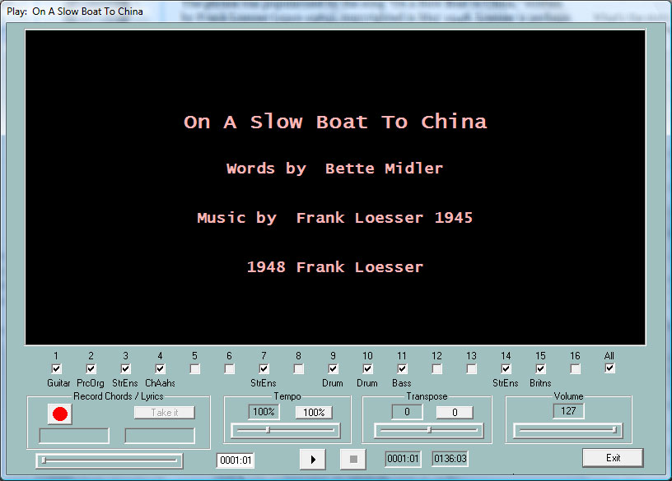

The black karaoke area displays the songtitle, the composer and if defined, the copyright string before the start of the song. Playing the song, the lyrics and chords are displayed here synchronously with the music, if the MIDI file was created with lyrics and/or chords.

Below the Karaoke area all MIDI channels are displayed. Channels without any notes are greyed. Hooks in the fields mean that the notes of the channel will be played. The channel is muted if a hook is removed. A channel is played solo if it is the only one with a hook. If the hook at "All" is removed or set , all channels are muted or activated.

Start/Pause/Stop and measure display

The left button with a black triangle is used for start, pause and continue after pause. The song is started with a click at the button. The triangle symbol then changes to two vertical lines. Another click will continue the song. The right button with the black square will finish the song. The space key also can be used to start, to pause and to continue the song. The key "E" or "e" finishes the song.

On the right side the actual and the last measures and beats are displayed.

Starting the play at an arbitrary timeposition

The left slider is used to posit, start or continue the play from an arbritrary timeposition. The positions are displayed and can also be also changed in the field right of the slider. By releasing the mouse button, the selected position is accepted. With a short click on the slider beam, the song restarts at the last position.

The areas Tempo and Transpose

The tempo of the play can be changed between 10% and 300% of the original tempo. It is possible to transpose the notes of the song while playing, but the chords are not transposed. It is not possible to transpose Midifiles with Mega Voices The selected tempo and the transposition will not be stored in the MIDI file. With clicks on a button, the original tempo or transposition will be adjusted.

The area Volume

In the state of playing the volume can be changed between 0 and 127. This is done by sending a Master Volume event with the chosen value. See chapter 7. The selected volume will not be stored in the MIDI file.

The left region: Record Chords and Lyrics

With the functions of this area it is possible to read chords or lyrics from prepared textfiles and to insert associated MIDI events into the MIDI file. This will be done in realtime with the play: The user has to press the enter key at the right moment. Therefore it is recommended to reduce the tempo before.

The structure of the textfiles for chords and lyrics displayed here differs from the files that are used with the function "Chords/Lyrics Import/Export".

The structure of a chord file

======================
Ich hew mol en Hamborger Veermaster sehn
Chords

[start chordlist]
C G7 C G7 C
C C7 F C
F C G7 C
[end list]
======================

PSRUTI skips all the text outside of the region [start chordlist] ... [end list]. The delimiter between two chords is a space or a linefeed. A linefeed will not result in a linefeed in the karaoke display.

The structure of a lyric file

======================
Ich hew mol en Hamborger Veermaster sehn
Lyrics

[start lyriclist]
Ick heff mol en
Ham-bor-ger Veer-mas-ter sehn,
To my hoo-da!
To my hoo-da!
De Mas-ten so scheef
As den Schip-per sien Been,
To my hoo da hoo da ho!
Blow boys blow,
for Ca-li-for-ni-o,
There is plen-ty of Gold
So I‘ve been told
On the banks of Sa-cra-men-to.
[end list]
======================

PSRUTI skips all the text outside of the region [start lyriclist] ... [end list].

The delimiter between two lyric-syllables is a hyphen, a space or a linefeed. The syllables of a word are separated by a hyphen '-' . A linefeed results in a linefeed in the karaoke display.

Each line of the next example is treated as a single lyric event. Here, the delimiter between two words is an underscore '_' that results in a space at the karaoke display.

======================
Ich hew mol en Hamborger Veermaster sehn
Lyrics

[start lyriclist]
Ick_heff_mol_en
Hamborger_Veermaster_sehn,
To_my_hooda!
To_my_hooda!
De_Masten_so_scheef
As_den_Schipper_sien_Been,
To_my_hoo_da_hoo_da_ho!
Blow_boys_blow,
for_Californio,
There_is_plenty_of_Gold
So_I‘ve_been_told
On_the_banks_of_Sacramento.
[end list]
======================

How do we perform the recording of chords and lyrics?

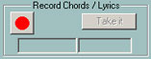

This first image shows the initial state of the record area. The button on the left, the record button, has a red color. A click opens a file dialog. Here we have to select either a textfile with chords or a textfile with the lyrics.

PSRUTI checks the selected file. If the file is correct, the record button changes its colour into yellow and the type of the file is shown. The image on the right below displays the first chord or the first lyric syllable.

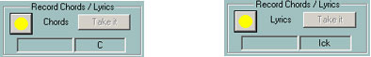

Now recording is prepared and it will be started at the moment, when the play is started. Then the record button changes its colour into green. With each push of the enter key, the next chord or lyric syllable on the right side is accepted. It is then shifted to the left side and the next item is displayed on the right.

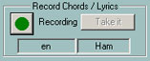

The record state is finished
when the end of the text file has arrived,
when the end of the MIDI file has arrived or
when the user clicks the stop button or enters "E" or "e".

The record button then changes its colour into yellow. It is possible to repeat recording again if needed.

PSRUTI inserts the events not until the user clicks at the "Take it" button. Because it often is difficult to press the enter key at the right moment, the user will be asked to quantisize the events. The record button changes its colour into red after this step.

The play of the MIDI file can be started now and the just inserted chords or lyrics are displayed in the karaoke area.

If the recording process was not successful, we can repeat all steps once more; it is not required to close and open the Play window .

11. Controller and Effects

The button Controller/Effects (Shortcut "C" or "c") opens the selection of the functions "Controller" and "Effects".

Controller

Button "Controller/Effects" - "Controller"

With this function, we are able to change the values of some controller events, for example the volume (Main Volume). Additional "Channel Aftertouch" events can be edited.

The changes are performed with single MIDI channels separately or for the complete song. In the first case a new value between 0 and 127 must be entered, in the second case a percentage is needed.

The procedure will be explained with the change of the volume "7: Main Volume".

With "Max. Value" the maximal value is displayed of all volume controller of all main volume events that are associated with the MIDI channel. If there is no event of this type, the default value is displayed.

If we find for example the value 100 and change it to 80, the function will change the max. value to 80. All other values (less or equal 100) of main volume events for this channel are changed proportionally, here by 20 percent. A main volume of 60 will get the new value of 60 minus 20% of 60 = 48 afterwards. This method conserves the dynamic of events, for example fade in and fade out.

With "Max. Value (all)" a percentage must be entered that works on all channels. To get higher values of 1/3, the percentage 133% is needed; to get the half, we must enter 50%. The result for all channels is displayed by pressing the button "Take it".

The same procedure works with all other events, specified in the edit box at the top.

With the change of the values of channel aftertouch, it is very easy to convert some MIDI files of the PSR 9000 or 9000Pro for newer keyboards such as the Tyros. Here the rate of aftertouch values that often are 127, can be reduced by selecting a percentage of 30 percent.

Effects

Button "Controller/Effects" - "Effects"

With this function we are able to check and change the channel specific intensity of the System and Insertion effects, that are defined in the MIDI file. In contrast to the function Controller only the area before the first notes will be considered.

This function will be profitable for example, if the user has inserted new XG effects into the file.This can be done with the SysEditor or with the PSRUTI function "Voicefile Revoicing" – look at "Import and export SysEx".

Reverb (MIDI event Controller 91)
Sets the intensity of the System Hall Effects.

Chorus (MIDI event Controller 93)
Sets the intensity of the System Chorus Effects.

Variation (MIDI event Controller 94)
Sets the intensity of the System Variation Effect, that must be defined in the MIDI file.

Insertion (SysEx Dry/Wet)
Sets the intensity (Dry/Wet) of a channel specific Insertion effect, that must be defined in the MIDI file. If there does not exist a Dry/Wet SysEx before, the keyboard will play the effect with a default intenseness. Changing the default "---" by a number, PSRUTI will insert an appropriate Dry/Wet SysEx.

12. Velocity Compressor

Button "Velocity Compressor"

If we record MIDI files with the keyboards, we often get notes with velocities with bad values: Some have low values, others are too high. Using the "Velocity Compressor" we can solve this problem in most cases.

For each channel separately, we can change the velocities as follows:

1. All notes are deleted if its velocity are lower than a fixed limit. For example: If most velocities lie between 60 and 90, notes below the velocity 20 can be deleted.

2. We are able to define a new velocity interval. PSRUTI shifts all velocities of the channel notes into this interval. The dynamic of the velocities remains.

Remember that a note with changed velocity not only will get another volume but also another sound. A note with low velocity is soft, with high velocity often sounds hard. I recommend reducing the maximal value 127 of velocities to 110 if we use MIDI files that are not XG in original.

13. Edit Drum- and SFX-Notes

This function allows to change or delete single drum instruments or SFX noises of drum/SFX channels.

Edit Drums/SFX (Dialog)
Button "Edit Drums/SFX" - "Drums/SFX (Dialog)"

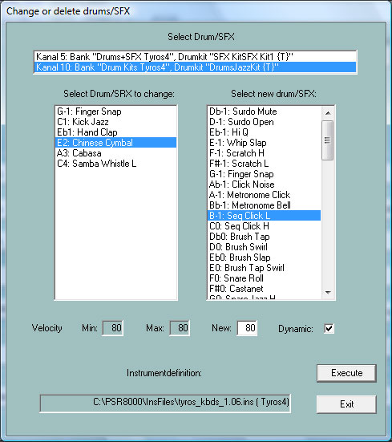

To get the names of the drums and SFX noises, it is recommended to use a suitable instrument definition – see chapter Revoicing - Standard Revoicing..
In the top edit line all drum/SFX channels of the file are listed. With a click at the channel, we see in the left field the drum/SFX notes that are used. On the right side all drum/SFX notes of the used kit appear. If we want to change a drum/SFX note, we have to click in the left original note and on the right at the desired new note. In the sample above we want to change all Snare Tight notes with Snare Roll. We also can change the velocities of the selected note, here 70. If we only want to change the velocity of a drum/SFX note, we have to select the same drum/SFX in both windows. If "Dynamic" is selected, the dynamic of the velocity is preserved. If not, all notes get the new velocity. With a click on a new note the associated drum instrument or SFX noise will be played. To delete a note, we select the note only on the left side.

Edit Drums/SFX with a Drumfile template

Button "Edit Drums/SFX" - "Drums/SFX (Drumfile)"

This function allows do change or delete some or all drum or SFX notes in MIDI Files with different drum/SFX channels by requirements of a template file. The user has to create a so called drumfile before with informations how to manipulate drums.

Drumfile examples

=================================================
Drumfile to change three drums (all drum channels, all drumkits)

[start drumlist]
C#-1 : D-1 ; Surdo Mute : Surdo Open
E0 : F0 ; Brush Tap Swirl : Snare Roll
C3 : C#3 ; Bongo H : Bongo L
[end list]
=================================================

=================================================
Drumfile to change three drums (only drum channel 9, all drumkits)

[start drumlist]
chan 9

C#-1 : D-1 ; Surdo Mute : Surdo Open
E0 : F0 ; Brush Tap Swirl : Snare Roll
C3 : C#3 ; Bongo H : Bongo L
[end list]
=================================================

=================================================
Drumfile

- Change drums with and without constraints of drumkits
- Delete drums with and without constraints of drumkits
- Double drum notes

[start drumlist]
; Potential constraint of a special channel.
; Insert for example the line: chan 9

#127-0-82 :: D-1 : Db-1 ; in Live!Brush Kit only: Change all D-1 to Db-1
#127-0-86 :: Eb-1 : G-1 ; in Live!Studio Kit only: Change all Eb-1 to G-1
C2 : G2 ; in all drumkits: Change all C2 to G2
#127-0-16 :: C : - ; in Rock Kit only: Delete all C
F4 : - ; in all drumkits: Delete all F4
C#1 : + C#1 ; in all drumkits: Double same drumnotes on same time positions
Db5 : + D5 ; in all drumkits: Double all Db5 und exchange the doubled notes by D5
#127-0-86 :: Db5 : + D5 ; in Live!Studio Kit only: Double all Db5 und exchange
; the doubled notes by D5
#127-0-82 :: C#1 : + C#1 ; in Live!Brush Kit only: Double same drumnotes
[end list]
=================================================

The drum/SFX specifications start after [start drumlist] and end with [end list]. Text outside of these brackets are comments; also text behind ';'.
Drums/SFX are identified by its note names. On the left side of ':' we have the note, that must be changed and on the right side the note. Channel (chan) and Kits (voice) may be joined.

The users have to get the correct note names for drums/SFX from the datalist manual of his keyboard.

Changing drums or SFX by drumfile can be applied for single files and as batch job for all files of a folder. Do not load a MIDI file before, if batch is wanted. Activate the function and select a drumfile, a source and then a destination folder. PSRUTI handles all source files and saves the new files with the original filenames into the destination.

14. Delete, copy and exchange Midi channels

Button "Edit channels"

This function manipulates all MIDI events that work on a single channel. Insertion effect SysEx that are associated with the channel are also considered.

"Delete channel" removes all events of the source channel.
"Exchange Channel" exchanges all events of one channel with another channel.
"Cut and paste channel" copies all events of the source to the destination. The original events of source and destination are deleted.
"Double channel" works in a similar way, but the events of the source are not deleted.

Note: If "Double channel" is selected and the channel is associated with insertion effects, PSRUTI does not copy the insertion effects to the new channel.

15. Import and export SysEx

Button: "Import/Export SysEx"

SysEx (System Exclusive Events) are used to generate special sound effects. The user must have some basic knowledges to program SysEx. It is recommended to get experience with Rainer Martin's program SysEditor, http://www.go4musik.de

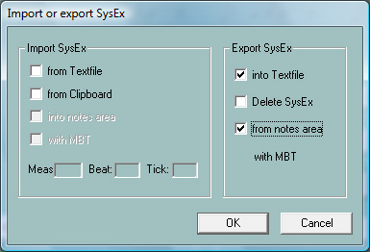

Export SysEx

This function reads all System Exclusive events of the MIDI file and creates a protocol in a textfile. Behind the hex strings of the SysExes the meanings (as known) are added as comments.
With "Preferences" - "XG Effectdefinition" we can load a so-called "SysEditor XG Effect Data File" (extension .4xg). This file includes model specific meanings of SysExes for some keyboards. Without this file we get the sense for Tyros effect Sysexes.

The SysEx are read alternatively from two areas if the MIDI file: The setup region before the notes and the note area. In the second case a hook must be set at "from notes area". If selected, the SysEx events are removed from the file afterwards. The SysEx protocol can be edited and imported back into the MIDI file; see next paragraph.

Against the selected area different protocols are created.

Example 1: SysEx Protocol of the region before the notes

=====================
PSRUTI SysEx-Protocol
File: C:\Songs\SysExDemo.mid

[start sysexlist]

F0 7E 7F 09 01 F7 ; Turn General Midi System On
F0 43 10 4C 00 00 7E 00 F7 ; (XG) XG System On
F0 43 10 4C 02 01 00 01 11 F7 ; (XG) Reverb Type Hall 3
F0 43 10 4C 02 01 20 42 10 F7 ; (XG) Chorus Type Chorus 3
F0 43 10 4C 02 01 40 4B 08 F7 ; (XG) Variation Type St Amp 3
F0 43 10 4C 02 01 46 00 2A F7 ; (XG) Variation LPF Cutoff 2,5kHz
F0 43 10 4C 02 01 48 00 26 F7 ; (XG) Variation Output Level 38
F0 43 10 4C 02 01 58 26 F7 ; (XG) Send Variation to Reverb 38
F0 43 10 4C 02 01 59 0C F7 ; (XG) Send Variation to Chorus 12
F0 43 10 4C 02 01 5A 01 F7 ; (XG) Variation Connection: System
F0 43 10 4C 03 00 00 01 11 F7 ; (XG) Insertion Type, Eff. Block 1, Hall 3
F0 43 10 4C 03 00 0B 2E F7 ; (XG) Insertion Eff. Block 1, Dry/Wet D18>W
F0 43 10 4C 03 00 0C 00 F7 ; (XG) Insertion Part, Eff. Block 1, Part 1
F0 43 10 4C 08 00 76 10 F7 ; (XG) Multi Part, Part 1 EQ BASS frequ. 118 [Hz]
F0 43 10 4C 08 00 77 2F F7 ; (XG) Multi Part, Part1 EQ TREBLE frequ. 10316[Hz]
F0 43 10 4C 08 00 20 00 F7 ; (XG) Multi Part, Part 1 MW LFO PMod Depth 0
F0 43 10 4C 08 00 22 18 F7 ; (XG) Multi Part, Part 1 MW LFO AMod Depth 24
F0 43 10 4C 0A 00 42 47 F7 ; (XG) Part 1 Offset Level Control CAT, data 71
F0 43 10 4C 08 00 04 00 F7 ; (XG) Multi Part, Part 1 Rcv Channel 1

[end list]
======================

Example 2: SysEx Protocol of the notes area

======================
PSRUTI SysEx-Protocol
File: C:\Songs\SysExDemo.mid

[start sysexlist mbt]

004:01:000 F0 43 10 4C 03 00 00 01 11 F7 ; (XG) Insertion Type, Eff. Block 1, Hall 3
004:01:005 F0 43 10 4C 03 00 0B 1E F7 ; (XG) Insertion Eff. Block 1, Dry/Wet D34>W
004:01:010 F0 43 10 4C 03 00 0C 00 F7 ; (XG) Insertion Part, Eff. Block 1, Part 1

[end list]
======================

Unlike Example 1 each sysex line of this protocol includes measure:beat:tick (MBT) positions.

Between [start sysexlist] resp. [start sysexlist mbt] and [end list] each line is a sysex string and comment behind a colon. The texts before [start sysexlist] resp. [start sysexlist mbt] and after [end list] are comments too.

The content of the protocol files may be edited but the global structure has to be respected strictly. Comments can be omitted.

PSRUTI protocols the DSP Numbers as effect blocks. With effect blocks the user has to check, if the associated DSP's are available on his keyboard.

Import SysEx
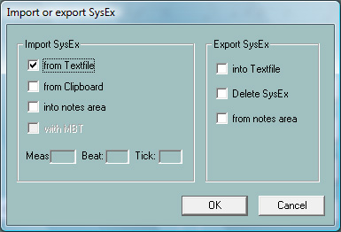

This function reads the lines of a SysEx protocol file, generates SysEx events and inserts these into the MIDI file.

PSRUTI inserts the SysEx alternatively into two areas of the MIDI file.

Import into the region before the notes.

Here "into the notes area is not selected. The SysEx will be inserted behind other possibly existing SysEx but before the first note. Only protocol files without MBT information or sysex sequences from the Clipboard are allowed.

The freeware Program SysEditor of Rainer Martin and Volker Zimmer, homepage http://www.go4musik.de/musikerseite.html , creates sequences of SysEx into the clipboard from user defined parameters that control the effects of voices and vocal harmony. If selected PSRUTI reads the SysEx-events from the Clipboard.

Import into the notes area

Set a hook at "into notes area". The sysex sequences are taken from a PSRUTI protocol file ore from the Clipboard.

Case 1: SysEx sequences from the Clipboard or from a protocolfile without MBT information.

The user has to select a position in Meas, Beat and Tick. The default is the position of the first note that is the lowest position. Beginning with the selected position the SysEx are inserted in distances of 5 ticks.

Case 2: SysEx sequences from a MBT protocolfile

The SysEx are inserted at the given positions.

16. Delete and insert Count In

Button "Count In"

Many MIDI files start with a "Count In" drum sequence. In most cases we have six notes that are positioned at beats (1,-,2,-,1,2,3,4).

With PSRUTI we are able to insert and to delete the Count In. By inserting Count In, we get two or if wanted one additional measure before the first melody note. The user can choose the drum and the number of velocity. In the case of deleting, all Count In notes are deleted and the associated measures also (if possible). PSRUTI considers drum notes at beats upto the first note, that is not posited nearby a beat or if it is a melody note belonging to the Count In.

The function can be applied for single files and as batch job for all files of a folder. Do not load a MIDI file before, if batch is wanted. Activate the function and select a source folder and then a destination folder. PSRUTI revoices all source files and saves the new files with the original filename into the destination.

17. Miscellaneous

Expression <-> Main Volume

Button "Volume" - "Expression <-> Main Volume"

For "Fade In" or "Fade Out" we find two methods in MIDI files: The usage of controller event 7 (Main Volume) or controller event 11 (Expression). I recommend to use Expression Fades. Remember that we don't get another sound character. Here it is possible to change the implementation of "Fade In" or "Fade Out".

The function can be applied for single files and as batch job for all files of a folder. Do not load a MIDI file before, if batch is wanted. Activate "Expression<->Main Volume" and select a source and then a destination folder. PSRUTI changes all source files and saves the new files with the original filename into the destination.

Songname, Componist, Lyricist, Copyright

Button "Extras" (Shortcut E or e) - "Songname..."

This function is used to insert, edit or delete the songname, the composer and the lyricist. These titles are displayed on the Lyric and Score Display of the keyboard.Copyright

Button "Extras" (Shortcut E or e) - "Copyright"

We are able to insert, to edit or to delete a copyright event in the MIDI file. The text may consist upto 250 characters in 10 lines, each line may have less 64 characters. The copyright is displayed in the copyright area in the Lyric Display of the keyboard. The edit field has the same dimension as the copyright area of the Tyros. PSRUTI shortens the copyright text in its own Play display.

Score

Score channel

Button "Extras" (Shortcut E or e) - "Score Channel"

Some keyboards, such as the Tyros, are able to display the notes, the lyrics and chords of the song in a Score display. Here we are able to select the MIDI channels with the suitable notes of the left and right hand site.

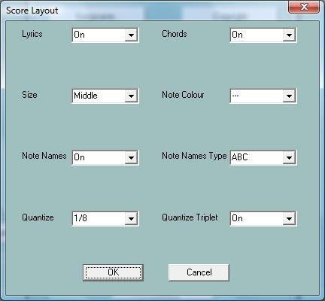
Score Layout

Button "Extras" (Shortcut E or e) - "Score" - "Score Layout"

With this function the appearance (layout) of the score
window are defined in the MIDI file by using certain Score SysEx
events (see Data List). With the entry of "---" the event in question will be not stored or is deleted. The effect corresponds to the
settings on the keyboard.

Hints:

"Note Names Type" is only effective if "Note Names" is
switched On and "Quantize Triplet" (triplet = triplet) is only
effective when a note value is set with "Quantize".

The function can be applied for single files and as batch job for all files of a folder. Do not load a MIDI file before, if batch is wanted. Activate "Score Layout", fix the layout parameter, select a source folder and then a destination folder. PSRUTI works on all source files and saves the new files with the original filename into the destination.

Optimize Score Notes

Button "Extras" (Shortcut E or e) - "Optimize Score Notes"

The notes of a normal melody channel often are not ideal to be displayed in the Score display. Therefore programmers of MIDI files use a special channel with optimized notes. The velocity here is set to 1 because the sound should be muted.

I recommend the following procedure.

1. Copy a suited melody channel at a free channel (Edit Channels)
2. Reduce the velocity here to 1 (Velocity Compressor)
3. Sometimes it is recommended to quantisize the start time of the notes
3. Apply this function "Optimize Score Notes"
4. Select the new score channel (Score Channel)

With this function each note is lengthened upto the following note but not longer than the selected value.

Vocal Harmony (Vocoder)

Button "Extras" (Shortcut E or e) - "Vocal Harmony"

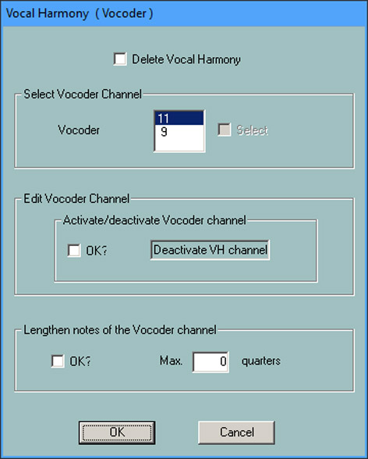
The function performs two different actions with the vocal harmony channel.

1. Deleting Vocal Harmony and selecting, activating, deactivating a vocoder channel

Before editing Vocoder settings you must first delete any existing Vocal Harmony events. In addition, a suitable vocoder channel must be present and selected.
PSRUTI detects potential vocoder channels at the usual low note velocities of the channel. The effect is that the volume is practically zero and thus does not disturb the vocals. Megavoice channels are not suitable because of the additional effect notes. It should also be noted that for organ voices, the volume is unaffected by the velocity.
With the activation the vocoder function is switched on, but can be switched off later (deactivated).
In addition to this property, there must be special SysEx events that associate the vocoder function with the channel. PSRUTI inserts these into the area in front of the notes with activation. The occupation of the vocoder function with vocoder types, e.g. MenChoir is not supported as well as the attribution of effects of PSRUTI.
By activating the vocoder channel, further SysEx events are inserted before and within the note area. This will automatically turn on and off the Vocal Harmony on the keyboard during playback.
In the example above, the channel 11 has already been set as an activated VH channel, because it can only be deleted or even deactivated. Deleting Vocal Harmony removes all these SysEx events.

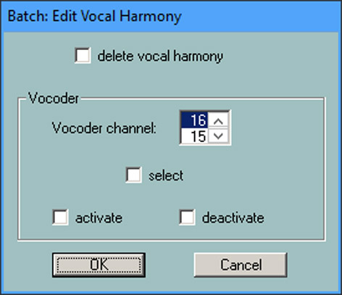
2. Edit the Vocal Harmony in batch mode.

The function can be used in both single and batch mode. In batch mode, no MIDI file may be loaded beforehand. In this case, after calling and selecting
the desired functions, a source and a destination folder must be specified.
All MIDI files of the source folder are edited and saved under the same name in the destination folder. It's closed note that for all MIDI files in the folder, the selected channel is a VH channel and the selected function is also useful.
If this does not apply to individual MIDI files, they will not be processed.
With "Remove Vocal Harmony" all events are deleted independently of the Vocal Harmony type.

3. Lengthen the notes of a Vocoder channel

Vocoder channels, that are programmed by a normal melody channel often use to short notes. As result, the voice of the vocalist will be stopped soon. This function lenghtens the notes up to four ticks before the following notes but not more as the selected number of quarter notes. With the choice of zero the minimal four ticks to the following notes are considered only.

Hint: In most cases it is not recommend to lengthen the vocal harmony notes for commercial MIDI files with a vocal harmony channel.

Quickstart

Button "Extras" (Shortcut E or e) - "Quickstart"

With Quickstart, the initial events of a MIDI file are executed at the moment of loading the file. Therefore we will get the sound immediate with a push on the Start button of the keyboard. PSRUTI is able to insert or delete the quickstart event.

Delete Keyboard events

Button "Extras" (Shortcut E or e) - "Delete Keyboard events"

If we record a MIDI file at the keyboard or use the Song Creator we often get additional events "Keyboard Voice" and Style SysEx. The first one changes the voices of the key pad (Left, Right1,...), the second affects the Style part. Both types of events can be deleted. Additional it is possible to remove the Meta Events Lyrics Bitmap, Score Start Bar, Phrase Mark (together with Max Phrase Mark), Guide Track Flag and all Song Position Markers.

The function can be applied for single files and as batch job for all files of a folder. Do not load a MIDI file before, if batch is wanted. Start the function, select the type of events, a source and then a destination folder. PSRUTI changes all source files and saves the new files with the original filename into the destination.

Delete short Notes

Button "Extras" (Shortcut E or e) - "Delete short Notes"

Sometime we find very short notes in Midi Files that have to be deleted. In the following example in the channels 11, 12 and 14. Here we delete all notes upto the length of 5 ticks. In drum channels short note lengths are used. Here delete is not allowed.

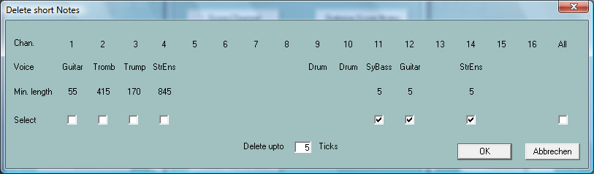

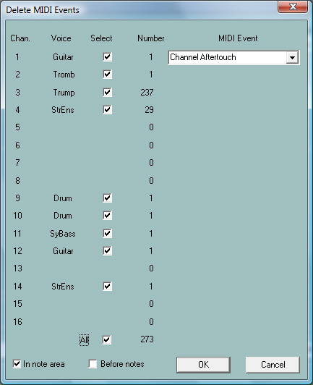
Delete MIDI Events

Button "Extras" (Shortcut E or e) - "Delete MIDI Events"

This function deletes events that may produce troublesome effects. Here for example "Channel Aftertouch" and "Controller 84 Portamento Control" . Sometimes there exist MIDI Events that are not used in General MIDI (GM).

With the following example all , i.e. 273, Channel Aftertouch Events
of the note area will be deleted.

Quantize Notes

Button "Extras" (Shortcut E or e) - "Quantize Notes"

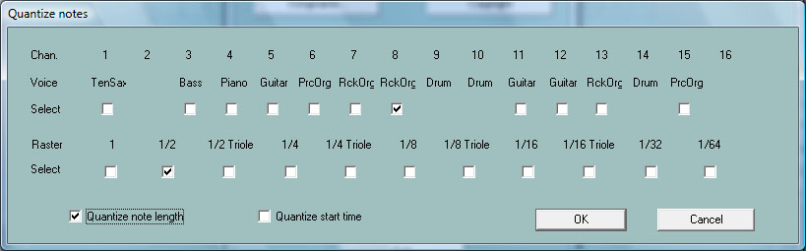
With this function the notes of a MIDI channel are adjusted at a uniform timing raster. The raster can be selected from the length of a whole note (1) upto a 1/64th note. With each channel a raster is proposed, that is derived from the least note length. Alternatively the lengths and/or the start positions of the notes are quantized.

Change lengths of notes

Button "Extras" (Shortcut E or e) - "Change lengths of notes"

This function lengthens or shortens the notes of all channels. All MIDI events will get new positions.
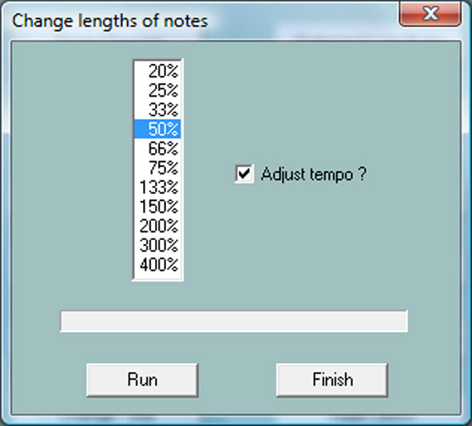
Example:

With the selection 50% all lengths of notes are halved. For
example all Quarternotes will become quavers and all 16th notes 32th notes. With respect of the changed positions of all events the length of the whole MIDI file is halved. To avoid that the playtime of the file also is halved, is is possible, to order that the tempo will be adjusted.

Remark: This funktion does not change the time signature. As a consequence of this eight quarternotes within two 4/4 measures after the procedure lie in only one measure. To change the time signature you need the help of a real sequencer.

Change Time

Button "Extras" (Shortcut E or e) - "Change Time"

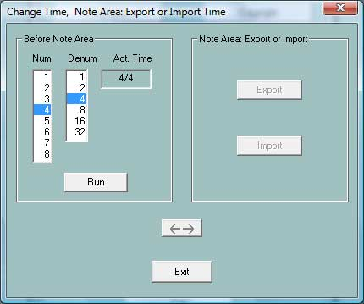

The window is divided into two areas, that can be switched by a click at the button with the two arrows.

With the left area it is possible, to change the time of a MIDI File, for example from 4/4 to 2/4. Here only the first time definition (before the first note) of the file will be changed. Later definitions inside the note area can not be edited here.

The right area is used to export or import all time signatures of the note area into or from a special structured textfile.

============================================
PSRUTI Time-Protocol
File: C:\Users\Heiko\Desktop\test.mid
(Example: A midifile with 3 time signatures of the note area)

[start timelist mbt]

004:01:000 2/4
010:01:000 3/4
020:01:000 6/8

[end list]
============================================

The lines inside [start timelist mbt] and [end list] can be changed, deleted or new ones added. After saving the textfile the new specifications can be imported back into the MIDI file.

Insert Clicks

Button "Extras" (Shortcut E or e) - "Insert Clicks"

With this function the standard drum channel 10 is filled with drum clicks similar to metronome clicks.

There are two different drum instruments used: One is sited only at the first beat of measures and the second at the other beats. It is possible to select both drum instruments and their velocities.

Before using the function it is necessary to clear channel 10 from all events; for example with PSRUTI's "Delete Count In" and "Delete channel". If you want to retain the original drums you before have to cut and paste channel 10 to another empty one (Edit channels).

The clicks do not start with "Count In" drums but it is possible to insert "Count In" later. Channel 10 may be edited with all functions of PSRUTI like a normal drum channel.

18. Preferences
Button "Preferences"

Here we define the global setup of PSRUTI: All parameters are set to same meaning with each program start.

Select the MIDI port of the soundgenerator

Button "MIDI"

Detailed description in the chapter "Play MIDI files; record Lyrics and Chords".

Select a suited Instrument Definition

Button "Instrument Definition"

Detailed description in the chapter "Revoicing" - "Standard Revoicing".

Select a SysEditor XG effect data file

Button "XG Effectdefinition"

Detailed description in the chapter "Import an export SysEx" - "Export SysEx".

Define the form of Fill Lyrics

Button "Fill Lyrics"

Detailed description in the chapter "Define Fill Lyrics"

More Preferences

Button "More Preferences"

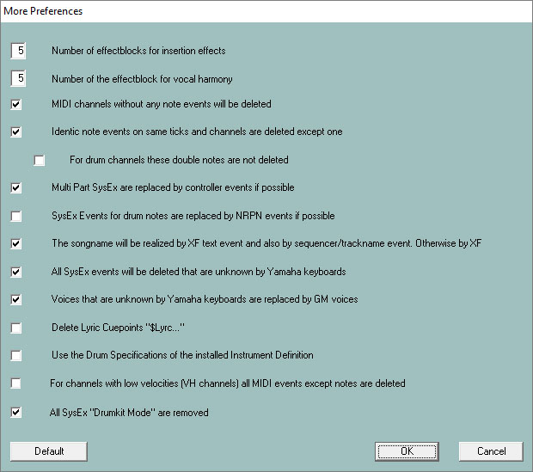
Here we can change parameters, that for most users have minor importance. Only change the default values, if you know the implication.
Number of effectblocks for insertion effects

Number of the effectblock for vocal harmony
Look at the detailed description in the chapter "About Effect Blocks and Blocknumbers".

MIDI channels without any note events will be deleted

Here all events are deleted, that adress such channels. But there may be situations where the channel has to send special controller events to external devices only. Then the hook must be removed.

Identic note events on same ticks and same channels are deleted except on

We find such notes sometimes in songs, that are recorded with the keyboards: Such situations are bugs. But sometimes double notes are used in drum channels to get special effects. Then it is possible to avoid the deletion.

Multi Part SysEx are replaced by controller events if possible

Only controller events can be manipulated with sequencers or with PSRUTI in a simple way.

SysEx Events for drum notes are replaced by NRPN events if possible

Some MIDI file tools use NRPN events for drum effects. If we apply such software it is recommended to order the conversion.

The songname will be realized by XF text event and also by Sequencer/Trackname event.. Otherwise by XF

The keyboards interpret XF songname events; sequencers only the trackname event only. In some situations it may be better, if the songname is realized only by XF.

All SysEx events will be deleted that are unknown by Yamaha keyboards
Voices that are unknown by Yamaha keyboards are replaced by GM voices

I recommend to use the default setup if the sound of MIDI files is produced on Yamaha keyboards only. But if the keyboard is connected with an external soundgenerator that uses unknown SysEx and voices, the
functions must be deselected.

Delete Lyric Cuepoints "$Lyrc..."

Look at "Determine Lyrics Offset" in "Shift Lyrics". Without a hook PSRUTI inserts implicitely a cuepoint event with offset 0. Some keyboard models have a bug and shift the lyric events nevertheless. In this case it is better to set a hook here.

Use the Drum Specifications of the installed Instrument Definition

Look at "PSRUTI with MIDI Files for Keyboards of other Manufacturers" in Addendum.

For channels with low velocities (VH channels) all MIDI events except notes are deleted

The Yamaha keyboards only need note events to realize the Vocoder and Score functions. External Vocoder and other devices often have to be influenced by special MIDI events.

All SysEx „Drumkit Mode“ are removed

It is about the SysEx "F0 43 10 4C 08 <channel> 07 <partmode> F7", to facilitate to use upto three different drumkits on different channels – look at the datalist of your keyboard. Because the existence of these SysEx in midifiles produce negative effects with some keyboard types, these events are removed by default.

19. Addendum

Voicenames and Instrument Definition

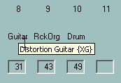
With a suited Instrument Definition, that is designed for the keyboard model of the user, it is possible to revoice MIDI files by the voicenames of the keyboard and not by numbers MSB (Controller 0), LSB (Controller 32) and voice (Patchname event). Addional PSRUTI displays the real drum-note names of the keyboard (function "Edit Drums").

In some program windows PSRUTI displays short voicenames that are derived from GM (General Midi). With the usage of an Instrument Definition
the correct voicename is displayed for a short moment if the mouse cursor is drawn over the short voicename.

PSRUTI uses Instrument Definition files that are originally implemented for the sequencers Cakewalk and Sonar. Most of these files are created by users and with each keyboard model it is worth to search for a suited file in the internet.

With "Preferences" an Instrument Definition is selected and after this PSRUTI will use this definition implicitely with each start.

PSRUTI with MIDI Files of other Manufacturers

PSRUTI is primarily specialized for editing of Yamaha XG MIDI files. The program provides functions that are not meaningful to be used with MIDI files of different keyboards; e.g. XF chords, XG effects and the Voicefile Revoicing. Otherwise all other manufacturer independed MIDI facilities can be edited with success.

Before editing such MIDI files it is required to change some settings in Preferences - Special Preferences.

- Delete the hook at "All sysex events will be deleted that are unknown by Yamaha keyboards".

- Delete the hook at "Voices that are unknown by Yamaha keyboards are replaced by GM voices".

- Set the hook at "Use the Drum Specifications of the installed Instrument Definition".

The last setting only works if an instrument definition is installed where the drumkit and SFX-kit voices are defined by drum specifications (Drum[...]=1). If the instrument definition also includes the drum names of the notes these names are displayed with the function "Edit Drums".

Batch Processing

Some functions of PSRUTI can be performed in batch processing.

- Protocol of MIDI file characteristics (MIDI file Data)
- Optimize XG
- Master Volume
- Revoicing with a Revoicefile template
- Protocol Lyrics with Chords (Print)
- Delete and insert Count In (Count In)
- Insert Fill Lyrics
- Expression <-> Main Volume
- Activate or deactivate Vocal Harmony channel
- Delete Keyboard Events
- Edit Drums with Drumfile Template
- GM Conversion

To apply batch processing copy all source files into a new source directory and create a directory for the changed MIDI files. After this start PSRUTI but do not load a MIDI file. After selecting the PSRUTI function asks for the source and the destination directory. If required in some functions some parameters must be entered. The batch ends with the last MIDI file. To abort a batch before click once more at the program button.

The file psruti.ini

The textfile psruti.ini is stored in the user specific "Documents" folder. With each update of PSRUTI this file is used again. PSRUTI creates or updates this file with each session and it is used as default with later activations of the program. The content of the file will be adapted by the global setups of the button "Preferences". 20. Installation and Deinstallation

PSRUTI will be downloaded with the file psrutixx.zip. xx denotes the programm version, xx = 718 for 7.18 for example. Unzip this file into any directory to get the files

psruti_eng.pdf English manual ( this text)
psruti_germ.pdf German manual
PSRUTIxxx-Setup.exe Setup file of the PSRUTI Version x.xx

PSRUTI will be installed by starting the setup file.

List of installed files:

psruti.exe Executable file
HP_midifile.dll MIDI file library. Freeware, look at https://www.heikoplate.de/hp-midifile.html
psruti_res_eng.dll Resources for the english language
psruti_res_germ.dll Resources for the german language
psruti_eng.pdf Helpfile english
psruti_germ.pdf Helpfile german
psruti.ini Initialisation file

PSRUTI will be deinstalled with the Windows deinstaller. The file psruti.ini of the folder "Documents" remains.

21. Final remarks

PSRUTI is Freeware. The further development has been stopped, but the tool has been published under the MIT license to make further improvements possible. Visit https://github.com/HeikoPlate/psruti for more details The software can be downloaded from https://www.heikoplate.de.

PSRUTI is supplied as is. The author disclaims all warranties, expressed or implied, including, without limitation, the warranties of fitness for any purpose. The author assumes no liability for damages, direct or consequential that may result from the use or inability to use PSRUTI.

There can‘t be any further support given for PSRUTI.

