**Module: BENV0119 MLiSB**

Week 1: Data Readme

**The data**

The data (Week1_data.csv) provided in week 1 was generated using parametric simulations in EnergyPlus for a simple box model as shown in Fig 1. Each row of data represents an EnergyPlus simulation with inputs and outputs provided.

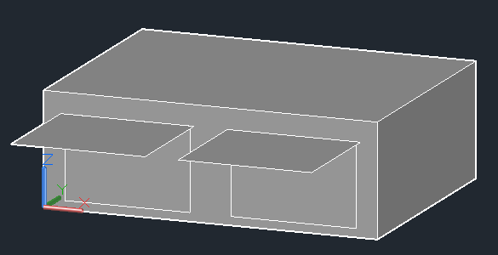

**Fig 1.** Simple box model with overhangs.

**Input variables:**

The input variables varied within the simulation are provided in table 1.

**Table 1.** Input parameters

|  |  |  |
| --- | --- | --- |
| **#** | **Column title** | **Parameter description** |
| **1** | @@ORI@@ | Orientation relative to North |
| **2** | @@WINS@@ | Wall Insulation Conductivity (W/mK) |
| **3** | @@RSA@@ | Roof Solar Absorptance (0-1) |
| **4** | @@OVER@@ | Overhang depth (m) |
| **5** | @@HS@@ | Heating Setpoint (oC) |
| **6** | @@LIGHTS@@ | Lights Level (W) |

**Output variables:**

The output variables varied within the simulation are provided in table 2.

**Table 2.** Output parameters

|  |  |  |
| --- | --- | --- |
| **#** | **Column title** | **Parameter description** |
| **1** | Electricity:Facility [J](RunPeriod) | The annual electricity consumption of the buildings (Joules) |
| **2** | DistrictHeating:Facility [J](RunPeriod) | The annual heating consumption of the buildings (Joules) |
| **3** | DistrictCooling:Facility [J](RunPeriod) | The annual cooling consumption of the buildings (Joules) |
| **4** | ZONE ONE:Zone Thermal Comfort ASHRAE 55 Simple Model Summer or Winter Clothes Not Comfortable Time [hr](RunPeriod) | Number of hours outside of the ASHRAE 55 thermal comfort bands. More info here: <https://designbuilder.co.uk/helpv5.0/Content/Comfort_Analysis.htm> |