UNIVERSITY OF COMPUTER STUDIES YANGON
2025 2026 ACADEMIC YEAR



Project Report On

Descriptive and Predictive Data Mining of Eurasian Tree Sparrow Nest Use

Semester IX
DATA AND KNOWLEDGE MINING IS 212

Submitted by
YKPT - 22270 Hein Htet San

September, 2026 B.C.Sc(KE)

Table of Contents
Acknowledgement 4
Abstract 4
Chapter 1 Introduction 5
1.1 Background 5
1.2 Problem Statement 5
1.3 Aim and Objectives 5
1.4 Overall Analytical Framework 6
Chapter 2 Data Preparation and Preprocessing 7
2.1 Dataset Source and Study Scope 7
2.2 Raw Data Audit 7
2.3 Selected Variables 7
2.4 Validity Checks and Cleaning Decision 8
2.5 Descriptive Statistics 8
2.6 Correlation Analysis 9
2.7 Target Construction and Data Split 9
Chapter 3 Applied Methodologies and Mining 10
3.1 Descriptive and Predictive Mining 10
3.2 Association Rule Mining 10
3.3 Clustering 12
3.4 Cluster Profiles 13
3.5 Classification 14
3.6 Regression 17
Chapter 4 Evaluation and Discussion 19
Chapter 5 User Interface Implementation Design 22
Chapter 6 Conclusion 24
References 25
Appendix A Reproducibility Record 25
Appendix B Key Formulas 26

List of Figures
Figure 1.1 Analytical framework for the project 6
Figure 2.1 Distribution of occupied nest count 9
Figure 2.2 Pearson correlation of selected variables 9
Figure 3.1 Highest-lift positive nest-count rules 11
Figure 3.2 K-means elbow and Silhouette comparison 12
Figure 3.3 K-means clusters in a PCA projection 13
Figure 3.4 Nest-count profiles of the five K-means clusters 14
Figure 3.5 Classification comparison using grouped cross-validation 15
Figure 3.6 Decision Tree out-of-fold confusion matrix 16
Figure 3.7 Decision Tree fitted to the training data 16
Figure 3.8 Regression comparison using grouped cross-validation 18
Figure 3.9 Regression MAE across validation folds 18
Figure 4.1 Final holdout evaluation summary 19
Figure 5.1 Proposed implementation architecture for the research interface 23

List of Tables
Table 2.1 Variables used in the mining workflow 7
Table 2.2 Descriptive statistics 8
Table 3.1 Association mining parameters and results 10
Table 3.2 Selected association rules 11
Table 3.3 Clustering comparison 12
Table 3.4 Cluster profiles 13
Table 3.5 Classification methods 14
Table 3.6 Classification cross-validation results 15
Table 3.7 Regression methods 17
Table 3.8 Regression cross-validation results 18
Table 4.1 Classification final holdout results 19
Table 4.2 Regression final holdout results…………………………………………………………20

Abstract
This project uses descriptive and predictive data-mining methods to study building-level records of Eurasian Tree Sparrow nest use. The supplied CSV has 657 records from field surveys in northern Chinese cities. Seven building and environmental features are used: building height, building width, altitude average noise, warm‑season temperature, warm‑season precipitation and wind speed. The descriptive analysis includes summary statistics, Pearson correlation, association rules, K‑means and average‑linkage hierarchical clustering. For prediction, several classification and regression models are compared using group-aware validation. One association rule linked high altitude and low building width with the Lower nest-count group, with 91.23% confidence and 1.656 lift. K-means gave a provisional five-cluster solution, including a warm, wet, low-altitude cluster with mean NestCount 13.58. In cross-validation, Decision Tree classification reached F1 0.630, while the best regression MAE was 2.824 nests. However, on spatially separate holdout groups, classification ROC-AUC dropped to 0.505 and Decision Tree regression was worse than the mean baseline. The main result is that the dataset contains descriptive patterns. However the models are not reliable, for predicting in geographic groups.

Chapter 1

Introduction
This chapter starts by showing the background the problem and the overall goals of the project. It looks at how the Eurasian Tree Sparrow picks places to nest in cities, across China and why the Eurasian Tree Sparrow chooses those spots. The chapter describes the situation where these birds live closely with humans, known as human commensalism. It presents three research questions: How does nest density change, across urban environments? What environmental factors are linked to nest placement?. Can the findings be applied more broadly in other areas? To answer these the study follows a seven-step process: checking and cleaning data; second, exploring patterns in the data; third using machine learning models that consider groups; and finally creating clear visual dashboards to show the results. Each step builds on the last to ensure interpretable findings.

1.1 Background
Eurasian Tree Sparrows live close to people and use openings in buildings, as nest sites. Urban buildings vary in height, width, openings noise and local climate. Since several factors may act together, it is difficult to understand the full pattern by checking records one by one. Data mining helps summarize the records, find repeated environmental combinations, group similar sites, and test whether the measured features can predict observed nest counts.

1.2 Problem Statement
This project looks at three main questions. First, how are occupied nest counts distributed across the buildings? Second, which combinations of building and environmental conditions appear with the Lower or Higher nest-count groups? Third, can the selected features predict the nest-count group or the numerical NestCount for spatial groups that were not used during training?
Scope The data come from northern China. The project does not measure breeding success, and the results should not be treated as validated predictions for Myanmar.

1.3 Aim and Objectives
The aim of this project is to carry out an understandable end-to-end data-mining study of Eurasian Tree Sparrow nest-use records.
- Check the supplied data and choose variables with clear meanings for modeling.
- Describe the feature distributions and their relationships with NestCount.
- Find frequent patterns and association rules using Apriori and FP-Growth.
- Compare K-means and hierarchical clustering and explain the resulting site groups.
- Compare classification and regression models with simple baseline models.
- Evaluate model selection using spatial group-aware cross-validation and a separate holdout.
Design a research dashboard that presents the methods, findings, and limitations clearly.

1.4 Overall Analytical Framework
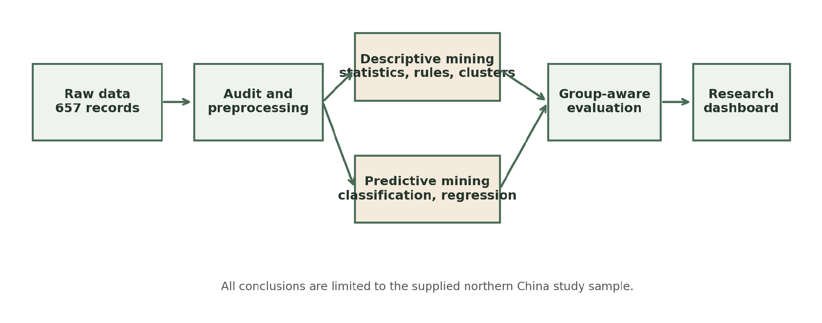
Figure 1.1 Analytical framework for the project
The workflow divides the work into four stages: data preparation, mining, predictive model development and final evaluation. This approach is useful because descriptive findings can still be discussed even if predictive model development does not generalise well.

1.5 Summary
IIn summary Chapter 1 explains why it is important to study how urban birds choose where to build their nests. It outlines the research questions that the study will address and sets clear limits, on what the study will cover. The chapter also describes a seven-step plan that guides all the data collection and model testing work throughout the project.

Chapter 2

Data Preparation and Preprocessing
This chapter details the data acquisition, auditing, and preprocessing procedures for 657 building-level records collected across 22 northern Chinese cities from the Dryad Digital Repository. It documents the selection of seven key building and microclimate features (height, width, altitude, noise, temperature, precipitation, and wind speed), validity checks, and descriptive statistical profiling revealing a right-skewed NestCount distribution (mean 5.74, median 4). Furthermore, it presents Pearson correlation analysis—highlighting a strong inverse relation between altitude and temperature—and establishes the spatial group-aware train/test split strategy (501 training records across 28 groups vs. 156 holdout records across 8 groups).

2.1 Dataset Source and Study Scope
The dataset package is titled Adapting to Urban Heights Flexible Nest-site Selection Strategies of a Human Commensal Bird Along Climate and Anthropogenic Gradients. The dataset package is available from the Dryad Digital Repository, at DOI 10.5061/dryad.rn8pk0ppz. The README states that surveys were carried out across 22 Chinese cities during the April-July breeding seasons of 2021 and 2022 together with building, climate and anthropogenic variables. The supplied raw CSV contains 657 building-level rows and 26 columns.

2.2 Raw Data Audit
The CSV was read using GB18030 encoding because standard UTF-8 did not decode all of the source text correctly. Building identifiers and the supplied ID were kept as strings. The audit found no missing values and no exact duplicate rows, with 654 unique building names among 657 records. NestCount ranged from 1 to 50, so there are no zero-nest examples in the file.
I recalculated the derived occupied and available density fields as a check. One row, Zuobiaocheng Area D 8, did not match the supplied derived densities. I kept the raw building width and NestCount because the selected models do not use those inconsistent density fields. The difference is documented instead of being changed without evidence.

2.3 Selected Variables
Variable | Role | Meaning | Unit | Use
BuildingHeight | Predictor | Building height | m | Field measurement
BuildingWidth | Predictor | Building width | m | Field measurement
Altitude | Predictor | Elevation above sea level | m | Spatial/environmental source
AveNoise | Predictor | Average measured noise level | dB | Field measurement
temp | Predictor | Warm-season mean temperature | degrees C | Climate source
prec | Predictor | Warm-season precipitation | mm | Climate source
win | Predictor | Warm-season wind speed | m/s | Climate source
NestCount | Regression target | Observed occupied nests | count | Field survey
HigherNestCount | Classification target | 0 for 1-4 nests; 1 for 5+ nests | binary | Derived for project
ID | Grouping only | Approximate spatial group identifier | categorical | Supplied data

Table 2.1 Variables used in the mining workflow
Target-derived density fields and identifiers were left out of the predictors to avoid leakage. Variables with unclear scale or meaning in the supplied file were also excluded from the main modeling feature set.

2.4 Validity Checks and Cleaning Decision
- All selected predictors and NestCount were converted to numeric values and checked for missing, non-numeric, and infinite values.
- Building height and width were checked to make sure they were positive.
- NestCount was checked to make sure it was a non-negative integer.
- Precipitation and wind speed were checked to make sure they were non-negative.
No rows failed these checks, so all 657 records were kept for the analysis.

2.5 Descriptive Statistics
Feature | Mean | Std | Min | Median | Max
BuildingHeight | 31.68 | 22.52 | 9.00 | 21.00 | 110.00
BuildingWidth | 52.63 | 23.05 | 6.00 | 50.00 | 151.00
Altitude | 874.30 | 535.81 | -12.00 | 1028.00 | 2328.00
AveNoise | 51.54 | 8.35 | 20.00 | 52.00 | 85.00
temp | 16.64 | 1.84 | 12.15 | 16.35 | 20.48
prec | 52.41 | 17.89 | 24.17 | 55.83 | 89.67
win | 2.60 | 0.47 | 1.68 | 2.52 | 4.15
NestCount | 5.74 | 5.39 | 1.00 | 4.00 | 50.00

Table 2.2 Descriptive statistics for selected variables
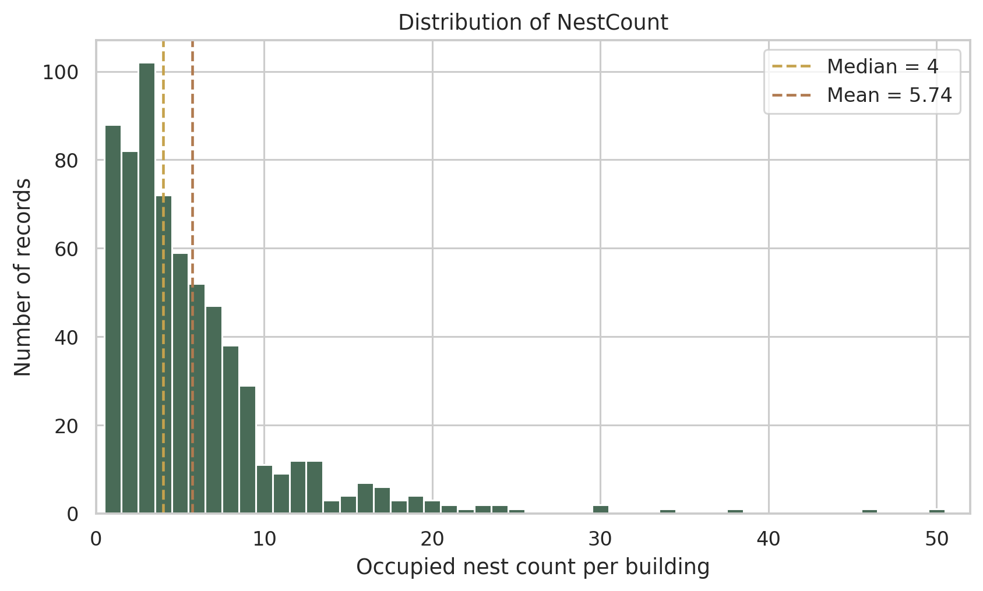
Figure 2.1 Distribution of occupied nest count
NestCount has a mean of 5.74, a median of 4, and a maximum of 50. The higher mean and the long upper tail show that most buildings have lower counts, while a small number have much higher nest counts.

2.6 Correlation Analysis
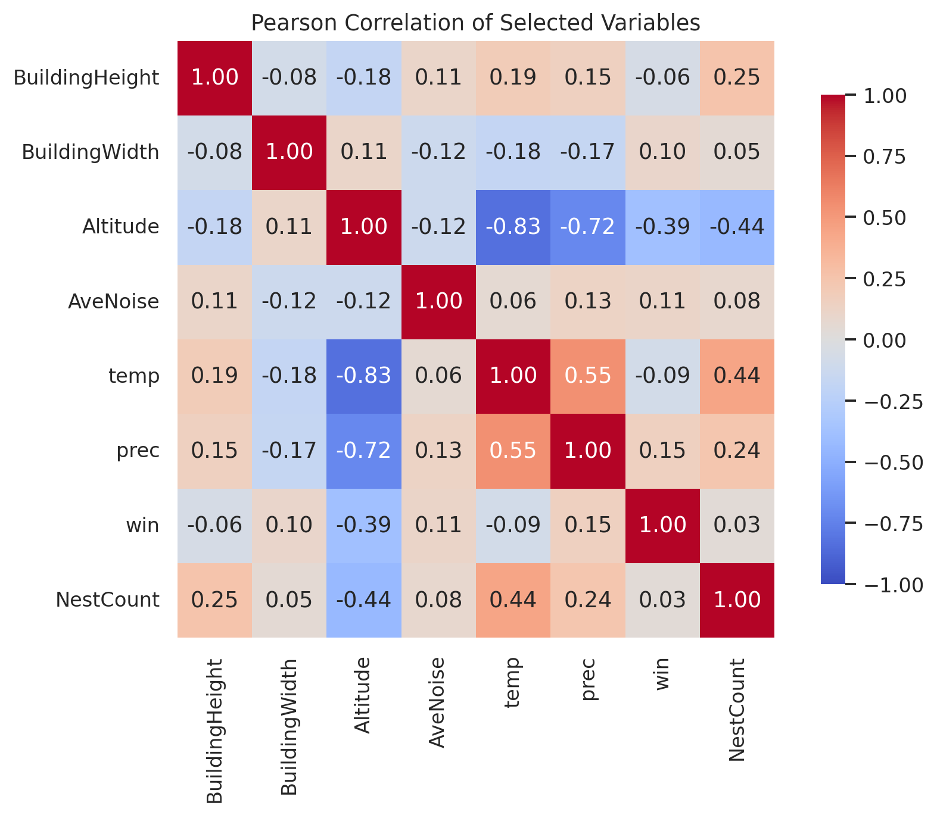
Figure 2.2 Pearson correlation of selected variables
Linear relations were analyzed by Pearson correlation. NestCount shows a link with temperature around 0.44 and with altitude, around -0.44. Altitude and temperature themselves are strongly connected in a way about -0.83. These figures only show that NestCount, temperature and altitude are related; they do not prove that one causes the other and they do not reveal any complex patterns.

2.7 Target Construction and Data Split
We consider NestCount as the numerical regression target. For classification, the median of four from the full-data was used as an exploratory cutoff: One to four nests were coded Lower, five or more nests were coded Higher. This gives 344 Lower, 313 Higher records. And the cutoff is just a project convention, not a biological convention.
GroupShuffleSplit reserved ~20% of data keeping provided spatial ID groups separate. The training set has 501 rows from 28 groups and the final test set has 156 rows from eight groups. Groups do not overlap and holdout was not used to choose models.

2.8 Summary
In summary, Chapter 2 established a clean, fully audited dataset of 657 building records, defined the binary target classification threshold along with continuous regression targets, demonstrated key feature correlations, and partitioned the spatial groups to ensure rigorous downstream model validation without data leakage.

Chapter 3

Applied Methodologies and Mining
This chapter details the implementation and comparative execution of descriptive and predictive mining methodologies on the training dataset. For analysis the Apriori method and the FP-Growth method were used to process transactions. These methods helped find 217 groups of items. They also found association rules that show a connection between altitude and narrow building width with fewer nests. To model the data several classifiers like Decision Tree, Random Forest, Logistic Regression and Naive Bayes were checked. In addition regressors such, as Linear Regression, Decision Tree and Random Forest were also tested. The evaluation used 5fold StratifiedGroupKFold cross-validation. Based on the -validated F1 score and MAE the Decision Tree models stood out as the best performers. The F1 score, for the Decision Tree model was 0.630 and the MAE was 2.824 nests.

3.1 Descriptive and Predictive Mining
Mining family | Methods | Purpose
Descriptive | Summary statistics, Pearson correlation, Apriori, FP-Growth, K-means, hierarchical clustering | Describe distributions, associations, and site groups
Predictive | Decision Tree, Naive Bayes, Logistic Regression, Random Forest, Linear Regression | Predict nest-count class or numerical count

Descriptive methods do not aim to be accurate in the future, but rather to find structure in the existing data. Predictive methods are trained on labeled training examples and tested on data that was not used to fit.

3.2 Association Rule Mining

3.2.1 Transaction Construction
Association mining requires categorical transactions. For each numerical feature, we created three levels: Low, Medium, and High using the 33.3rd and 66.7th percentiles of the 501 training records. Each building now represented one transaction, with seven feature-category items and one NestCountGroup item. One-hot encoding resulted in a Boolean basket of 501 rows and 23 possible items.

3.2.2 Apriori and FP-Growth
Using downward closure, Apriori will prune larger candidate itemsets if a subset is not frequent. FP-Growth, however, compresses the transactions into an FP-tree and mines frequent patterns without generating the same candidate sequence. Same thresholds were tested for both algos.
Setting or result | Value | Interpretation
Minimum support | 0.10 | An itemset must occur in at least 51 of 501 records
Maximum itemset length | 3 | At most two conditions plus one nest-group conclusion
Minimum rule confidence | 0.60 | At least 60% of antecedent records satisfy the consequent
Apriori frequent itemsets | 217 | Runtime 0.006676 s
FP-Growth frequent itemsets | 217 | Runtime 0.010431 s

Table 3.1 Association mining parameters and results
Both algorithms returned the same frequent itemsets with matching support values. The runtime difference was only a few milliseconds on this small dataset, so no general speed claim is made.

3.2.3 Rule Metrics and Findings
For a rule A to B support tells us how often A and B appear together. Confidence tells us how often B happens when A is there. Lift compares that confidence to how B happens on its own. If the lift is, than 1 it means A and B are more likely to occur together than we would expect by chance.
Antecedent | Consequence | Support | Confidence | Lift
Altitude=High + BuildingWidth=Low | Lower | 0.104 | 0.912 | 1.656
Altitude=Low + prec=High | Higher | 0.156 | 0.743 | 1.654
Altitude=Low + BuildingHeight=High | Higher | 0.132 | 0.742 | 1.651
BuildingHeight=High + temp=High | Higher | 0.114 | 0.722 | 1.607
Altitude=High + BuildingHeight=Low | Lower | 0.136 | 0.883 | 1.603

Table 3.2 Selected positive association rules
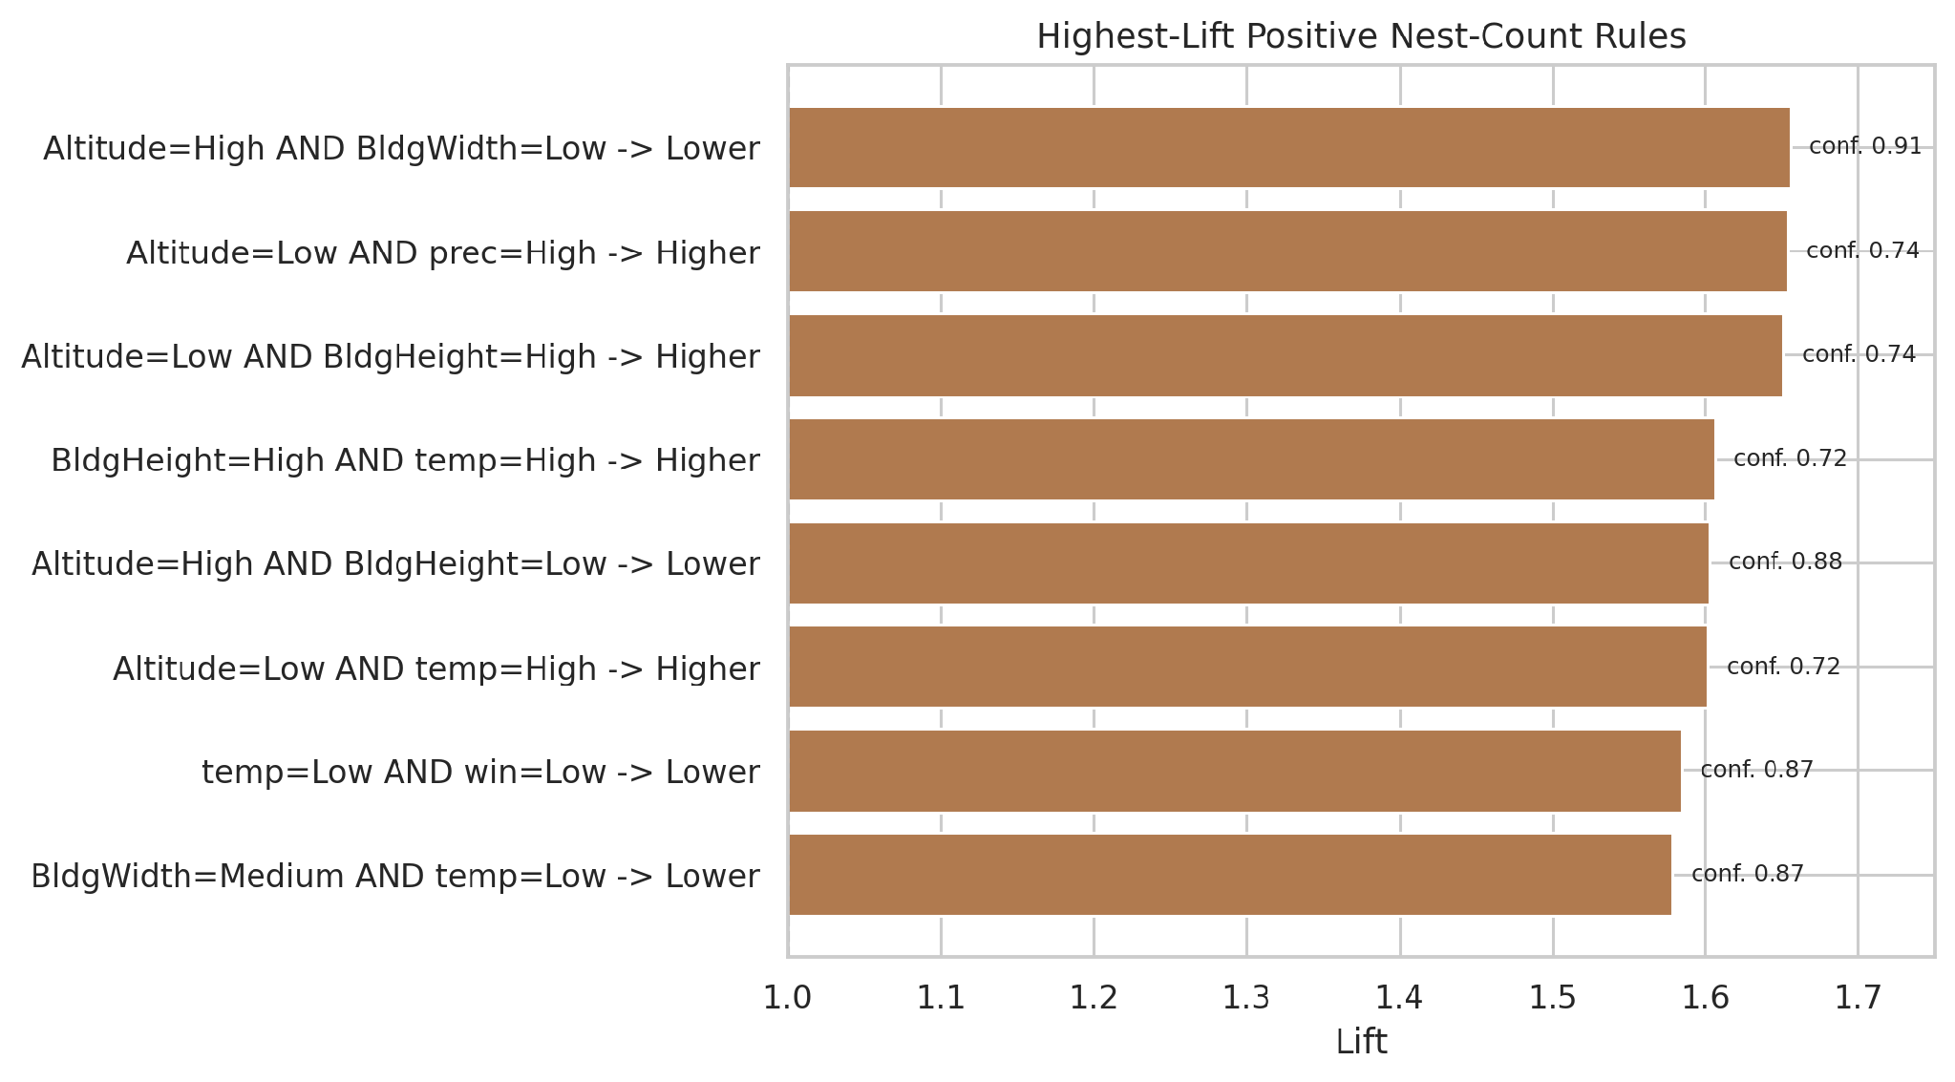
Figure 3.1 Highest-lift positive nest-count rules
The highest-lift rule is High Altitude and Low BuildingWidth leading to the Lower NestCountGroup. It appears in 52 of 501 training records, giving support 0.1038. Of the 57 records meeting the two conditions, 52 are Lower, so confidence is 0.9123. The Lower base rate is 276/501, giving lift 1.656. This is an association in the training sample, not proof of an ecological cause.

3.3 Clustering

3.3.1 Standardization and Algorithms
Clustering used the seven predictors without NestCount. StandardScaler put the features on a similar scale so that altitude would not dominate Euclidean distance just because its values are numerically larger. K-means was run with 20 initializations and a fixed random state. Average-linkage hierarchical clustering merged clusters using the average Euclidean distance between their members.

3.3.2 Cluster Selection
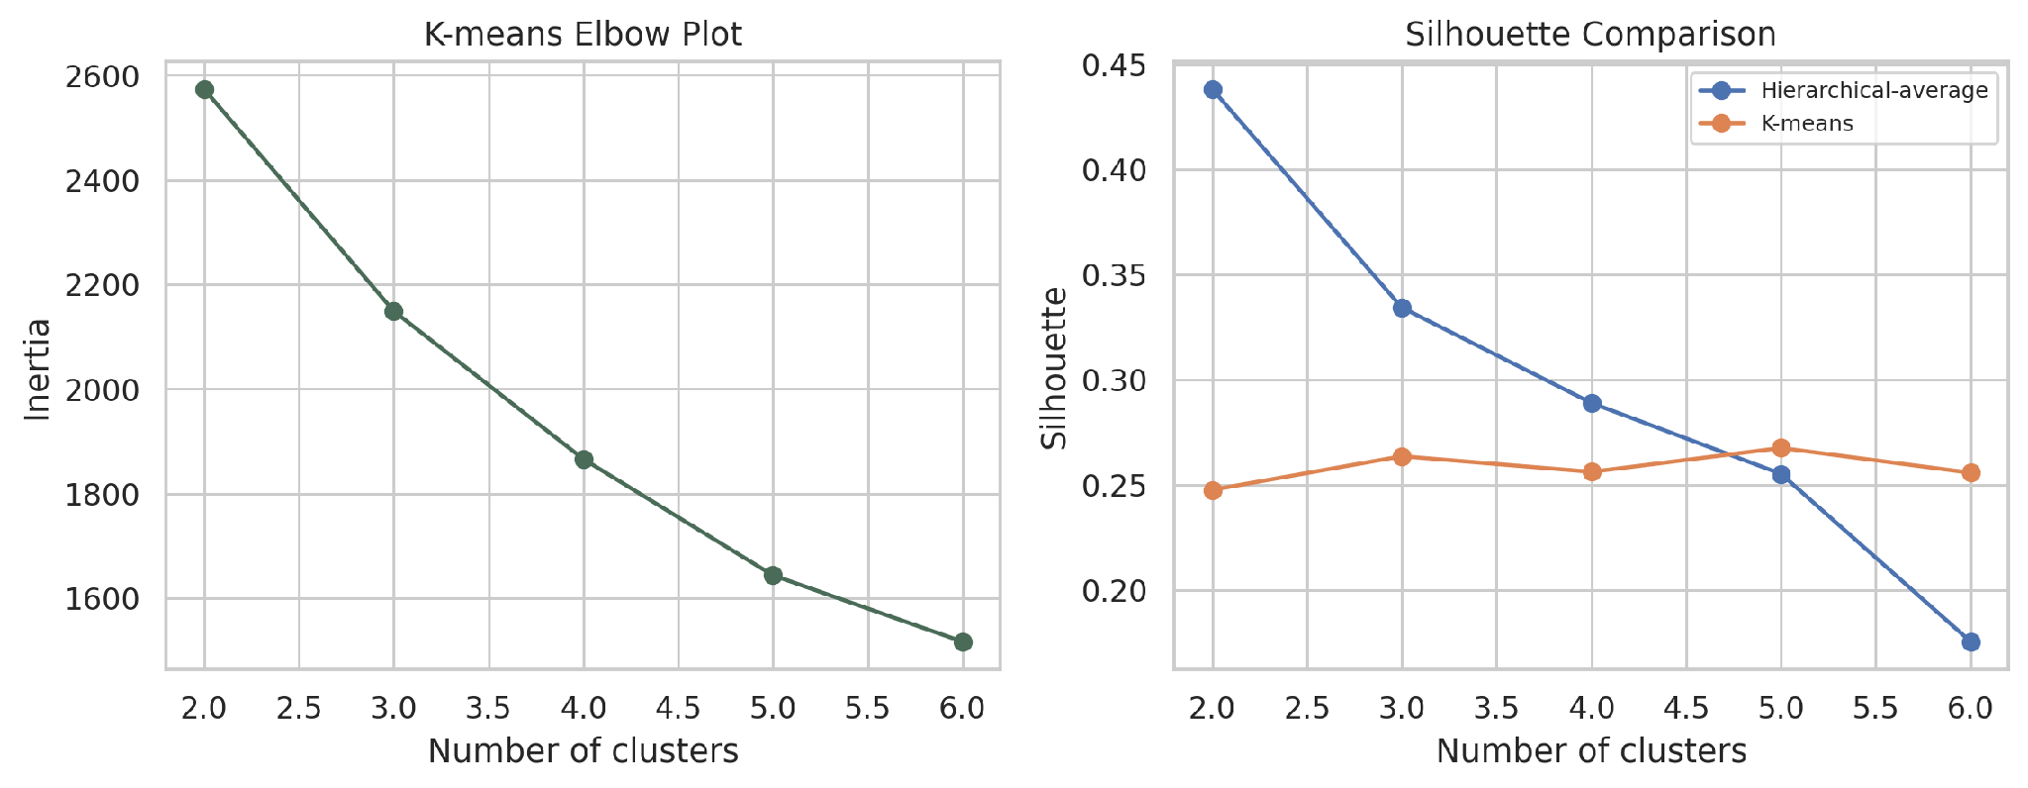
Figure 3.2 K-means elbow and Silhouette comparison

Method | k | Silhouette | CH | Size range | Inertia
K-means | 2 | 0.247 | 181.0 | 236-265 | 2573.6
Hierarchical-average | 2 | 0.438 | 9.7 | 2-499
K-means | 3 | 0.264 | 157.4 | 102-205 | 2148.9
Hierarchical-average | 3 | 0.334 | 7.8 | 2-497
K-means | 4 | 0.256 | 145.7 | 76-164 | 1865.9
Hierarchical-average | 4 | 0.289 | 53.5 | 2-422
K-means | 5 | 0.267 | 140.6 | 51-156 | 1643.5
Hierarchical-average | 5 | 0.255 | 40.6 | 1-422
K-means | 6 | 0.256 | 129.9 | 57-119 | 1516.6
Hierarchical-average | 6 | 0.175 | 35.1 | 1-416

Table 3.3 Clustering comparison
Among the tested K-means solutions k=5 gives the Silhouette score, which is 0.2675. Hierarchical clustering at k=2 has a Silhouette score of 0.4381 but it divides the data into just two clusters—one with only two records and the other with 499. The Calinski-Harabasz score for this method is 9.7. Because of the imbalance in cluster sizes and the difficulty in interpreting two clusters K-means with k=5 is chosen as the provisional solution. It offers balance and more meaningful groupings, for analysis. Its low Silhouette score still shows limited cluster separation.

3.3.3 Cluster Interpretation
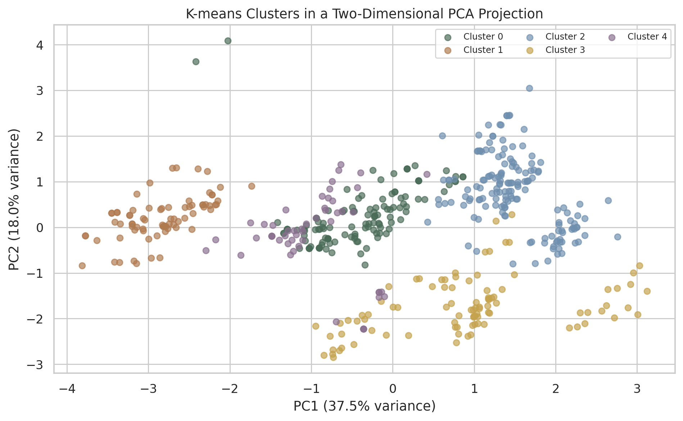
Figure 3.3 K-means clusters in a PCA projection
PCA is used only to show the clusters in two dimensions. The first two components explain 55.53% of the standardized-feature variance, while the actual clustering uses all seven features. Because the plot loses some information, visual overlap should be considered together with the numerical metrics.
C | n | Height | Width | Altitude | Noise | Temp | Prec | Wind
0 | 125 | 23.0 | 48.8 | 789.9 | 54.7 | 16.8 | 58.5 | 2.57
1 | 76 | 44.5 | 41.9 | 53.9 | 52.6 | 20.0 | 68.2 | 2.43
2 | 156 | 21.2 | 59.3 | 1269.5 | 49.3 | 15.7 | 29.0 | 2.65
3 | 93 | 24.5 | 48.6 | 1481.0 | 50.0 | 15.5 | 53.6 | 1.92
4 | 51 | 79.2 | 52.1 | 881.1 | 52.7 | 16.7 | 56.2 | 2.44

Table 3.4 Mean feature profiles for K-means k=5
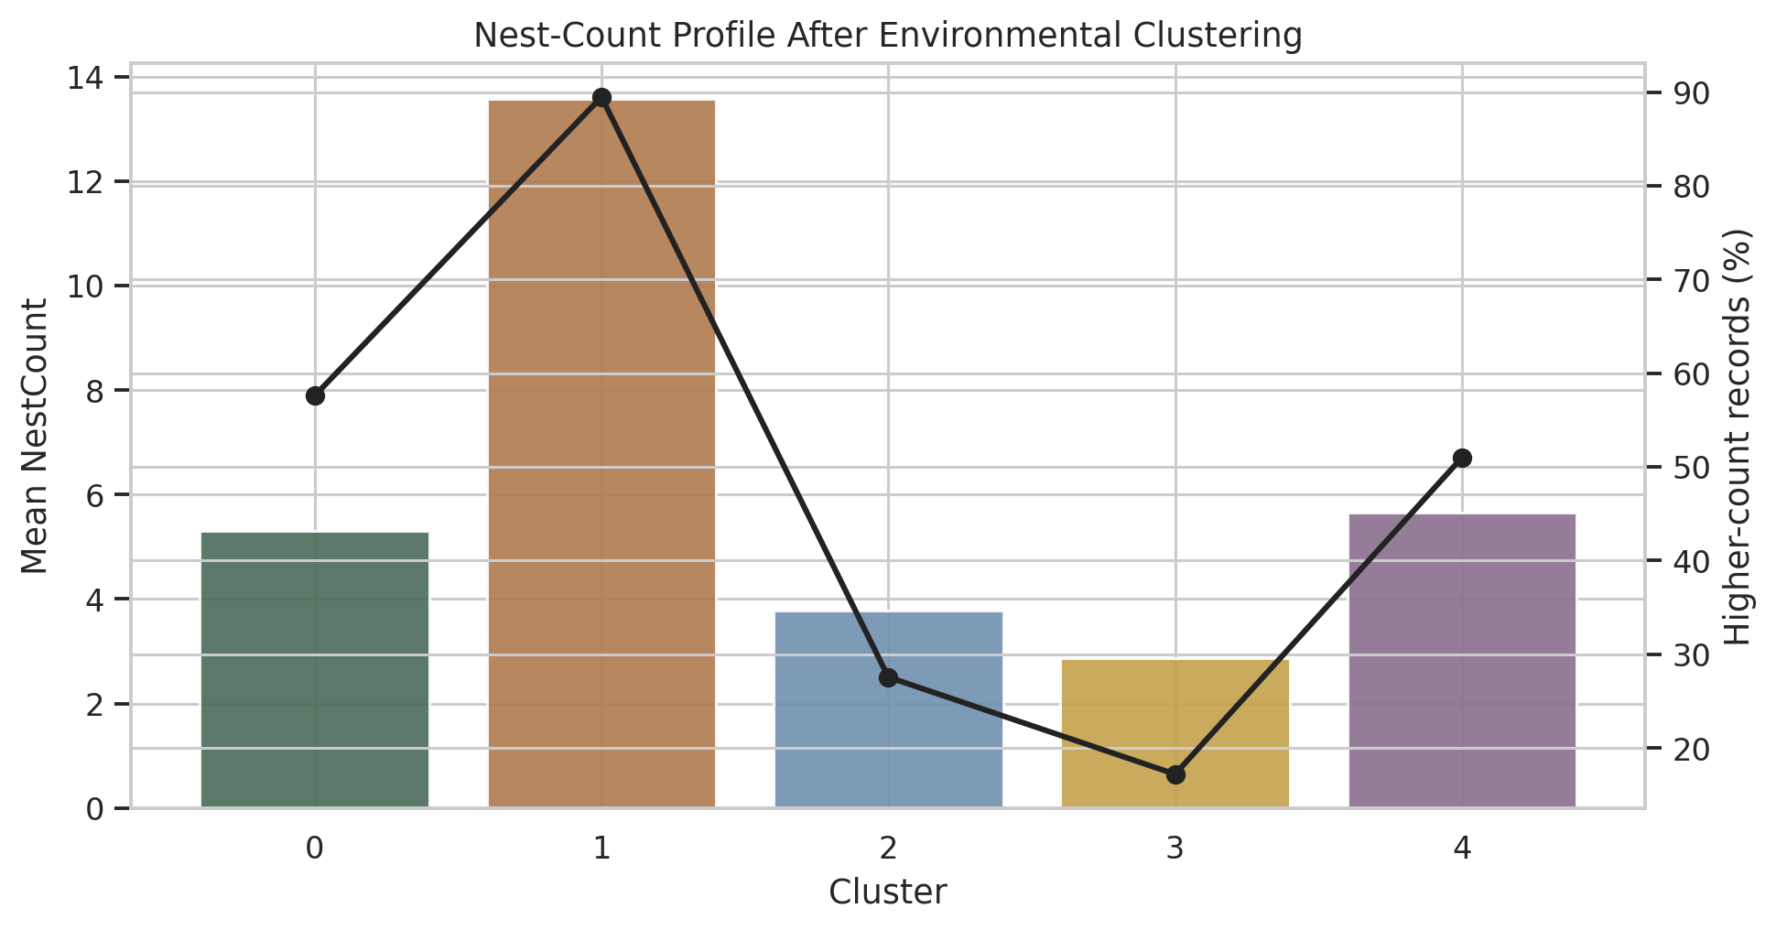
Figure 3.4 Nest-count profiles of the five K-means clusters

3.3.4 Cluster Profiles
NestCount was excluded from K-means and compared only after cluster formation. The selected K-means solution has a silhouette score of 0.267, so the groups overlap and should be interpreted as descriptive profiles.

Cluster | Characteristic profile | Training records | Mean nests
0 | Moderate-altitude, noisy sites | 125 | 5.31
1 | Warm, wet, low-altitude sites | 76 | 13.58
2 | High-altitude, dry, wide buildings | 156 | 3.78
3 | Highest-altitude, cool, low-wind sites | 93 | 2.86
4 | Very tall buildings | 51 | 5.65

Cluster 1 contains relatively warm, wet, low-altitude records and has the highest mean NestCount of 13.58, with 89.5% Higher-count records. Cluster 3 has the highest mean altitude with lower temperature and wind; it has the lowest mean NestCount of 2.86 and only 17.2% Higher-count records. Since NestCount was checked after clustering, these are descriptive associations rather than causal results.

3.4 Classification

3.4.1 Target and Models
For classification, one to four nests are labeled Lower and five or more nests are labeled Higher. Higher is the positive class. Five-fold StratifiedGroupKFold was used on the 501 training records, keeping every spatial ID inside one fold while roughly balancing the two classes.
Method | Purpose and configuration
Majority baseline | Always predicts the most common training-fold class
Decision Tree | Gini criterion, maximum depth 3, minimum leaf size 10
Gaussian Naive Bayes | Probabilistic comparison under conditional-independence assumptions
Logistic Regression | Scaled linear probability model, maximum 2000 iterations
Random Forest | 200 trees, depth 5, minimum leaf size 5

Table 3.5 Classification methods

3.4.2 Metrics and Model Selection
Accuracy is the overall proportion of correct classifications. Precision measures how many predicted Higher records are actually Higher, while recall measures how many actual Higher records are found. F1 combines precision and recall. ROC-AUC measures probability ranking across thresholds. The predefined model-selection criterion was mean F1.
Model | Accuracy | Precision | Recall | F1 | ROC-AUC
Decision Tree | 0.655 | 0.601 | 0.702 | 0.630 | 0.698
Random Forest | 0.684 | 0.687 | 0.628 | 0.620 | 0.734
Logistic Regression | 0.668 | 0.646 | 0.602 | 0.596 | 0.750
Naive Bayes | 0.670 | 0.701 | 0.569 | 0.564 | 0.732
Majority baseline | 0.548 | 0.000 | 0.000 | 0.000 | 0.500

Table 3.6 Classification grouped cross-validation results
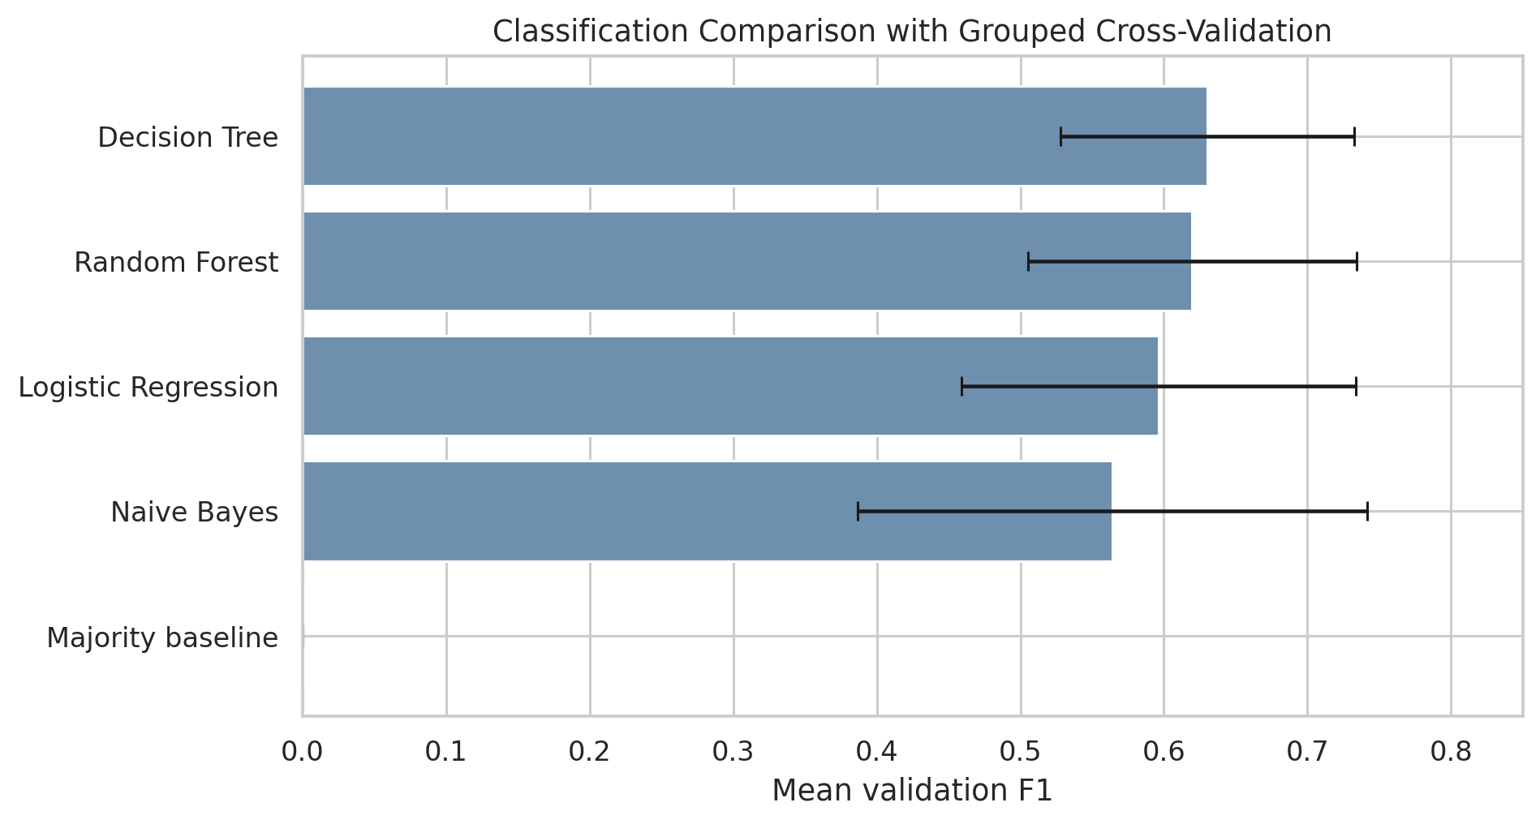
Figure 3.5 Classification comparison using grouped cross-validation
Decision Tree has the mean F1 score which is 0.630 and the highest mean recall which is 0.702. Random Forest has the mean accuracy. Logistic Regression has the mean ROC-AUC. The F1 score difference between Decision Tree and Random Forest is 0.010. This difference is small compared with the variation, between folds. So no statistical significance is claimed. Decision Tree was selected using the predefined F1 criterion.
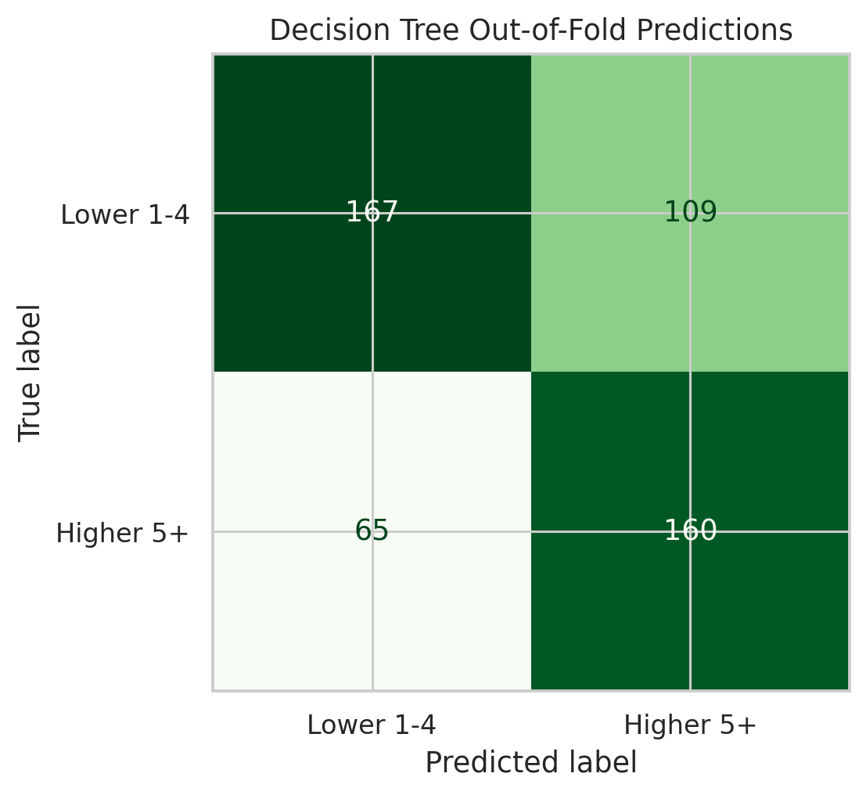
Figure 3.6 Decision Tree out-of-fold confusion matrix
When I examined the out-of-fold confusion matrix I saw that TN equals 167 FP equals 109 FN equals 65 and TP equals 160. I also noticed that each training record was predicted by a model that had not been fitted on that record even though the same cross-validation process was still used for model selection.
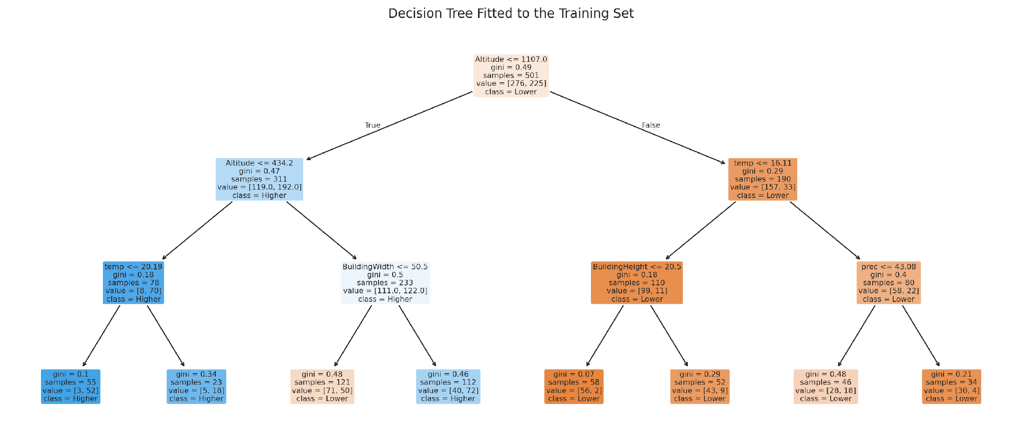
Figure 3.7 Decision Tree fitted to the training data
The fitted Decision Tree uses altitude, temperature, building width, building height, and precipitation in its displayed splits. The tree is easy to inspect, but its thresholds were learned from this sample and should not be treated as universal ecological boundaries.

3.5 Regression

3.5.1 Target and Models
Regression predicts the numerical NestCount. The same group-aware five-fold assignments were reused. HigherNestCount was used only to help balance the folds; it was not the regression target. The models were fitted to the numerical count.
Method | Purpose and configuration
Mean baseline | Predicts the training-fold mean for every record
Median baseline | Predicts the training-fold median for every record
Linear Regression | Standardized predictors in a linear least-squares model
Decision Tree | Maximum depth 3 and minimum leaf size 10
Random Forest | 200 trees, maximum depth 5, minimum leaf size 5

Table 3.7 Regression methods

3.5.2 Metrics and Model Selection
MAE is the average absolute difference between actual and predicted counts. RMSE gives more weight to large errors. R-squared compares squared error with a mean reference and can be negative. The predefined model-selection criterion was mean MAE, where lower is better.
Model | MAE mean | MAE std | RMSE mean | R2 mean
Decision Tree | 2.824 | 0.990 | 4.354 | 0.227
Random Forest | 2.827 | 0.991 | 4.291 | 0.219
Linear Regression | 3.209 | 1.202 | 4.525 | 0.145
Baseline Median | 3.388 | 1.405 | 5.336 | -0.094
Baseline Mean | 3.708 | 1.173 | 5.277 | -0.116

Table 3.8 Regression grouped cross-validation results
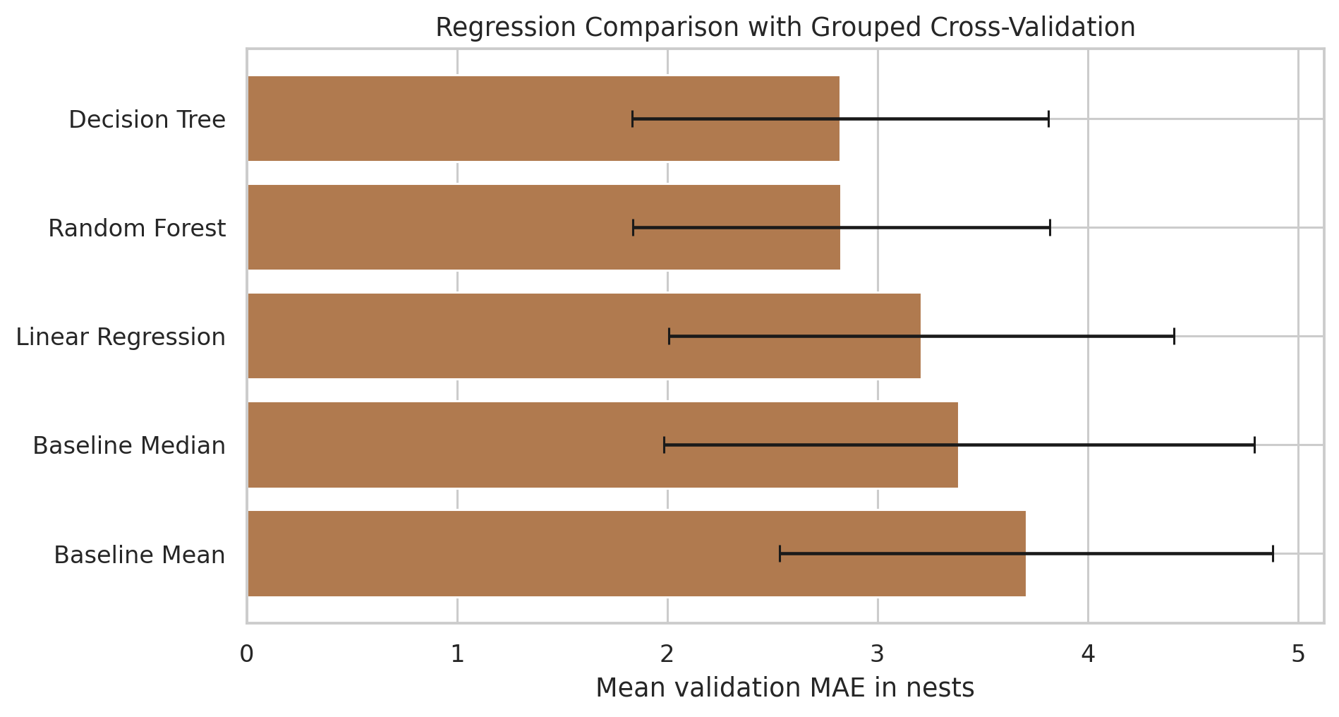
Figure 3.8 Regression comparison using grouped cross-validation
Decision Tree has the lowest mean MAE at 2.824 nests. Random Forest is almost identical at 2.827 and has the lowest RMSE. Compared with the best baseline, the median baseline with MAE 3.388, Decision Tree reduces cross-validation MAE by 16.63%. This is an error reduction, not an accuracy increase.
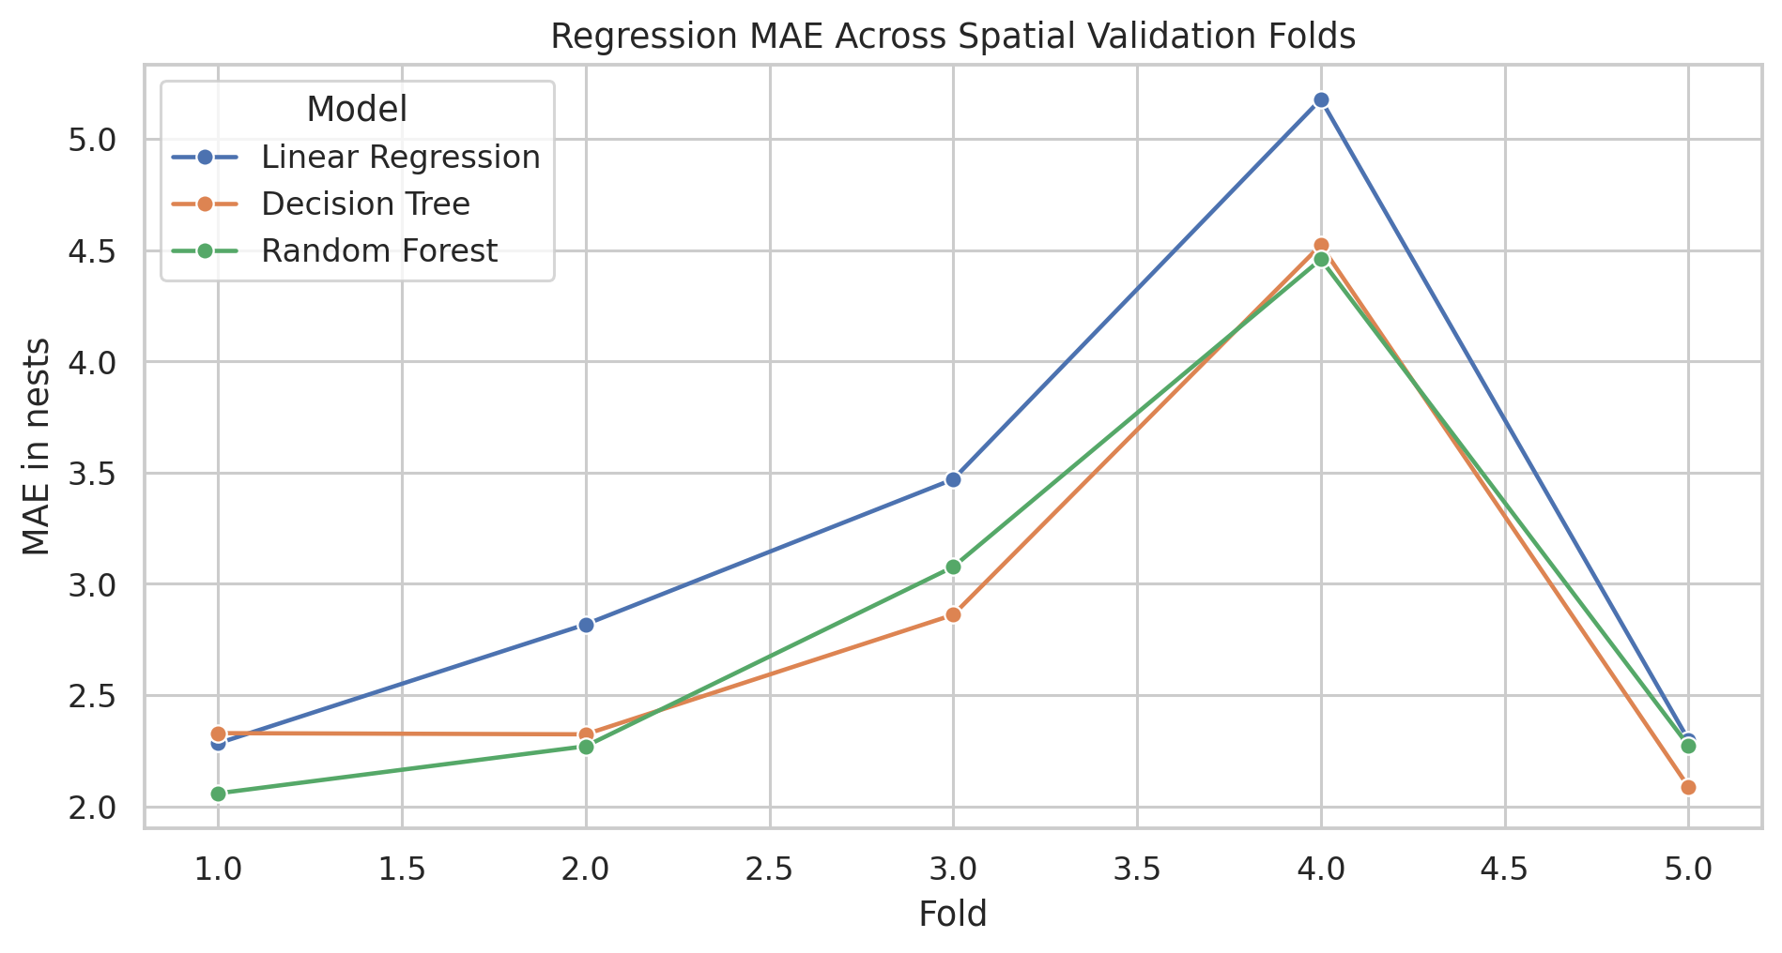
Figure 3.9 Regression MAE across validation folds
Results vary noticeably across the validation folds. Decision Tree MAE ranges from 2.088 to 4.522 nests, showing that some held-out spatial groups are harder to predict than others.

3.6 Summary
In summary, Chapter 3 applied descriptive mining to reveal consistent environmental patterns and site clusters, and executed group-aware cross-validation to select the most promising Decision Tree classification and regression models for subsequent holdout evaluation.

Chapter 4

Evaluation and Discussion
This chapter evaluates the generalization capabilities of the selected Decision Tree models on an independent 156-record spatial holdout set across eight unseen city groups. The test showed a drop in how well things worked: the classification ROC-AUC went down to 0.505 (which is almost like guessing even though the F1 was 0.653) and the regression MAE went up to 4.095 nests (R-squared of -0.575) which means it did worse than the basic average model. The chapter looks closely at why the model failed to work in places—including changes, in data distribution and things that were not measured that affect small areas—while also talking about the good parts of the study the problems that were there and real steps that can be taken to collect better data and make better models in the future.

4.1 Evaluation Strategy
Model development used 501 training records and five group-aware validation folds. The separate 156-record holdout contains different spatial groups and was kept aside until Decision Tree had been selected for classification by F1 and regression by MAE. Each selected model was then fitted once on all 501 training rows and tested on the holdout. Baselines were calculated from training targets only.
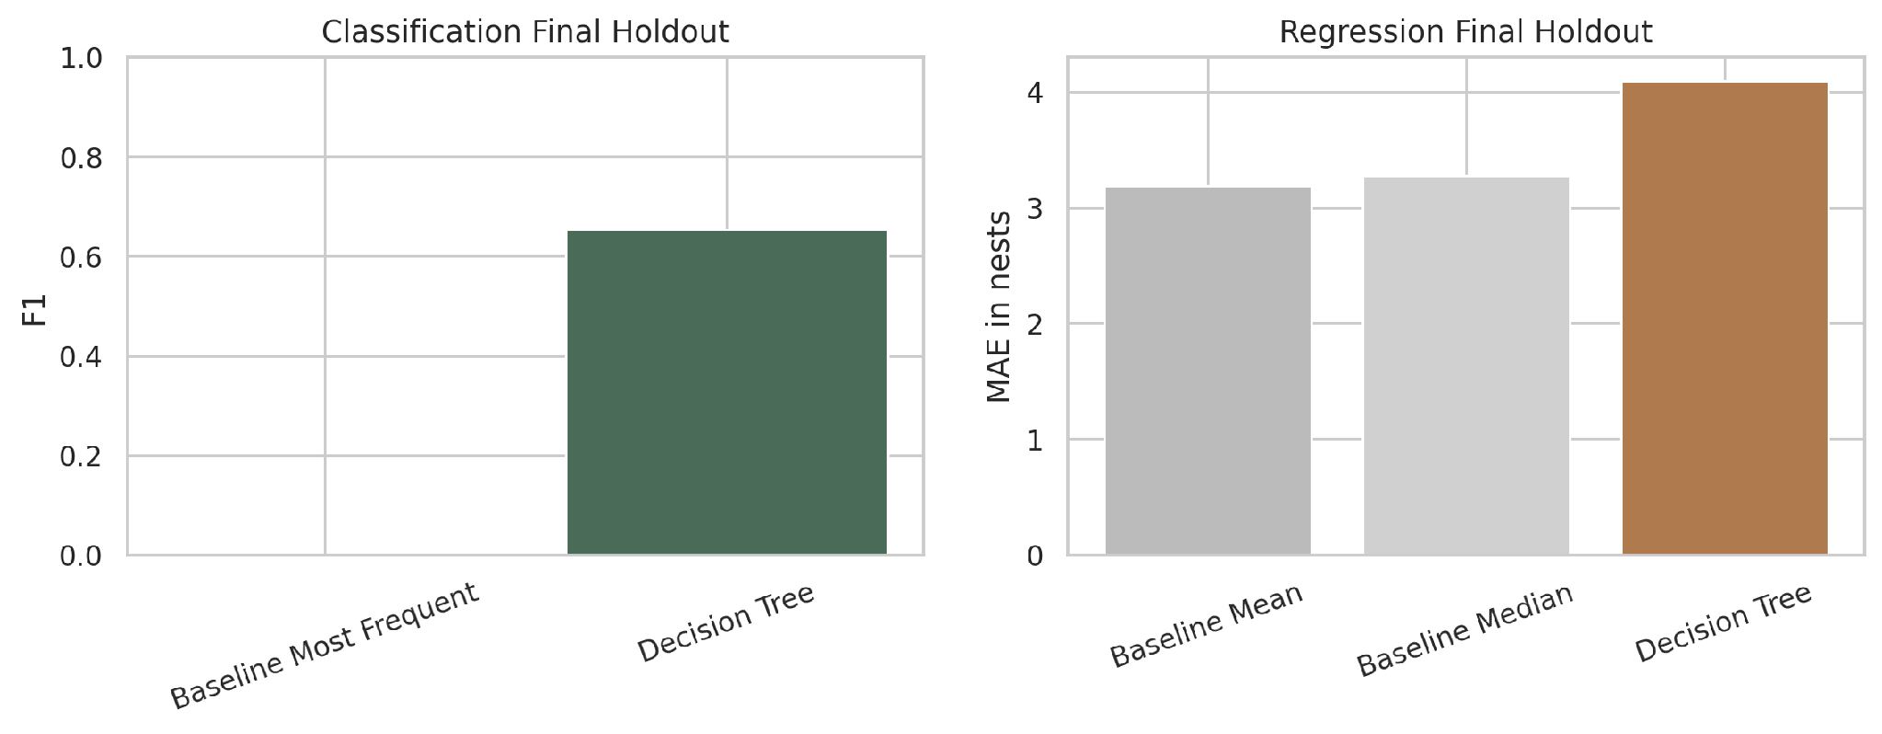
Figure 4.1 Final holdout evaluation summary

4.2 Classification Holdout Results
Model | Accuracy | Precision | Recall | F1 | ROC-AUC
Baseline Most Frequent | 0.436 | 0.000 | 0.000 | 0.000 | 0.500
Decision Tree | 0.551 | 0.579 | 0.750 | 0.653 | 0.505

Table 4.1 Classification final holdout results
On the holdout set the Decision Tree model reaches a recall of 0.750 and an F1 score of 0.653. Its accuracy is 0.551. The ROC‑AUC is only 0.505, which is almost the same, as random ranking. The holdout data contains 88 records and 68 Lower records so a model that predicts Higher for every case would already reach an accuracy of 56.4%. Therefore, accuracy alone does not show useful discrimination on this holdout.

4.3 Regression Holdout Results
Model | MAE | RMSE | R2
Baseline Mean | 3.190 | 4.550 | -0.005
Baseline Median | 3.276 | 4.953 | -0.190
Decision Tree | 4.095 | 5.698 | -0.575

Table 4.2 Regression final holdout results
Decision Tree regression gives MAE 4.095, RMSE 5.698, and R-squared -0.575 on the holdout. The mean baseline is better, with MAE 3.190 and RMSE 4.550. Decision Tree MAE is about 28.4% higher than the mean baseline. The negative R-squared means the model has more squared error than the mean reference; it is not an accuracy percentage.

4.4 Interpretation of Generalization
Cross-validation suggested some useful structure in the training data, but performance was weaker on the reserved spatial groups. The holdout results show that the current features and model settings do not generalize reliably to this geography. Possible reasons include spatial distribution shift, unmeasured nest-site features, the small number of groups, and the long-tailed count target. This analysis does not prove which reason is responsible.

4.5 Strengths of the Evaluation
- Baseline models are included for both predictive tasks.
- Spatial groups are kept separate between fitting and validation partitions.
- Several metrics are reported instead of selecting only one favorable score.
- The final holdout is reported even though its results are worse than the cross-validation results.
Association and clustering results are treated as descriptive patterns, not proof of causation.

4.6 Limitations
- All supplied rows contain at least one occupied nest, so nest presence versus absence cannot be modeled.
- The dataset does not include eggs, hatching, fledging, or survival outcomes, so it cannot measure breeding success.
- The five-nest Higher threshold is an exploratory data-based choice, not a biological standard.
- The supplied ID is used as an approximate spatial grouping variable and may not capture all dependence in the observations.
- Environmental summaries and building observations may represent different spatial or time scales.
- The study data come from northern China, so Myanmar use would require local data and validation.
The holdout has now been examined and cannot be reused as a new independent test after further tuning.

4.7 Improvement Strategy
- Collect more buildings, including verified zero-nest examples and new geographic groups.
- Confirm unclear variable definitions and units before adding them as predictors.
- Measure independent features such as accessible nest openings and local disturbance consistently.
- Tune models only inside nested group-aware cross-validation on development data.
- Compare count-aware methods such as Poisson or negative-binomial models when appropriate.
- Use a new independent dataset for final confirmation after model changes.
Collect and validate Myanmar observations before making Myanmar-specific claims.

4.8 Summary
In summary Chapter 4 showed that predictive accuracy gets worse when it is applied to spatial groups. This points to a difference between descriptive pattern extraction and robust regional forecasting. The chapter also gives advice for future field sampling and, for refining the model.

Chapter 5

User Interface Implementation Design
This chapter outlines the functional design and architectural specifications for an interactive research dashboard intended to communicate the project's data mining findings transparently. It describes a seven-page information architecture covering the complete analytical pipeline, coupled with a full-stack technical framework pairing a Next.js frontend for static asset rendering with a lightweight Python/scikit-learn backend API for educational model inference. Additionally, it defines presentation mode guidelines to ensure clear, single-takeaway visual storytelling and responsible disclosure of model boundary limitations.

5.1 Purpose
The interface is planned as a presentation and research dashboard for explaining the complete mining workflow. The main goal is transparency. Each analysis page should show why a method was used, how it was applied, what result was obtained, and what conclusion can reasonably be supported.

5.2 Information Architecture
Page | Content
Overview | Problem, objectives, data origin, scope, and key findings
Dataset and preprocessing | Raw preview, variable dictionary, audit, cleaning, and split
Descriptive mining | Statistics, correlation, association rules, and clustering
Predictive mining | Classification, regression, models, parameters, and training strategy
Evaluation | Cross-validation, baselines, final holdout, and limitations
Prediction demonstration | Seven inputs, selected model outputs, and explicit reliability note
Conclusion | Supported findings, future work, references, and report download

5.3 Proposed Technical Architecture
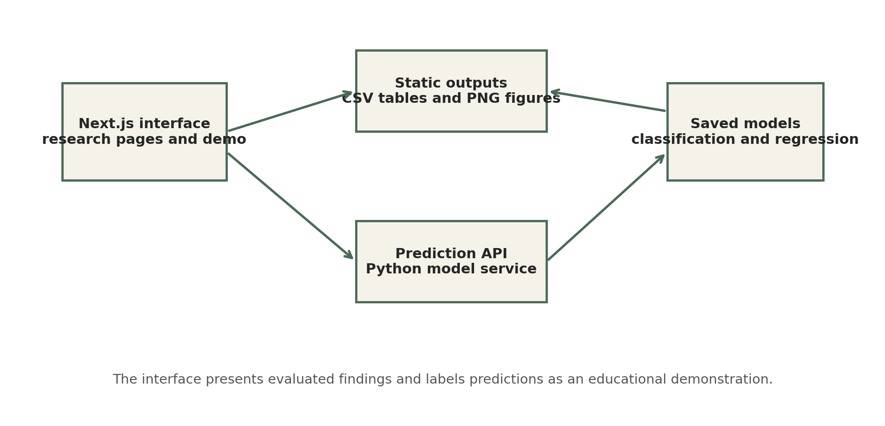
Figure 5.1 Proposed implementation architecture for the research interface
A Next.js front end can display the saved CSV tables and PNG figures without retraining the models. A small Python service can load the saved scikit-learn Decision Tree models for an educational prediction demo. The interface should also show the training feature ranges and the holdout limitations beside each prediction. A simple two-dimensional sparrow animation can support the presentation, while the analytical figures remain static and numerically exact.

5.4 Presentation Mode
Presentation mode should focus on one research question, one figure, and one main takeaway at a time. More detailed methodology can be opened when questions come up. Motion should be pausable and respect reduced-motion preferences. Any clustering animation should be labeled as an illustration unless it uses the actual PCA coordinates and cluster assignments.

5.5 Summary
In summary, Chapter 5 formulated a complete web implementation design combining a Next.js interface with a Python API, structuring the research findings and model demonstrations into a user-friendly, transparent research dashboard.

Chapter 6

Conclusion
This chapter brings together the results and methods, from the whole study. It clearly answers the research questions. It shows that descriptive data mining does a job of finding important environmental patterns and areas where nests are grouped.. It also says that machine learning models that only use big environmental and building details don't work well when they are used in new places. Finally, it presents actionable directions for future urban ecological research, emphasizing zero-nest sampling, microhabitat feature integration, and localized regional validation.

6.1 Summary of Findings
This project completed an end-to-end descriptive and predictive mining workflow for 657 Eurasian Tree Sparrow building records. The descriptive analysis showed a long-tailed NestCount distribution. Apriori and FP-Growth both produced 217 matching frequent itemsets and found useful rules involving altitude, temperature, precipitation, building height, and building width. K-means gave a provisional five-cluster description with noticeable differences in environmental profiles and NestCount.
The predictive results were less reliable. Cross-validation was moderate, but performance dropped on the reserved spatial groups. Decision Tree classification reached holdout F1 0.653 but ROC-AUC 0.505. Decision Tree regression had holdout MAE 4.095 and was worse than the mean baseline. The strongest conclusion is that the dataset contains descriptive patterns, while the current models are not dependable for prediction in new spatial groups.

6.2 Specific Problem Solution
The project gives a structured way to examine which building and environmental conditions occur with lower or higher observed nest counts and to group sites with similar profiles. This can help form new hypotheses and plan future field sampling. It does not provide a validated management rule or a breeding-success forecast.

6.3 Future Development
Future work should expand geographic coverage and include verified absence cases, confirm unclear feature definitions, test count-aware models with nested spatial validation, and use a new independent test set. The dashboard could then add interactive rule filtering, cluster comparisons, fold-level evaluation, and a clearly labeled model demonstration.

6.4 Summary
In summary, Chapter 6 concluded the project report by reaffirming the value of descriptive site associations, summarizing the key limitations in cross-regional prediction, and highlighting necessary prerequisites for deploying predictive models in practical conservation management.

References
Dryad Digital Repository. (2023). Adapting to urban heights: Flexible nest-site selection strategies of a human commensal bird along climate and anthropogenic gradients [Data set]. Dryad. https://doi.org/10.5061/dryad.rn8pk0ppz
Agrawal, R., & Srikant, R. (1994). Fast algorithms for mining association rules in large databases. In J. B. Bocca, M. Jarke, & C. Zaniolo (Eds.), Proceedings of the 20th International Conference on Very Large Data Bases (VLDB '94) (pp. 487–499). Morgan Kaufmann Publishers Inc.
Han, J., Pei, J., & Yin, Y. (2000). Mining frequent patterns without candidate generation. In W. Chen, J. Naughton, & P. A. Bernstein (Eds.), Proceedings of the 2000 ACM SIGMOD International Conference on Management of Data (pp. 1–12). Association for Computing Machinery. https://doi.org/10.1145/342009.335372
MacQueen, J. (1967). Some methods for classification and analysis of multivariate observations. In L. M. Le Cam & J. Neyman (Eds.), Proceedings of the Fifth Berkeley Symposium on Mathematical Statistics and Probability, Volume 1: Statistics (pp. 281–297). University of California Press.
Pearson, K. (1895). VII. Mathematical contributions to the theory of evolution.—II. Skew variation in homogeneous material. Philosophical Transactions of the Royal Society of London. (A.), 186, 343–414. https://doi.org/10.1098/rsta.1895.0010
Pedregosa, F., Varoquaux, G., Gramfort, A., Michel, V., Thirion, B., Grisel, O., Blondel, M., Prettenhofer, P., Weiss, R., Dubourg, V., Vanderplas, J., Passos, A., Cournapeau, D., Brucher, M., Perrot, M., & Duchesnay, É. (2011). Scikit-learn: Machine learning in Python. Journal of Machine Learning Research, 12(85), 2825–2830.
Raschka, S. (2018). MLxtend: Providing machine learning and data science utilities and extensions to Python's scientific computing stack. Journal of Open Source Software, 3(24), 638. https://doi.org/10.21105/joss.00638
The pandas development team. (2024). pandas-dev/pandas: Pandas (Version v2.2.0) [Software]. Zenodo. https://doi.org/10.5281/zenodo.3509134

Appendix A Reproducibility Record
Stage | Notebook | Main outputs
Audit and descriptive analysis | main.ipynb | cleaning_log.csv, descriptive_statistics.csv, sparrow_model_data.csv
Association mining | association.ipynb | positive_nest_rules.csv, algorithm comparison
Clustering | clustering.ipynb | cluster profiles, assignments, evaluation
Classification | classification.ipynb | cross-validation results, tree rules, figures
Regression | regression.ipynb | cross-validation results and OOF predictions
Final evaluation | final_eval.ipynb | holdout results, predictions, saved models

For reproducibility, random_state=42 was used for splitting and stochastic models, K-means used 20 initializations, and the validation kept spatial groups separate with explicit model settings. The final holdout results were kept even when they were unfavorable, so the analysis can be reviewed and reproduced as reported.

Appendix B Key Formulas
Measure | Formula and reading
Support | count(A and B) / N; prevalence of the complete rule
Confidence | count(A and B) / count(A); P(B given A)
Lift | confidence / support(B); above 1 indicates positive association
MAE | mean of absolute(actual - predicted); lower is better
RMSE | square root of mean squared error; penalizes large errors
R2 | 1 - SSE/SST; can be negative and is not accuracy
Precision | TP / (TP + FP)
Recall | TP / (TP + FN)
F1 | 2 x precision x recall / (precision + recall)

