**Pauli exclusion principle**

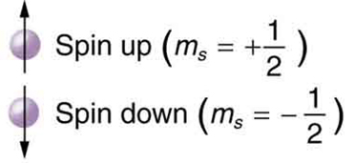Electrons are an example of a type of particle called a **fermion**. Other fermions include protons and neutrons. In addition to their charge and mass, electrons have another fundamental property called **spin**. A particle with spin behaves as though it has some intrinsic angular momentum. This causes each electron to have a small magnetic dipole. Electrons have spin ½, which can be aligned in two possible ways, usually referred to as 'spin up' or 'spin down'. A consequence of the half-integer spin of fermions is that this imposes a constraint on the behavior of a system containing more than one fermion.

This constraint is the **Pauli exclusion principle**, which states that no two fermions can have the exact same set of quantum numbers. It is for this reason that only two electrons can occupy each electron energy level – one electron can have spin up and the other can have spin down, so that they have different spin quantum numbers, even though the electrons have the same energy. Therefore, as Fermions are added to an energy band, they will fill the available states in an energy band just like water fills a bucket. The states with the lowest energy are filled first, followed by the next higher ones.

At absolute zero temperature (*T* = 0 K), the energy levels are all filled up to a maximum energy, which we call the **Fermi level**. No states above the Fermi level are filled. At higher temperature, the transition between completely filled states and completely empty states is gradual rather than abrupt.

These constraints on the behavior of a system of many fermions can be treated statistically. The result is that electrons will be distributed into the available energy levels according to the **Fermi Dirac Distribution**.

**The Fermi-Dirac Distribution Function and Fermi Level**

This distribution describes the occupation probability for a state of energy E at a temperature T. This is the ground state of the *N* electron system at absolute zero. When the temperature is increased, The kinetic energy of the electron gas increases with temperature. Therefore, some energy levels become occupied which were vacant at zero temperature, and some levels become vacant which were occupied at absolute zero. The distribution of electrons among the levels isusually described by the **distribution function, f(E) ,** which is defined as the probability that the level *E* is occupied by an electron. Thus if the level is certainly empty, then*, f*(*E*) = 0, while if it is certainly full, then *f*(*E*) = 1. In general, *f*(*E*) has a value between zero and unity.

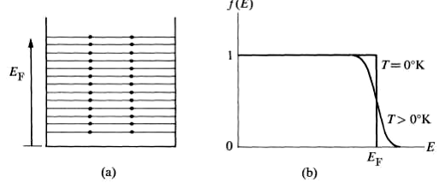

**Fig. 1** (a) Occupation of energy levels according to the Pauli exclusion principle,

(b) The distribution function *f*(*E*)*,* at *T* = 0°K and *T>* 0°K.

It follows from the preceding discussion that the distribution function for electrons at  *T =* 0°K has the form

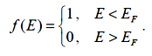

That is, all levels below *EF* are completely filled, and all those above *EF* are completely empty. This function is plotted in Fig. 1(b), which shows the discontinuity at the Fermi energy.

When the system is heated (*T>*0°K), thermal energy excites the electrons. However, all the electrons do not share this energy equally, as would be the case in the classical treatment, because the electrons lying well below the Fermi level *EF* cannot absorb energy. If they did so, they would move to a higher level, which would be already occupied, and hence the exclusion principle would be violated..

Therefore only those electrons close to the Fermi level can be excited, because the levels above *EF* are empty, and hence when those electrons move to a higher level there is no violation of the exclusion principle. Thus only these electrons - which are a small fraction of the total number - are capable of being thermally excited.

The distribution function at non-zero temperature is given by the *Fermi distribution function*.

The conduction band in a piece of semiconductor consists of many available, allowed, empty energy levels. When calculating how many electrons will fill these levels and thus be counted in n, contributing to conductivity, we consider two factors:

• How many energy levels are there within a given range of energy, in our case the conduction band, and

• How likely is it that each level will be populated by an electron.

The likelihood in the second item is given by a probability function called the Fermi-Dirac distribution function. *f(E)* is the probability that a level (orbital) with energy E will be filled by an electron at thermal equilibrium, and the expression is:

 or 

Where: **kB** is Boltzmann’s constant, 8.62×10−5 [eV/K],

**T** is the temperature in degrees Kelvin.

**EF** is called the Fermi energy or Fermi level.

**μ** (the Greek letter mu) is the chemical potential.

This function is also plotted in Fig. 1(b), which shows that it is substantially the same as the distribution at *T* = 0°K, except very close to the Fermi level, where some of the electrons are excited from below *EF* to above it.

The quantity **μ** is called the chemical potential. The chemical potential can be determined in a waythat the total number of electrons in the system is equal to *N*. At absolute   
zero **μ = *EF***.

In order to understand the behavior of electrons at finite temperature qualitatively in metals and pure undoped semiconductors, it is clearly sufficient to treat μ as a constant to a first approximation. With this approximation, the Fermi-Dirac distribution can be plotted at several different temperatures. In the figure below, μ was set at 5 eV.

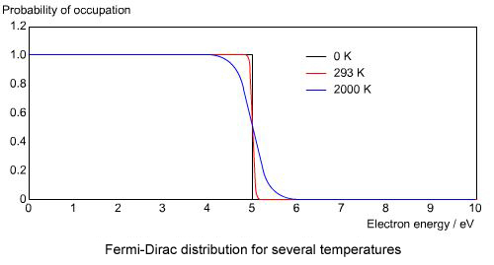

From this figure it is clear that at absolute zero the distribution is a step function. It has the value of 1 for energies below the Fermi energy, and a value of 0 for energies above. For finite temperatures the distribution gets smeared out, as some electrons begin to be thermally excited to energy levels above the chemical potential, μ. The figure shows that at room temperature the distribution function is still not very far from being a step function.

**Example 1**

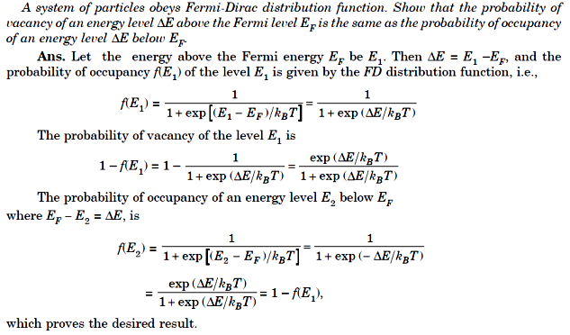

**Meaning of *(1 − f(E))***

Since *f(E1)* is the probability that the energy level *E1* will be filled by an electron, *(1−f(E1))* is the probability that the energy level *E* will be empty. Or, equivalently, if *(E1)* is in the valence band, *(1 − f(E1))* is the probability that the energy level *(E1)* will have a hole.

**Example** 2

To better understand the origin of distribution functions, we now consider a specific system with equidistant energy levels at 0.5, 1.5, 2.5, 3.5, 4.5, 5.5, .... eV. Each energy level can contain two electrons. Since electrons are indistinguishable from each other, no more than two electrons (with opposite spin) can occupy a given energy level. This system contains 20 electrons.

The minimum energy of this system corresponds to the situation here all 20 electrons occupy the ten lowest energy levels without placing more than 2 in any given level. This situation occurs at *T* = 0 K and the total energy equals 100 eV.

Since we are interested in a situation where the temperature is not zero, we arbitrarily set the total energy at 106 eV, which is 6 eV more than the minimum possible energy of this system. This ensures that the thermal energy is not zero so that the system must be at a non-zero temperature.

There are 24 possible and different configurations, which satisfy these particular constraints. Eight of those configurations are shown in the following Figure, where the filled circles represent the electrons:

[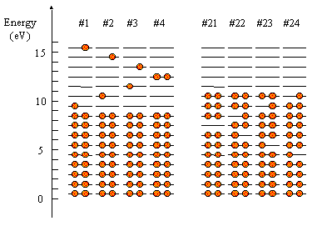](http://ecee.colorado.edu/~bart/book/book/chapter2/ch2_5.htm#fig2_5_3)

Eight of the 24 possible configurations in which 20 electrons can be placed having a total   
energy of 106 eV.

We now apply the basic postulate of statistical thermodynamics, namely that all possible configurations are equally likely to occur. The expected configuration therefore equals the average occupancy of all possible configurations.

The average occupancy of each energy level taken over all (and equally probable) 24 configurations is compared in the Figure to the Fermi-Dirac distribution function. A best fit was obtained using a Fermi energy of 9.998 eV and *kT* = 1.447 eV or   
*T* = 16,800 K. The agreement is surprisingly good considering the small size of this system.

[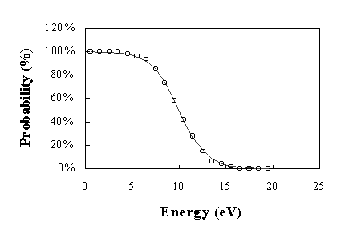](http://ecee.colorado.edu/~bart/book/book/chapter2/ch2_5.htm#fig2_5_4)

Probability versus energy averaged over the 24 possible configurations (circles) fitted with a Fermi-Dirac function (solid line) using *kT* = 1.447 eV and *E*F = 9.998 eV.

**Derivation of the Fermi-Dirac distribution function**

To derive the Fermi-Dirac distribution function, we start from a series of possible energies, labeled *Ei*. At each energy, we can have *gi* possible states and the number of states that are occupied equals *gifi*, where *fi* is the probability of occupying a state at energy *Ei*. We also assume that the number of possible states is very large, so that the discrete nature of the states can be ignored.

The number of possible ways - called configurations - to fit *gi* *fi* electrons in *gi* states, given the restriction that only one electron can occupy each state, equals:

http://ecee.colorado.edu/%7Ebart/book/book/chapter2/gif/eq2_5_6.gif

This equation is obtained by numbering the individual states and exchanging the states rather than the electrons. This yields a total number of *gi*! possible configurations. However since the empty states are all identical, we need to divide by the number of permutations between the empty states, as all permutations cannot be distinguished from each other and can therefore only be counted once. In addition, all the filled states are indistinguishable from each other, so we need to divide also by all permutations between the filled states, namely *gifi*!.

The number of possible ways to fit the electrons in the number of available states is called the multiplicity function.

The multiplicity function for the whole system is the product of the multiplicity functions for each energy *EI*:

http://ecee.colorado.edu/%7Ebart/book/book/chapter2/gif/eq2_5_7.gif

Using Stirling’s approximation, one can eliminate the factorial signs, yielding:

http://ecee.colorado.edu/%7Ebart/book/book/chapter2/gif/eq2_5_8.gif

The total number of electrons in the system equals *N* and the total energy of those *N* electrons equals *U*. These system parameters are related to the number of states at each energy, *gi*, and the probability of occupancy of each state, *fi*, by:

http://ecee.colorado.edu/%7Ebart/book/book/chapter2/gif/eq2_5_9.gif

and

http://ecee.colorado.edu/%7Ebart/book/book/chapter2/gif/eq2_5_10.gif

According to the basic assumption of statistical thermodynamics, all possible configurations are equally probable. The multiplicity function provides the number of configurations for a specific set of occupancy probabilities, *fi*. The multiplicity function sharply peaks at the thermal equilibrium distribution since this is the most likely distribution of the system and must therefore be associated with the largest number of - equally probable - configurations. The occupancy probability in thermal equilibrium is therefore obtained by finding the maximum of the multiplicity function, *W*, while keeping the total energy and the number of electrons constant.

For convenience, we maximize the logarithm of the multiplicity function instead of the multiplicity function itself. According to the Lagrange method of undetermined multipliers, we must maximize the following function:

http://ecee.colorado.edu/%7Ebart/book/book/chapter2/gif/eq2_5_11.gif

where *a* and *b* need to be determined. The maximum of the multiplicity function, *W*, is obtained from:

http://ecee.colorado.edu/%7Ebart/book/book/chapter2/gif/eq2_5_12.gif

which can be solved, yielding:

http://ecee.colorado.edu/%7Ebart/book/book/chapter2/gif/eq2_5_13.gif

|  |
| --- |
| or |

http://ecee.colorado.edu/%7Ebart/book/book/chapter2/gif/eq2_5_14.gif

which can be written in the following form

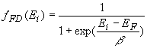

with *β* = *1*/*b* and *EF* = -*a*/*b*. The symbol *EF* was chosen since this constant has units of energy and will be the constant associated with this probability distribution.

Taking the derivative of the total energy, one obtains:

http://ecee.colorado.edu/%7Ebart/book/book/chapter2/gif/eq2_5_16.gif

Using the Lagrange equation, this can be rewritten as:

http://ecee.colorado.edu/%7Ebart/book/book/chapter2/gif/eq2_5_17.gif

Any variation of the energies, *EI*, can only be caused by a change in volume, so that the middle term can be linked to a volume variation *dV*.

http://ecee.colorado.edu/%7Ebart/book/book/chapter2/gif/eq2_5_18.gif

Comparing this to the thermodynamic identity:

http://ecee.colorado.edu/%7Ebart/book/book/chapter2/gif/eq2_5_19.gif

The comparison also identifies the entropy, *S*, as being proportional to the logarithm of the multiplicity function, *W*. The proportionality constant, *k*, is known as Boltzmann’s constant.

The Fermi-Dirac distribution function then becomes:

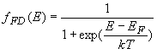

Note that this derivation can only truly be followed if one has prior knowledge of statistical thermodynamics. Those who are well versed in this field can quickly derive the Fermi-Dirac and other distribution functions using the Gibbs sum.

**Impurity distribution functions**

The distribution function of impurities differs from the Fermi-Dirac distribution function even though the particles involved are still Fermions. The difference is due to the fact that an ionized donor energy level still contains one electron with either spin. The donor energy level cannot be empty since this would leave a doubly positively charged atom, which would have energy different from that of the singly ionized donor level. The distribution function for donors therefore differs from the Fermi function and is given by:

http://ecee.colorado.edu/%7Ebart/book/book/chapter2/gif/eq2_5_2.gif

The distribution function for acceptors differs also because of the different possible ways to occupy the acceptor level. The neutral acceptor contains no electrons. The ionized acceptor contains one electron, which can have either spin, while the doubly negatively charged state is not allowed since this would require a different energy. This restriction would yield a factor of 2 in front of the exponential term. In addition, one finds that most commonly used semiconductors have a two-fold degenerate valence band, which causes this factor to increase to four, yielding:

http://ecee.colorado.edu/%7Ebart/book/book/chapter2/gif/eq2_5_3.gif

**Other distribution functions and comparison**

Other distribution functions include the **Bose-Einstein distribution** and the **Maxwell-Boltzmann distribution**. These are briefly discussed below and compared to the Fermi-Dirac distribution function.

The ***Bose-Einstein distribution function*** applies to bosons. Bosons are particles with integer spin and include photons, phonons and a large number of atoms. Bosons do not obey the Pauli exclusion principle so that any number can occupy a single energy level. The Bose-Einstein distribution function is given by:

http://ecee.colorado.edu/%7Ebart/book/book/chapter2/gif/eq2_5_4.gif

This function is only defined for *E* > *E*F.

The ***Maxwell Boltzmann*** applies to non-interacting particles, which can be distinguished from each other. This distribution function is also called the classical distribution function since it provides the probability of occupancy for non-interacting particles at low densities. Atoms in an ideal gas form a typical example of such particles. The Maxwell-Boltzmann distribution function is given by:

http://ecee.colorado.edu/%7Ebart/book/book/chapter2/gif/eq2_5_5.gif

A plot of the three distribution functions, the Fermi-Dirac distribution, the Maxwell-Boltzmann distribution and the Bose-Einstein distribution is shown the following in Figure

[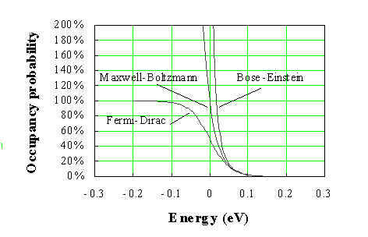](http://ecee.colorado.edu/~bart/book/book/chapter2/ch2_5.htm#fig2_5_1)

Probability of occupancy versus energy of the Fermi-Dirac, the Bose-Einstein and the Maxwell-Boltzmann distribution. The Fermi energy, *E*F, is assumed to be zero.

All three functions are almost equal for large energies (more than a few *kT* beyond the Fermi energy). The Fermi-Dirac distribution reaches a maximum of 100% for energies, which are a few *kT* below the Fermi energy, while the Bose-Einstein distribution diverges at the Fermi energy and has no validity for energies below the Fermi energy.

**Fermi Level in Intrinsic and Extrinsic Semiconductors**

**Fermi level in intrinsic semiconductor:**

At absolute zero temperature intrinsic semiconductor acts as perfect insulator, since the number of holes in valence band is equal to the number of electrons in the conduction band (n = p). Hence, the probability of occupation of energy levels in conduction band and valence band are equal. Therefore, the Fermi level for the intrinsic semiconductor lies in the middle of forbidden band.

If we use the band-symmetry approximation, which assumes that there are equal number of states in equal-sized energy bands at the edges of the conduction and valence bands,  
 n = p implies that there is an equal chance of finding an electron at the conduction band edge as there is of finding a hole at the valence band edge:

*f(EC) = 1 − f(EV)*

From above equation, we can deduce that the Fermi level *EF* must be in the middle of the band gap for an intrinsic semiconductor, as seen in the following Figure. In fact, this level is called the “**intrinsic Fermi level**” and shown by **Ei**:

*Ei = EC − Eg/2 = EV + Eg/2*

where *Eg* is the band gap energy.

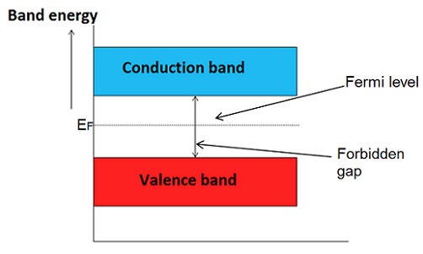

The hole-concentration in the valence band is given as

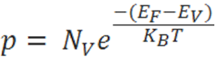

The electron-concentration in the conduction band is given as

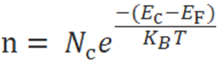

Where: **KB** is the Boltzmann constant

**T** is the absolute temperature of the intrinsic semiconductor

**Nc** is the effective density of states in the conduction band.

**Nv**is the effective density of states in the valence band.

The number of electrons in the conduction band is depends on:

1- effective density of states in the conduction band,

2- the distance of Fermi level from the conduction band.

The number of holes in the valence band is depends on

1- effective density of states in the valence band ,

2- the distance of Fermi level from the valence band.

**For an intrinsic semiconductor**, the electron-carrier concentration is equal to the hole-carrier concentration. It can be written as

p = n = ni

Where: **P** = hole-carrier concentration

**n** = electron-carrier concentration

**ni** = intrinsic carrier concentration

The fermi level for intrinsic semiconductor is given as,

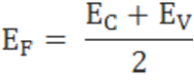

  Where: **EF** is the Fermi level

**EC**is the conduction band

**EV** is the valence band

Therefore, the Fermi level in an intrinsic semiconductor lies in the middle of the forbidden gap.

## Fermi level in extrinsic semiconductor

In extrinsic semiconductor, the number of electrons in the conduction band and the number of holes in the valence band are not equal. Hence, the probability of occupation of energy levels in conduction band and valence band are not equal. Therefore, the Fermi level for the extrinsic semiconductor lies close to the conduction or valence band.

## Fermi level in n-type semiconductor

For an n-type semiconductor, there are more electrons in the conduction band than there are holes in the valence band *(Each pentavalent impurity donates a* [*free electron*](http://www.physics-and-radio-electronics.com/electronic-devices-and-circuits/introduction/free-electrons.html)*. The addition of pentavalent impurity creates large number of free electrons in the conduction band).*

This also implies that the probability of finding an electron near the conduction band edge is larger than the probability of finding a hole at the valence band edge. Therefore, the Fermi level is closer to the conduction band in an n-type semiconductor

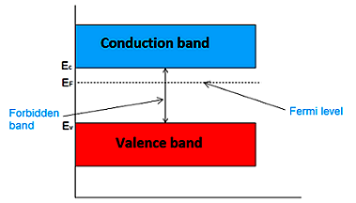

The Fermi level for n-type semiconductor is given as

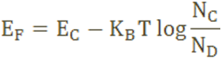

**Where**: **EF** is the fermi level.

**EC**is the conduction band.

**KB** is the Boltzmann constant.

**T** is the absolute temperature.

**NC** is the effective density of states in the conduction band.

**ND** is the concentration of donar atoms.

## Fermi level in p-type semiconductor

For a p-type semiconductor, there are more holes in the valence band than there are electrons in the conduction band *(Each trivalent impurity creates a hole in the valence band and ready to accept an electron. The addition of trivalent impurity creates large number of holes in the valence band).*

This also implies that the probability of finding an electron near the conduction band edge is smaller than the probability of finding a hole at the valence band edge. Therefore, the Fermi level is closer to the valence band in an n-type semiconductor.

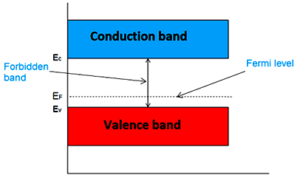

At room temperature, the number of holes in the valence band is greater than the number of electrons in the conduction band. Hence, the probability of occupation of energy levels by the holes in the valence band is greater than the probability of occupation of energy levels by the electrons in the conduction band. Therefore, the Fermi level in the p-type semiconductor lies close to the valence band. The Fermi level for p-type semiconductor is given as

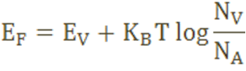

**Where:** **NV** is the effective density of states in the valence band.

**NA** is the concentration of acceptor atoms.

## The following relationships summarize Fermi level in extrinsic semiconductor:

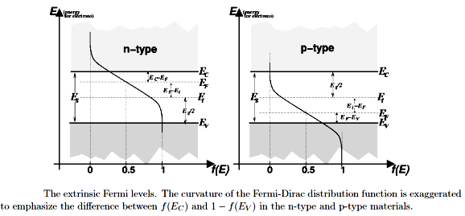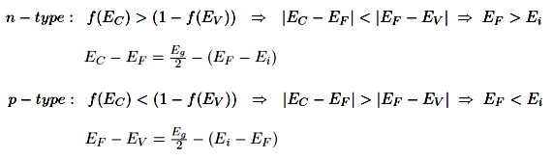

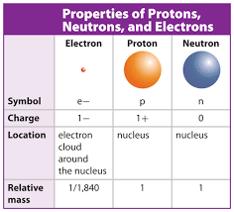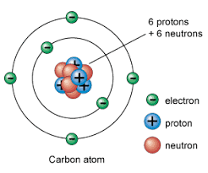**اشكال توضيحية اضافية:**

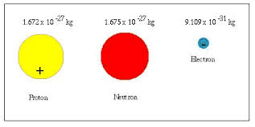

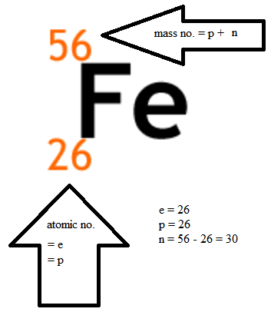

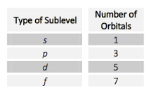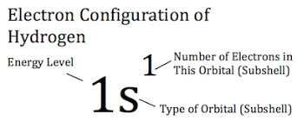

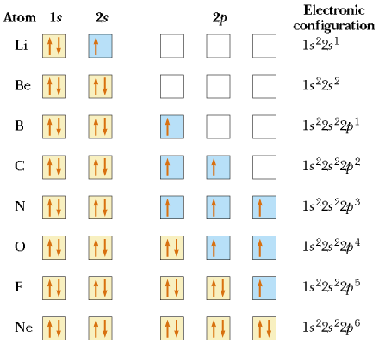

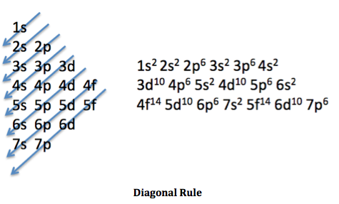

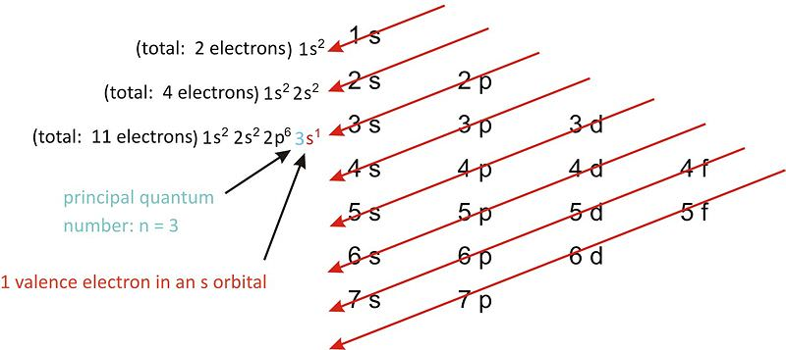

The illustration below shows the implications of the Fermi function for the electrical conductivity of a [semiconductor](http://hyperphysics.phy-astr.gsu.edu/hbase/Solids/intrin.html#c1). The [band theory of solids](http://hyperphysics.phy-astr.gsu.edu/hbase/Solids/band.html#c5) gives the picture that there is a sizable gap between the Fermi level and the conduction band of the semiconductor. At higher temperatures, a larger fraction of the electrons can bridge this gap and participate in electrical conduction

