Mock Assessment 2 Report
(Rename this file as: LabNo_Name_Admin_MockAssm2)
User accounts for testing
username | password | remarks
hein | hlh123
linn | hlh123
htet | hlh123

User Authentication (Examples)

Register User
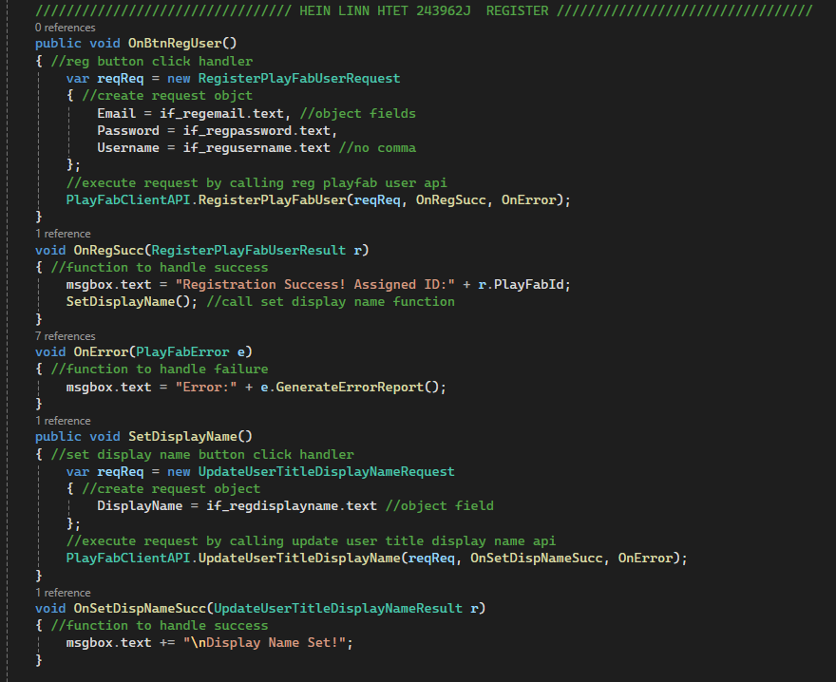
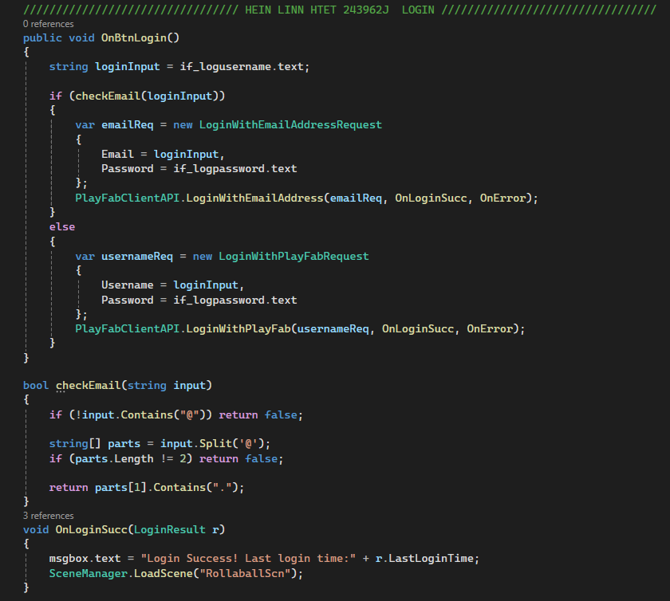
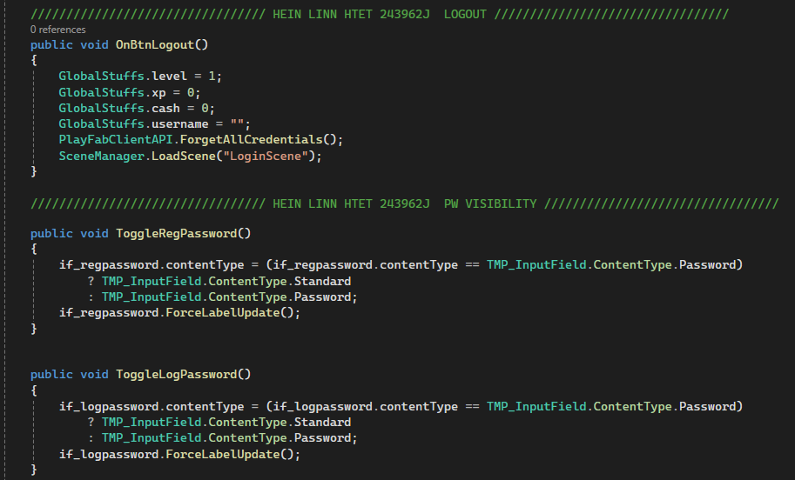
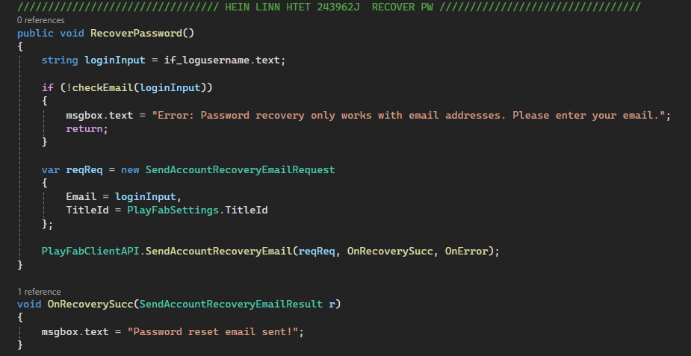
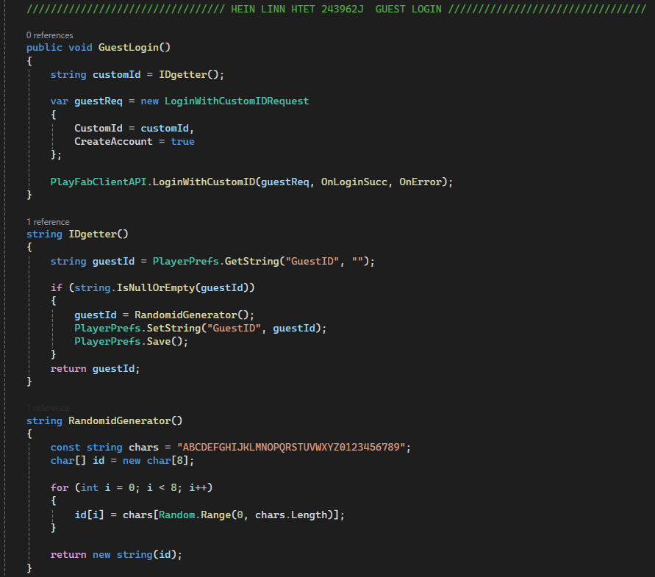
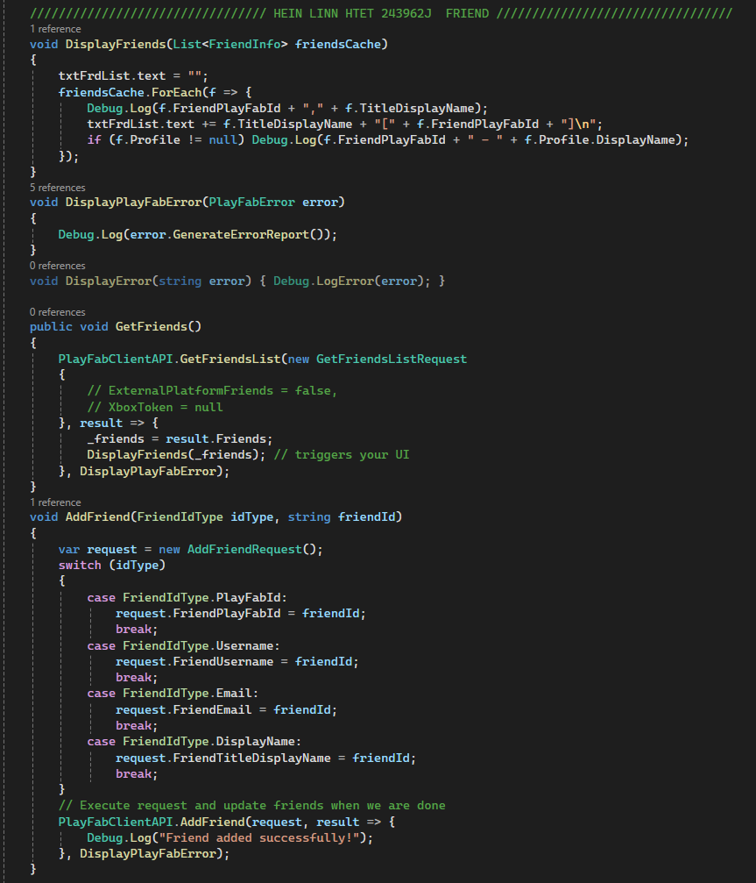
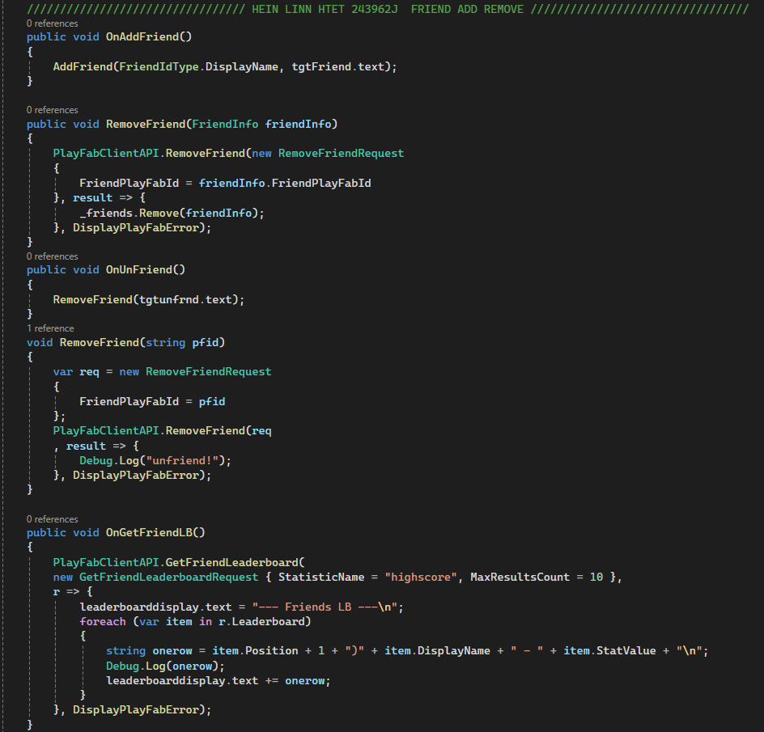
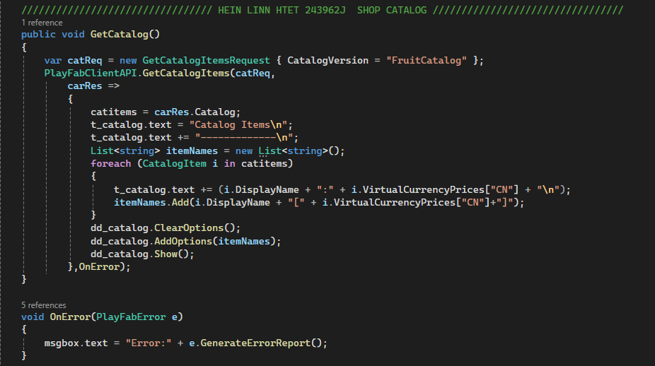
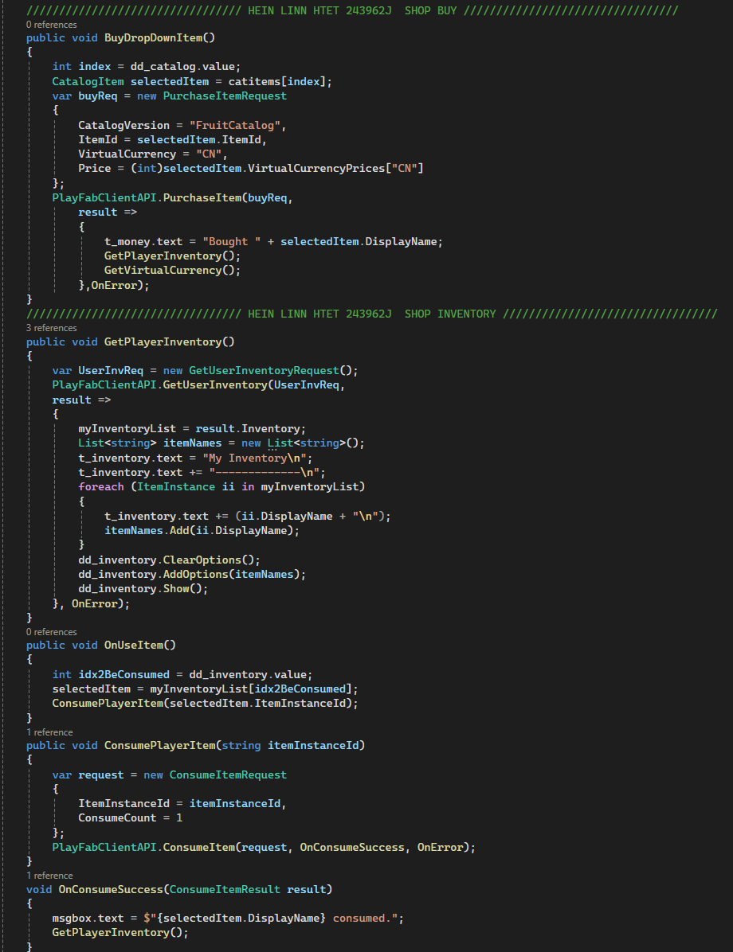
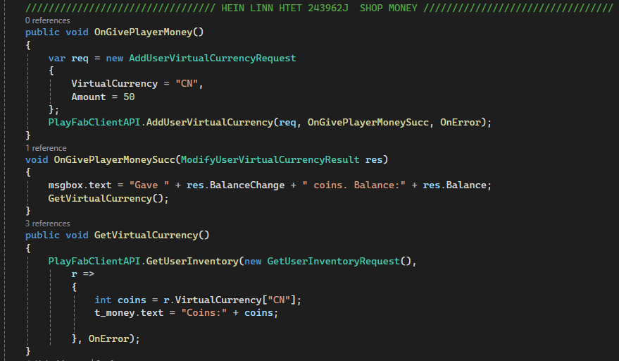
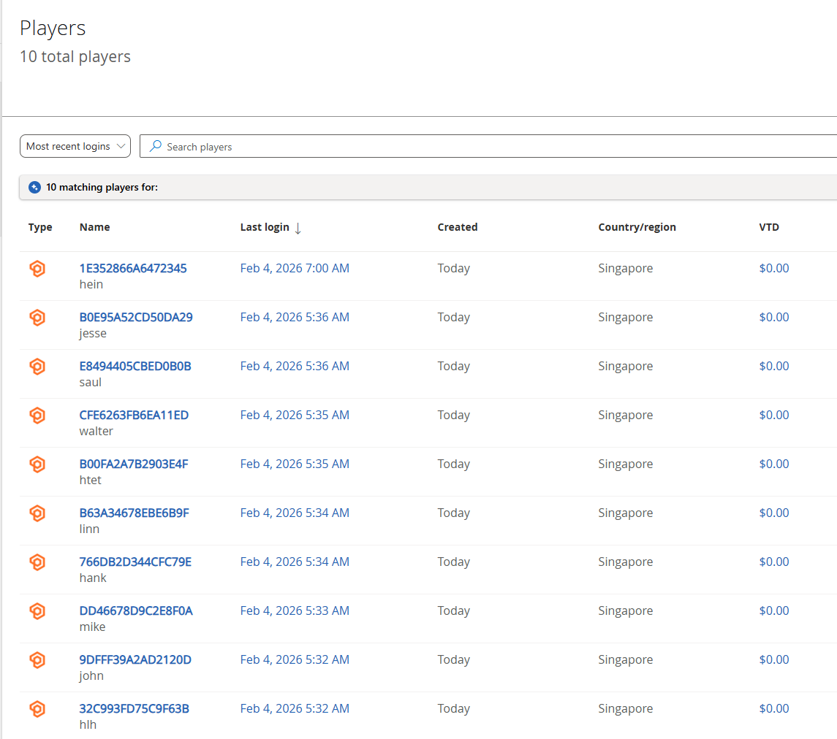
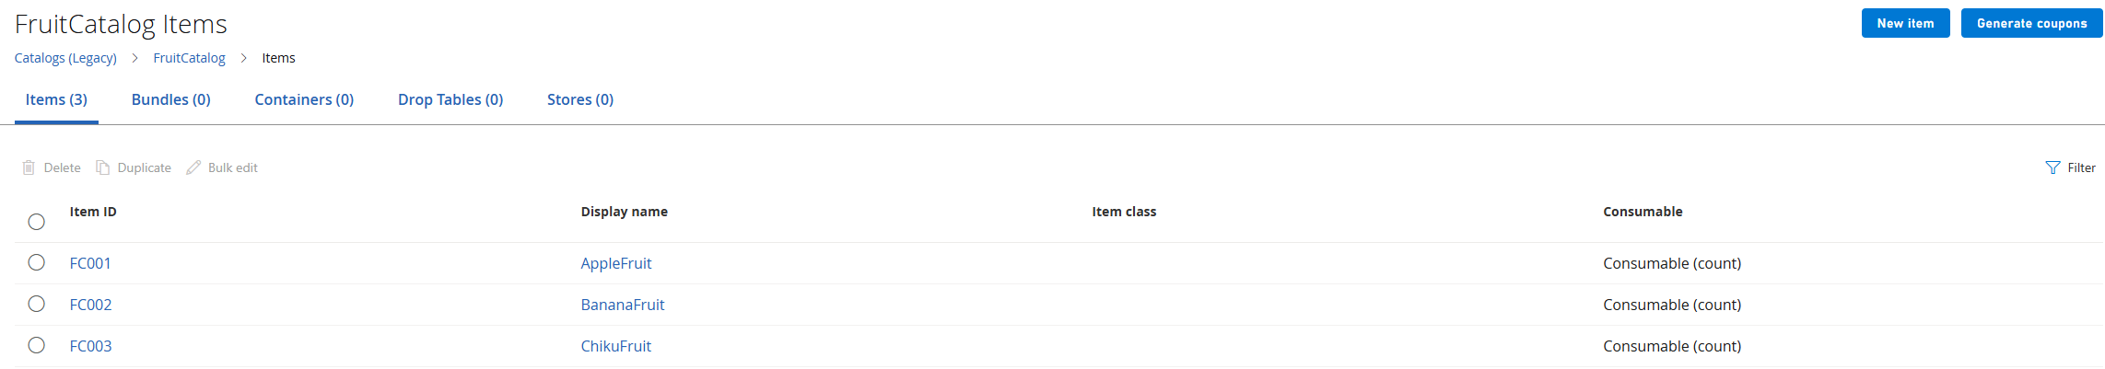
(Actual Gameplay Screenshot)

Login User

Guest/Device Login

Password Reset
- Logout

Leaderboard Features

Leaderboard Update

Retrieve Global Leaderboard

Retrieve aroundme Leaderboard*

Data
- Title Data
- Player Data

In-Game Economy
- Virtual Currency
- Catalog/Store/Shop
- Add Money
- Buying
- Inventory

Friends
- Add Friends
- Remove Friends
- List Friends
- Friends Leaderboard

