Facebook Integration

Please be following instruction

This doc is exactly for your needs. Reading it will guide you get data about Facebook Integration, so you can follow by doing.

# Requirements To integrate Facebook and OCRH

1. Facebook Developer Account
2. Facebook Developer App
3. Setup Facebook Login Permission
4. Adding Permission to Graph API
5. Create Shop in Commerce Manager
6. Configure Page Messenger to add Ecommerce
7. Facebook Developer Account
   1. **Login** Facebook with your account
   2. Go to <https://developers.facebook.com>
   3. **Click** “Get Started“
   4. Please **Check** “I agree to receive marketing-related electronic communication …… “
   5. **Confirm** Email
      * 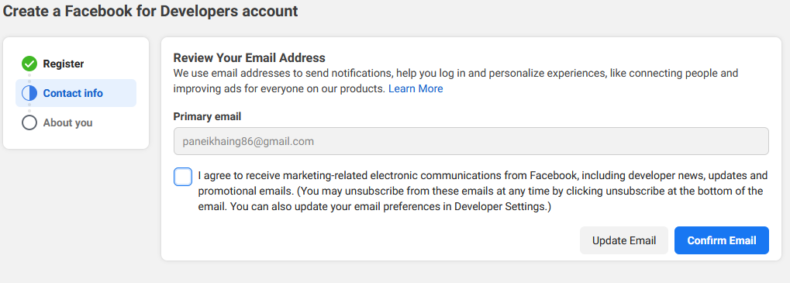
   6. Next , **Check** “ Other “ for about you
   7. Next ,Complete Registration
8. Facebook Developer App
   1. Go to <https://developers.facebook.com>
   2. **Click** “Create App“ button
   3. Next , **Choose** “Business“ in Select an app type
   4. Next , **Fill** the following
      * Display Name

Type “app name” you want to

* + - Business Account is optional
  1. **Click** “Create App“ button
  2. **Click** “Setting” 🡪 “Basic” and Fill the following
     + Private Policy URL

Eg: https://ocrhdev.acedatasystems.com:96/

* + - Terms of Service URL

Eg: https://ocrhdev.acedatasystems.com:96/

* + - App icon

Choose “icon” for your app

* + - Category

Business and pages

* 1. **Copy** “App ID” and **Insert** data in “Facebook Information” entry of OCRH Website

1. Setup Facebook Login Permission
   1. **Click** “Setup” of Facebook Login Product in “Add products to your app”
   2. After that, “Facebook Login” is one of your product in your app
   3. **Click** “Setting” of Facebook Login

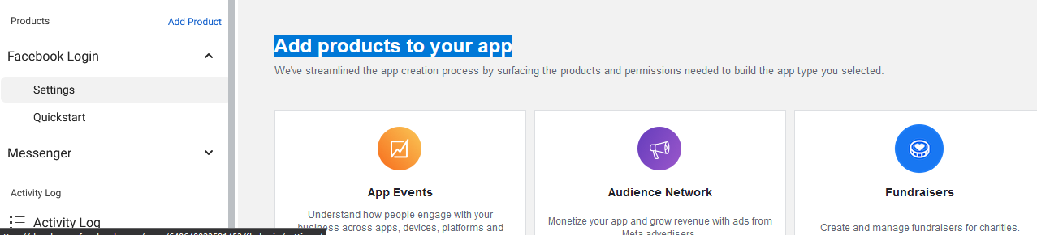

* 1. **Click** “Get Advanced Access”



* 1. In “Permission and Features”
     + **Click** “Get Advanced Access” in public_profile
     + 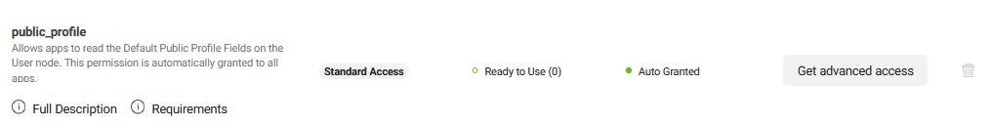
     + Agree and Confirm.
     + ** “Your app has standard access to public_profile” warning will be disappear.
     + In Facebook Login Setting, **Switch** “Login with the javascript SDK” to **Yes**
     + **Fill** “ Allowed Domains for the javascript SDK”
       - 1. Eg: https://ocrhdev.acedatasystems.com:96/
     + **Click** “Save Changes”
     + Data use checkup
       1. **Click** “Get Started”
       2. **Check** “I certify that any use of public_profile is in compliance ….” And **continue**
       3. **Check** “I certify compliance with the Facebook Platform Terms ….” And **continue**
       4. **Submit**
       5. Data use checkup is **complete**

1. Adding Permission To Graph API
   1. Go to <https://developers.facebook.com/>
   2. **Click** “My Apps”
   3. **Point** to “Tools” and **Click** “Graph API Explorer”
   4. First of all, you will see like this
   5. **Generate** Access Token
      * To get Access Token
   6. Meta App
      * Facebook App Name
   7. User Or Page
      * Using API for user Or Page
   8. Permissions
      * Permissions list for API

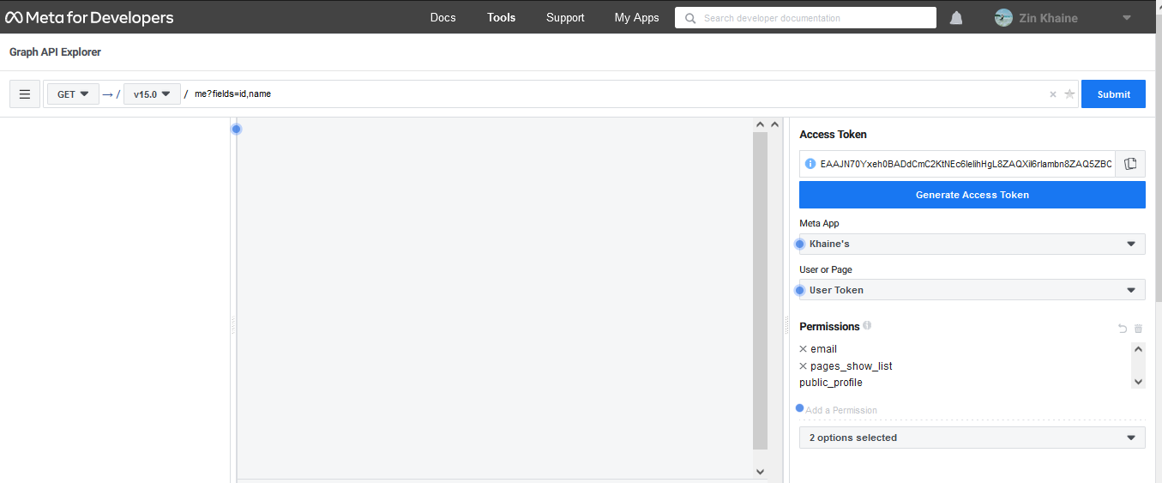

* 1. Then, **Click** “User Token” and **Click** “Get Page Access Token”
  2. **Choose** “your Page” to connect to your Facebook App
  3. After **Connect** to your page , you can select your page in “User Or Page” Combo

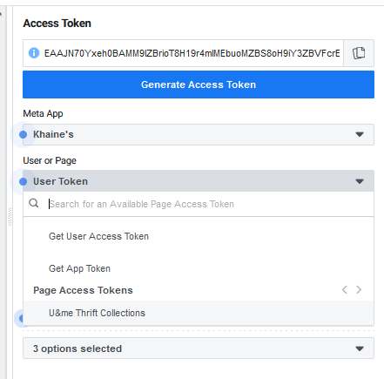

* 1. After **choose** your page, **Login** into your account, you can **add** permission to your page.
  2. **Add** the following permissions
  3. Under “User Data Permissions”
     + Add “user_messenger_contact”
  4. Under “Events Goups Pages”
     + Add “business_management”
     + “pages_manage_engagement”
     + “pages_manage_metadata”
     + “pages_manage_posts”
     + “pages_messaging”
     + “pages_read_engagement”
     + “pages_read_user_content”
     + “pages_show_list”
  5. Under “Other”
     + Add “catalog_management”
     + “publish_video”
     + “read_insights”
  6. And then, **Click** “Generate Access Token” button for your selected permissions request
  7. And **Click** “Continue”

1. Create Shop in Commerce Manager
   1. Go To <https://business.facebook.com/commerce>
   2. **Click** “Get Started”

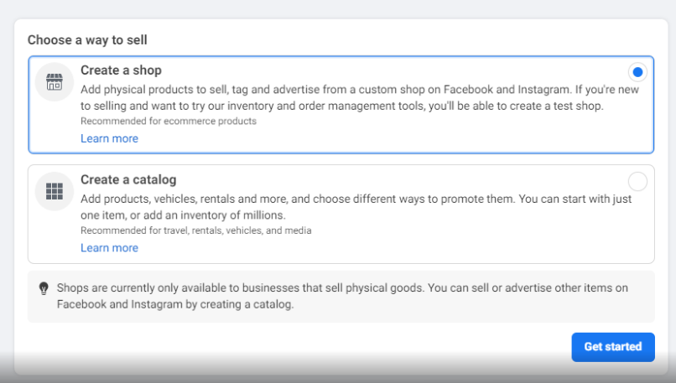

* 1. **Choose** “Facebook” and **click** “Next”

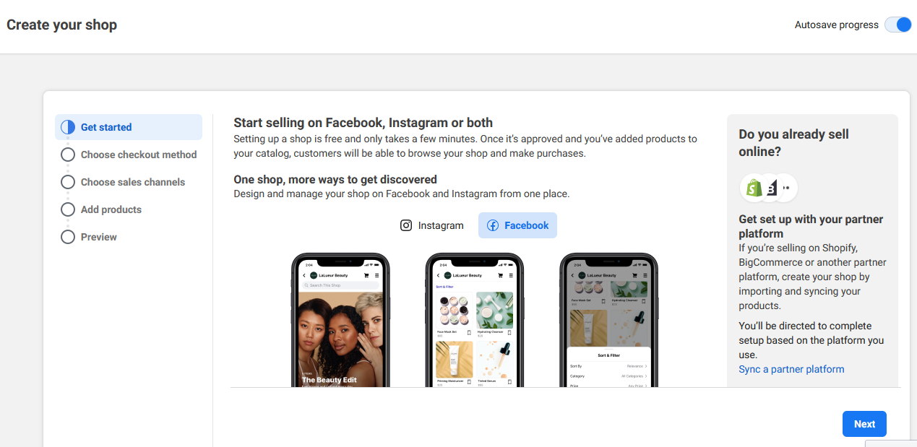

* 1. **Choose** “Checkout on another website” and **click** “Next”
  2. **Choose** your page in “Where do you want to sell from?” and **click** “Next”
  3. **Click** “Create a new Business Account” and **click** “Next”
  4. **Fill** and **click** “Create”
     + Business Manager Account Name
     + Business Email
  5. **Choose** “Create new Catalog” and **fill** “Catalog Name” and **click** “Next”
  6. In “ Where do you ship to “, **Choose** “Myanmar” and **click** “Next”
  7. **Check** “ Seller Agreement” and **click** “Finish Setup”

**After that, you will add products to Catalog**

* 1. **Click** “ Add items” to add products to catalog

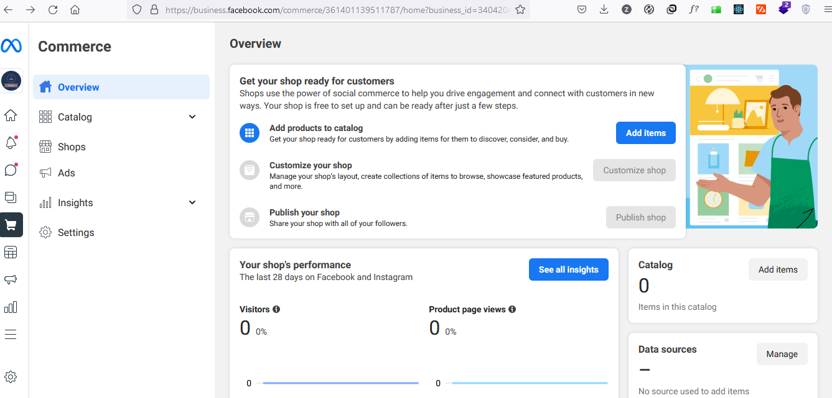

* 1. **Choose** “Data feed” and **click** “Next”
  2. **Click** “get started”
  3. **Choose** “Yes” in “ Create a new data feed” and **click** “Next”
  4. In “ Choose how to upload your file “, **Choose** “ Use a URL” and **fill** your OCRH Commerce URL

<https://ocrhdev.acedatasystems.com:96/FacebookShopBulkFile/ShopItems.csv>

and **click** “Next”

* 1. And,Set your schedule hour with your choice and **click** “Next”
     + Hourly,Daily,Weekly
  2. **Click** “ Save Feed and Upload”

1. Create Shop in Facebook
   1. Firstly, Facebook Page does not contain “Shop” Tag .

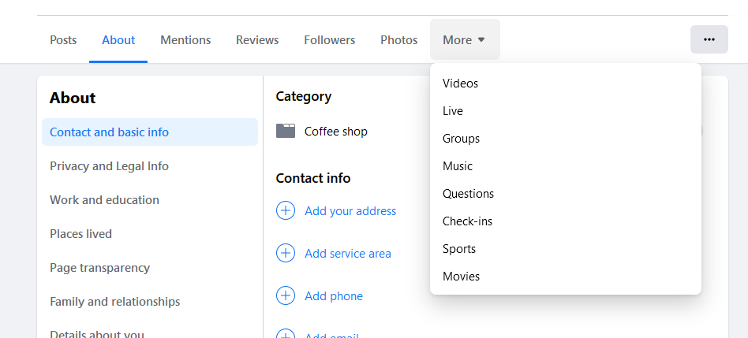

* 1. **Go to** “ Commerce Manager “
  2. **Click** “ Catalog Items “ you already created.

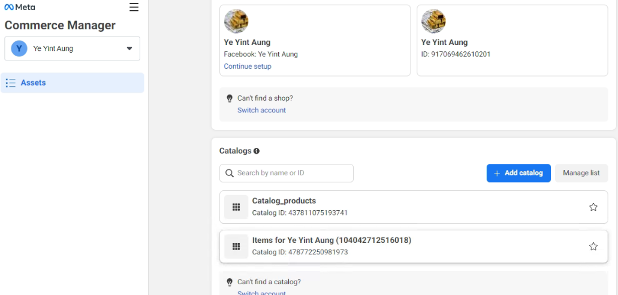

* 1. Click “ Explore”

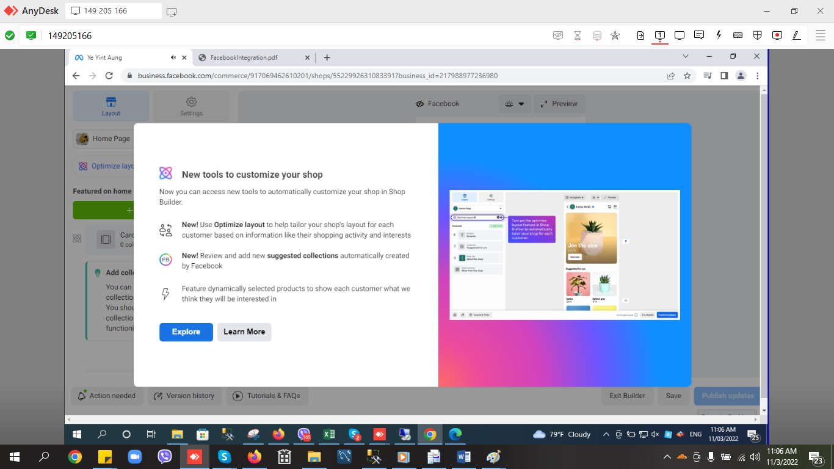

* 1. Choose “ Data Feed” Method and click Next.

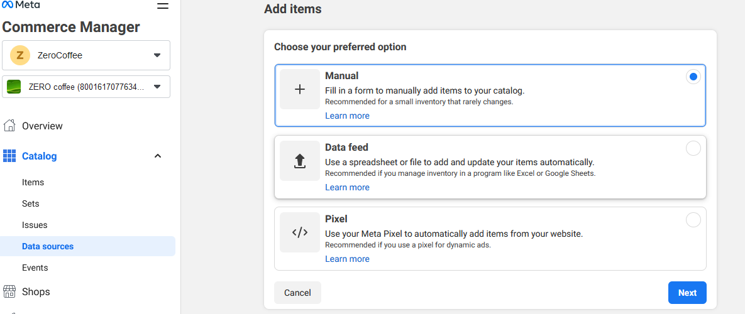

* 1. Click “ Get Started “ for data feed upload

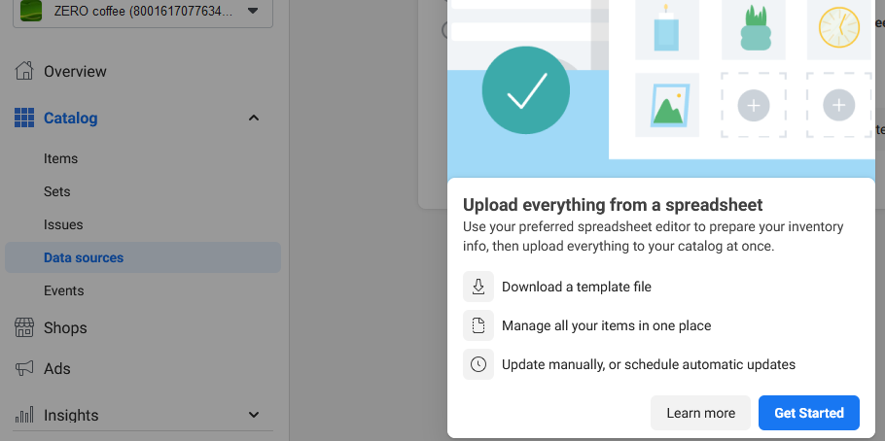

* 1. **Choose** “Yes” in “ Create a new data feed” and **click** “Next”
  2. In “ Choose how to upload your file “, **Choose** “ Use a URL” and **fill** your OCRH Commerce URL

<https://ocrhdev.acedatasystems.com:96/FacebookShopBulkFile/ShopItems.csv>

and **click** “Next”

* 1. And,Set your schedule hour with your choice and **click** “Next”
     + Hourly,Daily,Weekly
  2. **Click** “ Save Feed and Upload”

W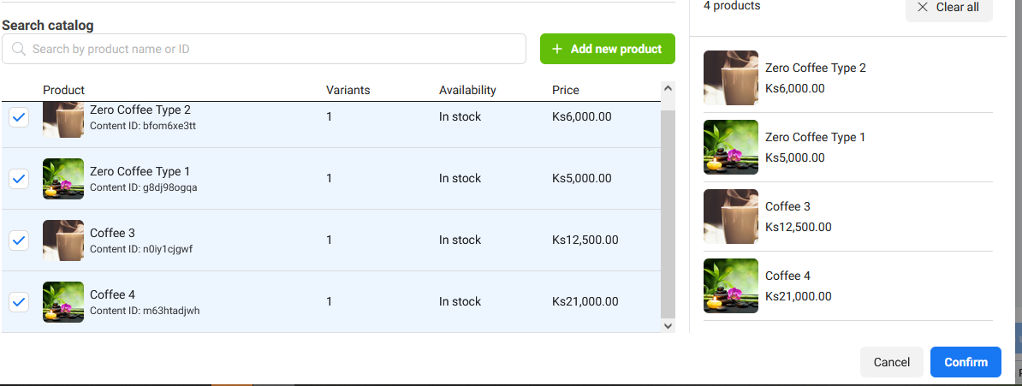

1. Configure Page Messenger to add Ecommerce
   1. Go To your page => Setting

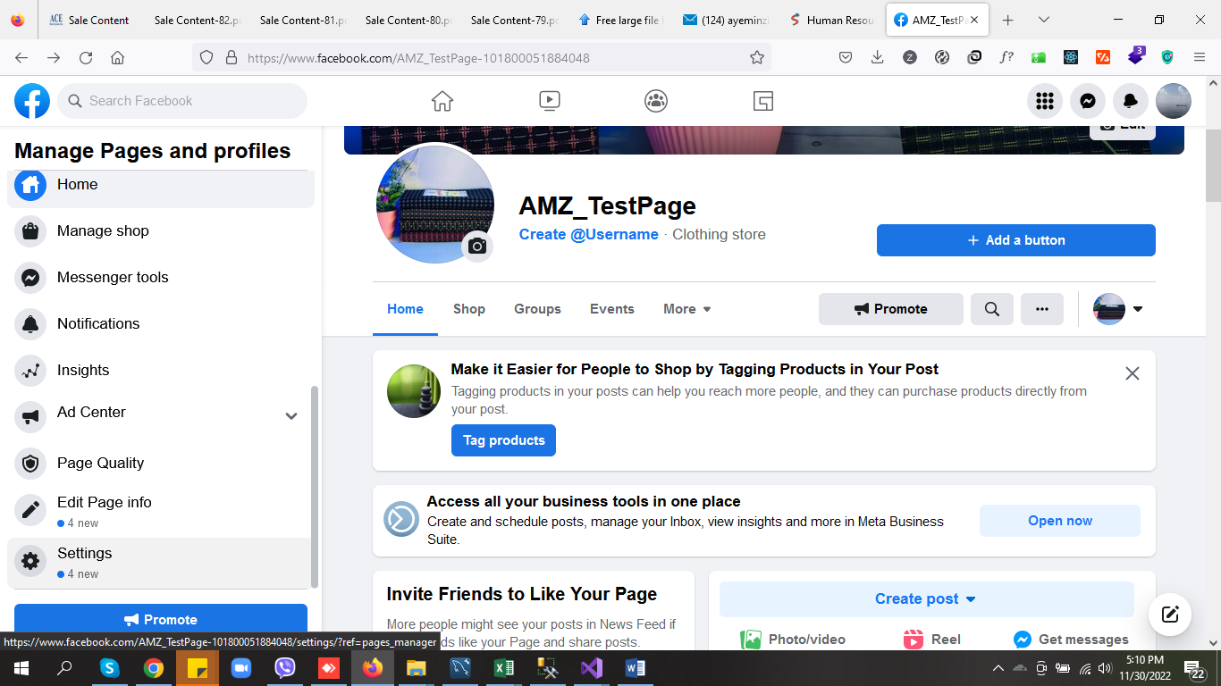

* 1. **Click** “Messaging”
  2. **At “**Add Messenger to your website**” click “**Get Started**”** and it will bring you “Business.facebook.com”
  3. At “Setup your Chat Plugin” **Click** “Setup”

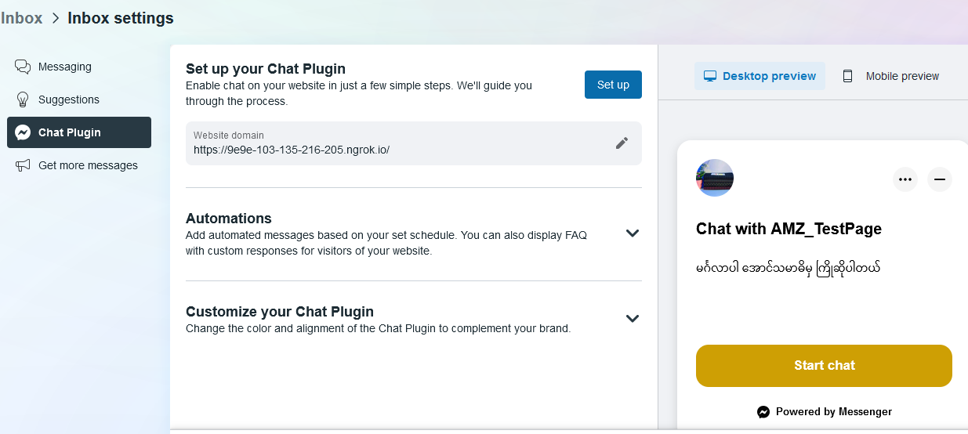

* 1. At “Pick a setup method” **click** “ Standard”
  2. At “Set Language” default is “English” .So, **click** “ Save & Continue “
  3. Add Domain of your Ecommerce , **click** “ Save & Continue “
     + Eg. <https://ocrhdev.acedatasystems.com:96>
  4. **Click** “ Copy Code” and **click** “Next”
     + This code is already use in project
  5. Finish