TITLE: Hotel Reservation System (BookHaven)

NAMES OF THE TEAM: Corpuz, Heinrich John I
Ronquillo, Jessa Mae Y.
Marquez, Mark Joseph A.

INTRODUCTON
BookHaven is a web-based hotel reservation system designed to make booking easier for guests and management tasks simpler for hotel staff. It allows guests to view available rooms, check prices, and book directly online. For the hotel staff (admin), it provides tools to manage room listings, confirm or cancel bookings, and keep track of guest records.

PURPOSE AND DESCRIPTION
Target Clients:
- Hotels or inns that want an online booking system.
- Guests who prefer to reserve rooms easily through their phones or computers.
Problems and Issues:
- Manual booking can lead to double-bookings or lost records.
- Guests need to call or visit the hotel just to reserve a room.
- Staff may have a hard time tracking available rooms and managing guest information.
Solutions Provided by BookHaven:
- Guests can book rooms online anytime.
- The system shows real-time room availability.
- Admins can manage and update room listings and bookings in one place.
- Guests can cancel or print their booking receipts easily.

USERS, ROLES AND PRIVILEGES IN THE DEVELOPED SYSTEM
Guest (User):
- Can register and log in.
- Can view available rooms with details and prices.
- Can book rooms for specific dates.
- Can cancel their bookings.
- Can print booking receipts.
Admin (Hotel Staff):
- Can log in to the admin dashboard.
- Can add, edit, or delete room details.
- Can confirm, cancel, or view booking details.
- Can view the list of registered guests and their transactions.

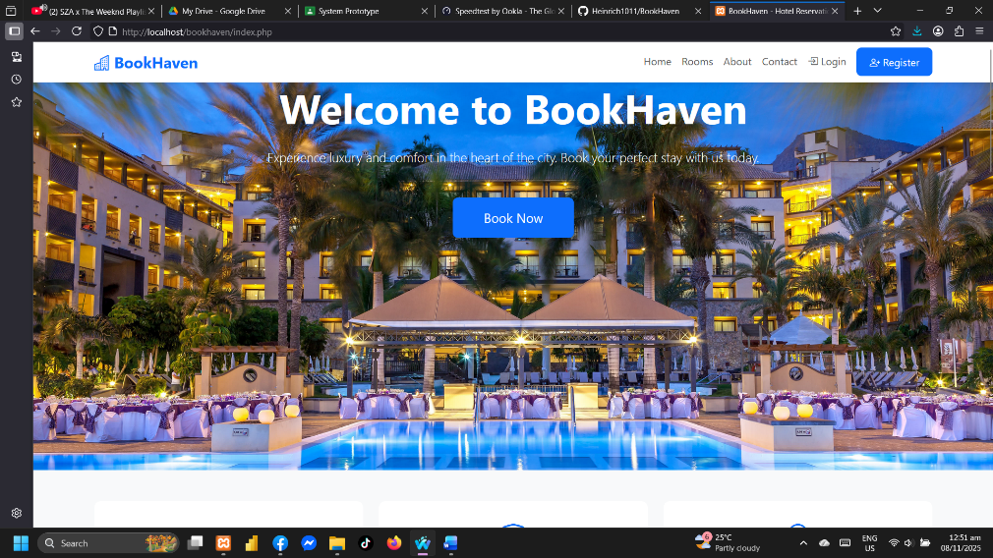
SYSTEM FEATURES
This is the homepage of our system. When a user searched our website, this is the first page that the user will see. This serves as our landing page.

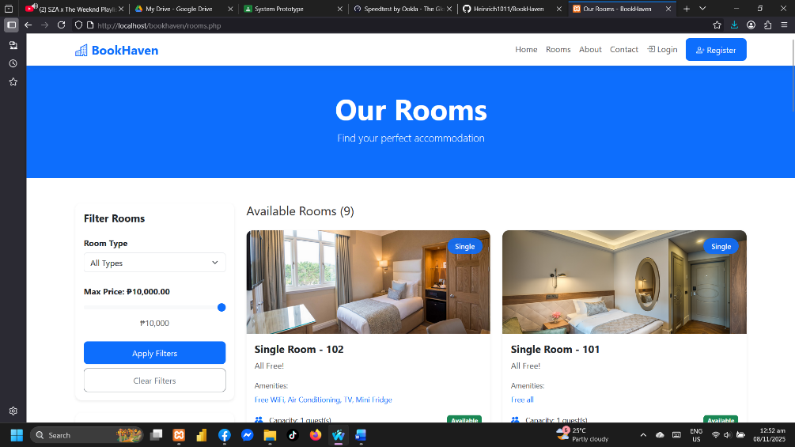
This is our Room section, where users/guests can see all rooms, whether it is occupied, if it is under maintenance, or available. The guest can see the full description of each room including their price, capacity, amenities, etc.

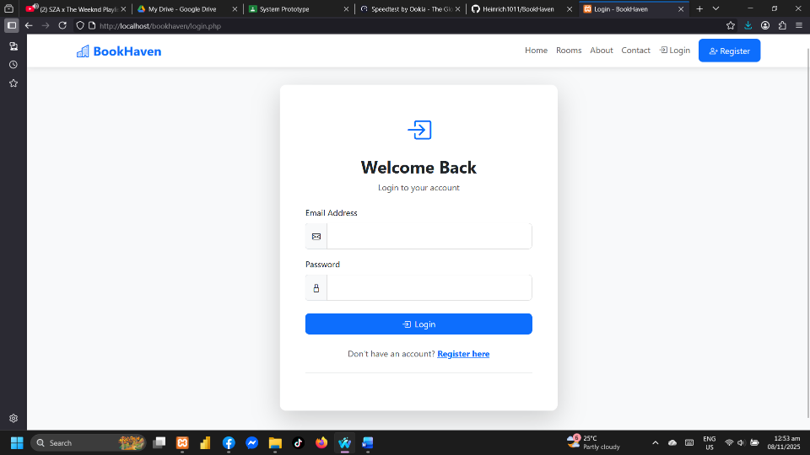
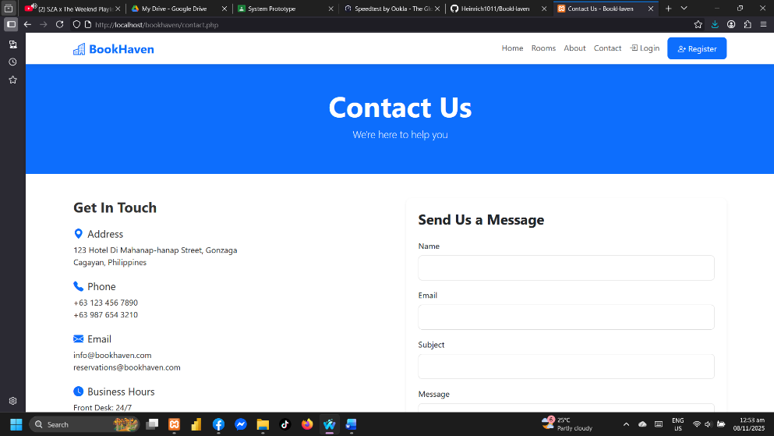
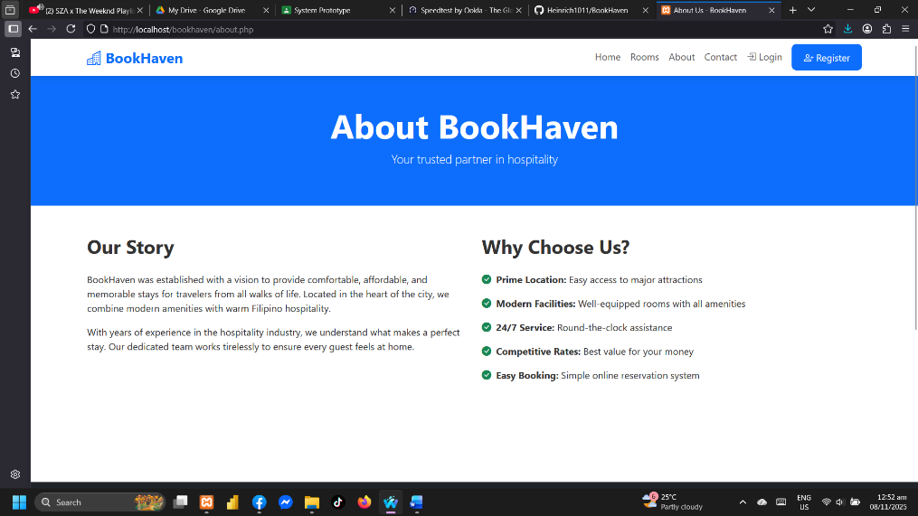
The Login section lets users securely access their accounts. By entering their email and password, they can sign in to manage their profile, view information, or use personalized features on the website.
The Contact Us section allows visitors to easily get in touch with us. It includes our email, phone number, and a message form for questions, feedback, or support. This helps users connect directly and receive quick assistance.
On About section, you can see there the History of the BookHaven itself and what the BookHaven all about.

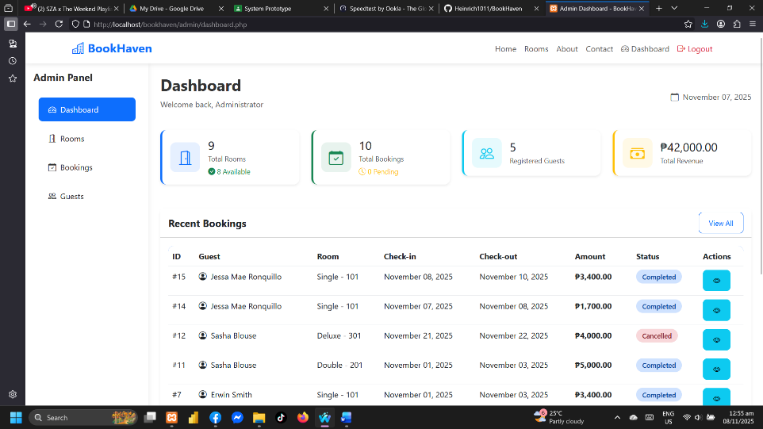
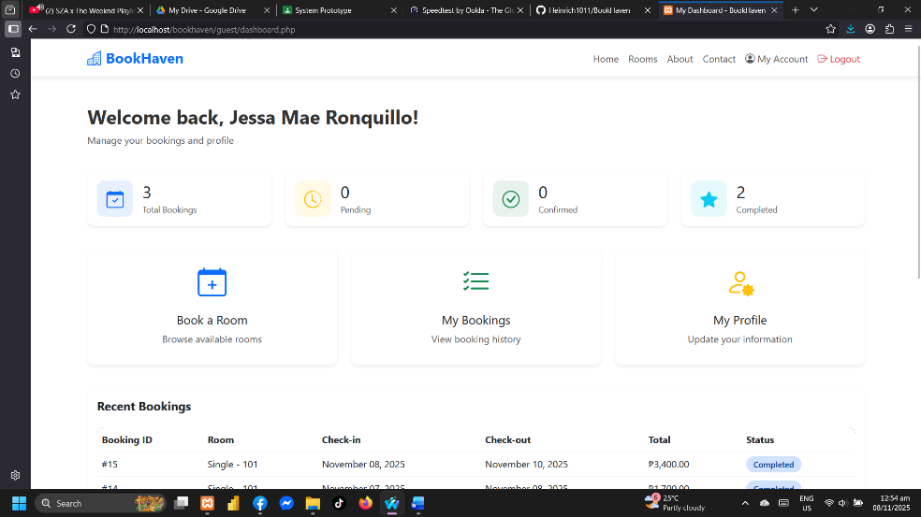
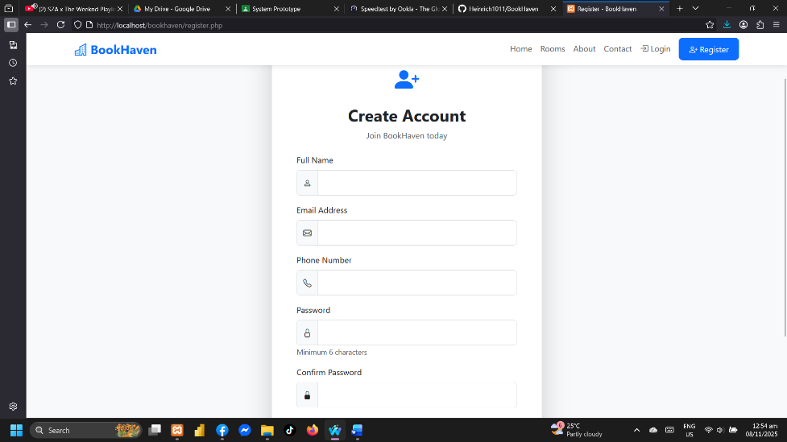
The Guest Dashboard gives visitors a simple view of the website’s features without needing to log in. Guests can browse information, explore services, and get an overview of what the site offers before creating an account.
The Guest Dashboard gives visitors a simple view of the website’s features without needing to log in. Guests can browse information, explore services, and get an overview of what the site offers before creating an account.
The Register section allows new users to create an account. By filling out a simple form with their details, they can sign up to access exclusive features and personalized services on the website.

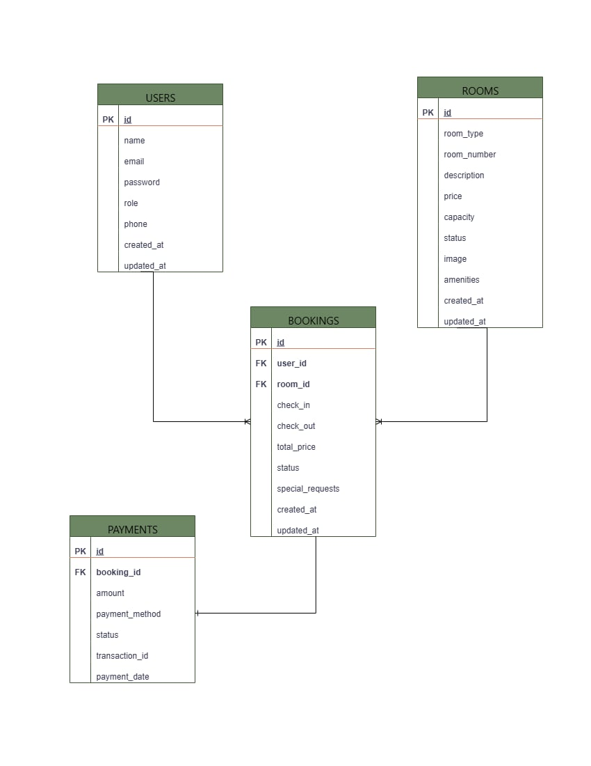
ENTITY RELATIONSHIP DIAGRAM (ERD) OF THE SYSTEM

GITHUB LINK TO THE SYSTEM
Link: https://github.com/Heinrich1011/BookHaven

VIDEO PRESENTATION LINK OF THE SYSTEM
Link: https://drive.google.com/file/d/1B4hJ0xPmq67HsxvDRgzHPJu_G1QP9Jqq/view?usp=drive_link

