Propagation Path Loss Modeling in Stacked Containers Environments

Y.C Huanga, L.Y Tianb, C.Q XUc*

aInstitute for Sensing and Navigation, Shanghai, P.R.China, ianhuang15@outlook.com;

bInstitute for Sensing and Navigation, Shanghai, P.R.China, 00555-9642

* Corresponding author: [XXXXXXX@163.com](mailto:XXXXXXX@163.com)

AbstracT

The container terminals and carriers are regarded as a hard wireless enviroment, because of the reflection caused by the metalic walls of container, the resulting multipath effect, and also the shadow effect caused by the corners. Quality of the received signal would be deteriorated while propagating through the space between containers.However, few researches focused on the propagation characteristics within those intervals. In this paper, the propagation environment of the stacked containers have been further studied via commertial electromagnetic simulation software, and a path loss model based on street canyon wireless propagation model are then proposed.

**Keywords:** path loss, Wireless Communication, stacked containers, HFSS

# INTRODUCTION

With the rapid development of logistics industry in the globalization context, the scale of container freight as its main form is also expanding gradually. Thanks to the complete standardization of containers, the logistics industry has established a series of container-centered logistics systems,such as marine, highway, railway and multimodal transportation. So that containers undertake more than 80$\%$ of the global trade and transportation[1]. In order to cope with the rapid growth of the number of orders and containers, as well as the security problems, management, transportation efficiency and service quality problems brought by them, one of the effective ways is to establish an efficient electronic container supervision system. Nowadays, based on the available radiocommunication standards(GSM/GPRS, UMTS, TETRA, WiFi, WiMAX, ZigBee, Bluetooth, many different RFID systems or other unlicensed frequency band solutions), various wireless communication systems with operating frequencies ranging from 0.4GHz to 5GHz have been applied in almost all major container ports[2]. However, the radio wave propagation characteristics in densely packed and stacked containers have not been widely studied.

Radio wave propagation characteristics or radio frequency channel characteristics are critical knowledge for reliability in the design of wireless systems, which can improve the service quality in industrial environments such as personnel communication, emergency positioning, and M2M communication. The storage yard environment where containers are densely placed is considered to be a wireless transmission scene with relatively harsh environment. In this scenario, containers made of alloy steel constantly reflect wireless signals, making the receiver affected by multipath effect. Secondly, the densely placed containers form many obstacles on the propagation path, resulting in shadow fading at the receiver end. In addition, container yard is an outdoor transmission environment, which can be affected by atmospheric activities, climate change and other factors. At the same time, the stacking of containers in the yard will change over time, and the channel characteristics will change accordingly.

## Related Works

In recent years, some researches based on actual measurement were conducted on radio propagation characteristic in container terminal environment.Katulski et al.[3]and Ambroziak et al.[2]carried out a series of measurements and proposed a novel empirical model to represent the features of links between transmitters outside the stacking area and the receivers within it in DCT Gdansk Container Terminal(Poland).There are various channel models for industrial environments, but less of them considered the outdoor scenarios.Thus the statistical-tuned version of the well-known propagation models for urban areas are usually used in outdoor environments just like container terminal.Ambroziak[4]further fitted the same data with several generic models applied to urban environments.The comparisons of their performance were also provided.He then statistically tuned the Walfisch-Ikegami model[5] and took the different locations of the storage site into account.Finally a new empirical model considering more parameters was then proposed[6].

Ferreira et al.[7]further studied the characteristic of slow and fast fading components of the path loss and proposed a propagation model of container terminal in the case of mobile communication. The result shows that the slow and fast fading component subjects to Lognormal and Nakagami Distribution respectively.

The works above has gained the knowledge of basic propagation characteristics in the overall container terminal environment. However, it is more necessary to consider the communication environment within stacked containers when the Internet-of-Things(IoT) applications are deployed within the terminal. Tanghe et al.[8] and Ruckebusch et al.[9]analyzed the intra-,inter- and extra-container links. They then proposed the propagation model for two different stack scenario,i.e. row stacking and block stacking.

Their works still did not consider the propagation characteristics of containers in the middle of container stacks. Nevertheless,the actual measurement in the stack requires a certain number of containers to be placed in some specific schemes,which brings practical difficulties.Computer simulation software, as a kind of technology to solve the theoretical electromagnetic field through the Maxwell Equations, is a solution with many advantages. Computer simulation has been widely used in researches of radio wave propagation characteristics under various scenarios. Azpilicueta et al.[10] used a 3d Ray Launching simulation system based on Ray Tracing and Geometric Diffraction Theory to evaluate the radio wave propagation in the railway carriage. The technology is especially popular in the field of Human Body Communication(HBC) or Vivo Communication[11]-[15]. In the container environment, Jarma et al.[16]used a wireless LAN design tool named WILDE to study the metal shielding and waveguide effect of propagation path. They provided a lot of information for understanding the characteristics of inter-container communication inside the stacks,while no specific analytical model is proposed.

In this paper, the propagation characteristics of radio waves with working frequency of 433MHz and 868MHz in stacked containers are studied when the transmitters are located at the midpoint of width side, the top corner point and the midpoint of height side. Based on the propagation model recommended by the International Telecommunication Union (ITU), the radio wave propagation model in the interval between adjacent containers is proposed by utilizing linear regression method.

This paper is organized as follows. In Section \Rmnum{2}, the design of simulation environment is described. Section \Rmnum{3} give the analytical model and parameters derived by linear regression. Section \Rmnum{4} presents and evaluates the fitting performance of the model. Finally, the conclusions are drawn in Section \Rmnum{5}.

Table 1. Margins and print area specifications.（表格标题字体Times New Roman，字号小五，居中，段后6 磅）

**PAPER MARGINS**

A4 Letter

Top margin 2.54 cm  *(1in.)* Top margin 1.0 in.  *(2.54 cm)*

Bottom margin 4.94 cm *(1.95 in.)* Bottom margin 1.25 in. *(3.17 cm)*

Left, right margin 1.925 cm *(.76 in.)* Left, right margin .875 in.  *(2.22 cm)*

Printable area--all text, figures and footnotes:   
A4: 17.15×22.23 cm Letter : 6.75×8.75 in.

表格里面的内容，字体Times New Roman，字号小五

# Simulation Design

HFSS is a commercial simulation software developed by ANSYS. It aims at solving problems of electromagnetic fields based on finite element method. In order to make our simulation environments more authentic, parameters reflecting the container stacks are set and a certain degrees of simplifications to the simulation model, considering the computing complexity, are also needed.

## Physical Properties of Container Stacks

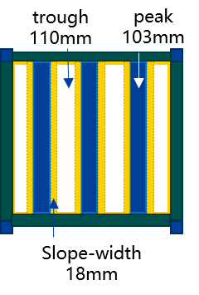 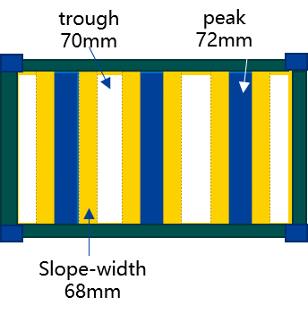

Figure .. Geometric sizes of steel panels

20-ft container with code of "1CC" is selected according to the relevant specifications[17] released by the International Organization of Standardization.It is the most widely used type with size of $6058×2438×2591mm$, which is also the baseline of container stacking.

Containers are not a regular cuboid, but ones with landmark periodic Trapezoidal corrugated steel plate. Side panel with wave peak of $72mm$, wave trough of $70mm$, slope width of $68mm$ and front end panel with wave peak of $103mm$, wave trough of $110mm$, slop width of $18mm$ are set, according to the size of corrugated panels on the market and size regulated by [18]. Diagrams of a container are shown in Figure \ref{fig:container} and Figure \ref{fig:panel_wave}. It should be noted that the door, bottom and top panel are chosen to be smooth because of their small waveness coefficient, which brings more simple simulation model to reduce the computing complexity.

Furthermore, physical properties of the materials are considered to fit the real environment. According to[19], weathering or Cor-Ten steels with grades of Q355GNHJ(corresponding to S355J2WP in European Norm). Thus the conductivity and relative permeability of the container surface are set to be $7.6\% IACS$ and $850$ respectively.

This subsection introduced the physical properties of a single container according with the international specification. Several "1CC" containers will be placed as a stack since they are the baseline for stacking at container yards. In next subsection, simplification to the modelling of a container stack is then illustrated.

## Container Stacks Modeling

Containers will be densely placed with certain space in the direction of length, width and height. A central container within the stack surrounded by others endures the worst propagation environment. In order to study how tough the communication channel is for the central container, a simulation model of stacked containers is required.

According to [20]-[23] and actual situation, a standard interval of $76mm$ called ISO Gap in the length direction is adopted. Considering the height of possible securing fittings and that the corner fittings of upper and lower container should be aligned accordingly, a interval of $30mm$ is selected in the direction of height. Meanwhile, empty and heavy containers with different intervals may be placed in two storage areas. The distance could reach $400mm$ in the heavy containers area , while it may smaller than $100mm$ in the empty containers area. The research set interval along the direction of width as 80mm, which refers to the relevant documents released by MacGregor Company to take the case of densely stacked containers into account.

When modeling in the HFSS simulation environment, only one complete model of container was created. The adjacent containers are replaced relatively with one of their six surfaces since the target area is confined to the scope of container intervals, as is shown in Figure \ref{fig:model}.

In the following part, the feasibility of studying the propagation characteristics by using only one container model in stacks is illustrated by taking the case of transmitter mounted at midpoint of width edge on the top panel as an example.

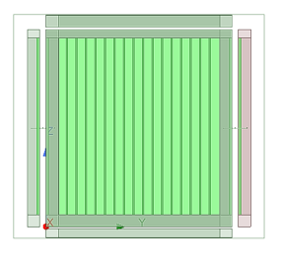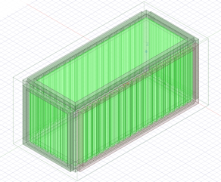

Figure 2.2. Model of the simplified container stack

Propagation links through intervals between adjacent containers, As is shown in Figure \ref{fig:simplified}, can be divided into line-of-sight(LoS) and non-line-of-sight(NLoS) paths depending on the installation location of the transmitter.

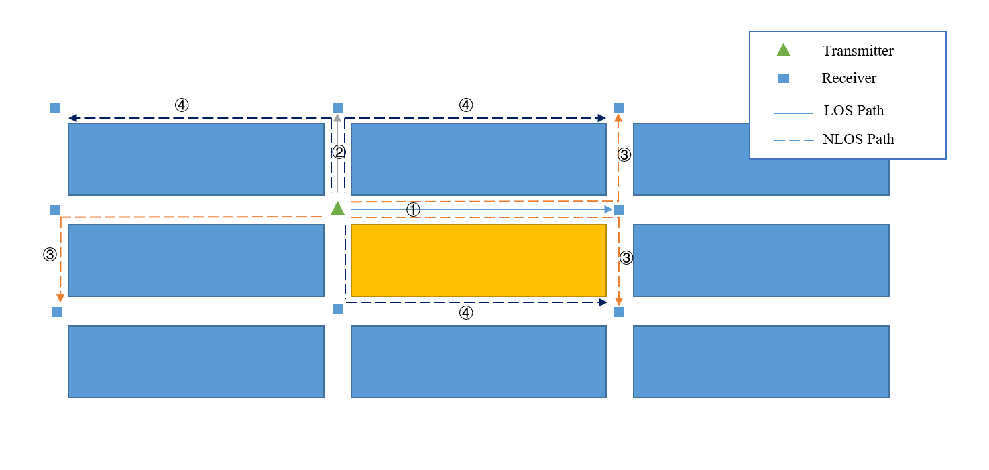

Figure 2.3. Side view of one containers stack

Path 1 and 2 in the figure represent LoS paths along the side and end panels respectively.It can be deduced that LoS paths exist in cases of coplanar transmitters and receivers. Path 3 and 4 represent two kinds of NLoS paths. NloS paths only pass around one corner(1-Turn NLoS) at most. Furthermore, some receivers at different positions may have equivalent paths, which are represented by the same number(e.g. two paths of the same number 2). Hence, almost all of the different paths in container stacks can be studied by only focusing on area around the central container, and the model could then be simplified to contain only one complete container. Figure \ref{fig:reachable} shows the distribution of adjacent containers with LoS and NLoS paths under different transceivers deployments.

In this subsection, the propagation problems in the container stacks are discussed and therefore a simplified scheme to balance the computing complexity and the authenticity of our simulation environments are illustrated. Furthermore, antenna design including polarization direction and radiation pattern issues should also be considered, which would be illustrated briefly in next subsection.

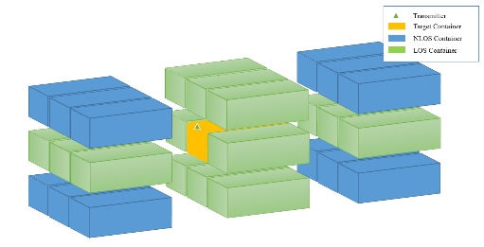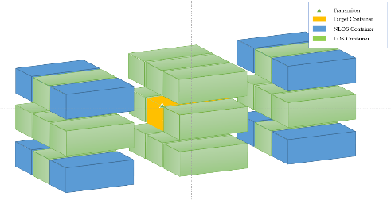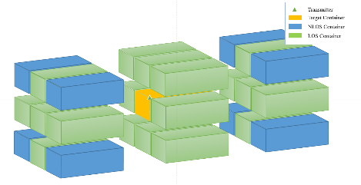

Figure 2.4. Reachable containers in different deploy location of transceivers

## Antenna Modeling

To obtain more general propagation characteristics in stacked containers, a nearly omnidirectional half-wave dipole antenna is used in our simulation environment, which is isotropic with a circular radiation pattern in the horizontal direction.

In addition, LoS paths are studied in such a cases that the direction with strongest intensity is just parallel with the walls between two intervals, which makes those paths more easier to be evaluated.

In this section, settings of the modeling process and relative physical properties are illustrated. To study the propagation characteristic in the container stack, a path loss model based on generic urban propagation model is proposed to fit the data acquired from our simulation, which would be introduced in the next section.

# Proposed Path Loss Model

Propagation loss of a wireless link between a transmitter and receiver may depend on many different factors, such as losses from antenna and feeder or brought by impedance or polarization mismatches, and attenuation caused by physical transmission environments. This paper focuses on propagation characteristics in the interval of stacked containers, and the data of interests are the energy flow density vector of the electromagnetic fields. Assuming that both transmitting and receiving antennas are isotropic, that is, the directional gain for all $θ$ and $ϕ$ satisfies $g\left(θ,ϕ\right)=1$, where $θ$ and $ϕ$ refers respectively to the pitch angle and the azimuth angle. Average Poynting vector could be represented as $\left|\overset{⃑}{P_{av}}\right|=\frac{1}{2}Re[E×H^{*}]$, thus the relationship between Poynting vector and transmitted or received power can be derived as below according to \cite{bertoni1999radio24,gupta2003towards25}

$P_{t}≈\frac{πL^{2}\left|\overset{⃑}{P_{av0}}\right|}{16δ}$ (3.1)

$P_{r}=\left|\overset{⃑}{P_{av}}\right|∙A_{e}=\left|\overset{⃑}{P_{av}}\right|∙\frac{λ^{2}}{4π}∙g\left(θ,ϕ\right)=\left|\overset{⃑}{P_{av}}\right|∙\frac{λ^{2}}{4π}$ (3.2)

$\overset{⃑}{P_{av0}}$ is the maximum average Poynting vector at axis of the dipole antenna in the near field, while $\overset{⃑}{P_{av}}$ is average Poynting vector at the receiving point. $L$ and $δ$ refers to the maximum size and aperture efficiency of the antenna respectively. Then path loss can be represented via Poynting vectors since it is the ratio of transmitted power to the power available at the point of receiver, as is shown by (3.3).

$L=\frac{P_{t}}{P_{r}}=\frac{\left|\overset{⃑}{P_{av0}}\right|∙πL^{2}}{\left|\overset{⃑}{P_{av}}\right|∙\frac{λ^{2}}{4π}∙16δ}=\frac{π^{2}L^{2}}{4δλ^{2}}∙\frac{\left|\overset{⃑}{P_{av0}}\right|}{\left|\overset{⃑}{P_{av}}\right|}$ (3.3)

It can be derived that path loss represented by Poynting vector differs from the usual path loss only in a constant coefficient. Therefore, the logarithmic path loss can be represented by (3.4).

$L_{b}=P_{t}\left[dB\right]-P_{r}\left[dB\right]=10\log_{10}\left(\frac{p_{t}}{p_{r}}\right)≈\left|\overset{⃑}{P_{av0}}\right|\left[dB\right]-\left|\overset{⃑}{P_{av}}\right|\left[dB\right]=L_{bf}+L_{m}$ (3.4)

The right side of (3.4) corresponds to the basic transmission loss defined by \citen{itu26} where $L_{bf}$ represents the propagation loss in free space and $L_{m}$ represents the additional loss, including the loss caused by diffraction, reflection and other effects.

In stacked containers environment, intervals around the container are very similar to the streets in cities. The corrugated panels around intervals could be regarded as buildings with a certain height on both sides of the street, and intersections of two intervals in different directions around the container are just similar to the crossroads in cities. The propagation signal is reflected and propagated continuously in the container intervals, which leads to waveguide effects. And diffraction phenomenon occurs at the intersections. This propagation pattern is usually called as "Street Canyon", which suits the scenario of this paper.The difference is that radio waves can travel through the plane thoroughly where the interval is located because the reflected wave from the earth is ignored in our simulation model.

The propagation path loss model of two cases(i.e. LoS and NLoS) in container intervals is derived, based on the street canyon model in section 4.1 of\cite{itu27}.

The model for LoS paths such as Path 1 and Path 2 in \ref{fig:simplified} is then represented as:

$L_{b}\left(d\right)=10∙α_{0}∙\log_{10}\left(d\right)+α_{1}$ (3.5)

The model for NLoS paths such as Path 3 and Path 4 in \ref{fig:simplified} is represented as:

$L_{b}\left(d_{1},d_{2}\right)=-10∙α_{0}∙\log_{10}\left({10}^{-\frac{α_{1}L_{r}}{10}}+{10}^{-\frac{α_{2}L_{d}}{10}}\right)$ (3.6)

$where\left\{\begin{aligned}L_{r}&=20∙β_{0}∙\log_{10}\left(d_{1}+d_{2}\right)+\frac{β_{1}d_{1}d_{2}}{{\left(\frac{π}{2}\right)}^{β_{2}}}+β_{3} \\ L_{d}&=10∙β_{4}∙\log_{10}\left[d_{1}d_{2}\left(d_{1}+d_{2}\right)\right] \\ &+β_{5}\left[\arctan\left(\frac{d_{1}}{w_{1}}\right)+\arctan\left(\frac{d_{2}}{w_{2}}\right)-\frac{π}{2}\right]+β_{6}\end{aligned}\right.$ (3.7)

In (3.7), $L_{r}$ and $L_{d}$ refers to the reflection and diffraction components respectively. $d_{1}$ and $d_{2}$ refers to the distance traveled along two intervals respectively. Meanwhile, $w_{1}$ and $w_{2}$ refers to the width of two intervals, as is shown in Figure \ref{fig:canyon}.Parameters obtained by utilizing multiple linear regression to fit the simulation data in the corresponding interval of each surface at different frequencies are shown in [Appendix- edit waited]. To evaluate whether the proposed model could reflect the propagation characteristics, a performance evaluation based on the parameters calculated during fitting process is illustrated in the next subsection.

Table 3. Information on video and audio files that can accompany a manuscript submission.

|  |  |  |
| --- | --- | --- |
| **Item** | **Video** | **Audio** |
| File name | Video1, video2, … | Audio1, audio2, … |
| Number of files | 0-10 | 0-10 |
| Size of each file | max. 5 mb | max. 5mb |
| File types accepted | .mpeg, .mov (Quicktime), .wmv (Windows Media Player) | .wav, .mp3 |

## Antenna Modeling

In this paper, multiple linear regression is utilized to fit the proposed inter-container propagation model. At the same time, several metrics representing performance of the model are calculated, the most important of which is Deterministic Coefficient (represented by DC or $R^2\in(-\infty,1]$) which indicates our model's adaptability to our simulation data. A deterministic coefficient takes a value more close to one means a better performance of matching data for our model. DC is used to determine the fitting performance combined with Root Mean Square Error (RMSE), since a model only with a small RMSE value may not be able to represent details of the data, e.g. a model that takes the average of all data as its value cannot give any information about fluctuation of the data curves.

The following tables show the performance of proposed model in stacked container with antenna mounted at midpoint of the width edge of the top panel. It can be seen that performance of model with LoS path, which is assumed to contain direct and reflection components only, is relatively stable. Reflection component can be represented as a "waveguide effect" parameter in the model of LoS path. This simple form of model with LoS path just leads to a more stable performance. The fitting figure of one LoS path is shown by Figure \ref{fig:LoSfit}.

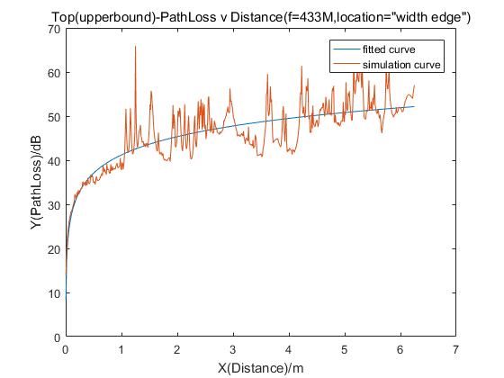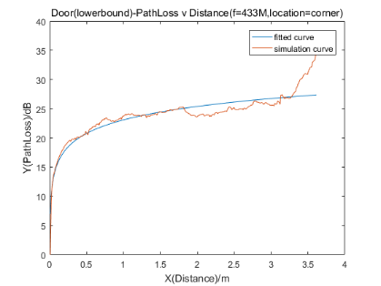

Figure 2.5. Fitting figure for LoS path corresponding to the top panel

In contrast, performance of model with NLoS paths varies a lot in intervals corresponding to different panels. As is shown by Table \ref{tab:upper}, NLoS model in interval corresponding to left-side panel shows the best performance with DC only equals to about 0.7. This may be attributed to the short distance between left-side panel and the transmitter antenna, since the radio wave would diffract at the edge after traveling a short distance. For intervals corresponding to other panels, the energy of signal would be small after experiencing a long distance propagation and diffraction loss at edges, which influence the performance since that NLoS model mainly considering diffraction and reflection loss. Another important factor leading to the unstable performance is the reflection effect caused by corrugated side panels, which is not considered completely in proposed model. However, overall trend of the data with NLoS paths could be shown by our proposed model as is shown by Figure \ref{fig:upperfit}, which proves that the model based on "Street Canyon" is capable to represent the overall propagation characteristic.

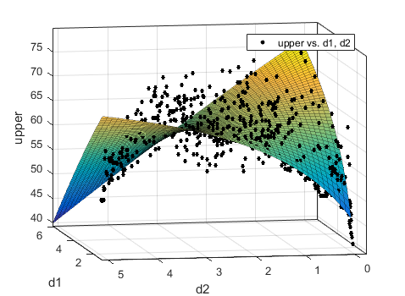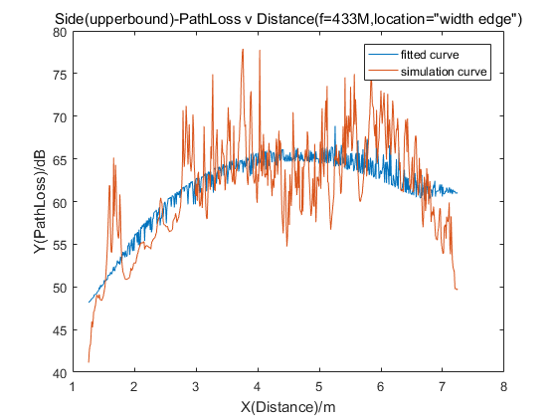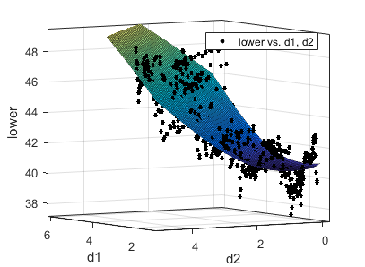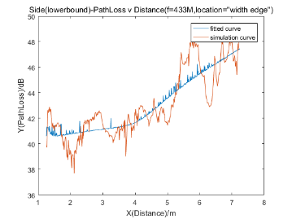

Figure 2.5. Fitting figure for NLoS path corresponding to the left panel

In addition, performance for lower-bound curves are generally better than those for upper-bound curves, as is shown in Table \ref{tab:lower}. From perspective of data characteristics, this can be explained as that the lower bound curve is relatively more gentle compared with the upper-bound curve with strong fluctuation, which makes it easier to be predicted. In terms of transmission characteristics, the fluctuation is brought by the superposition of reflection and diffraction component.These two components then depend on the geometric shapes and antenna positions. Thus, the general "Street Canyon" model is hardly cover all details of the propagation process especially for such a specific scenario. In general, the improved street canyon model performs well on lower-bound curve. Its DC is generally above 0.6 and even can reach 0.8 and 0.9 for some cases. The relatively accurate prediction to the lower-bound curve is helpful for supervision of the wireless system design.

In this section, evaluations on the performance of proposed model are illustrated. The results show that the model can reflect the overall propagation characteristic since it performs well in fitting curves of LoS paths and the lower-bound of NLoS paths. However, the performance for upper-bound curves of NLoS paths are unstable. Hence, the model failed to take all details in the reflection and diffraction process into account , which indicates that a more accurate model with geometric optics theory are needed for later researches.

# Conclusions

Considering that there are few researches on the propagation characteristics of radio wave in stacked containers environment and there exists many difficulties to collect data in container terminals, computer simulation technology is utilized to simplify and model the stacked container environment. A propagation path loss model based on urban wireless communication model is then proposed at frequency 433M and 868M, which are usually used in Internet-of-Things applications. In this paper, propagation links through intervals around the container are divided into LoS and NLoS link, and multiple linear regression method is applied to fit the upper-bound and lower-bound of the simulation data. The results show that the proposed model shows a good performance on LoS paths whose deteministic coefficient is more stable. In addition, the fitting performance for the lower-bound curve is better than that fot the upper-bound curve.

In general, the proposed model can reflect the radio propagation characteristics of inter-containers and provide relevant guidance for the application of IoT technology in stacked container environment. This model, however, failed to reflect the details of the upper-bound curve of the simulation data, which could be attributed to that the general model originally applied to urban environment failed to fully consider the periodically corrugated panels of containers and the influence it brings to the reflection components of the propagation. Thus, the proposed model can still be improved by applying the relevant theory of geometrical optics to better relfect the propagation characteristics in stacked container environment, which will be the main target of our later researches.

# using THIS TEMPLATE AND ITS Automatic formatting

This document template and more information is available on SPIE.org:

<http://spie.org/x14101.xml> or by emailing [authorhelp@spie.org](mailto:authorhelp@spie.org)

## View the pre-formatted styles

To see the formats available with this manuscript, go to the Format menu and choose "Styles and Formatting". To view which style is being used in any part of this document, place your cursor on the line and look in the Styles and Formatting display.

## Using SPIE styles

To use this template in Microsoft Word: open this file and save it to a new file name. Type over the existing text with your paper. Alternately, you can delete all text, and select the SPIE style for each paragraph from the Styles and Formatting menu.

## Notes on SPIE styles

The styles listed in Table 2 automatically add extra spacing before and/or after paragraphs: SPIE title, SPIE authors-affiliations, SPIE section heading, SPIE subsection heading, and SPIE body text. The 1.1 Heading 2 style automatically goes into the body text style after one paragraph return.

References（References字体Times New Roman，字号11，加粗，居中，段前24 磅，段后12 磅）

1. Shenzhen Institute of Standards and Technology. "Intelligent Container Industry Operation Analysis Report" ,2020.
2. Ambroziak, Slawomir J., et al. "Propagation path loss modelling in container terminal environment." Vehicular Technologies: Increasing Connectivity (2011): 415-432.
3. Katulski, Ryszard J., Jaroslaw Sadowski, and Jacek Stefanski. "Propagation path loss modeling in container terminal environment." 2008 IEEE 68th Vehicular Technology Conference. IEEE, 2008.
4. Ambroziak, Slawomir J., and Ryszard J. Katulski. "On the usefulness of selected radio waves propagation models for designing mobile wireless systems in container terminal environment." 2011 XXXth URSI General Assembly and Scientific Symposium. IEEE, 2011.
5. Ambroziak, S. J. , and R. J. Katulski . "Statistical tuning of Walfisch-Ikegami model for the untypical environment." IEEE.
6. S. J. Ambroziak and R. J. Katulski, "An Empirical Propagation Model for Mobile Radio Links in Container Terminal Environment," in IEEE Transactions on Vehicular Technology, vol. 62, no. 9, pp. 4276-4287, Nov. 2013.
7. Ferreira, M. M. , et al. "Fading Modeling in Maritime Container Terminal Environments." IEEE Transactions on Vehicular Technology (2018).
8. Tanghe, E. , et al. "Intra-, Inter-, and Extra-Container Path Loss for Shipping Container Monitoring Systems." IEEE Antennas & Wireless Propagation Letters 11(2012):889-892.
9. Ruckebusch, P. , et al. "Smart container monitoring using custom-made WSN technology: from business case to prototype." Eurasip Journal on Wireless Communications & Networking 2018.1(2018):16.
10. Azpilicueta, Leyre, et al. "Optimization and design of wireless systems for the implementation of context aware scenarios in railway passenger vehicles." IEEE Transactions on Intelligent Transportation Systems 18.10 (2017): 2838-2850.
11. S. K. S. Gupta, S. Lalwani, Y. Prakash, E. Elsharawy and L. Schwiebert, "Towards a propagation model for wireless biomedical applications," IEEE International Conference on Communications, 2003. ICC '03., Anchorage, AK, USA, 2003, pp. 1993-1997 vol.3.
12. K. Sayrafian-Pour, W. Yang, J. Hagedorn, J. Terrill and K. Y. Yazdandoost, "A statistical path loss model for medical implant communication channels," 2009 IEEE 20th International Symposium on Personal, Indoor and Mobile Radio Communications, Tokyo, Japan, 2009, pp. 2995-2999.
13. Y. Liu, T. P. Ketterl, G. E. Arrobo and R. D. Gitlin, "Modeling the wireless in vivo path loss," 2014 IEEE MTT-S International Microwave Workshop Series on RF and Wireless Technologies for Biomedical and Healthcare Applications (IMWS-Bio2014), London, UK, 2014, pp. 1-3.
14. Y. Liu and R. D. Gitlin, "A phenomenological path loss model of the in vivo wireless channel," 2015 IEEE 16th Annual Wireless and Microwave Technology Conference (WAMICON), Cocoa Beach, FL, USA, 2015, pp. 1-3.
15. J. Park, H. Garudadri and P. P. Mercier, "Channel Modeling of Miniaturized Battery-Powered Capacitive Human Body Communication Systems," in IEEE Transactions on Biomedical Engineering, vol. 64, no. 2, pp. 452-462, Feb. 2017.
16. Jarma, Yesid, et al. "Volume-aware positioning in the context of a marine port terminal." Computer Communications 34.8 (2011): 962-972.
17. ISO. "Series 1 freight containers—Classification, dimensions and ratings." ISO 668:1995, 1995.
18. "Freight Containers - Air/Surface(Intermodal) General Purpose Containers - Specification and Tests". GB/T 17770-1999.1999.
19. Standardization Administration of the People’s Republic of China, "Steel Plates and Strips for freight containers". GB/T 32570-2016.
20. ISO. "Series 1 freight containers—Handling and securing." ISO 3874:2017, 2017.
21. "Safe Handling Rules in Container Storage Area in Port". GB/T 35551-2017, 2017.
22. ISO. "Series 1 freight containers—Corner Fittings." ISO 1161:1984, 1984.
23. ISO. "Series 1 freight containers—Specification and Testing—Part 1: General Cargo Containers for General Purposes." ISO 1496:1990, 1990.
24. Bertoni, Henry L. Radio propagation for modern wireless systems. Pearson Education, 1999.
25. Gupta, Sandeep KS, et al. "Towards a propagation model for wireless biomedical applications." IEEE International Conference on Communications, 2003. ICC'03.. Vol. 3. IEEE, 2003
26. ITU-R. "The Concept of Transmission Loss for Radio Links" ITU-R P.431-7, 2019.
27. ITU-R. " Propagation data and prediction methods for the planning of short-range outdoor radiocommunication systems and radio local area networks in the frequency range 300 MHz to 100 GHz " ITU-R P.1411-10, 2019

参考文献的内容字体Times New Roman，字号10，左侧0.63 厘米，悬挂缩进0.63 厘米