# Impacts of EITI on Governance

# Perception of Corruption

# EITI vs. CC

# /Users/jianghanhanli/Documents/MyWork/MyGitSite/Heipihanhan.github.io/projects/QMSS_DataDive/img/grouped_cc.png

# Year of Countries join EITI – Summary Statistics

# EITI countries generally perform better in CC and GDP than non-EITI countries, even before enforcement. Yet after joining EITI, there seems to be a slight increase for EITI member countries

**OLS Regression**

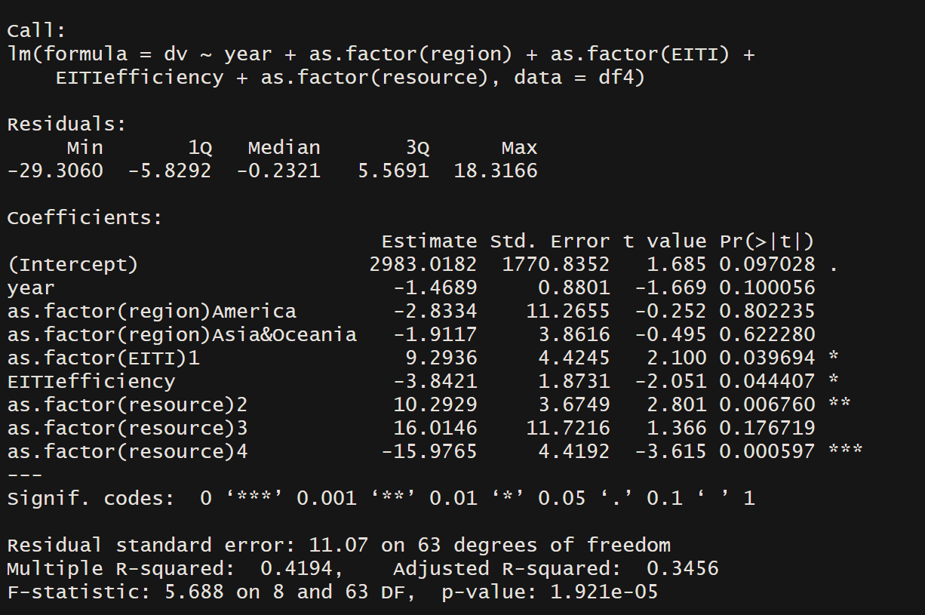

Feature construction

**EITIefficiency**

EITIefficiency measures how efficient EITI policy took into effect in a country.

We want to measure how efficient countries were in adopting EITI initiative, from announcing to candidacy to compliance. We calculate the distance between these three phases.

We created :

**EITIefficiency** =((YR\_EITIcompliance-YR\_EITIcandidacy)^2+(YR\_EITIcandidacy-YR\_EITIannounce)^2)^0.5 \* 0.5

**EITIefficiency descriptive statistics**

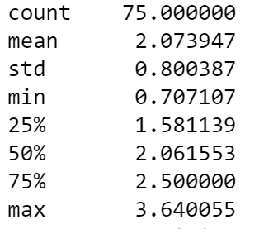

We added region variables.

**Region**

Africa

America

Asia & Oceania (only 1 Oceania country)

Summary statistics

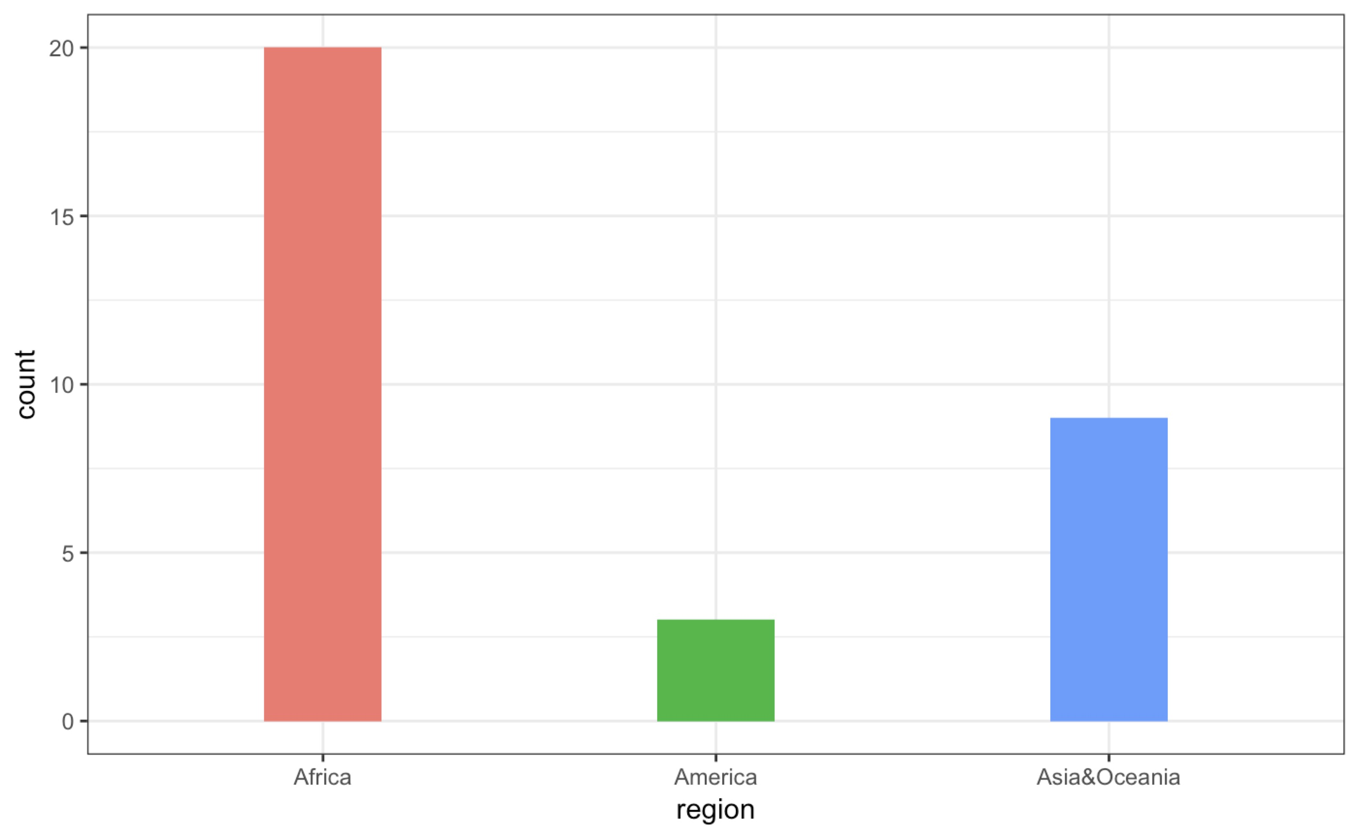

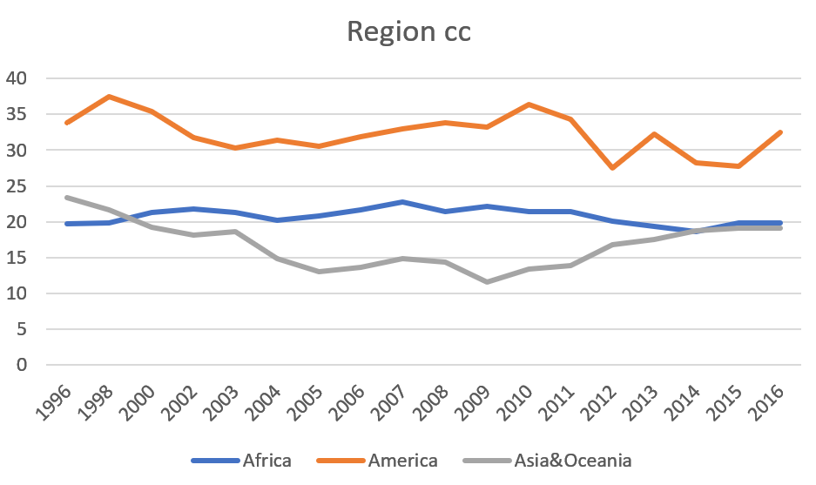

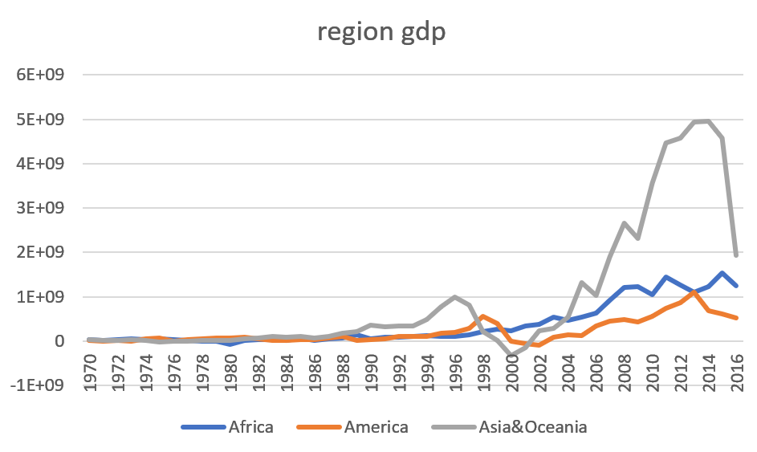

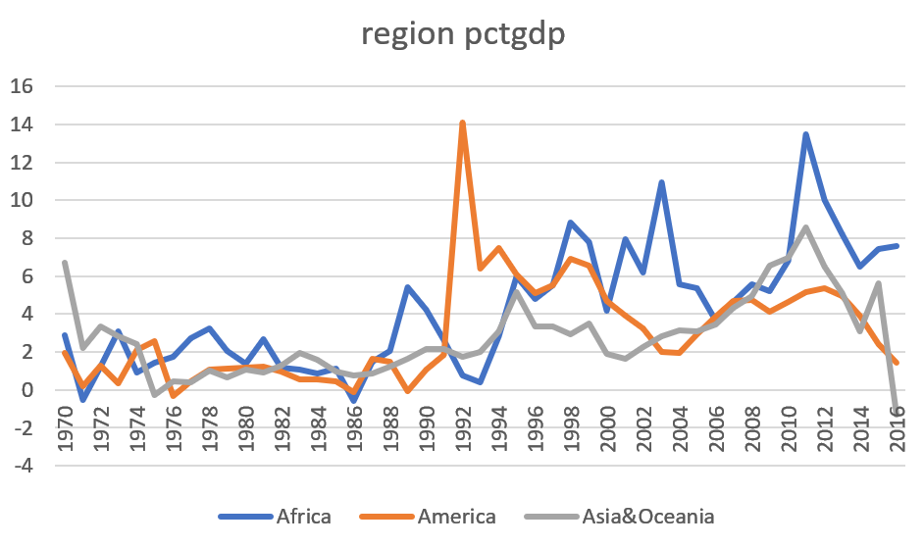

The results show that how fast that countries adopt EITI initiative is negatively associated with control of corruption. The smaller the value of EITIefficiency, the higher control of corruption. The statistics is significant.

**Foreign Direct Investment**

**EITI vs GDP**

**We wonder if EITI status and EITIefficiency has impacted GDP?**

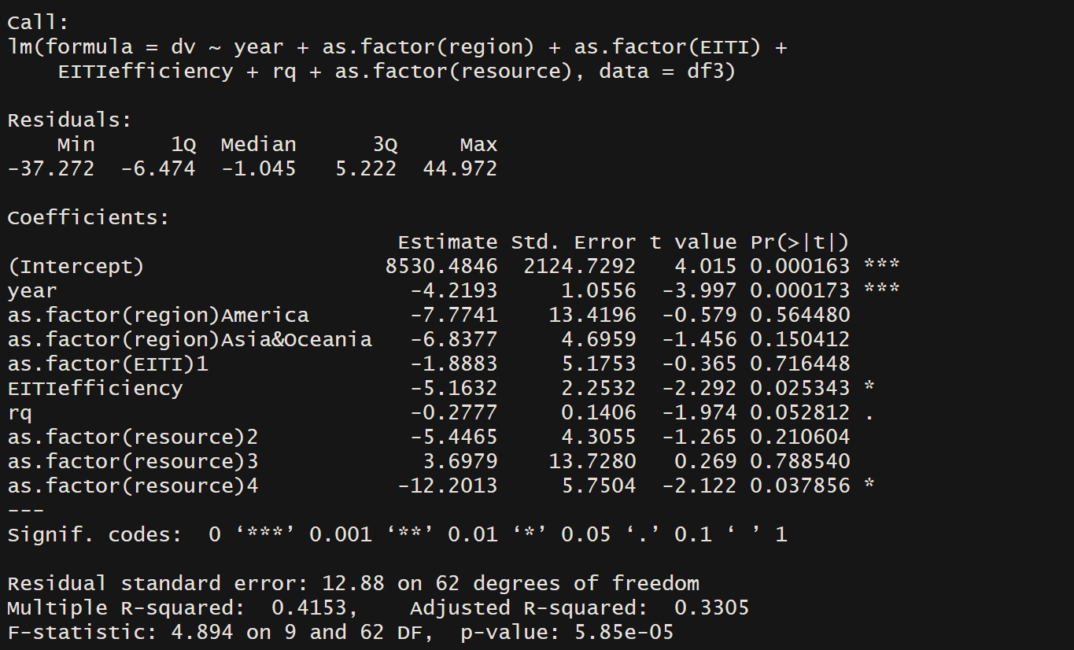

**EITI** is positively associated with FDI

**Rq** minorly statistics significant

**Region – Asia & Ocieania** minorlystatistically significant

**Resource – represents the natural resource capacity**

**The Business Case for Transparency**

Mining - Transparency vs. P/E

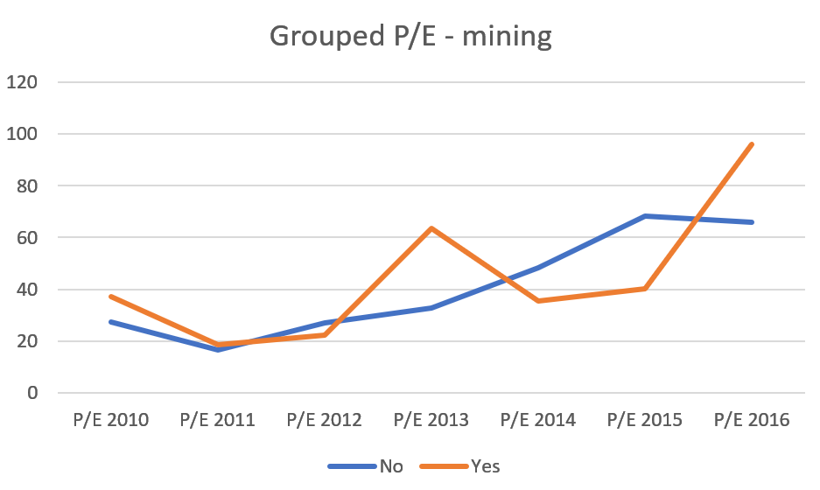

Mining - Transparency vs. ROE

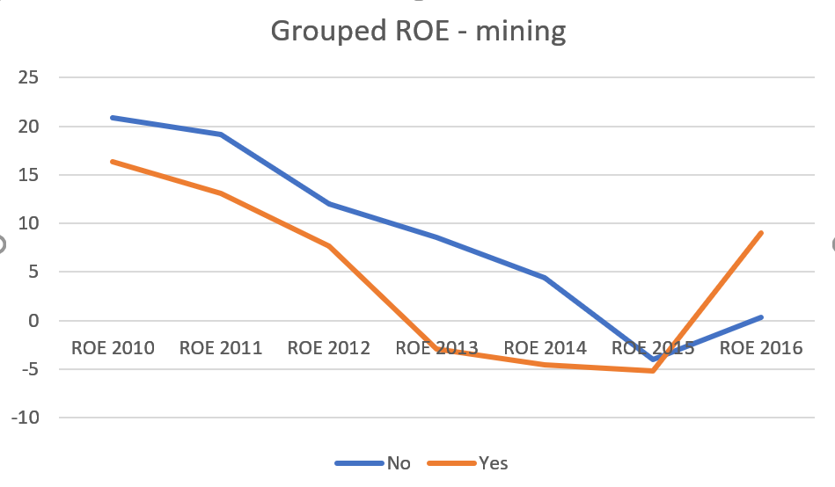

Mining - Transparency vs. ROIC

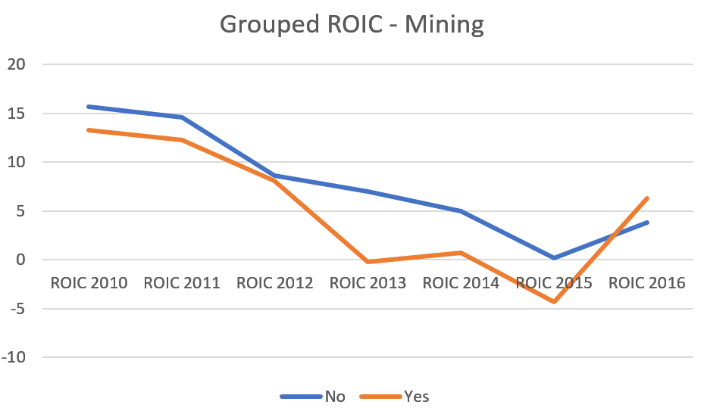

Oilgas –Transparency vs. P/E

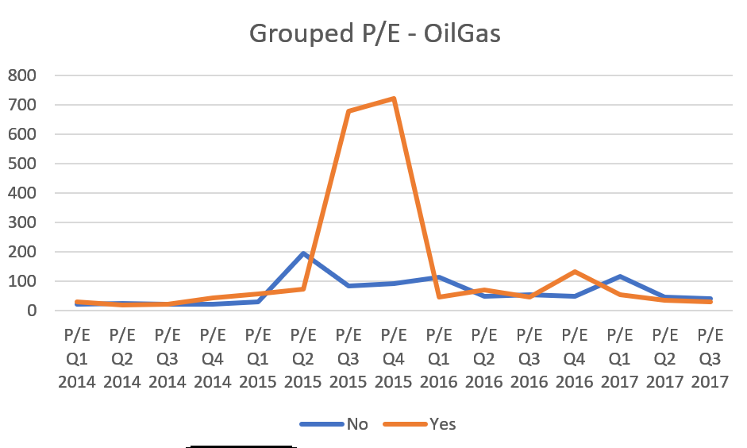

Oilgas – ROE

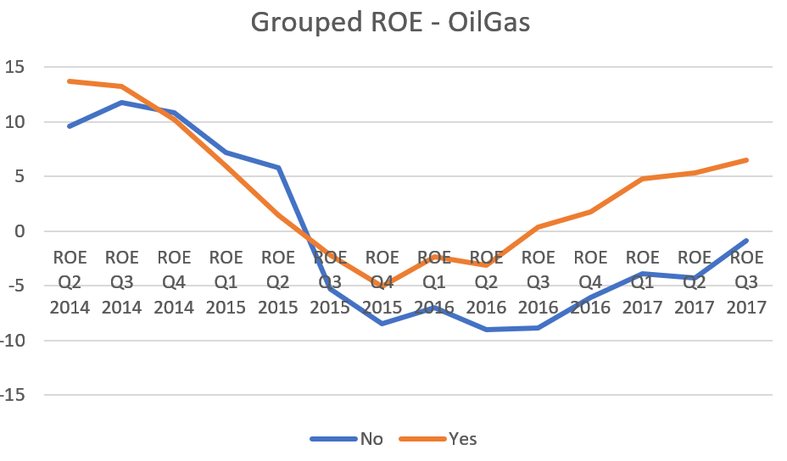

Oilgas – ROIC

