Source: UNHCR

Downloaded: April 5th, 2017

Country of Origin: Syria

Year: 1968 - 2015

1. Asylum seekers column – if * then it is treated as 0

Check out what * means on UNHCR website

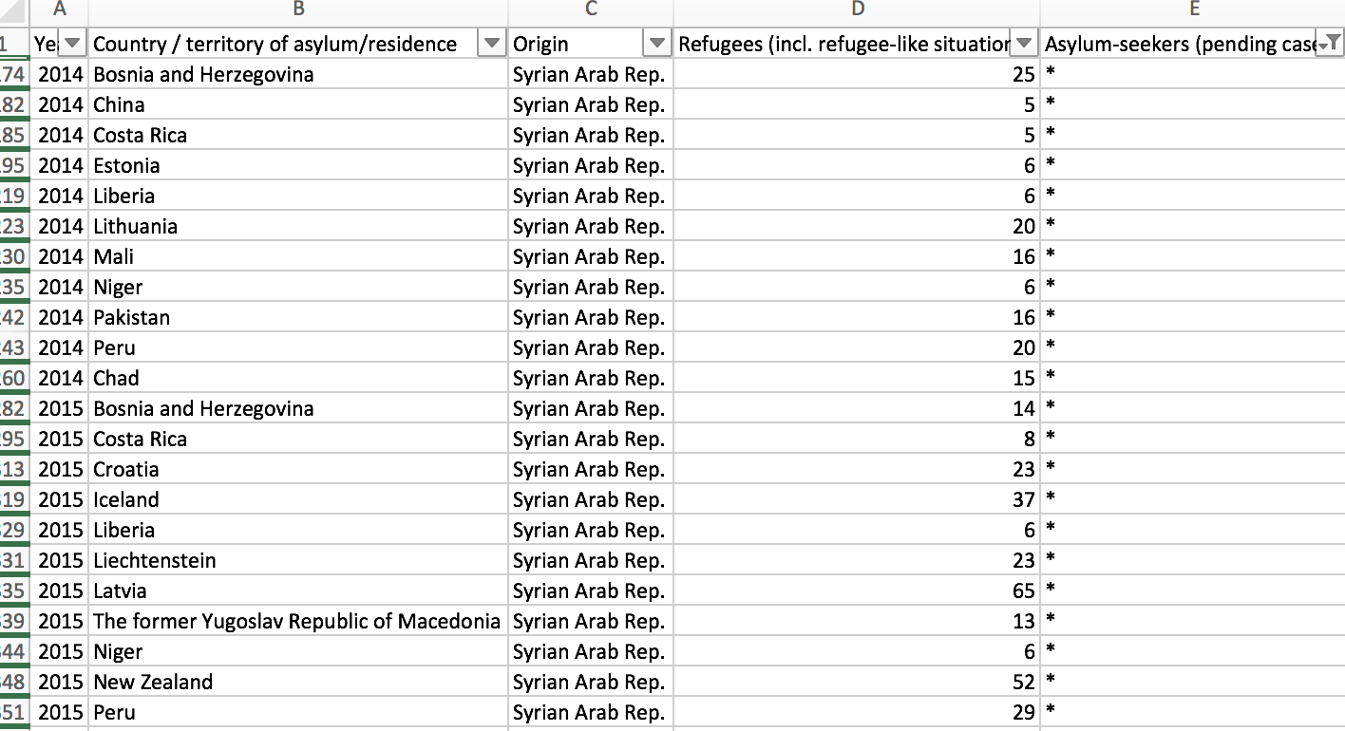

1. I add Hong Kong and Macao to China (otherwise they don’t have numcode)

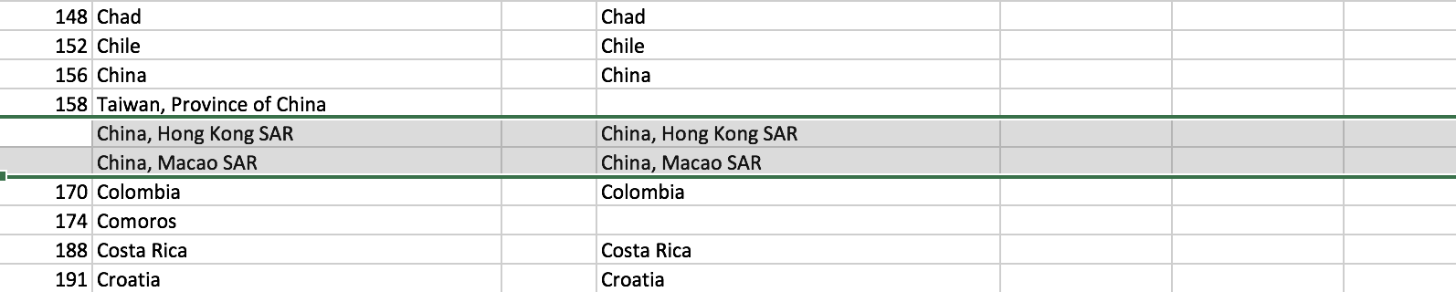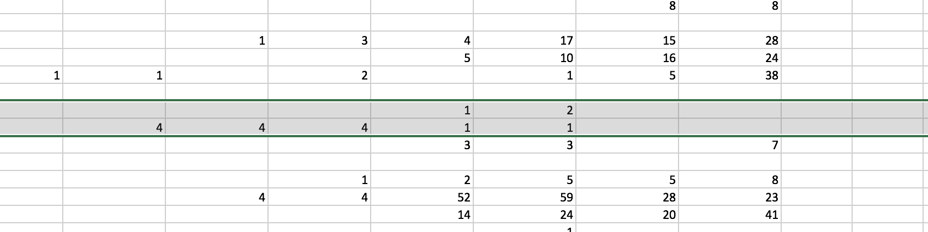

1. I deleted the countries without numcode. If we want to add them, we should find it out in the json shapefile. The deleted countries are highlighted in the full_version sheet. Some of these countries have taken quite a lot of refugees and asylum seekers.