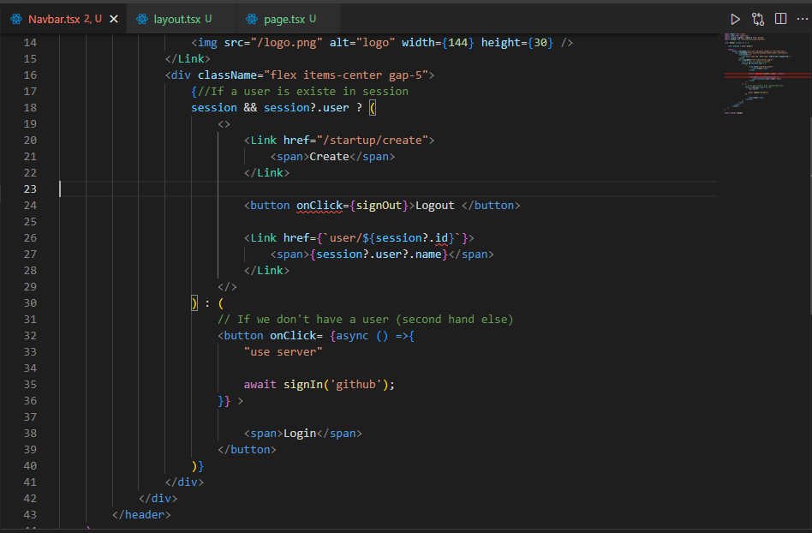

Exemple code using next for client server because we use for exemple onClick=”” this actions is useful only for the user side not on server.

To be able to login or logout, we should transform this logic to the server side component to make things work.

