marriage Plebiscite voters analysis

CAB432 Assignment 1

By Alexander Santander- n9684026

**Introduction**

“Marriage Plebiscite Voters Analysis” or “MPVA” has been developed in response to the current same-sex marriage plebiscite for which people around Australia are currently voting. Because it is such a heated topic that so many people are deeply invested in, it’s only natural that they would be interested in the opinions of those around them.

To address this figurative hole in the market “MPVA” will retrieve a large amount of tweets from a user defined area. which relate to the current plebiscite. It will then determine what percentage are positive, neutral or negative through sentiment analysis.

This could suit anyone from an LGBTIQ activist who wishes to turn the tide in indifferent areas to an uninvolved individual who wants to know which way his home town is leaning.

**Dependant Services**

MPVA relies on three main services for functionality

Node-geocoder:

Link: https://www.npmjs.com/package/node-geocoder

Node-geocoder is an npm package that supports geocoding and reverse geocoding. Ultimately it acts as a wrapper for providers such as “mapquest” and “locationiq”. In my case I chose google as the provider due to its reliability and scale. This was used to return the location which the user inputs.

Twit:

Link: https://www.npmjs.com/package/twit

Twit is an npm package which acts as a wrapper for the Twitter API. It supports any and all functionality of the Twitter API and yet provides simple integration into my NodeJS environment. As long as the particular users Twitter account is public everything from the tweets location to the time it was sent can be retrieved. By querying through this medium I obtained the relevant data for analysis.

sentiment:

Link: https://www.npmjs.com/package/sentiment

Sentiment is yet another npm package which analysis text and returns its overall sentiment. It performs this through the use of the AFINN-165 wordlist as a database. This was used to analyse the data from twitter and return the sentiment of each individual tweet. It’s only real limitation being that it will only accept English text as an input.

**User Cases**

#1

As an Australian adolescent citizen, I have grown up in an environment with rapidly changing opinions regarding sexuality and self-identification. Because of this the current plebiscite has caught my attention and made me wonder what Australia really thinks. By querying any location in MPVA I can easily acquire such information to a reasonable degree of accuracy

#2

As stated this is an extremely heated topic close to the hearts of many. With this in mind it would not be farfetched to say that there are many who would consider themselves activists for this cause. This is evidenced by the constant parades and picketing of the LGBTIQ community. In order to have maximum effect they would want to spread their message to indifferent areas that have a negative outlook on their plight. By using MPVA they can search through Australia and find places that have such an opinion and focus their efforts there.

#3

This once again draws upon the fact this is a very invested topic which many religiously uphold. If there were to be a significant number of supporters in both directions within a small area trouble could ensue. In fact, in recent times there is a strong possibility of confrontation or even violence. The beginning of this article [reference # 1] regarding a doctor who spoke out against the plebiscite is a prime example. Through the use of MPVA peacekeeping forces such as the police may analyse different areas. If they were to see a large amount of both positive and negative support in one area could act pre-emptively to prevent harm.

**Technical Description of the Application**

This service has been built with both the user and simplicity in mind. Because of this it has a fast, responsive interface that retrieves data quickly to prevent load times. Compromises were made to uphold the simplicity and responsiveness of MPVA and will be discussed in a later section

**Server**

MPVA has three separate web pages, the first of which is simply for aesthetic purposes. Once the button on this page is pressed the user is redirected to the “/userAddress” path. (code shown in figure 1 below)

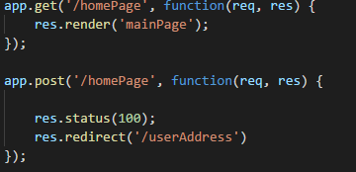

Figure 1

At this point the user is prompted to enter a location. The “node-geocoder” npm package then queries google with this input and is returned with the coordinates of the location (assuming the input was valid). The code for this is shown in figure 2

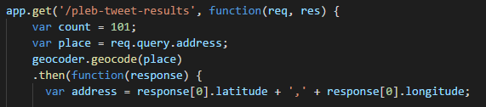

Figure 2

These coordinates are then used to query Twitters “search/tweets” path through the use of the “Twit” package. Shown in figure 3

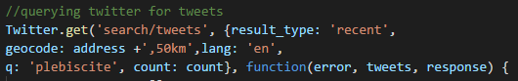

Figure 3

Once the tweets have been retrieved they are analysed for sentiment using the “sentiment” npm package and then sorted depending on the results. Code shown in figure 4

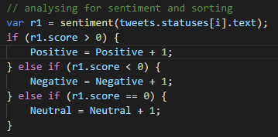

Figure 4

Finally these results are stored in variables and rendered to the web page.

**Client**

The client side has been coded using pug. This was done because I am new to web computing and so found this syntax to be less daunting. Through the use of pug the spacing of various elements and inputting information was streamlined greatly. Each of the three webpages have their own pug file which then links to a similarly unique .CSS file for styling.

**Use of Docker**

The service has been successfully deployed using Docker and hosted on an EC2 AWS ubuntu instance.

**Testing and Limitations**

As the development of this project began there quickly became some glaring issues and limitations regarding functionality. The most prudent of these is that Twitter only allows the user to query a maximum of 100 tweets at a time. After the query sent through sentiment analysis and then rendered to the webpage an average of one and a half seconds has passed. This Meant that either numerous queries would have to be made and therefore drastically slow the pages load time. Or the averages would have to be over a much smaller amount of data than anticipated. In the end, the latter was decided upon because a lengthy load time is strongly against my policy.

**Possible Extensions:**

Considering I have never before used any of the languages needed in this assignment or attempted any sort of web design I am very proud of what I have accomplished, however there is always room for improvements. The most obvious of these would be to increase the number of tweets the application can search through thereby having a much larger database and more accurate average, the reasons as to why this was not attained were explained previously.

Finally a graphical representation of the area which the user entered may not be essential, but would greatly visually enhance and clarify the results returned to them.

# References

Shanahan, D. (2017, 09 04). *GetUp!-backed petition seeks to deregister doctor from No-case ad*. Retrieved from THE AUSTRALIAN: http://www.theaustralian.com.au/news/nation/getupbacked-petition-seeks-to-deregister-doctor-from-nocase-ad/news-story/79a8aa4579e83bab2c55ffba41f14149

**User Guide**

Step 1: navigate to localhost:3000/homepage

Step2: press the get started button on our homepage

Step3: enter any location or address in any format (without symbols) and press enter

Step 4: see the sentiment of those around that area regarding the same-sex marriage plebiscite