**QBot Platform**

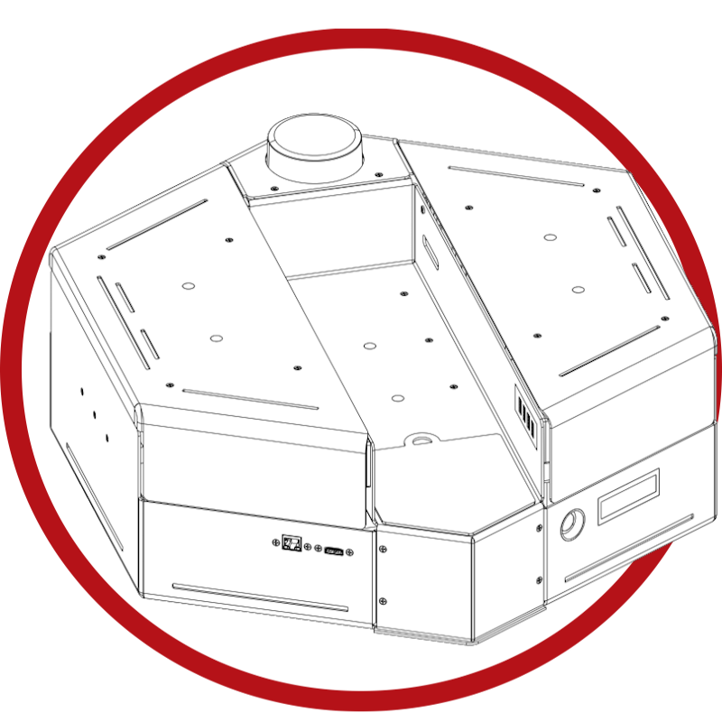

Connectivity User Manual

© 2023 Quanser Inc., All rights reserved

For more information on the solutions Quanser Inc. offers,   
please visit the web site at: <http://www.quanser.com>

|  |  |
| --- | --- |
| Quanser Inc.  119 Spy Court  Markham, Ontario  L3R 5H6, Canada | info@quanser.com  Phone : 19059403575  Fax : 19059403576  printed in Markham, Ontario. |

This document and the software described in it are provided subject to a license agreement. Neither the software nor this document may be used or copied except as specified under the terms of that license agreement. Quanser Inc. grants the following rights: a) The right to reproduce the work, to incorporate the work into one or more collections, and to reproduce the work as incorporated in the collections, b) to create and reproduce adaptations provided reasonable steps are taken to clearly identify the changes that were made to the original work, c) to distribute and publicly perform the work including as incorporated in collections, and d) to distribute and publicly perform adaptations. The above rights may be exercised in all media and formats whether now known or hereafter devised. These rights are granted subject to and limited by the following restrictions: a) You may not exercise any of the rights granted to You in above in any manner that is primarily intended for or directed toward commercial advantage or private monetary compensation, and b) You must keep intact all copyright notices for the Work and provide the name Quanser Inc. for attribution. These restrictions may not be waved without express prior written permission of Quanser Inc.

**Waste Electrical and Electronic Equipment (WEEE)**

This symbol indicates that waste products must be disposed of separately from municipal household waste, according to Directive 2002/96/EC of the European Parliament and the Council on waste electrical and electronic equipment (WEEE). All products at the end of their life cycle must be sent to a WEEE collection and recycling center. Proper WEEE disposal reduces the environmental impact and the risk to human health due to potentially hazardous substances used in such equipment. Your cooperation in proper WEEE disposal will contribute to the effective usage of natural resources.

|  |  |
| --- | --- |
| caution.png **Caution** | **This equipment is designed to be used for educational and research purposes and is not intended for use by the public.** The user is responsible to ensure that the equipment will be used by technically qualified personnel only. While the end-effector board provides connections for external user devices, users are responsible for certifying any modifications or additions they make to the default configuration. |
|  |  |

# 

# Table of Contents

A. Network Setup 3

i. Router Setup 3

ii. LAN 4

iii. Wireless 4

B. User Interface 5

i. Direct 5

ii. Remote 5

File Transfer 5

PuTTY 6

VNC Viewer 7

# Network Setup

## i. Router Setup

Each QBot Platform Bundle comes provided with a router, router power supply and ethernet cable. The key ports and parts have been outlined in Figure 1 for easy setup.

|  |  |  |
| --- | --- | --- |
|  |  |  |
| a. provided router | b. router power supply | c. ethernet cable |
|  | | |
| d. wiring the router | | |
| Figure 1. Router parts and key ports | | |
| Set up sequence:   1. Connect the power supply (Figure 1b) provided with the router to the power port on the back of the router (Figure 7d). 2. *Optional Step***:** Connect the PC to the router by using the provided ethernet cable (Figure 1c) and one of the four ports on the back of the router labelled 1 to 4 (Figure 1d).  |  | | --- | | **Note: DO NOT** use the yellow port labelled WAN to connect to a PC. This port is used to provide an internet connection to the router, which is not recommended, as the router is configured to optimize local traffic only. |  1. *Optional Step:* Connect the other end of the ethernet cable directly into the PC using an Ethernet port.  |  | | --- | | **Note: DO NOT** use an ethernet switch or any other device between the router and the PC |   Turn on the router. After a few minutes, the lights on the front of the router (Figure 7a) should start flashing with a white light to indicate to the user that the ports are active. | | |

## ii. LAN

The QBot Platform may be connected to the supplied router or network of your choice using an ethernet cable connected to the 10/100/1000 Base-T Ethernet jack highlighted in Figure 2a. In this mode, the LCD will show an ethernet symbol highlighted in Figure 2b.

|  |  |
| --- | --- |
|  |  |
| a. Ethernet jack on QBot Platform | b. LCD showing wired connectivity |

Figure 2. Ethernet setup with the QBot Platform

The LCD will also show the IPv4 address of the QBot Platform assigned dynamically by the DHCP server on the provided router (if using LAN) or the network of your choice.

## iii. Wireless

The QBot Platform is configured to automatically connect to the router provided with the QBot Platform System. The wireless access point (AP) settings for the network with the provided router are,

|  |  |  |
| --- | --- | --- |
| SSID | - | **Quanser_UVS** (2.4GHz) or **Quanser_UVS-5G** (5 GHz) |
| Password | - | **UVS_wifi** |

If the QBot Platform was not purchased as part of the System package or if you choose to set up your own network, you will need to manually configure the Wi-Fi. Please keep the following considerations in mind:

1. The QBot Platform can use either the 2.4GHz (full spectrum) or 5GHz bands. The 5GHz band at higher frequencies is disabled on the router sent with the QBot Platform for easy integration with all Quanser products. Ensure that your 5GHz network is broadcast over the channels in the range 36 to 60 and not higher. If you are using your own router, this warning can be ignored.  
   **Note**: The 2.4GHz band offers coverage over farther distances but performs at slower speeds. The 5GHz network offers higher bandwidth and data rates over shorter distances.
2. Ensure that your router has the Dynamic Host Configuration Protocol (DHCP) server enabled. This will ensure that the router automatically assigns an IP address to the platform when it connects.
3. To have the QBot Platform connect to a wireless network of your choice, you need to access the Raspberry Pi Wi-Fi configuration menu in the Raspbian OS desktop. To access this GUI desktop, you have two options.
   1. Direct – connect to the QBot Platform using a monitor/keyboard/mouse as described in section B.i.
   2. Remote – connect to the QBot Platform through VNC viewer over a known LAN network and access the desktop. Refer to section A.i. for LAN connection, and section B.ii. VNC Viewer for information on remotely accessing the desktop.

Once the wireless connection is established, the LCD will show a wireless symbol as highlighted in Figure 3, as well as the IPv4 address of the platform dynamically assigned by the provided router or the router for the network of your choice.

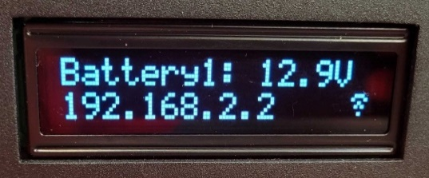

Figure 3. Wi-Fi setup with the QBot Platform

# B. User Interface

## i. Direct

The QBot Platform can be used directly as a computer. Connect a keyboard/mouse using the provided USB ports and connect a monitor using the HDMI port on board. The network can be set up using LAN as described in section A.i. The **username** for the QBot Platform is “**pi”** and the **password** is “**QuanserPi4**”.

## ii. Remote

For applications that require the QBot Platform to be moving or require remote access, a direct setup is not feasible. In such cases, a wireless setup is preferred with a personal computer (PC) or the provided Ground Control Station (GCS) (if the QBot Platform was purchased as part of the Autonomous Vehicles Research Studio). It must be connected to the same network as the QBot Platform and will deploy applications to the platform.

Connect your computer to the same network as the QBot Platform. To ensure that this was successful, use the command **ipconfig** (in a Windows command prompt) or **ifconfig** (in Ubuntu terminal) to check your current computer’s IPv4 address. You can also use the **ping** command in both Windows and Ubuntu to check your connection to the QBot Platform, eg.

**>> ping xxx.xxx.xxx.xxx -t**

where **xxx.xxx.xxx.xxx** represents the IPv4 address of the QBot Platform.

### File Transfer

To transfer files between the GCS and the platform manually, a software tool **WinSCP** can be used (This is installed by default if you have a provided GCS). Find more information on WinSCP [here](https://winscp.net/eng/docs/introduction). This can be used for one-time transfers of files, or you can navigate to a file onboard the QBot Platform.

To use WinSCP, enter the QBot Platform’s IP address as the host name, **pi** as the username, and **QuanserPi4** as the password, as shown in Figure 4a. You can now use the WinSCP browsers to transfer files from the computer to the QBot Platform (right browser), shown in Figure 4b. Double clicking a file on the right will automatically transfer a copy of the file to your PC and open it in your default editor. Clicking save in your editor will automatically transfer the saved version back to the QBot Platform.

|  |  |
| --- | --- |
|  |  |
| a. WinSCP login | b. WinSCP browser to transfer files |

Figure 4. WinSCP usage for file transfer

### PuTTY

Once your files are transferred, you can deploy them via remote terminal using a tool - **PuTTY** (installed by default on a GCS). Find more information on PuTTY [here](https://www.putty.org/). If you are familiar with Linux command-line text editors, you can also edit code on the QBot Platform via PuTTY. This software by itself is sufficient to access the file system and execute code that does not require any graphical feedback display.

To use PuTTY, open the application and enter the hostname or IP address of the QBot Platform in the hostname field as shown in Figure 5 then click Open. You will be prompted to login (username **pi**, and password **QuanserPi4**). Note that you can open more than one PuTTY terminal to the QBot Platform if you need to.

|  |
| --- |
|  |

Figure 5. Connecting to the QBot Platform with PuTTY

### VNC Viewer

The final method of remote access with the QBot Platform is to use a remote desktop application such as VNC Viewer (if you do not have VNC Viewer installed you may download the application by going [here](https://www.realvnc.com/en/connect/download/viewer/)). The advantage of this approach is that the QBot Platform desktop VNC server sends compressed image data to the remote desktop which allows for higher frame rates (though not as high as the direct connection method). This is useful for remotely monitoring image processing outputs. This approach also gives you the full graphical desktop which may be easier for users less familiar with Linux commands.

A VNC server has been pre-installed on the QBot Platform. To connect from your computer, you will need to perform the following steps:

For the QBot Platform:

1. Power **ON** the QBot Platform.

On the computer:

1. Launch VNC viewer.
2. In the VNC connect window enter the IP address of the QBot Platform which can be found on the LCD screen shown in section A.

|  |
| --- |
|  |

Figure 6. VNC Viewer connection screen.

1. When prompted to allow the remote desktop connection, click on yes.
2. You will be asked for the user password for the QBot Platform to start the remote desktop connection. You may optionally check the box to ‘Remember password’.

|  |
| --- |
|  |
| Figure 7. VNC Viewer QBot Platform credential screen. |

1. A successful connection will take you to the main user desktop.

|  |
| --- |
|  |

Figure 8. QBot Platform Raspberry Pi user screen

Note, an ethernet connection will provide a more responsive interface than Wi-Fi, but you can also try reducing the desktop resolution. You can select which combination of features, desktop space, and interface responsiveness work best for your workflow.

Note that VNC viewer is a bandwidth intensive application. Using it to develop and monitor code continuously is not recommended as it may saturate your router.

© Quanser Inc., All rights reserved.

Solutions for teaching and research. Made in Canada.