Application Train Target Analysis

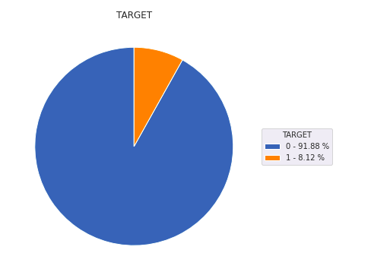

Data is highly imbalanced

* 91.88 % applicants will be able to repay loan on time
* 8.12 % applicants will be having difficulty in repaying the loan.

Analysis of Previous application train

|  |  |
| --- | --- |
| Previous Applications received by home were fairly distrusted among all days of the week except for Thursday (lesser than ~5% compared to other days) | Previous application had high demand of Consumer and Cash loans as compared to Revolving loans.   * Consumer loans: 44.76% * Cash loans: 43.66% * Revolving loans: 11.57 =% |
| More than half of the previous application got approved.   * Approved: 62.07% * Refused + Canceled: 36.34% * Unused offer: 1.58% |  |

Analysis of Credit Card Balance

|  |  |
| --- | --- |
|  | Contract status (active, completed, signed, ...) on the previous credit. 96.31% status are still active. |

Analysis of Previous installments.

|  |  |
| --- | --- |
|  | As we can see in the graph  When the installment of previous credit was **supposed to be paid** is **100% correlated** with When was the installments of previous credit **paid actually**.  And same goes with….  What was **the prescribed installment amount of previous credit** on this installment is **highly correlated** with What the client **actually paid on previous credit** on this installment |