# OUTPUT

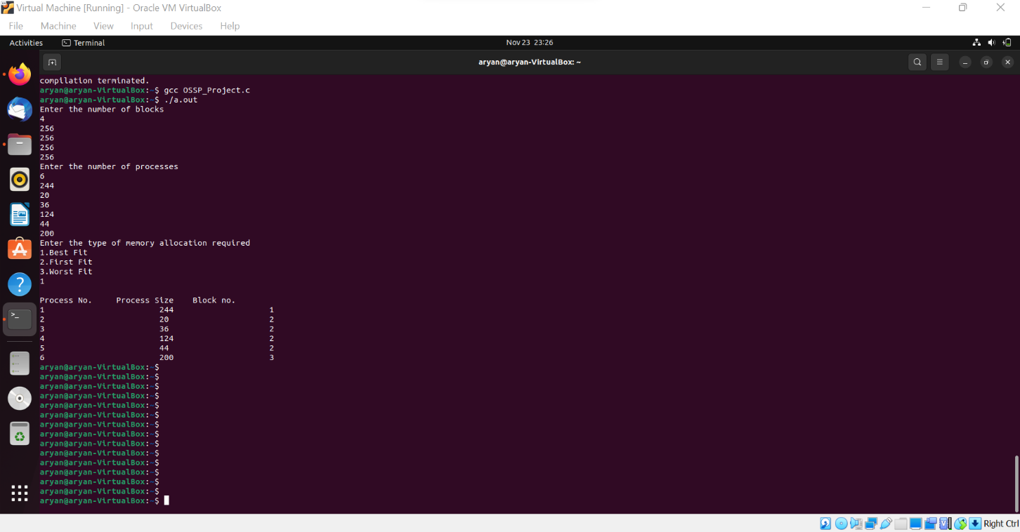

(The following code shows the memory allocation according to best fit where Best fit allocates the process to a partition which is the smallest sufficient partition among the free available partitions)

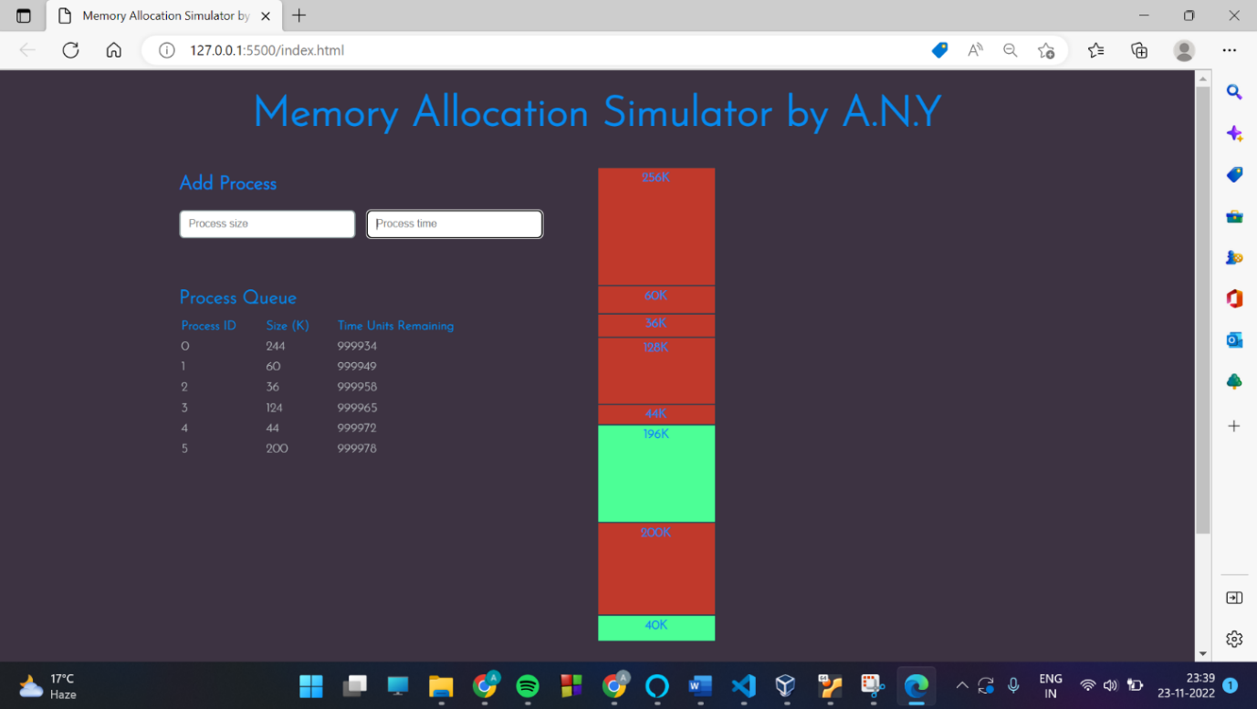

* (Users can input processes of a given size and length of time.
* Each process is automatically allocated to a ‘chunk’ in memory (as would be done by an operating system).
* Memory chunks are partitioned for efficient process allocation (using the ‘Best-Fit’ strategy to reduce fragmentation).
* As the program runs, a clock ticks in the background, decrementing the time remaining for each process.
* When a process terminates, chunks are automatically deallocated (freeing memory).
* Memory is simulated using a doubly linked list data structure.)