**Name:** Ansari Adeeba Anjum N.  **Roll no. :** 18CO01

**Subject:** Database & Information System Lab **Lab Code:** CSL503

**Exp 9:** Hosting the website with Domain Registration Process

1. Domain Registration

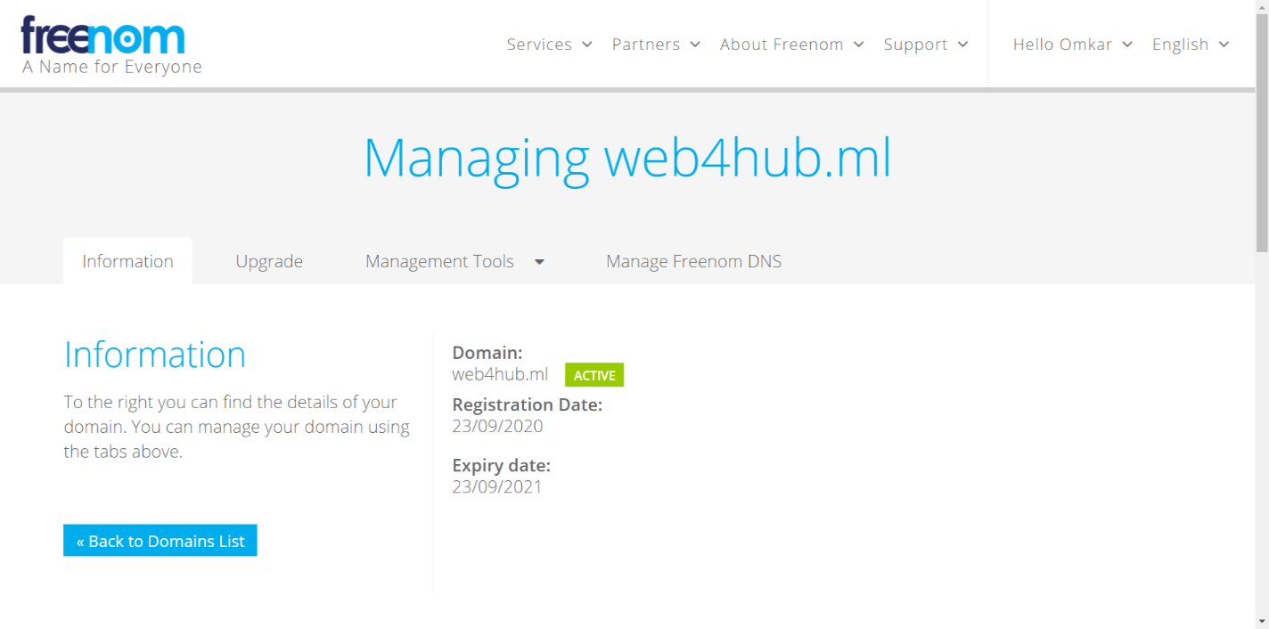

1. Web Hosting Registration

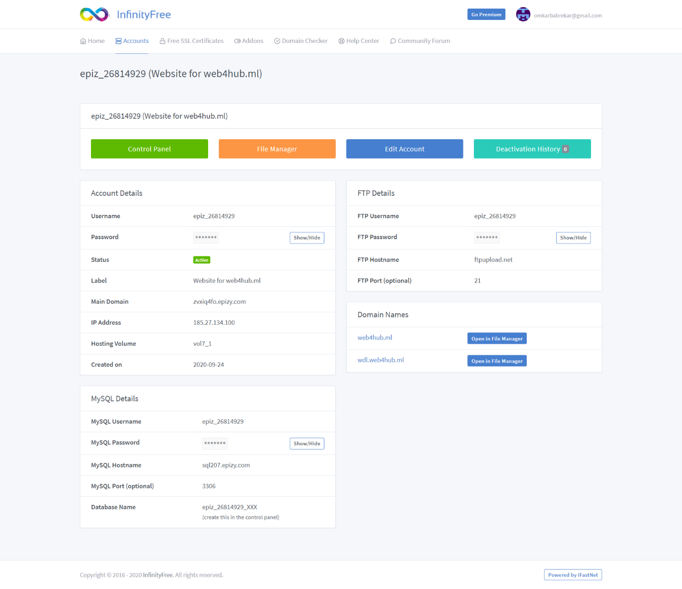

1. 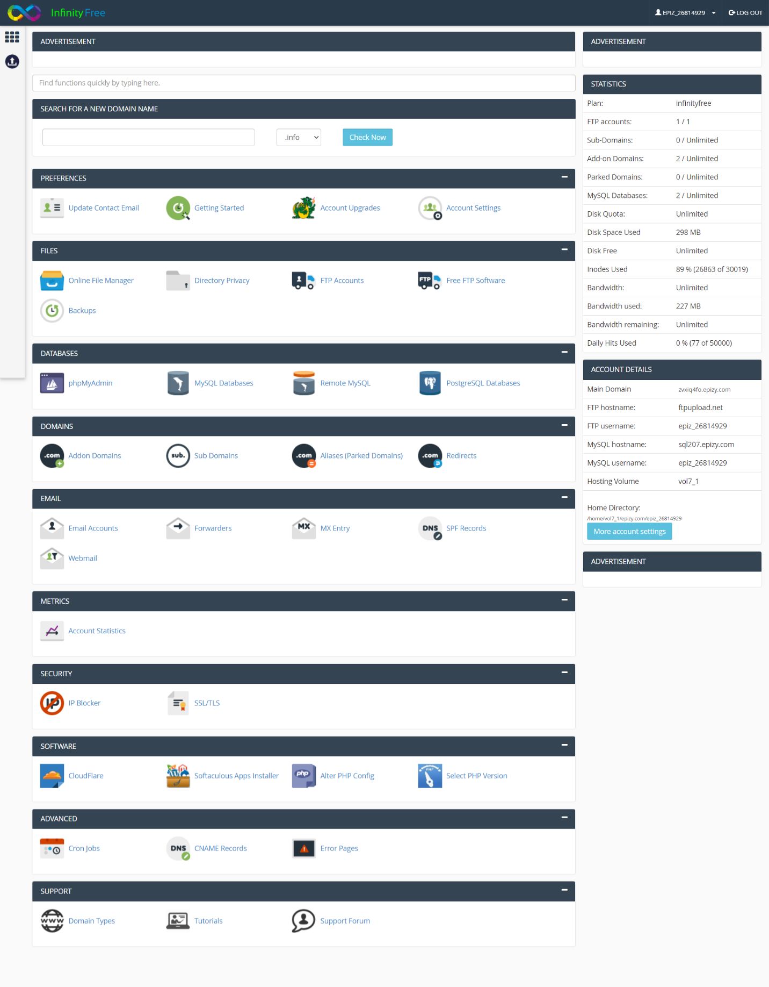Control Panel
2. 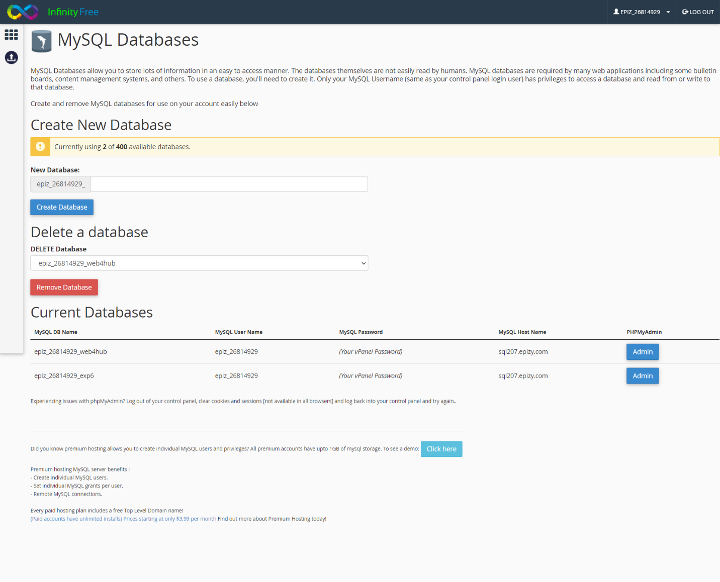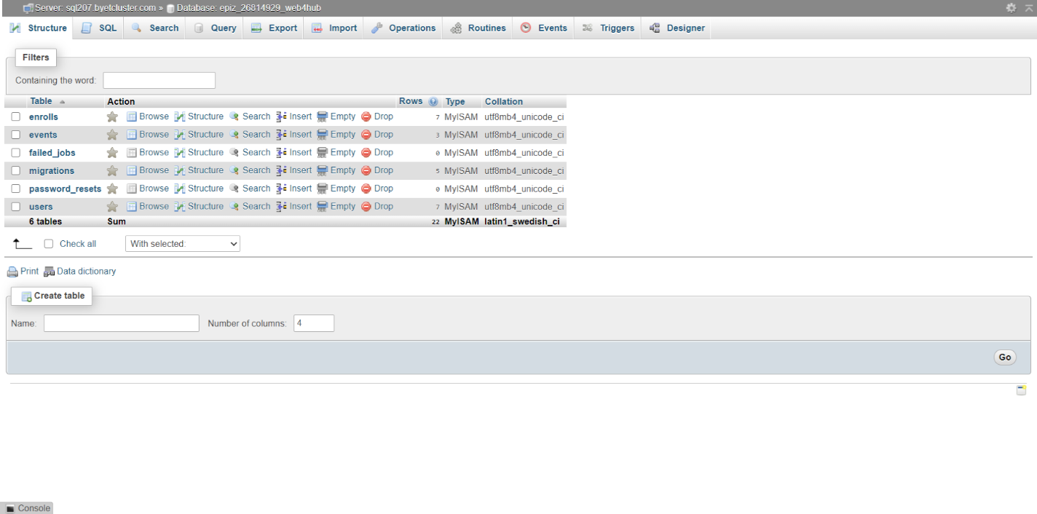MySQL Database Upload
3. File Manager

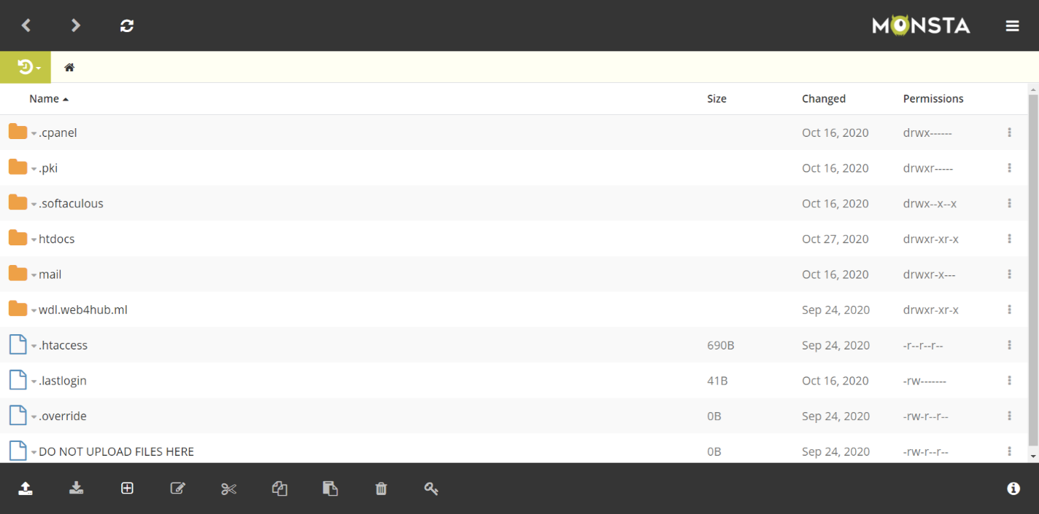

1. Home page of your domain.