**Name :** Amank Akram Kazi **Roll no. :** 18CO27

**Subject :** Database & Information System Lab **Lab Code :** CSL503

**Exp 9 :** Hosting the website with Domain Registration Process

1. Domain Registration

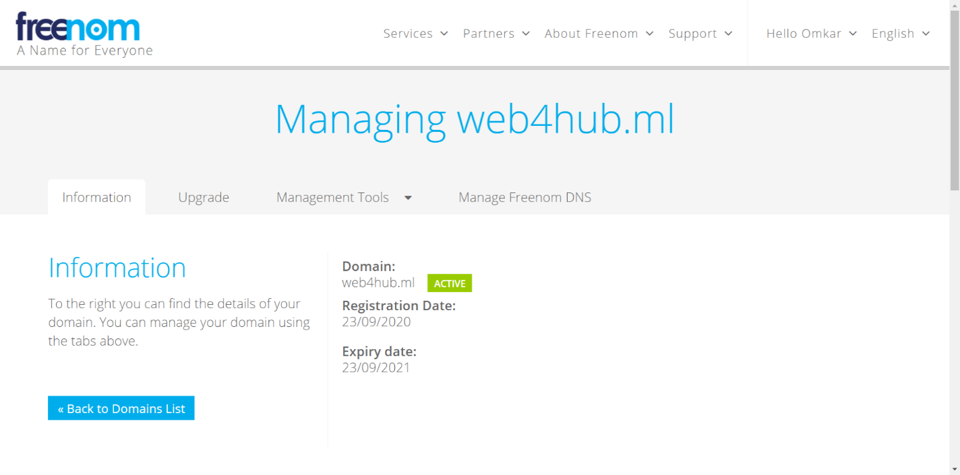

1. Web Hosting Registration

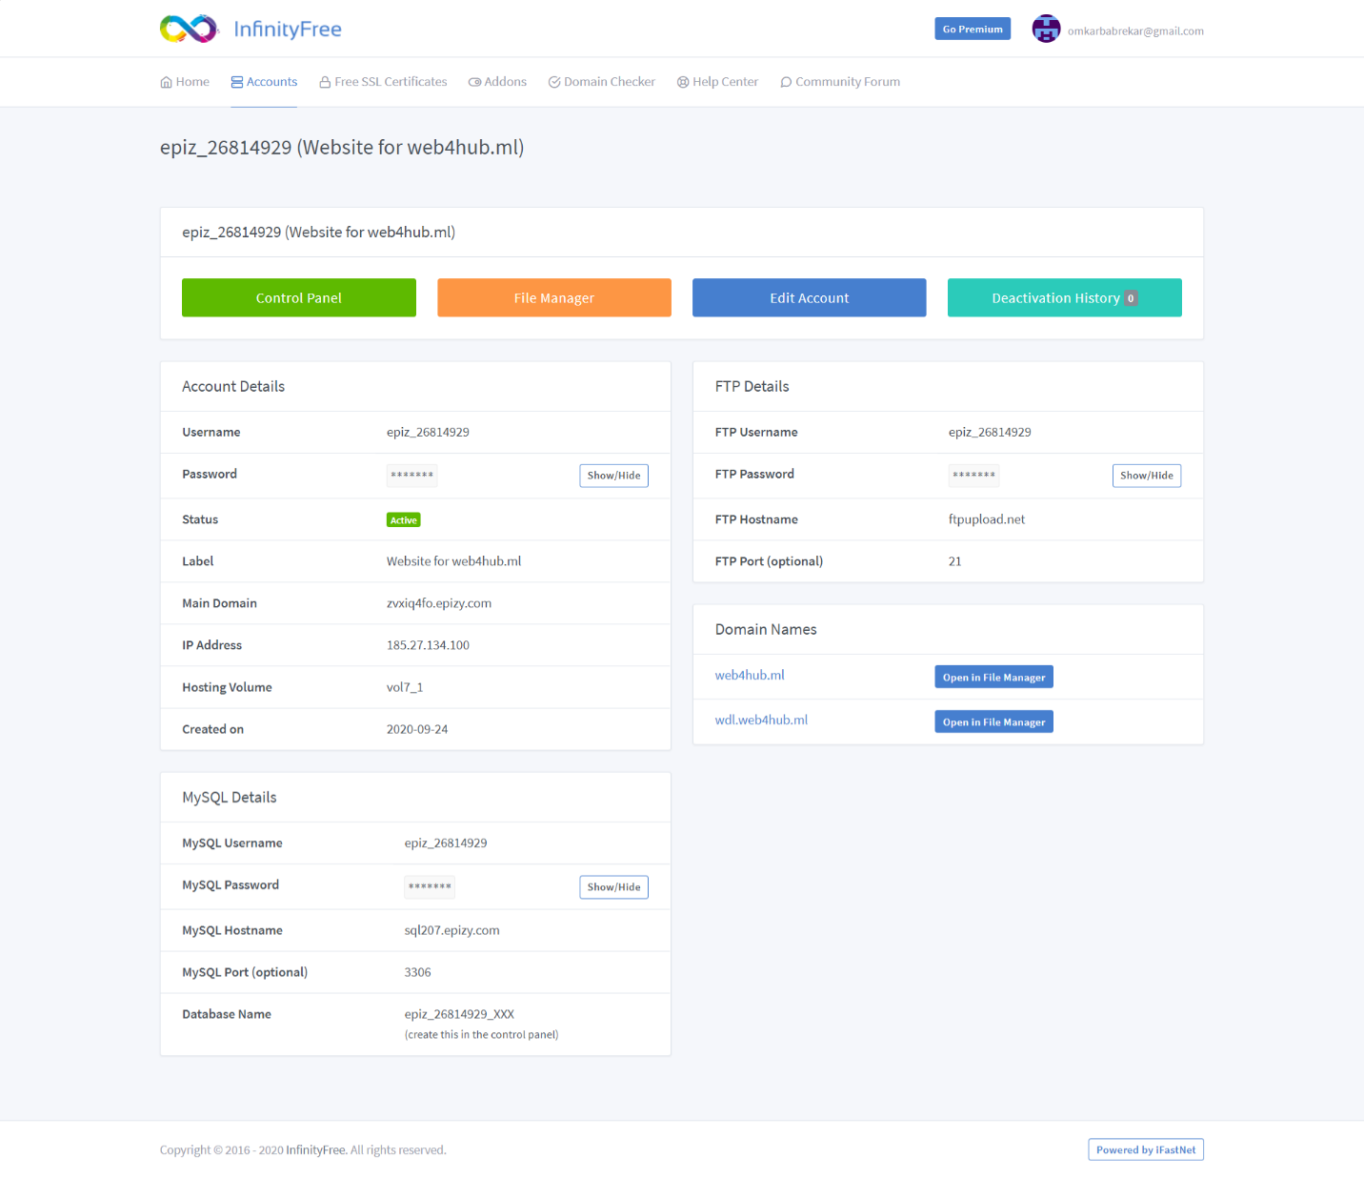

1. Control Panel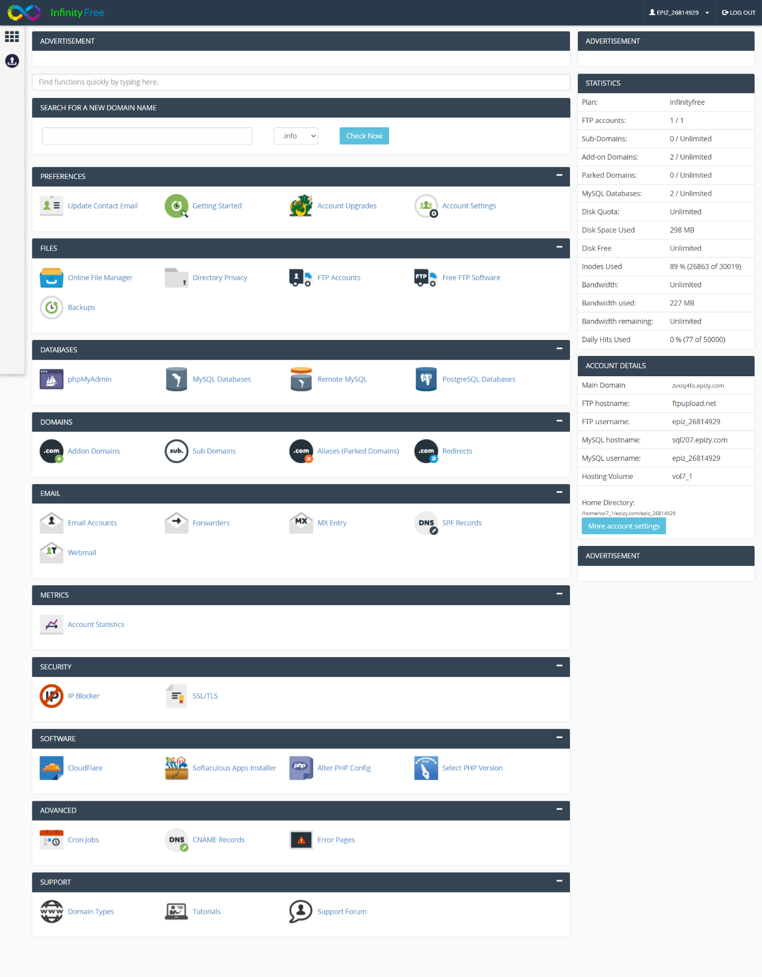
2. 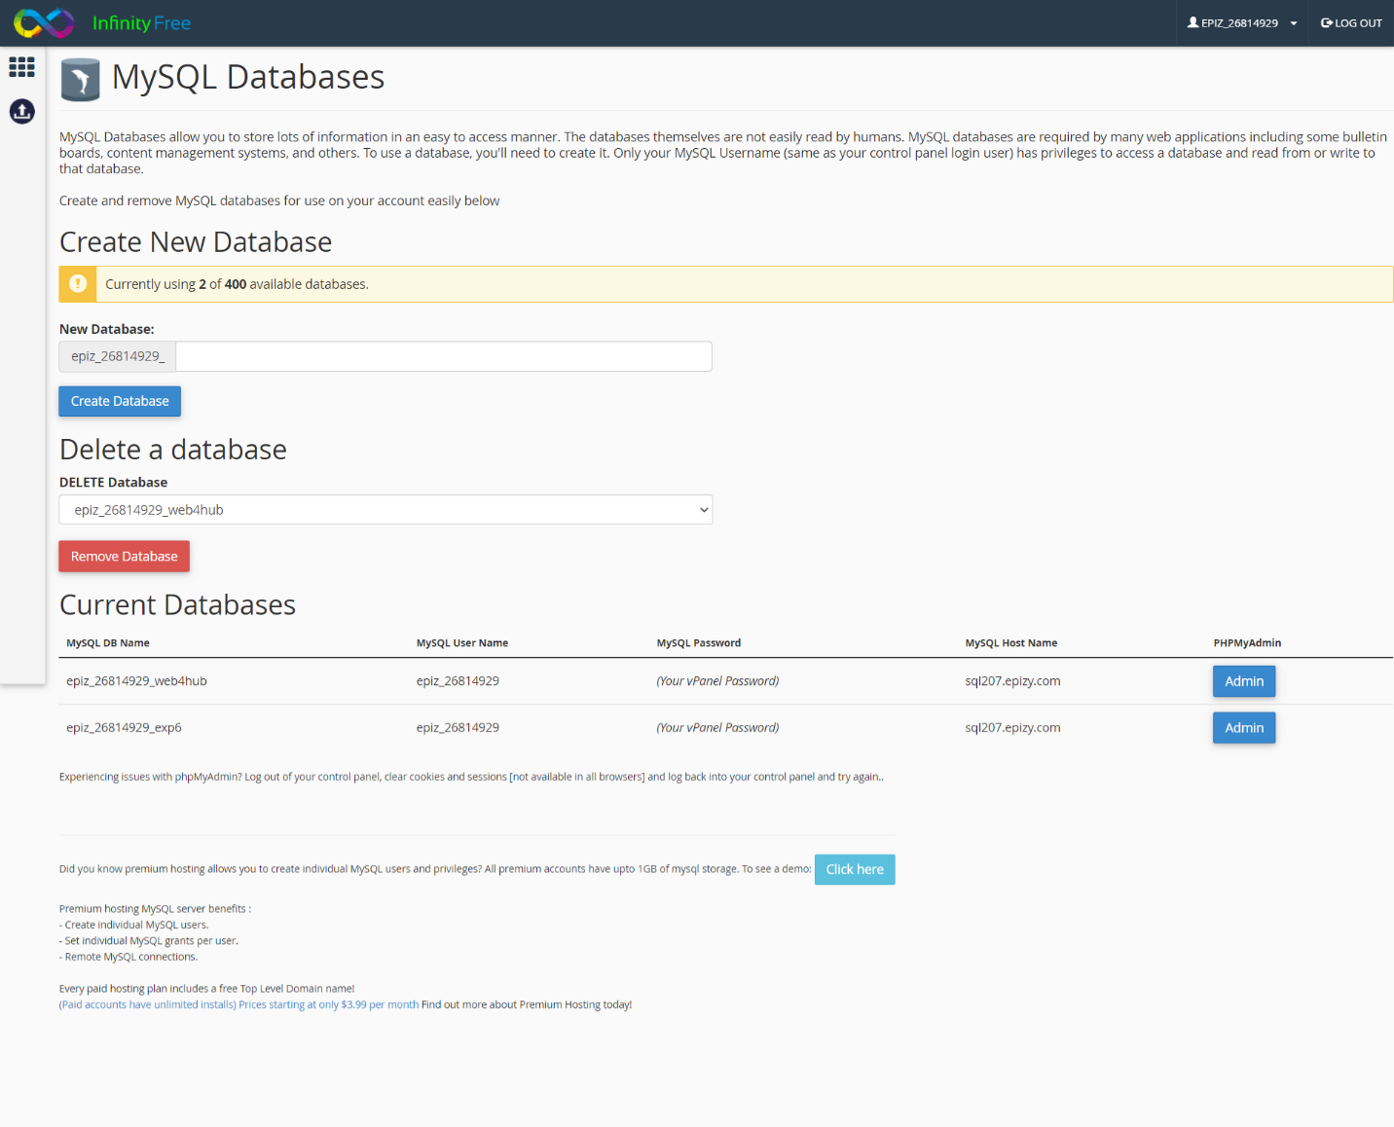MySQL Database Upload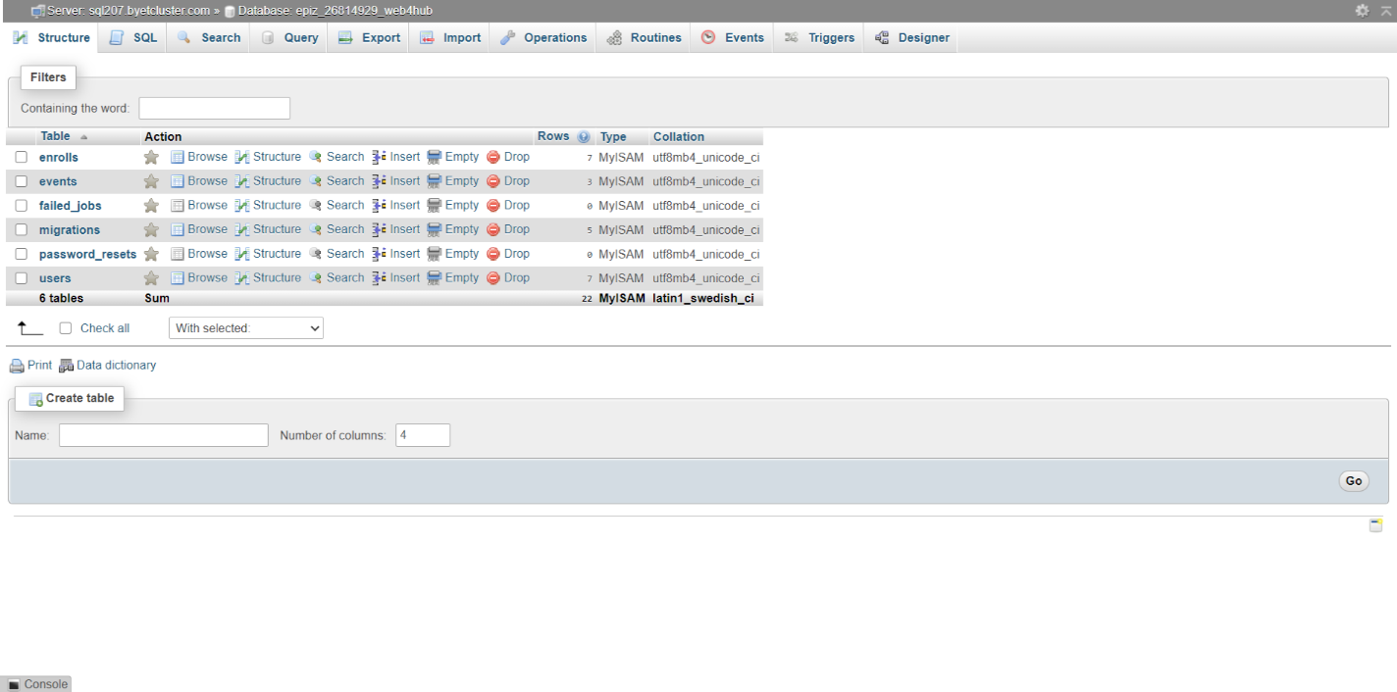
3. File Manager

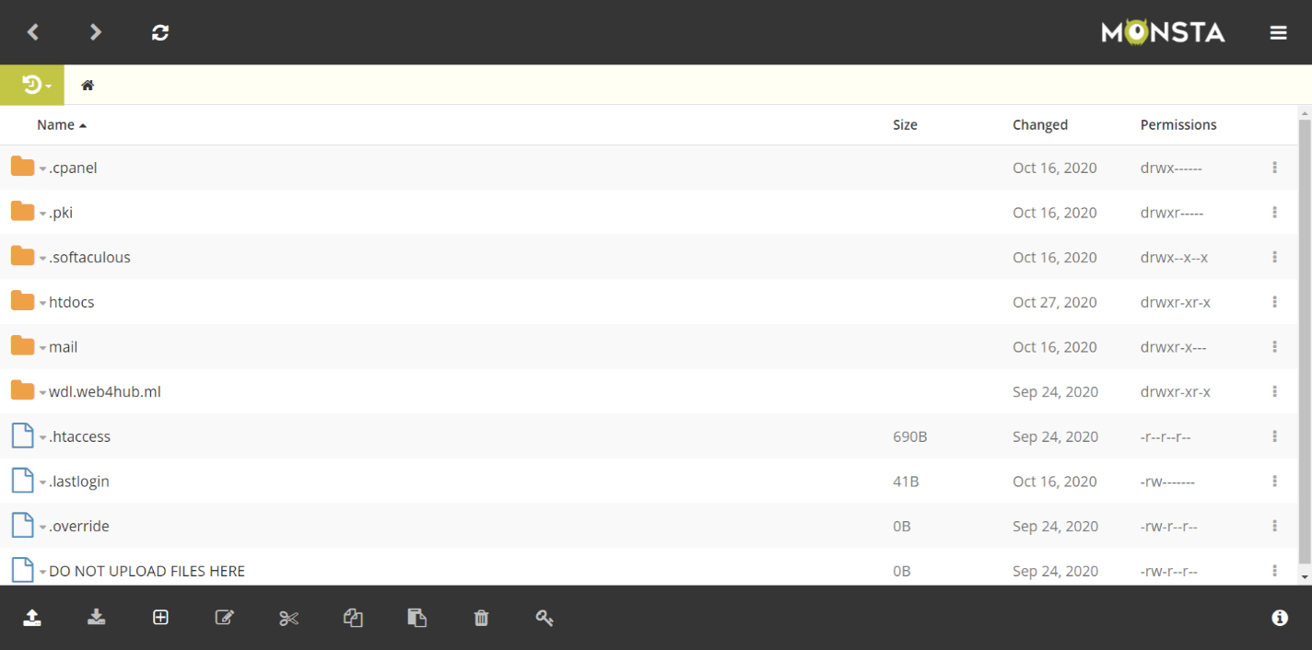

1. Home page of your domain.