Light Control V1.0 03/2023 Rev 1.0

Main Electric Characteristics
Main Supply | External +12V (min. 2A) through Barrel-Jack
MCU Supply | +5V (stepped down from main)
Remote Control Supply | +5V (stepped down from main)

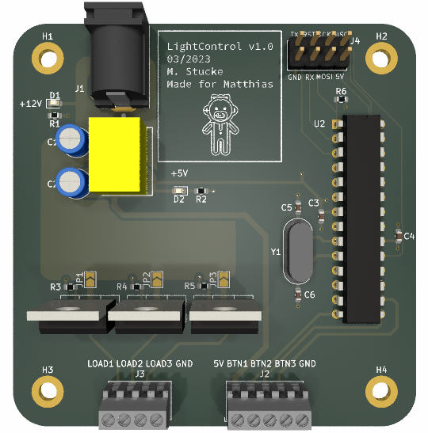 Figure 1: Mainboard TOP View
Figure 2: Git Repository

