024

DZone.com/refcardz

 |  | BROUGHT TO YOU BY:
NT E NT S |  | Core Java
NT E NT S | »»Java Keywords | Core Java
NT E NT S | »»Standard Java Packages | Core Java
NT E NT S | »»Lambda Expressions | Core Java
NT E NT S | »»Collections & Common Algorithms | Core Java
C O | »»Character Escape Sequences, | By Cay S. Horstmann; Revised & Updated by Ivan St. Ivanov
C O | and more... | By Cay S. Horstmann; Revised & Updated by Ivan St. Ivanov


Get More Refcardz! Visit

CORE JAVA

ABOUT CORE JAVA

This Refcard gives you an overview of key aspects of the Java language and cheat sheets on the core library (formatted output, collections, regular expressions, logging, properties) as well as the most commonly used tools (javac, java, jar).

JAVA KEYWORDS

KEYWORD | DESCRIPTION | EXAMPLE
abstract | an abstract class | abstract class Writable {
 | or method | public abstract void
 |  | write(Writer out);
 |  | public void save(String
 |  | filename) { ... }
 |  | }
assert | with assertions | assert param != null;
 | enabled, throws | Note: Run with -ea to enable
 | an error if condition | Note: Run with -ea to enable
 | an error if condition | assertions
 | not fulfilled | assertions
boolean | the Boolean type | boolean more = false;
 | with values true
 | and false
break | breaks out of a | while ((ch = in.next()) !=
 | switch or loop | -1) {
 |  | if (ch == '\n') break;
 |  | process(ch);
 |  | }
 |  | Note: Also see switch
byte | the 8-bit integer | byte b = -1; // Not the
 | type | same as 0xFF
 |  | Note: Be careful with bytes < 0
case | a case of a switch | see switch
catch | the clause of a try | see try
 | block catching an
 | exception
char | the Unicode | char input = 'Q';
 | character type
class | defines a class | class Person {
 | type | private String name;
 |  | public Person(String
 |  | aName) {
 |  | name = aName;
 |  | }
 |  | public void print() {
 |  | System.out.
 |  | println(name);
 |  | }
 |  | }
continue | continues at the | while ((ch = in.next()) !=
 | end of a loop | -1) {
 |  | if (ch == ' ') continue;
 |  | process(ch);
 |  | }
default | 1) the default | see switch
 | clause of a switch

KEYWORD | DESCRIPTION | EXAMPLE
default | 2) denotes default | public interface
(cont.) | implementation | Collection<E> {
 | of an interface | @Override
 | of an interface | default Spliterator<E>
 | method | default Spliterator<E>
 | method | spliterator() {
 |  | return Spliterators.
 |  | spliterator(this, 0);
 |  | }
 |  | }
do | the top of a do/ | do {
 | while loop | ch = in.next();
 |  | } while (ch == ' ');
double | the double- | double oneHalf = 0.5;
 | precision floating-
 | number type
else | the else clause of | see if
 | an if statement
enum | an enumerated type | enum Mood { SAD, HAPPY };
extends | defines the parent | class Student extends
 | class of a class | Person {
 |  | private int id;
 |  | public Student(String
 |  | name, int anId) { ... }
 |  | public void print()
 |  | { ... }
 |  | }
final | a constant, or a | public static final int
 | class or method | DEFAULT_ID = 0;
 | that cannot be
 | overridden
finally | the part of a | see try
 | try block that is
 | always executed
float | the single- | float oneHalf = 0.5F;
 | precision floating-
 | point type

Run Java on a scalable,
container-based cloud platform.

Java/Spring, Scala/Play, Clojure, Groovy/Grails...

SIGN UP FO R FREE H ER OKU . C OM/ JAVA

© DZONE, INC. | DZONE.COM
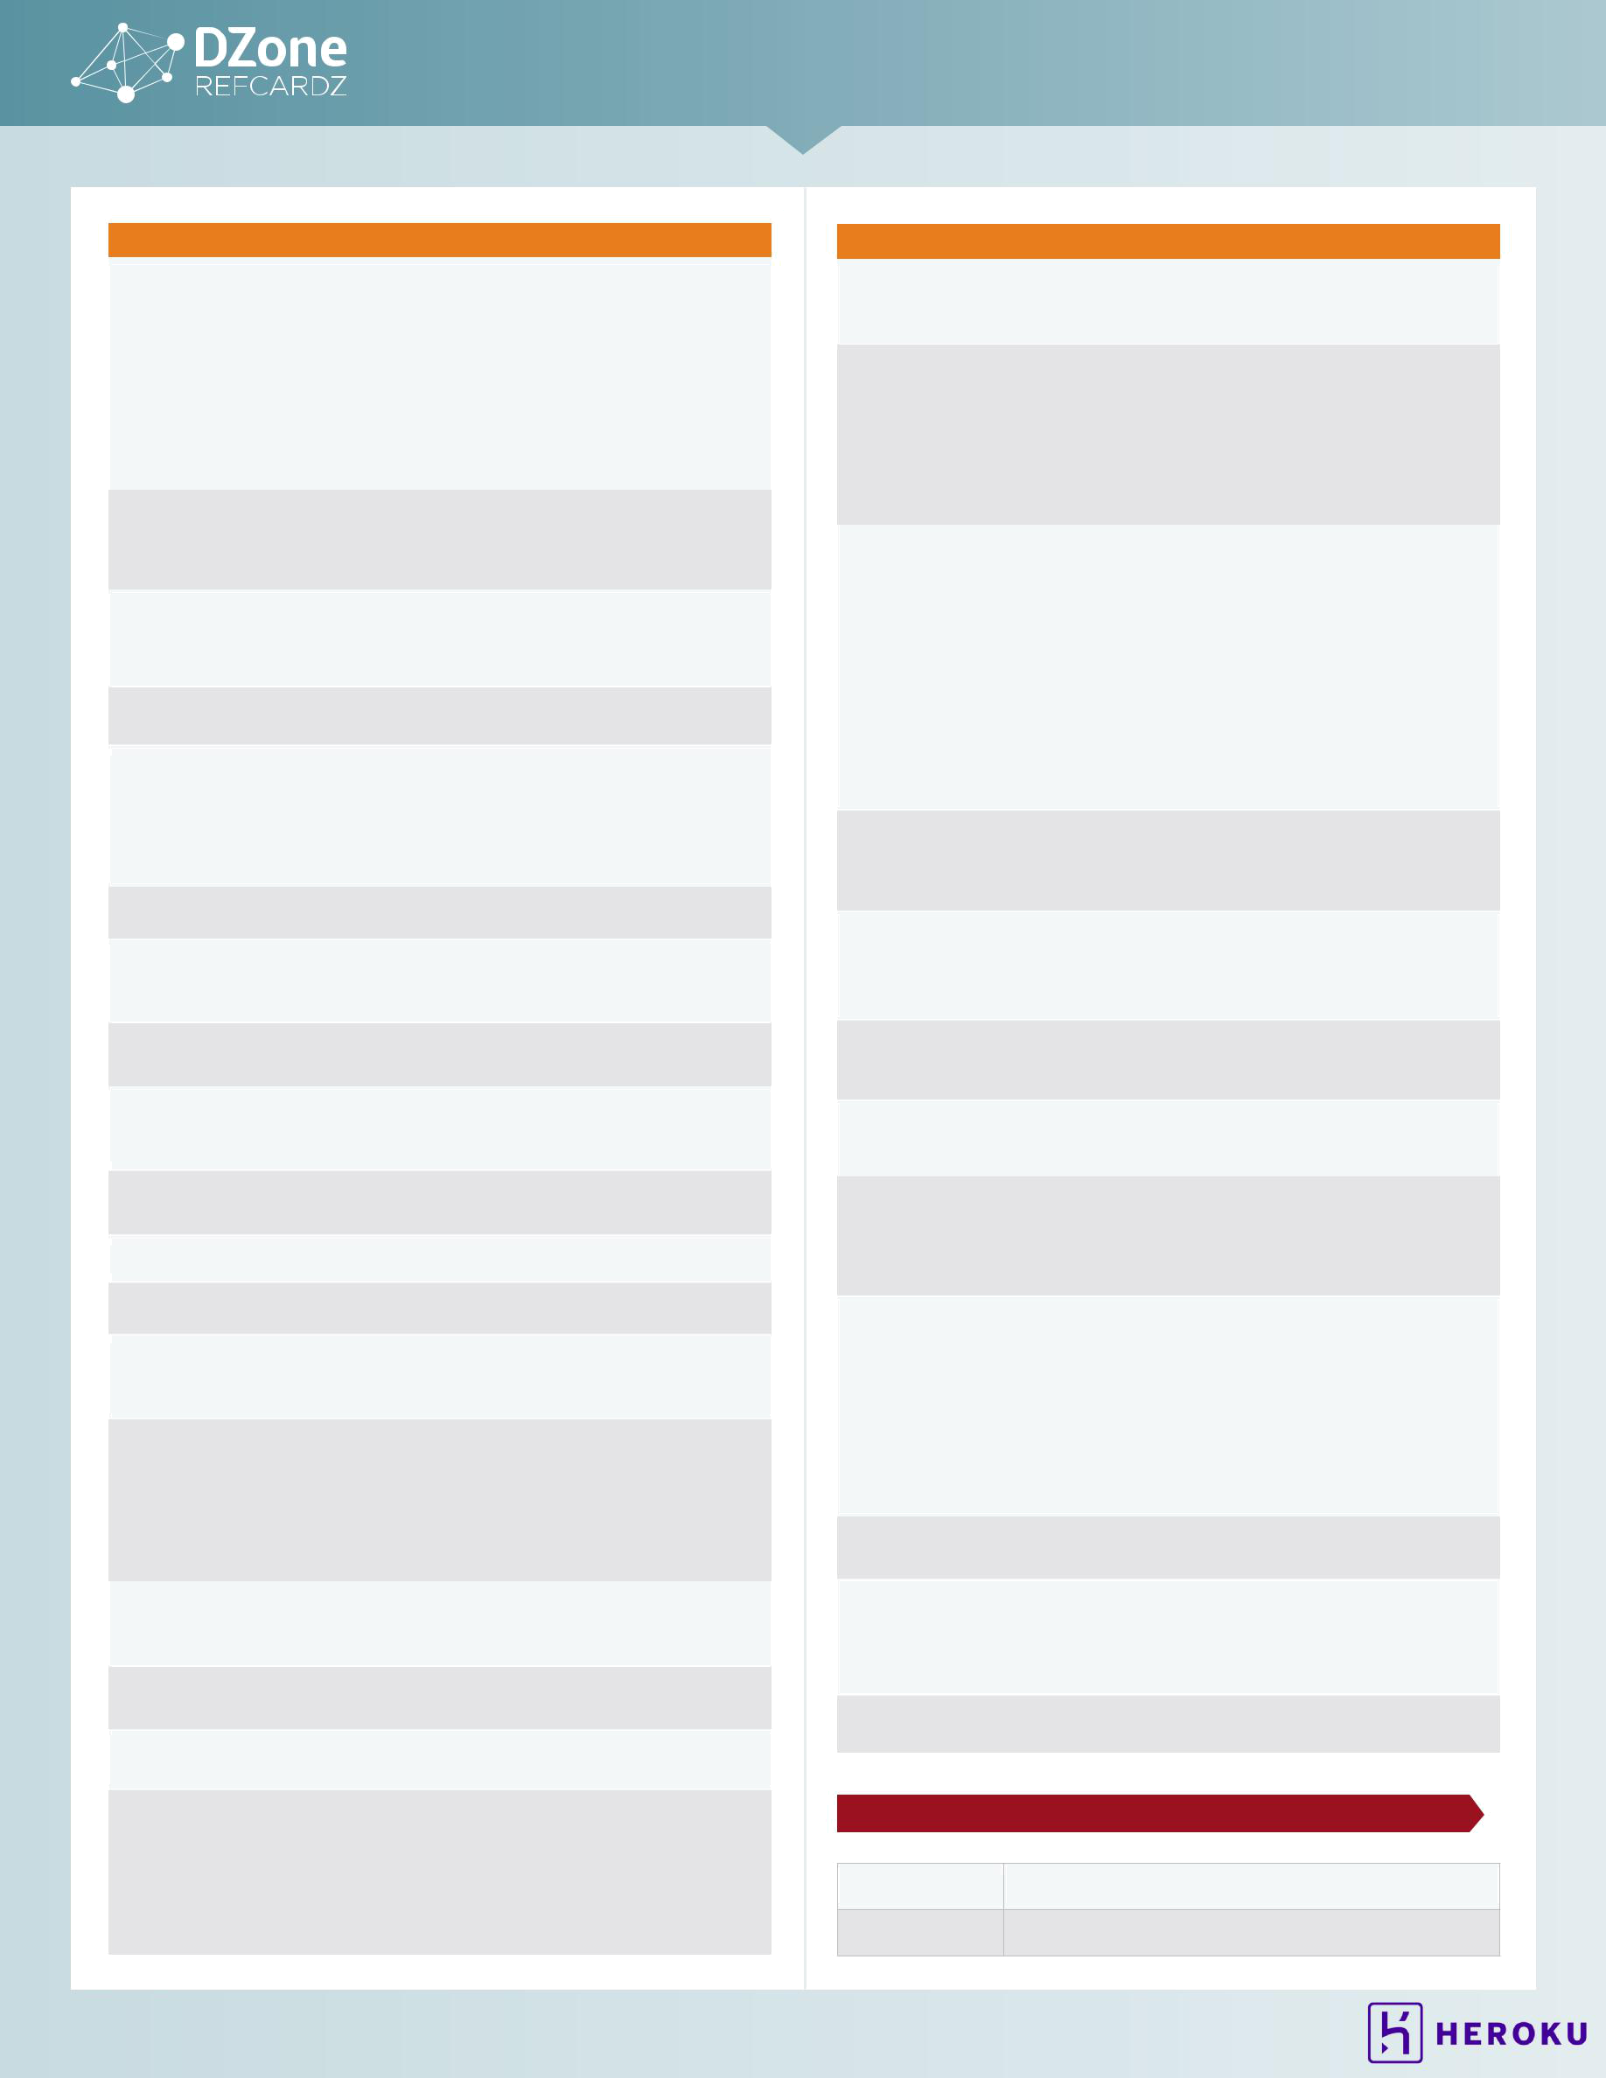
2 CORE JAVA

KEYWORD | DESCRIPTION | EXAMPLE
for | a loop type | for (int i = 10; i >= 0;
 |  | i--)
 |  | System.out.println(i);
 |  | for (String s : line.
 |  | split("\\s+"))
 |  | System.out.println(s);
 |  | Note: In the “generalized” for
 |  | loop, the expression after the :
 |  | must be an array or an Iterable
if | a conditional | if (input == 'Q')
 | statement | System.exit(0);
 |  | else
 |  | more = true;
implements | defines the | class Student
 | interface(s) that a | implements Printable {
 | class implements | ...
 | class implements | }
import | imports a package | import java.util.ArrayList;
 |  | import com.dzone.refcardz.*;
instanceof | tests if an object | if (fred instanceof Student)
 | is an instance of a | value = ((Student) fred).
 | class | getId();
 |  | Note: null instanceof T is
 |  | always false
int | the 32-bit integer type | int value = 0;
interface | an abstract type | interface Printable {
 | with methods that a | void print();
 | class can implement | }
long | the 64-bit long | long worldPopulation =
 | integer type | 6710044745L;
native | a method
 | implemented by the
 | host system
new | allocates a new | Person fred = new
 | object or array | Person("Fred");
null | a null reference | Person optional = null;
package | a package of classes | package com.dzone.refcardz;
private | a feature that is | see class
 | accessible only by
 | methods of this class
protected | a feature that is | class Student {
 | accessible only by | protected int id;
 | methods of this | ...
 | methods of this | }
 | class, its children, | }
 | and other classes in
 | the same package
public | a feature that is | see class
 | accessible by
 | methods of all classes
return | returns from a | int getId() { return id; }
 | method
short | the 16-bit integer | short skirtLength = 24;
 | type
static | a feature that is | public class WriteUtil {
 | unique to its class, | public static void
 | not to objects of its | write(Writable[] ws,
 | not to objects of its | String filename);
 | class | String filename);
 | class | public static final
 |  | String DEFAULT_EXT = ".dat";
 |  | }

KEYWORD | DESCRIPTION | EXAMPLE
strictfp | Use strict rules
 | for floating-point
 | computations
super | invoke a superclass | public Student(String name,
 | constructor or | int anId) {
 | method | super(name); id = anId;
 | method | }
 |  | public void print() {
 |  | super.print();
 |  | System.out.println(id);
 |  | }
switch | a selection | switch (ch) {
 | statement | case 'Q':
 |  | case 'q':
 |  | more = false; break;
 |  | case ' ';
 |  | break;
 |  | default:
 |  | process(ch); break;
 |  | }
 |  | Note: If you omit a break,
 |  | processing continues with the
 |  | next case.
synchronized | a method or code | public synchronized void
 | block that is atomic | addGrade(String gr) {
 | to a thread | grades.add(gr);
 | to a thread | }
this | the implicit argument | public Student(String id)
 | of a method, or a | {this.id = id;}
 | constructor of this | public Student() {
 | constructor of this | this(""); }
 | class | this(""); }
throw | throws an exception | if (param == null)
 |  | throw new
 |  | IllegalArgumentException();
throws | the exceptions that | public void print()
 | a method can throw | throws PrinterException,
 |  | IOException
transient | marks data that | class Student {
 | should not be | private transient Data
 | persistent | cachedData;
 | persistent | ...
 |  | }
try | a block of code that | try {
 | traps exceptions | try {
 |  | fred.print(out);
 |  | } catch (PrinterException
 |  | ex) {
 |  | ex.printStackTrace();
 |  | }
 |  | } finally {
 |  | out.close();
 |  | }
void | denotes a method | public void print() { ... }
 | that returns no value
volatile | ensures that a | class Student {
 | field is coherently | private volatile int
 | accessed by | nextId;
 | accessed by | ...
 | multiple threads | ...
 | multiple threads | }
while | a loop | while (in.hasNext())
 |  | process(in.next());

STANDARD JAVA PACK AGES

java.applet Applets (Java programs that run inside a web page)

java.awt | Graphics and graphical user interfaces

© DZONE, INC. | DZONE.COM
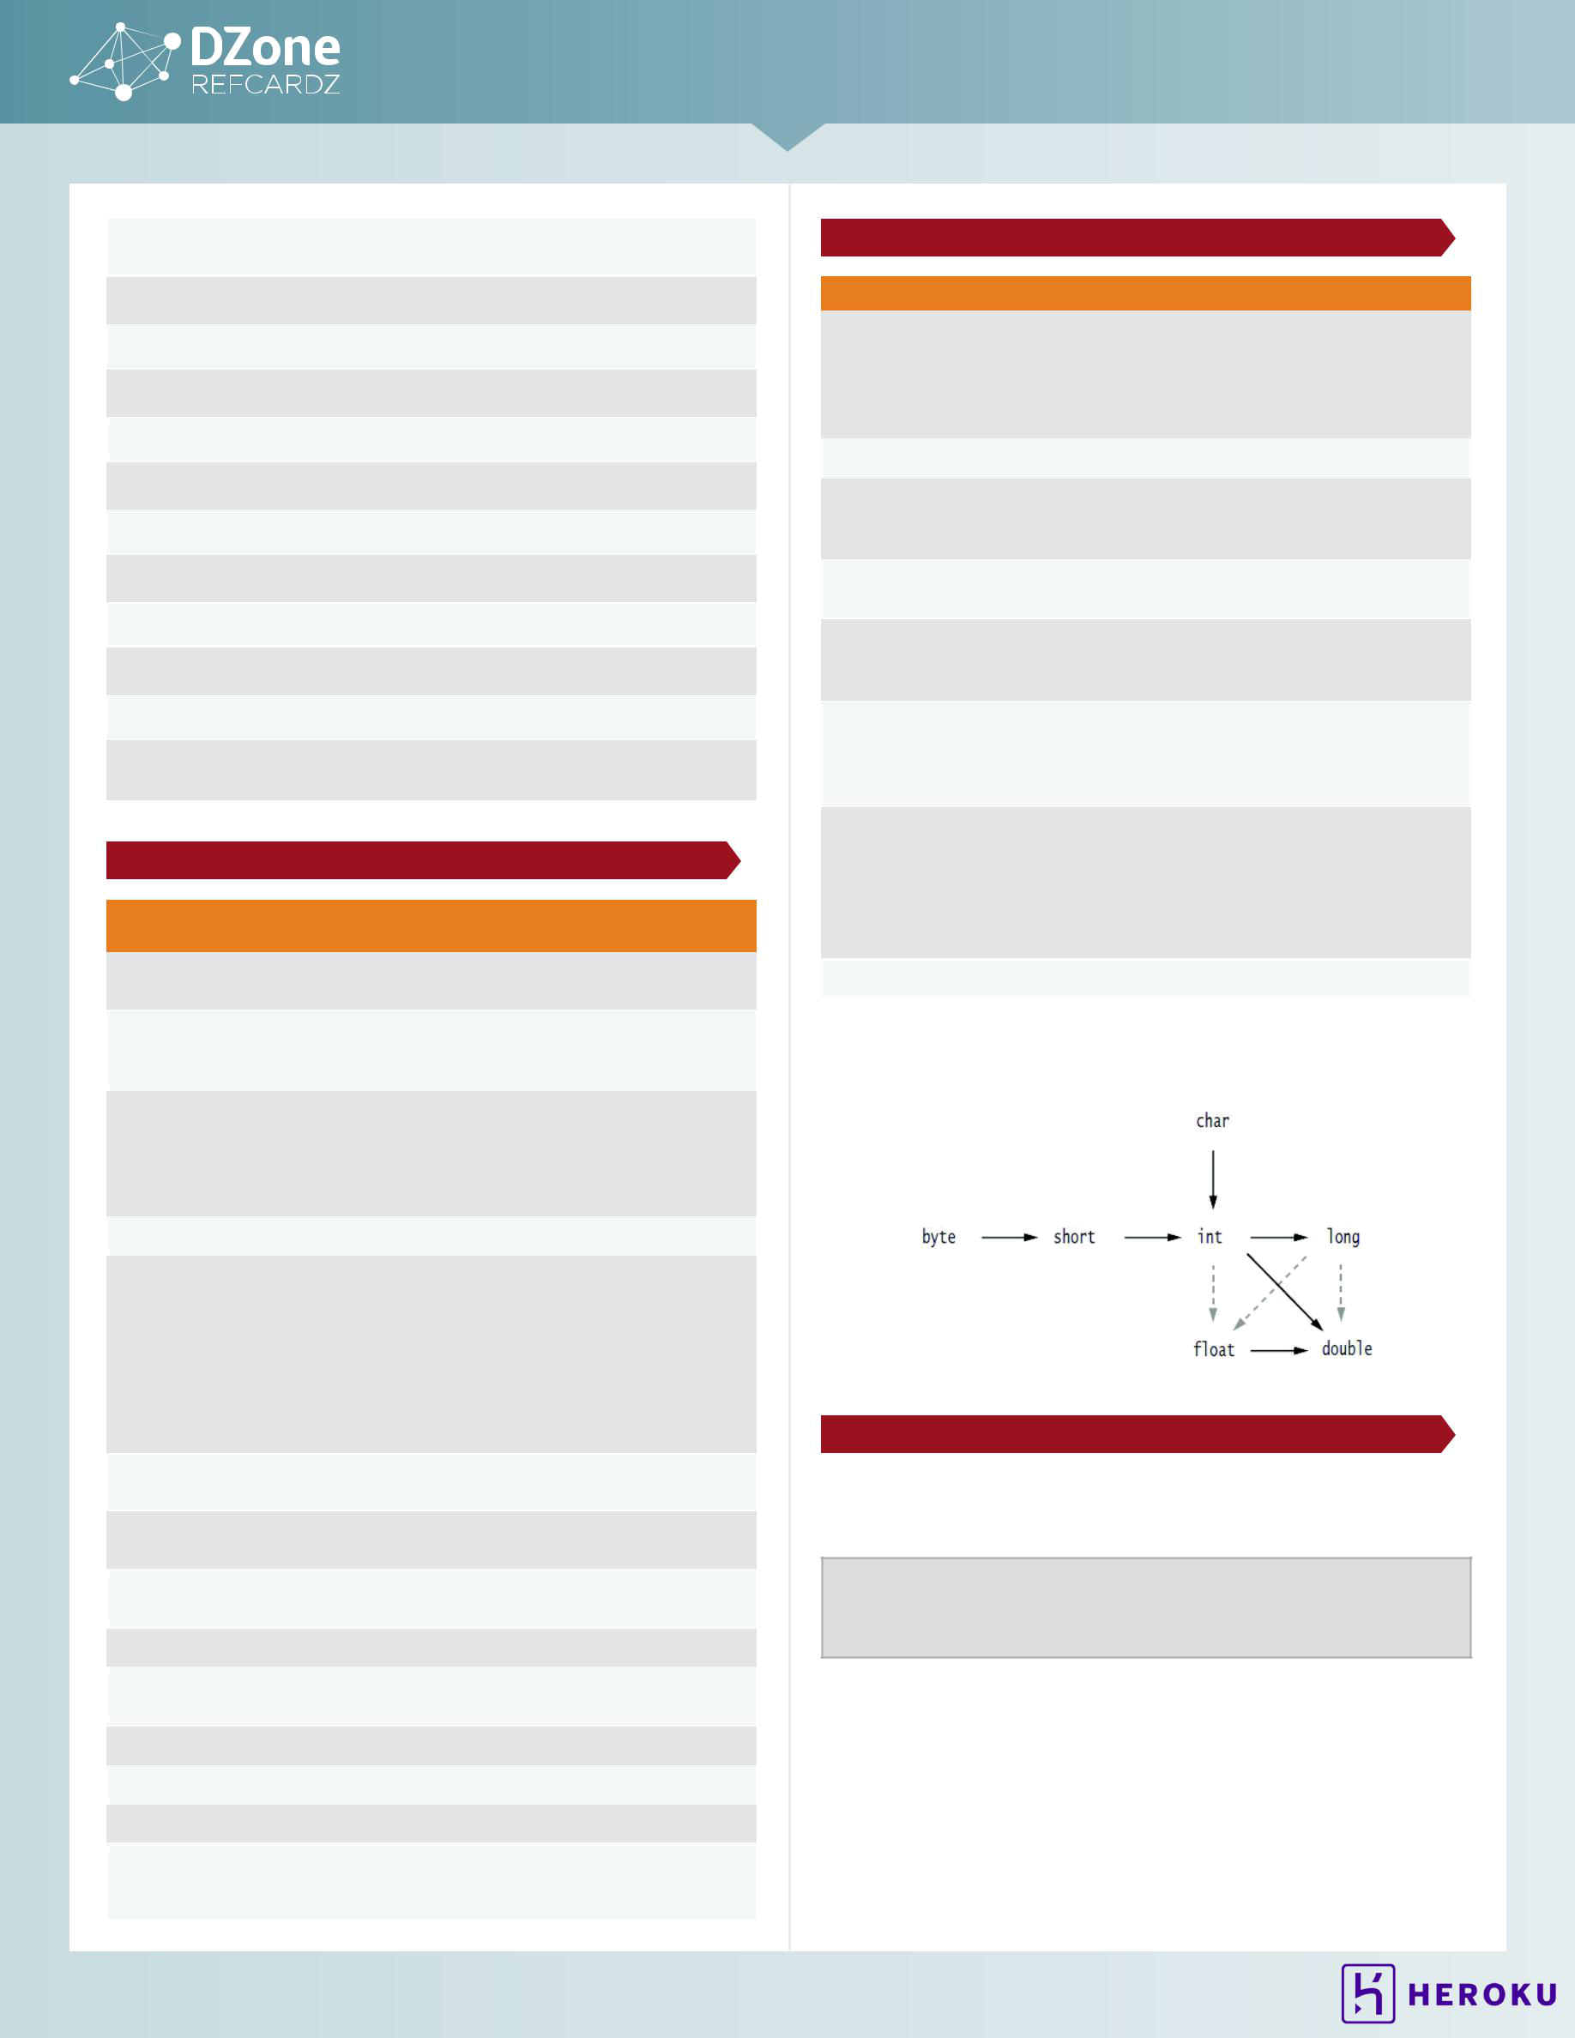
3 CORE JAVA

java.beans | Support for JavaBeans components (classes with
 | properties and event listeners)
java.io | Input and output
java.lang | Language support
java.math | Arbitrary-precision numbers
java.net | Networking
java.nio | “New” (memory-mapped) I/O
java.rmi | Remote method invocations
java.security | Security support
java.sql | Database support
java.text | Internationalized formatting of text and numbers
java.time | Dates, time, duration, time zones, etc.
java.util | Utilities (including data structures, concurrency, regular
 | expressions, and logging)

OPER ATOR PRECEDENCE

OPERATORS WITH THE SAME |  | NOTES
PRECEDENCE
[] . () | Left to right
(method call)
! ~ ++ -- + | Right to left | ~ flips each bit of a number
(unary) – (unary)
() (cast) new
* / % | Left to right | Be careful when using % with
 |  | negative numbers. -a % b == -(a
 |  | % b), but a % -b == a % b.
 |  | For example, -7 % 4 == -3, 7 %
 |  | -4 == 3
+ - | Left to right
<< >> >>> | Left to right | >> is arithmetic shift (n >> 1 == n / 2
 |  | for positive and negative numbers),
 |  | >>> is logical shift (adding 0 to the
 |  | highest bits). The right hand side is
 |  | reduced modulo 32 if the left hand
 |  | side is an int or modulo 64 if the left
 |  | hand side is a long. For example, 1
 |  | << 35 == 1 << 3
< <= > >= | Left to right | null instanceof T is always
instanceof |  | false
== != | Left to right | Checks for identity. Use equals to
 |  | check for structural equality
& | Left to right | Bitwise AND; no lazy evaluation
 |  | with bool arguments
^ | Left to right | Bitwise XOR
| | Left to right | Bitwise OR; no lazy evaluation with
 |  | bool arguments
&& | Left to right
|| | Left to right
?: | Right to left
= += -= *= /= | Right to left
%= &= |= ^= <<=
>>= >>>=

PRIMITIVE TYPES

TYPE | SIZE | RANGE | NOTES
int | 4 bytes | –2,147,483,648 to 2,147,483, | The wrapper type
 |  | 647 | is Integer. Use
 |  | (just over 2 billion) | BigInteger for
 |  |  | arbitrary precision
 |  |  | integers
short | 2 bytes | –32,768 to 32,767
long | 8 bytes | –9,223,372,036,854,775,808 | Literals end with
 |  | to | L (e.g. 1L)
 |  | 9,223,372,036,854,775,807
byte | 1 byte | –128 to 127 | Note that the range
 |  |  | is not 0 to 255
float | 4 bytes | approximately | Literals end with
 |  | ±3.40282347E+38F (6–7 | F (e.g. 0.5F)
 |  | significant decimal digits)
double | 8 bytes | approximately | Use BigDecimal
 |  | ±1.79769313486231570E+308 | for arbitrary
 |  | (15 significant decimal digits) | precision floating-
 |  |  | point numbers
char | 2 bytes | \u0000 to \uFFFF | The wrapper type
 |  |  | is Character.
 |  |  | Unicode
 |  |  | characters >
 |  |  | U+FFFF require
 |  |  | two char values
boolean |  | true or false

LEGAL CONVERSIONS BETWEEN PRIMITIVE TYPES

Dotted arrows denote conversions that may lose precision.

LAMBDA EXPRESSIONS

FUNCTIONAL INTERFACES

Interfaces with a single abstract method. Example:

@FunctionalInterface

public interface Predicate<T> {

boolean test(T t);

}

Implementations of this interface can be supplied in-line as a lambda expression:

- Anonymous implementations of functional interfaces

- Parameters and body are separated by an arrow sign ("->")

- Parameters of the abstract method are on the left of the arrow

- The implementation is on the right of the arrow

© DZONE, INC. | DZONE.COM
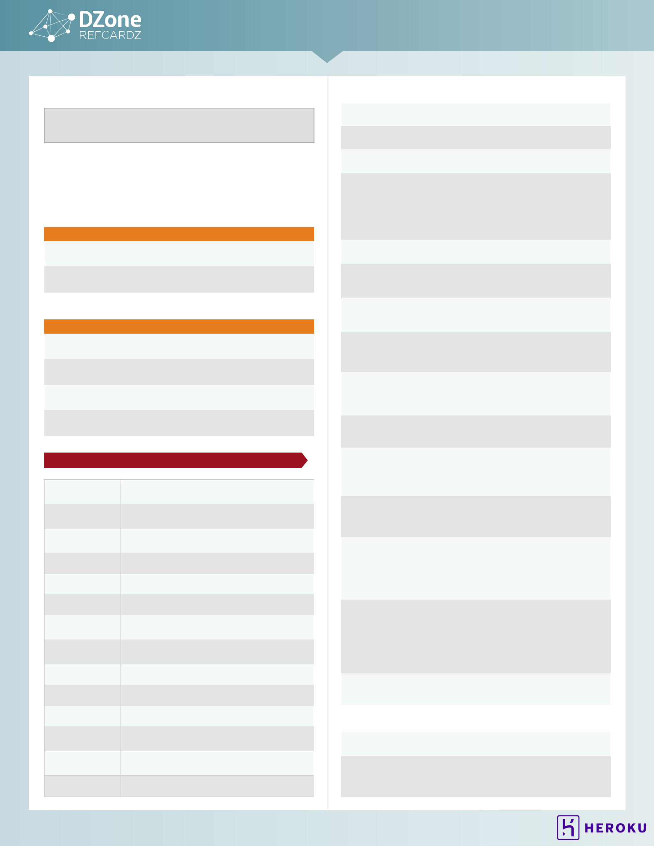
4 CORE JAVA

Typical usage of lambda expressions:

JButton button = new JButton("MyButton"); button.addActionListener(event -> doSomeImportantStuff(event));

METHOD REFERENCES

Lambda expressions represent anonymous functions. You can pass them as method parameters or return them. The same can be done with named methods using method references.

Typical usage of method references:

WITHOUT METHOD REFERENCE | WITH METHOD REFERENCE
button.addActionListener(event -> | button.addActionListener(
doSomeImportantStuff(event)); | this::doSomeImportantStuff);
list.forEach(element -> | list.forEach(System.
System.out.println(element)); | out::println);

There are four kinds of method references:

KIND OF METHOD REFERENCE | EXAMPLE
To a static method | Collections::emptyList
To an instance method of a particular | user::getFirstName
(named) object
To an instance method of an arbitrary | User::getFirstName
object (to be named later) of a given type
To a constructor | User::new

COLLECTIONS & COMMON ALGORITHMS

ArrayList | An indexed sequence that grows and shrinks
 | dynamically
LinkedList | An ordered sequence that allows efficient insertions
 | and removal at any location
ArrayDeque | A double-ended queue that is implemented as a
 | circular array
HashSet | An unordered collection that rejects duplicates
TreeSet | A sorted set
EnumSet | A set of enumerated type values
LinkedHashSet | A set that remembers the order in which elements
 | were inserted
PriorityQueue | A collection that allows efficient removal of the
 | smallest element
HashMap | A data structure that stores key/value associations
TreeMap | A map in which the keys are sorted
EnumMap | A map in which the keys belong to an enumerated type
LinkedHashMap | A map that remembers the order in which entries
 | were added
WeakHashMap | A map with values that can be reclaimed by the
 | garbage collector if they are not used elsewhere

IdentityHashMap A map with keys that are compared by ==, not equals

COMMON TASKS

List<String> strs = new | Collect strings
ArrayList<>();
strs.add("Hello"); strs. | Add strings
add("World!");
for (String str : strs) System. | Do something with all elements
out.println(str); | in the collection
Iterator<String> iter = strs. | Remove elements that match a
iterator(); | condition. The remove method
while (iter.hasNext()) { | removes the element returned
String str = iter.next(); | by the preceding call to next
if (someCondition(str)) iter. | by the preceding call to next
remove();
}
strs.addAll(strColl); | Add all strings from another
 | collection of strings
strs.addAll(Arrays.asList(args)) | Add all strings from an array of
 | strings. Arrays.asList makes a
 | List wrapper for an array
strs.removeAll(coll); | Remove all elements of another
 | collection. Uses equals for
 | comparison
if (0 <= i && i < strs.size()) { | Get or set an element at a
str = strs.get(i); | specified index
strs.set(i, "Hello");
}
strs.insert(i, "Hello"); | Insert or remove an element
str = strs.remove(i); | at a specified index, shifting
 | the elements with higher index
 | values
String[] arr = new String[strs. | Convert from collection to array
size()];
strs.toArray(arr);
String[] arr = ...; | Convert from array to list. Use
List<String> lst = Arrays. | the varargs form to make a small
asList(arr); | collection
lst = Arrays.asList("foo",
"bar", "baz");
List<String> lst = ...; | Sort a list by the natural order of
lst.sort(); | the elements, or with a custom
lst.sort((a, b) -> | comparator
a.length() - b.length());
Map<String, Person> map = new | Make a map that is traversed
LinkedHashMap<String, | in insertion order (requires
Person>(); | hashCode for key type). Use
 | a TreeMap to traverse in sort
 | order (requires that key type is
 | comparable)
for (Map.Entry<String, Person> | Iterate through all entries of the
entry : | map
map.entrySet()) {
String key = entry.getKey();
Person value = entry.
getValue();
} ...
Person key = map.get(str); | Get or set a value for a given
// null if not found | key
map.put(key, value);

BULK OPERATIONS WITH STREAM API

strs.forEach(System.out::println); | Do something with all
 | elements in the collection
List<String> filteredList = strs | Filter elements that match
.stream() | a condition
.filter(this::someCondition)
.collect(Collectors.toList());

© DZONE, INC. | DZONE.COM
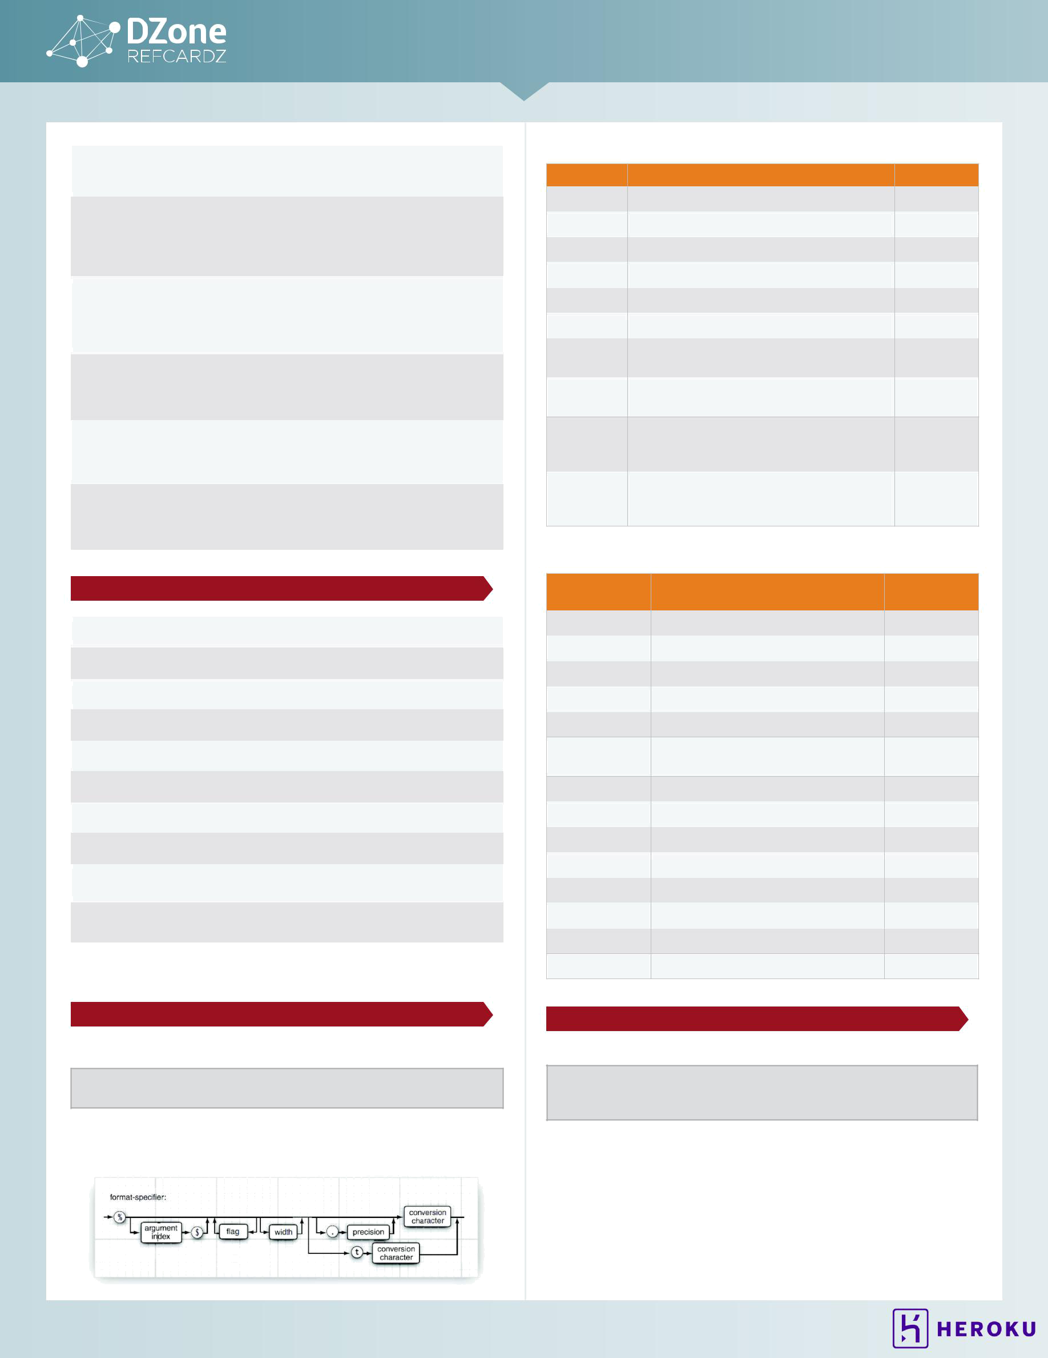
5 CORE JAVA

String concat = strs | Concatenate the elements
.stream() | of a stream
.collect(Collectors.joining(", "));
List<User> users = ...; | Create a new list that
List<String> firstNames = users | maps to the original one
.stream()
.map(User::getFirstName)
.collect(Collectors.toList());
List<String> adminFirstNames = users | Combine operations
.stream() | This will not result in
.filter(User::isAdmin) | two traversals of the list
.map(User::getFirstName) | elements
.collect(Collectors.toList()); | elements
int sumOfAges = users | Simple reduction
.stream() | operation
.mapToLong(User::getAge)
.sum();
Map<Role, List<User>> byRole = users | Group users by a certain
.stream() | attribute
.collect(Collectors
.groupingBy(User::getRole));
int sumOfAges = users | All the above operations
.parallelStream() | can be done in parallel
.mapToLong(User::getAge)
.sum();

CHAR ACTER ESCAPE SEQUENCES

\b | backspace \u0008
\t | tab \u0009
\n | newline \u000A
\f | form feed \u000C
\r | carriage return \u000D
\" | double quote
\' | single quote
\\ | backslash
\uhhhh (hhhh is a hex number between | The UTF-16 code point
0000 and FFFF) | with value hhhh
\ooo (ooo is an octal number between 0 | The character with octal
and 377) | value ooo

Note: Unlike in C/C++, \xhh is not allowed.

FORMATTED OUTPUT WITH PRINTF

TYPICAL USAGE

System.out.printf("%4d %8.2f", quantity, price);

String str = String.format("%4d %8.2f", quantity, price);

Each format specifier has the following form. See the tables for flags and conversion characters.

FLAGS

FLAG |  | DESCRIPTION | EXAMPLE
+ |  | Prints sign for positive and negative numbers | +3333.33
space |  | Adds a space before positive numbers | | 3333.33|
0 |  | Adds leading zeroes | 003333.33
- |  | Left-justifies field | |3333.33 |
( |  | Encloses negative number in parentheses | (3333.33)
, |  | Adds group separators | 3,333.33
# (for | f | Always includes a decimal point | 3,333.
format)
# (for | x or | Adds 0x or 0 prefix | 0xcafe

- format)

$ | Specifies the index of the argument to be | 159 | 9F
 | formatted; for example, %1$d %1$x prints the
 | first argument in decimal and hexadecimal
< | Formats the same value as the previous | 159 | 9F
 | specification; for example, %d %<x prints the
 | same number in decimal and hexadecimal

CONVERSION CHARACTERS

CONVERSION | DESCRIPTION | EXAMPLE
CHARACTER
d | Decimal integer | 159
x | Hexadecimal integer | 9f
o | Octal integer | 237
f | Fixed-point floating-point | 15.9
e | Exponential floating-point | 1.59e+01

- General floating-point (the shorter of e and f)

a | Hexadecimal floating-point | 0x1.fccdp3
s | String | Hello
c | Character | H
b | boolean | true
h | Hash code | 42628b2
tx | Date and time | See next table
% | The percent symbol | %

- The platform-dependent line separator

FORMATTED OUTPUT WITH MESSAGEFORMAT

Typical usage:

String msg = MessageFormat.format("On {1, date, long}, a {0} caused {2,number,currency} of damage.", "hurricane", new GregorianCalendar(2009, 0, 15). getTime(), 1.0E8);

Yields "On January 1, 1999, a hurricane caused $100,000,000 of damage"

- The nth item is denoted by {n, format, subformat} with optional formats and subformats shown below

- {0} is the first item

- The following table shows the available formats

© DZONE, INC. | DZONE.COM

6 CORE JAVA

- Use single quotes for quoting, for example '{' for a literal left curly brace

- Use '' for a literal single quote

FORMAT | SUBFORMAT | EXAMPLE
number | none | 1,234.567
 | integer | 1,235
 | currency | $1,234.57
 | percent | 123,457%
date | none or medium | Jan 15, 2015
 | short | 1/15/15
 | long | January 15,
 |  | 2015
 | full | Thursday,
 |  | January 15,
 |  | 2015
time | none or medium | 3:45:00 PM
 | short | 3:45 PM
 | long | 3:45:00 PM PST
 | full | 3:45:00 PM PST
choice | List of choices, separated by |. Each | no houses
 | choice has | one house
 | • a lower bound (use -\u221E for -∞) | one house
 | • a relational operator: < for “less | 5 houses
 | than”, # or \u2264 for ≤
 | • a message format string
 | For example, {1,choice,0#no
 | houses|1#one house|2#{1} houses}

REGULAR EXPRESSIONS

COMMON TASKS

String[] words = str.split("\\s+"); | Split a string along
 | white space boundaries
Pattern pattern = Pattern. | Replace all matches.
compile("[0-9]+"); | Here we replace all
Matcher matcher = pattern.matcher(str); | digit sequences with
String result = matcher.replaceAll("#"); | a #.
Pattern pattern = Pattern. | Find all matches.
compile("[0-9]+");
Matcher matcher = pattern.matcher(str);
while (matcher.find()) {
process(str.substring(matcher.start(),
matcher.end()));
}
Pattern pattern = Pattern.compile( | Find all groups
"(1?[0-9]):([0-5][0-9])[ap]m"); | (indicated by
Matcher matcher = pattern.matcher(str); | parentheses in the
for (int i = 1; i <= matcher. | pattern). Here we
groupCount(); i++) { | pattern). Here we
groupCount(); i++) { | find the hours and
process(matcher.group(i)); | find the hours and
process(matcher.group(i)); | minutes in a date.
} | minutes in a date.

REGULAR EXPRESSION SYNTAX

CHARACTERS

- The character c

\unnnn, \x nn, The code unit with the given hex or octal value \0n, \0nn,

\0nnn

\t, \n, \r, | The control characters tab, newline, return, form feed,
\f, \a, \e | alert, and escape
\cc | The control character corresponding to the character c
CHARACTER CLASSES
[C₁C₂ ...] | Union: Any of the characters represented by C₁C₂ , . . .
 | The C_{i} are characters, character ranges c₁-c₂, or
 | character classes.
 | Example: [a-zA-Z0-9_]
[^C₁C₂ ...] | Complement: Characters not represented by any of
 | C₁C₂ , . . .
 | Example: [^0-9]
[C₁&&C₂&& ...] Intersection: Characters represented by all of C₁C₂ , . . .

Example: [A-f&&[^G-`]]

PREDEFINED CHARACTER CLASSES

. | Any character except line terminators (or any character
 | if the DOTALL flag is set)
\d | A digit [0-9]
\D | A nondigit [^0-9]
\s | A whitespace character [ \t\n\r\f\x0B]
\S | A nonwhitespace character
\w | A word character [a-zA-Z0-9_]
\W | A nonword character
\p{name} | A named character class—see table below
\P{name} | The complement of a named character class
BOUNDARY MATCHERS
^ $ | Beginning, end of input (or beginning, end of line in
 | multiline mode)
\b | A word boundary
\B | A nonword boundary
\A | Beginning of input
\z | End of input
\Z | End of input except final line terminator
\G | End of previous match
QUANTIFIERS
X? | Optional X
X* | X, 0 or more times
X+ | X, 1 or more times
X{n} X{n,} | X n times, at least n times, between n and m times
X{n,m}

QUANTIFIER SUFFIXES

- Turn default (greedy) match into reluctant match

- Turn default (greedy) match into reluctant match

SET OPERATIONS

XY | Any string from X, followed by any string from Y
X|Y | Any string from X or Y

© DZONE, INC. | DZONE.COM

7 CORE JAVA

GROUPING
(X) |  | Capture the string matching X as a group
\g |  | The match of the gth group
ESCAPES
\c |  | The character c (must not be an alphabetic character)
\Q ... \E |  | Quote . . . verbatim
(? ... ) |  | Special construct—see API notes of Pattern class
PREDEFINED CHARACTER CLASS NAMES
Lower |  | ASCII lower case | [a-z]
Upper |  | ASCII upper case | [A-Z]
Alpha |  | ASCII alphabetic | [A-Za-z]
Digit |  | ASCII digits [0-9]
Alnum |  | ASCII alphabetic or digit |  | [A-Za-z0-9]
XDigit |  | Hex digits [0-9A-Fa-f]
Print or Graph |  | Printable ASCII character [\x21-\x7E]
Punct |  | ASCII nonalpha or digit |  | [\p{Print}&&\P{Alnum}]
ASCII |  | All ASCII [\x00-\x7F]
Cntrl |  | ASCII Control character |  | [\x00-\x1F]
Blank |  | Space or tab [ \t]
Space |  | Whitespace [ \t\n\r\f\0x0B]
javaLowerCase |  | Lower case, as determined by
 |  |  | Character.isLowerCase()
javaUpperCase |  | Upper case, as determined by
 |  |  | Character.isUpperCase()
javaWhitespace |  | White space, as determined by
 |  |  | Character.isWhitespace()
javaMirrored |  | Mirrored, as determined by
 |  |  | Character.isMirrored()
InBlock |  | Block is the name of a Unicode character block,
 |  |  | with spaces removed, such as BasicLatin or
 |  |  | Mongolian
Category or |  | Category is the name of a Unicode character
InCategory |  | category such as | L (letter) or Sc (currency symbol)

FLAGS FOR MATCHING

The pattern matching can be adjusted with flags, for example:

Pattern pattern = Pattern.compile(patternString, Pattern.CASE_INSENSITIVE + Pattern.UNICODE_CASE)

FLAG DESCRIPTION

CASE_INSENSITIVE Match characters independently of the letter case. By default, this flag takes only US ASCII characters into account

UNICODE_CASE | When used in combination with CASE_INSENSITIVE,
 | use Unicode letter case for matching
MULTILINE | ^ and $ match the beginning and end of a line, not
 | the entire input
UNIX_LINES | Only '\n' is recognized as a line terminator when
 | matching ^ and $ in multiline mode
DOTALL | When using this flag, the . symbol matches all
 | characters, including line terminators

FLAG | DESCRIPTION
CANON_EQ | Takes canonical equivalence of Unicode characters
 | into account. For example, u followed by ¨
 | (diaeresis) matches ü
LITERAL | The input string that specifies the pattern is treated
 | as a sequence of literal characters, without special
 | meanings for . [ ] etc

LOGGING

COMMON TASKS

Logger logger = | Get a logger for a category
Logger.getLogger("com.
mycompany.myprog.
mycategory");
logger.info("Connection | Logs a message of level FINE.
successful."); | Available levels are SEVERE, WARNING,
 | INFO, CONFIG, FINE, FINER,
 | FINEST, with corresponding methods
 | severe, warning, and so on
logger.log(Level.SEVERE, | Logs the stack trace of a Throwable
"Unexpected exception",
Throwable);
logger.setLevel(Level. | Sets the logging level to FINE. By
FINE); | default, the logging level is INFO, and
 | less severe logging messages are not
 | logged
Handler handler = new | Adds a file handler for saving the log
FileHandler("%h/myapp.log", | records in a file. See the table below
SIZE_LIMIT, LOG_ROTATION | for the naming pattern. This
_COUNT); | handler uses a simple formatter
handler.setFormatter(new | handler uses a simple formatter
handler.setFormatter(new | instead of the XML formatter that is
SimpleFormatter()); | instead of the XML formatter that is
SimpleFormatter()); | the default for file handlers
logger.addHandler(handler); | the default for file handlers

LOGGING CONFIGURATION FILES

The logging configuration can be configured through a logging configuration file, by default jre/lib/logging.properties. Another file can be specified with the system property java.util.logging. config.file when starting the virtual machine. (Note that the LogManager runs before main.)

CONFIGURATION | DESCRIPTION | DEFAULT
PROPERTY
loggerName.level | The logging level of the | None; the logger
 | logger by the given name | inherits the handler
 |  | from its parent
handlers | A whitespace or comma- | java.util.logging.
 | separated list of class | ConsoleHandler
 | names for the root logger.
 | An instance is created for
 | each class name, using
 | the default constructor
loggerName. | A whitespace or comma- | None
handlers | separated list of class
 | names for the given logger
loggerName. | false if the parent logger's | true
useParentHandlers | handlers (and ultimately
 | the root logger's handlers)
 | should not be used
config | A whitespace or comma- | None
 | separated list of class
 | names for initialization

© DZONE, INC. | DZONE.COM

8 CORE JAVA

CONFIGURATION | DESCRIPTION | DEFAULT
PROPERTY
java.util.logging. | The default handler level | Level.ALL for
FileHandler.level |  | FileHandler,
java.util.logging. |  | Level.INFO for
ConsoleHandler. |  | ConsoleHandler
level
java.util.logging. | The class name of the | None
FileHandler.filter | default filter
java.util.logging.
ConsoleHandler.
filter
java.util.logging. | The class name of the | java.util.logging.
FileHandler. | default formatter | XMLFormatter for
formatter |  | FileHandler,
java.util.logging. |  | java.util.logging.
ConsoleHandler. |  | SimpleFormatter
formatter |  | for ConsoleHandler
java.util.logging. | The default encoding | default platform
FileHandler. |  | encoding
encoding
java.util.logging.
ConsoleHandler.
encoding
java.util.logging. | The default limit for | 0 (No limit), but set
FileHandler.limit | rotating log files, in bytes | to 50000 in jre/lib/
 |  | logging.properties
java.util.logging. | The default number of | 1
FileHandler.count | rotated log files
java.util.logging. | The default naming pattern | %h/java%u.log
FileHandler. | for log files. The following
pattern | tokens are replaced when
 | the file is created:

TOKEN DESCRIPTION

- Path seperator

%t | System temporary directory
%h | Value of user.home system property
%g | The generation number of rotated logs
%u | A unique number for resolving naming
 | conflicts

- The % character

java.util.logging. | The default append mode false
FileHandler. | for file loggers; true to
append | append to an existing log file

PROPERTY FILES

- Contain name/value pairs, separated by =, :, or whitespace

- Whitespace around the name or before the start of the value is ignored

- Lines can be continued by placing an \ as the last character; leading whitespace on the continuation line is ignored

button1.tooltip = This is a long \ tooltip text.

- \t \n \f \r \\ \uxxxx escapes are recognized (but not \b or octal escapes)

- Files are assumed to be encoded in ISO 8859-1; use native2ascii to encode non-ASCII characters into Unicode escapes

- Blank lines and lines starting with # or ! are ignored

Typical usage:

Properties props = new Properties(); props.load(new FileInputStream("prog.properties")); String value = props.getProperty("button1.tooltip"); // null if not present

Also used for resource bundles:

ResourceBundle bundle = ResourceBundle.getBundle("prog");

- Searches for prog_en_US.properties,

- prog_en.properties, etc.

String value = bundle.getString("button1.tooltip");

JAR FILES

- Used for storing applications, code libraries

- By default, class files and other resources are stored in ZIP file format

- META-INF/MANIFEST.MF contains JAR metadata

- META-INF/services can contain service provider configuration

- Use the jar utility to make JAR files

JAR UTILITY OPTIONS

OPTION DESCRIPTION

- Creates a new or empty archive and adds files to it. If any of the specified file names are directories, the jar program processes them recursively

- Temporarily changes the directory. For example, jar cvfC myprog.jar classes *.class changes to the classes subdirectory to add class files

- Creates a Main-Class entry in the manifest
jar cvfe myprog.jar com.mycom.mypkg.MainClass files

- Specifies the JAR file name as the second command-line argument. If this parameter is missing, jar will write the result to standard output (when creating a JAR file) or read it from standard input (when extracting or tabulating a JAR file)

- Creates an index file (for speeding up lookups in a large archive)

- Adds a manifest to the JAR file
jar cvfm myprog.jar mymanifest.mf files

- Does not create a manifest file for the entries

- Displays the table of contents jar tvf myprog.jar

- Updates an existing JAR file
jar uf myprog.jar com/mycom/mypkg/SomeClass.class

- Generates verbose output

- Extracts files. If you supply one or more file names, only those files are extracted. Otherwise, all files are extracted
jar xf myprog.jar

- Stores without ZIP compression

© DZONE, INC. | DZONE.COM

9 CORE JAVA

COMMON JAVAC OPTIONS

OPTION | DESCRIPTION
-cp or -classpath | Sets the class path, used to search for class files.
 | The class path is a list of directories, JAR files,
 | or expressions of the form directory/'*' (Unix) or
 | directory\* (Windows). The latter refers to all JAR
 | files in the given directory. Class path items are
 | separated by : (Unix) or ; (Windows). If no class
 | path is specified, it is set to the current directory.
 | If a class path is specified, the current directory
 | is not automatically included—add a . item if you
 | want to include it
-sourcepath | Sets the path used to search for source files. If
 | source and class files are present for a given file,
 | the source is compiled if it is newer. If no source
 | path is specified, it is set to the current directory
-d | Sets the path used to place the class files. Use this
 | option to separate .java and .class files
-source | Sets the source level. Valid values are 1.3, 1.4, 1.5,
 | 1.6, 1.7, 1.8, 5, 6, 7, 8
-deprecation | Gives detail information about the use of
 | deprecated features
-Xlint:unchecked | Gives detail information about unchecked type
 | conversion warnings

COMMON JAVA OPTIONS

OPTION | DESCRIPTION
-cp or -classpath | Sets the class path, used to search for class files.
 | See the previous table for details. Note that javac can
 | succeed when java fails if the current directory is
 | on the source path but not the class path
-ea or | Enable assertions. By default, assertions are
-enableassertions | disabled
-Dproperty=value | Sets a system property that can be retrieved by
 | System.getProperty(String)
-jar | Runs a program contained in a JAR file whose
 | manifest has a Main-Class entry. When this
 | option is used, the class path is ignored
-verbose | Shows the classes that are loaded. This option
 | may be useful to debug class loading problems
-Xmssize | Sets the initial or maximum heap size. The size is
-Xmxsize | a value in bytes. Add a suffix k or m for kilobytes or
 | megabytes, for example, -Xmx10m

ABOUT THE AUTHORS

Cay S. Horstmann has written many books on C++, Java and objectoriented development, is the series editor for Core Books at Prentice-Hall and a frequent speaker at computer industry conferences. For four years, Cay was VP and CTO of an Internet startup that went from 3 people in a tiny office to a public company. He is now a computer
science professor at San Jose State University. He was elected Java Champion in 2005. Cay blogs at weblogs.java.net/blog/cayhorstmann.

Ivan St. Ivanov is a development architect at SAP Labs Bulgaria, working in the HANA Cloud Platform performance team. He is a leader in the Bulgarian JUG, driving the adoption of OpenJDK in Bulgaria. In his free time he likes contributing to open-source software, mostly to JBoss Forge. Ivan is obtaining his doctorate in the area of cloud
multi-tenancy at the University of National and World Economy in Sofia.

He is teaching Java and Java EE at Sofia University.

CREDITS:

Editor: G. Ryan Spain | Designer: Yassee Mohebbi | Production: Chris Smith | Sponsor Relations: Chris Brumfield | Marketing: Chelsea Bosworth

BROWSE OUR COLLECTION OF 250+ FREE RESOURCES, INCLUDING:

RESEARCH GUIDES: Unbiased insight from leading tech experts

REFCARDZ: Library of 200+ reference cards covering the latest tech topics

COMMUNITIES: Share links, author articles, and engage with other tech experts

JOIN NOW

DZone communities deliver over 6 million pages each month to more than 3.3 million software developers, architects and decision makers. DZone offers something for everyone, including news, tutorials, cheat sheets, research guides, feature articles, source code and more.

"DZONE IS A DEVELOPER'S DREAM," SAYS PC MAGAZINE.

Copyright © 2015 DZone, Inc. All rights reserved. No part of this publication may be reproduced, stored in a retrieval system, or transmitted, in|| any © DZONE, IINC..
form or by means electronic, mechanical, photocopying, or otherwise, without prior written permission of the publisher.

DZONE, INC.
150 PRESTON EXECUTIVE DR.
CARY, NC 27513
888.678.0399
919.678.0300
REFCARDZ FEEDBACK WELCOME
refcardz@dzone.com
SPONSORSHIP OPPORTUNITIES
DZONE.COM | VERSION 1.0 | $7.95
sales@dzone.com | VERSION 1.0 | $7.95



Better Java Apps Happen on Heroku

H E R O K U . C O M / J A V A

Download the Java haiku wallpaper: art.heroku.com/java

