Topic Modeling and Trend Detection in Large Text Corpora

- Introduction

Topic modeling is a technique in natural language processing (NLP) and machine learning that aims to uncover latent thematic structures within a collection of texts. Topic modelling is a system learning technique that robotically discovers the principle themes or "topics" that represents a huge collection of documents. The intention of topic modelling is to discover the hidden semantic systems within textual content facts, permitting customers to arrange, apprehend, and summarize the data in a manner that is each green and insightful.

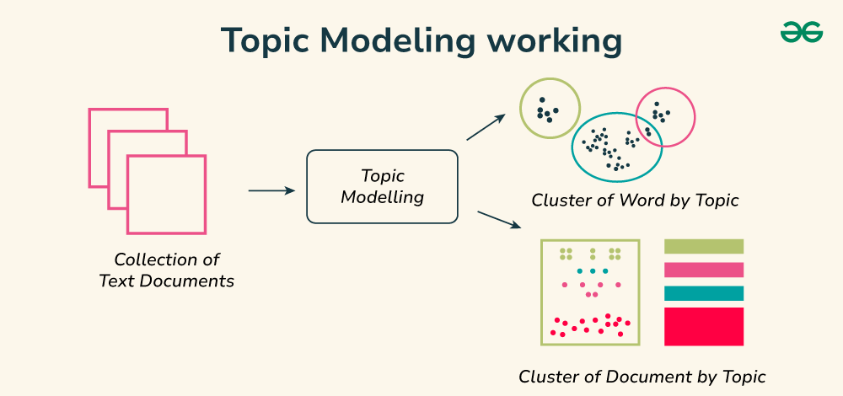
At the coronary heart of topic modelling, the concepts of "topics" and "topic models" comes into mind. A 'topic' is defined as a recurring pattern of words that best represents a theme within the documents. Topic models are algorithms that scan the document collection to discover these topics. They provide a way to quantify the structure of topics within the text and how these topics are related to each other. Topic models can be useful tools to discover latent topics in collections of documents. Recent studies have shown the feasibility of approach topic modeling as a clustering task.

- BertTopic

BERTopic is a topic modeling technique that leverages transformers and c-TF-IDF to create dense clusters allowing for easily interpretable topics whilst keeping important words in the topic descriptions.

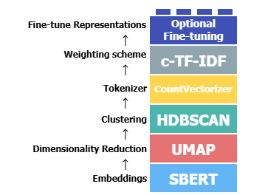
BERTopic can be viewed as a sequence of steps to create its topic representations. There are five steps to this process:

Although these steps are the default, there is some modularity to BERTopic. Each step in this process was carefully selected such that they are all somewhat independent from one another. For example, the tokenization step is not directly influenced by the embedding model that was used to convert the documents which allow us to be creative in how we perform the tokenization step.
This effect is especially strong in the clustering step. Models like HDBSCAN assume that clusters can have different shapes and forms. As a result, using a centroid-based technique to model the topic representations would not be beneficial since the centroid is not always representative of these types of clusters. A bag-of-words representation, however, makes very few assumptions concerning the shape and form of a cluster.

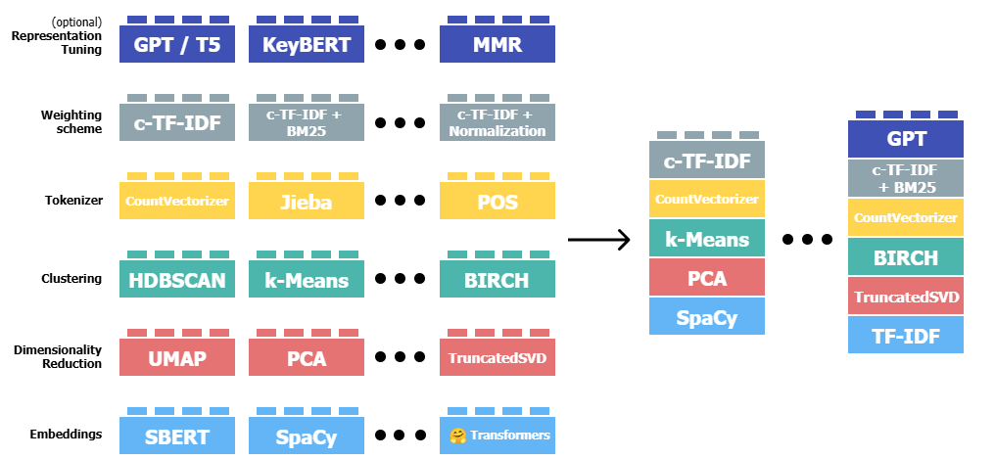

Embedding Models are models for transforming our input documents into numerical representations. Although there are many ways this can be achieved, we typically use sentence-transformers ("all-MiniLM-L6-v2") as it is quite capable of capturing the semantic similarity between documents.
Type of Embedding Models:
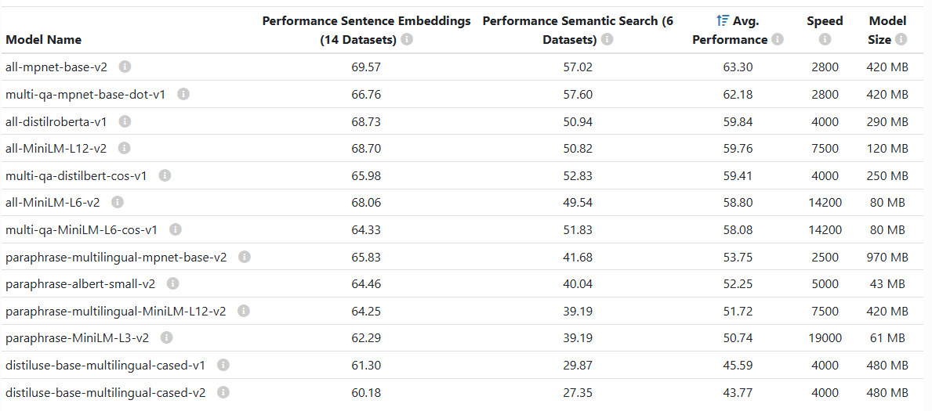
- Sentence Transformers is a powerful framework designed to compute dense vector representations for sentences, paragraphs, and images using transformer networks like BERT, RoBERTa, and XLM-RoBERTa. These embeddings are useful for various tasks such as semantic textual similarity, semantic search, clustering, and paraphrase mining.
- Model2Vec is a technique to turn any sentence transformer into a really small static model, reducing model size by a factor up to 50 and making the models up to 500 times faster, with a small drop in performance. Model2vec creates a small, fast, and powerful model that outperforms other static embedding models by a large margin on all tasks we could find, while being much faster to create than traditional static embedding models such as GloVe. Like BPEmb, it can create subword embeddings, but with much better performance. Distillation doesn't need any data, just a vocabulary and a model. The core idea is to forward pass a vocabulary through a sentence transformer model, creating static embeddings for the indiviudal tokens. After this, there are a number of post-processing steps we do that results in our best models. For a more extensive deepdive, please refer to the following resources.

- Flair is a powerful NLP library. Flair allows you to apply our state-of-the-art natural language processing (NLP) models to your text, such as named entity recognition (NER), sentiment analysis, part-of-speech tagging (PoS), special support for biomedical texts, sense disambiguation and classification, with support for a rapidly growing number of languages. A text embedding library. Flair has simple interfaces that allow you to use and combine different word and document embeddings, including our proposed Flair embeddings and various transformers. A PyTorch NLP framework. Our framework builds directly on PyTorch, making it easy to train your own models and experiment with new approaches using Flair embeddings and classes.

- spaCy is a library for advanced Natural Language Processing in Python and Cython. It's built on the very latest research, and was designed from day one to be used in real products. spaCy comes with pretrained pipelines and currently supports tokenization and training for 70+ languages. It features state-of-the-art speed and neural network models for tagging, parsing, named entity recognition, text classification and more, multi-task learning with pretrained transformers like BERT, as well as a production-ready training system and easy model packaging, deployment and workflow management.

- Universal Sentence Encoder (USE), encodes text into high-dimensional vectors that are used here for embedding the documents. The model is trained and optimized for greater-than-word length text, such as sentences, phrases, or short paragraphs.

- Gensim, is primarily used for Word Embedding models. This works typically best for short documents since the word embeddings are pooled.

- Scikit-Learn Embeddings, offers many preprocessing tools, some of which can be used to create representations for text. Many of these tools are relatively lightweight and do not require a GPU. While the representations may be less expressive than many BERT models, the fact that it runs much faster can make it a relevant candidate to consider.

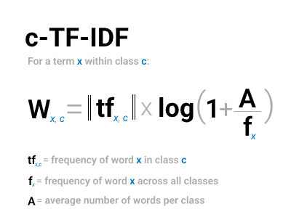
- TF-IDF (Term Frequency–Inverse Document Frequency), is a numerical statistic used to represent the importance of a word in a document relative to a collection (or corpus) of documents. It combines two measures: term frequency (TF), which counts how often a term appears in a document (indicating its local importance), and inverse document frequency (IDF), which downscales terms that appear frequently across many documents (indicating they're less informative). The result is a vector representation of each document, where each dimension corresponds to a word and its weight reflects how unique and relevant that word is in the context of the document.
Dimensionality Reduction is an important aspect of BERTopic where the main goal is to reduce the dimensionality of the embeddings to a workable dimensional space (e.g., 5) for clustering algorithms to work with. UMAP is used as a default in BERTopic since it can capture both the local and global high-dimensional space in lower dimensions. However, there are other solutions out there, such as PCA that users might be interested in trying out. Since BERTopic allows assumes some independency between steps, we can use any other dimensionality reduction algorithm.
Type of dimensionality reduction algorithms:
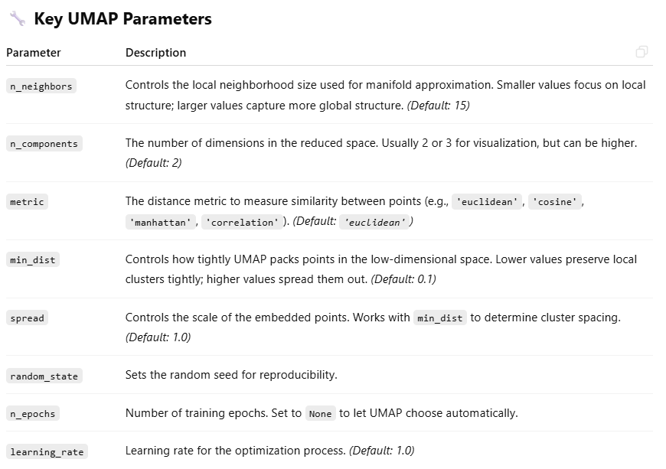
- UMAP is a dimensionality reduction technique that transforms high-dimensional data into a lower-dimensional space (typically 2D or 3D) while preserving the underlying structure as much as possible. It works by modeling the data as a graph of nearest neighbors and then optimizing a low-dimensional representation that maintains the topological and geometric relationships. UMAP is particularly effective for visualizing complex datasets like word embeddings or image features, and it's often preferred over alternatives like t-SNE due to its faster performance and better preservation of global structure. It’s commonly used in machine learning workflows for data exploration and clustering.
- Principal Component Analysis is a technique used to reduce the dimensionality of data. The goal is to transform a set of correlated attributes into a new set of uncorrelated attributes called principal components. Then, by selecting the 'k' principal components that most highlight the variability, we have reduced the dimensionality while preserving the most important patterns, structures, and information in the data.
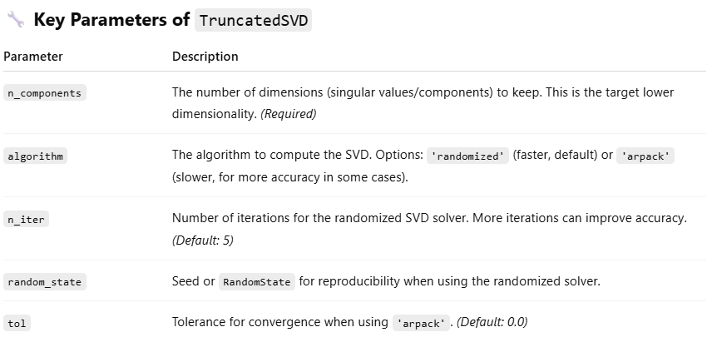
- Truncated SVD, a dimensionality reduction technique used to reduce the number of features in high-dimensional data while preserving as much information as possible. It factorizes a matrix A into three matrices U, Σ, and V^{T}, and keeps only the top k singular values (and corresponding vectors), where k is much smaller than the original dimensionality. This "truncation" leads to an approximation of the original matrix with reduced rank, capturing the most important patterns and discarding noise. It's particularly useful for sparse data such as TF-IDF matrices in natural language processing and is the core of Latent Semantic Analysis (LSA). Unlike PCA, Truncated SVD can operate directly on sparse matrices without centering the data.

- cuML UMAP, although the original UMAP implementation is an amazing technique, it may have difficulty handling large amounts of data. Instead, we can use cuML to speed up UMAP through GPU acceleration.

Clustering is a process where we need to cluster our input embeddings into groups of similar embeddings to extract our topics. This process of clustering is quite important because the more performant our clustering technique the more accurate our topic representations are. In BERTopic, we typically use HDBSCAN as it is quite capable of capturing structures with different densities. However, there is not one perfect clustering model and you might want to be using something entirely different for your use case.
Type of clusters models:
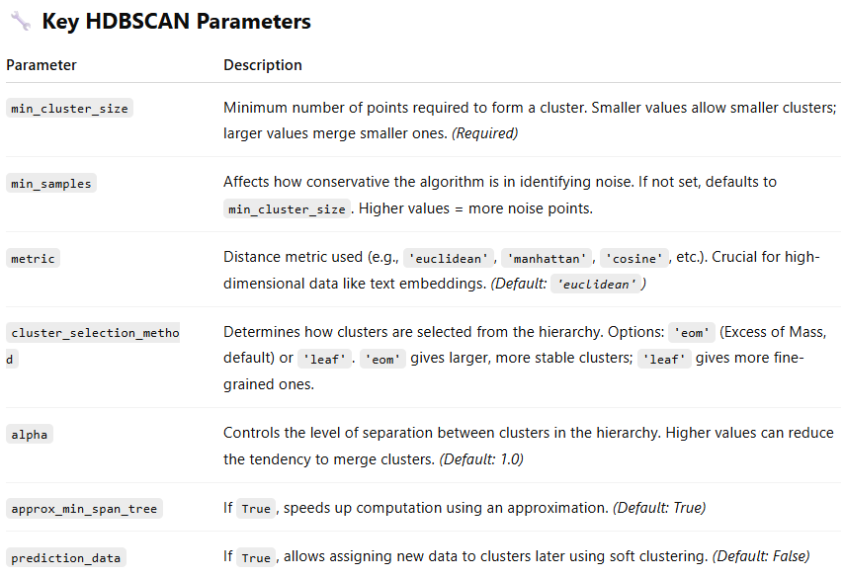
- HDBSCAN (Hierarchical Density-Based Spatial Clustering of Applications with Noise) is an advanced clustering algorithm that extends DBSCAN by building a hierarchy of clusters based on varying density thresholds and then extracting the most stable ones. It works well with clusters of varying densities and arbitrary shapes, and it can automatically identify noise points (outliers). Unlike k-means or DBSCAN, HDBSCAN does not require specifying the number of clusters and is more robust to parameter settings. It’s especially useful for clustering high-dimensional data like embeddings (e.g., from UMAP or Sentence Transformers) where the number and shape of clusters are not known in advance.

- k-Means allows you to select how many clusters you would like and forces every single point to be in a cluster. Therefore, no outliers will be created. This also has disadvantages. When you force every single point in a cluster, it will mean that the cluster is highly likely to contain noise which can hurt the topic representations.

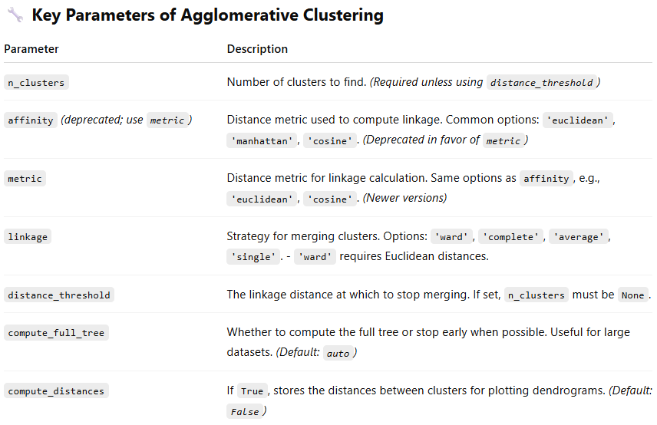
- Agglomerative Clustering is a type of hierarchical clustering that builds clusters by recursively merging the closest pairs of clusters. It starts with each data point as its own cluster and merges them step by step based on a linkage criterion (like average, complete, or single linkage) until a stopping condition is met (such as a predefined number of clusters). It creates a dendrogram (tree diagram) showing how clusters are merged, which can be used to understand the data’s structure at different levels of granularity. Unlike k-means, it does not require the clusters to be spherical and is better suited for irregularly shaped clusters.

- cuML HDBSCAN, although the original HDBSCAN implementation is an amazing technique, it may have difficulty handling large amounts of data. Instead, we can use cuML to speed up HDBSCAN through GPU acceleration.

Vectorizers in topic modeling are representing the quality of the topic representations is key for interpreting the topics, communicating results, and understanding patterns. It is of utmost importance to make sure that the topic representations fit with your use case.
Type of vectorizer:
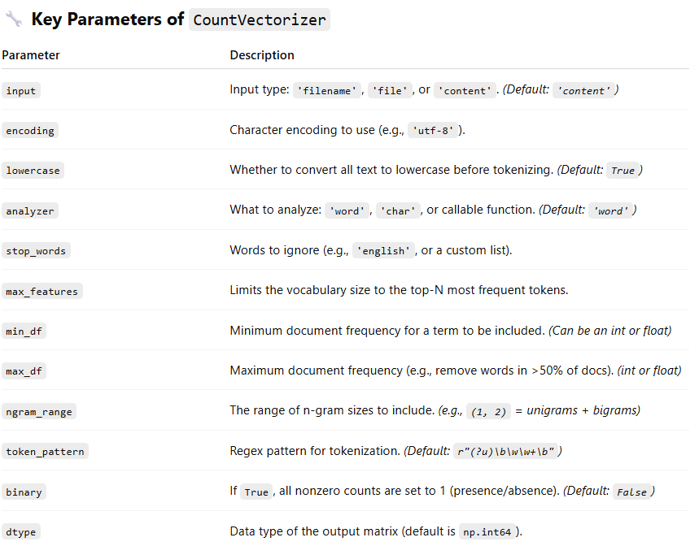
- CountVectorizer is a tool from sklearn.feature_extraction.text that transforms a collection of text documents into a bag-of-words (BoW) representation. It creates a sparse matrix where each row corresponds to a document, and each column corresponds to a unique token (usually words). The values in the matrix are simply the counts of each token in the corresponding document. This is one of the most basic and widely used techniques for converting text into numerical data for machine learning tasks.

