

Requirement & Design Specification
SoundWave
Version: 1.0

– Can Tho, September 2026 –

Record of Changes
Version | Date | A*  M, D | In charge | Change Description
V1.0 | 15/2 | A | KienNTHE11
*A - Added M - Modified D - Deleted

Contents
Record of Changes 2
I. Overview 8
1. User Requirements 8
1.1 Actors 8
1.2 Use Cases 9
2. Overall Functionalities 14
2.1 Screens Flow 14
2.2 Screen Descriptions 15
2.3 Screen Authorization 19
2.4 Non-UI Functions 24
3. System High Level Design 25
3.1 ERD 25
3.2. Database Design 25
3.2 Code Packages 29
II. Requirement Specifications 31
1. User Authentication Feature 31
1.1 UC-1: Login 31
1.2 UC-2: Register Account 32
1.3 UC-3: Verify Email 33
1.4 UC-4: Forgot Password 34
1.5 UC-5: Logout 35
2. Music search & Browsing Feature 36
2.1 UC-6: View Recommended Song 36
2.2 UC-7: Search Public Catalog 38
2.3 UC-8: Filter Public Catalog 39
3. Audio Playback Feature 41
3.1 UC-9: Listen to Public Song 41
3.2 UC-10: Stream Music 42
3.3 UC-11: Control Playback 44
4. Profile Management 46
4.1 UC-12.1: Manage Personal Profile (Read) 46
4.2 UC-12.2: Manage Personal Profile (Update) 47
5. Music Interaction Feature 49
5.1 UC-13: View Listening History 49
5.2 UC-14.1: Manage my Favorite Tracks (Read) 50
5.3 UC-14.2: Manage my Favorite Tracks (Create) 51
5.4 UC-14.3: Manage my Favorite Tracks (Delete) 53
6. Playlist Management 54
6.1 UC-15.1 Manage my Playlist (Read) 54
6.2 UC-15.2 Manage my Playlist (Create) 55
6.3 UC-15.3: Manage my Playlist (Update) 56
6.4 UC-15.4 Manage my Playlist (Update) 57
6.5 UC-15.5 Manage my Playlist (Delete) 58
7. Lyrics Interaction 59
7.1 UC-16 View Lyrics 59
7.2 UC-17 Switch Lyrics Language 60
7.3 UC-18 Create Custom Lyric 61
8. Track Management 62
8.1 UC-19.1 Manage my Tracks (Read) 62
8.2 UC-19.2 Manage my Tracks (Create) 63
8.3 UC-19.3 Manage my Tracks (Update) 64
8.4 UC-19.4 Manage my Tracks (Update Status) 65
8.5UC-19.5 Manage my Tracks (Delete) 66
8.6 UC-20 View Rejection Reason 67
9. Album Management 68
9.1 UC-35 Create Album 68
9.2 UC-36 View Albums 69
9.3 UC-37 Update Album 70
9.4 UC-38 Delete Album 71
9.5 UC-39 Add Track to Album 71
10. Content Reporting Feature 72
10.1 UC-40: Submit Content Report 72
10.2 UC-41: View Report Status 73
10.3 UC-42: Withdraw Content Report 74
11. Content Moderation 76
11.1 UC-43: Review Pending Track 76
11.2 UC-44: Approve Track 77
11.3 UC-45: Reject Track 78
11.4 UC-46: Enter Reject Reason 80
11.5 UC-47: Review Content Report 81
11.6 UC-48: Approve Report 82
11.7 UC-49: Remove Violated Track 84
11.8 UC-50: Reject Report 85
12. Lyrics Management 86
12.1 UC-51: Upload Official Lyrics 86
12.2 UC-52: Maintain Official Lyrics 88
13. System Administration 89
13.1 UC-53: Ban User Account 89
13.2 UC-54 Unban User Account 90
13.3 UC-55 Assign User Roles 92
13.4 UC-56 Create Genre 93
13.5 UC-57 View Genre 94
13.6 UC-58 Update Genre 95
13.7 UC-59 Delete Genre 97
13.8 UC-60 View System Statistics 98
III. Design Specifications 99
1. User Authentication 99
1.1 System Access 99
2. Music Discovery 111
2.1 Public Catalog 111
3. Music Playback 115
3.1 Audio Playback 115
4. Listener Profile and Library 117
4.1 Personal Profile 117
4.2 Favorite Management 118
4.3 Playlist Management 119
4.4 Lyrics 121
5. User Content Management 123
5.1 Track Management 123
5.2 Album Management 125
5.3 Content Report 127
6. Staff Moderation 128
6.1 Track Moderation 128
6.2 Report Moderation 130
6.3 Official Lyrics 132
7. System Administration 133
7.1 User Administration 133
7.2 Genre Administration 135
7.3 Statistics 136
8. External Integration 137
8.1 Cloud Media 137
IV. Appendix 138
1. Assumptions & Dependencies 138
2. Limitations & Exclusions 138
3. Business Rules 138
4. 143

I. Overview

1. User Requirements

1.1 Actors

# | Actor | Description
1 | Guest | Unauthenticated guest user. Interacts with the system to view the homepage, search for songs, listen to full tracks (with a login/registration prompt displayed after each song), and perform the account registration flow.
2 | Listener | Authenticated general user. Has full access to advanced playback tools (queue, shuffle, repeat), manages playlists, writes personal (private) translated/transliterated lyrics, and uploads personal audio files to submit to the moderation queue.
3 | Staff | Content management staff. Responsible for previewing and making approval/rejection decisions (with mandatory reasons) for songs uploaded by Listeners, as well as uploading official lyric files.
4 | Admin | The highest-level system administrator. Has the authority to manage all accounts (role assignment, ban/unban), add/edit/delete core categories (such as Music Genres), and monitor system statistics.
5 | Email Service | Automated email delivery system (Secondary Actor). Receives signals from the system to send welcome emails upon new account creation and distributes authentication codes/links during the password recovery flow.
6 | Cloud Storage | Cloudinary cloud storage platform (Secondary Actor). Responsible for receiving, securely storing, and directly distributing multimedia files (MP3, cover art, avatars) to the user's browser, supporting byte-range data transmission techniques (HTTP Range Requests).

1.2 Use Cases

a. Diagram(s)
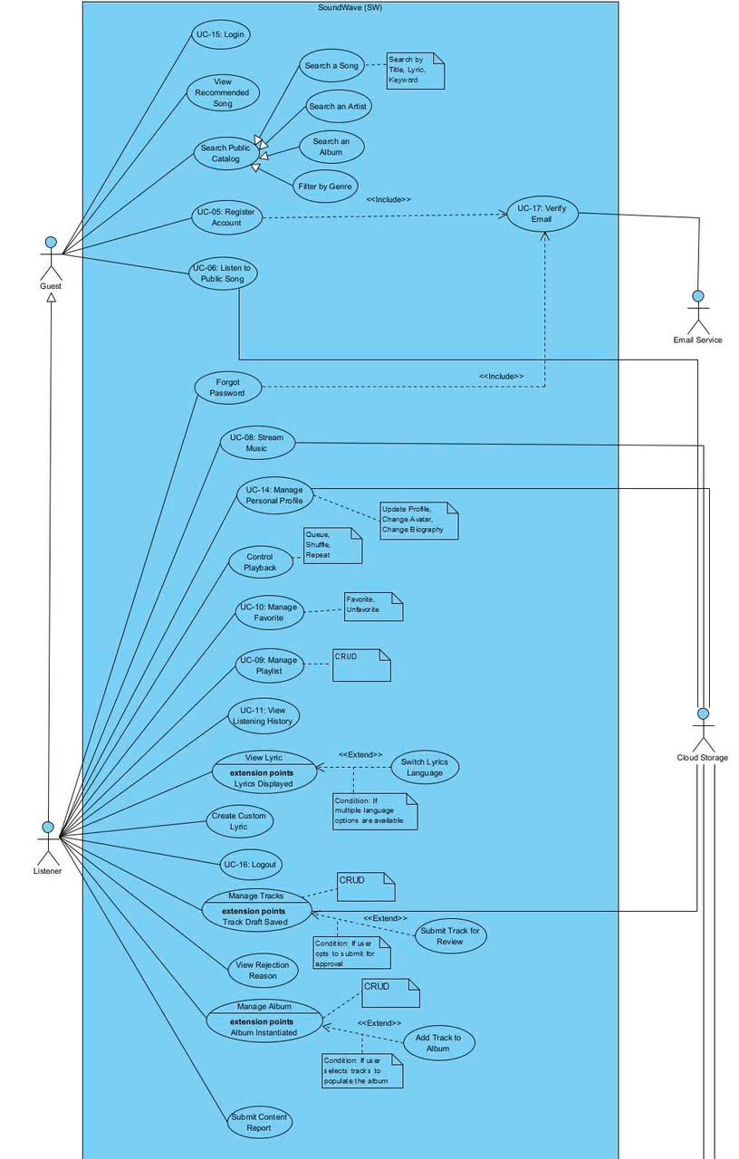
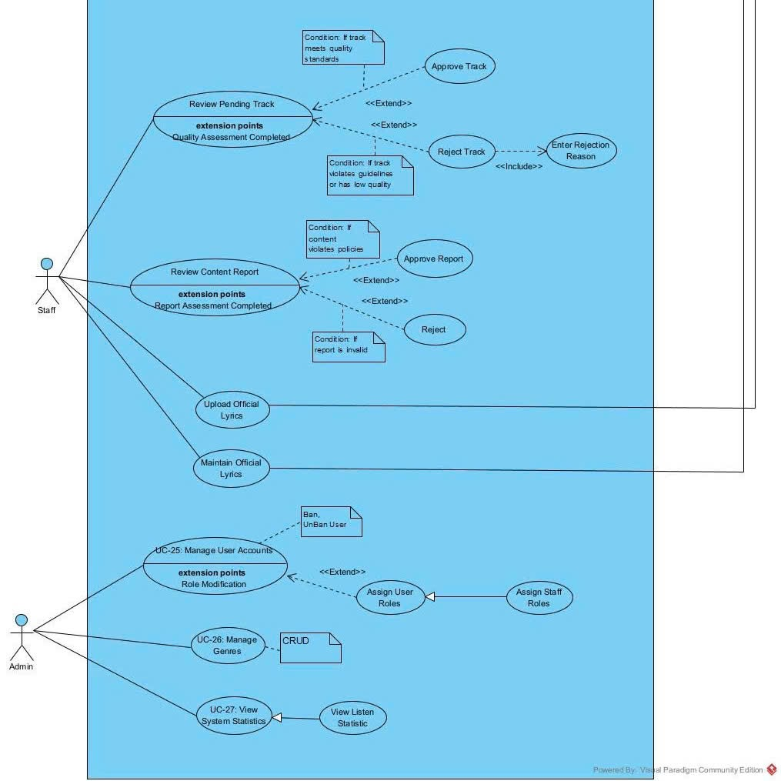

b. Descriptions

ID | Feature | Use Case | Use Case Description
01 | User Authentication | Login | Allows users to authenticate and log into the system.
02 | User Authentication | Register Account | Allows Guests to register a new account; includes a mandatory email verification step.
03 | User Authentication | Verify Email | The system triggers the Email Service to send a verification link/code for registration or password recovery.
04 | User Authentication | Forgot Password | Allows users to request password recovery, which includes verifying their email address.
05 | User Authentication | Logout | Allows authenticated users to end their current active session.
06 | Music Search & Browsing | View Recommended Song | Allows Guests and Listeners to view a list of suggested songs on the platform.
07 | Music Search & Browsing | Search Public Catalog | A generalized use case that allows users to search for published music content across the platform.
08 | Music Search & Browsing | Search a Song | Allows users to search for specific songs by title, keyword, or lyric phrases.
09 | Music Search & Browsing | Search an Artist | Allows users to search for specific artists or creators.
10 | Music Search & Browsing | Search an Album | Allows users to search for specific albums or EPs.
11 | Music Search & Browsing | Filter by Genre | Allows users to filter the search results based on music genres.
12 | Audio Playback | Listen to Public Song | Allows Guests to stream full songs; the system prompts them to log in or register after each track ends.
13 | Audio Playback | Stream Music | Allows Listeners to stream full songs continuously using HTTP Range Requests via Cloud Storage.
14 | Audio Playback | Control Playback | Allows Listeners to manage their active playback with queue, shuffle, and repeat functions.
15 | Profile Management | Manage Personal Profile | Allows users to update their profile information, biography, and avatar (linked to Cloud Storage).
16 | Music Interaction | Manage Favorite | Allows Listeners to like (Favorite) or unlike a song.
17 | Playlist Management | Manage Playlist | Allows Listeners to perform CRUD operations (create, read, update, delete) on their personal playlists.
18 | Music Interaction | View Listening History | Allows Listeners to access their automatically saved personal listening history.
19 | Lyrics Interaction | View Lyric | Allows Listeners to view synchronized lyrics during playback. (Extension Point: Lyrics Displayed).
20 | Lyrics Interaction | Switch Lyrics Language | Allows Listeners to switch the displayed lyric language. (Extends: View Lyric).
21 | Lyrics Interaction | Create Custom Lyric | Allows Listeners to create private custom lyrics or transliterations. (Extends: View Lyric).
22 | Track Management | Manage My Tracks | Allows Listeners to upload audio/cover files and initialize metadata, saving the track as a draft. (Extension Point: Track Draft Saved).
23 | Track Management | Submit Track for Review | Allows Listeners to submit a saved draft to the Staff for moderation. (Extends: Manage Tracks).
24 | Track Management | View Rejection Reason | Allows Listeners to view the specific reason provided by Staff if their track was rejected.
25 | Album Management | Manage My Album | Allows Listeners to create and perform CRUD operations on their Albums/EPs. (Extension Point: Album Instantiated).
26 | Album Management | Add Track to Album | Allows Listeners to group their uploaded tracks into a specific album. (Extends: Manage Album).
27 | Content Reporting | Manage Content Report | Allows Listeners to perform CRUD operations on their content reports, such as submitting new reports, viewing status, or withdrawing them.
28 | Content Moderation | Review Pending Track | Allows Staff to listen to and review newly uploaded tracks. (Extension Point: Quality Assessment Completed).
29 | Content Moderation | Approve Track | Changes the pending track's status to Published. (Extends: Review Pending Track).
30 | Content Moderation | Reject Track | Changes the pending track’s status to Rejected. (Extends: Review Pending Track).
31 | Content Moderation | Enter Rejection Reason | Requires Staff to input a mandatory explanation when rejecting a track. (Included in: Reject Track).
32 | Content Moderation | Review Content Report | Allows Staff to review violation reports submitted by users. (Extension Point: Report Assessment Completed).
33 | Content Moderation | Approve Report | Accepts the user's report and takes action against the violating content. (Extends: Review Content Report).
34 | Content Moderation | Remove Violated Track | Executes the mandatory system action to delete or hide a track that violates platform policies. (Included in: Approve Report).
35 | Content Moderation | Reject Track | Dismisses the user’s report if deemed invalid or a false alarm. (Extends: Review Content Report).
36 | Lyrics Management | Upload Official Lyrics | Allows Staff to upload official (.lrc) lyric files in their original language to Cloud Storage.
37 | Lyrics Management | Maintain Official Lyrics | Allows Staff to update and maintain existing official lyric files.
38 | System Administration | Manage User Accounts | Allows Admins to manage user accounts, including banning/unbanning actions. (Extension Point: Role Modification).
39 | System Administration | Assign User Roles | Allows Admins to grant or revoke specific system privileges, such as the Staff role. (Extends: Manage User Accounts).
40 | System Administration | Manage Genres | Allows Admins to perform CRUD operations on the system’s music genre categories.
41 | System Administration | View System Statistics | Allows Admins to monitor platform activity and view listening statistics.

2. Overall Functionalities

2.1 Screens Flow
The Screen Flow diagram presents the navigation among the main screens of the SoundWave music streaming system. Screens are grouped according to their main authorization scope: Public, Registered User, Staff, and Admin.
A Guest can access public music discovery screens, listen to song previews, register an account, verify an email address, log in, or reset a forgotten password. After successful authentication, the system redirects the account to the appropriate home screen according to its role.
A registered User can stream complete songs, control playback, view synchronized lyrics, manage playlists and favorite songs, view listening history, maintain a personal profile, create custom lyrics, upload tracks, create albums, submit tracks for moderation, and report inappropriate content.
A Staff member can review pending tracks, approve or reject track submissions, process content reports, and upload or maintain official synchronized lyrics.
An Admin can manage user accounts, assign system roles, manage music genres, and view system and listening statistics.
The music player is displayed as a persistent component at the bottom of the applicable screens. Therefore, playback controls are not represented as an independent navigation page. The expanded Now Playing screen provides additional information such as the playback queue and synchronized lyrics.
Normal rectangles represent full screens. Oval shapes represent modal or pop-up screens.

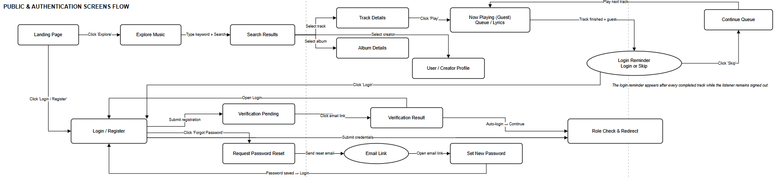

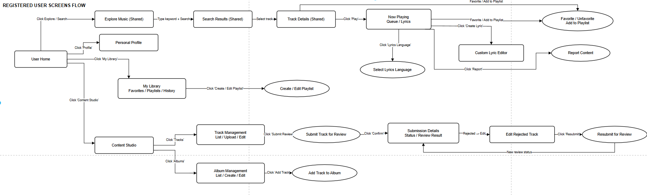

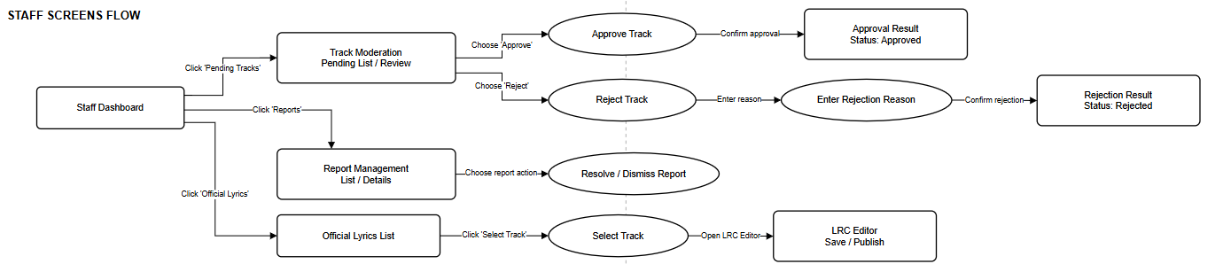

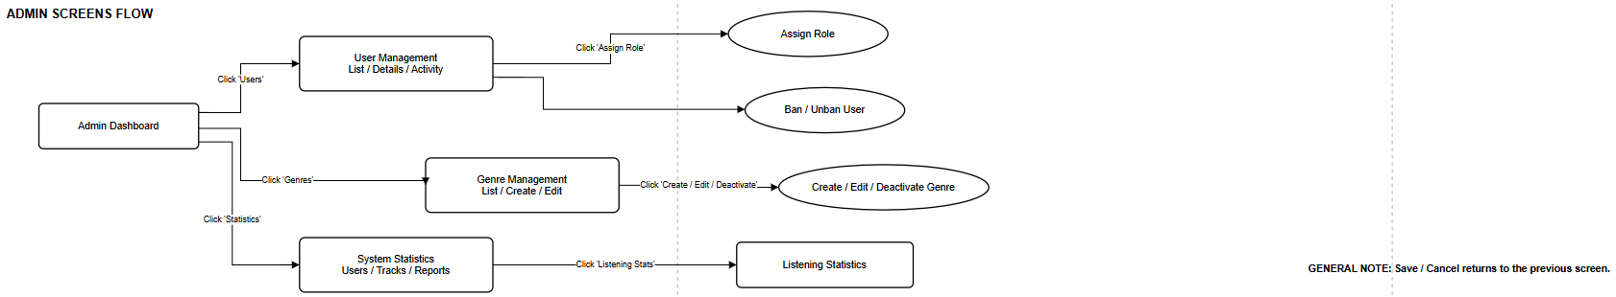

2.2 Screen Descriptions

# | Feature | Screen | Description
1 | Public Navigation | Landing Page | Displays the introduction to SoundWave, featured tracks, popular albums, recommended creators, and navigation to music discovery and authentication features.
2 | Music Discovery | Explore Music | Allows guests and registered users to browse public tracks, albums, creators, and genres available on the platform.
3 | Music Discovery | Search Results | Displays tracks, albums, and creators matching the entered keyword. Users can select a result to open its corresponding detail screen.
4 | Music Discovery | Track Details | Displays the selected track’s title, cover image, creator, album, genre, duration, lyrics availability, and playback controls. Registered users can also favorite, add the track to a playlist, or report it.
5 | Music Discovery | Album Details | Displays album information and the list of approved tracks belonging to the album. Users can select a track to view its details or start playback.
6 | Music Discovery | User/Creator Profile | Displays a user’s public profile, biography, avatar, published albums, and approved tracks. Every registered user may publish music, so a separate artist account is not required.
7 | Authentication | Login | Allows a user to sign in using an email address and password. After successful authentication, the system checks the user’s role and redirects the user to User Home, Staff Dashboard, or Admin Dashboard.
8 | Authentication | Register Account | Allows a guest to create an account by providing the required information such as display name, email, and password. The system sends an email verification link after registration.
9 | Authentication | Verify Email Notice | Informs the user that a verification email has been sent and asks the user to open the link in that email to activate the account.
10 | Authentication | Verification Result | Displays whether email verification was successful, expired, or invalid. A successful result allows the user to continue to Login or User Home when automatic login is supported.
11 | Password Recovery | Request Password Reset | Allows the user to enter the email address associated with the account and request a password reset link.
12 | Password Recovery | Reset Email Sent | Informs the user that a password reset link has been sent if the entered email belongs to an account.
13 | Password Recovery | Set New Password | Opens from the password reset link and allows the user to enter and confirm a new password. After successful completion, the user is redirected to Login.
14 | User Navigation | User Home | Acts as the main screen for a registered listener. It provides access to music discovery, search, playback, personal library, profile, and Content Studio.
15 | Music Playback | Now Playing | Plays the selected track and displays its cover, title, creator, progress, duration, queue, and synchronized lyrics. It provides pause, resume, seek, next, previous, shuffle, and repeat controls.
16 | Music Playback | Queue | Displays tracks waiting to be played. Users can change the playback order, remove a track, or select a track to play immediately. This may be implemented as a tab or panel inside Now Playing.
17 | Guest Playback | Login Reminder | Appears after a guest finishes listening to a track. It asks the guest to log in or register, but the guest may dismiss the message and continue listening. The reminder appears again whenever another track finishes while the listener remains logged out.
18 | Lyrics | Select Lyrics Language | Allows the user to select one of the available official lyric languages for the currently playing track. This popup is only shown when multiple lyric versions are available.
19 | Lyrics | Custom Lyric Editor | Allows a registered user to create or edit personal LRC lyrics by entering lyric lines and synchronizing each line with the track’s playback time. Personal lyrics are visible only to their owner.
20 | User Profile | Personal Profile | Displays and allows the user to update personal information, display name, avatar, and biography. It may also show the user’s published tracks and albums.
21 | Personal Library | My Library | Provides tabs for the user’s favorite tracks, playlists, and listening history. Selecting an item opens the related track, playlist, or playback screen.
22 | Playlist Management | Playlist Details | Displays playlist information and its ordered list of tracks. The owner can play the playlist, change track order, remove tracks, or open the playlist editor.
23 | Playlist Management | Create/Edit Playlist | Allows the user to create a playlist or update its name, description, cover image, visibility, and track list. It can be implemented as a modal or a separate screen.
24 | Content Reporting | Report Content | Allows a registered user to select a report reason and provide additional details about a track that may violate platform policies.
25 | Content Publishing | Content Studio | Provides registered users with access to their track and album management functions. Since every user can upload music, this screen does not require a separate Artist role.
26 | Track Management | Track Management | Displays tracks uploaded by the current user and their statuses, such as Draft, Pending, Approved, or Rejected. Users can create a new track or edit an eligible existing track.
27 | Track Management | Upload Track | Allows the user to upload an audio file and cover image, then enter track metadata such as title, genre, album, and description. Uploaded media files are stored on Cloudinary.
28 | Track Management | Edit Track | Allows the owner to edit the metadata or replace the media files of a Draft or Rejected track. After correcting a rejected track, the user can submit it again for review.
29 | Track Submission | Submit Track for Review | Displays a confirmation of the track information before sending it to the moderation queue. After confirmation, the track status becomes Pending.
30 | Track Submission | Submission Details | Displays the submitted version, submission date, current review status, reviewer information when applicable, and the final moderation result.
31 | Track Submission | Review Result | Displays an Approved or Rejected result. A rejected result includes the rejection reason and provides navigation to Edit Track; an approved result provides navigation to the public Track Details screen.
32 | Album Management | Album Management | Displays albums created by the current user and provides options to create, edit, view, or manage an album.
33 | Album Management | Create/Edit Album | Allows the album owner to enter or update the album title, description, cover image, release information, and other metadata.
34 | Album Management | Add Track to Album | Allows the album owner to select eligible uploaded tracks and add them to the album. It can be implemented as a popup or modal.
35 | Staff Navigation | Staff Dashboard | Displays an overview of pending track submissions, content reports, and official lyric management functions available to Staff.
36 | Track Moderation | Pending Track List | Displays tracks waiting for moderation. Staff can filter submissions and select one to review.
37 | Track Moderation | Track Review | Displays the submitted audio, cover image, metadata, creator information, and submission history. Staff can listen to the track and approve or reject it.
38 | Track Moderation | Approve Track Confirmation | Asks Staff to confirm track approval. After approval, the track becomes publicly available and the submission owner receives a notification.
39 | Track Moderation | Enter Rejection Reason | Requires Staff to enter a clear rejection reason before rejecting a submission. The reason becomes visible to the track owner.
40 | Track Moderation | Moderation Result | Confirms whether the track was successfully approved or rejected and provides navigation back to the pending track list.
41 | Report Management | Report Management | Displays submitted content reports and their statuses. Staff can filter the list and open a report for review.
42 | Report Management | Report Details | Displays the reported track, reporter, report reason, description, creation time, and current processing status.
43 | Report Management | Resolve/Reject Report | Allows Staff to resolve a valid report or reject an invalid report. Staff may enter a processing note before confirming the decision.
44 | Official Lyrics | Official Lyrics List | Displays tracks and their official lyric status. Staff can search for a track and open its official LRC lyrics for editing.
45 | Official Lyrics | Official LRC Editor | Allows Staff to upload, create, edit, and synchronize official LRC lyrics with the track’s audio timeline. It may also support language and synchronization offset settings.
46 | Admin Navigation | Admin Dashboard | Displays an overview of account management, genre management, and system statistics available to Admin.
47 | User Administration | User Management | Displays user accounts with search and status filters. Admin can open an account to view its details and activity.
48 | User Administration | User Details and Activity | Displays account information, assigned role, status, uploaded content, reports, and relevant account activity.
49 | User Administration | Assign Role | Allows Admin to assign or change a user’s system role, such as User, Staff, or Admin.
50 | User Administration | Ban/Unban User | Displays a confirmation popup for locking or unlocking an account. A banned user cannot authenticate or use protected system functions.
51 | Genre Management | Genre Management | Displays all music genres and provides options to create or edit genre information.
52 | Genre Management | Create/Edit Genre | Allows Admin to create a genre or update its name, description, and active status.
53 | System Statistics | System Statistics | Displays summary statistics about users, tracks, albums, submissions, and content reports.
54 | System Statistics | Listening Statistics | Displays listening data such as play counts, popular tracks, popular genres, and listening trends over a selected period.

2.3 Screen Authorization

Screen / Function | Guest | User | Staff | Admin
Landing Page | X | X | X | X
View featured tracks, albums and creators | X | X | X | X
Explore Music | X | X | X | X
Browse public music catalog | X | X | X | X
Filter tracks by genre | X | X | X | X
Search Results | X | X | X | X
Search tracks, albums and creators | X | X | X | X
Track Details | X | X | X | X
View approved track information | X | X | X | X
Play full track | X | X | X | X
Add track to favorites | — | X | X | X
Add track to own playlist | — | X (Own) | X (Own) | X (Own)
Report track content | — | X | X | X
Album Details | X | X | X | X
View public album and track list | X | X | X | X
Play tracks from album | X | X | X | X
User/Creator Profile | X | X | X | X
View public profile and published content | X | X | X | X
Now Playing | X | X | X | X
Play, pause and seek audio | X | X | X | X
Use next, previous, shuffle and repeat | X | X | X | X
View synchronized official lyrics | X | X | X | X
Manage temporary playback queue | X | X | X | X
Select Lyrics Language | X | X | X | X
Select an available official lyric version | X | X | X | X
Guest Login Reminder | X | — | — | —
Continue to Login/Register | X | — | — | —
Dismiss reminder and continue listening | X | — | — | —
Login | X | — | — | —
Submit login credentials | X | — | — | —
Register Account | X | — | — | —
Create a new user account | X | — | — | —
Verify Email Notice | X | — | — | —
Request verification email to be resent | X | — | — | —
Verification Result | X | X | — | —
Continue to Login | X | — | — | —
Continue to User Home after automatic login | — | X | — | —
Request Password Reset | X | — | — | —
Submit account email | X | — | — | —
Reset Email Sent | X | — | — | —
Set New Password | X | — | — | —
Submit and confirm new password | X | — | — | —
User Home | — | X | — | —
Access common user navigation | — | X | — | —
Personal Profile | — | X | X | X
View own profile | — | X (Own) | X (Own) | X (Own)
Update own display name and biography | — | X (Own) | X (Own) | X (Own)
Change own avatar | — | X (Own) | X (Own) | X (Own)
My Library | — | X | X | X
View own favorite tracks | — | X (Own) | X (Own) | X (Own)
View own playlists | — | X (Own) | X (Own) | X (Own)
View own listening history | — | X (Own) | X (Own) | X (Own)
Playlist Details | — | X | X | X
View own playlist | — | X (Own) | X (Own) | X (Own)
Play own playlist | — | X (Own) | X (Own) | X (Own)
Reorder tracks in own playlist | — | X (Own) | X (Own) | X (Own)
Remove tracks from own playlist | — | X (Own) | X (Own) | X (Own)
Create/Edit Playlist | — | X | X | X
Create playlist | — | X (Own) | X (Own) | X (Own)
Update own playlist | — | X (Own) | X (Own) | X (Own)
Delete own playlist | — | X (Own) | X (Own) | X (Own)
Custom Lyric Editor | — | X | X | X
Create personal lyrics | — | X (Own) | X (Own) | X (Own)
Edit personal lyrics | — | X (Own) | X (Own) | X (Own)
Delete personal lyrics | — | X (Own) | X (Own) | X (Own)
Synchronize personal lyrics with audio | — | X (Own) | X (Own) | X (Own)
Report Content | — | X | X | X
Submit a content report | — | X | X | X
Content Studio | — | X | X | X
Access own track and album management | — | X (Own) | X (Own) | X (Own)
Track Management | — | X | X | X
View own uploaded tracks | — | X (Own) | X (Own) | X (Own)
Upload a new track | — | X (Own) | X (Own) | X (Own)
Edit a Draft or Rejected track | — | X (Own) | X (Own) | X (Own)
Delete an eligible track | — | X (Own) | X (Own) | X (Own)
Upload Track | — | X | X | X
Upload audio and cover image | — | X (Own) | X (Own) | X (Own)
Enter track metadata | — | X (Own) | X (Own) | X (Own)
Save track as Draft | — | X (Own) | X (Own) | X (Own)
Edit Track | — | X | X | X
Update own track metadata | — | X (Own) | X (Own) | X (Own)
Replace own track media files | — | X (Own) | X (Own) | X (Own)
Submit Track for Review | — | X | X | X
Submit own Draft track | — | X (Own) | X (Own) | X (Own)
Resubmit own Rejected track | — | X (Own) | X (Own) | X (Own)
Submission Details | — | X | X | X
View own submission status | — | X (Own) | X (Own) | X (Own)
View own approval result | — | X (Own) | X (Own) | X (Own)
View own rejection reason | — | X (Own) | X (Own) | X (Own)
Album Management | — | X | X | X
View own albums | — | X (Own) | X (Own) | X (Own)
Create an album | — | X (Own) | X (Own) | X (Own)
Update own album | — | X (Own) | X (Own) | X (Own)
Delete an eligible album | — | X (Own) | X (Own) | X (Own)
Add Track to Album | — | X | X | X
Add own eligible track to own album | — | X (Own) | X (Own) | X (Own)
Remove own track from own album | — | X (Own) | X (Own) | X (Own)
Staff Dashboard | — | — | X | —
View moderation summary | — | — | X | —
Pending Track List | — | — | X | —
View all pending submissions | — | — | X (All) | —
Filter pending submissions | — | — | X (All) | —
Track Review | — | — | X | —
View submission information | — | — | X (All) | —
Listen to submitted audio | — | — | X (All) | —
View submission history | — | — | X (All) | —
Approve Track Confirmation | — | — | X | —
Approve a pending track | — | — | X (All) | —
Enter Rejection Reason | — | — | X | —
Reject a pending track | — | — | X (All) | —
Enter rejection reason | — | — | X (All) | —
Moderation Result | — | — | X | —
View approval or rejection result | — | — | X (All) | —
Report Management | — | — | X | —
View submitted content reports | — | — | X (All) | —
Filter content reports | — | — | X (All) | —
Report Details | — | — | X | —
View report and reported track information | — | — | X (All) | —
Resolve/Reject Report | — | — | X | —
Resolve a valid report | — | — | X (All) | —
Reject an invalid report | — | — | X (All) | —
Enter report processing note | — | — | X (All) | —
Official Lyrics List | — | — | X | —
View tracks and official lyric status | — | — | X (All) | —
Official LRC Editor | — | — | X | —
Upload official LRC lyrics | — | — | X (All) | —
Create or edit official lyrics | — | — | X (All) | —
Synchronize official lyrics | — | — | X (All) | —
Delete an official lyric version | — | — | X (All) | —
Admin Dashboard | — | — | — | X
View administration summary | — | — | — | X
User Management | — | — | — | X
View all user accounts | — | — | — | X (All)
Search and filter user accounts | — | — | — | X (All)
User Details and Activity | — | — | — | X
View account information and activity | — | — | — | X (All)
Assign Role | — | — | — | X
Assign User or Staff role | — | — | — | X (All)
Change an existing user role | — | — | — | X (All)
Ban/Unban User | — | — | — | X
Ban an active account | — | — | — | X (All)
Unban a locked account | — | — | — | X (All)
Genre Management | — | — | — | X
View all genres | — | — | — | X (All)
Create a genre | — | — | — | X (All)
Update a genre | — | — | — | X (All)
Delete or deactivate a genre | — | — | — | X (All)
System Statistics | — | — | — | X
View user, track, album and report statistics | — | — | — | X (All)
Listening Statistics | — | — | — | X
View play counts and listening trends | — | — | — | X (All)

2.4 Non-UI Functions
[Provide the descriptions for the functions which have no UI (or not screens), i.e batch/cron job, service, API, etc.]
# | Feature | System Function | Description
1 | <<Feature Name>> | <<Function Name1>> | <<Function Name1 Description>>
2 | …

3. System High Level Design

3.1 ERD
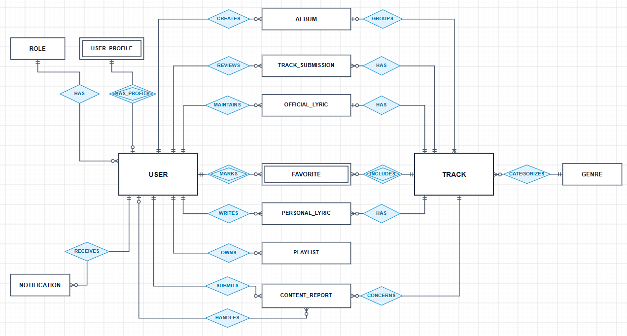

3.2. Database Design

a. Database Schema

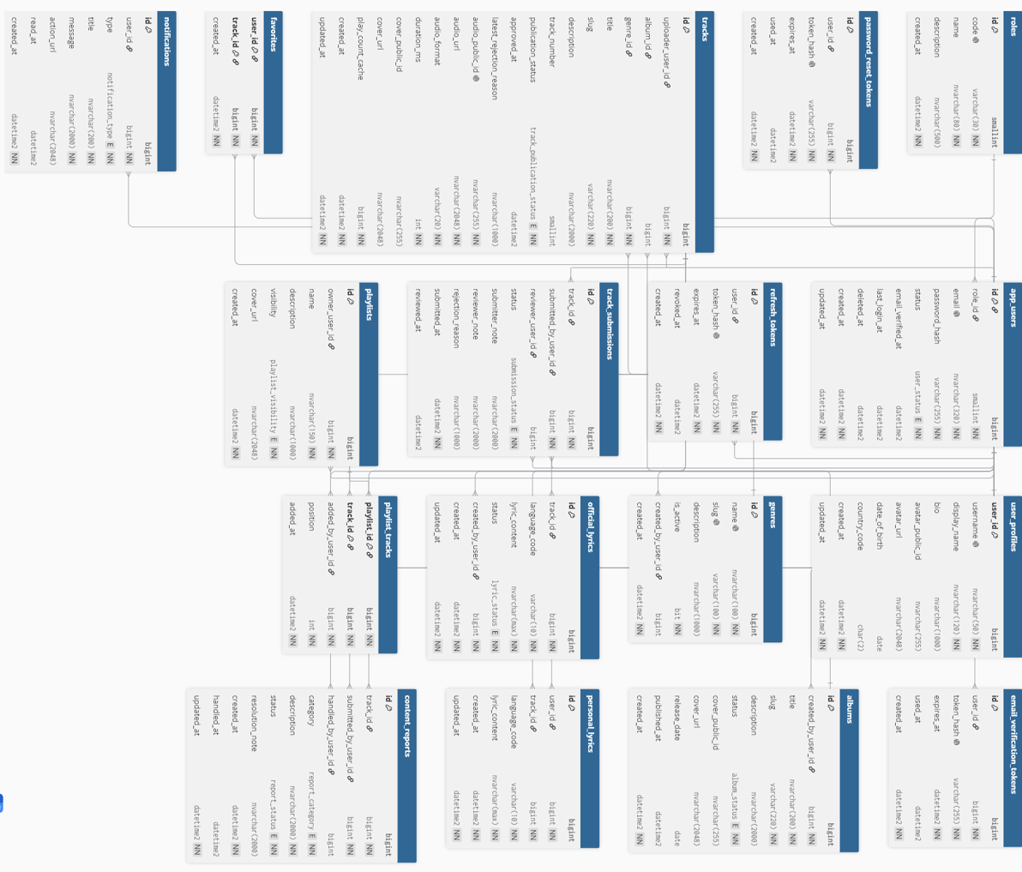

b. Table Descriptions
No. | Table | Description
1 | roles | Stores the system roles used for authorization and role-based login redirection, such as Listener, Staff, and Admin. Guest is not stored as a role because Guest represents an unauthenticated visitor.  Primary key: id  Foreign keys: None
2 | app_users | Stores authentication and account-status information for registered accounts. Every registered account may listen to and publish music. The table also records email verification, login time, account banning, and soft deletion information.  Primary key: id  Foreign keys: role_id → roles.id; banned_by_user_id → app_users.id
3 | user_profiles | Stores the public and personal profile information of a registered account, including username, display name, biography, avatar, date of birth, and country. User and creator information is stored in the same profile because SoundWave does not use a separate Artist account.  Primary key: user_id  Foreign keys: user_id → app_users.id
4 | email_verification_tokens | Stores one-time token hashes used to verify email addresses after account registration. A token has an expiration time and can only be used once.  Primary key: id  Foreign keys: user_id → app_users.id
5 | password_reset_tokens | Stores one-time token hashes used in the forgot-password process. The token allows a user to open the Set New Password screen before its expiration time.  Primary key: id  Foreign keys: user_id → app_users.id
6 | refresh_tokens | Stores hashed refresh tokens used to issue new access tokens without requiring the user to log in again. It also stores device and session information and supports token expiration and revocation.  Primary key: id  Foreign keys: user_id → app_users.id
7 | genres | Stores music genres used to categorize and filter tracks. Admin manages genre information and may deactivate a genre without deleting existing track data.  Primary key: id  Foreign keys: created_by_user_id → app_users.id
8 | albums | Stores albums, EPs, and singles created by registered users. It contains album metadata, Cloudinary cover information, publication status, and release information.  Primary key: id  Foreign keys: created_by_user_id → app_users.id
9 | tracks | Stores track metadata and references to audio and cover files hosted on Cloudinary. It records the uploader, optional album, genre, duration, bitrate, approval status, rejection reason, and cached play count.  Primary key: id  Foreign keys: uploader_user_id → app_users.id; album_id → albums.id; genre_id → genres.id
10 | track_submissions | Stores each version of a track submitted for Staff review. It records the submitter, reviewer, review status, notes, rejection reason, submission time, and review time. A rejected track can be edited and submitted as a new version.  Primary key: id  Foreign keys: track_id → tracks.id; submitted_by_user_id → app_users.id; reviewer_user_id → app_users.id
11 | official_lyrics | Stores official synchronized lyrics for tracks in LRC format. It supports multiple languages, version numbers, synchronization offsets, publication status, and optional Cloudinary LRC file information. Official lyrics are maintained by Staff.  Primary key: id  Foreign keys: track_id → tracks.id; created_by_user_id → app_users.id; maintained_by_user_id → app_users.id
12 | personal_lyrics | Stores private LRC lyrics created by registered users for specific tracks. Each user may maintain a separate lyric version and synchronization offset for each track and language.  Primary key: id  Foreign keys: user_id → app_users.id; track_id → tracks.id
13 | favorites | Represents the many-to-many relationship between users and their favorite tracks. A user can favorite many tracks, and a track can be favorited by many users.  Primary key: (user_id, track_id)  Foreign keys: user_id → app_users.id; track_id → tracks.id
14 | playlists | Stores playlists created by registered users. It contains the playlist name, description, visibility, cover information, owner, and creation and modification timestamps.  Primary key: id  Foreign keys: owner_user_id → app_users.id
15 | playlist_tracks | Represents the many-to-many relationship between playlists and tracks. It also stores the track order, the account that added the track, and the time when it was added.  Primary key: (playlist_id, track_id)  Foreign keys: playlist_id → playlists.id; track_id → tracks.id; added_by_user_id → app_users.id
16 | content_reports | Stores reports submitted by registered users about tracks that may violate platform policies. It records the report category, description, processing status, assigned Staff member, resolution note, and processing time.  Primary key: id  Foreign keys: track_id → tracks.id; submitted_by_user_id → app_users.id; handled_by_user_id → app_users.id
17 | notifications | Stores in-application notifications sent to registered accounts, including track approval, track rejection, report results, email verification, password reset, and general system notifications.  Primary key: id  Foreign keys: user_id → app_users.id

3.2 Code Packages
[Provide the package diagram for each sub-system. The content of this section including the overall package diagram, the explanation, package and class naming conventions in each package. Please see the sample & description table format below]
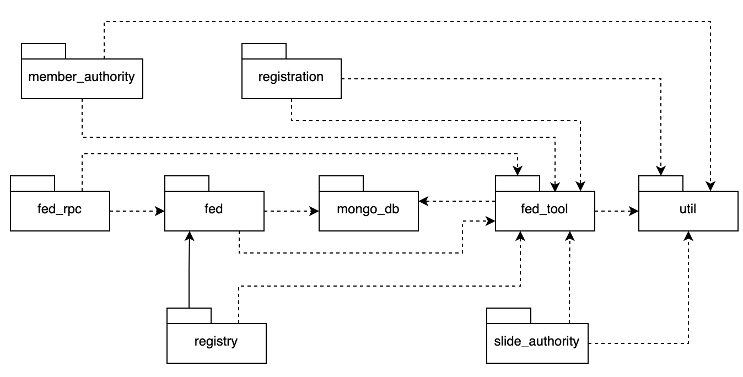
Package descriptions
No | Package | Description

II. Requirement Specifications

1. User Authentication Feature

1.1 UC-1: Login

a. Functional description
UC ID and Name: | UC-1 Login
Created By: |  | Date Created: | 18/09/2026
Primary Actor: | Guest / Unauthenticated User | Secondary Actors: | None
Trigger: | The user accesses the login page, enters their credentials, and clicks the “Login” button.
Description: | Authenticates registered users via their email and password credentials to establish a secure session and grant access to platform features.
Preconditions: | PRE-1: The user has navigated to the User Login interface.  PRE-2: The user holds a valid, registered account on the system.
Postconditions: | POST-1: A valid session or authentication token is successfully generated for the user.  POST-2: The user is redirected to the appropriate dashboard corresponding to their assigned role.
Normal Flow: | 1.0  1. The user enters their Email and Password into the login form and clicks the Login button.  2. The system validates the input format (see 1.0.E1).  3. The system verifies the email and password against stored database credentials.  4. The system generates an active login session and grants access authorization.  5. The system displays a success message and redirects the user to their respective dashboard.  6. The use case ends.
Alternative Flows: | 1.1 Unverified Account Login  1. The system detects that the account email has not been verified yet and displays a notice requiring email confirmation.  2. The system provides a resend activation option.  3. The use case ends.
Exceptions: | 1.0.E1 Invalid Credentials Provided  1. The system detects that credentials do not match any records.  2. The system displays an error message (“Invalid email or password”) and permits retry attempts. Database state remains unchanged.  3. The use case ends.
Priority: | Must Have
Frequency of Use: | High
Business Rules: | FR1, FR2, FR3, BR-01, BR-06, BR-48
Other Information: | Passwords must be securely hashed before being stored in the database.
Assumptions: | The user has a stable internet connection and a JavaScript-enabled web browser.

b. Business Rules
ID | Business Rule | Business Rule Description
FR1 | Password Encoding | User’s password must be encoded with MD5 hashing
FR2 | Invalid Logging In | Users can’t be authenticated to login the system if their logging-in details are incorrect, account has not been verified, or account has been locked or blocked.
FR3 | Account Locking | If a user inputs wrong logging-in details 6 times continuously, his/her account would be locked in 30 minutes .
BR-01 | Email Verification | Email must be verified (via OTP or link) before the account is fully activated; unverified accounts only have Guest privileges.
BR-06 | Banned Account Restriction | Accounts locked (banned) by an Admin cannot log in or perform any actions until they are unbanned.
BR-48 | Guest Interaction Restrictions | Guests only have permission to view/search public content; all interactive actions (like, playlist, upload, report…) require logging in.

1.2 UC-2: Register Account

a. Functional description
UC ID and Name: | UC-2 Register Account
Created By: | BA | Date Created: | 18/09/2026
Primary Actor: | Guest | Secondary Actors: | None
Trigger: | The user clicks “Register” and submits the registration form with personal details.
Description: | Enables guests to create a new platform account with mandatory email verification to confirm user identity.
Preconditions: | PRE-1: The user is on the registration page.  PRE-2: The email address is not already registered in the system.
Postconditions: | POST-1: A new user account is created with an “Unverified” status.  POST-2: A verification email is triggered and sent to the user’s email address.
Normal Flow: | 2.0  1. The user fills out registration details (Name, Email, Password) and submits.  2. The system validates input fields and checks email uniqueness (see 1.2.0.E1).  3. The system creates the account with an unverified status.  4. The system triggers Email Service to send a verification link.  5. The system displays a success message instructing the user to check their email.  6. The use case ends.
Alternative Flows: | None
Exceptions: | 2.0.E1 Email Already Exists  1. The system detects the email is already registered.  2. The system displays an error message prompting the user to log in or use another email. Database state remains unchanged.  3. The use case ends.
Priority: | Must Have
Frequency of Use: | Medium
Business Rules: | FR1, BR-02, BR-03
Other Information: | Email verification token has an expiration time limit.
Assumptions: | Email Service is fully operational.

b. Business Rules
ID | Business Rule | Business Rule Description
FR1 | Password Encoding | User’s password must be encoded with MD5 hashing
BR-02 | Unique Account Registration | Each email can only be registered for one unique account on the system.
BR-03 | Password Complexity | Passwords must meet minimum complexity requirements (e.g., ≥ 8 characters, including uppercase/lowercase/numbers).

1.3 UC-3: Verify Email

a. Functional description
UC ID and Name: | UC-3 Verify Email
Created By: | BA | Date Created: | 18/09/2026
Primary Actor: | Guest / Unverified User | Secondary Actors: | Email Service
Trigger: | The user clicks the verification link received in their email inbox.
Description: | Validates the activation token dispatched via email to transition an unverified user account into active status.
Preconditions: | PRE-1: The user has an unverified account.  PRE-2: The user has a valid verification token.
Postconditions: | POST-1: User account status is updated to “Active/Verified” in the database.
Normal Flow: | 3.0  1. The user clicks the verification link in the email (see 3.0.E1).  2. The system validates the token and checks expiration.  3. The system updates account status to be verified in the database.  4. The system displays a success message and redirects to the login page.  5. The use case ends.
Alternative Flows: | None
Exceptions: | 3.0.E1 Token Expired or Invalid  1. The system detects an invalid or expired token.  2. The system displays an error message and offers a “Resend Verification” button.  3. The use case ends.
Priority: | Must Have
Frequency of Use: | Medium
Business Rules: | BR-01
Other Information: | Tokens must be securely generated and tracked.
Assumptions: | The user can access their email client.

b. Business Rules
ID | Business Rule | Business Rule Description
BR-01 | Email Verification | Email must be verified (via OTP or link) before the account is fully activated; unverified accounts only have Guest privileges.

1.4 UC-4: Forgot Password

a. Functional description
UC ID and Name: | UC-4 Forgot Password
Created By: | BA | Date Created: | 18/09/2026
Primary Actor: | User / Guest | Secondary Actors: | Email Service
Trigger: | The user clicks “Forgot Password” on the login page and submits their registered email.
Description: | Initiates the credential recovery workflow by dispatching a time-limited password reset link to the user’s registered email address.
Preconditions: | PRE-1: The user is on the password recovery page.  PRE-2: The email address exists in the database.
Postconditions: | POST-1: A password reset token is generated and sent via email.
Normal Flow: | 4.0  1. The user enters their registered email address and submits (see 4.0.E1).  2. The system verifies if the email exists in the database.  3. The system generates a secure reset token with expiration.  4. The system triggers Email Service to send the reset link.  5. The system displays a confirmation message.  6. The use case ends.
Alternative Flows: | None
Exceptions: | 4.0.E1 Email Not Found  1. The system detects the email does not exist.  2. The system displays a generic confirmation message for security purposes to avoid exposing registered email addresses.  3. The use case ends.
Priority: | Should Have
Frequency of Use: | Low
Business Rules: | FR1, BR-04
Other Information: | Reset link expires after a specific short timeframe (e.g., 15 mins).
Assumptions: | The user has access to their registered email.

b. Business Rules
ID | Business Rule | Business Rule Description
FR1 | Password Encoding | User’s password must be encoded with MD5 hashing
BR-04 | Password Reset Expiration | “Forgot password” requests are only valid for a limited time (e.g., 15 minutes) before the OTP/link expires.

1.5 UC-5: Logout

a. Functional description
UC ID and Name: | UC-5 Logout
Created By: | BA | Date Created: | 18/09/2026
Primary Actor: | Authenticated User | Secondary Actors: | None
Trigger: | The user clicks the “Logout” button in the application menu.
Description: | Terminates the active session for an authenticated member, invalidating tokens and returning the interface to public guest state.
Preconditions: | PRE-1: The user is currently logged into the system.
Postconditions: | POST-1: Session/Token is invalidated.  POST-2: The user is redirected to the public Home Page.
Normal Flow: | 5.0  1. The user clicks Logout.  2. The system terminates the active user session and clears tokens (see 5.0.E1).  3. The system displays a success notification.  4. The system redirects the user to the public Home Page.  5. The use case ends.
Alternative Flows: | None
Exceptions: | 5.0.E1 Network Timeout  1. The system encounters a timeout during session termination.  2. The system forces local session clears and redirects to the login/home page.  3. The use case ends.
Priority: | Must Have
Frequency of Use: | High
Business Rules: | None
Other Information: | Ensures security on shared devices.
Assumptions: | Active network connection.

b. Business Rules
ID | Business Rule | Business Rule Description
 | None | None

2. Music search & Browsing Feature

2.1 UC-6: View Recommended Song

a. Functional description
UC ID and Name: | UC-6 View Recommended Song
Created By: | BA | Date Created: | 21/09/2026
Primary Actor: | Guest / Listener | Secondary Actors: | None
Trigger: | The user navigates to the Home Page or discovery section.
Description: | Delivers a curated showcase of trending and suggested tracks on the home discovery screen for both visitors and members.
Preconditions: | PRE-1: The system contains published songs with metadata.
Postconditions: | POST-1: The recommended song list is rendered on the UI.
Normal Flow: | 6.0  1. The user loads the Home Page.  2. The system fetches published tracks from the database based on trending or recommendation algorithms (see 6.0.E1).  3. The system renders the list of recommended songs with title, artist, cover art, and duration.  4. The use case ends.
Alternative Flows: | None
Exceptions: | 6.0.E1 No Published Tracks Available  1. The system finds no tracks to recommend.  2. The system displays an empty placeholder state.  3. The use case ends.
Priority: | Should Have
Frequency of Use: | High
Business Rules: | BR-09, BR-48
Other Information: | Only tracks with status Published are displayed.
Assumptions: | The database has sample tracks.

b. Business Rules
ID | Business Rule | Business Rule Description
BR-09 | Public Content Visibility | Only content with an “Approved/Published” status will appear in search results and public browsing (Guest, Free Listener, Premium).
BR-48 | Guest Interaction Restrictions | Guests only have permission to view/search public content; all interactive actions (like, playlist, upload, report…) require logging in.

2.2 UC-7: Search Public Catalog

a. Functional description
UC ID and Name: | UC-7 Search Public Catalog
Created By: | BA | Date Created: | 21/09/2026
Primary Actor: | Guest / Listener | Secondary Actors: | None
Trigger: | The user inputs keywords into the global search bar and presses Enter/Search.
Description: | Executes broad keyword querying across multiple entities in the public catalog, including track titles, artists, and album releases.
Preconditions: | PRE-1: The search bar is accessible on the UI.
Postconditions: | POST-1: Relevant matching catalog items are displayed.
Normal Flow: | 7.0  1. The user enters keywords into the search bar and initiates search.  2. The system queries the database filtering by published status (see 7.0.E1).  3. The system categorizes and displays matching results across songs, artists, and albums.  4. The use case ends.
Alternative Flows: | 7.1 No Matching Records Found  1. The system finds no records matching the query.  2. The system displays an empty result message: “No results found. Try different keywords.”  3. The use case ends.
Exceptions: | 7.2.0.E1 Database Timeout  1. The query exceeds the timeout limit.  2. The system displays an error message and a retry option.  3. The use case ends.
Priority: | Must Have
Frequency of Use: | High
Business Rules: | BR-09, BR-48
Other Information: | Core feature for navigation.
Assumptions: | Indexing is properly configured.

b. Business Rules
ID | Business Rule | Business Rule Description
BR-09 | Public Content Visibility | Only content with an “Approved/Published” status will appear in search results and public browsing (Guest, Free Listener, Premium).
BR-48 | Guest Interaction Restrictions | Guests only have permission to view/search public content; all interactive actions (like, playlist, upload, report…) require logging in.

2.3 UC-8: Filter Public Catalog

a. Functional description
UC ID and Name: | UC-8 Filter Public Catalog
Created By: | BA | Date Created: | 21/09/2026
Primary Actor: | Guest, Listener | Secondary Actors: | None
Trigger: | The user selects a music genre tag or selects a genre from the dropdown list on the Browse page.
Description: | Enables listeners to narrow down song discovery by selecting one or more music genres, dynamically updating the browsing view without full-page reloads.
Preconditions: | PRE-1: User is currently on the Search or Browse page.  PRE-2: The system has at least one active genre and published songs.
Postconditions: | POST-1: System renders only songs that are published and belong to the selected genre(s).  POST-2: Selected genre filters are highlighted visually on the interface.
Normal Flow: | 8.0  1. The user navigates to the Browse screen.  2. System displays available genre filter tags (see 8.0.E1).  3. The user clicks on a specific genre tag (e.g., “Ballad”).  4. System queries for all published songs associated with the chosen genre (see 8.0.E2).  5. System renders matching song cards showing cover art, title, artist name, and duration.  6. System updates the URL parameter to reflect the active genre filter without reloading the full page.  7. The use case ends.
Alternative Flows: | 8.1 Filter Combined with Search Keyword  1. The user enters a text keyword into the search bar (e.g., “Mưa”).  2. The user clicks on a genre filter tag (e.g., "Ballad").  3. The system applies both conditions: song title contains keyword AND song belongs to selected genre.  4. Return to Step 5 of the Normal Flow.
Exceptions: | 8.0.E1 No Genre Available in System  1. The system detects no active genres configured.  2. The system displays a message: “No genres are currently available.”  3. The use case ends.  8.0.E2 No Published Songs Found for Selected Genre  1. The system cannot find any published songs matching the selected genre.  2. System displays message: “No published songs found for this genre. Please select another genre!”  3. The user chooses a different genre.
Priority: | High
Frequency of Use: | High
Business Rules: | BR-09, BR-48
Other Information: | None
Assumptions: | - Customers have a stable internet connection.  - System time is synchronized with standard local time.

b. Business Rules
ID | Business Rule | Business Rule Description
BR-09 | Public Content Visibility | Only content with an “Approved/Published” status will appear in search results and public browsing (Guest, Free Listener, Premium).
BR-48 | Guest Interaction Restrictions | Guests only have permission to view/search public content; all interactive actions (like, playlist, upload, report…) require logging in.

3. Audio Playback Feature

3.1 UC-9: Listen to Public Song

a. Functional description
UC ID and Name: | UC-9 Listen to Public Song
Created By: | BA | Date Created: | 21/09/2026
Primary Actor: | Guest (Unauthenticated User) | Secondary Actors: | Cloud Audio Service
Trigger: | Guests click the Play button on any public song card.
Description: | Permits unauthenticated visitors to experience full-length public music streaming directly within the web player, displaying an onboarding prompt upon song completion.
Preconditions: | PRE-1: Target song is in published status.  PRE-2: User is unauthenticated (guest session).
Postconditions: | POST-1: Public song streams through the bottom audio player.  POST-2: System increments song play count upon reaching 30 seconds of playback.  POST-3: System displays a registration prompt dialog upon track completion.
Normal Flow: | 9.0  1. Guest clicks “Play” on a published song card (see 9.0.E1).  2. System verifies track availability and retrieves audio stream URL (see 9.0.E2).  3. The system initializes the bottom audio player and begins streaming audio.  4. System checks playback duration continuously; once playback exceeds 30 continuous seconds, system increments song play count.  5. The song plays until completion.  6. System displays prompt modal: “Enjoying SoundWave? Create a free account to save favorites and create custom playlists!”  7. The use case ends.
Alternative Flows: | 9.1 Guest Skips to Another Public Song  1. Guest clicks Play on a different public song card before the current track ends.  2. System pauses current audio and loads new audio stream.  3. Return to Step 3 of the Normal Flow.
Exceptions: | 9.0.E1 Audio Stream Fails to Load  1. The system fails to establish audio streaming connection with cloud storage.  2. System displays message: “Audio stream is currently unavailable. Please try again later.”  3. The use case ends.  9.0.E2 Network Disconnected During Playback  1. The system detects network disconnection while streaming audio.  2. System pauses playback and displays buffering alert: “Connection interrupted. Attempting to reconnect…”  3. If reconnect fails after 15 seconds, the system displays: “Network connection lost. Please check your internet connection.”  4. The use case ends.
Priority: | High
Frequency of Use: | High
Business Rules: | BR-09, BR-11, BR-12, BR-13, BR-14
Other Information: | None
Assumptions: | - Customers have a stable internet connection.  - System time is synchronized with standard local time.

b. Business Rules
ID | Business Rule | Business Rule Description
BR-09 | Public Content Visibility | Only content with an “Approved/Published” status will appear in search results and public browsing (Guest, Free Listener, Premium).
BR-11 | Valid Stream Threshold | A listening session is only counted as a “valid stream” when playback duration is ≥ 30 continuous seconds; this is the baseline for analytics and revenue.
BR-12 | Free Listener Ad Rules | Free Listeners are not allowed to skip/close playing advertisements; the seek/skip function is completely disabled during ad playback.
BR-13 | Ad Insertion Frequency | For every 3 songs played for a Free Listener, the system automatically inserts a 15-second audio advertisement before playing the next song.
BR-14 | Premium Subscriber Benefits | Premium Subscribers never receive advertisements, have unlimited skips, and stream at high bitrate quality.

3.2 UC-10: Stream Music

a. Functional description
UC ID and Name: | UC-10 Stream Music
Created By: | BA | Date Created: | 21/09/2026
Primary Actor: | Listener (Registered User) | Secondary Actors: | Cloud Audio Service
Trigger: | Listener clicks Play on any song card, album, or playlist.
Description: | Delivers uninterrupted high-fidelity audio streaming for authenticated members, buffering ahead for gapless listening and logging verified plays into listening history.
Preconditions: | PRE-1: User is logged in with an active account.  PRE-2: Target song is published.
Postconditions: | POST-1: Continuous audio streaming initiates without initial delay.  POST-2: Song is appended to user's Listening History.  POST-3: System updates song play count after 30 seconds.
Normal Flow: | 10.0  1. Listener clicks “Play” on a song card, album, or playlist (see 10.0.E1).  2. System verifies track published status and retrieves streaming endpoint (see 10.0.E2).  3. The system loads audio streams in segments from cloud storage.  4. The system launches playback on persistent player bars and displays metadata (title, artist, cover art).  5. System records song entry into user’s Listening History.  6. System verifies playback elapsed time and increments play count when reaching 30 seconds.  7. Playback continues smoothly until completion or user interruption.  8. The use case ends.
Alternative Flows: | 10.1 User Seeks to Different Track Position  1. Listener drags the playback progress bar to a new timestamp.  2. The system requests an audio chunk corresponding to the target timestamp.  3. Audio resumes instantly from target position without downloading unplayed segments.  4. Return to Step 7 of the Normal Flow.
Exceptions: | 10.0.E1 Audio Track Temporarily Unavailable  1. System encounters inaccessible audio file on storage server.  2. System displays message: “Audio file is temporarily unavailable. Skipping to the next track…”  3. The system automatically advances to the next available track in the active queue.  10.0.E2 Audio Stream Buffering Timeout  1. The system experiences network stall exceeding 10 seconds.  2. System displays notification: “Slow connection detected. Lowering audio buffering bitrate.”  3. System re-attempts streaming at optimized bitrate.
Priority: | High
Frequency of Use: | Very High
Business Rules: | BR-09, BR-11, BR-12, BR-14, BR-15
Other Information: | None
Assumptions: | - Customers have a stable internet connection.  - System time is synchronized with standard local time.

b. Business Rules
ID | Business Rule | Business Rule Description
BR-09 | Public Content Visibility | Only content with an “Approved/Published” status will appear in search results and public browsing (Guest, Free Listener, Premium).
BR-11 | Valid Stream Threshold | A listening session is only counted as a “valid stream” when playback duration is ≥ 30 continuous seconds; this is the baseline for analytics and revenue.
BR-12 | Free Listener Ad Rules | Free Listeners are not allowed to skip/close playing advertisements; the seek/skip function is completely disabled during ad playback.
BR-14 | Premium Subscriber Benefits | Premium Subscribers never receive advertisements, have unlimited skips, and stream at high bitrate quality.
BR-15 | Listening History Access | Listening history is only recorded for logged-in accounts (not applicable to Guests).

3.3 UC-11: Control Playback

a. Functional description
UC ID and Name: | UC-11 Control Playback
Created By: | BA | Date Created: | 21/09/2026
Primary Actor: | Listener (Registered User) | Secondary Actors: | None
Trigger: | Listener interacts with player controls (Play/Pause, Seek Bar, Next, Previous, Shuffle, Repeat, Volume).
Description: | Provides listeners with real-time interactive playback controls, including pausing, seeking to timestamps, randomizing upcoming tracks via shuffle, toggling repeat, and adjusting volume.
Preconditions: | PRE-1: An audio track is currently loaded and active in the audio player.
Postconditions: | POST-1: Audio player state immediately reflects requested control command.  POST-2: UI indicators (shuffle active, repeat badge, volume slider) update visually.
Normal Flow: | 11.0  1. Listener clicks the “Pause” button while audio is playing (or “Play” while paused) (see 11.0.E1).  2. System pauses audio playback immediately (or resumes from exact paused position).  3. System toggles button icon between Play and Pause.  4. The use case ends.
Alternative Flows: | 11.1 Seek to Timestamp  1. Listener drags progress slider to target timestamp (e.g., 02:15).  2. System relocates audio playhead and streams from target timestamp.  3. The use case ends.  11.2 Toggle Shuffle Mode  1. The listener clicks the “Shuffle” icon.  2. System toggles shuffle state between ON and OFF.  3. The system randomizes the order of upcoming songs in the active queue while keeping the current track intact.  4. The use case ends.  11.3 Cycle Repeat Mode  1. The listener clicks the “Repeat” icon.  2. System cycles mode: Repeat All -> Repeat One -> Repeat Off.  3. System updates UI icon badge accordingly.  4. The use case ends.  11.4 Skip Next or Previous Track  1. The listener clicks "Next Track" (or "Previous Track").  2. If Next: System advances to next song in active queue.  3. If Previous: If current playback > 3s, restarts current song; otherwise plays previous song.  4. The use case ends.
Exceptions: | 11.0.E1 Invalid Seek Position Beyond Duration  1. The system receives invalid seek requests exceeding track length.  2. System snaps playhead to final second of track.  3. The use case ends.  11.0.E2 End of Queue Reached with Repeat Off  1. The last song in the queue finishes while Repeat is disabled.  2. The system stops playback and leaves the player positioned at the start of the last song.  3. The use case ends.
Priority: | High
Frequency of Use: | Very High
Business Rules: | BR-12, BR-14
Other Information: | None
Assumptions: | - Customers have a stable internet connection.  - System time is synchronized with standard local time.

b. Business Rules
ID | Business Rule | Business Rule Description
BR-12 | Free Listener Ad Rules | Free Listeners are not allowed to skip/close playing advertisements; the seek/skip function is completely disabled during ad playback.
BR-14 | Premium Subscriber Benefits | Premium Subscribers never receive advertisements, have unlimited skips, and stream at high bitrate quality.

4. Profile Management

4.1 UC-12.1: Manage Personal Profile (Read)

a. Functional description
UC ID and Name: | UC-12.1 View Personal Profile
Created By: | BA | Date Created: | 21/09/2026
Primary Actor: | Listener (Registered User) | Secondary Actors: | None
Trigger: | Listener clicks on the "Profile" option from the navigation menu or user menu.
Description: | Retrieves and displays the Listener's current profile information, including their display name, biography, and avatar.
Preconditions: | PRE-1: The system must successfully call UC-01: Login before executing this function.
Postconditions: | POST-1: The user's personal profile information is successfully rendered on the Profile Dashboard.
Normal Flow: | 12.1.0  1. Listener selects the "Profile" option to navigate to the Profile Dashboard.  2. The system verifies the user's active session.  3. The system queries the database to retrieve the current user's profile data (display name, avatar URL, biography, join date).  4. The system renders the Profile Dashboard displaying the retrieved information.  5. The use case ends.
Alternative Flows: | None
Exceptions: | 12.1.0.E1 Session Expired: If the user's session is invalid or expired, the system redirects the user to the Login page.
Priority: | High
Frequency of Use: | Medium – accessed periodically to review profile status.
Business Rules: | None
Other Information: | None
Assumptions: | - Customers have a stable internet connection.  - System time is synchronized with standard local time.

b. Business Rules
ID | Business Rule | Business Rule Description
 | None | None

4.2 UC-12.2: Manage Personal Profile (Update)

a. Functional description
UC ID and Name: | UC-12.2 Update Personal Profile
Created By: | BA | Date Created: | 21/09/2026
Primary Actor: | Listener (Registered User) | Secondary Actors: | Cloud Storage Service
Trigger: | Listener clicks the "Edit Profile" button on the Profile Dashboard.
Description: | Provides a form for the Listener to modify their personal details, validating text inputs and processing avatar image uploads before updating the database.
Preconditions: | PRE-1: The system must successfully call UC-01: Login.  PRE-2: The Listener is currently on the Profile Dashboard (UC-12.1 completed).
Postconditions: | POST-1: The user's profile information is updated in the database.  POST-2: If a new avatar is chosen, the file is securely uploaded to Cloud Storage.
Normal Flow: | 12.2.0  1. Listener clicks the "Edit Profile" button.  2. The system opens an edit form pre-filled with the current display name and biography.  3. Listener modifies the display name, updates the biography, or selects a new avatar image file.  4. Listener clicks "Save Changes".  5. The system validates the input fields (e.g., display name is not empty).  6. If a new avatar is selected, the system implicitly calls UC-36: Process Cloud Media to upload the image and retrieve the new secure URL.  7. The system updates the profile record in the database with the new text and URL.  8. The system displays a success notification ("Profile updated successfully").  9. The system refreshes the Profile Dashboard to display the newly updated information.  10. The use case ends.
Alternative Flows: | 12.2.1 Cancel Update: At step 4, the Listener clicks "Cancel". The system discards all unsaved changes and closes the edit form without modifying the database.
Exceptions: | 12.2.0.E1 Invalid Avatar File: The selected image exceeds the maximum allowed size or has an unsupported format. The system blocks the upload and displays an error message: "Avatar must be in JPG/PNG format and under 5MB."  12.2.0.E2 Empty Display Name: The display name field is submitted blank. The system prompts: "Display name cannot be empty."
Priority: | High
Frequency of Use: | Low
Business Rules: | BR-07, BR-08
Other Information: | None
Assumptions: | - Customers have a stable internet connection.  - System time is synchronized with standard local time.

b. Business Rules
ID | Business Rule | Business Rule Description
BR-07 | Profile Edit Authorization | Users are only permitted to edit their own personal information and avatar.
BR-08 | Avatar Constraints | Profile pictures (avatars) must comply with format/size limits specified by the system before being saved to the Storage Service.

5. Music Interaction Feature

5.1 UC-13: View Listening History

a. Functional description
UC ID and Name: | UC-13 View Listening History
Created By: | BA | Date Created: | 21/09/2026
Primary Actor: | Listener (Registered User) | Secondary Actors: | None
Trigger: | Listener clicks 'Listening History' in the sidebar navigation menu.
Description: | Maintains a chronological log of tracks played by the listener, giving them the ability to revisit past listening sessions, replay songs on demand, or wipe the entire history log.
Preconditions: | PRE-1: Listener is logged into the SoundWave platform.
Postconditions: | POST-1: System renders chronological listening log with track titles, artists, and playback timestamps.
Normal Flow: | 13.0  1. The Listener clicks "Listening History" in the sidebar menu (see 13.0.E1).  2. System retrieves chronological playback log for current user, ordered by most recent playback first.  3. System renders listening history list displaying song cards with cover art, title, artist, and playback timestamp.  4. Listeners can click the Play button on any song card to replay tracks immediately.  5. The use case ends.
Alternative Flows: | 13.1 Listener Clears Entire Listening History  1. The Listener clicks the "Clear History" button at the top of the history page.  2. The system displays a confirmation dialog: "Are you sure you want to clear your listening history?"  3. Listener clicks "Confirm".  4. The system purges all listening history records for current users.  5. The system displays an empty state message: "Listening history cleared."  6. The use case ends.
Exceptions: | 13.0.E1 Listening History is Empty  1. The system finds no playback records for current users.  2. The system displays an empty view message: "You haven't listened to any songs yet. Discover exciting music now!"  3. System displays "Explore Music" button redirecting to Browse page.  4. The use case ends.
Priority: | Medium
Frequency of Use: | Medium
Business Rules: | BR-15
Other Information: | None
Assumptions: | - Customers have a stable internet connection.  - System time is synchronized with standard local time.

b. Business Rules
ID | Business Rule | Business Rule Description
BR-15 | Listening History Access | Listening history is only recorded for logged-in accounts (not applicable to Guests).

5.2 UC-14.1: Manage my Favorite Tracks (Read)

a. Functional description
UC ID and Name: | UC-14.1 View Favorite Tracks
Created By: | BA | Date Created: | 21/09/2026
Primary Actor: | Listener (Registered User) | Secondary Actors: | None
Trigger: | Listeners navigate to the "My Favorites" or "Liked Songs" section in their personal library.
Description: | Retrieves and displays the list of all published tracks that the Listener has previously marked as favorite (liked).
Preconditions: | PRE-1: The system must successfully call UC-01: Login.
Postconditions: | POST-1: The chronological list of favorite tracks is displayed to the user.
Normal Flow: | 14.1.0 View Favorite List  1. Listener selects the "My Favorites" tab from the navigation menu.  2. The system queries the database for all tracks associated with the user's favorites collection.  3. The system filters the results to ensure only tracks with "Approved/Published" status are rendered.  4. The system displays the list of favorite tracks, including track title, artist name, cover art, and duration.  5. The use case ends.
Alternative Flows: | None
Exceptions: | 14.1.0.E1 Empty Favorites List: The system finds no favorited tracks for the user. The system displays an empty state message (e.g., "You haven't liked any tracks yet. Discover new music!") and provides a button to redirect to the Explore page.
Priority: | High
Frequency of Use: | High
Business Rules: | BR-09, BR-48
Other Information: | None
Assumptions: | - Customers have a stable internet connection.  - System time is synchronized with standard local time.

b. Business Rules
ID | Business Rule | Business Rule Description
BR-09 | Public Content Visibility | Only content with an "Approved/Published" status will appear in search results and public browsing (Guest, Free Listener, Premium).
BR-48 | Guest Interaction Restrictions | Guests only have permission to view/search public content; all interactive actions (like, playlist, upload, report…) require logging in.

5.3 UC-14.2: Manage my Favorite Tracks (Create)

a. Functional description
UC ID and Name: | UC-14.2 Add Track to Favorites
Created By: | BA | Date Created: | 21/09/2026
Primary Actor: | Listener (Registered User) | Secondary Actors: | None
Trigger: | Listener clicks the empty "Heart" icon on a published track card or audio player.
Description: | Allows the Listener to bookmark a specific track into their personal favorites collection, instantly updating the UI state.
Preconditions: | PRE-1: The system must successfully call UC-01: Login.  PRE-2: The target track must be in "Published" status and not currently in the user's favorites list.
Postconditions: | POST-1: A new favorite record associating the Listener and the track is saved in the database.  POST-2: The UI heart icon is dynamically updated to a filled state.
Normal Flow: | 14.2.0 Add to Favorites  1. The listener clicks the empty "Heart" icon next to a track.  2. The system verifies that the track is publicly available and not already favorited.  3. The system creates a new favorite association record in the database.  4. The system updates the "Heart" icon to a filled/highlighted state.  5. The system displays a brief success toast notification ("Added to Favorites").  6. The use case ends.
Alternative Flows: | None
Exceptions: | 14.2.0.E1 Track Already Favorited: The system detects the track is already in the user's favorites list. The system maintains the filled heart state and prevents duplicate database insertion.  14.2.0.E2 Track Unavailable: The track is no longer published. The system displays an error message ("This track is no longer available").
Priority: | High
Frequency of Use: | High
Business Rules: | BR-18, BR-19, BR-48
Other Information: | None
Assumptions: | - Customers have a stable internet connection.  - System time is synchronized with standard local time.

b. Business Rules
ID | Business Rule | Business Rule Description
BR-18 | Song Like Uniqueness | A song can only be "liked" once per user; pressing like again will be unlike (toggle).
BR-19 | Liked Songs Synchronization | The "Liked Songs" list is automatically updated (add/remove) as soon as the user likes/unlikes, without requiring manual playlist creation.
BR-48 | Guest Interaction Restrictions | Guests only have permission to view/search public content; all interactive actions (like, playlist, upload, report…) require logging in.

5.4 UC-14.3: Manage my Favorite Tracks (Delete)

a. Functional description
UC ID and Name: | UC-14.3 Remove Song from Favorites
Created By: | BA | Date Created: | 21/09/2026
Primary Actor: | Listener (Registered User) | Secondary Actors: | None
Trigger: | Listener clicks the filled "Heart" icon on a previously favorited track.
Description: | Allows the Listener to remove a track from their personal favorites collection, immediately un-syncing the track from their library.
Preconditions: | PRE-1: The system must successfully call UC-01: Login.  PRE-2: The target track is currently present in the user's favorites list.
Postconditions: | POST-1: The favorite association record is permanently deleted from the database.  POST-2: The UI heart icon reverts to an empty outline state.
Normal Flow: | 14.3.0 Remove from Favorites  1. The listener clicks the highlighted "Heart" icon on a track.  2. The system locates and deletes the favorite record associating the Listener with the target track.  3. The system updates the "Heart" icon to an empty/outline state.  4. If the Listener is currently viewing the "My Favorites" screen, the system dynamically removes the track's row from the active display without reloading the page.  5. The system displays a brief toast notification ("Removed from Favorites").  6. The use case ends.
Alternative Flows: | None
Exceptions: | 14.3.0.E1 Network Failure: The system fails to communicate with the database due to a connection error. The system displays an error ("Could not update favorites. Please retry") and retains the highlighted heart state.
Priority: | High
Frequency of Use: | Medium
Business Rules: | BR-18, BR-19, BR-48
Other Information: | None
Assumptions: | - Customers have a stable internet connection.  - System time is synchronized with standard local time.

b. Business Rules

ID | Business Rule | Business Rule Description
BR-18 | Song Like Uniqueness | A song can only be "liked" once per user; pressing like again will be unlike (toggle).
BR-19 | Liked Songs Synchronization | The "Liked Songs" list is automatically updated (add/remove) as soon as the user likes/unlikes, without requiring manual playlist creation.
BR-48 | Guest Interaction Restrictions | Guests only have permission to view/search public content; all interactive actions (like, playlist, upload, report…) require logging in.

6. Playlist Management

6.1 UC-15.1 Manage my Playlist (Read)

a. Functional Description
UC ID and Name: | UC-15.1 View My Playlists
Created By: | BA | Date Created: | 21/09/2026
Primary Actor: | Listener (Registered User) | Secondary Actors: | None
Trigger: | Listener navigates to the "My Playlists" section in the library or clicks on a specific playlist card.
Description: | Retrieves and displays the list of playlists created by the user, as well as the detailed tracklist, cover image, and total duration when a specific playlist is selected.
Preconditions: | PRE-1: The system must successfully call UC-01: Login.
Postconditions: | POST-1: The playlist collection or detailed playlist view is rendered on the screen.
Normal Flow | 15.1.0 View Playlist Details  1. The listener selects "My Playlists" from the navigation menu.  2. The system queries the database for all playlists owned by the current user.  3. The system displays the list of playlists.  4. The listener clicks on a specific playlist to view its details.  5. The system verifies ownership permissions and retrieves the playlist's metadata (title, cover, description, privacy status) and its chronological tracklist.  6. The system displays the detailed playlist page.  7. The use case ends.
Alternative Flows: | None
Exceptions: | 15.1.0.E1 Playlist Not Found: The requested playlist has been deleted or does not exist. The system displays an error message ("Playlist not found") and redirects to the library.
Priority: | High
Frequency of Use: | High
Business Rules: | BR-17, BR-48
Other Information: | None
Assumptions: | - Customers have a stable internet connection.  - System time is synchronized with standard local time.

b. Business Rules
ID | Business Rule | Business Rule Description
BR-17 | Private Playlist Visibility | Playlists in the "private" state are not visible to any users other than the owner. .
BR-48 | Guest Interaction Restrictions | Guests only have permission to view/search public content; all interactive actions (like, playlist, upload, report…) require logging in.

6.2 UC-15.2 Manage my Playlist (Create)

a. Functional Description
UC ID and Name: | UC-15.2 Create Playlist
Created By: | BA | Date Created: | 21/09/2026
Primary Actor: | Guest, Listener | Secondary Actors: | None
Trigger: | Listener clicks the "Create Playlist" button in the sidebar or library interface.
Description: | Empowers the Listener to initialize a new custom music collection by defining a title, optional description, and privacy visibility mode (Public or Private).
Preconditions: | PRE-1: The system must successfully call UC-01: Login.
Postconditions: | POST-1: A new playlist record assigned to the Listener is created in the database.
Normal Flow | 15.2.0 Create New Playlist  1. Listener clicks the "Create Playlist" button.  2. The system displays a modal dialog with input fields for Title, Description, and a Privacy toggle.  3. Listener enters the required playlist title and selects the desired privacy mode.  4. The listener clicks the "Create" button.  5. The system validates the title length (must not be empty).  6. The system saves the new playlist record in the database under the current user's ID.  7. The system closes the modal, displays a success notification ("Playlist created"), and navigates the user to the newly created playlist view.  8. The use case ends.
Alternative Flows: | None
Exceptions: | 15.2.0.E1 Empty Playlist Title: The title field is submitted blank. The system displays an error message ("Playlist title cannot be empty") and prompts the user to retry.
Priority: | High
Frequency of Use: | High – primary screen for accessing curated collections.
Business Rules: | BR-16, BR-48
Other Information: | None
Assumptions: | - Customers have a stable internet connection.  - System time is synchronized with standard local time.

b. Business Rules

ID | Business Rule | Business Rule Description
BR-16 | Playlist Management Rights | Only the owner of a playlist has the authority to add/remove songs, change public/private status, or delete the playlist.
BR-48 | Guest Interaction Restrictions | Guests only have permission to view/search public content; all interactive actions (like, playlist, upload, report…) require logging in. .

6.3 UC-15.3: Manage my Playlist (Update)

a. Functional Description
UC ID and Name: | UC-15.3 Update Playlist Information
Created By: | BA | Date Created: | 21/09/2026
Primary Actor: | Listener (Playlist Owner) | Secondary Actors: | Cloud Storage Service
Trigger: | Listener clicks the "Edit Details" button on their owned playlist page.
Description: | Allows the playlist owner to modify the metadata of an existing playlist, including renaming the title, editing the description, changing privacy settings, or uploading a new cover image.
Preconditions: | PRE-1: The system must successfully call UC-01: Login.  PRE-2: The Listener is the confirmed owner of the target playlist.
Postconditions: | POST-1: The updated playlist information and new cover image URL are saved in the database.
Normal Flow | 15.3.0 Edit Playlist Metadata  1. Listener clicks the "Edit Details" button on the playlist view.  2. The system opens an edit modal pre-filled with the current title, description, and cover image preview.  3. Listener modifies the text fields, toggles privacy settings, or selects a new cover image file.  4. Listener clicks "Save Changes".  5. The system validates the inputs.  6. If a new cover image is selected, the system implicitly calls UC-36: Process Cloud Media to upload the image and retrieve the secure URL.  7. The system updates the playlist record in the database.  8. The system refreshes the playlist page to reflect the new details.  9. The use case ends.
Alternative Flows: | None
Exceptions: | 15.3.0.E1 Invalid Image Format/Size: The uploaded cover image is not in JPG/PNG format or exceeds 5MB. The system blocks the update and displays an error message.
Priority: | Medium
Frequency of Use: | Low to Medium – executed during playlist maintenance.
Business Rules: | BR-16, BR-17
Other Information: | None
Assumptions: | - Customers have a stable internet connection.  - System time is synchronized with standard local time.

b. Business Rules
ID | Business Rule | Business Rule Description
BR-16 | Playlist Management Rights | Only the owner of a playlist has the authority to add/remove songs, change public/private status, or delete the playlist. .
BR-17 | Private Playlist Visibility | Playlists in the "private" state are not visible to any users other than the owner. .

6.4 UC-15.4 Manage my Playlist (Update)

a. Functional Description
UC ID and Name: | UC-15.4 Manage Playlist Tracks
Created By: | BA | Date Created: | 21/09/2026
Primary Actor: | Listener (Playlist Owner) | Secondary Actors: | None
Trigger: | Listener selects "Add to Playlist" from a track's action menu, or clicks "Remove" on a track inside a playlist.
Description: | Enables the playlist owner to curate their collection by inserting new published songs or removing existing songs from the playlist, automatically recalculating track counts.
Preconditions: | PRE-1: The system must successfully call UC-01: Login.  PRE-2: The Listener is the confirmed owner of the target playlist.
Postconditions: | POST-1: The song association is either added to or removed from the playlist in the database.
Normal Flow | 15.4.0 Add Song to Playlis  1. Listener clicks the "..." action menu on a published track and selects "Add to Playlist".  2. The system displays a list of playlists owned by the Listener.  3. Listener selects the destination playlist.  4. The system verifies the song is not already in the selected playlist.  5. The system creates an association record appending the song to the playlist.  6. The system displays a success toast ("Added to playlist").  7. The use case ends.
Alternative Flows: | 15.4.1 Remove Song from Playlist: Listener opens the playlist details, clicks the action icon next to a track, and selects "Remove from Playlist". The system deletes the association record, re-indexes the remaining tracks, and smoothly removes the row from the UI.
Exceptions: | 15.4.0.E1 Duplicate Song Insertion: The system detects the track is already in the destination playlist. The system displays a warning ("Song is already in this playlist") and prevents duplicate addition.
Priority: | High
Frequency of Use: | High
Business Rules: | BR-16
Other Information: | None
Assumptions: | - Customers have a stable internet connection.  - System time is synchronized with standard local time.

b. Business Rules
ID | Business Rule | Business Rule Description
BR-16 | Playlist Management Rights | Only the owner of a playlist has the authority to add/remove songs, change public/private status, or delete the playlist. .

6.5 UC-15.5 Manage my Playlist (Delete)

a. Functional Description
UC ID and Name: | UC-15.5 Delete Playlist
Created By: | BA | Date Created: | 18/09/2026
Primary Actor: | Listener (Playlist Owner) | Secondary Actors: | None
Trigger: | Listener clicks the "Delete Playlist" option from the playlist's action menu.
Description: | Permits the playlist owner to permanently remove an entire playlist and all its track associations from the system.
Preconditions: | PRE-1: The system must successfully call UC-01: Login.  PRE-2: The Listener is the confirmed owner of the target playlist.
Postconditions: | POST-1: The playlist record and all its song associations are permanently purged from the database.
Normal Flow | 15.5.0 Delete Playlist  1. Listener clicks the "Delete Playlist" button inside the playlist view.  2. The system displays a warning confirmation modal ("Are you sure you want to delete this playlist? This action cannot be undone.").  3. Listener clicks "Confirm Delete".  4. The system verifies ownership permissions.  5. The system deletes the playlist record and purges all related track-playlist associations in the database (the underlying tracks remain untouched).  6. The system displays a success notification ("Playlist deleted").  7. The system redirects the Listener back to their "My Playlists" library view.  8. The use case ends.
Alternative Flows: | 15.5.1 Cancel Deletion: At step 2, Listener clicks "Cancel". The system closes the modal without performing any database operations.
Exceptions: | None
Priority: | Medium
Frequency of Use: | Low
Business Rules: | BR-16
Other Information: | None
Assumptions: | - Customers have a stable internet connection.  - System time is synchronized with standard local time.

b. Business Rules
ID | Business Rule | Business Rule Description
BR-16 | Playlist Management Rights | Only the owner of a playlist has the authority to add/remove songs, change public/private status, or delete the playlist. .

7. Lyrics Interaction

7.1 UC-16 View Lyrics

a. Functional Description
UC ID and Name: | UC-16 View Lyrics
Created By: | BA | Date Created: | 18/09/2026
Primary Actor: | Listener (Registered User) | Secondary Actors: | None
Trigger: | Listener clicks the lyrics (microphone) icon on bottom player bar during active playback.
Description: | Delivers synchronized real-time lyric scrolling aligned with the playing audio, highlighting the current vocal phrase automatically.
Preconditions: | PRE-1: A song is actively playing in the audio player.  PRE-2: Synchronized lyrics exist for the playing track.
Postconditions: | POST-1: System opens dedicated lyrics view with active lyric line highlighted.  POST-2: View automatically auto-scrolls to keep active line centered.
Normal Flow | 16.0  1. Listener clicks the lyrics icon on the player bar while a song is playing (see 16.0.E1).  2. System checks for available lyrics for the current track.  3. The system loads synchronized lyric timestamps.  4. System renders full-screen or side-panel lyrics view with current line prominently highlighted.  5. The system automatically scrolls lyrics as audio time advances to maintain active line in center.  6. The use case ends.
Alternative Flows: | 16.1 User Clicks Lyric Line to Seek Audio Directly  1. Listener clicks on a preceding or upcoming lyric line.  2. System retrieves timestamp associated with clicked line.  3. The system commands the audio player to seek directly to the target timestamp.  4. Audio playback resumes seamlessly from the clicked line.  5. The use case ends.
Exceptions: | 16.0.E1 Synchronized Lyrics Not Available for Track  1. The system cannot find the lyrics file for the current track.  2. The system displays a message: "Lyrics aren't available for this song yet."  3. The use case ends.
Priority: | High
Frequency of Use: | High – popular user enhancement feature during listening.
Business Rules: | BR-28
Other Information: | None
Assumptions: | - Customers have a stable internet connection.  - System time is synchronized with standard local time.

b. Business Rules
ID | Business Rule | Business Rule Description
BR-28 | Time-Synced Lyrics Format | The .lrc file must be in a valid time-synced format to be accepted for storage and display.

7.2 UC-17 Switch Lyrics Language

a. Functional Description
UC ID and Name: | UC-17 Switch Lyrics Language
Created By: | BA | Date Created: | 18/09/2026
Primary Actor: | Listener (Registered User) | Secondary Actors: | None
Trigger: | Listener clicks language dropdown on active lyrics view.
Description: | Facilitates bilingual or multilingual lyric comprehension by allowing listeners to toggle between original text and translated lyric versions.
Preconditions: | PRE-1: Lyrics view is actively displayed.  PRE-2: Multiple language translations are available for a current song.
Postconditions: | POST-1: Lyrics text transitions to selected language while maintaining current playback timestamp synchronization.
Normal Flow | 17.0  1. Listener opens Lyrics view and clicks Language dropdown (see 17.0.E1).  2. The system displays a list of available language translations for a current song.  3. The listener selects the desired language (e.g., "Vietnamese").  4. System updates lyrics display to chosen translation text while maintaining exact current playback timestamp synchronization.  5. The system continues real-time auto-scrolling in a new language.  6. The use case ends.
Alternative Flows: | 17.1 Bilingual Mode Display  1. Listener toggles "Bilingual" switch to ON.  2. The system displays both original lyrics and translated lines stacked together.  3. The system highlights both active lines simultaneously in sync with audio.  4. The use case ends.
Exceptions: | 17.0.E1 Selected Language Translation Fails to Load  1. System encounters error loading selected translation version.  2. System displays message: "Could not load selected translation. Reverting to original lyrics."  3. Lyrics view remains in the original language without disrupting music playback.  4. The use case ends.
Priority: | Medium
Frequency of Use: | Medium – widely used when listening to foreign language music.
Business Rules: | BR-29, BR-30
Other Information: | None
Assumptions: | - Customers have a stable internet connection.  - System time is synchronized with standard local time.

b. Business Rules
ID | Business Rule | Business Rule Description
BR-29 | Single Original Lyric | A song can have multiple lyric translations (Original, Vietnamese, English…), but there can be only one "Original" version.
BR-30 | Lyric Language Switch | Users can only switch the lyric language among approved/public translations.

7.3 UC-18 Create Custom Lyric

a. Functional Description
UC ID and Name: | UC-18 Create Custom Lyric
Created By: | BA | Date Created: | 18/09/2026
Primary Actor: | Listener (Registered User) | Secondary Actors: | None
Trigger: | The user clicks “Create Custom Lyric” while viewing the lyrics of a track.
Description: | Provides an interactive lyric editor enabling listeners to compose private custom lyrics, transliterations, or personal karaoke timecodes.
Preconditions: | PRE-1: The user is authenticated as a Listener.  PRE-2: The user is on the playback screen and viewing lyrics (View Lyric).
Postconditions: | POST-1: The custom lyric is saved in the database as private (visible only to the creating Listener).
Normal Flow | 18.0  1. The system displays a lyric input form with timecode synchronization tools.  2. The Listener inputs the new lyrics or transliteration text.  3. The Listener clicks “Save”.  4. The system validates the data, saves it to the database, and displays a success notification.  5. The use case ends.
Alternative Flows: | None
Exceptions: | 18.0.E1 Network Timeout  1. Network timeout occurs at the save step.  2. The system saves a local draft and displays an error message prompting the user to retry.  3. The use case ends.
Priority: | Medium
Frequency of Use: | Moderate (Depends on individual translation/karaoke needs).
Business Rules: | BR-31
Other Information: | None
Assumptions: | - Customers have a stable internet connection.  - System time is synchronized with standard local time.

b. Business Rules
ID | Business Rule | Business Rule Description
BR-31 | Custom Lyrics Privacy | Custom Private Lyrics (Post-MVP) are only visible within the Premium account that created them, and cannot be shared or displayed publicly.

8. Track Management

8.1 UC-19.1 Manage my Tracks (Read)

a. Functional Description
UC ID and Name: | UC-19.1 View My Tracks
Created By: | BA | Date Created: | 21/09/2026
Primary Actor: | Listener | Secondary Actors: | Cloud Storage Service
Trigger: | Listener navigates to the "My Tracks" section in their management dashboard.
Description: | Retrieves and displays a comprehensive list of all audio tracks uploaded by the Listener, categorized by their current moderation status (Draft, Pending, Published, Rejected, Banned).
Preconditions: | PRE-1: The system must successfully call UC-01: Login.
Postconditions: | POST-1: The track list and their current statuses are displayed to the user.
Normal Flow | 19.1.0 View Track List  1. Listener selects the "My Tracks" tab from the navigation menu.  2. The system queries the database for all track records owned by the current user.  3. The system renders the track list, displaying the title, cover thumbnail, upload date, and a distinct status badge (e.g., Gray for Draft, Yellow for Pending, Green for Published, Red for Rejected/Banned).  4. The use case ends.
Alternative Flows: | None
Exceptions: | 19.1.0.E1 Empty Track List: The system finds no tracks uploaded by the user. The system displays an empty state message ("You haven't uploaded any tracks yet") and provides an "Upload Track" button.
Priority: | High
Frequency of Use: | Meidum
Business Rules: | BR-25
Other Information: | Provides Extension Point: "Track Draft Saved".
Assumptions: | Cloud Storage API is fully operational and stable.

b. Business Rules
ID | Business Rule | Business Rule Description
BR-25 | Content Ownership Management | Artists can only manage (edit/delete) songs and albums that they own.

8.2 UC-19.2 Manage my Tracks (Create)

a. Functional Description
UC ID and Name: | UC-19.2 Upload Track
Created By: | BA | Date Created: | 21/09/2026
Primary Actor: | Listener | Secondary Actors: | None
Trigger: | Listener clicks the "Upload Track" button.
Description: | Allows the Listener to upload an MP3 audio file and cover image, initialize the mandatory metadata, and securely save the new record as a private "Draft".
Preconditions: | PRE-1: The system must successfully call UC-01: Login.
Postconditions: | POST-1: A new track record is created in the database with a "Draft" status.  POST-2: The audio and image files are securely stored in Cloud Storage.
Normal Flow | 19.2.0 Upload New Track  1. Listener clicks "Upload Track".  2. The system opens the upload form.  3. Listener selects an MP3 file, uploads a cover image, and inputs mandatory metadata (Title, Genre, Release Date).  4. Listener clicks "Save Draft".  5. The system validates the input fields and file formats.  6. The system implicitly calls UC-36: Process Cloud Media to stream and upload the MP3 and cover image to Cloud Storage.  7. The system receives the secure URLs and saves the new track record in the database with the status set to "Draft".  8. The system displays a success notification and returns the user to the track list.  9. The use case ends.
Alternative Flows: | None
Exceptions: | 19.2.0.E1 Invalid Media Format/Size: The uploaded audio is not an MP3 or exceeds 15MB. The system blocks the upload and displays an error message.
Priority: | High
Frequency of Use: | Medium
Business Rules: | BR-23, BR-25
Other Information: | None
Assumptions: | None

b. Business Rules
ID | Business Rule | Business Rule Description
BR-23 | Required Metadata | Mandatory metadata (title, genre, release date) must be fully entered before the submission can be sent for review.
BR-25 | Content Ownership Management | Artists can only manage (edit/delete) songs and albums that they own.

8.3 UC-19.3 Manage my Tracks (Update)

a. Functional Description
UC ID and Name: | UC-19.3 Update Track Metadata
Created By: | BA | Date Created: | 21/09/2026
Primary Actor: | Listener | Secondary Actors: | None
Trigger: | Listener clicks the "Edit" button on a specific track in the "My Tracks" list.
Description: | Enables the track owner to modify the title, genre, cover image, and other descriptive details of a track, provided the track is not currently under review or published.
Preconditions: | PRE-1: The system must successfully call UC-01: Login.  PRE-2: The track must be in the "Draft" or "Rejected" status.
Postconditions: | POST-1: The track's metadata is updated in the database.
Normal Flow | 19.3.0 Edit Track Details  1. Listener clicks "Edit" on a valid track.  2. The system populates the edit form with the track's current data.  3. Listener modifies the text fields or selects a new cover image.  4. The listener clicks "Update".  5. The system validates the inputs.  6. If a new cover image is uploaded, the system calls UC-36: Process Cloud Media to handle the file.  7. The system updates the database record and refreshes the list.  8. The use case ends.
Alternative Flows: | None
Exceptions: | 19.3.0.E1 Invalid State for Edit: The system detects the track is in "Pending" or "Published" status. The system disables the Edit button and displays a warning ("Cannot edit a track that is pending review or already published").
Priority: | High
Frequency of Use: | Medium
Business Rules: | BR-23, BR-25
Other Information: | None
Assumptions: | None

b. Business Rules
ID | Business Rule | Business Rule Description
BR-23 | Required Metadata | Mandatory metadata (title, genre, release date) must be fully entered before the submission can be sent for review.
BR-25 | Content Ownership Management | Artists can only manage (edit/delete) songs and albums that they own.

8.4 UC-19.4 Manage my Tracks (Update Status)

a. Functional Description
UC ID and Name: | UC-19.4 Submit Track for Review
Created By: | BA | Date Created: | 21/09/2026
Primary Actor: | Listener / Creator | Secondary Actors: | Cloud Storage Service
Trigger: | Listener clicks the "Submit for Review" button on a Draft or previously Rejected track.
Description: | Transitions a finalized draft track into the moderation queue, locking further creator edits while staff conduct quality and policy compliance verification.
Preconditions: | PRE-1: The system must successfully call UC-01: Login.  PRE-2: The track must be in the "Draft" or "Rejected" status and have all mandatory metadata filled.
Postconditions: | POST-1: The track's status is officially updated to "Pending" in the database.
Normal Flow | 19.4.0 Submit Track  1. Listener selects a draft track and clicks "Submit for Review".  2. The system displays a confirmation dialog outlining content policies and copyright agreements.  3. Listener clicks "Agree & Submit".  4. The system verifies that all mandatory metadata is complete.  5. The system changes the track's status to "Pending" and queues it for the Staff moderation dashboard.  6. The system displays a success notification ("Track submitted successfully").  7. The use case ends.
Alternative Flows: | None
Exceptions: | 19.4.0.E1 Missing Mandatory Data: The system detects incomplete metadata (e.g., missing Genre). The system blocks the submission and prompts the user to edit the track first.  19.4.0.E2 Banned Content Resubmission: The system detects the track was previously "Banned". The system blocks the submission per platform policy.
Priority: | High
Frequency of Use: | High
Business Rules: | BR-20, BR-23, BR-25, BR-26
Other Information: | None
Assumptions: | None

b. Business Rules
ID | Business Rule | Business Rule Description
BR-20 | Default Pending Status | A newly uploaded song/album has the default status "Pending" and is not displayed publicly until approved by a Content Moderator.
BR-23 | Required Metadata | Mandatory metadata (title, genre, release date) must be fully entered before the submission can be sent for review.
BR-25 | Content Ownership Management | Artists can only manage (edit/delete) songs and albums that they own.
BR-26 | Banned Content Resubmission | Banned content cannot be resubmitted under the same record; the Artist must create a new submission if they wish to resubmit.

8.5UC-19.5 Manage my Tracks (Delete)

a. Functional Description
UC ID and Name: | UC-19.5 Delete Draft Track
Created By: | BA | Date Created: | 21/09/2026
Primary Actor: | Listener | Secondary Actors: | None
Trigger: | Listener clicks the "Delete" option on a Draft track.
Description: | Permanently purges a draft track from the database along with its associated media files stored on the cloud repository.
Preconditions: | PRE-1: The system must successfully call UC-01: Login.  PRE-2: The target track must be strictly in the "Draft" status.
Postconditions: | POST-1: The track record is permanently removed from the database.  POST-2: Associated media files are deleted from Cloud Storage.
Normal Flow | 19.5.0 Delete Track  1. Listener clicks "Delete" on a draft track.  2. The system displays a permanent deletion confirmation warning.  3. Listener clicks "Confirm Delete".  4. The system implicitly calls UC-36: Process Cloud Media with a delete command to remove the MP3 and cover image files from the cloud.  5. The system removes the track record from the database.  6. The system refreshes the UI and removes the track's row.  7. The use case ends.
Alternative Flows: | None
Exceptions: | 19.5.0.E1 Invalid State for Deletion: The user attempts to delete a Pending or Published track. The system blocks the action and displays an error message ("Only draft tracks can be deleted").
Priority: | Medium
Frequency of Use: | Low
Business Rules: | BR-25
Other Information: | Extends the "Manage Tracks" Use Case.
Assumptions: | The Listener has completed data entry during the Manage Tracks flow.

b. Business Rules
ID | Business Rule | Business Rule Description
BR-25 | Content Ownership Management | Artists can only manage (edit/delete) songs and albums that they own.

8.6 UC-20 View Rejection Reason

a. Functional Description
UC ID and Name: | UC-20 View Rejection Reason
Created By: | BA | Date Created: | 18/09/2026
Primary Actor: | Listener / Creator | Secondary Actors: | None
Trigger: | The Listener clicks the warning/reason icon on a track with a "Rejected" status.
Description: | Displays the feedback and policy violation explanation recorded by staff moderators when a track submission was declined.
Preconditions: | PRE-1: The track's status is "Rejected" and a Rejection_Reason exists in the database.
Postconditions: | POST-1: The system state remains unchanged (Read-only operation).
Normal Flow | 20.0  1. The Listener navigates to the Track Management list and locates a rejected track.  2. The Listener clicks "View Rejection Reason".  3. The system queries the database and displays a modal containing the Staff's feedback text.  4. The use case ends.
Alternative Flows: | None
Exceptions: | 20.0.E1 Connection Failure  1. Database connection error occurs.  2. The system displays: "Unable to load rejection details. Please try again."  3. The use case ends.
Priority: | Must Have
Frequency of Use: | Low (Only triggered upon track violation).
Business Rules: | BR-22
Other Information: | None
Assumptions: | Staff members are strictly required to input a reason upon rejecting a track.

b. Business Rules
ID | Business Rule | Business Rule Description
BR-22 | Mandatory Moderation Feedback | When Rejecting or Banning content, a feedback reason is mandatory to send a notification to the Artist.

9. Album Management

9.1 UC-35 Create Album

a. Functional Description
UC ID and Name: | UC-35 Create Album
Created By: | BA | Date Created: | 18/09/2026
Primary Actor: | Listener / Creator | Secondary Actors: | Cloud Storage Service
Trigger: | The Listener clicks "Create New Album".
Description: | Permits creators to initialize a new studio Album or EP release record with a title, release date, and cover artwork.
Preconditions: | PRE-1: The user is authenticated as a Listener.
Postconditions: | POST-1: A new Album record is created in the database.
Normal Flow | 35.0  1. The Listener clicks "Create Album".  2. The system displays a modal to input the Album Title and Release Date.  3. The Listener fills in the details and clicks "Save" (see 9.1.0.E1).  4. The system initializes a new record in the ALBUM table and updates the UI list.  5. The use case ends.
Alternative Flows: | None
Exceptions: | 35.0.E1 Duplicate Album Title  1. Duplicate Album name detected for same creator.  2. The system displays a prompt asking for a unique album name.  3. The use case ends.
Priority: | Medium
Frequency of Use: | Moderate
Business Rules: | BR-20, BR-23, BR-25
Other Information: | Provides Extension Point: "Album Instantiated".
Assumptions: | None

b. Business Rules
ID | Business Rule | Business Rule Description
BR-20 | Default Pending Status | A newly uploaded song/album has the default status "Pending" and is not displayed publicly until approved by a Content Moderator.
BR-23 | Required Metadata | Mandatory metadata (title, genre, release date) must be fully entered before the submission can be sent for review.
BR-25 | Content Ownership Management | Artists can only manage (edit/delete) songs and albums that they own.

9.2 UC-36 View Albums

a. Functional Description
UC ID and Name: | UC-36 View Albums
Created By: | BA | Date Created: | 18/09/2026
Primary Actor: | Listener / Creator | Secondary Actors: | None
Trigger: | The Listener accesses the Album Management page.
Description: | Displays an organized gallery of all albums, EPs, and discography collections established by the authenticated creator.
Preconditions: | PRE-1: The user is authenticated.
Postconditions: | POST-1: The system displays the user's albums.
Normal Flow | 36.0  1. The Listener navigates to the "Albums" tab.  2. The system queries the ALBUM table using the user's ID.  3. The system renders the list of the user's albums with cover artwork and track counts.  4. The use case ends.
Alternative Flows: | None
Exceptions: | None
Priority: | Medium
Frequency of Use: | Moderate
Business Rules: | BR-24, BR-25
Other Information: | None
Assumptions: | None

b. Business Rules
ID | Business Rule | Business Rule Description
BR-24 | Album Component Approval | An Album/EP/Single is only displayed publicly when all (or according to policy) component tracks have been approved.
BR-25 | Content Ownership Management | Artists can only manage (edit/delete) songs and albums that they own.

9.3 UC-37 Update Album

a. Functional Description
UC ID and Name: | UC-37 Update Albums
Created By: | BA | Date Created: | 18/09/2026
Primary Actor: | Listener (Album Owner) | Secondary Actors: | None
Trigger: | The Listener selects "Edit" on an existing Album.
Description: | Enables creators to modify the title, release scheduling, and cover graphic of an album they own.
Preconditions: | PRE-1: The user owns the Album.
Postconditions: | POST-1: The Album's details are updated in the database.
Normal Flow | 37.0  1. The Listener clicks "Edit" on an existing album.  2. The system loads the current Album data into the form.  3. The Listener updates the Title or Cover and clicks "Update".  4. The system updates the corresponding record in the ALBUM table.  5. The use case ends.
Alternative Flows: | None
Exceptions: | None
Priority: | Medium
Frequency of Use: | Moderate
Business Rules: | BR-25
Other Information: | None
Assumptions: | None

b. Business Rules
ID | Business Rule | Business Rule Description
BR-25 | Content Ownership Management | Artists can only manage (edit/delete) songs and albums that they own.

9.4 UC-38 Delete Album

a. Functional Description
UC ID and Name: | UC-38 Delete Albums
Created By: | BA | Date Created: | 18/09/2026
Primary Actor: | Listener (Album Owner) | Secondary Actors: | None
Trigger: | The Listener selects "Delete" on an existing Album.
Description: | Removes an album container from the system while automatically converting all bundled songs into standalone singles.
Preconditions: | PRE-1: The user owns the Album.
Postconditions: | POST-1: The Album record is deleted.  POST-2: Tracks formerly belonging to the Album are unlinked into standalone Singles.
Normal Flow | 38.0  1. The Listener clicks "Delete" on an Album.  2. The system displays a warning: "Tracks within this Album will not be deleted, but will be converted to Singles."  3. The Listener clicks "Confirm".  4. The system sets Album_ID = Null for all associated tracks, then deletes the Album record from the database.  5. The use case ends.
Alternative Flows: | None
Exceptions: | None
Priority: | Medium
Frequency of Use: | Low
Business Rules: | BR-25
Other Information: | None
Assumptions: | None

b. Business Rules
ID | Business Rule | Business Rule Description
BR-25 | Content Ownership Management | Artists can only manage (edit/delete) songs and albums that they own.

9.5 UC-39 Add Track to Album

a. Functional Description
UC ID and Name: | UC-39 Add Track to Album
Created By: | BA | Date Created: | 18/09/2026
Primary Actor: | Listener / Creator | Secondary Actors: | None
Trigger: | The Listener initiates the action to add tracks into a specific Album.
Description: | Associates one or more uploaded songs with a specific album collection, organizing them under a unified release discography.
Preconditions: | PRE-1: The target Album has been created (Album Instantiated).  PRE-2: The Listener has available tracks (Draft or Published).
Postconditions: | POST-1: The Album_ID attribute of the selected tracks is updated to reference the current Album.
Normal Flow | 39.0  1. The system displays a list of the Listener's tracks that do not belong to any album.  2. The Listener selects the desired tracks and clicks "Add to Album".  3. The system updates the database and displays the Album's updated tracklist.  4. The use case ends.
Alternative Flows: | None
Exceptions: | None
Priority: | Medium
Frequency of Use: | Moderate
Business Rules: | BR-25
Other Information: | Extends the "Manage Album" Use Case.
Assumptions: | A single track can only belong to a maximum of one Album at any given time.

b. Business Rules
ID | Business Rule | Business Rule Description
BR-25 | Content Ownership Management | Artists can only manage (edit/delete) songs and albums that they own.

10. Content Reporting Feature

10.1 UC-40: Submit Content Report

a. Functional Description
UC ID and Name: | UC-40: Submit Content Report
Created By: | BA | Date Created: | 18/09/2026
Primary Actor: | Listener | Secondary Actors: | None
Trigger: | The Listener clicks the "Report" (flag) icon while listening to a track.
Description: | Allows listeners to flag published audio tracks for copyright violations, abusive material, or platform rule infractions.
Preconditions: | PRE-1: The track being viewed is in the "Published" state.
Postconditions: | POST-1: The report is saved to the database with a "Pending" status.
Normal Flow: | 40.0  1. The Listener clicks "Report" on a Published track.  2. The system displays a form with report categories (Copyright, Inappropriate, Quality).  3. The Listener inputs a description and clicks "Submit Report".  4. The system saves the record to the CONTENT_REPORT table and displays a success notification.  5. The use case ends.
Alternative Flows: | None
Exceptions: | None
Priority: | High
Frequency of Use: | Low
Business Rules: | BR-42, BR-43
Other Information: | Report data feeds directly into the Staff's moderation dashboard.
Assumptions: | None

b. Business Rules
ID | Business Rule | Business Rule Description
BR-42 | Reporting Privilege | Only logged-in users have the right to report content (song/album/lyric); Guests do not have this right.
BR-43 | Required Report Reason | Each report must be associated with a specific reason (copyright infringement, inappropriate content, incorrect metadata…).

10.2 UC-41: View Report Status

a. Functional Description
UC ID and Name: | UC-41: View Report Status
Created By: | BA | Date Created: | 18/09/2026
Primary Actor: | Listener | Secondary Actors: | None
Trigger: | The Listener accesses their Report History in the Account Settings.
Description: | Provides reporting listeners with tracking visibility regarding the moderation lifecycle and staff decisions on their submitted reports.
Preconditions: | PRE-1: The user is authenticated.
Postconditions: | POST-1: The system displays the user's report history.
Normal Flow: | 41.0  1. The Listener navigates to "Report History".  2. The system queries the database for reports created by this Listener.  3. The system displays the list along with their current resolution status (Pending, Resolved, Dismissed).  4. The use case ends.
Alternative Flows: | None
Exceptions: | None
Priority: | Low
Frequency of Use: | Low
Business Rules: | BR-44
Other Information: | None
Assumptions: | None

b. Business Rules
ID | Business Rule | Business Rule Description
BR-44 | Report Processing Flow | Reports are routed to a Content Moderator/Admin for processing; the report status (Pending/Resolved) must be tracked.

10.3 UC-42: Withdraw Content Report

a. Functional Description
UC ID and Name: | UC-42: Withdraw Content Report
Created By: | BA | Date Created: | 18/09/2026
Primary Actor: | Listener | Secondary Actors: | None
Trigger: | The Listener clicks "Withdraw" on a pending report.
Description: | Enables listeners to retract a previously filed report prior to moderation action if submitted erroneously.
Preconditions: | PRE-1: The report must be in the "Pending" status.
Postconditions: | POST-1: The report is removed or marked as withdrawn.
Normal Flow: | 42.0  1. The Listener clicks "Withdraw Report".  2. The system prompts for cancellation confirmation.  3. The Listener clicks "Confirm" (see 42.0.E1).  4. The system deletes the record and refreshes the list.  5. The use case ends.
Alternative Flows: | None
Exceptions: | 42.0.E1 Report Already Processed  1. The report was just resolved by Staff before withdrawal.  2. The system blocks withdrawal and refreshes the status to "Resolved".  3. The use case ends.
Priority: | Low
Frequency of Use: | Low
Business Rules: | BR-44
Other Information: | None

b. Business Rules
ID | Business Rule | Business Rule Description
BR-44 | Report Processing Flow | Reports are routed to a Content Moderator/Admin for processing; the report status (Pending/Resolved) must be tracked.

11. Content Moderation

11.1 UC-43: Review Pending Track

a. Functional Description
UC ID and Name: | UC-43: Review Pending Track
Created By: | BA | Date Created: | 18/09/2026
Primary Actor: | Staff | Secondary Actors: | None
Trigger: | A Staff member selects a track from the Pending Queue.
Description: | Enables staff moderators to audition submitted audio files, inspect accompanying metadata, and assess policy compliance.
Preconditions: | PRE-1: Logged in with Staff privileges.  PRE-2: At least one track exists in the database with a "Pending" status.
Postconditions: | POST-1: The Quality Assessment process is completed, enabling Approve or Reject actions.
Normal Flow: | 43.0  1. The system displays the list of Pending Tracks.  2. The Staff clicks on a specific track.  3. The system fetches metadata and loads the MP3 file from Cloud Storage into the audio player (see 43.0.E1).  4. The Staff listens to the audio and verifies the provided information.  5. The use case ends.
Alternative Flows: | None
Exceptions: | 43.0.E1 Cloud Storage Retrieval Failure  1. Audio file retrieval fails from Cloud Storage.  2. The system displays a "Failed to load media" error alert.  3. The use case ends.
Priority: | High
Frequency of Use: | Very High
Business Rules: | BR-21, BR-50
Other Information: | Provides Extension Point: "Quality Assessment Completed" which triggers Approve or Reject.
Assumptions: | Staff members are equipped with appropriate audio output devices for quality assessment.

b. Business Rules
ID | Business Rule | Business Rule Description
BR-21 | Submission Moderation Rights | Only a Content Moderator (or Admin) has the authority to change the submission status to Approve/Reject/Ban.
BR-50 | Moderator Scope Limits | Content Moderators do not have the authority to manage user accounts or advertisements — they are restricted to content and lyric moderation.

11.2 UC-44: Approve Track

a. Functional Description
UC ID and Name: | UC-44: Approve Track
Created By: | BA | Date Created: | 18/09/2026
Primary Actor: | Staff | Secondary Actors: | None
Trigger: | The Staff clicks the "Approve" button upon completing the Review Pending Track workflow.
Description: | Promotes a reviewed song to Published status, exposing it to search discovery and streaming for all platform listeners.
Preconditions: | PRE-1: The track is currently under review and meets all quality standards.
Postconditions: | POST-1: Database is updated: Track_Status = "Published".
Normal Flow: | 44.0  1. The Staff clicks the "Approve" button.  2. The system prompts an approval confirmation dialog.  3. The Staff clicks "Confirm".  4. The system updates the track's status, removes it from the Pending queue, and makes it available on the public catalog.  5. The use case ends.
Alternative Flows: | None
Exceptions: | None
Priority: | High
Frequency of Use: | Very High
Business Rules: | BR-09, BR-21, BR-45, BR-50
Other Information: | Extends the "Review Pending Track" Use Case under the condition that the track meets standards.
Assumptions: | None

b. Business Rules
ID | Business Rule | Business Rule Description
BR-09 | Public Content Visibility | Only content with an "Approved/Published" status will appear in search results and public browsing (Guest, Free Listener, Premium).
BR-21 | Submission Moderation Rights | Only a Content Moderator (or Admin) has the authority to change the submission status to Approve/Reject/Ban.
BR-45 | Status Change Notification | The system must send notifications (in-app + email) immediately when the submission status or account status changes (approve, reject, ban…).
BR-50 | Moderator Scope Limits | Content Moderators do not have the authority to manage user accounts or advertisements — they are restricted to content and lyric moderation.

11.3 UC-45: Reject Track

a. Functional Description
UC ID and Name: | UC-45: Reject Track
Created By: | BA | Date Created: | 18/09/2026
Primary Actor: | Staff | Secondary Actors: | None
Trigger: | The Staff clicks the "Reject" button upon detecting violations or low quality during Review.
Description: | Declines a submitted song, updates status to Rejected, and invokes mandatory feedback collection to notify the creator.
Preconditions: | PRE-1: The track violates content guidelines or possesses low audio quality.
Postconditions: | POST-1: Database is updated: Track_Status = "Rejected" and the Rejection_Reason is saved.
Normal Flow: | 45.0  1. The Staff clicks the "Reject" button.  2. The system calls the "Enter Rejection Reason" action, displaying a mandatory text input form.  3. The Staff inputs the detailed reason and clicks "Confirm Rejection" (see 45.0.E1).  4. The system updates the status, saves the reason, and dispatches an update notification to the Uploader.  5. The use case ends.
Alternative Flows: | None
Exceptions: | 45.0.E1 Empty Rejection Reason  1. The Staff leaves the Rejection Reason field blank.  2. The system blocks submission and warns: "Rejection reason is mandatory."  3. The use case ends.
Priority: | High
Frequency of Use: | Moderate
Business Rules: | BR-21, BR-22, BR-45, BR-50
Other Information: | Extends the "Review Pending Track" Use Case.
Assumptions: | None

b. Business Rules
ID | Business Rule | Business Rule Description
BR-21 | Mandatory Rejection Reason | A rejection reason must be provided (Not Null/Not Blank) to adequately inform the Listener.
BR-22 | Rejection Reason Validation | Rejection reasons cannot be empty and must be at least 10 characters long.
BR-45 | Status Change Notification | The system must send notifications (in-app + email) immediately when the submission status or account status changes (approve, reject, ban…).
BR-50 | Moderator Scope Limits | Content Moderators do not have the authority to manage user accounts or advertisements — they are restricted to content and lyric moderation.

11.4 UC-46: Enter Reject Reason

a. Functional Description
UC ID and Name: | UC-46: Enter Rejection Reason
Created By: | BA | Date Created: | 18/09/2026
Primary Actor: | Staff | Secondary Actors: | None
Trigger: | The Staff selects the "Reject Track" action during the track moderation process.
Description: | Enforces input validation on rejection explanations submitted by moderators to ensure actionable transparency for creators.
Preconditions: | PRE-1: Staff is logged into the system.  PRE-2: Staff is currently reviewing a "Pending" track.  PRE-3: Staff has initiated the "Reject Track" action.
Postconditions: | POST-1: The rejection reason is securely saved in the database.  POST-2: The track's status is officially updated to "Rejected".
Normal Flow: | 46.0  1. The system displays a mandatory input dialog requesting the rejection reason.  2. Staff inputs the specific reason (e.g., copyright violation, poor bitrate).  3. Staff clicks the "Confirm" button.  4. The system validates the input length (see 46.0.E1).  5. The system saves the reason, updates the track status, and closes the dialog.  6. The system automatically sends a notification containing the reason to the track's owner.  7. The use case ends.
Alternative Flows: | None
Exceptions: | 46.0.E1 Insufficient Feedback Length  1. The system detects input is under 10 characters.  2. The system displays an error: "Please provide a detailed rejection reason (minimum 10 characters)."  3. Staff corrects the input.
Priority: | High (Must Have)
Frequency of Use: | Used every time a track is rejected.
Business Rules: | BR-22
Other Information: | The track owner must be able to view this reason via the "View Rejection Reason" use case.
Assumptions: | Staff has clear guidelines on what constitutes a valid rejection.

b. Business Rules
ID | Business Rule | Business Rule Description
BR-22 | Rejection Reason Validation | Rejection reasons cannot be empty and must be at least 10 characters long.

11.5 UC-47: Review Content Report

a. Functional Description
UC ID and Name: | UC-47: Review Content Report
Created By: | BA | Date Created: | 18/09/2026
Primary Actor: | Staff | Secondary Actors: | None
Trigger: | Staff navigates to the "Content Reports" moderation queue from their dashboard.
Description: | Enables staff to examine violation claims filed by community members against published content.
Preconditions: | PRE-1: Staff is authenticated and authorized.  PRE-2: There is at least one pending report in the system.
Postconditions: | POST-1: The report is reviewed and a decision is reached (either Approved or Rejected).
Normal Flow: | 47.0  1. Staff requests to view the pending reports list.  2. The system displays a list of pending reports, grouped by track.  3. Staff selects a specific report for review (see 47.0.E1).  4. The system displays report details (reporter, category, description) and loads the flagged track for playback.  5. Staff reviews the details and listens to the track.  6. Staff completes the assessment.  7. The use case ends.
Alternative Flows: | None
Exceptions: | 47.0.E1 Report Withdrawn Prior to Review  1. Staff selects a report, but the system detects the Listener has already withdrawn it.  2. The system displays an info message: "This report has been withdrawn by the user."  3. The system refreshes the report list.  4. The use case ends.
Priority: | High (Must Have)
Frequency of Use: | Daily, dependent on user reporting activity.
Business Rules: | BR-44, BR-50
Other Information: | Reports for the same track should be aggregated into a single review case to save time.
Assumptions: | The audio playback system is fully functional within the report dashboard.

b. Business Rules
ID | Business Rule | Business Rule Description
BR-44 | Report Processing Flow | Reports are routed to a Content Moderator/Admin for processing; the report status (Pending/Resolved) must be tracked.
BR-50 | Moderator Scope Limits | Content Moderators do not have the authority to manage user accounts or advertisements — they are restricted to content and lyric moderation.

11.6 UC-48: Approve Report

a. Functional Description
UC ID and Name: | UC-48: Approve Report
Created By: | BA | Date Created: | 18/09/2026
Primary Actor: | Staff | Secondary Actors: | None
Trigger: | Staff concludes that the reported content violates platform policies and clicks "Approve Report".
Description: | Validates a user's violation report and automatically executes sanctions to retract the infringing song from public access.
Preconditions: | PRE-1: The Report Assessment Completed extension point in UC-47 is reached.  PRE-2: The condition [If content violates policies] evaluates to true.
Postconditions: | POST-1: The report status is marked as "Approved".  POST-2: The violating track is processed for removal.
Normal Flow: | 48.0  1. Staff clicks the "Approve Report" button.  2. The system displays a confirmation prompt warning that this action will remove the track.  3. Staff confirms the action.  4. The system automatically executes UC-49: Remove Violated Track (see 48.0.E1).  5. The system updates the report status to "Approved".  6. The system notifies the reporting user that their report was successful.  7. The use case ends.
Alternative Flows: | None
Exceptions: | 48.0.E1 Removal Process Failure  1. The system attempts track removal but encounters a cloud storage timeout.  2. The system displays: "Failed to remove the track. Please try again."  3. The report remains in Pending state.  4. The use case ends.
Priority: | High (Must Have)
Frequency of Use: | Low
Business Rules: | BR-44, BR-45, BR-50
Other Information: | None
Assumptions: | Staff possesses the authority to unilaterally remove content based on policy violations.

b. Business Rules
ID | Business Rule | Business Rule Description
BR-44 | Report Processing Flow | Reports are routed to a Content Moderator/Admin for processing; the report status (Pending/Resolved) must be tracked.
BR-45 | Status Change Notification | The system must send notifications (in-app + email) immediately when the submission status or account status changes (approve, reject, ban…).
BR-50 | Moderator Scope Limits | Content Moderators do not have the authority to manage user accounts or advertisements — they are restricted to content and lyric moderation.

11.7 UC-49: Remove Violated Track

a. Functional Description
UC ID and Name: | UC-49: Remove Violated Track
Created By: | BA | Date Created: | 18/09/2026
Primary Actor: | System | Secondary Actors: | None
Trigger: | Automatically triggered by the system when UC-48 (Approve Report) is confirmed.
Description: | An automated system-level procedure that revokes media access, delists the track from user libraries, and notifies the uploader.
Preconditions: | PRE-1: UC-48 has been successfully confirmed by Staff.
Postconditions: | POST-1: The track is completely inaccessible to public Listeners.  POST-2: The media file is removed or restricted in Cloud Storage.
Normal Flow: | 49.0  1. The system updates the track's status in the database from "Published" to "Removed".  2. The system removes the track reference from all user playlists and favorites.  3. The system sends an API request to Cloud Storage to delete or restrict access to the MP3 file (see 49.0.E1).  4. Cloud Storage confirms the action.  5. The system logs the removal and sends a policy violation email to the track's uploader.  6. The use case ends.
Alternative Flows: | None
Exceptions: | 49.0.E1 Cloud Storage Unreachable  1. Cloud storage provider is unreachable.  2. The system flags the media file for automated retry in background workers.  3. The system immediately hides the track in the database.  4. The use case ends.
Priority: | High (Must Have)
Frequency of Use: | Dependent on report approval frequency.
Business Rules: | BR-45
Other Information: | Critical for DMCA compliance.
Assumptions: | The Cloud Storage provider API supports instant file invalidation.

b. Business Rules
ID | Business Rule | Business Rule Description
BR-45 | Status Change Notification | The system must send notifications (in-app + email) immediately when the submission status or account status changes (approve, reject, ban…).

11.8 UC-50: Reject Report

a. Functional Description
UC ID and Name: | UC-50: Reject Report
Created By: | BA | Date Created: | 18/09/2026
Primary Actor: | Staff | Secondary Actors: | None
Trigger: | Staff determines the content report is invalid, false, or spam, and clicks "Reject Report".
Description: | Dismisses an unsubstantiated report, keeping the associated track active and notifying the reporter.
Preconditions: | PRE-1: The Report Assessment Completed extension point is reached.  PRE-2: Staff verifies track does not violate rules.
Postconditions: | POST-1: The report status is marked as "Rejected".  POST-2: The track remains "Published".
Normal Flow: | 50.0  1. Staff clicks the "Reject Report" button.  2. The system prompts Staff to provide an optional reason for rejection (e.g., "No violation found").  3. Staff submits the decision.  4. The system updates the report status to "Rejected" and closes the case.  5. The system notifies the reporting user that their report was declined.  6. The use case ends.
Alternative Flows: | None
Exceptions: | None
Priority: | Medium (Should Have)
Frequency of Use: | Low
Business Rules: | BR-44, BR-45, BR-50
Other Information: | None
Assumptions: | None

b. Business Rules
ID | Business Rule | Business Rule Description
BR-44 | Report Processing Flow | Reports are routed to a Content Moderator/Admin for processing; the report status (Pending/Resolved) must be tracked.
BR-45 | Status Change Notification | The system must send notifications (in-app + email) immediately when the submission status or account status changes (approve, reject, ban…).
BR-50 | Moderator Scope Limits | Content Moderators do not have the authority to manage user accounts or advertisements — they are restricted to content and lyric moderation.

12. Lyrics Management

12.1 UC-51: Upload Official Lyrics

a. Functional Description
UC ID and Name: | UC-51: Upload Official Lyrics
Created By: | BA | Date Created: | 18/09/2026
Primary Actor: | Staff | Secondary Actors: | None
Trigger: | Staff decides to add a synchronized .lrc file to a published track that lacks official lyrics.
Description: | Uploads and associates an official, synchronized LRC lyric asset with a published track to elevate the listener experience.
Preconditions: | PRE-1: Staff is authenticated.  PRE-2: The target track is in the "Published" state.
Postconditions: | POST-1: The .lrc file is stored in Cloud Storage.  POST-2: The file URL is linked to the track in the database.
Normal Flow: | 51.0  1. Staff navigates to the track management dashboard and selects a track.  2. Staff selects the "Add Official Lyrics" option.  3. Staff browses their local device and uploads an .lrc file (see 51.0.E1).  4. The system validates the file format.  5. The system uploads the file to Cloud Storage.  6. Cloud Storage returns the secure URL.  7. The system links the URL to the track and displays a success message.  8. The use case ends.
Alternative Flows: | None
Exceptions: | 51.0.E1 Invalid File Extension  1. Staff uploads non-LRC files.  2. The system displays: "Invalid format. Only .lrc files are allowed."  3. The use case ends.
Priority: | Medium (Should Have)
Frequency of Use: | Routine, dependent on content availability.
Business Rules: | BR-27, BR-28 , BR-50
Other Information: | Official lyrics are prioritized over Listener-created custom lyrics during playback.
Assumptions: | The .lrc file is pre-synchronized before uploading.

b. Business Rules
ID | Business Rule | Business Rule Description
BR-27 | Official Lyrics Management | Only Content Moderators and the Artist who owns the song are allowed to add/edit/translate official lyrics (.lrc).
BR-28 | Time-Synced Lyrics Format | The .lrc file must be in a valid time-synced format to be accepted for storage and display.
BR-50 | Moderator Scope Limits | Content Moderators do not have the authority to manage user accounts or advertisements — they are restricted to content and lyric moderation.

12.2 UC-52: Maintain Official Lyrics

a. Functional Description
UC ID and Name: | UC-52: Maintain Official Lyrics
Created By: | BA | Date Created: | 18/09/2026
Primary Actor: | Staff | Secondary Actors: | None
Trigger: | Staff discovers an error in existing official lyrics and needs to update or delete the file.
Description: | Permits editorial staff to replace, synchronize, or remove official LRC lyric assets for catalog tracks.
Preconditions: | PRE-1: The target track currently has an official lyric file attached.
Postconditions: | POST-1: The lyric file is successfully updated or removed from the system and Cloud Storage.
Normal Flow: | 52.0  1. Staff navigates to a track with existing lyrics.  2. Staff selects "Update Lyrics".  3. Staff uploads a new .lrc file.  4. The system uploads the new file to Cloud Storage, overwriting the old asset.  5. The system updates the database reference and confirms success.  6. The use case ends.
Alternative Flows: | 52.1 Delete Official Lyrics  1. At step 2, Staff selects "Delete Lyrics".  2. The system asks for confirmation.  3. Staff confirms.  4. The system removes the URL link from the database and purges the file from Cloud Storage.  5. The use case ends.
Exceptions: | None
Priority: | Low (Could Have)
Frequency of Use: | Low
Business Rules: | BR-27, BR-28 , BR-50
Other Information: | Caching mechanisms on the client side must be cleared when lyrics are updated.
Assumptions: | None

b. Business Rules
ID | Business Rule | Business Rule Description
BR-27 | Official Lyrics Management | Only Content Moderators and the Artist who owns the song are allowed to add/edit/translate official lyrics (.lrc).
BR-28 | Time-Synced Lyrics Format | The .lrc file must be in a valid time-synced format to be accepted for storage and display.
BR-50 | Moderator Scope Limits | Content Moderators do not have the authority to manage user accounts or advertisements — they are restricted to content and lyric moderation.

13. System Administration

13.1 UC-53: Ban User Account

a. Functional Description
UC ID and Name: | UC-53: Ban User Account
Created By: | BA | Date Created: | 18/09/2026
Primary Actor: | Admin | Secondary Actors: | None
Trigger: | Admin clicks the "Ban User" button on a specific user's profile.
Description: | Suspends platform access privileges for a user account due to repeated policy infractions, revoking all active sessions immediately .
Preconditions: | PRE-1: Admin is authenticated.  PRE-2: The target user account is currently in the "Active" state .
Postconditions: | POST-1: The user's status is changed to "Banned".  POST-2: The user's active login sessions are immediately terminated .
Normal Flow: | 53.1.0  1. Admin views the user list and selects an Active user.  2. Admin clicks "Ban User".  3. The system displays a dialog requesting a reason for the ban.  4. Admin inputs the reason and clicks "Confirm Ban" (see 53.0.E1).  5. The system updates the database, revokes the user's access tokens, and updates the UI.  6. The system triggers an automated email notifying the user of their suspension.  7. The use case ends .
Alternative Flows: | None
Exceptions: | 53.0.E1 Missing Ban Justification  1. Admin leaves reason empty.  2. The system prompts: "A reason is required to ban an account."  3. Admin provides reason .
Priority: | High (Must Have)
Frequency of Use: | As needed.
Business Rules: | BR-06, BR-49
Other Information: | Banned users' published tracks remain on the platform unless explicitly removed.
Assumptions: | None

b. Business Rules
ID | Business Rule | Business Rule Description
BR-06 | Banned Account Restriction | Accounts locked (banned) by an Admin cannot log in or perform any actions until they are unbanned.
BR-49 | Update Genre | Admins have full override authority over system data (user, artist, song, genre, ads), but sensitive actions (ban, payout approval) should be logged (audit trail) to ensure transparency.

13.2 UC-54 Unban User Account

a. Functional Description
UC ID and Name: | UC-54: Unban User Account
Created By: | BA | Date Created: | 18/09/2026
Primary Actor: | Admin | Secondary Actors: | None
Trigger: | Admin clicks the "Unban User" button on a suspended user's profile.
Description: | Restores platform login privileges and account standing for a previously suspended user following successful appeal review.
Preconditions: | PRE-1: Admin is authenticated.  PRE-2: The target user account is currently in the "Banned" state.
Postconditions: | POST-1: The user's status is changed back to "Active".
Normal Flow: | 54.0  1. Admin filters the user list to show suspended accounts and selects a Banned user.  2. Admin clicks "Unban User".  3. The system asks for confirmation: "Are you sure you want to restore access for this user?"  4. Admin clicks "Confirm".  5. The system updates the user's status to Active in the database.  6. The system sends an email notifying the user that their account is restored.  7. The use case ends.
Alternative Flows: | None
Exceptions: | None
Priority: | High (Must Have)
Frequency of Use: | Rare (usually following an appeal process).
Business Rules: | BR-06, BR-49
Other Information: | None
Assumptions: | None

b. Business Rules
ID | Business Rule | Business Rule Description
BR-06 | Banned Account Restriction | Accounts locked (banned) by an Admin cannot log in or perform any actions until they are unbanned.
BR-49 | Update Genre | Admins have full override authority over system data (user, artist, song, genre, ads), but sensitive actions (ban, payout approval) should be logged (audit trail) to ensure transparency.

13.3 UC-55 Assign User Roles

a. Functional Description
UC ID and Name: | UC-55: Assign User Roles
Created By: | BA | Date Created: | 18/09/2026
Primary Actor: | Admin | Secondary Actors: | None
Trigger: | Admin decides to promote a Listener to Staff or demote a Staff member.
Description: | Configures authorization levels and role assignments (Listener, Staff, Admin) for platform accounts, enforcing session refresh.
Preconditions: | PRE-1: Admin is viewing a specific user's details.  PRE-2: Admin has elevated administrative privileges.
Postconditions: | POST-1: The user's role is updated.  POST-2: The user is forced to re-authenticate to receive new permissions.
Normal Flow: | 55.0  1. Admin clicks the "Change Role" dropdown on the user's profile.  2. Admin selects a new role (e.g., from 'Listener' to 'Staff').  3. The system displays a high-security confirmation prompt.  4. Admin clicks "Confirm Role Change".  5. The system updates the database.  6. The system revokes the user's current authentication tokens, requiring a fresh login.  7. The use case ends.
Alternative Flows: | None
Exceptions: | None
Priority: | High (Must Have)
Frequency of Use: | Rare (only when changing staffing or roles).
Business Rules: | BR-05, BR-49
Other Information: | None
Assumptions: | Admin understands the privileges associated with each role.

b. Business Rules
ID | Business Rule | Business Rule Description
BR-05 | Single Primary Role | An account can only hold exactly one primary role at a time (Free Listener, Premium Subscriber, Artist, Content Moderator, Admin), except when an Artist is simultaneously a Listener.
BR-49 | Update Genre | Admins have full override authority over system data (user, artist, song, genre, ads), but sensitive actions (ban, payout approval) should be logged (audit trail) to ensure transparency.

13.4 UC-56 Create Genre

a. Functional Description
UC ID and Name: | UC-56: Create Genre
Created By: | BA | Date Created: | 18/09/2026
Primary Actor: | Admin | Secondary Actors: | None
Trigger: | Admin clicks the "Add New Genre" button on the Genre Management page.
Description: | Introduces a new music genre category into the catalog taxonomy for music tagging and discovery filters.
Preconditions: | PRE-1: Admin is successfully logged in.
Postconditions: | POST-1: A new genre is added to the database.  POST-2: The new genre is available for Listeners to filter and select.
Normal Flow: | 56.0  1. Admin clicks "Add New Genre".  2. The system displays a blank input form.  3. Admin enters the genre name and optional description.  4. Admin clicks "Save" (see 13.4.0.E1, 13.4.0.E2).  5. The system validates the input.  6. The system saves the new genre to the database.  7. The system updates the genre list and displays a success message.  8. The use case ends.
Alternative Flows: | None
Exceptions: | 56.0.E1 Empty Genre Name  1. Admin leaves genre name blank.  2. The system displays: "Genre name is required."  3. Admin inputs name.  13.4.0.E2 Duplicate Genre Name  1. Genre name already exists.  2. The system displays: "This genre already exists."  3. Admin enters a unique name.
Priority: | High (Must Have)
Frequency of Use: | Low (primarily during initial catalog setup).
Business Rules: | BR-49
Other Information: | None
Assumptions: | None

b. Business Rules
ID | Business Rule | Business Rule Description
BR-49 | Update Genre | Admins have full override authority over system data (user, artist, song, genre, ads), but sensitive actions (ban, payout approval) should be logged (audit trail) to ensure transparency.

13.5 UC-57 View Genre

a. Functional Description
UC ID and Name: | UC-57 View Genre
Created By: | BA | Date Created: | 18/09/2026
Primary Actor: | Admin | Secondary Actors: | None
Trigger: | Admin navigates to the "Genre Management" section from the Dashboard.
Description: | Displays the complete inventory of platform music genres along with associated track counts and usage metrics.
Preconditions: | PRE-1: Admin is successfully logged in.
Postconditions: | POST-1: The list of genres is displayed on the screen.
Normal Flow: | 57.0  1. Admin accesses the Genre Management page.  2. The system queries the database for all existing genres (see 13.5.0.E1).  3. The system displays the list of genres in a tabular format, including the total number of tracks associated with each genre.  4. Admin can use the search bar to filter genres by name.  5. The use case ends.
Alternative Flows: | None
Exceptions: | 57.0.E1 No Genres Found  1. The database currently has no genres.  2. The system displays: "No genres available. Please add a new genre."  3. The use case ends.
Priority: | High (Must Have)
Frequency of Use: | High (viewed every time the Admin manages catalog taxonomy).
Business Rules: | None
Other Information: | The list should be sorted alphabetically by default.
Assumptions: | None

b. Business Rules
ID | Business Rule | Business Rule Description
 | None | None

13.6 UC-58 Update Genre

a. Functional Description
UC ID and Name: | UC-58 Update Genre
Created By: | BA | Date Created: | 18/09/2026
Primary Actor: | Admin | Secondary Actors: | None
Trigger: | Admin clicks the "Edit" button next to a specific genre in the list.
Description: | Enables administrators to adjust genre titles and descriptions, immediately cascading changes to all tagged music items.
Preconditions: | PRE-1: Admin is logged in.  PRE-2: The target genre exists in the database.
Postconditions: | POST-1: The genre's information is updated in the database.  POST-2: The updated name is reflected across all associated tracks.
Normal Flow: | 58.0  1. Admin clicks "Edit" for a selected genre.  2. The system displays the input form pre-filled with current data.  3. Admin modifies the name or description.  4. Admin clicks "Update" (see 58.0.E1).  5. The system validates the input.  6. The system updates the record in the database.  7. The system refreshes the list and shows a success notification.  8. The use case ends.
Alternative Flows: | None
Exceptions: | 58.0.E1 Duplicate Name on Update  1. Admin changes name to one already in use.  2. The system displays: "This genre name is already in use."  3. Admin provides an alternate name.
Priority: | Medium (Should Have)
Frequency of Use: | Low
Business Rules: | BR-49
Other Information: | Changing a genre name must automatically cascade to the UI of all tracks tagged with this genre.
Assumptions: | None

b. Business Rules
ID | Business Rule | Business Rule Description
BR-49 | Update Genre | Admins have full override authority over system data (user, artist, song, genre, ads), but sensitive actions (ban, payout approval) should be logged (audit trail) to ensure transparency.

13.7 UC-59 Delete Genre

a. Functional Description
UC ID and Name: | UC-59 Delete Genre
Created By: | BA | Date Created: | 18/09/2026
Primary Actor: | Admin | Secondary Actors: | None
Trigger: | Admin clicks the "Delete" button next to a specific genre in the list.
Description: | Removes an unused genre category from the platform, enforcing strict foreign-key verification to safeguard active tracks.
Preconditions: | PRE-1: Admin is logged in.  PRE-2: The target genre exists in the database.
Postconditions: | POST-1: The genre is permanently removed from the database.
Normal Flow: | 59.0  1. Admin clicks "Delete" for a selected genre.  2. The system checks for database dependencies (tracks currently using this genre) (see 59.0.E1).  3. The system displays a confirmation prompt: "Are you sure you want to delete this genre?"  4. Admin clicks "Confirm Delete".  5. The system permanently deletes the genre from the database.  6. The system refreshes the list and displays a success message.  7. The use case ends.
Alternative Flows: | None
Exceptions: | 59.0.E1 Genre in Use  1. The system detects tracks assigned to this genre.  2. The system displays: "Cannot delete this genre because it is linked to active tracks."  3. Deletion is aborted until tracks are reassigned.
Priority: | Medium (Should Have)
Frequency of Use: | Rare
Business Rules: | BR-49
Other Information: | Strict relational database constraints (Foreign Key) must be enforced to prevent orphaned tracks.
Assumptions: | None

b. Business Rules
ID | Business Rule | Business Rule Description
BR-49 | BR-49 | Admins have full override authority over system data (user, artist, song, genre, ads), but sensitive actions (ban, payout approval) should be logged (audit trail) to ensure transparency.

13.8 UC-60 View System Statistics

a. Functional Description
UC ID and Name: | UC-60 View System Statistics
Created By: | BA | Date Created: | 18/09/2026
Primary Actor: | Admin | Secondary Actors: | None
Trigger: | Admin successfully logs into the system and is redirected to the Admin Dashboard.
Description: | Consolidates platform performance metrics, active streaming volumes, user acquisition statistics, and moderation throughput into visual charts.
Preconditions: | PRE-1: Admin is authenticated.
Postconditions: | POST-1: Real-time or cached statistical data is presented on screen.
Normal Flow: | 60.0  1. Admin navigates to the Dashboard.  2. The system queries the database for key metrics (Total Users, Total Streams, Pending Tracks queue size) (see 13.8.0.E1).  3. The system renders the data into graphical charts and numerical cards.  4. Admin selects a specific time filter (e.g., "Last 7 Days").  5. The system dynamically updates the charts based on the selected filter.  6. The use case ends.
Alternative Flows: | None
Exceptions: | 60.0.E1 Database Query Timeout  1. Querying massive statistics times out.  2. The system displays a partial dashboard: "Some statistics are currently unavailable. Please refresh."  3. The use case ends.
Priority: | Low (Could Have for MVP)
Frequency of Use: | High (viewed every time an Admin logs in).
Business Rules:
Other Information: | Caching should be heavily utilized here to prevent database overload.
Assumptions: | None

b. Business Rules
ID | Business Rule | Business Rule Description
 | None | None

III. Design Specifications

1. User Authentication

1.1 System Access

a. User Login
This screen allows registered users to log in to SoundWave using their email and password. The system automatically identifies the user’s role and grants the appropriate permissions.
Related use cases:
- UC-01: Login

UI Design

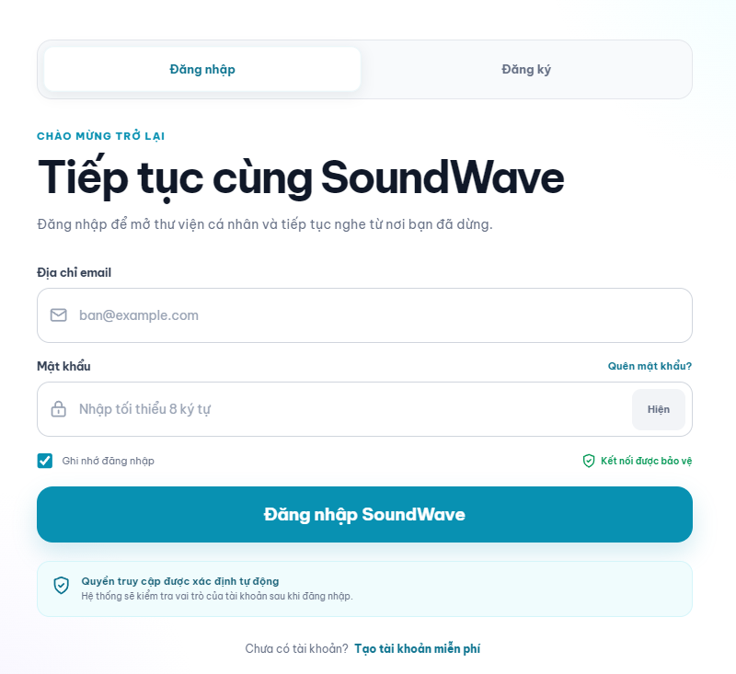
Field Name | Field Type | Description
Email | Textbox | Allows the user to enter their registered email.
Password | Password field | Allows the user to enter their password.
Show Password | Icon button | Shows or hides the entered password.
Remember Me | Checkbox | Keeps the user signed in.
Login | Button | Submits the login information.
Forgot Password | Link | Opens the password recovery screen.
Register | Link | Opens the account registration screen.
Error Message | Message | Displays a custom validation or login error.

Database Access

Table | CRUD | Description
app_users | R, U | Reads account information and updates the last login time.
roles | R | Reads the role assigned to the account.
refresh_tokens | C | Stores the refresh token after successful login.

SQL Commands
- Find account

SELECT
u.id,
u.email,
u.password_hash,
u.status,
u.email_verified_at,
u.deleted_at,
r.code AS role_code
FROM app_users AS u
INNER JOIN roles AS r
ON r.id = u.role_id
WHERE u.email = ?
AND u.deleted_at IS NULL;

- Update login time

UPDATE app_users
SET last_login_at = SYSUTCDATETIME(),
updated_at = SYSUTCDATETIME()
WHERE id = ?;

- Store refresh-token hash

INSERT INTO refresh_tokens (
user_id,
token_hash,
expires_at,
created_at
)
VALUES (?, ?, ?, SYSUTCDATETIME());
#note
The password is verified against password_hash by Spring Security PasswordEncoder. Account status and email verification are checked by the service layer.

b. Register Account
This screen allows guests to create a SoundWave account. A verification email is sent after successful registration.
Related use cases:
- UC-02: Register Account

UI Design
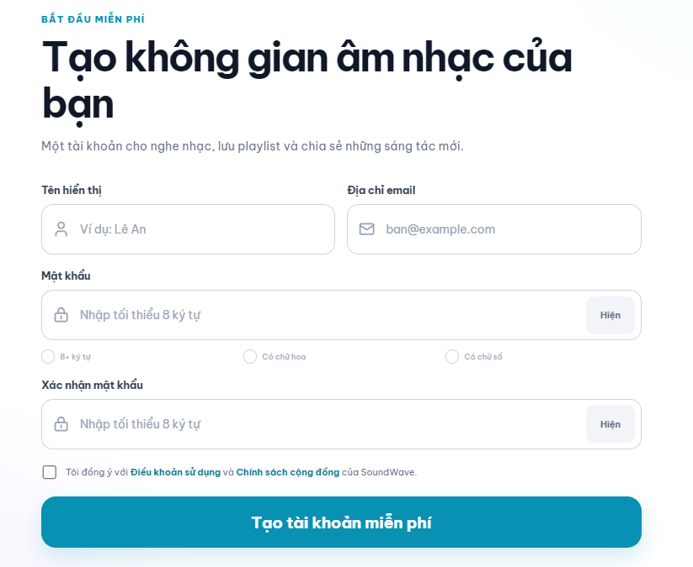

Field Name | Field Type | Description
Display Name | Textbox | Allows the user to enter their display name.
Email | Email field | Allows the user to enter a valid email address.
Password | Password field | Allows the user to create a password.
Confirm Password | Password field | Confirms the entered password.
Show Password | Icon button | Shows or hides the password.
Password Rules | Indicator | Displays the password requirements.
Accept Terms | Checkbox | Confirms acceptance of the terms and policies.
Register | Button | Submits the registration information.
Login | Link | Opens the login screen.
Validation Message | Message | Displays invalid or missing information.

Database Access

Table | CRUD | Description
roles | R | Reads the default Listener role.
app_users | R, C | Checks the email and creates the account.
user_profiles | C | Creates the initial user profile.
email_verification_tokens | C | Stores the email verification token hash.

SQL Command

- Check registered email
SELECT id
FROM app_users
WHERE email = ?
AND deleted_at IS NULL;

- Find default role
SELECT id
FROM roles
WHERE code = ?;

- Create user account
role_id,
email,
password_hash,
status,
created_at,
updated_at
)
OUTPUT INSERTED.id
VALUES (?, ?, ?, ?, SYSUTCDATETIME(), SYSUTCDATETIME());

- Create user profile
INSERT INTO user_profiles (
user_id,
username,
display_name,
created_at,
updated_at
)
VALUES (?, ?, ?, SYSUTCDATETIME(), SYSUTCDATETIME());

- Store verification-token hash
INSERT INTO email_verification_tokens (
user_id,
token_hash,
expires_at,
created_at
)
VALUES (?, ?, ?, SYSUTCDATETIME());

c. Verify Email
This screen displays the result of email verification. A verified account can access authenticated features.
Related use cases:
- UC-03: Verify Email

UI Design
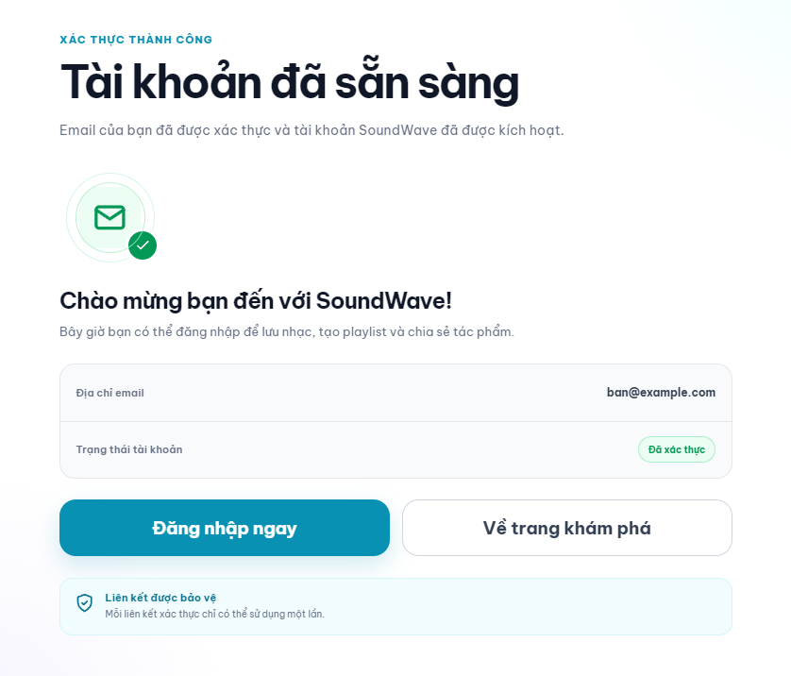

Field Name | Field Type | Description
Verification Status | Message | Displays the verification result.
Login | Button | Opens the login screen after verification.
Resend Email | Link | Sends a new verification email if needed.
Error Message | Message | Displays an expired or invalid link error.

Database Access

Table | CRUD | Description
email_verification_tokens | R, U | Validates the token and marks it as used.
app_users | R, U | Verifies the email and activates the account.

SQL Command
- Validate verification token
SELECT
t.id,
t.user_id
FROM email_verification_tokens AS t
INNER JOIN app_users AS u ON u.id = t.user_id
WHERE t.token_hash = ?
AND t.used_at IS NULL
AND t.expires_at > SYSUTCDATETIME()
AND u.deleted_at IS NULL;

- Verify user email
UPDATE app_users
SET email_verified_at = SYSUTCDATETIME(),
status = ?,
updated_at = SYSUTCDATETIME()
WHERE id = ?;

- Mark token as used
UPDATE email_verification_tokens
SET used_at = SYSUTCDATETIME()
WHERE id = ?;

d. Forgot Password
This screen allows users to request a password-reset link using their registered email.
Related use cases:
- UC-04: Forgot Password

UI Design
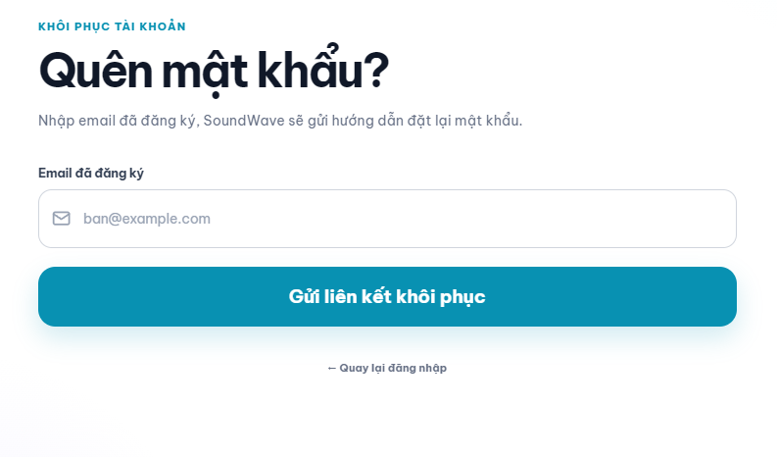

Field Name | Field Type | Description
mail | Email field | Allows the user to enter their registered email.
Send Reset Link | Button | Sends a password-reset email.
Back to Login | Link | Returns to the login screen.
Result Message | Message | Displays the request result.
Validation Message | Message | Displays an invalid or missing email error.

Database Access

Table | CRUD | Description
app_users | R | Finds the account associated with the email.
password_reset_tokens | C, U | Invalidates old tokens and stores a new token hash.

SQL Command

- Find user account
SELECT id, email, status
FROM app_users
WHERE email = ?
AND deleted_at IS NULL;
- Invalidate previous reset tokens
UPDATE password_reset_tokens
SET used_at = SYSUTCDATETIME()
WHERE user_id = ?
AND used_at IS NULL;
- Store password-reset token hash
INSERT INTO password_reset_tokens (
user_id,
token_hash,
expires_at,
created_at
)
VALUES (?, ?, ?, SYSUTCDATETIME());

e. Reset Password
This screen allows users to create a new password using a valid password-reset link.
Related use cases:
- UC-04: Forgot Password

UI Design
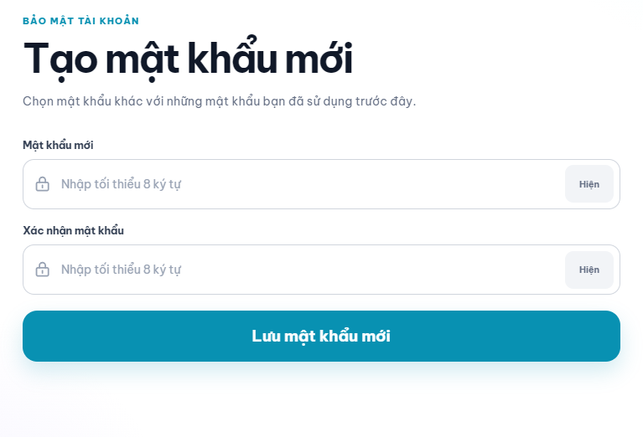

Field Name | Field Type | Description
New Password | Password field | Allows the user to enter a new password.
Confirm Password | Password field | Confirms the new password.
Show Password | Icon button | Shows or hides the entered password.
Save Password | Button | Updates the account password.
Validation Message | Message | Displays password or token errors.
New Password | Password field | Allows the user to enter a new password.

Database Access

Table | CRUD | Description
password_reset_tokens | R, U | Validates and marks the reset token as used.
app_users | U | Updates the account password hash.
refresh_tokens | U | Revokes existing login sessions.

SQL Command
- Validate password-reset token
SELECT id, user_id
FROM password_reset_tokens
WHERE token_hash = ?
AND used_at IS NULL
AND expires_at > SYSUTCDATETIME();
- Update password hash
UPDATE app_users
SET password_hash = ?,
updated_at = SYSUTCDATETIME()
WHERE id = ?
AND deleted_at IS NULL;
- Mark reset token as used
UPDATE password_reset_tokens
SET used_at = SYSUTCDATETIME()
WHERE id = ?;
- Revoke existing sessions
UPDATE refresh_tokens
SET revoked_at = SYSUTCDATETIME()
WHERE user_id = ?
AND revoked_at IS NULL;

f. Logout
This function allows authenticated users to securely end their current session.
Related use cases:
- UC-05: Logout

UI Design
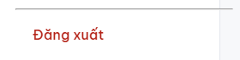

Field Name | Field Type | Description
Logout | Button | Ends the current user session.
Confirm Logout | Dialog button | Confirms the logout action, if required.
Logout | Button | Ends the current user session.

Database Access

Table | CRUD | Description
efresh_tokens | U | Revokes the refresh token of the current session.

SQL Command

- Revoke current refresh token
UPDATE refresh_tokens
SET revoked_at = SYSUTCDATETIME()
WHERE user_id = ?
AND token_hash = ?
AND revoked_at IS NULL;

2. Music Discovery

2.1 Public Catalog

a. Explore Music
This screen presents recommended songs, trending tracks, new releases, genres, albums, and creators for discovery.
Related use cases:
- UC-06: View Recommended Song
- UC-09: Listen to Public Song

UI Design
Field Name | Field Type | Description
Search bar | Search input | Opens catalog search with the entered keyword.
Recommended songs | Track card list | Shows suggested public tracks.
Trending tracks | Track list | Shows popular tracks ordered by play count.
New releases | Track card list | Shows recently published tracks.
Genres | Genre chips | Opens music filtered by the selected genre.
Featured albums | Album card list | Opens the selected album details.
Featured creators | Creator card list | Opens the selected creator profile.
Play | Icon button | Starts playback for the selected track.

Database Access
Table | CRUD | Description
tracks | R | Reads approved public tracks and playback statistics.
albums | R | Reads published album information.
genres | R | Reads active genres.
app_users, user_profiles | R | Reads public creator information.

SQL Commands
1. Load trending tracks
SELECT TOP (12) * FROM tracks WHERE publication_status = 'PUBLISHED' ORDER BY play_count_cache DESC, published_at DESC;
2. Load new releases
SELECT TOP (12) * FROM tracks WHERE publication_status = 'PUBLISHED' ORDER BY published_at DESC;
3. Load active genres
SELECT id, name, slug FROM genres WHERE is_active = 1 ORDER BY name;

b. Search Public Catalog
This screen allows users to search public tracks, albums, and creators by keyword.
Related use cases:
- UC-07: Search Public Catalog

UI Design
Field Name | Field Type | Description
Keyword | Search input | Accepts a song, album, or creator keyword.
All | Tab | Shows combined search results.
Tracks | Tab | Shows matching public tracks.
Albums | Tab | Shows matching published albums.
Creators | Tab | Shows matching public creator profiles.
Result list | Card list | Displays results for the selected category.
No-result message | Message | Appears when no matching content is found.

Database Access
Table | CRUD | Description
tracks | R | Searches published tracks.
albums | R | Searches published albums.
app_users, user_profiles | R | Searches creator profiles.

SQL Commands
1. Search tracks
SELECT TOP (@limit) id, title, slug, cover_url FROM tracks WHERE publication_status = 'PUBLISHED' AND title LIKE '%' + @keyword + '%' ORDER BY play_count_cache DESC;
2. Search albums
SELECT TOP (@limit) id, title, slug, cover_url FROM albums WHERE status = 'PUBLISHED' AND title LIKE '%' + @keyword + '%' ORDER BY published_at DESC;
3. Search creators
SELECT TOP (@limit) u.id, p.username, p.display_name, p.avatar_url FROM app_users u JOIN user_profiles p ON p.user_id = u.id WHERE u.deleted_at IS NULL AND (p.username LIKE '%' + @keyword + '%' OR p.display_name LIKE '%' + @keyword + '%');

c. Filter Public Catalog
This screen narrows the public catalog by genre and sorting option.
Related use cases:
- UC-08: Filter Public Catalog

UI Design
Field Name | Field Type | Description
Genre | Dropdown | Filters tracks by an active genre.
Sort by | Dropdown | Sorts by newest, most played, or title.
Clear filters | Button | Restores the default catalog view.
Filtered results | Track card list | Displays tracks matching the selected conditions.
Result count | Text | Shows the number of matching tracks.

Database Access
Table | CRUD | Description
genres | R | Loads available filter values.
tracks | R | Reads approved tracks matching the filter.
albums | R | Reads album data displayed on track cards.

SQL Commands
1. Load genre options
SELECT id, name FROM genres WHERE is_active = 1 ORDER BY name;
2. Filter tracks
SELECT t.id, t.title, t.cover_url, t.duration_ms, a.title AS album_title FROM tracks t LEFT JOIN albums a ON a.id = t.album_id WHERE t.publication_status = 'PUBLISHED' AND (@genreId IS NULL OR t.genre_id = @genreId) ORDER BY t.published_at DESC OFFSET @offset ROWS FETCH NEXT @limit ROWS ONLY;

d. Track Details
This screen displays the selected track, creator, album, lyrics, and related music.
Related use cases:
- UC-09: Listen to Public Song
- UC-16: View Lyric
- UC-17: Switch Lyrics Language

UI Design
Field Name | Field Type | Description
Track cover | Image | Displays the track artwork.
Title | Text | Displays the track title.
Creator | Link | Opens the creator profile.
Album | Link | Opens album details when available.
Genre | Link | Opens the corresponding genre catalog.
Play | Primary button | Starts playback.
Favorite | Icon button | Adds or removes the track from favorites.
Report | Action button | Opens the content report form.
Lyrics language | Dropdown | Changes the displayed lyric language.
Related tracks | Track list | Shows other public tracks in the same genre.

Database Access
Table | CRUD | Description
tracks | R | Reads track metadata and audio URL.
albums, genres | R | Reads related album and genre information.
app_users, user_profiles | R | Reads creator information.
official_lyrics, personal_lyrics | R | Reads available lyric versions.
favorites | R | Reads the current user's favorite state.

SQL Commands
1. Load track details
SELECT t.*, a.title AS album_title, g.name AS genre_name, p.display_name AS creator_name FROM tracks t LEFT JOIN albums a ON a.id = t.album_id JOIN genres g ON g.id = t.genre_id JOIN user_profiles p ON p.user_id = t.uploader_user_id WHERE t.id = @trackId AND t.publication_status = 'PUBLISHED';
2. Load lyrics
SELECT language_code, lyric_content FROM official_lyrics WHERE track_id = @trackId AND status = 'PUBLISHED' ORDER BY language_code;
3. Load related tracks
SELECT TOP (8) id, title, cover_url FROM tracks WHERE genre_id = @genreId AND id <> @trackId AND publication_status = 'PUBLISHED' ORDER BY play_count_cache DESC;

3. Music Playback

3.1 Audio Playback

a. Music Player
This fixed player controls the current track and remains visible throughout the main music application.
Related use cases:
- UC-10: Stream Music
- UC-11: Control Playback

UI Design
Field Name | Field Type | Description
Current track | Track summary | Shows cover, title, and creator.
Previous | Icon button | Plays the previous queue item.
Play or pause | Icon button | Starts or pauses playback.
Next | Icon button | Plays the next queue item.
Progress | Slider | Shows and changes playback position.
Time | Text | Shows elapsed and total duration.
Volume | Slider | Changes playback volume.
Repeat and shuffle | Icon buttons | Changes queue playback behavior.
Favorite | Icon button | Updates the favorite state.
Queue | Icon button | Opens or closes the queue drawer.

Database Access
Table | CRUD | Description
tracks | R, U | Reads playable media and increments the cached play count.
favorites | R, C, D | Reads and updates the favorite state.

SQL Commands
1. Load playable track
SELECT id, title, audio_url, audio_format, duration_ms, cover_url FROM tracks WHERE id = @trackId AND publication_status = 'PUBLISHED';
2. Record a valid play
UPDATE tracks SET play_count_cache = play_count_cache + 1, updated_at = SYSUTCDATETIME() WHERE id = @trackId;

b. Playback Queue
This drawer displays the current track and the tracks that will play next.
Related use cases:
- UC-10: Stream Music
- UC-11: Control Playback

UI Design
Field Name | Field Type | Description
Now playing | Track row | Displays the current track.
Next tracks | Sortable list | Displays upcoming queue items.
Move item | Drag control | Changes a track's queue position.
Remove item | Icon button | Removes a track from the queue.
Clear queue | Button | Removes all upcoming items.
Close | Icon button | Closes the queue drawer.

Database Access
Table | CRUD | Description
tracks | R | Loads metadata for queue items.
Client playback state | R, U | Keeps queue order in the current client session.

SQL Commands
1. Load queue item metadata
SELECT id, title, audio_url, duration_ms, cover_url FROM tracks WHERE id IN (@trackIds) AND publication_status = 'PUBLISHED';

4. Listener Profile and Library

4.1 Personal Profile

a. Manage Personal Profile
This screen allows a listener to view and update personal profile information.
Related use cases:
- UC-12: Manage Personal Profile

UI Design
Field Name | Field Type | Description
Avatar | Image upload | Uploads or changes the profile image.
Username | Text input | Stores the unique public username.
Display name | Text input | Stores the public display name.
Biography | Textarea | Stores a short profile introduction.
Date of birth | Date input | Stores the listener's date of birth.
Country | Dropdown | Stores a two-letter country code.
Save changes | Primary button | Validates and saves profile changes.

Database Access
Table | CRUD | Description
user_profiles | R, U | Reads and updates profile information.
app_users | R | Reads account email and status.

SQL Commands
1. Load profile
SELECT u.email, u.status, p.* FROM app_users u JOIN user_profiles p ON p.user_id = u.id WHERE u.id = @userId AND u.deleted_at IS NULL;
2. Update profile
UPDATE user_profiles SET username = @username, display_name = @displayName, bio = @bio, avatar_public_id = @avatarPublicId, avatar_url = @avatarUrl, date_of_birth = @dateOfBirth, country_code = @countryCode, updated_at = SYSUTCDATETIME() WHERE user_id = @userId;

b. Listening History
This screen displays tracks previously played by the listener. The required listening history table must be added to the current database schema.
Related use cases:
- UC-13: View Listening History

UI Design
Field Name | Field Type | Description
History date | Section label | Groups listening activity by date.
Track | Track row | Displays the played track and creator.
Played at | Date and time | Shows when the track was played.
Play again | Icon button | Starts the selected track.
Remove item | Icon button | Removes one history record.
Clear history | Button | Removes all history records for the user.

Database Access
Table | CRUD | Description
listening_history (planned) | R, C, D | Stores user, track, and playback time. This table is not yet present in the supplied ERD.
tracks | R | Reads track metadata for history rows.

SQL Commands
1. Load listening history
SELECT h.id, h.played_at, t.id AS track_id, t.title, t.cover_url FROM listening_history h JOIN tracks t ON t.id = h.track_id WHERE h.user_id = @userId ORDER BY h.played_at DESC OFFSET @offset ROWS FETCH NEXT @limit ROWS ONLY;
2. Clear listening history
DELETE FROM listening_history WHERE user_id = @userId;

4.2 Favorite Management

a. My Favorite Tracks
This screen allows a listener to view, play, and remove favorite tracks.
Related use cases:
- UC-14: Manage My Favorite Tracks

UI Design
Field Name | Field Type | Description
Favorite tracks | Track list | Displays tracks favorited by the current user.
Play | Icon button | Starts the selected track.
Remove favorite | Icon button | Removes the selected track from favorites.
Sort by | Dropdown | Sorts by recently added, title, or creator.
Empty state | Message | Appears when the user has no favorites.

Database Access
Table | CRUD | Description
favorites | R, C, D | Reads, creates, and removes favorite relationships.
tracks | R | Reads track information.
user_profiles | R | Reads creator names.

SQL Commands
1. Load favorites
SELECT f.created_at, t.id, t.title, t.cover_url, p.display_name FROM favorites f JOIN tracks t ON t.id = f.track_id JOIN user_profiles p ON p.user_id = t.uploader_user_id WHERE f.user_id = @userId ORDER BY f.created_at DESC;
2. Add favorite
INSERT INTO favorites (user_id, track_id, created_at) VALUES (@userId, @trackId, SYSUTCDATETIME());
3. Remove favorite
DELETE FROM favorites WHERE user_id = @userId AND track_id = @trackId;

4.3 Playlist Management

a. My Playlists
This screen displays playlists owned by the current listener.
Related use cases:
- UC-15: Manage My Playlist

UI Design
Field Name | Field Type | Description
Create playlist | Primary button | Opens the playlist form.
Playlist cards | Card grid | Displays owned playlists and track counts.
Visibility | Badge | Shows whether a playlist is public or private.
Edit | Action button | Opens the selected playlist for editing.
Delete | Action button | Deletes the selected playlist after confirmation.
Empty state | Message | Appears when no playlist exists.

Database Access
Table | CRUD | Description
playlists | R, D | Reads and deletes playlists owned by the user.
playlist_tracks | R, D | Reads track counts and removes deleted playlist items.

SQL Commands
1. Load owned playlists
SELECT p.*, COUNT(pt.track_id) AS track_count FROM playlists p LEFT JOIN playlist_tracks pt ON pt.playlist_id = p.id WHERE p.owner_user_id = @userId GROUP BY p.id, p.owner_user_id, p.name, p.description, p.visibility, p.cover_url, p.created_at ORDER BY p.created_at DESC;
2. Delete playlist
DELETE FROM playlists WHERE id = @playlistId AND owner_user_id = @userId;

b. Playlist Details
This screen displays playlist information and its ordered track list.
Related use cases:
- UC-15: Manage My Playlist

UI Design
Field Name | Field Type | Description
Playlist cover | Image | Displays playlist artwork.
Name | Text | Displays the playlist name.
Description | Text | Displays the playlist description.
Owner | Link | Opens the owner's profile.
Play all | Primary button | Adds all public tracks to the queue.
Track list | Sortable table | Displays playlist tracks in order.
Add track | Button | Opens track selection for the owner.
Remove track | Icon button | Removes a selected track for the owner.

Database Access
Table | CRUD | Description
playlists | R | Reads playlist information and visibility.
playlist_tracks | R, C, U, D | Reads and manages ordered playlist items.
tracks | R | Reads public track information.

SQL Commands
1. Load playlist
SELECT p.*, up.display_name AS owner_name FROM playlists p JOIN user_profiles up ON up.user_id = p.owner_user_id WHERE p.id = @playlistId AND (p.visibility = 'PUBLIC' OR p.owner_user_id = @userId);
2. Load playlist tracks
SELECT pt.position, t.id, t.title, t.duration_ms, t.cover_url FROM playlist_tracks pt JOIN tracks t ON t.id = pt.track_id WHERE pt.playlist_id = @playlistId ORDER BY pt.position;
3. Remove playlist track
DELETE FROM playlist_tracks WHERE playlist_id = @playlistId AND track_id = @trackId;

c. Create or Edit Playlist
This screen allows the owner to create a playlist or update its information.
Related use cases:
- UC-15: Manage My Playlist

UI Design
Field Name | Field Type | Description
Name | Text input | Required playlist name.
Description | Textarea | Optional playlist description.
Visibility | Radio group | Selects public or private visibility.
Cover | Image upload | Optional playlist artwork.
Save | Primary button | Creates or updates the playlist.
Cancel | Secondary button | Returns without saving.

Database Access
Table | CRUD | Description
playlists | C, U | Creates or updates a playlist owned by the current user.

SQL Commands
1. Create playlist
INSERT INTO playlists (owner_user_id, name, description, visibility, cover_url, created_at) VALUES (@userId, @name, @description, @visibility, @coverUrl, SYSUTCDATETIME());
2. Update playlist
UPDATE playlists SET name = @name, description = @description, visibility = @visibility, cover_url = @coverUrl WHERE id = @playlistId AND owner_user_id = @userId;

4.4 Lyrics

a. Lyrics Viewer
This screen displays official or personal lyrics and allows switching between available languages.
Related use cases:
- UC-16: View Lyric
- UC-17: Switch Lyrics Language

UI Design
Field Name | Field Type | Description
Lyrics source | Tab | Switches between official and personal lyrics when available.
Language | Dropdown | Selects an available lyric language.
Lyric content | Scrollable text | Displays the selected lyrics.
Create personal lyrics | Button | Opens the custom lyric editor.
No-lyrics state | Message | Appears when the selected language has no lyrics.

Database Access
Table | CRUD | Description
official_lyrics | R | Reads published official lyrics.
personal_lyrics | R | Reads the current user's personal lyrics.

SQL Commands
1. Load official lyrics
SELECT language_code, lyric_content FROM official_lyrics WHERE track_id = @trackId AND status = 'PUBLISHED' ORDER BY language_code;
2. Load personal lyrics
SELECT language_code, lyric_content FROM personal_lyrics WHERE user_id = @userId AND track_id = @trackId ORDER BY language_code;

b. Custom Lyric Editor
This screen allows a listener to create, update, or delete personal lyrics for a track.
Related use cases:
- UC-18: Create Custom Lyric

UI Design
Field Name | Field Type | Description
Track | Read-only track summary | Identifies the track being edited.
Language | Dropdown | Selects the lyric language code.
Lyric content | Textarea | Accepts the listener's personal lyrics.
Save | Primary button | Creates or updates the personal lyrics.
Delete | Danger button | Deletes the selected personal lyric version.
Cancel | Secondary button | Returns without saving.

Database Access
Table | CRUD | Description
personal_lyrics | R, C, U, D | Manages lyrics owned by the current user.
tracks | R | Checks that the target track exists and is accessible.

SQL Commands
1. Create personal lyrics
INSERT INTO personal_lyrics (user_id, track_id, language_code, lyric_content, created_at, updated_at) VALUES (@userId, @trackId, @languageCode, @lyricContent, SYSUTCDATETIME(), SYSUTCDATETIME());
2. Update personal lyrics
UPDATE personal_lyrics SET lyric_content = @lyricContent, updated_at = SYSUTCDATETIME() WHERE user_id = @userId AND track_id = @trackId AND language_code = @languageCode;
3. Delete personal lyrics
DELETE FROM personal_lyrics WHERE user_id = @userId AND track_id = @trackId AND language_code = @languageCode;

5. User Content Management

5.1 Track Management

a. Content Studio
This screen summarizes tracks and albums created by the current listener.
Related use cases:
- UC-19: Manage My Tracks
- UC-21: Manage My Album

UI Design
Field Name | Field Type | Description
Create track | Primary button | Opens the track form.
Create album | Secondary button | Opens the album form.
Status summary | Statistic cards | Shows draft, pending, published, and rejected counts.
My tracks | Table | Lists owned tracks and review status.
My albums | Card list | Lists albums created by the user.
Edit | Action button | Opens the selected item for editing.
Delete | Action button | Deletes an eligible item after confirmation.

Database Access
Table | CRUD | Description
tracks | R, D | Reads and deletes eligible owned tracks.
albums | R, D | Reads and deletes eligible owned albums.
track_submissions | R | Reads the latest review status.

SQL Commands
1. Load owned tracks
SELECT t.*, s.status AS submission_status FROM tracks t OUTER APPLY (SELECT TOP (1) status FROM track_submissions WHERE track_id = t.id ORDER BY submitted_at DESC) s WHERE t.uploader_user_id = @userId ORDER BY t.updated_at DESC;
2. Load owned albums
SELECT a.*, COUNT(t.id) AS track_count FROM albums a LEFT JOIN tracks t ON t.album_id = a.id WHERE a.created_by_user_id = @userId GROUP BY a.id, a.created_by_user_id, a.title, a.slug, a.description, a.status, a.cover_url, a.release_date, a.published_at, a.created_at ORDER BY a.created_at DESC;

b. Upload or Edit Track
This screen allows a listener to create or update track metadata, upload media, and submit the track for review.
Related use cases:
- UC-19: Manage My Tracks
- UC-36: Process Cloud Media

UI Design
Field Name | Field Type | Description
Title | Text input | Required track title.
Album | Dropdown | Optional album owned by the user.
Genre | Dropdown | Required active genre.
Track number | Number input | Optional position within the album.
Description | Textarea | Optional track description.
Audio file | File upload | Uploads the required audio file.
Cover image | Image upload | Uploads optional track artwork.
Save draft | Button | Saves the track without review submission.
Submit for review | Primary button | Creates a pending review submission.

Database Access
Table | CRUD | Description
tracks | C, U | Creates or updates track metadata and cloud media references.
albums | R | Loads albums owned by the user.
genres | R | Loads active genres.
track_submissions | C | Creates a review request.

SQL Commands
1. Create track draft
INSERT INTO tracks (uploader_user_id, album_id, genre_id, title, slug, description, track_number, publication_status, audio_public_id, audio_url, audio_format, duration_ms, cover_public_id, cover_url, play_count_cache, created_at, updated_at) VALUES (@userId, @albumId, @genreId, @title, @slug, @description, @trackNumber, 'DRAFT', @audioPublicId, @audioUrl, @audioFormat, @durationMs, @coverPublicId, @coverUrl, 0, SYSUTCDATETIME(), SYSUTCDATETIME());
2. Submit track for review
INSERT INTO track_submissions (track_id, submitted_by_user_id, status, submitter_note, submitted_at) VALUES (@trackId, @userId, 'PENDING', @note, SYSUTCDATETIME());

c. Track Rejection Details
This screen displays the staff decision and rejection reason for a submitted track.
Related use cases:
- UC-20: View Rejection Reason

UI Design
Field Name | Field Type | Description
Track | Track summary | Identifies the rejected track.
Submission status | Status badge | Shows the latest review state.
Rejection reason | Read-only text | Displays the reason entered by staff.
Reviewer note | Read-only text | Displays additional review feedback.
Reviewed at | Date and time | Shows when the decision was recorded.
Edit track | Primary button | Opens the track form for correction.

Database Access
Table | CRUD | Description
track_submissions | R | Reads the latest rejected submission and review details.
tracks | R | Reads track information.

SQL Commands
1. Load latest rejection
SELECT TOP (1) s.status, s.rejection_reason, s.reviewer_note, s.reviewed_at, t.id, t.title FROM track_submissions s JOIN tracks t ON t.id = s.track_id WHERE s.track_id = @trackId AND s.submitted_by_user_id = @userId AND s.status = 'REJECTED' ORDER BY s.reviewed_at DESC;

5.2 Album Management

a. My Albums
This screen allows a listener to view and manage albums they created.
Related use cases:
- UC-21: Manage My Album

UI Design
Field Name | Field Type | Description
Create album | Primary button | Opens the album form.
Album cards | Card grid | Displays owned albums and status.
Track count | Text | Shows the number of tracks in each album.
Edit | Action button | Opens the selected album for editing.
Delete | Action button | Deletes an eligible album after confirmation.

Database Access
Table | CRUD | Description
albums | R, D | Reads and deletes albums owned by the user.
tracks | R, U | Counts album tracks and clears album references when required.

SQL Commands
1. Load owned albums
SELECT a.*, COUNT(t.id) AS track_count FROM albums a LEFT JOIN tracks t ON t.album_id = a.id WHERE a.created_by_user_id = @userId GROUP BY a.id, a.created_by_user_id, a.title, a.slug, a.description, a.status, a.cover_url, a.release_date, a.published_at, a.created_at ORDER BY a.created_at DESC;
2. Delete album
DELETE FROM albums WHERE id = @albumId AND created_by_user_id = @userId AND status <> 'PUBLISHED';

b. Create or Edit Album
This screen allows the owner to create or update album information and select album tracks.
Related use cases:
- UC-21: Manage My Album

UI Design
Field Name | Field Type | Description
Title | Text input | Required album title.
Description | Textarea | Optional album description.
Cover image | Image upload | Uploads optional album artwork.
Release date | Date input | Stores the intended release date.
Tracks | Selectable list | Selects owned tracks for the album.
Track order | Drag control | Changes track numbers within the album.
Save | Primary button | Creates or updates the album.

Database Access
Table | CRUD | Description
albums | C, U | Creates or updates the album.
tracks | R, U | Loads eligible tracks and updates album membership.

SQL Commands
1. Create album
INSERT INTO albums (created_by_user_id, title, slug, description, status, cover_public_id, cover_url, release_date, created_at) VALUES (@userId, @title, @slug, @description, 'DRAFT', @coverPublicId, @coverUrl, @releaseDate, SYSUTCDATETIME());
2. Update album track
UPDATE tracks SET album_id = @albumId, track_number = @trackNumber, updated_at = SYSUTCDATETIME() WHERE id = @trackId AND uploader_user_id = @userId;

5.3 Content Report

a. Manage Content Reports
This screen displays reports submitted by the current listener and their processing status.
Related use cases:
- UC-22: Manage Content Report

UI Design
Field Name | Field Type | Description
Report list | Table | Displays submitted reports.
Track | Link | Opens the reported track.
Category | Text | Shows the selected report category.
Status | Status badge | Shows pending, resolved, or rejected status.
Resolution note | Text | Shows staff feedback when available.
Delete | Action button | Deletes a pending report owned by the user.

Database Access
Table | CRUD | Description
content_reports | R, D | Reads and deletes eligible reports submitted by the user.
tracks | R | Reads reported track information.

SQL Commands
1. Load submitted reports
SELECT r.*, t.title AS track_title FROM content_reports r JOIN tracks t ON t.id = r.track_id WHERE r.submitted_by_user_id = @userId ORDER BY r.created_at DESC;
2. Delete pending report
DELETE FROM content_reports WHERE id = @reportId AND submitted_by_user_id = @userId AND status = 'PENDING';

b. Create Content Report
This dialog allows a listener to report a public track that may violate content rules.
Related use cases:
- UC-22: Manage Content Report

UI Design
Field Name | Field Type | Description
Track | Read-only track summary | Identifies the reported track.
Category | Dropdown | Selects the report category.
Description | Textarea | Explains the suspected violation.
Submit report | Primary button | Validates and creates the report.
Cancel | Secondary button | Closes the dialog without saving.

Database Access
Table | CRUD | Description
content_reports | C | Creates a pending report.
tracks | R | Validates the target public track.

SQL Commands
1. Create report
INSERT INTO content_reports (track_id, submitted_by_user_id, category, description, status, created_at, updated_at) VALUES (@trackId, @userId, @category, @description, 'PENDING', SYSUTCDATETIME(), SYSUTCDATETIME());

6. Staff Moderation

6.1 Track Moderation

a. Pending Track List
This screen allows staff to find and open tracks waiting for quality review.
Related use cases:
- UC-23: Review Pending Track

UI Design
Field Name | Field Type | Description
Search | Search input | Finds submissions by track or submitter.
Status | Dropdown | Filters pending or reviewed submissions.
Submission table | Table | Displays track, submitter, date, and status.
Open review | Action button | Opens the selected submission.
Pagination | Pagination | Moves between result pages.

Database Access
Table | CRUD | Description
track_submissions | R | Reads submissions awaiting review.
tracks | R | Reads submitted track metadata.
user_profiles | R | Reads submitter information.

SQL Commands
1. Load pending submissions
SELECT s.id, s.submitted_at, s.status, t.id AS track_id, t.title, p.display_name AS submitter FROM track_submissions s JOIN tracks t ON t.id = s.track_id JOIN user_profiles p ON p.user_id = s.submitted_by_user_id WHERE s.status = 'PENDING' ORDER BY s.submitted_at ASC OFFSET @offset ROWS FETCH NEXT @limit ROWS ONLY;

b. Track Review
This screen allows staff to inspect track metadata, audio quality, and submitter notes.
Related use cases:
- UC-23: Review Pending Track

UI Design
Field Name | Field Type | Description
Track information | Details panel | Displays metadata and ownership.
Audio preview | Audio player | Streams the submitted audio for assessment.
Cover preview | Image | Displays the submitted artwork.
Submitter note | Read-only text | Displays the note from the uploader.
Quality checklist | Checklist | Records the staff assessment.
Approve | Primary button | Opens the approval confirmation.
Reject | Danger button | Opens the rejection form.

Database Access
Table | CRUD | Description
track_submissions | R | Reads the selected pending submission.
tracks, albums, genres | R | Reads submitted track context.
user_profiles | R | Reads submitter information.

SQL Commands
1. Load review details
SELECT s.*, t.*, a.title AS album_title, g.name AS genre_name, p.display_name AS submitter FROM track_submissions s JOIN tracks t ON t.id = s.track_id LEFT JOIN albums a ON a.id = t.album_id JOIN genres g ON g.id = t.genre_id JOIN user_profiles p ON p.user_id = s.submitted_by_user_id WHERE s.id = @submissionId;

c. Approve or Reject Track
This dialog records the staff decision. A rejection requires a clear reason.
Related use cases:
- UC-24: Approve Track
- UC-25: Reject Track
- UC-26: Enter Rejection Reason

UI Design
Field Name | Field Type | Description
Decision | Radio group | Selects approve or reject.
Reviewer note | Textarea | Stores optional internal feedback.
Rejection reason | Textarea | Required when the decision is reject.
Confirm | Primary button | Records the decision and updates the track.
Cancel | Secondary button | Returns to review without saving.

Database Access
Table | CRUD | Description
track_submissions | U | Stores reviewer, decision, notes, and review time.
tracks | U | Publishes an approved track or marks a rejected track.
notifications | C | Notifies the uploader about the decision.

SQL Commands
1. Approve submission
UPDATE track_submissions SET reviewer_user_id = @staffId, status = 'APPROVED', reviewer_note = @reviewerNote, reviewed_at = SYSUTCDATETIME() WHERE id = @submissionId AND status = 'PENDING'; UPDATE tracks SET publication_status = 'PUBLISHED', approved_at = SYSUTCDATETIME(), published_at = SYSUTCDATETIME(), updated_at = SYSUTCDATETIME() WHERE id = @trackId;
2. Reject submission
UPDATE track_submissions SET reviewer_user_id = @staffId, status = 'REJECTED', reviewer_note = @reviewerNote, rejection_reason = @rejectionReason, reviewed_at = SYSUTCDATETIME() WHERE id = @submissionId AND status = 'PENDING'; UPDATE tracks SET publication_status = 'REJECTED', latest_rejection_reason = @rejectionReason, updated_at = SYSUTCDATETIME() WHERE id = @trackId;

6.2 Report Moderation

a. Content Report List
This screen allows staff to find and open content reports requiring assessment.
Related use cases:
- UC-27: Review Content Report

UI Design
Field Name | Field Type | Description
Search | Search input | Finds reports by track or reporter.
Category | Dropdown | Filters by report category.
Status | Dropdown | Filters pending or completed reports.
Report table | Table | Displays report summary and submission time.
Open review | Action button | Opens the selected report.

Database Access
Table | CRUD | Description
content_reports | R | Reads reports requiring review.
tracks | R | Reads reported track information.
user_profiles | R | Reads reporter information.

SQL Commands
1. Load pending reports
SELECT r.id, r.category, r.description, r.created_at, t.id AS track_id, t.title, p.display_name AS reporter FROM content_reports r JOIN tracks t ON t.id = r.track_id JOIN user_profiles p ON p.user_id = r.submitted_by_user_id WHERE r.status = 'PENDING' ORDER BY r.created_at ASC;

b. Content Report Review
This screen allows staff to assess a report, remove violating content, or reject an invalid report.
Related use cases:
- UC-27: Review Content Report
- UC-28: Approve Report
- UC-29: Remove Violated Track
- UC-30: Reject Report

UI Design
Field Name | Field Type | Description
Report details | Details panel | Displays category, description, and reporter.
Reported track | Track preview | Displays and plays the reported content.
Resolution note | Textarea | Records the assessment result.
Approve report | Danger button | Resolves the report and removes the violating track.
Reject report | Secondary button | Marks the report as invalid.

Database Access
Table | CRUD | Description
content_reports | R, U | Reads and resolves the selected report.
tracks | R, U | Reads and removes a violating track from public access.
notifications | C | Notifies the reporter and content owner.

SQL Commands
1. Approve report
UPDATE content_reports SET handled_by_user_id = @staffId, status = 'RESOLVED', resolution_note = @resolutionNote, handled_at = SYSUTCDATETIME(), updated_at = SYSUTCDATETIME() WHERE id = @reportId AND status = 'PENDING'; UPDATE tracks SET publication_status = 'REMOVED', updated_at = SYSUTCDATETIME() WHERE id = @trackId;
2. Reject report
UPDATE content_reports SET handled_by_user_id = @staffId, status = 'REJECTED', resolution_note = @resolutionNote, handled_at = SYSUTCDATETIME(), updated_at = SYSUTCDATETIME() WHERE id = @reportId AND status = 'PENDING';

6.3 Official Lyrics

a. Manage Official Track Lyrics
This screen allows staff to create, update, publish, and remove official lyric versions.
Related use cases:
- UC-31: Manage Official Track Lyrics

UI Design
Field Name | Field Type | Description
Track search | Search input | Selects a published track.
Language | Dropdown | Selects the lyric language code.
Lyric content | Textarea | Edits official lyrics.
Status | Dropdown | Sets draft or published status.
Save | Primary button | Creates or updates the lyric version.
Delete | Danger button | Deletes the selected lyric version.

Database Access
Table | CRUD | Description
official_lyrics | R, C, U, D | Manages official lyric versions.
tracks | R | Loads eligible published tracks.

SQL Commands
1. Create official lyrics
INSERT INTO official_lyrics (track_id, language_code, lyric_content, status, created_by_user_id, created_at, updated_at) VALUES (@trackId, @languageCode, @lyricContent, @status, @staffId, SYSUTCDATETIME(), SYSUTCDATETIME());
2. Update official lyrics
UPDATE official_lyrics SET lyric_content = @lyricContent, status = @status, updated_at = SYSUTCDATETIME() WHERE id = @lyricId;
3. Delete official lyrics
DELETE FROM official_lyrics WHERE id = @lyricId;

7. System Administration

7.1 User Administration

a. Manage User Accounts
This screen allows administrators to search, filter, ban, and unban user accounts.
Related use cases:
- UC-32: Manage User Accounts

UI Design
Field Name | Field Type | Description
Search | Search input | Finds accounts by email, username, or display name.
Role | Dropdown | Filters accounts by role.
Status | Dropdown | Filters active, pending, or banned accounts.
User table | Table | Displays account and role information.
Ban | Action button | Changes an eligible account to banned.
Unban | Action button | Restores an eligible banned account.
View details | Action button | Opens the selected account.

Database Access
Table | CRUD | Description
app_users | R, U | Reads accounts and updates account status.
roles | R | Reads role information.
user_profiles | R | Reads public profile information.

SQL Commands
1. Load user accounts
SELECT u.id, u.email, u.status, u.email_verified_at, u.last_login_at, r.code AS role_code, p.username, p.display_name FROM app_users u JOIN roles r ON r.id = u.role_id LEFT JOIN user_profiles p ON p.user_id = u.id WHERE u.deleted_at IS NULL ORDER BY u.created_at DESC;
2. Change account status
UPDATE app_users SET status = @status, updated_at = SYSUTCDATETIME() WHERE id = @userId AND deleted_at IS NULL;

b. User Details
This screen displays account, profile, role, and recent content information for administrative review.
Related use cases:
- UC-32: Manage User Accounts

UI Design
Field Name | Field Type | Description
Account information | Details panel | Displays email, status, and verification state.
Profile information | Details panel | Displays username, display name, and country.
Current role | Badge | Displays the assigned role.
Content summary | Statistic cards | Shows track, album, and report counts.
Ban or unban | Action button | Updates the account status.
Assign role | Action button | Opens the role assignment dialog.

Database Access
Table | CRUD | Description
app_users | R, U | Reads account information and changes status.
roles | R | Reads the current role.
user_profiles | R | Reads profile information.
tracks, albums, content_reports | R | Reads administrative summary counts.

SQL Commands
1. Load user details
SELECT u.*, r.code AS role_code, r.name AS role_name, p.* FROM app_users u JOIN roles r ON r.id = u.role_id LEFT JOIN user_profiles p ON p.user_id = u.id WHERE u.id = @userId;
2. Load content summary
SELECT (SELECT COUNT(*) FROM tracks WHERE uploader_user_id = @userId) AS track_count, (SELECT COUNT(*) FROM albums WHERE created_by_user_id = @userId) AS album_count, (SELECT COUNT(*) FROM content_reports WHERE submitted_by_user_id = @userId) AS report_count;

c. Assign User Role
This dialog allows an administrator to assign an authorized role to an account.
Related use cases:
- UC-33: Assign User Roles

UI Design
Field Name | Field Type | Description
User | Read-only user summary | Identifies the account being changed.
Current role | Text | Displays the current role.
New role | Dropdown | Selects an available role.
Confirm | Primary button | Updates the user's role.
Cancel | Secondary button | Closes the dialog without saving.

Database Access
Table | CRUD | Description
roles | R | Loads available roles.
app_users | U | Updates the assigned role.

SQL Commands
1. Load roles
SELECT id, code, name, description FROM roles ORDER BY id;
2. Assign role
UPDATE app_users SET role_id = @roleId, updated_at = SYSUTCDATETIME() WHERE id = @userId AND deleted_at IS NULL;

7.2 Genre Administration

a. Manage Genres
This screen allows administrators to search, activate, deactivate, edit, and create music genres.
Related use cases:
- UC-34: Manage Genres

UI Design
Field Name | Field Type | Description
Search | Search input | Finds genres by name or slug.
Status | Dropdown | Filters active or inactive genres.
Create genre | Primary button | Opens the genre form.
Genre table | Table | Displays genre information and track count.
Edit | Action button | Opens the selected genre.
Activate or deactivate | Action button | Changes genre availability.

Database Access
Table | CRUD | Description
genres | R, U | Reads genres and updates active status.
tracks | R | Counts tracks assigned to each genre.

SQL Commands
1. Load genres
SELECT g.*, COUNT(t.id) AS track_count FROM genres g LEFT JOIN tracks t ON t.genre_id = g.id GROUP BY g.id, g.name, g.slug, g.description, g.is_active, g.created_by_user_id, g.created_at ORDER BY g.name;
2. Change genre status
UPDATE genres SET is_active = @isActive WHERE id = @genreId;

b. Create or Edit Genre
This screen allows an administrator to create a genre or update its information.
Related use cases:
- UC-34: Manage Genres

UI Design
Field Name | Field Type | Description
Name | Text input | Required unique genre name.
Slug | Text input | Required unique URL-friendly value.
Description | Textarea | Optional genre description.
Active | Switch | Controls whether the genre is available for selection.
Save | Primary button | Creates or updates the genre.
Cancel | Secondary button | Returns without saving.

Database Access
Table | CRUD | Description
genres | C, U | Creates or updates a genre.

SQL Commands
1. Create genre
INSERT INTO genres (name, slug, description, is_active, created_by_user_id, created_at) VALUES (@name, @slug, @description, @isActive, @adminId, SYSUTCDATETIME());
2. Update genre
UPDATE genres SET name = @name, slug = @slug, description = @description, is_active = @isActive WHERE id = @genreId;

7.3 Statistics

a. System Statistics Dashboard
This dashboard presents key account, catalog, moderation, and playback statistics for administrators.
Related use cases:
- UC-35: View System Statistics

UI Design
Field Name | Field Type | Description
Date range | Date filter | Limits statistics to the selected period where supported.
Total users | Statistic card | Shows the number of non-deleted accounts.
Published tracks | Statistic card | Shows the number of public tracks.
Total plays | Statistic card | Shows the sum of cached track plays.
Pending reviews | Statistic card | Shows pending track submissions.
Pending reports | Statistic card | Shows reports awaiting staff action.
Top tracks | Chart or table | Shows tracks with the highest play counts.
Users by role | Chart | Shows the account distribution by role.

Database Access
Table | CRUD | Description
app_users, roles | R | Calculates account and role statistics.
tracks | R | Calculates catalog and playback statistics.
track_submissions | R | Calculates moderation workload.
content_reports | R | Calculates report workload.

SQL Commands
1. Load summary statistics
SELECT (SELECT COUNT(*) FROM app_users WHERE deleted_at IS NULL) AS total_users, (SELECT COUNT(*) FROM tracks WHERE publication_status = 'PUBLISHED') AS published_tracks, (SELECT COALESCE(SUM(play_count_cache), 0) FROM tracks) AS total_plays, (SELECT COUNT(*) FROM track_submissions WHERE status = 'PENDING') AS pending_reviews, (SELECT COUNT(*) FROM content_reports WHERE status = 'PENDING') AS pending_reports;
2. Load top tracks
SELECT TOP (10) id, title, play_count_cache FROM tracks WHERE publication_status = 'PUBLISHED' ORDER BY play_count_cache DESC;
3. Load users by role
SELECT r.code, COUNT(u.id) AS user_count FROM roles r LEFT JOIN app_users u ON u.role_id = r.id AND u.deleted_at IS NULL GROUP BY r.code ORDER BY r.code;

8. External Integration

8.1 Cloud Media

a. Process Cloud Media
This background function uploads, replaces, and removes audio or image assets through the configured cloud storage provider.
Related use cases:
- UC-36: Process Cloud Media

UI Design
Not applicable. This function runs in the background and has no standalone user interface.
Field Name | Field Type | Description
Media file | Binary input | Audio or image content received from an authorized feature.
Media type | Parameter | Identifies audio, track cover, album cover, or avatar.
Owner reference | Parameter | Identifies the related user, track, or album.
Public ID | Service result | Stores the cloud provider resource identifier.
Secure URL | Service result | Stores the delivered media URL.

Database Access
Table | CRUD | Description
tracks | U | Stores audio and track-cover public IDs and URLs.
albums | U | Stores album-cover public IDs and URLs.
user_profiles | U | Stores avatar public ID and URL.
Cloud Storage | C, U, D | Stores, replaces, and removes media objects.

SQL Commands
1. Update track media reference
UPDATE tracks SET audio_public_id = @audioPublicId, audio_url = @audioUrl, audio_format = @audioFormat, duration_ms = @durationMs, cover_public_id = @coverPublicId, cover_url = @coverUrl, updated_at = SYSUTCDATETIME() WHERE id = @trackId;
2. Update profile avatar reference
UPDATE user_profiles SET avatar_public_id = @avatarPublicId, avatar_url = @avatarUrl, updated_at = SYSUTCDATETIME() WHERE user_id = @userId;

IV. Appendix

1. Assumptions & Dependencies
AS-1: The user must have a stable internet connection with a minimum speed of 1Mbps to ensure uninterrupted audio streaming.
AS-2: All audio files uploaded by creators are assumed to be legally owned or appropriately licensed, minimizing copyright liabilities for the platform.
DE-1: The platform relies heavily on a third-party Cloud Storage provider (e.g., AWS S3, Google Cloud Storage, or Firebase) for hosting and streaming large MP3 audio files and image assets.
DE-2: The system's email verification and password recovery functionalities depend entirely on an external SMTP Email Service (e.g., SendGrid, Mailgun).

2. Limitations & Exclusions
Offline Playback: The current scope of the project does not support downloading songs for offline listening. Users must be online to stream music.
Mobile Application: The platform is designed strictly as a responsive web application. A native mobile app (iOS/Android) is excluded from this phase.
Monetization/Payment: The platform will operate entirely free of charge. Subscription plans, payment gateways, and creator royalty payouts are not included in the initial release.

3. Business Rules
ID | Category | Rule Definition
FR1 | Constraint | The user's password must be encoded with MD5 hashing.
FR2 | Constraint | Users can’t be authenticated to login the system if their logging-in details are incorrect, account has not been verified, or account has been locked or blocked.
FR3 | Constraint | If a user inputs wrong logging-in details 6 times continuously, his/her account would be locked in 30 minutes.
BR-01 | Constraint | Email must be verified (via OTP or link) before the account is fully activated; unverified accounts only have Guest privileges.
BR-02 | Constraint | Each email can only be registered for one unique account on the system.
BR-03 | Constraint | Passwords must meet minimum complexity requirements (e.g., ≥ 8 characters, including uppercase/lowercase/numbers).
BR-04 | Constraint | "Forgot password" requests are only valid for a limited time (e.g., 15 minutes) before the OTP/link expires.
BR-05 | Constraint | An account can only hold exactly one primary role at a time (Free Listener, Premium Subscriber, Artist, Content Moderator, Admin), except when an Artist is simultaneously a Listener.
BR-06 | Constraint | Accounts locked (banned) by an Admin cannot log in or perform any actions until they are unbanned.
BR-07 | Constraint | Users are only permitted to edit their own personal information and avatar.
BR-08 | Constraint | Profile pictures (avatars) must comply with format/size limits specified by the system before being saved to the Storage Service.
BR-09 | Constraint | Only content with an "Approved/Published" status will appear in search results and public browsing (Guest, Free Listener, Premium).
BR-10 | Constraint | Searching by lyrics (lyric search) is only applicable to songs that have an officially approved .lrc file.
BR-11 | Fact | A listening session is only counted as a "valid stream" when playback duration is ≥ 30 continuous seconds; this is the baseline for analytics and revenue.
BR-12 | Constraint | Free Listeners are not allowed to skip/close playing advertisements; the seek/skip function is completely disabled during ad playback.
BR-13 | Inference | For every 3 songs played for a Free Listener, the system automatically inserts a 15-second audio advertisement before playing the next song.
BR-14 | Fact | Premium Subscribers never receive advertisements, have unlimited skips, and stream at high bitrate quality.
BR-15 | Constraint | Listening history is only recorded for logged-in accounts (not applicable to Guests).
BR-16 | Constraint | Only the owner of a playlist has the authority to add/remove songs, change public/private status, or delete the playlist.
BR-17 | Constraint | Playlists in the "private" state are not visible to any users other than the owner.
BR-18 | Constraint | A song can only be "liked" once per user; pressing like again will be unlike (toggle).
BR-19 | Inference | The "Liked Songs" list is automatically updated (add/remove) as soon as the user likes/unlikes, without requiring manual playlist creation.
BR-20 | Inference | A newly uploaded song/album has the default status "Pending" and is not displayed publicly until approved by a Content Moderator.
BR-21 | Constraint | Only a Content Moderator (or Admin) has the authority to change the submission status to Approve/Reject/Ban.
BR-22 | Constraint | When Rejecting or Banning content, a feedback reason is mandatory to send a notification to the Artist.
BR-23 | Constraint | Mandatory metadata (title, genre, release date) must be fully entered before the submission can be sent for review.
BR-24 | Constraint | An Album/EP/Single is only displayed publicly when all (or according to policy) component tracks have been approved.
BR-25 | Constraint | Artists can only manage (edit/delete) songs and albums that they own.
BR-26 | Constraint | Banned content cannot be resubmitted under the same record; the Artist must create a new submission if they wish to resubmit.
BR-27 | Constraint | Only Content Moderators and the Artist who owns the song are allowed to add/edit/translate official lyrics (.lrc).
BR-28 | Constraint | The .lrc file must be in a valid time-synced format to be accepted for storage and display.
BR-29 | Constraint | A song can have multiple lyric translations (Original, Vietnamese, English…), but there can be only one "Original" version.
BR-30 | Constraint | Users can only switch the lyric language among approved/public translations.
BR-31 | Constraint | Custom Private Lyrics (Post-MVP) are only visible within the Premium account that created them, and cannot be shared or displayed publicly.
BR-32 | Constraint | Audio advertisements must have a fixed duration of 15 seconds; only Admins have the authority to upload/activate/deactivate advertisements.
BR-33 | Constraint | Only advertisements in the "Active" state are queued to be played for Free Listeners.
BR-34 | Fact | Advertisement insertion applies to the entire listening session of a Free Listener, regardless of the content type (single song, album, playlist).
BR-35 | Inference | Upgrading to Premium takes effect immediately after the Simulated Payment Service confirms a successful transaction.
BR-36 | Constraint | Every checkout transaction must generate a transaction record (even if simulated) for traceability and revenue reporting.
BR-37 | Inference | Premium packages (Monthly/Annual) have a defined expiration date; upon expiration, the account automatically reverts to Free Listener status if not renewed.
BR-38 | Computation | The estimated revenue for an Artist is calculated solely based on the accumulated number of valid streams (≥ 30s), excluding streams below this threshold.
BR-39 | Constraint | Artists can only submit a withdrawal request within the limits of their current revenue balance.
BR-40 | Inference | A newly created withdrawal request has the default status "Pending" until reviewed by an Admin.
BR-41 | Inference | After a withdrawal request is approved, the corresponding revenue balance of the Artist is automatically deducted to prevent duplicate withdrawals.
BR-42 | Constraint | Only logged-in users have the right to report content (song/album/lyric); Guests do not have this right.
BR-43 | Constraint | Each report must be associated with a specific reason (copyright infringement, inappropriate content, incorrect metadata…).
BR-44 | Fact | Reports are routed to a Content Moderator/Admin for processing; the report status (Pending/Resolved) must be tracked.
BR-45 | Action Enabler | The system must send notifications (in-app + email) immediately when the submission status or account status changes (approve, reject, ban…).
BR-46 | Constraint | Email notifications are delegated through an Email Service; if sending fails, the system requires a retry mechanism or error logging.
BR-47 | Constraint | Deep sharing links only function for public content; private playlists or pending content cannot generate valid sharing links.
BR-48 | Constraint | Guests only have permission to view/search public content; all interactive actions (like, playlist, upload, report…) require logging in.
BR-49 | Constraint | Admins have full override authority over system data (user, artist, song, genre, ads), but sensitive actions (ban, payout approval) should be logged (audit trail) to ensure transparency.
BR-50 | Constraint | Content Moderators do not have the authority to manage user accounts or advertisements — they are restricted to content and lyric moderation.

4.

