ATLAS CLARUS

Browser Bundle RC22
User Manual
Version 0.2.0 rc22 parallel image preview
Browser sRGB → PKL FULL REFERENCE → 4C / 7C ECG
This manual explains how to select and freeze ATLAS colour identities, build portable palettes, prepare independent 4C and ECG paths, create local ICC previews and export traceable evidence.
Important. RC22 is a release candidate. Its validation record is READY_PENDING_VISUAL_AUDIT. A screen preview is not a measured print, contract proof or production approval.
Every colour has an address.

01 Quick start
ATLAS Clarus runs locally in a modern browser. No account, server or network connection is required after download.
1 Extract the ZIP file
Do not run the application from inside the ZIP archive. Extract the complete folder and keep its internal structure unchanged.
2 Open index.html
Open atlas-clarus-browser-bundle/index.html in a current desktop browser. The header should show OFFLINE · LOCAL.
3 Choose a colour source
Use Image Picker for an image pixel or Hover Library for a known ATLAS reference.
4 Freeze and save the identity
Add the selected reference to a palette and export Clarus JSON. Browser storage is convenient but is not a backup.
5 Continue to production preparation
Open Prepare for print, attach the appropriate CMYK and/or 7CLR output profile, record the settings and export the handoff JSON.

MAP Main areas
Area | Purpose
Image Picker | Resolve an observed image pixel or area mean to one ATLAS reference.
Hover Library | Search and inspect all 13,283 frozen references.
Identity Wheel | Explore relationships without changing the selected identity.
Print handoff | Prepare independent 4C and ECG paths and local ICC previews.
Appearance | Explore illustrative material and viewing effects.
App connections | Read guidance for external design applications.
FAQ and About | Review claim boundaries, validation and licensing.

02 Understand the identity model
The source colour is resolved to the active PKL master before any production path is prepared. The ATLAS address remains the reference identity. Output profiles create device-specific preparations; they do not rewrite the master.
Layer | Meaning | Not a claim of
Observed source | RGB pixels read from a local image. | Spectral measurement or physical colour.
PKL Full Reference | Frozen address, atlas_row_id, master RGB and provenance. | Universal device reproduction.
4C path | Preparation bound to a CMYK output profile. | Measured or certified print.
ECG path | Preparation bound to a seven-channel 7CLR profile. | Automatic press compatibility.
Measured QC | A later result appended to the record. | Permission to overwrite identity.

Rule. Keep identity, production preparation and physical measurement as separate layers.

CHECK Validation baseline
✓ Reference count: 13,283.
✓ Master SHA-256: 8283ab91b10f89ac758d09ecf5fb4d6343536600a06dd468b1cc1ecf4ec747c4.
✓ atlas_row_id values are zero-based and unique.
✓ A′ v0.4 selection logic is unchanged; v0.5 Wheel values are diagnostic only.
! Status: READY_PENDING_VISUAL_AUDIT.

03 Use the Image Picker
The Image Picker is the shortest route from an image to a documented ATLAS reference. Image data is processed locally.
1 Choose an image
Load PNG, JPEG, WebP or GIF. Production preview accepts PNG, JPEG or WebP.
2 Choose sampling
Single pixel is exact for one pixel. Area mean 5 × 5, 11 × 11 or 21 × 21 is more stable for textured regions.
3 Click the intended region
Use the loupe. Pixels with alpha below 128 are excluded; edge samples are clipped.
4 Review the result
Check reference, atlas_row_id, master RGB, HEX and provenance.
5 Add or continue
Add to the palette, open in the Wheel, create a reference card or prepare for print.

EXAMPLE Example
A designer selects an orange flower petal. The browser resolves the observed sRGB sample to one frozen ATLAS address. Subsequent 4C and ECG previews start from this same identity; neither route may redefine it.
Sampling | Best use
Single pixel | Flat digital artwork and uniform fields.
5 × 5 | Small photographic details.
11 × 11 | General photographic regions.
21 × 21 | Broad textures away from edges.

Boundary. Area averaging is not spectral measurement, physical equality, production approval or measured QC.

04 Find references and build palettes

SEARCH Search the Hover Library
Search by HLC reference, atlas_row_id or HEX. Use the lightness filter and page controls. Selecting a card opens its frozen identity.
1 Search
Enter H040_L045_C095, 1382 or #D60000.
2 Inspect
Confirm the reference fields and active master provenance.
3 Add
Choose Add to palette. Duplicate references are blocked.

PALETTE Manage My Palettes
✓ Create, rename, duplicate or delete local palettes.
✓ Each palette can hold up to 64 references; the workspace can hold up to 50 palettes.
✓ Reorder colours with arrows or drag and drop.
✓ Export Clarus JSON after meaningful changes. Local browser storage is not a backup.

EXPORT Exports
Export | Use
Clarus JSON | Portable identity and provenance backup. Preferred for restoration.
ASE | Exact master-RGB swatches for Adobe and Affinity; verified by readback.
GPL | Palette exchange for GIMP and Inkscape.
Figma Tokens | Figma-compatible token JSON.
CSS | CSS custom properties with ATLAS naming and provenance.

05 Explore without changing identity
The Wheel visualises relationships around the selected reference. Its sRGB screen context never replaces the master identity.
✓ Review approximate white and dark text appearance.
✓ Review illumination resilience metadata.
✓ Lock one reference for ARBE λ* comparison.
✓ Explore complementary, analogous and triadic relationships.
✓ Review the tonal family with the same hue and chroma across L*.
Accessibility. The screen contrast preview is approximate and is not medical or regulatory certification.

QC Append measured QC
1 Select the target
The frozen ATLAS identity remains immutable.
2 Measure the sample
Use a documented instrument and measurement condition outside the bundle.
3 Enter the data
Enter L*, a*, b* and the instrument or source.
4 Evaluate
RC22 reports ΔE*ab for local review. It is not ΔE00 and is not stored in the master.

06 Prepare independent 4C and ECG paths
Both paths start from the same frozen reference or palette. Device values from one path are never passed into the other.
1 Name the job
Use a project and revision-specific name.
2 Choose the source
Use selected reference, active palette or imported handoff JSON.
3 Attach the 4C profile
Upload a printer-class CMYK ICC profile, no larger than 16 MiB.
4 Attach the ECG profile
Upload a printer-class 7CLR CMYKOGV profile. A CMYK profile cannot be used here.
5 Record production metadata
Enter printing condition and substrate. Choose intent and BPC independently.
6 Create profile-bound data
Run the enabled calculation. Keep NOT_MEASURED until real measurement.
7 Export evidence
Export both paths as JSON and the readable preparation report.
Setting | Expected value
4C profile | Printer profile with CMYK device space.
ECG profile | Printer profile with 7CLR CMYKOGV device space.
Rendering intent | Perceptual, Relative colorimetric, Saturation or Absolute colorimetric.
BPC | On or Off, recorded separately for each path.
Printing condition | For example PSO Coated v3 or FOGRA55 CMYKOGV exchange colour space TAC 300.
Substrate | The actual intended paper, board, film, textile or other substrate.

Compatibility. Image preview requires profiles with both A2B and B2A transforms. Header-only or one-way files are rejected.

07 Create parallel image previews
The preview module performs independent local LittleCMS round trips. The source is separated into the selected device space and returned to sRGB for screen comparison.
1 Load an image
Load PNG, JPEG or WebP, or reuse the Image Picker image. Longest side is limited to 1200 px.
2 Confirm both profiles
Create both previews is available when compatible profiles are attached.
3 Run
Create both together or run only the required path.
4 Export
Save each before-and-after PNG and preview-details JSON.
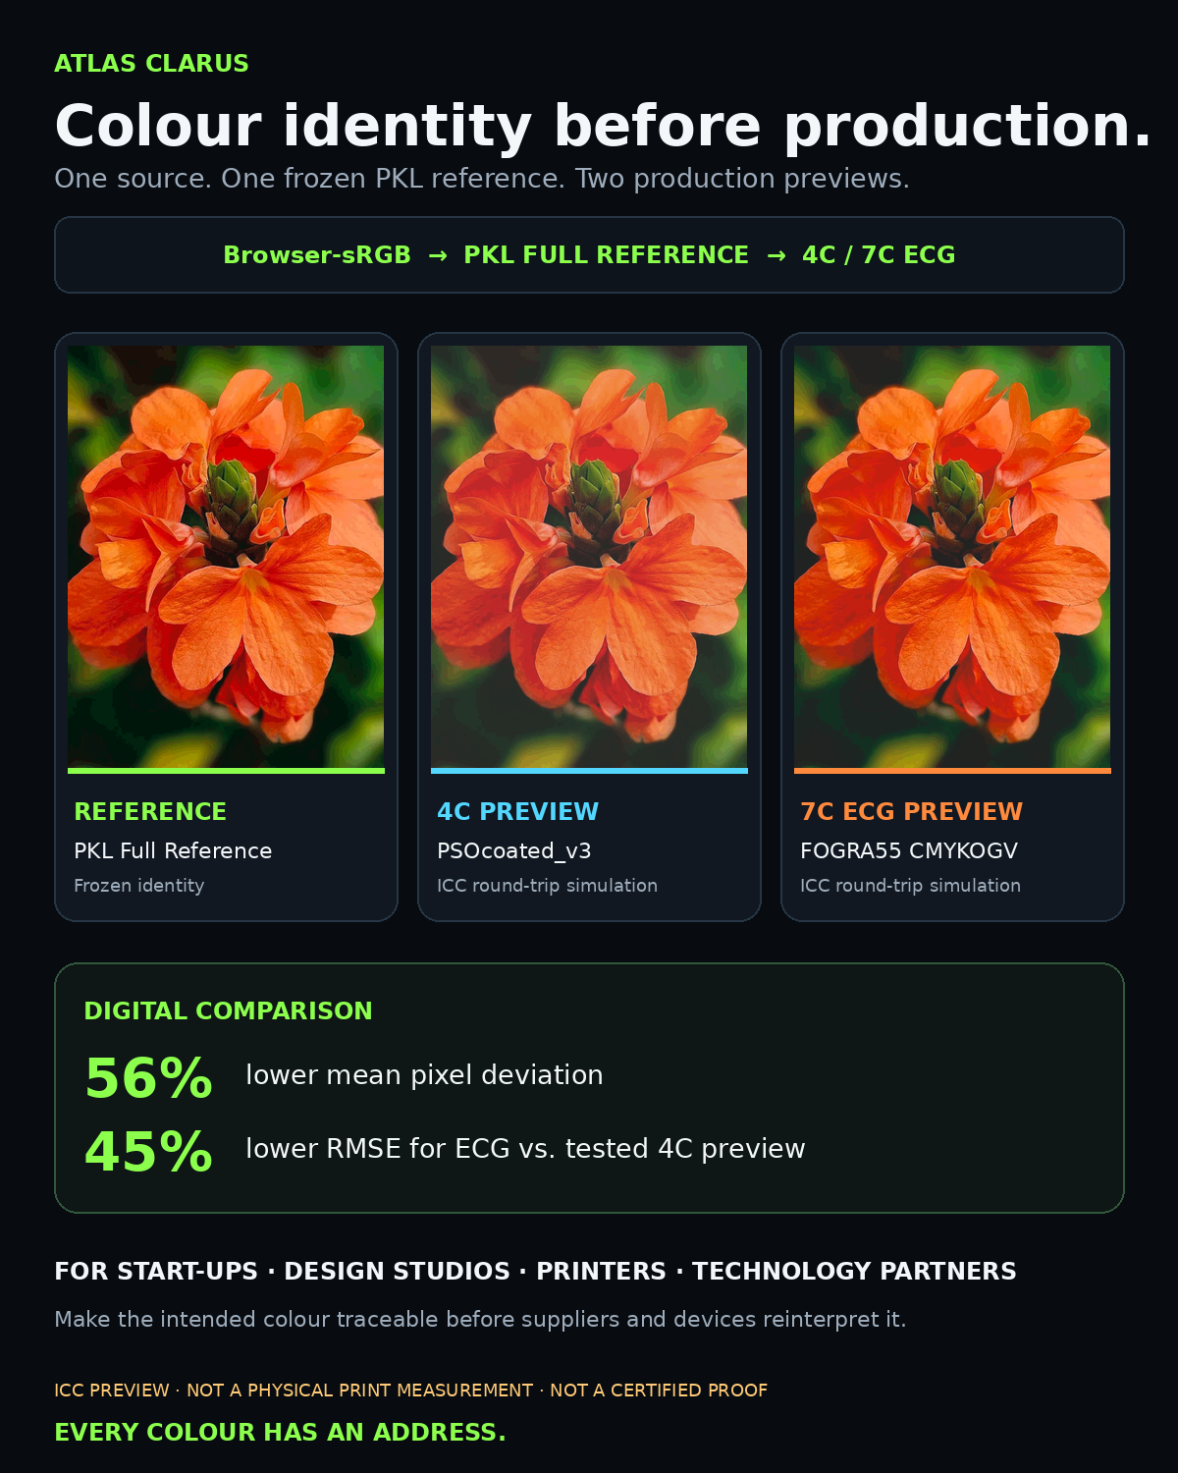
Example: one PKL reference compared with tested 4C and seven-channel ECG previews. Percentages describe this digital test only.
Do not claim. A round-trip preview is not paper-white simulation, a physical print, contract proof, certification or production approval.

08 Create reference cards and evidence

CARD Reference card
A reference card documents the frozen identity. Its displayed or printed appearance does not modify the PKL master.
✓ Keep ATLAS address and atlas_row_id visible.
✓ Include master provenance and creation metadata.
✓ Treat an unmeasured card as NOT_MEASURED.
✓ Preflight any production PDF for colour spaces, output intent, fonts and separations.

FILES Evidence files
File | Proves | Cannot prove
Clarus JSON | Identity and master provenance. | Physical appearance.
Print handoff JSON | Profiles, settings and independent paths. | Printer compliance.
Readable report | Human-readable preparation. | Colour approval.
B/A PNG | Screen comparison. | Measured paper result.
Preview JSON | Profile hash, settings and method. | Press calibration.
Device PDF | Encoded values and output intent. | Correct plates before preflight.

Archive. Keep the Clarus JSON, handoff JSON, report, profile evidence, production PDF, preflight report and later measurement together.

09 Appearance and app connections
Appearance Pixel Simulator illustrates material, finish, illumination, viewing angle and surface depth. It is not a spectral renderer or physical-material prediction.
Control | Examples
Material | Coated paperboard, polymer film, brushed metal, woven textile, glass or wood.
Finish | A visual finish option provided by the interface.
Illumination | A simulated viewing-light context.
Viewing angle | An illustrative change in geometry.
Surface depth | A visual depth treatment.

APPS External applications
✓ Adobe and Affinity: import ASE and retain the ATLAS reference as swatch name.
✓ GIMP and Inkscape: import GPL and preserve Clarus JSON as evidence.
✓ Figma: use token JSON; its RGB is the documented screen representation.
✓ CSS: use generated custom properties and keep provenance comments.
✓ Krita and Scribus: follow included demonstrations and keep identity separate from colour conversion.

10 Troubleshooting
Problem | Cause | Action
Application fails to open. | ZIP not extracted or files moved. | Extract the complete archive again and open index.html in the intact folder.
Palette disappeared. | Browser storage cleared or file moved. | Import the last Clarus JSON backup.
ICC profile rejected. | Wrong device space, invalid header, size or missing transforms. | Use CMYK for 4C or 7CLR CMYKOGV for ECG, below 16 MiB.
Preview button disabled. | Image or compatible profile missing. | Load an image and attach the required profile or both profiles.
Preview differs strongly. | Output gamut and settings differ. | Review profile, intent, BPC and condition; do not alter identity to hide it.
Physical print differs. | Press, substrate, calibration, viewing or conversion changed. | Preflight, document the RIP path and measure the dried print.

CHECK Before printer handoff
✓ Confirm ATLAS address, atlas_row_id and master SHA-256.
✓ Confirm the exact ICC profile and its SHA-256.
✓ Record printing condition, substrate, rendering intent and BPC.
✓ Preflight the production PDF and inspect all intended separations.
✓ Tell the printer not to apply an unintended additional conversion.
✓ Print under the agreed condition and measure the dried sample.

11 Version and claim record
Item | RC22 value
Bundle | ATLAS Clarus Browser Bundle v0.2.0 rc22 parallel image preview
Archive checked | rc22.zip
Archive SHA-256 | 2adc5120a98b6338c4a7b6e247712a3347424c03e3a14cb9fda3bf40148350ad
Reference count | 13,283
Master SHA-256 | 8283ab91b10f89ac758d09ecf5fb4d6343536600a06dd468b1cc1ecf4ec747c4
Validation | READY_PENDING_VISUAL_AUDIT
Preview engine | LittleCMS 2.16 via lcms-wasm 1.0.5
Method | sRGB to device 16-bit to sRGB
Measurement | NOT_MEASURED unless a real record is appended
A′ logic | v0.4 unchanged; v0.5 diagnostics do not change selection

CAUTION Claim boundary
ATLAS Clarus identifies, freezes and documents a reference colour and its preparation paths. It does not guarantee that every display, printer, ink set or material can reproduce that colour. ICC previews are computational simulations. Physical claims require a controlled print, documented viewing conditions and measurement.

CREDITS Credits and licensing
Review LICENSING.html, LCMS-LICENSE.txt, LCMS-WASM-LICENSE.txt and LCMS-PROVENANCE.json in the bundle before redistribution. Credit is due to freieFarbe e. V. and freieFarbe.de for the open HLC colour reference and foundational work.
End of manual

