Git hub link : https://github.com/Helah-Alkuraydis/WebTechnoLaps2
This lab session covers the basics of the Django development framework and the Git system. By the end of this session, students should have a very good understanding of how to install and configure a Django application and how to structure it. They should also have practical involvement with the Git system and how to use basic commands to version control their repository.

Pre-lab Preparation:
- Install Python: Ensure that Python 3.7+ is installed in your system (macOS users shouldn’t use their built-in Python version; they should have their own Python environment). Also, ensure to upgrade your pip command by typing 'python3 -m pip install --upgrade pip'
- Install Git: Ensure that you have git installed. (macOS users may install Xcode or install the commands without Xcode by typing ‘Xcode-select --install’ in the terminal command line).
- Since we are using the command line for Git, you must generate SSH keys. Here is an example of how to do that:
(https://docs.github.com/en/authentication/connecting-to-github-with-ssh/generating-a-new-ssh-key-and-adding-it-to-the-ssh-agent).

Lab Activities:
Part 1: Django web development framework
Task 1: install Django
Step 1: Once you have Python installed and PIP upgraded on your system, you must create a virtual environment using 'python3 -m venv djangoenv'. This command will create an isolated Python virtual environment for your development. You can do this anywhere, but it should not be in your local git repository.
Step 2: Once the virtual environment is created, you should activate it. You do this by changing the folder to the virtual environment you just created as follows:
> cd path_to_virtual_env/djangoenv
macOS: > source bin/activate
Windows: > Scripts\activate
Step 3: once activated, we can now install Django
> pip install django
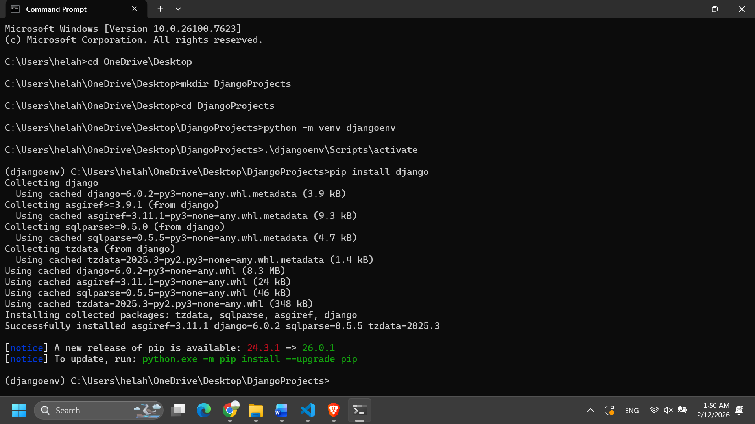
Task 2: create, configure, and organize a new Django project
Step 1: Navigate to the desired location at which you will create the Django web application. For example, 'DjangoProjects’ in your home folder.
> mkdir ~/DjangoProjects
> cd ~/DjangoProjects/
Step 2: Create your Django project as follows:
> Django-admin startproject libraryproject
Step 3: run the application to test that everything is working as intended:
> python manage.py runserver
Step 4: Open your favorite internet browser and navigate to the localhost ‘http://127.0.0.1:8000/’. You should see the Django default layout of the Django application.
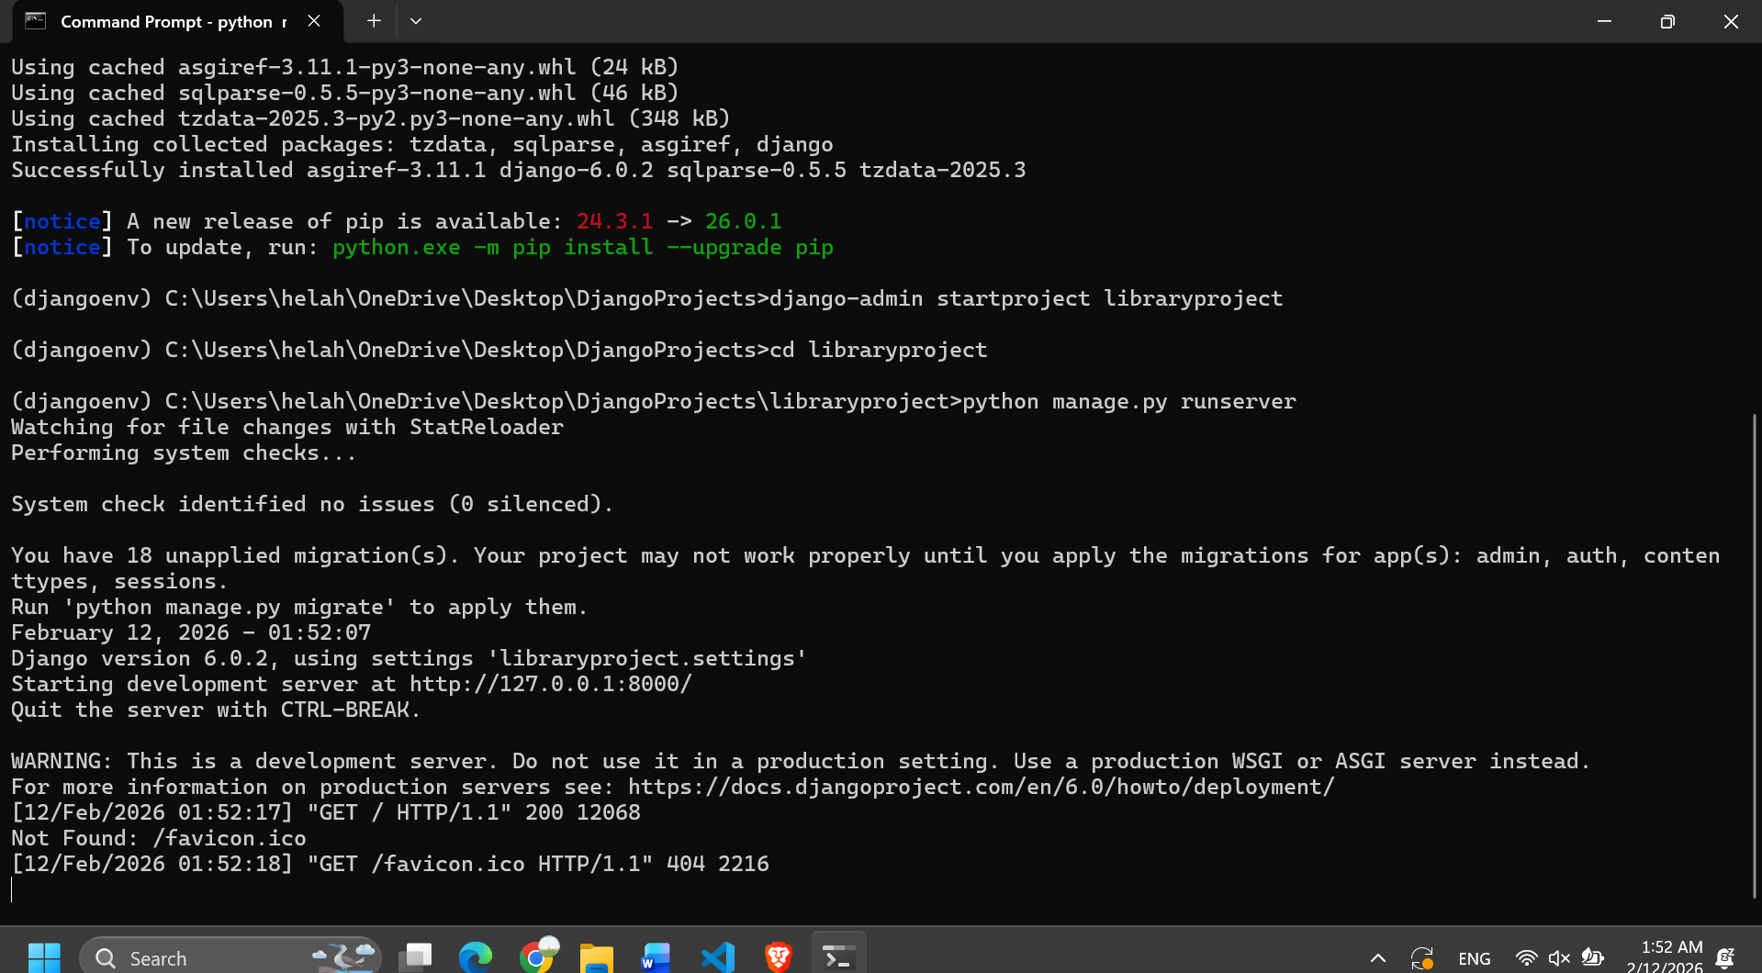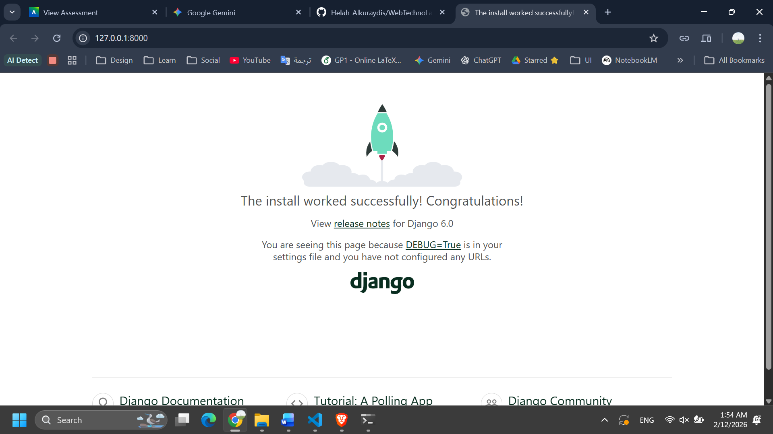
Task 3: configure your Django application
Throughout the lab sessions, the Django application will handle two services (sub-applications). This task guides you in creating the appropriate structure for these two services. Hereafter, we will refer to the ROOT folder as the folder that contains the manage.py file.
Step 1: Create some folders in the ROOT folder
> mkdir apps/ apps/template/ apps/static/
Step 2: create two module services in the apps folder: bookmodule and usermodule
> cd apps
> python ../manage.py startapp bookmodule
> python ../manage.py startapp usermodule
These commands create two folders inside of the apps folder, and each one has a list of files as follows:
├── __init__.py
├── admin.py
├── apps.py
├── migrations
│ └── __init__.py
├── models.py
├── tests.py
└── views.py

Step 3: Open the files modules configuration files.
Open the file apps/bookmodule/apps.py and update the module name:
name = 'apps.bookmodule'
Do the same for the usermodule at apps/usermodule/apps.py
name = 'apps.usermodule'
Step 4: Update the Django application settings at ROOT/libraryproject/settings.py, and add the following to the INSTALLED_APPS array.
INSTALLED_APPS = [
...,
'apps.bookmodule',
'apps.usermodule',
]
Step 5: run the server to test that everything works as intended. From the ROOT location of your Django project, do the following:
> python manage.py runserver

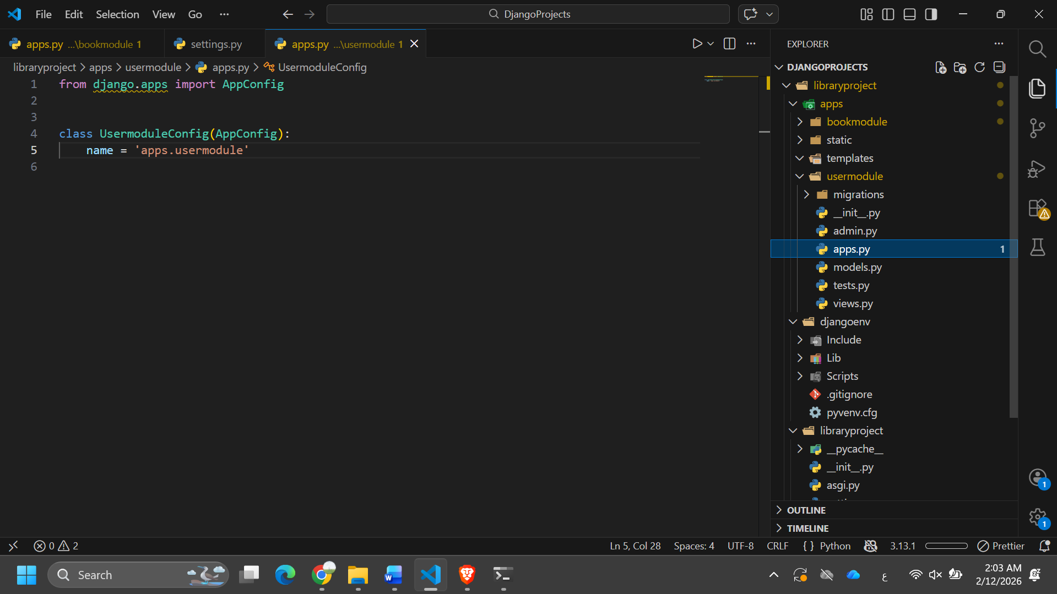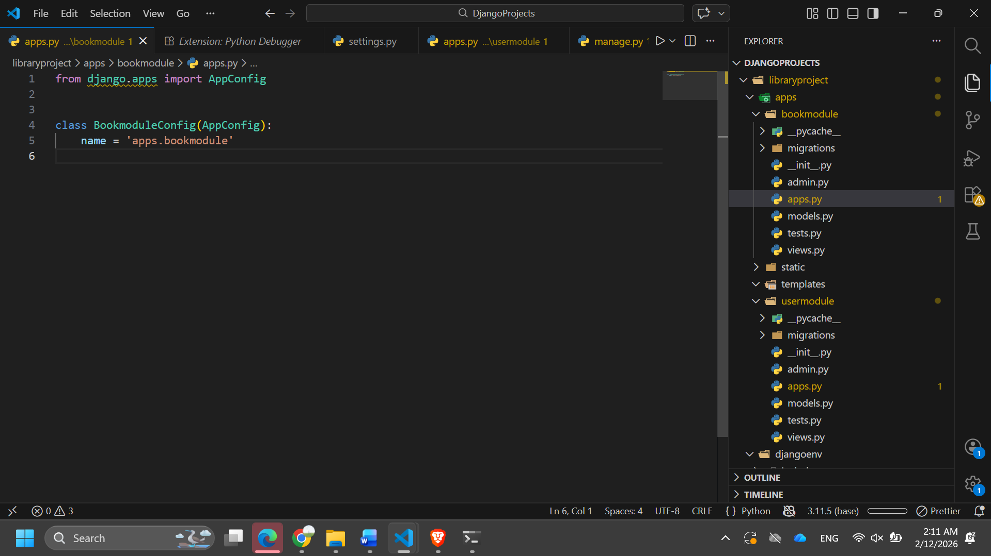
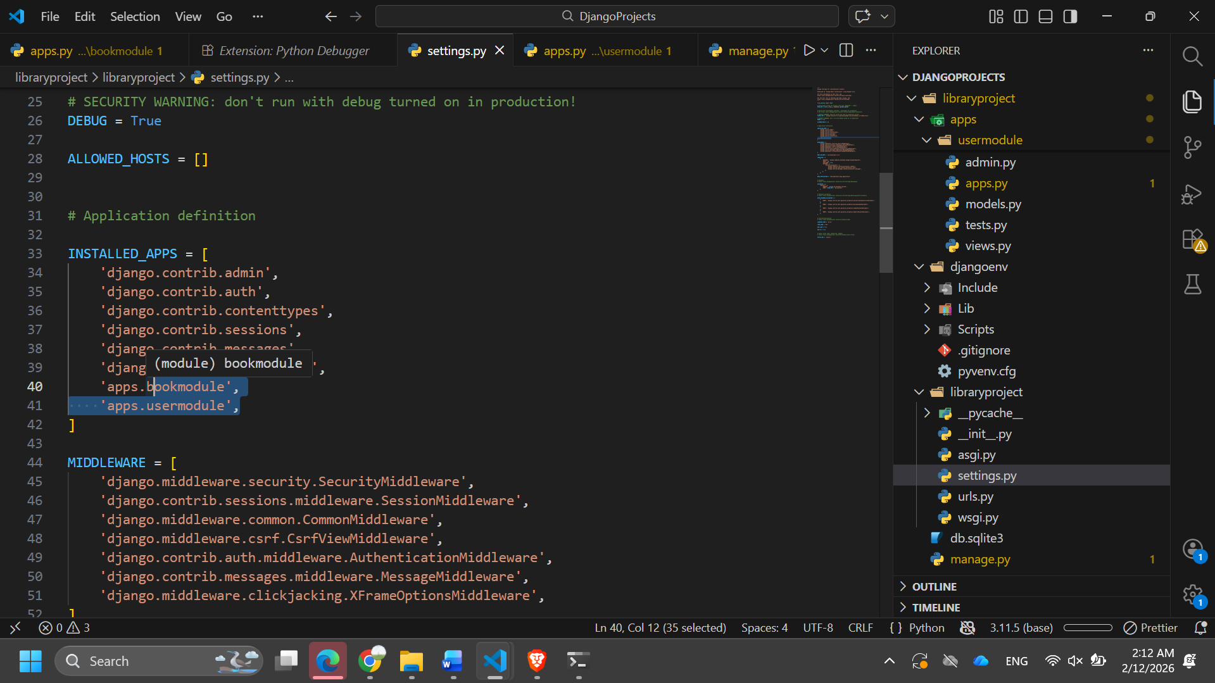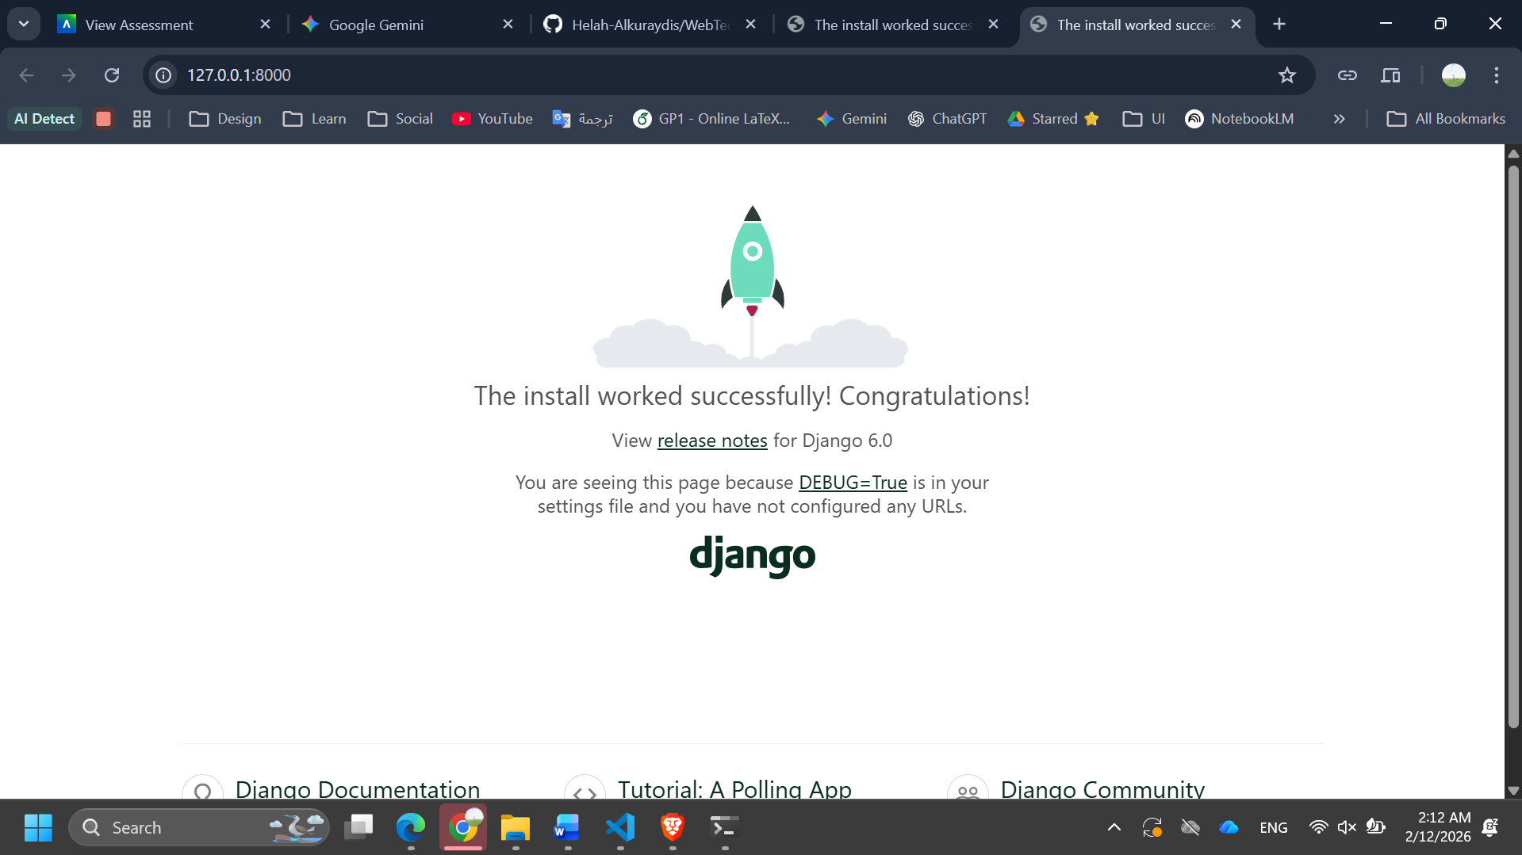
Part 2: Git system and connect your online repo with a local repo
Task 1: Create a local git repo.
Step 1: navigate to the ROOT folder of your Django application
> cd ~/DjangoProjects/libraryproject
Step 2: initialize your local Git repository:
> git init
(this command will create a git folder)
Step 3: You don’t want to add all the files from your local repository to the online one. So, create an ignore file to add all file extensions that the git system will overlook.
macOS: > touch .gitignore & open .gitignore
Windows: > type NUL > .gitignore & .gitignore
Once the file .gitignore is opened in a text editor, add the following lines:
*.log
*.pot
*.pyc
__pycache__
*.bak
*.py[cod]
*$py.class
pip-log.txt
pip-delete-this-directory.txt
.ipynb_checkpoints
.python-version
celerybeat-schedule.*
# Environments
.env
.venv
env/
venv/
ENV/
env.bak/
venv.bak/
.mypy_cache/
**/migrations
*.DS_Store
**/__pycache__
**/.DS_Store
.history

Then, we need to stage the ignore file and let Git know about it.
> git add .gitignore
> git commit -m "add ignore file"
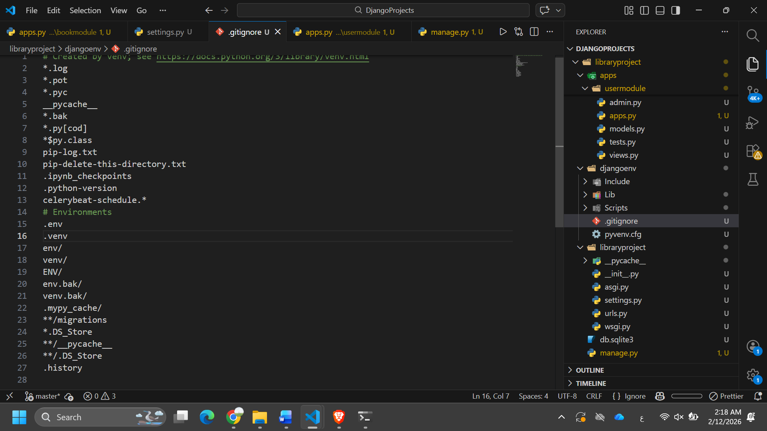
Task 2: connect your local repository with the remote repository you created in Lab 2.
Step 1: before you can do anything, we must first configure git to use the SSH connection with your remote repository. Use the same credentials that you used to create your online repository. Then, you should do the following:
> git config --global user.name "Pixel"
> git config --global user.email "pixel@webmail.com"
Step 2: Generate the authentication keys. You can visit this link for different operating systems, here we use macOS compatibility commands.
> ssh-keygen -t ed25519 -C "pixel@webmail.com"
You will be prompted to enter the key's location. Press the enter/return key on your keyboard to accept the default location, or you must give the full path to your SSH configuration folder.
> Enter a file in which to save the key(/Users/Pixel/.ssh/id_ed25519):[Press enter]
Then, you will be prompted to enter a passphrase. If you don’t want to set it up, you can press the enter/return key anyway.
Step 3: Add the key to ssh-agent
> eval "$(ssh-agent -s)"
Step 4: Navigate to the online git repository and copy the project link you dedicated to this module. For example, if your repository project is hosted on GitHub, then it should have this pattern:
https://github.com/<user_name>/<repo_name>.git
Step 4: Add your remote repository to your local git repository:
> git remote add origin https://github.com/<user_name>/<repo_name>.git
Step 5: Determine which branch your repository project has. Usually, it is called main. Then to the following:
> git fetch origin

> git push -u origin main
Step 6: Double-check your content is successfully uploaded by visiting your remote online repository. 