Transport Management System

Abstract
The Transport Management System is a software application developed to simplify the management of transportation-related information within an institution. The current project mainly focuses on the Bus Schedule Management module, which provides facilities for creating, viewing, updating, and deleting bus schedule information. Each bus schedule contains important details such as route name, starting point, destination, departure time, arrival time, driver name, available seats, and bus type.
The application was developed using Java and the Spring Boot framework. It follows a RESTful API architecture, where clients communicate with the server by sending HTTP requests. JSON is used as the standard data format for both requests and responses. The system follows a layered architecture consisting of model, controller, service, and data storage components. This separation makes the application easier to understand, maintain, test, and extend.
Postman was used to test the API endpoints and verify the CRUD operations. Maven was used to manage project dependencies and build the application. Git and GitHub were used for version control, collaboration, and source-code management. The current version provides the basic backend functions required for schedule management. Future improvements may include a graphical user interface, user authentication, real-time bus tracking, online seat booking, notifications, and cloud deployment.

Chapter 1: Project Description

1.1 Project Overview
The Transport Management System is designed to organize and manage transportation related activities through a centralized software platform. In many institutions, transportation information is often maintained through printed notices, spreadsheets, messaging applications, or informal communication. These methods may be sufficient for a small number of buses, but they become difficult to manage as the number of routes, passengers, drivers, and schedules increases.
The Bus Schedule Management module provides a structured solution for handling bus schedule information. The system allows an administrator to create a new bus schedule, retrieve all available schedules, search for a schedule using its unique identifier, update existing schedule information, and delete outdated or incorrect schedules. The system stores important transportation data such as route name, starting location, destination, departure and arrival times, assigned driver, available seats, and bus category.
The application was developed as a backend system using Spring Boot. It exposes REST API endpoints that can be used by Postman, a browser, a future web application, or a mobile application. The system communicates using JSON, which is a lightweight and commonly used format for exchanging information between clients and servers.
The project also demonstrates important software engineering concepts such as layered architecture, separation of concerns, object-oriented programming, API design, CRUD operations, testing, and collaborative development using GitHub.
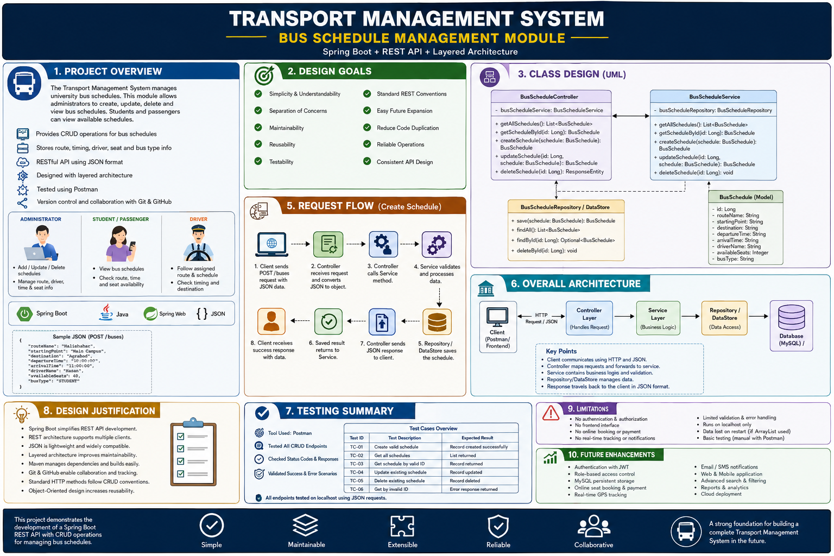
Figure 1: Overview of the Transport Management System

1.2 Background of the Project
Transportation is an important service in universities and other institutions. Students, teachers, staff members, and drivers depend on accurate schedules to complete their journeys on time. However, transportation information is often handled manually. Schedules may be written on notice boards, stored in spreadsheets, or shared through social media and messaging groups.
Manual methods create several problems. When a route or departure time changes, all copies of the schedule may not be updated. Students may continue to follow an old schedule, which can result in missed buses and unnecessary waiting. Administrators may also find it difficult to keep track of drivers, routes, destinations, and seat availability. Information may be duplicated, inconsistent, or lost.
A digital transport management system can reduce these difficulties. A centralized system keeps transportation information in one place and allows administrators to update it through standard operations. The stored information can later be connected to a website or mobile application so that passengers can view the latest schedules.
This project was therefore developed to demonstrate how Spring Boot and REST APIs can be used to build a simple, organized, and expandable transportation-management solution.

1.3 Problem Statement
The main problem addressed by this project is the absence of a centralized and structured platform for managing bus schedule information. In a manual system, route information, driver assignments, departure times, arrival times, and available seats may be maintained in separate documents or communication channels.
This creates several difficulties. Schedule information may become outdated. Administrators may accidentally enter duplicate information. Students may receive incorrect departure or arrival times. Updating a large number of schedules manually can also take considerable time.
The proposed system solves part of this problem by providing REST API endpoints for bus schedule management. It allows schedule information to be created, retrieved, updated, and deleted in a consistent format. The system also provides a foundation that can later be connected to other modules, such as student management, driver management, seat booking, and live vehicle tracking.

1.4 Purpose of the Project
The purpose of the project is to develop a simple backend application for managing university bus schedules. The project aims to reduce manual work and make transportation information easier to maintain.
The system provides a standard method for storing schedule details and performing CRUD operations. It also gives the development team practical experience with Spring Boot, REST APIs, JSON communication, Maven, Postman, Git, GitHub, and layered software architecture.
Another purpose of the project is to create a base system that can be expanded in the future. Although the present version mainly focuses on bus schedules, the architecture can support additional modules such as passenger registration, driver management, route management, booking, payment, notification, and real-time tracking.

1.5 Project Objectives
The primary objective of the project is to develop a functional Spring Boot application that can manage bus schedules through REST API endpoints.
The specific objectives are:
- To create a structured model for bus schedule information.
- To implement create, read, update, and delete operations.
- To provide an endpoint for retrieving all bus schedules.
- To provide an endpoint for retrieving one schedule using its ID.
- To allow new schedules to be added using JSON data.
- To allow existing schedules to be updated.
- To allow outdated schedules to be removed.
- To use a layered architecture that separates request handling, business logic, and data storage.
- To test all endpoints using Postman.
- To manage source code and team collaboration using Git and GitHub.
- To develop code that is understandable, maintainable, and suitable for future improvement.

1.6 Scope of the Project
The current scope of the project includes the backend management of bus schedules. The system stores information about routes, starting points, destinations, departure times, arrival times, drivers, seats, and bus types.
The current version supports the following functions:
- Creating a new bus schedule.
- Retrieving all bus schedules.
- Retrieving a single schedule using its ID.
- Updating an existing bus schedule.
- Deleting a bus schedule.
- Sending and receiving information in JSON format.
- Testing the application through Postman.
- Running the application on localhost.
The following features are outside the current scope:
- Online ticket purchasing.
- Online payment.
- Real-time GPS tracking.
- SMS or email notifications.
- Student and driver login.
- Role-based authorization.
- Mobile application.
- Automatic route optimization.
- Production deployment.
These features may be included in future versions of the system.

1.7 Stakeholders
The main stakeholders of the system are the transport administrator, students or passengers, drivers, the development team, and the course instructor.
The transport administrator is responsible for managing schedule information. The administrator may create new schedules, update route and driver information, change departure and arrival times, and remove schedules that are no longer required.
Students and passengers are the main consumers of schedule information. They need accurate route, destination, timing, and seat information to plan their journeys.
Drivers are responsible for following their assigned routes and schedules. Although the present version may not include a separate driver interface, driver information is stored as part of the schedule.
The development team is responsible for designing, implementing, testing, and maintaining the application. The course instructor evaluates the project according to its technical implementation, documentation, teamwork, and use of software engineering principles.

Stakeholder | Role in the system
Transport administrator | Creates, updates, views, and deletes schedules
Student or passenger | Views route and schedule information
Driver | Follows the assigned route and schedule
Development team | Designs, develops, tests, and documents the system
Course instructor | Reviews and evaluates the project

1.8 Technology Stack
Java was selected as the main programming language because it supports object-oriented programming and is widely used for backend development. Spring Boot was used to create the REST application because it reduces configuration requirements and provides built-in support for web applications.
Spring Web was used to define REST endpoints and process HTTP requests. Maven was used for dependency management and application building. JSON was used for exchanging data between the client and server. Postman was used to test API requests and responses.
Git was used to track source-code changes, while GitHub was used as the remote repository for collaboration. The application was developed using Microsoft Visual Studio.
Category | Technology
Programming language | Java
Framework | Spring Boot
Web dependency | Spring Web
API style | REST
Data format | JSON
Build tool | Maven
API testing tool | Postman
Version control | Git
Remote repository | GitHub
Development environment | VS Code
Storage | H2

1.9 Project Constraints
The system was developed as an academic project within a limited period. Therefore, the first version mainly focuses on the implementation of CRUD operations rather than a complete transportation platform.
The application currently runs in a local development environment. A graphical frontend, production deployment, authentication, and advanced security were not included in the initial release. Real-time bus information is also unavailable because the system is not connected to GPS devices.
When ArrayList is used for storage, the data is temporary and is lost after the server stops or restarts. When a database is used, correct database configuration and connectivity are required for the system to operate.

Chapter 2: Requirements Analysis

2.1 User Roles
The main user role in the current system is the transport administrator. The administrator manages schedule information by adding new schedules, retrieving records, updating schedule details, and deleting schedules.
Students or passengers act mainly as information viewers. They need access to route names, starting points, destinations, departure times, arrival times, and available-seat information.
A driver may also be considered a user of the complete system. The driver needs information about the assigned route and schedule. However, a separate driver account or interface is outside the current implementation unless it has already been developed.

2.2 Use-Case Description
The major use cases are create bus schedule, view all schedules, view schedule by ID, update schedule, and delete schedule.
In the create-schedule use case, the administrator provides schedule information in JSON format. The system validates and stores the information before returning the created schedule or a success response.
In the view-all-schedules use case, the client sends a GET request. The system retrieves the complete collection of schedules and returns it in JSON format.
In the view-by-ID use case, the client provides a schedule ID in the URL. The system searches for the matching schedule and returns it.
In the update-schedule use case, the administrator sends a schedule ID and new information. The system locates the schedule and replaces the old values.
In the delete-schedule use case, the administrator provides the schedule ID. The system removes the matching record and returns a confirmation response.
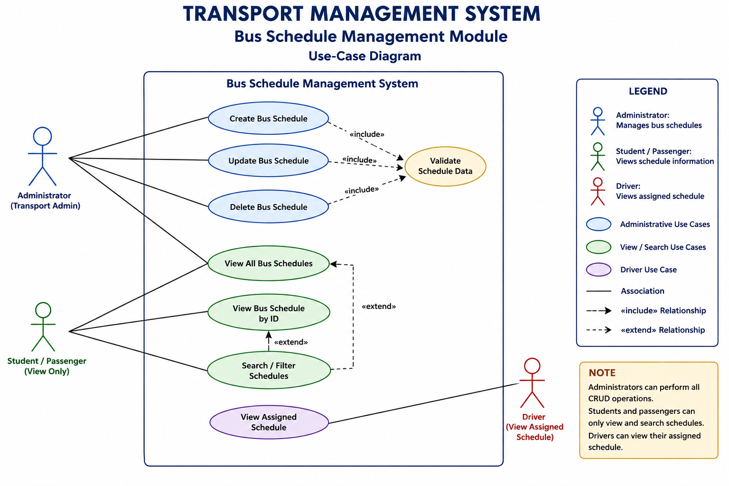
Figure 2: Use-Case Diagram of the Bus Schedule Management Module

2.3 Functional Requirements
The functional requirements describe the operations that the system must perform.
Requirement ID | Requirement
FR-01 | The system shall retrieve all bus schedules.
FR-02 | The system shall retrieve a bus schedule using its unique ID.
FR-03 | The system shall allow a new bus schedule to be created.
FR-04 | The system shall allow an existing bus schedule to be updated.
FR-05 | The system shall allow a bus schedule to be deleted.
FR-06 | The system shall accept request data in JSON format.
FR-07 | The system shall return schedule information in JSON format.
FR-08 | The system shall maintain a unique ID for every bus schedule.
FR-09 | The system shall store the route name.
FR-10 | The system shall store the starting point and destination.
FR-11 | The system shall store the departure and arrival times.
FR-12 | The system shall store the driver name.
FR-13 | The system shall store available-seat information.
FR-14 | The system shall store the bus type.
FR-15 | The system should return an appropriate response when a record does not exist.
Remove FR-15 when missing-record handling has not yet been implemented.

2.4 Non-Functional Requirements

Performance Requirements
The system should return responses within a reasonable period under normal local testing conditions. Basic CRUD requests should normally be completed within approximately two seconds. Since the current system is an academic prototype, it is not designed for a very large number of simultaneous users.

Maintainability Requirements
The application should follow a clear package and class structure. Request handling should remain inside the controller layer, while business operations should remain inside the service layer. The data model and storage logic should also be kept separate. This structure allows developers to modify one layer without significantly affecting the others.

Reliability Requirements
The system should return consistent results for valid requests. Invalid IDs should not cause the complete application to stop. Update and delete operations should only be performed on records that exist. Meaningful responses should be returned when an operation cannot be completed.

Usability Requirements
The API endpoints should be clearly named and follow common REST conventions. JSON property names should be understandable. The system should be easy to test using Postman without requiring a complex setup.

Portability Requirements
The project should run on any operating system that supports the required Java version and Maven. The dependencies listed in the pom.xml file should be downloaded automatically by Maven.

Security Requirements
The current version does not provide complete authentication or role-based access control. In a production version, only authorized administrators should be able to create, update, or delete schedules. Students and general passengers should only be allowed to view schedule information.

2.5 Data Requirements
The main data object in the project is BusSchedule. It represents one transportation schedule and contains all the information required to describe a scheduled bus journey.
The id field uniquely identifies each schedule. The routeName field stores the route name. The startingPoint stores the location from which the bus begins its journey, while the destination stores the final location.
The departureTime and arrivalTime fields store the expected journey times. The driverName identifies the assigned driver. The availableSeats field records the number of seats available, while busType indicates the category of the bus.
Attribute | Data type | Description
id | Long | Unique identifier of the schedule
routeName | String | Name of the route
startingPoint | String | Location where the journey begins
destination | String | Final destination
departureTime | Time/String | Scheduled departure time
arrivalTime | Time/String | Expected arrival time
driverName | String | Name of the assigned driver
availableSeats | Integer | Number of available seats
busType | String or Enum | Category of the bus

Chapter 3: System Design

3.1 Design Goals
The first design goal was simplicity. The project was designed so that developers with basic Spring Boot knowledge could understand the code and application flow.
The second goal was maintainability. The application separates request handling, business logic, data representation, and storage responsibilities. This reduces unnecessary dependencies between classes.
The third goal was reusability. Service methods can be called by different controllers or future modules. The bus schedule model can also be reused by a frontend or mobile application.
Another goal was testability. Since the system is divided into different layers, each layer can be tested separately. The REST endpoints can be tested through Postman, while service methods may later be tested using JUnit.
The system was also designed for future expansion. Additional transportation modules can be added without completely redesigning the existing schedule module.

3.2 Overall Architecture
The system follows a layered architecture. The client sends an HTTP request to the application. The controller receives the request and maps it to the appropriate method. The controller then calls the service layer.
The service layer performs the required business operation. It communicates with the repository or in-memory data store to retrieve or modify schedule information. The result is returned to the controller, which sends a JSON response to the client.
This architecture separates responsibilities and prevents all application logic from being placed inside one class.
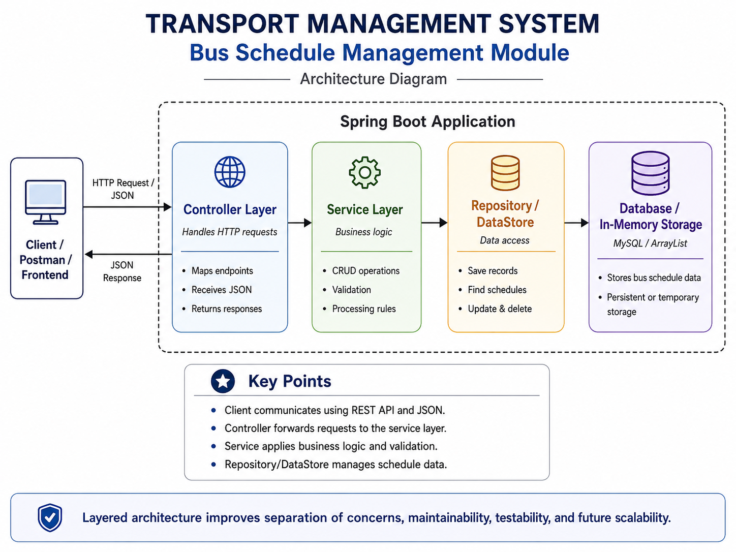
Figure 3: Layered Architecture of the Bus Schedule Management Module

3.3 Model Layer
The model layer represents the data used by the application. The main model class is BusSchedule. It contains the fields required to describe a bus journey.
The class includes constructors, getters, and setters. These methods allow Spring Boot to create and update objects using JSON request data. The model may also include validation annotations when validation has been implemented.
The model class should contain data-related responsibilities only. It should not handle HTTP requests or contain controller logic.

3.4 Controller Layer
The controller layer handles communication between the client and the application. The BusScheduleController class is marked with @RestController, which tells Spring Boot that the class contains REST API endpoints.
The @RequestMapping annotation defines the base URL. The @GetMapping annotation is used for retrieving information, @PostMapping is used for creating a new schedule, @PutMapping is used for updating a schedule, and @DeleteMapping is used for deleting a schedule.
The @RequestBody annotation converts incoming JSON data into a Java object. The @PathVariable annotation retrieves the schedule ID from the endpoint URL.
The controller should not contain complex business logic. Its primary responsibility is to receive the request, call the appropriate service method, and return the response.

3.5 Service Layer
The service layer contains the main application logic. The BusScheduleService class receives operation requests from the controller.
For a create operation, the service adds or saves the new schedule. For a read operation, it returns all schedules or searches for one schedule by ID. For an update operation, it locates the existing schedule and changes its information. For a delete operation, it removes the specified schedule.
The service layer may also perform validation and check whether a schedule exists before an update or delete operation. Keeping these operations in the service layer makes the code easier to maintain and test.

3.6 Repository or DataStore Layer
When a repository and database are used, the repository layer is responsible for storing and retrieving schedule records. It communicates with the database and provides methods for saving, searching, updating, and deleting information.
When an ArrayList is used, the application stores the schedule objects in memory. New schedules are added to the list. Existing schedules are found by comparing their IDs. Updated records replace previous values, and deleted records are removed from the collection.
ArrayList storage is suitable for demonstrating CRUD operations because it is simple and does not require database configuration. However, the stored information is lost when the application stops.
Use only the description that matches your actual implementation.

3.7 Package Structure
The application is divided into separate packages according to responsibility. The model package contains the schedule data class. The controller package contains the REST controller. The service package contains the business logic. A repository package may contain database-access components. An exception package may be included for custom error handling.
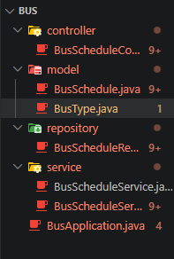
Figure 4: Package Structure of the Bus Schedule Module

3.8 Class Design
The BusSchedule class represents a schedule record. It stores route, destination, timing, driver, seat, and bus-type information.
The BusScheduleController class defines the REST endpoints and receives HTTP requests. It depends on BusScheduleService.
The BusScheduleService class performs the main CRUD operations and communicates with the storage layer.
The repository or DataStore stores the schedule objects and returns them when requested.
The relationship between the classes can be shown as follows:
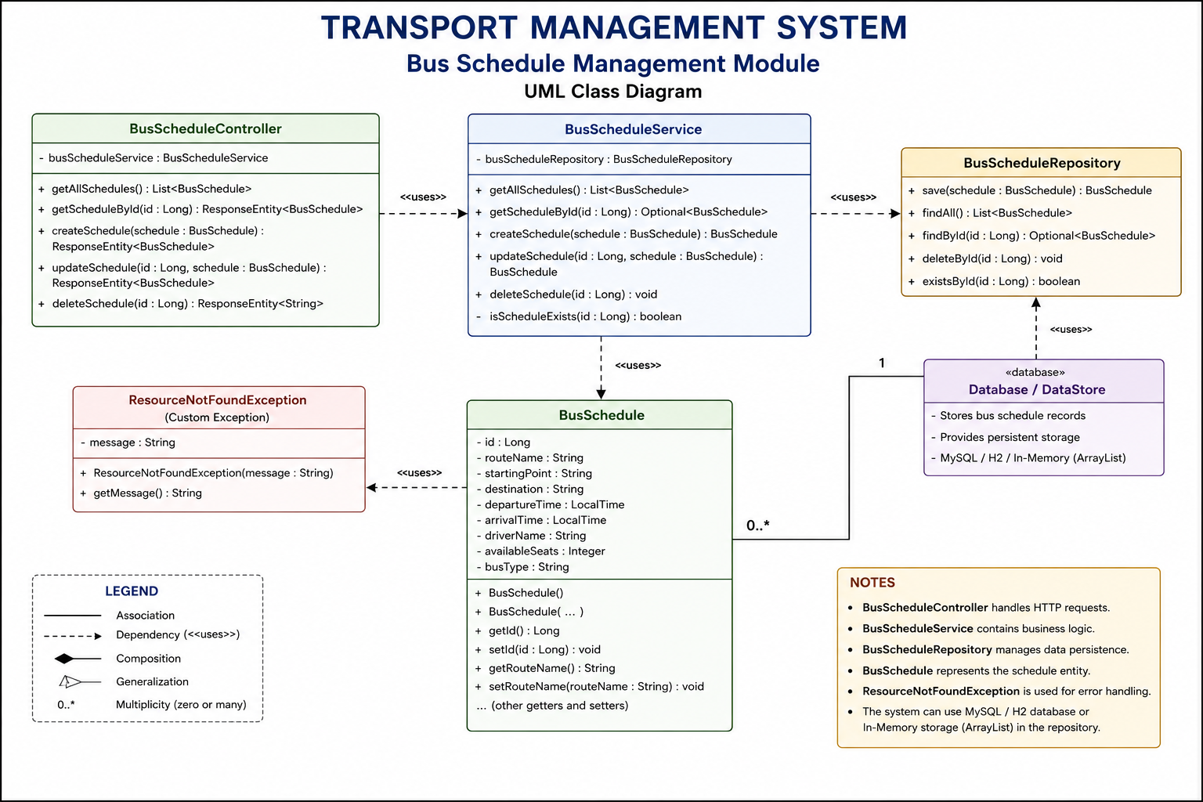
Figure 5: Class Diagram of the Bus Schedule Management Module

3.9 REST API Design
The system uses standard HTTP methods to perform CRUD operations. GET is used for reading data, POST is used for creating data, PUT is used for updating data, and DELETE is used for removing data.
Method | Endpoint | Description
GET | /buses | Retrieves all bus schedules
GET | /buses/{id} | Retrieves one schedule by ID
POST | /buses | Creates a new bus schedule
PUT | /buses/{id} | Updates an existing schedule
DELETE | /buses/{id} | Deletes a schedule
The endpoint names in the final report should exactly match the mappings used in the controller.
A sample POST request is shown below:
{
"routeName": "Halishahar",
"startingPoint": "Main Campus",
"destination": "Agrabad",
"departureTime": "10:00:00",
"arrivalTime": "11:00:00",
"driverName": "Hasan",
"availableSeats": 40,
"busType": "STUDENT"
}

3.10 Request Flow
The create-schedule operation begins when a client sends a POST request containing JSON data. Spring Boot receives the request and converts the JSON into a BusSchedule object.
The controller passes the object to the service layer. The service processes the information and sends it to the repository or DataStore. After the schedule is saved, the result moves back through the service and controller. The client then receives a JSON response.
The flow can be described as:
- Client sends an HTTP request.
- Controller receives the request.
- JSON is converted into a Java object.
- Controller calls the service.
- Service performs the required operation.
- Repository or DataStore manages the data.
- Result returns to the service.
- Controller sends the response.
- Client receives JSON output.
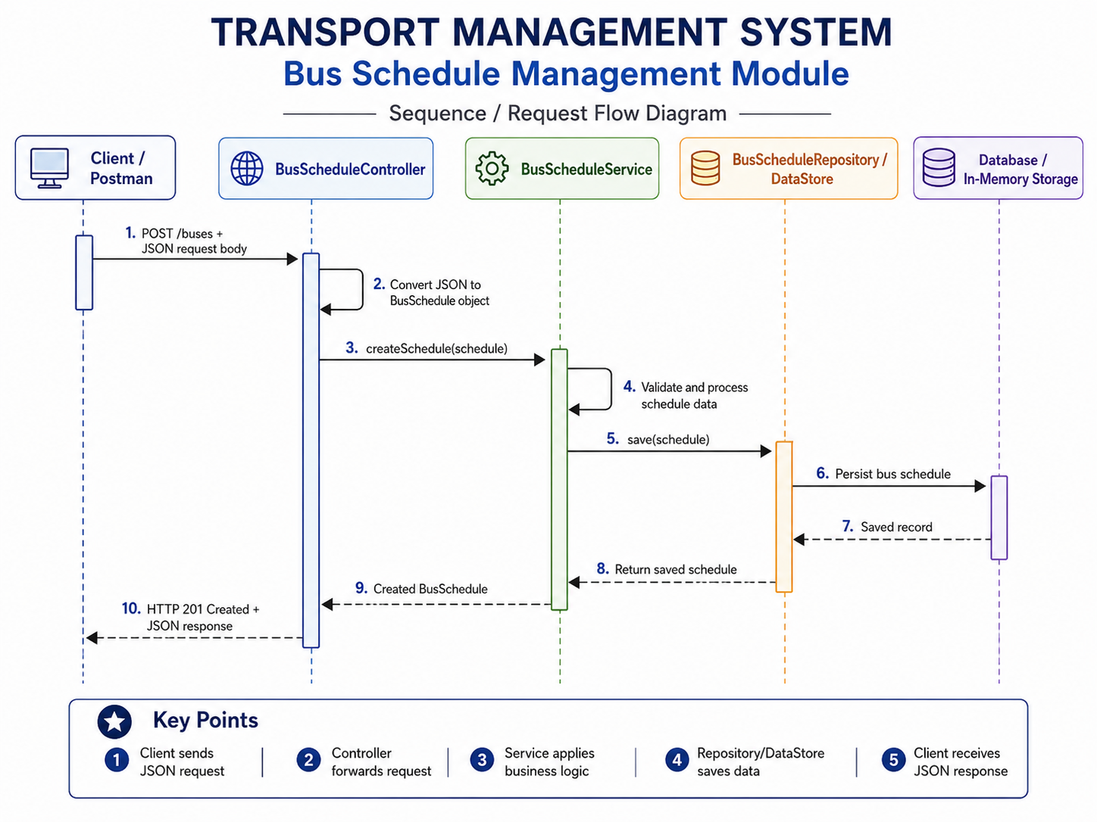
Figure 6: Request Flow for Creating a Bus Schedule

3.11 Justification of Design Choices
Spring Boot was selected because it simplifies the creation of Java web applications. It provides embedded server support, dependency injection, REST annotations, and automatic configuration.
REST architecture was selected because it allows the backend to communicate with different types of clients. The same REST endpoints can be used by Postman, a web application, or a mobile application.
JSON was selected because it is lightweight, readable, and widely supported. It can be easily converted into Java objects by Spring Boot.
Layered architecture was selected to separate responsibilities. The controller handles HTTP communication, the service handles business logic, and the storage layer manages data.
Maven was used because it manages project dependencies and creates a standard build process. Git and GitHub were used because they support version control, collaboration, code backup, and contribution tracking.

Chapter 4: System Implementation

4.1 Create Operation
The create operation is performed using a POST request. The client sends the schedule information in JSON format.
The controller receives the request body and converts it into a BusSchedule object. The object is sent to the service layer, where it is processed and stored. A unique ID may be generated automatically depending on the storage method.
After the record is successfully created, the application returns the saved object or a success message.

4.2 Read Operations
The application provides two read operations. The first retrieves all schedules, while the second retrieves one schedule using its ID.
When the client sends a GET request to /buses, the controller calls the service method that returns the complete schedule collection.
When the client sends a GET request to /buses/{id}, the ID is captured using @PathVariable. The service searches for the matching schedule. When the record exists, it is returned to the client in JSON format.

4.3 Update Operation
The update operation is performed using a PUT request. The client provides the ID of the schedule in the URL and sends updated information in the request body.
The service searches for the existing record. When the record exists, its route, location, time, driver, seat, or bus-type values are replaced with the new information.
The system then returns the updated schedule or a confirmation message. When the schedule does not exist, an error response should be returned.

4.4 Delete Operation
The delete operation is performed using a DELETE request. The client provides the schedule ID in the URL.
The service checks whether the schedule exists. When it exists, the corresponding record is removed from the repository or ArrayList. The system then returns a confirmation response.
When the supplied ID does not match a stored schedule, the system should return an appropriate not-found response.

4.5 Validation and Error Handling
Validation helps prevent incorrect information from entering the system. Route name, starting point, destination, departure time, and arrival time should not be empty. Available seats should not contain a negative number.
The system should also verify that a valid schedule exists before update and delete operations. Invalid IDs should return a clear error response instead of causing the application to stop.
When validation annotations, custom exceptions, or global exception handling have not been implemented, describe them as future improvements rather than completed features.

Chapter 5: Testing

5.1 Testing Objectives
The purpose of testing was to verify that each API endpoint behaved as expected. The create test checked whether valid schedule information could be stored. The read tests verified that all schedules and individual schedules could be retrieved.
The update test checked whether existing schedule information could be changed. The delete test verified that a schedule could be removed. Additional tests were performed to observe the response when invalid IDs or incorrect request data were provided.

5.2 Testing Environment
The application was run on localhost using the embedded Spring Boot server. Postman was used to send HTTP requests to the API endpoints.
For POST and PUT requests, JSON data was inserted into the raw request-body section and the content type was set to application/json. The returned status code and response body were checked after each request.
The console output was also examined to identify application errors.

5.3 Test Cases
Test ID | Test description | Expected result | Actual result | Status
TC-01 | Create a schedule with valid JSON | Schedule is created | [Write result] | Pass/Fail
TC-02 | Retrieve all schedules | Complete list is returned | [Write result] | Pass/Fail
TC-03 | Retrieve a schedule using a valid ID | Matching schedule is returned | [Write result] | Pass/Fail
TC-04 | Update an existing schedule | Information is updated | [Write result] | Pass/Fail
TC-05 | Delete an existing schedule | Schedule is removed | [Write result] | Pass/Fail
TC-06 | Retrieve a schedule using an invalid ID | Error response is returned | [Write result] | Pass/Fail
TC-07 | Submit incomplete or invalid JSON | Validation error is returned | [Write result] | Pass/Fail
Do not mark a test as passed until you have performed it.

  - Testing Screenshots
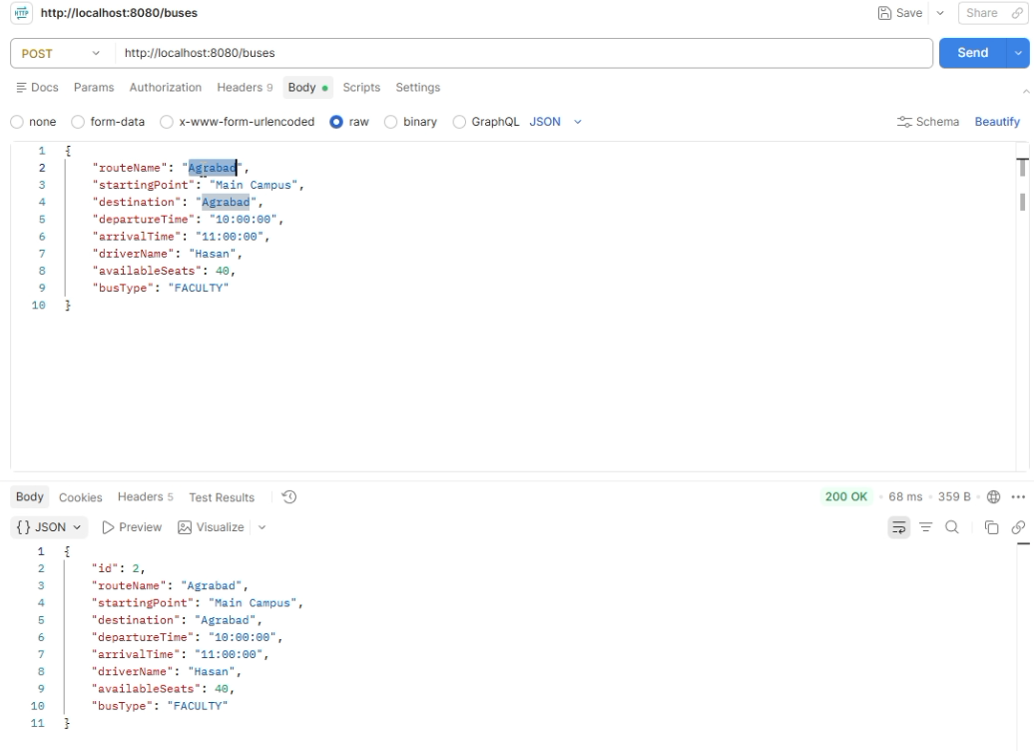
Figure 7: Successful Creation of a Bus Schedule
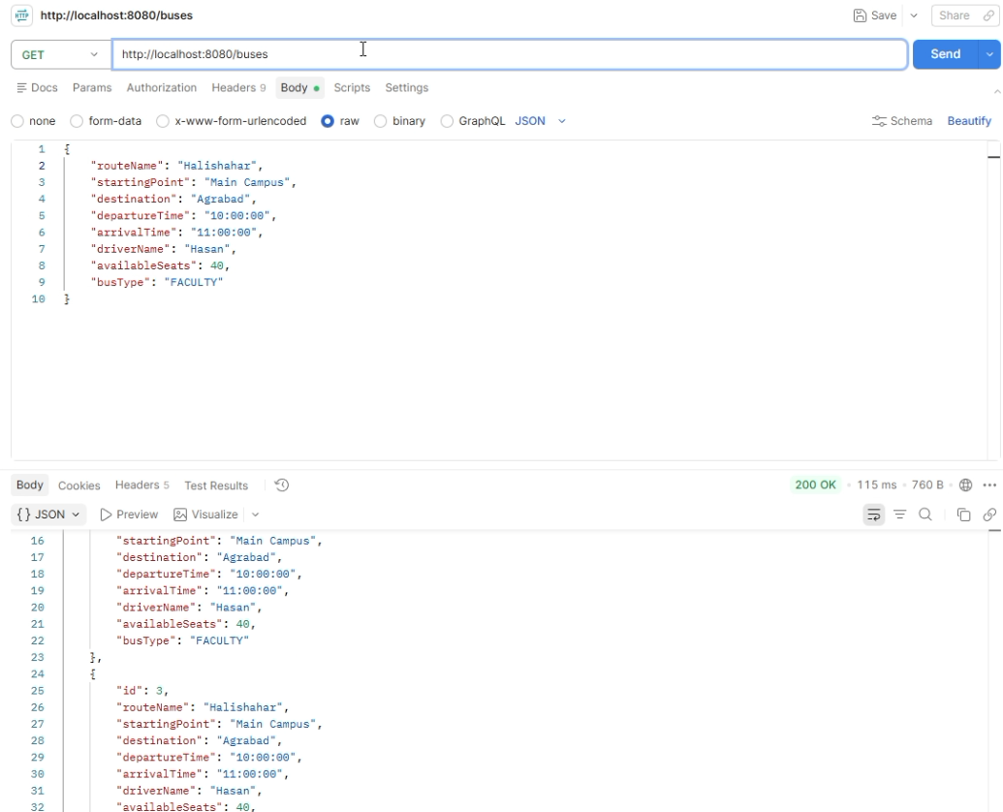
Figure 8: Retrieval of All Bus Schedules

Chapter 6: Project Management and Collaboration

6.1 Development Process
The project was developed in several stages. First, the team identified the required bus schedule fields and designed the model class. The service layer was then developed to support the CRUD operations.
After the service logic was prepared, the controller endpoints were implemented. Each endpoint was tested separately using Postman. Errors were corrected before the code was combined with the work of other team members.
The report and diagrams were prepared after the main implementation and testing activities.

6.2 Git and GitHub Collaboration
Git was used to track changes to the project. GitHub was used as the shared remote repository.
Each team member cloned or pulled the repository before beginning work. After completing a task, the member created a commit with a meaningful message and pushed the changes to GitHub.
When multiple members changed the same files, merge conflicts occurred. These conflicts were resolved by reviewing the conflicting sections and selecting the correct changes. Pulling the latest version before pushing reduced the possibility of conflicts.
GitHub also provided a record of the team’s contributions and acted as a backup for the project.
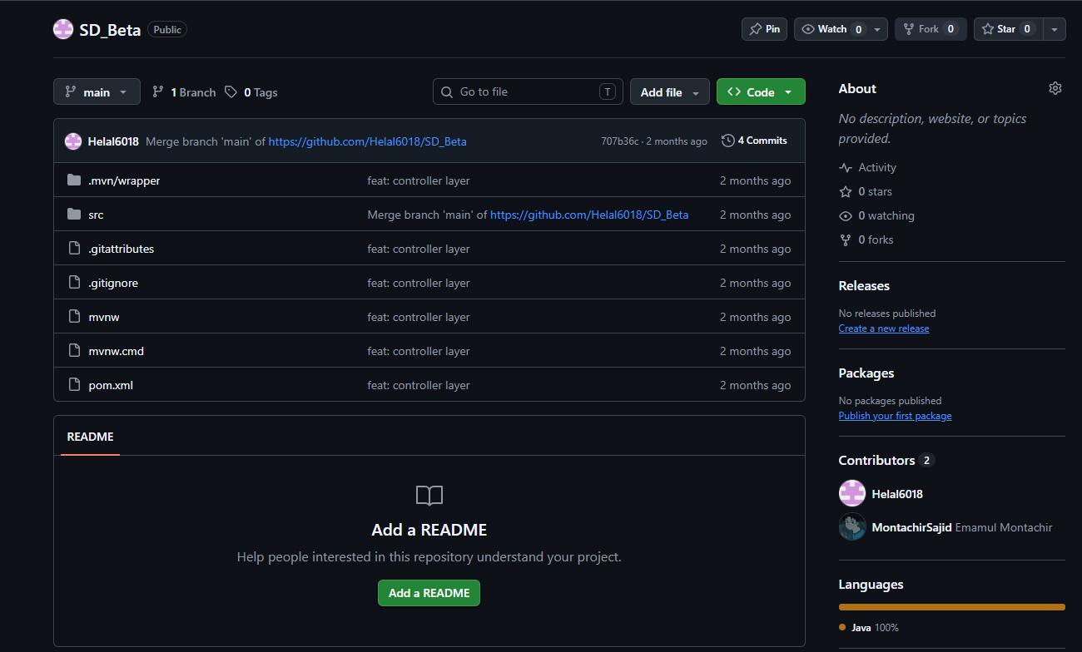
Figure 13: GitHub Collaboration and Commit History

6.3 Team Contributions
Team member | Student ID | Main contribution
Md Helal Uddin | C251033 | Model, data structure, Testing and documentation
Mohammed Emamul Montachir Sajid | C251022 | Controller and REST endpoints
Nurul Islam | C251031 | Service and storage logic

Chapter 7: Challenges and Solutions

7.1 Challenges Faced
One of the initial challenges was understanding the Spring Boot project structure. The team needed to understand the roles of the controller, service, model, and repository or DataStore.
Another challenge was creating correct endpoint mappings. Incorrect combinations of URLs, HTTP methods, and annotations sometimes caused requests to fail.
Sending JSON data through Postman was also a new experience. Errors occurred when the content type, property names, or time formats were incorrect.
The team also faced difficulties while using Git and GitHub. When several team members changed related files, merge conflicts sometimes occurred. Package-name differences and outdated local copies also created errors.
Running the project required correct Maven dependencies and a proper Java environment. Errors in the pom.xml file or application configuration prevented the server from starting.

7.2 Solutions Applied
The team solved structural problems by separating the application into clear packages. Each class was given a specific responsibility.
Postman was used repeatedly to test each endpoint and identify JSON-formatting problems. A consistent time format was followed for departure and arrival times.
Console error messages were examined to locate application problems. Maven dependencies were checked and reloaded when necessary.
For GitHub collaboration, team members pulled the latest changes before starting new work. Meaningful commit messages were used, and conflicts were reviewed carefully before merging.
The application was tested after every important change so that errors could be identified early.

Chapter 8: Limitations and Future Development

8.1 Current Limitations
The current version mainly provides backend REST APIs. It does not include a complete graphical web or mobile interface.
Authentication and role-based access control have not been implemented. Therefore, the application does not yet separate administrators, students, and drivers through secure accounts.
The system does not provide online booking, payment, real-time GPS tracking, email notifications, or SMS notifications. It is currently tested on localhost and has not been deployed to a public production server.
When ArrayList storage is used, all records are lost after the application stops. The system also provides only basic search, validation, exception handling, and concurrency support.
These limitations are acceptable for the current academic prototype but must be addressed before the application can be used in a real transportation environment.

8.2 Future Improvements
A future version should include a graphical frontend so that administrators and students can use the system without Postman. A React, Angular, or similar web interface could be connected to the REST APIs.
Spring Security and JWT authentication could be added to create secure administrator, student, and driver accounts. Role-based authorization could ensure that only administrators can create, update, or delete schedules.
A persistent database such as MySQL could be used to prevent data loss. Online booking and seat reservation could be added so that passengers can reserve seats before travelling.
GPS integration could provide live bus locations and estimated arrival times. Email, SMS, or application notifications could inform users about delays and schedule changes.
Automated testing using JUnit and MockMvc could improve reliability. Docker and cloud deployment could make the application easier to distribute and operate.

Chapter 9: Conclusion
The Transport Management System successfully demonstrates the development of a Spring Boot REST application for managing bus schedule information. The current module supports the main CRUD operations required to create, retrieve, update, and delete schedule records.
The project follows a layered architecture in which the controller handles HTTP communication, the service performs business operations, the model represents schedule data, and the repository or DataStore manages storage. JSON is used as the communication format between the client and server.
Postman testing was used to verify the API endpoints. Maven simplified dependency management, while Git and GitHub supported team collaboration and version control.
Through this project, the team gained practical experience with Java, Spring Boot, REST API development, JSON, Postman, Maven, Git, GitHub, debugging, testing, and software documentation.
Although the current system has several limitations, it provides a strong foundation for a complete transportation platform. Future versions can include authentication, persistent storage, online booking, notifications, real-time tracking, frontend integration, and cloud deployment.

