SYSTEM DESIGN DOCUMENT

1.0 Introduction

Virtual education is an emerging concept. Here the classes are not taken face-to-face in a classroom but through an electronic medium as a substitute. Taking up these virtual classes through an electronic medium is termed as E-Learning. E-Learning is proving itself as a boon for students especially for the disabled who are not able to go and attend the lectures.

1.1 Purpose

Developing a virtual classroom system to promote a greater count of students to splurge into the field of Education. The purpose of this software requirements specification is to verify that all the specifications are correct and are verified. This document also serves to ensure that the software is traceable throughout its software development life cycle.

1.2 Scope

This project has a lot of scope for future development. Features like ability to attach voice messages, attach document files as well as video presentations and many more such functionalities can be implemented in the later versions of the software.

1.3 Major constraints

For ensuring platform independence of the software, the implementation will be JAVA so the end users system must have a JAVA run time environment

1.4 Reference Material

<https://www.hindawi.com/journals/mpe/2021/9914790/>

<https://thejournal.com/Articles/1999/09/01/How-to-Design-a-Virtual-Classroom-10-Easy-Steps-to-Follow.aspx>

2.0 System Overview

3.0 Architecture

This section describes overall system function and the information domain in which it operates

3.1 System architecture

The system uses a B/S architectural pattern, i.e. browser/server pattern.

Design:

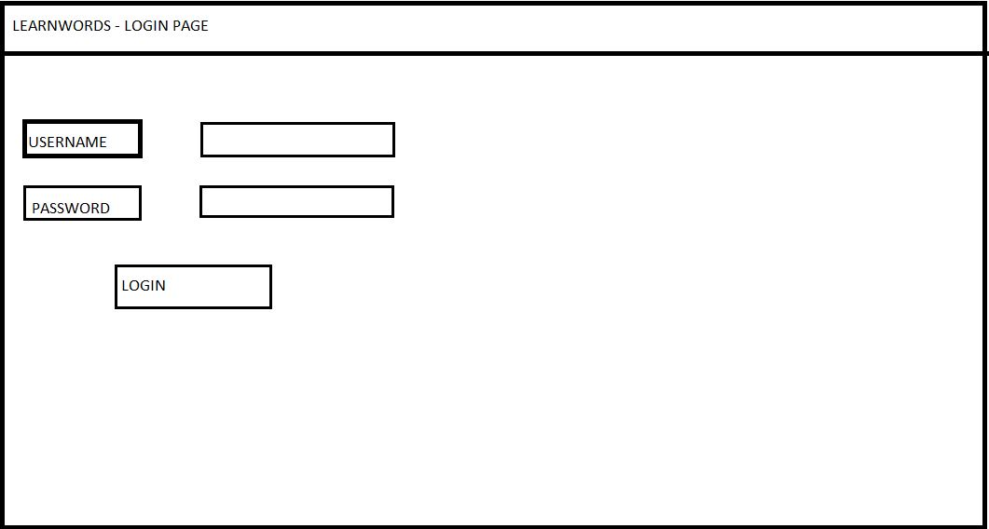

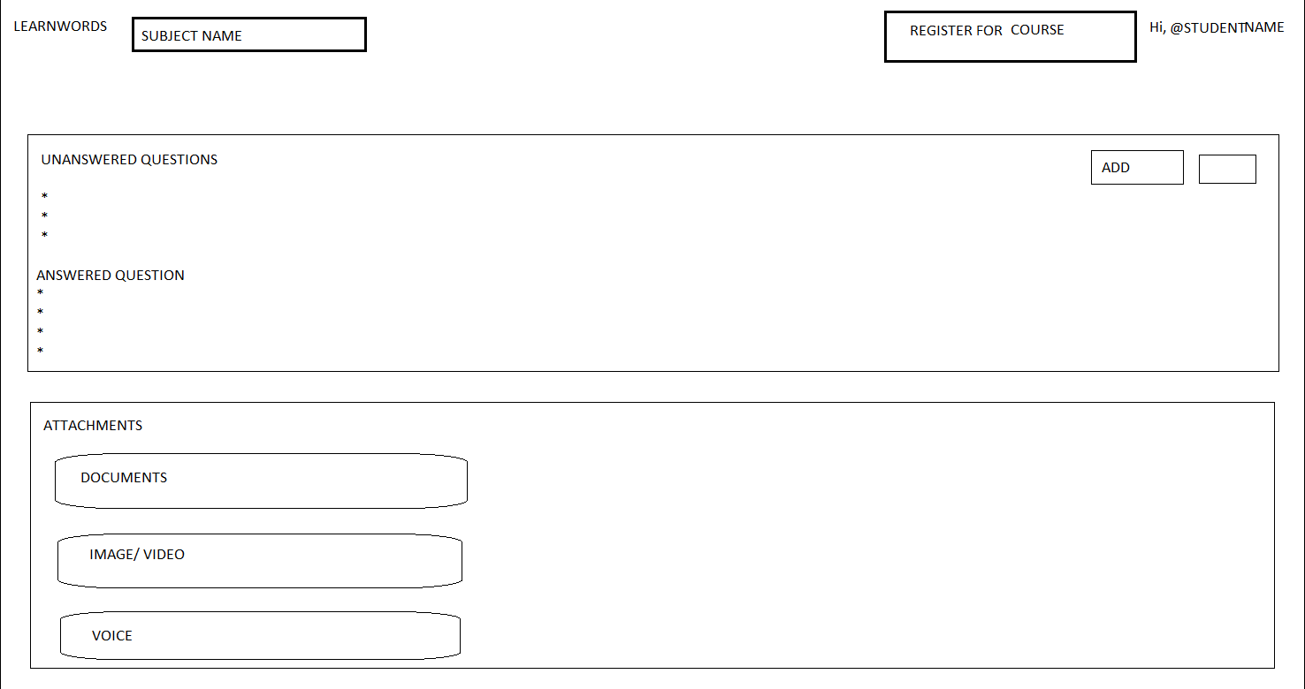

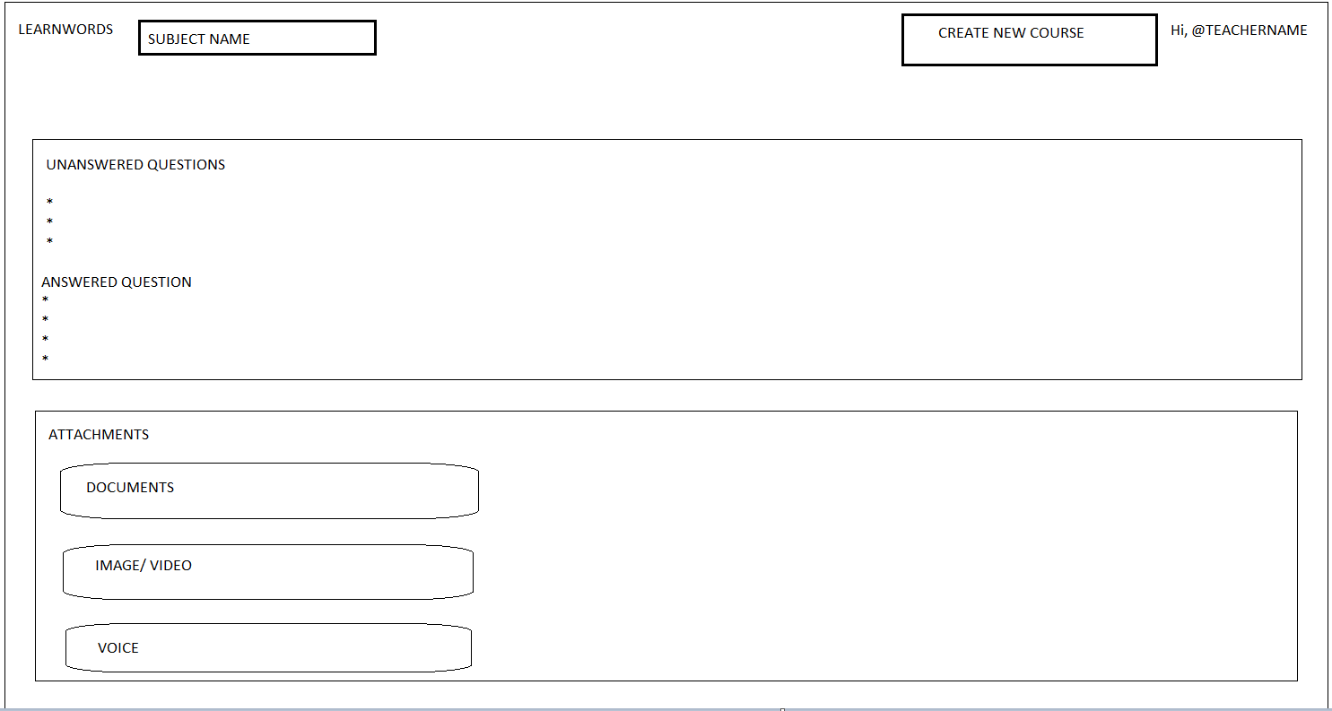

User Classes and Characteristics:

A use case diagram, is a visual depiction of the different scenarios of interaction between system actors and use cases. The usefulness of use case diagrams is more as a tool of communication.

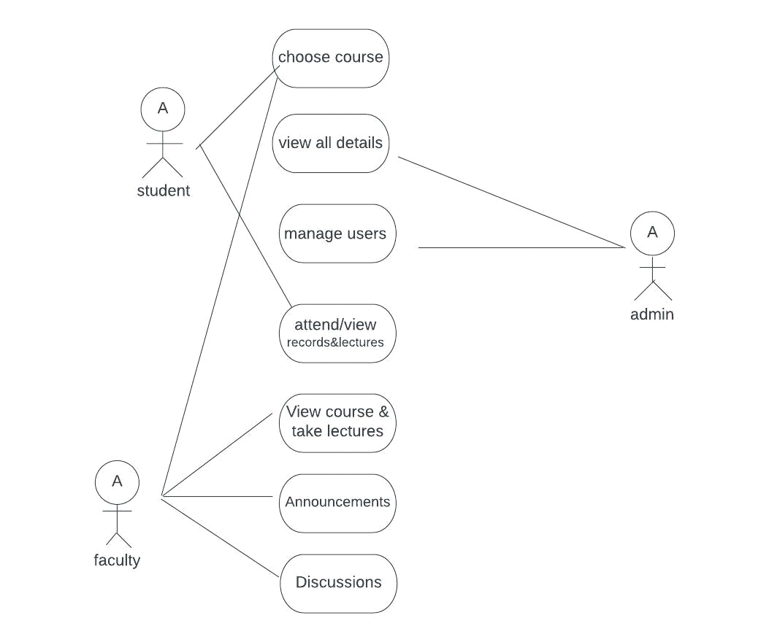

3.2 Design Rationale

The use of collaborative virtual environments in e-learning is one of the

most promising uses of virtual reality technology. While much research has been

done in the area of networked virtual environments corresponding to the sharing of

events, very little research has been done on specific services and functionality.

4.0 Class diagram Design

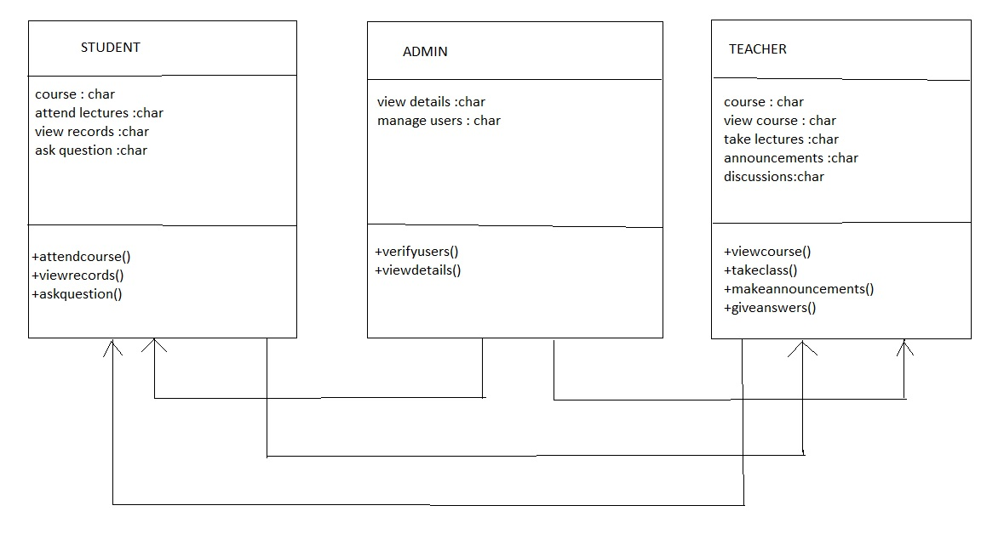

5.0 Human Interface Design

In any virtual learning system design, it is necessary to consider fundamental principles and rules of the user interface design in such system, and in this manner, in this research an adequate user interface is suggested for e-learning Environment in which has been evaluated with regard to these fundamental principles and rules. Evaluations have been done on this interface show its desirable ability to attract users’ satisfaction

6.0 Requirement Traceability

