**CHAPTER 1**

**INTRODUCTION**

Virtual classroom allows instructors to deliver web‐based training to geographically dispersed students, employees. A virtual classroom is an instrument for conducting live classroom-like sessions over the internet. In it, students and tutors can communicate using voice, video, chat and whiteboard tools. They also have facilities like application sharing, polling, breakout sessions and quizzes. It allows the tutor and students to participate in real time lessons and discussions. Students can ask questions, draw on the whiteboard, and participate in breakout sessions. Almost everything that can be done in a real classroom, can be done in a virtual classroom. Moreover, the whole classroom session can be recorded and made available for review afterwards. Virtual classroom can be used to hold live classroom lesson.

With the increasing use of network computers, the Internet and advances in telecommunication technology, e-Learning has been widely recognized as a valuable tool for learning and training [1]. The traditional means of higher education has remained dominant in schools in some developing countries. With the significant growth of e-learning, teachers and students normally explore new ways of constructing knowledge [2]. The current technology being heavily researched as an educational platform is the World Wide Web (WWW). The WWW which represents a platform for information storage and dissemination can be accessed in minimum time, and this is very important to the educational community. The fact is that the transition from digital divide society to a global village information society causes the traditional instructional model to be unable to cover the instructional needs of modern societies. The globe is faced with a transition from a static economy to a new knowledge driven economy. Population explosion and increasing admission request into schools in every region of the world brought greater constraints on the resources of several schools. For instance, there is problem of inadequate number of human and material resources to cater for the education of the large population. The population of school age citizen in most places has grown tremendously to the extent that only a small percentage can be offered admission [3]. A new learning environment needs to be created which will provide autonomy and flexibility, establish contacts and easy communication between centers of culture and knowledge, and facilitate easy access for all citizens of a knowledge-based society [4] Conventional classroom-based teaching involves the delivery of course lectures by the lecturer in a particular place at a specific time. Hence it imposes a constraint of time and place on both the instructor and the student. Due to the human factor, the lecturer may not always be able to put the optimum effort towards preparing and delivering course models. Direct interaction with the student is not easy because of the large number of students needing attention. The remedy to this situation seems to be the learning techniques that are based on modern technologies such as the Internet and WWW combined with traditional classroom teaching. One of the ways this can be achieved is through the use of virtual classrooms. A virtual classroom is an environment conducive for learning, which takes place in the cyberspace. It provides the tools that learners need and brings together educators and learners to share information and ideas. The virtual classroom is a special form of e-learning that finds relevant applications in enriching the conventional learning methods [5] opined that e-learning can be deployed using a wide range of technologies and media. The virtual classroom has its roots in the study of computers in education such as computer-mediated instruction and multimedia as an instructional tool. These broad fields covered not only hypermedia, such as web-based hypertext, but also non-internet instructional software design ranging from media school surgery tutorials to interactive CD-ROM geography atlases. Many of the issues facing these virtual classrooms, such as evaluation of interface design, integration of computers into course design, and social issues of computing are highly relevant to the design and use of internet-based virtual classrooms. Present technologies enable the creation of virtual classrooms using the Internet and its resources. For the educators and trainees, a benefit of the Internet as platform for virtual classroom is that the information that can be stored is almost limitless. One of the contributions of Virtual Classroom (VCR) is that access to high quality and flexible learning technologies [6]. The information being electronically stored can be accessed or downloaded by learners at their own pace, thereby overriding the constraint of time and place experienced in classroom-based learning. The involvement of the distance learning includes teaching using telecommunication tools, which transmit and receive numerous materials through data, voice, and video [7]. There is also an increased use of virtual classrooms (online presentations delivered live) as an online learning platform and classroom for a diverse set of education providers. In addition to virtual classroom environments, social networks have become an important part of e-learning [8]. The aim of this project is to provide a web enabled interactive model of e-learning in which the course material is presented using the advantages of multimedia and hypermedia.

Each subject includes a synchronous chat room for students. Besides being user friendly, good virtual classroom have built in collaboration tools that engage the students in active learning. For example, the virtual classroom has subject wise videos, and students who are not comfortable in asking question in front of teachers they can easily ask their questions. The Staff and the Student have to register in the website to use this website. The staff logs in and posts his lecture. The student logs in and views all the classes. If he has any doubt/query, he can post it and the staff give answers of those queries. The student can give examination to their Institute, can check their results in this site. The student can chat with staff for clarifying his doubts online. With the ever-increasing popularity and accessibility of the Internet, it is only natural that the educational community should want to make use of this tremendous resource. Use of the Internet and Web are leading to significant changes in educational models. Effective exploitation of these changes requires adequate attention to understanding the technology, the educational processes and issues, student’s characteristics, etc. Thus, E-Learning can be defined an approach to facilitate and enhance learning by means of personal computers, CD-ROMs, and the Internet. It may be as simple as that teachers may simply post their material on Internet, students can read it online or can download it for further access. Since student won’t be in a classroom with professor and classmates, he will need to be capable of independent learning. Instructor will provide him with a syllabus, course documents, and required readings. The interaction between the professor and the student will happen via e-mail, discussion board, forums etc. Since the class doesn’t meet in a physical space at a scheduled time, the student will have to learn independently.

The main intention of this project is to get good insight on existing education portal, which has a great future scope. Hence also, to see what else can be enhance in this domain in the mere future. Virtual classroom can be used to hold the classes by watching videos. Virtual classroom allows instructors to deliver web-based training to geographically dispersed student. employees, business partners and customers can also use if they needed. Each subject includes a synchronous chat room for students. Besides being user friendly, good virtual class room have built in collaboration tools that engage the students in active learning.

**CHAPTER 2**

**LITERATURE SURVEY**

Quite a lot of studies exist relating to e-learning, distance learning and virtual learning. These terms are sometimes used interchangeably. According to [9], e-learning means the learning that makes use of a network for delivery, interaction or facilitation. This type of learning includes distributed learning and distance learning. Computer-Based Training (CBT) is delivered over a computer network and web based training (WBT). It may be computer-based, synchronous, asynchronous, instructor-based or a combination of the aforementioned.

Some universities in Africa have implemented notable e-learning platforms. University of Nairobi for instance has implemented three different learning management systems in the last five years: Wedusoft, Chisimba and Claroline. A member of staff of the university specifically developed Wedusoft while Chisimba was adopted and implemented through collaboration with development partners. Currently, the university is using Claroline. A good number of available teaching and learning platforms use facilities like e-mail, wikis and bulletin board to provide students interaction, while some others use Learning Management System (LMS) [10]. Currently, the University of Cape Town is using Sakai as the major LMS. This has been customized and branded Vula. In the past, the university has deployed Moodle and WebCT as well. However, they still continue to seek for virtual learning platforms that would satisfy most of their requirements [10]. Previous works in the area of virtual classroom will be discussed in this section following their historical development of VCR, architectural design and system implementation and provision of elearning platforms for the disabled.

The paper in [8] addresses the history of distance learning, current issues, the federal government’s role, and four specific areas of improvement including: curricula change, new patterns of interaction, changes in organizational structures, and the roles and activities of participants in both business and academic distance-learning environments. A model for improving online educational systems for both teachers and learners was proposed in [8]. The model allows for more accurate assessment and more effective evaluation of the learning process. The model includes logistics systems to show that it could be necessary to integrate systems that handle shipment of textbooks and other physical materials to distance students. The study in [11] discusses the architectural design of an integrated system for the delivery of lectures in a virtual environment. The architecture and description of the system components are presented with the techniques and recommendations for the implementation of the designed system.

Kathleen A. Greenan, introduced a journal The Influence of Virtual Education on Classroom Culture[1] where she depicted the vital role of virtual classroom. a traditional class environment relies on verbal and nonverbal communication to create and foster cultural norms, behaviors, practices, and beliefs, virtual learning disrupts the process since technology changes an individual’s communication behaviors. It is important to develop social presence in virtual education courses through: 1) synchronous teaching and learning, and 2) self-disclosure for fostering student engagement, creating relationships, and building supportive class communities.

Ozgur Yilmaz [2] published a article on the effects of live virtual classroom on students achievement where he conducted a survey in such a manner 63 second-year Distance Computer Education & Instructional Technology students enrolled in this study. At the live virtual physics classroom, the instructor presented physics lessons. Midterm, final and make-up scores were examined after the LOC instruction. Students who are LOCFF (n=32), joined over 50 % percent and they had significantly higher scores than students who are LOCFR (n=31), joined below 50 % percent to the lessons. According to ttest result, LOCFF group more successfully than LOCFR group (p=.006*).

Sara Willermark[3] in 2021 established a journal of educational computing research where he focused on covid-19 crisis. He aims to explore aspects of interaction in the virtual classroom. The context is four high schools in Sweden. Data includes a teacher survey and ten workshops with teachers and school leaders. The interaction order framework is used as an analytic lens. The results draw a multifaceted picture of interaction that involves both increased and reduced contact with, and control over, the students and their activities. Some students find a place in the virtual classroom that they previously lacked, while others “disappear behind the screen.

Faieza Chowdhury[4] researched on how to create a digital Educational System in Bangladesh and concluded that The use of web-based tools for educational purposes is a rapidly growing trend in Bangladesh. This paper addresses students’ opinions on the use of virtual classroom from their own personal experiences and identifies features of virtual classroom that are vital to create an interactive student-centered learning environment. We try to understand whether the use of virtual classroom can bring improvement in students’ learning and performance in the class. The results from binary logistic regression indicate that most of the participants have positive opinions regarding the usage of virtual classroom for learning purposes. As the present Government of Bangladesh (GOB) has urged all higher education institutions (HEIs) to take effective measures in order to implement ‘Integrated University Information Management Platform’, the findings from this study will help educators and administrators to understand how to construct an interactive student-friendly academic portal that will fulfill all the needs of the customers and to assess whether the features of the existing portals that they are currently using need any further improvements.

Dussadee Seewungkum [Graduate School of Education Department, Siam University, Bangkok, Thailand] Hathairat Ketmaneechairat [College of Industrial Technology, King Mongkut University of Technology North Bangkok, Bangkok, Thailand] Mirko Caspar [Faculty of Computer Science, Chemnitz University of Technology, Chemnitz, Germany] [5]established an IEEE paper on a framework of virtual classroom. The architecture of virtual classroom on the Internet is composed of three processes: functions and protocol classification process, client/server sequential process and collaborative functions for lecturer and student process. The model bases up on four main technologies: the flash media server architecture, the RTMP protocol, client-server connection flows and shared objects. The concept has been implemented and tested in some classes with international participants. The results show that the students can immediately interact with lecturers as though they are studying in real classroom. The lecturer and students can publish streaming audio, video and other data messages to present streaming media with interaction or navigation.

[6]Bogdanova Signal Processing Institute (ITS), Swiss Federal Institute of Technology (EPFL), Lausanne, Switzerland , P. Vandergheynst Signal Processing Institute (ITS), Swiss Federal Institute of Technology (EPFL), Lausanne, Switzerland, M. Kunt Signal Processing Institute (ITS), Swiss Federal Institute of Technology (EPFL), Lausanne, Switzerland established a paper on multimedia teaching on WWW where they focused on specific functionality to allow a group of teachers and students to carry out the learning process in digital signal and image processing in an electronic virtual environment that is meant to replace the physical class environment. In order for such an environment to be obtained, not only the course content itself but also different Web-based tools for interaction between the students and teachers are needed. A graphical user interface (GUI), designed and presented in the paper, brings together the students and teachers through virtual class and lab-sessions help and chat rooms. As digital signal and image processing are areas that heavily depend on mathematics, the lab-sessions are performed through MATLAB Web Server.

Saba Maanvizhi, Jiyaram Neha Jaiswal, Ravi Ram Narayanan, Rajendra Rohit Jain, Members of Department of Pharmaceutics, Sri Ramachandra Faculty of Pharmacy, Sri Ramachandra Institute of Higher Education and Research, Porur, Chennai, Tamil Nadu, INDIA[7] exhibited a paper on virtual education which mainly focussed on field of education is going to be in high trend in the upcoming days and soon will be replacing the traditional mode of education as internet dependent learning is growing rapidly in almost every schools and colleges. Two major forms of virtual classroom are synchronous and asynchronous. In virtual classroom it’s the choice of student to take synchronous form of learning or asynchronous form, if synchronous is selected the online teaching is scheduled which is led by a teacher and students can interact at same time and can get their queries solved at the same time even from remote area. In asynchronous form the learner attain their education at their own pace and at their convenient time and it is time independent which in turn is sought to control the order of activities. It is a great field as the students can clarify their doubts at any time from any place. One of the important goals of this application is to improve collaboration among teachers and students.

The article in [2] attempts to develop a better understanding of students’ experiences of learning with the specific online learning technology of Adobe Connect virtual classroom. The research was carried out in a university in New Zealand using the method of case study. In [13], an investigative study from Norway was reported on the use of a virtual classroom and it affects learning and teaching. A student Master class was for two sessions exposed to the use of the Centre, being observed during the sessions and interviewed thereafter. An activity theory was engaged to frame the study. The research in [14] was aimed to investigate the impact of a number of e-learning activities on the students’ learning development. The results show that participation in virtual classroom sessions has the most substantial impact on the students’ final grades. This paper presents the process of applying data mining methods to the web usage records of students’ activities in a virtual learning environment. The main idea is to rank the learning activities based on their importance in order to improve students’ performance by focusing on the most important ones.

The purpose of the study in reported in this paper was to identify why instructors adopt synchronous virtual classrooms and how they use them after their adoption. In describing their reasons for adopting the technology, respondents most frequently cited institutional resource availability, increasing social presence, enhancing student learning, and the availability of technology. Students on various campuses of tertiary institutions are facing certain level of challenges that affect their participation in classes and learning generally. Some of these students may be physically challenged, and hospitalized due to illness or may be involved in one type of job or the other to be able to meet up with their financial needs. Web-based learning therefore offers interesting opportunities and democratic advantage to these categories of students. Certain studies in the past also addresses provision of assistive learning technology for the physical challenged. For instance, a paper reported a voiced-based learning system for the virtually impaired learners. More so, the paper in presents a central learning system, whose goal was to facilitate teaching and learning for both teachers of the deaf and deaf impaired persons in Jordan.

**CHAPTER 3**

**PROBLEM IDENTIFICATION**

In most cases, this is exactly what learners anticipate, leading virtual classroom usage into a vicious cycle. Although the technology is available for virtual classrooms to move beyond traditional (face-to-face) educational settings and to include practices that cannot be carried out in a traditional classroom, this is not the case and it will probably take some more years to become a widespread practice. This situation is similar in many cases when a modern technology is introduced in a field with established methods and traditions for numerous years. The use of virtual classrooms was initially driven by necessity, mainly in the context of synchronous distance learning, where a professor had to emulate a typical classroom for distance students. In these early examples, the main goal was to succeed to offer students an experience similar to a face-to-face classroom.

The main challenge of a virtual classroom is keeping students focused. Unlike a traditional classroom, teachers cannot walk around the room to supervise students. As most of the children can get easily distracted, they will not be able to grasp what the teacher is teaching online. Presently, many online platforms arise where they provide video lectures for making the students to be interactive as well attentive to the class. Here in this project, we can provide voice facilities rather than video facilities.

**CHAPTER 4**

**PROPOSED SYSTEM**

**4.1 EXISTING SYSTEM**

A virtual classroom is an online teaching and learning environment where teachers and students can present course materials, engage and interact with other members of the virtual class, and work in groups together. The key distinction of a virtual classroom is that it takes place in a live, synchronous setting. Online coursework can involve the viewing of pre-recorded, asynchronous material, but virtual classroom settings involve live interaction between instructors and participants. Virtual classrooms today are used by educators to replicate a customary practice carried out for centuries, i.e. to teach exactly as they did in a typical classroom. In most cases, this is exactly what learners anticipate, leading virtual classroom usage into a vicious cycle. Although the technology is available for virtual classrooms to move beyond traditional (face-to-face) educational settings and to include practices that cannot be carried out in a traditional classroom, this is not the case and it will probably take some more years to become a widespread practice. This situation is similar in many cases when a modern technology is introduced in a field with established methods and traditions for numerous years. The use of virtual classrooms was initially driven by necessity, mainly in the context of synchronous distance learning, where a professor had to emulate a typical classroom for distance students. In these early examples, the main goal was to succeed to offer students an experience similar to a face-to-face classroom. In many cases this wasn’t succeeded, due to network and equipment limitations that lead into sound and video problems, as well as due to lack of suitable tools.

**4.2 PROPOSED SYSTEM**

The ultimate aim of this project is to provide a suitable educational system as well as easy to follow guidelines on how to propel the lectures from the conventional dull chalk and talk environment to the realm of all interactive computer assisted Web based electronic classroom. This website allows full student interaction and use of multimedia in the lecture. Comparing the existing websites, this project relies more emphasis on voice supporting.

A student can login and register for the course. He/she is able to ask questions to the respective course teacher. There is a partition for answered and unanswered questions in order to easily understand. He/she can view the documents, images or videos which is attached by the teacher.

In the teacher panel, teacher can add new course with a course id and a course name. He/she has the ability to answer the questions asked by the student. He/she can attach the attachment files like documents/videos/images/voice using a URL.

**4.3 PROJECT PLAN**

The model that is basically being followed is the WATER FALL MODEL, which states that the phases are organized in a linear order. First of all, the feasibility study is done. Once that part is over the requirement analysis and project planning begins. If system exists one and modification and addition of new module is needed, analysis of present system can be used as basic model. The design starts after the requirement analysis is complete and the coding begins after the design is complete. Once the programming is completed, the testing is done. In this model the sequence of activities performed in a software development project are: ‐

1. Requirement Analysis

2. Project Planning

3. System Design

4. Coding

5. Unit testing

6. System integration & testing

The first step of preliminary study in the system analysis process involves the identification of needs for computerization. The motivation behind this project is to overcome all the defects in the existing system. Some of the difficulties are:

1. Existence of both students and instructor is must.

2. Some of the students may not clearly express the doubts in front of the instructor.

Some of the features of the proposed system are:

1. We provide voice supporting features which can help the student to understand far better than via reading.

2. There is no need of presence of both instructor and student at same time.

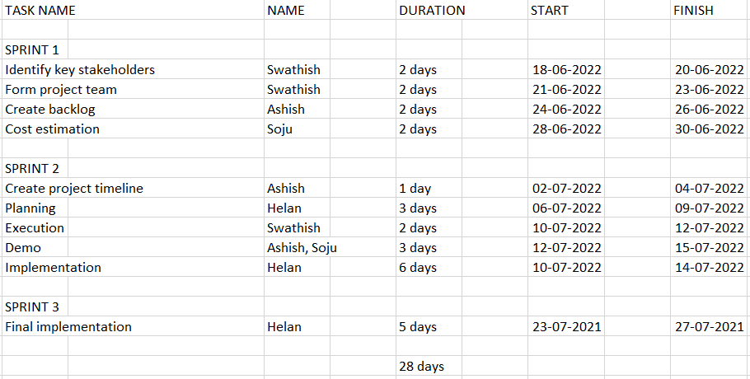

Fig 9: Project Plan

**4.4 FEASIBILITY STUDY**

System requirement is the process of gathering and interpreting facts, diagnosing the problems and using the information to recommended improvements on the system. System requirement is a problem-solving activity that requires intensive communication system user and system developer. In system analysis the system is studied to the fundamental detail and analyzed. The system analyst plays the role of an interrogator and dills deep into the working of the present system. The system is viewed as a whole and the inputs to the system are identified. The outputs from the organization are traced through various phases of the processing of inputs.

Feasibility study is done in my software development as a part of preliminary investigation. Specific method used by the analysis for collecting data about requirements and fact-finding techniques. These include record review, observations, interview and questionnaires. When the request is made, the first system activity, the preliminary investigation begins. This activity has 3 steps among them feasibility study is important. Feasibility study is an important outcome of the preliminary investigation and is the determination that the system request is feasible. And my website **LEARNWORDS** satisfies the different types of the feasibility studies. They are listed below:

The study done in three phases:

4.4.1 Operational feasibility

4.4.2 Technical feasibility

4.4.3 Economical feasibility

4.4.4 Hardware feasibility

4.4.5 Software feasibility

**4.4.1 Operational Feasibility**

Proposed systems are beneficial only if they can be turned into information systems. That is it will meet the organizations operating requirements and also checks that whether the system will work when it is developed and installed. *The Learnwords* supports the operational feasibility to a great extends. The performance of this software is more accurate, more user friendly, effective, error free.

**4.4.2 Technical Feasibility**

This is related to the technicality of the project. This evaluation determines whether the technology needed for the proposed system is available or not. It deals with hardware as well as software requirements. That is, type of hardware, software and the methods required for running the systems are analyzed. This involves financial consideration to accommodate technical enhancement. If the budget is a serious constraint, then the project is judged not feasible. The website LEARNWORDS supports the technical feasibility to a great extends. That is, this software can be operated with the minimum technical support. It uses JAVASCRIPT as front end, MYSQL as database at windows platform and Google Chrome as browser. And also, it provides accuracy, reliability, ease of access and data security.

**4.4.3 Economic Feasibility**

Economic analysis is the most frequently used for evaluating the effectiveness of a proposed system. More commonly known as cost/benefit analysis: the procedure is to determine the benefits and saving that are expected from a proposed system and compare them with cost. If benefits outweigh cost, a decision is taken to design and implement the system. Otherwise, further justification or alternative in the proposed system will have to be made if it is to have a chance of being approved. This is an ongoing effort that improves accuracy at each phase of the system life cycle. Hence the engineer will not find any difficulty at the installation time and after installation user also never find difficulty i.e., hang, slow speed or slow response time. One project is compulsory for each student this project is either dummy or lives. If I am 13 developing a live project then it gives a lot of confidence. It is better for me and for company because, I am developing a system without any money. So, everything is in favor now, I can say the cost of this software is I think negligible. Hence the economic feasibility is very good.

**4.4.4 Hardware feasibility**

The software can be developed with resource already existing. Here the consideration is that the existing hardware resources support the technologies that are to be used by the new system. No hardware was newly bought for the project and hence software is to achieve hardware feasibility.

**4.4.5 Software feasibility**

Even though software is developed in a very high software environment, it will be sup- ported by many other platform and environments with minimum changes.

**CHAPTER 5**

**REQUIREMENTS SPECIFICATION**

**5.1 Performance Requirements**

It requires an internet access, 256 MB of memory, and the system requires a google chrome or Firefox. System may require users to download updates to become compatible and compliant with the system.

**5.2 Safety & Security Requirements**

The user is responsible for content uploaded. Users may not use the system to upload or post data which is discriminatory in regards to race, caste or religion.

**5.3 Software Quality attributes**

The performance depends on the availability of the bandwidth. The portal may be periodically unavailable due to maintains upgrades.

**5.4 External Interface Requirements**

**5.4.1 User Interface:**

Virtual classroom software enables instructors to moderate student participation

display learning materials in the form of documents, slide decks, or multimedia files.

**5.4.2 Software Interface:**

It should be possible for E-learning tool to be implemented in both Windows and Linux Operating System environments. The GUI and other parts of the E-learning tool software are to be done in JAVA and J2EE.The output of this software will need a web browser for viewing it.

**5.4.3 Hardware Interface:**

Monitor screen – the software shall display information to the user via the monitor screen

Mouse – the software shall interact with the movement of the mouse and the mouse buttons. The mouse shall activate areas for data input, command buttons and select options from menus.

**CHAPTER 6**

**SYSTEM DESIGN**

**6.1 DATA FLOW**

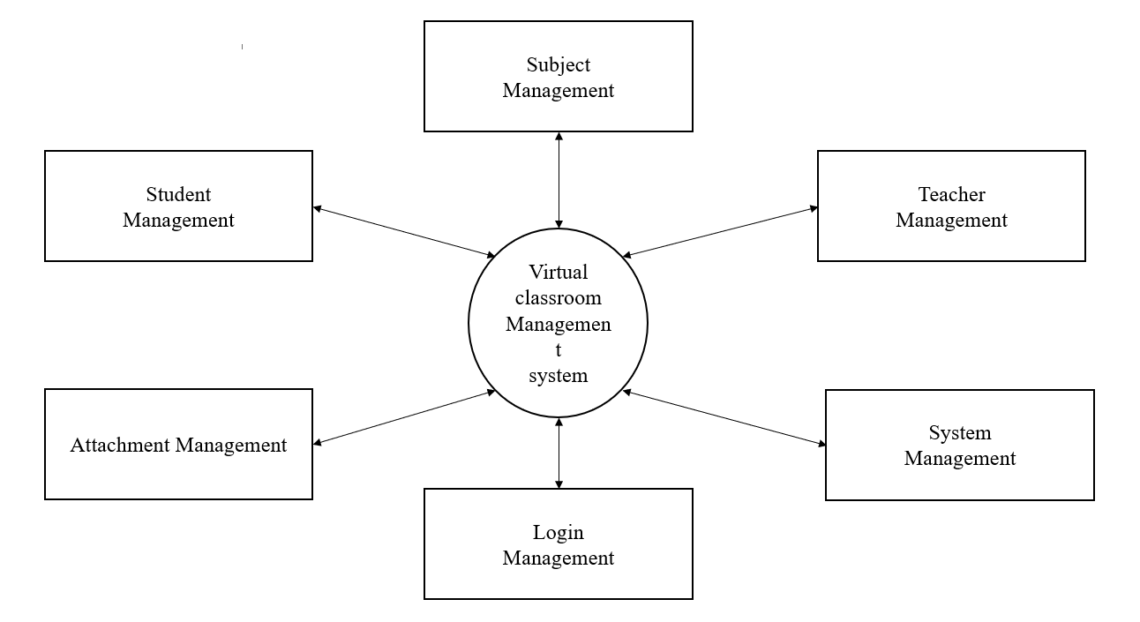

Fig 9 :Data Flow

**6.2 USECASE DIAGRAM**

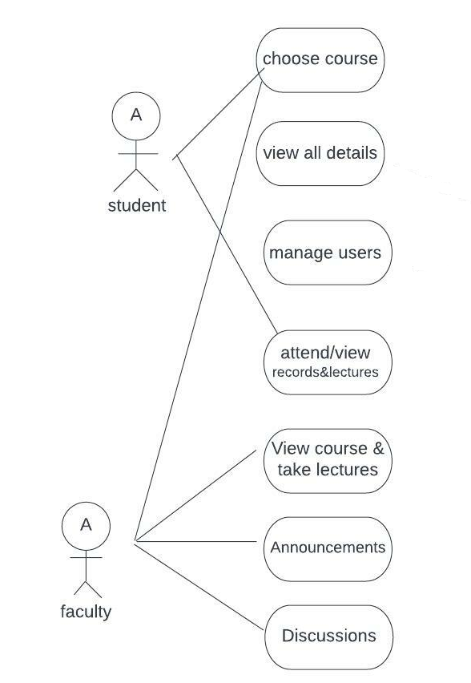Fig 1: Use case diagram

**6.3 CLASS DIAGRAM**

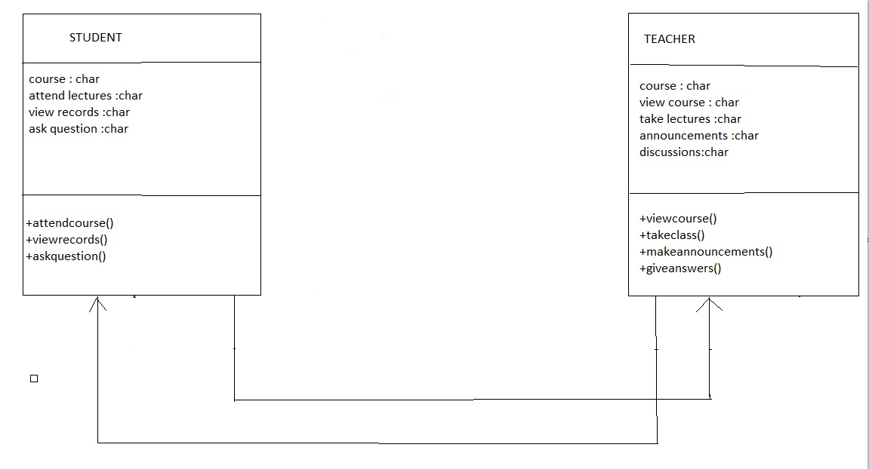

Fig 2: Class diagram

**6.4 INTERACTION DIAGRAM**

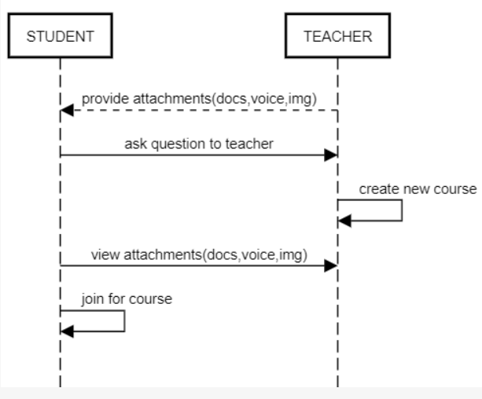

fig 7: Interaction Diagram

**6.5 SEQUENCE DIAGRAM**

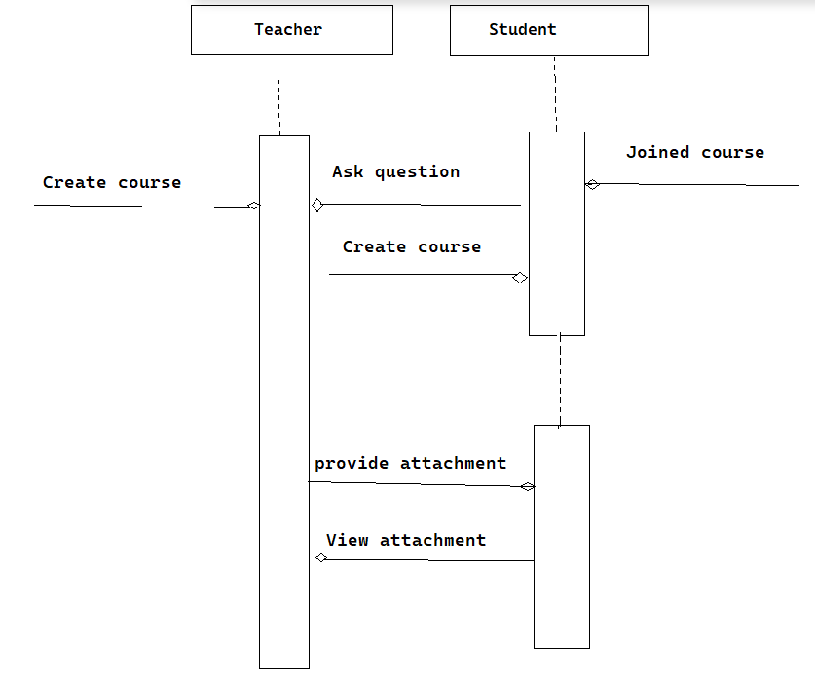

Fig 8: Sequence Diagram

**6.6 DATA BASE DESIGN**

Database Management System allows data to be protected and organized separately from other resources. Database is an integrated collection of data. This is the difference between logical and physical data. Database is a collection of interrelated data stored with minimum redundancy to serve many users quickly and effectively. The general objective is to make information 26 access easy, quick, inexpensive and flexible for users. The database approach to system design places greater emphasis on the integration, integrity and independence of data. The database design directly affects the performance of the software application. The database is normalized so as to avoid redundant data. Normalization reduces the wastage of valuable memory space. The database for this project has been created with at most care so as to follow the principles of normalization. The achievements from such a normalized database helped to

* + Control redundancy
  + Data independency
  + Ease of learning and use
  + More information at low cost
  + Accuracy and integrity, recovery and failure

The aim of database design is to create a group of relation schemas that symbolize the real-world situation that is being modelled. Normalization is the main concept of database that identifies relational schemas based upon their primary or candidate keys and the functional dependencies that exist among their attributes.

**Table Name:**

**Table 1: user_table**

|  |  |  |  |  |  |
| --- | --- | --- | --- | --- | --- |
| **Userid** | **username** | **Typeofstudent** | **password** |  | **listofcourses** |
| 1 | Abel | Student | abel01 |  | null, mal02 |
| 2 | Ajmal | Student | ajmal02 |  | eng01, mat01 |
| 3 | Akhilesh | Student | akhilesh03 |  |  |

**Table 2: attachmentlist_table**

|  |  |  |  |  |
| --- | --- | --- | --- | --- |
| **Attachmentid** | **attachment type** | **Name** | **Link** | **courseid** |
| 1657382695812 | English clip | Document | https://projectsgeek.com/2011/06/virtual-classroom-java-project.html | eng01 |
| 1657428400585 | English clip | Document | https://projectsgeek.com/2011/06/virtual-classroom-java-project.html | eng01 |
| A1 | English clip | Voice | <https://ieeexplore.ieee.org/document/6476574/authors#authors> | Eng01 |
| A2 | English clip | Document | https://projectsgeek.com/2011/06/virtual-classroom-java-project.html | Eng01 |
| A3 | English clip | Document | https://projectsgeek.com/2011/06/virtual-classroom-java-project.html | eng01 |
| A4 | English clip | Document | https://projectsgeek.com/2011/06/virtual-classroom-java-project.html | eng01 |
|  |  |  |  |  |

**Table 3: userlogin_table**

|  |  |
| --- | --- |
| **Username** | **Password** |
| bmc01 | Abel |

**Table 4: course_table**

|  |  |
| --- | --- |
| Courseid | coursename |
| daa30 | Data Analysis |
| eng01 | Introduction to English |
| mat01 | Mathematics World |

**Table 5: question_table**

|  |  |  |  |  |
| --- | --- | --- | --- | --- |
| Question id | question text | courseid | answer | is_answered |
| 1656846660973 | What is the past tense of speak | eng01 | null | 1 |
| 1656846819147 | What is the past tense of clean? | eng01 | spoke | 1 |
| 1656855388549 | what is addition | mat01 | 1+1 | 1 |
| q1 | What is the past tense of speak? | eng01 | spoke | 1 |
| q2 | What is the past tense of buy? | eng01 | bought | 1 |
| q3 | What is the past tense of strong? | eng01 |  | 1 |
| q4 | What is the past tense of weak? | eng01 |  | 1 |
| q5 | What is the table of 2? | mat01 |  | 1 |

**CHAPTER 7**

**IMPLEMENTATION**

**7.1 SYSTEM IMPLEMENTATION**

Implementation phase is the phase, which involves the process of converting a new system design into an operational one. It is the key stage in achieving a successful new system. Implementation is the stage if the project, where the theoretical design is turned into a working system. At this stage the main workload, the greatest up heal and the major impact on existing practices shift to user department. If the implementation stage is not planned and controllers carefully, it can cause chaos. The implementation stage is a system project in its own right. It involves careful planning, investigation of the current system and its constraints on the implementation, design methods to achieve the changeover procedures, and evaluation of change over methods. The implementation plan consists of the following steps

* Testing the developed system within the sample data
* Detection and correction of errors
* Making necessary changes in the system
* Training and involvement of user personnel
* Installation of software utilities

The implementation phase is less creative than system design. A system project may be dropped at any time prior to the implementation, although it becomes more difficult when it goes to the design phase. The final report to the implementation phase includes procedural charts record layout and a workable plan for implementing the candidate system. Implementation is used to the process of converting a new or revised system design into am operational one. Conversion is one aspect of implementation. Several procedures are unique to the implementation phase.

Maintenance is the most-costly process in the development of software. It is necessary to eliminate the errors in the system during its working life and to tune the system to tune the system to any variation in its working environment. The key software maintenance issues are both managerial and technical.

**7.2 MODULAR DESIGN**

Virtual classroom means a platform of teachers and students for teaching-studying relationship. The purpose of the virtual classroom system is to integrate the benefits of a physical classroom with the convenience of a “no-physical-bar” virtual learning environment. It will usher in the immense flexibility and sophistication in the existing learning platform structures, with the perfect blend of synchronous and asynchronous interaction. It provides a means of collaborative learning for the students.

This is mainly divided into two modules i.e., for a faculty and a student.

1. Students

Students can view the courses and join in the respective courses. They can view the lectures and ask any questions in need. Students can choose courses, attend lectures, view their attendance records, as per their convenience. There can be forums to discuss various queries and to put up suggestions posted both by students and teachers.

Student can login with their username and password to the respective course and can view the documents, video clip links or voice clip links. He or she can ask questions to the respective teacher for any clarification.

Student can also enrol for a course using the subject code and subject name and see the respective files.

1. Faculties

The main role of faculties is to take lectures, attach documents, attach voice clips and also respond to the queries asked by a student.

The faculty can create a new course by adding the course code and course name. He or she can add attachments like documents or video or voice clips for their students. He or she can answer to the questions raised by the student.

**7.3 WORKING**

A student can join using a username and password and he or she is able to join for a new course. The joined course provides the respective course details which the faculty has provided. The details include document files attached, voice or video links. The student can join the course and view the attachments. He or she can raise any question to the faculty. The faculty when she or he joins will reply back to the question raised by yourself.

The faculty has the ability to create a new course for their students. He or she can provide the subject related documents, can add voice clips or video clips through the link provided by the faculty. She or he has the ability to create a new course which is absent for student page. The questions raised by the student can be seen in the dashboard and the faculty can easily answer the questions which directly moves to answered section in the dashboard and the remaining unanswered questions stays in the same section itself.

**SCREENS**

(i) student

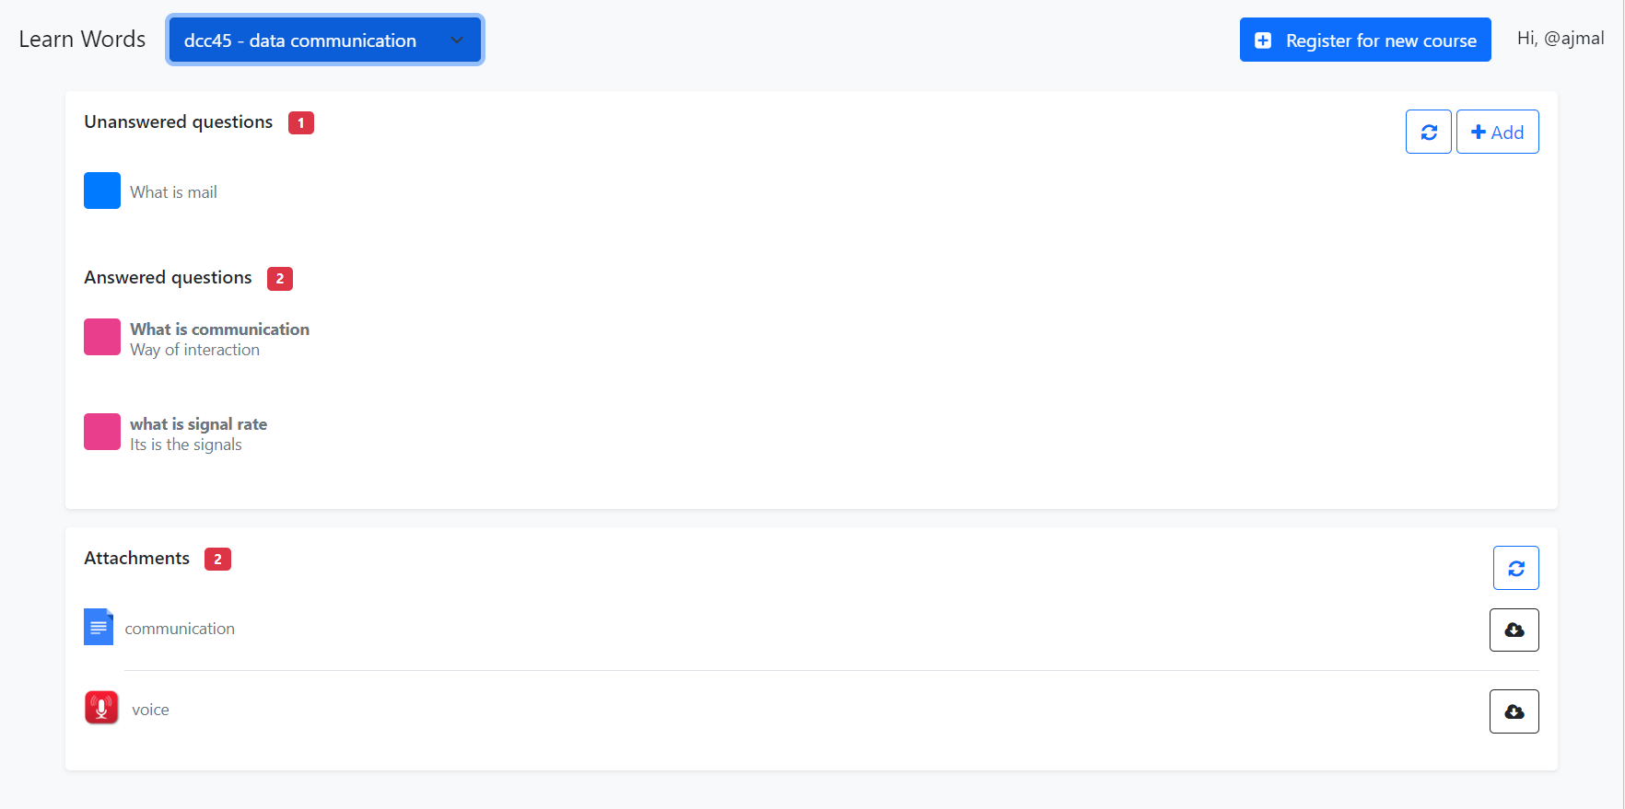

(ii) new course

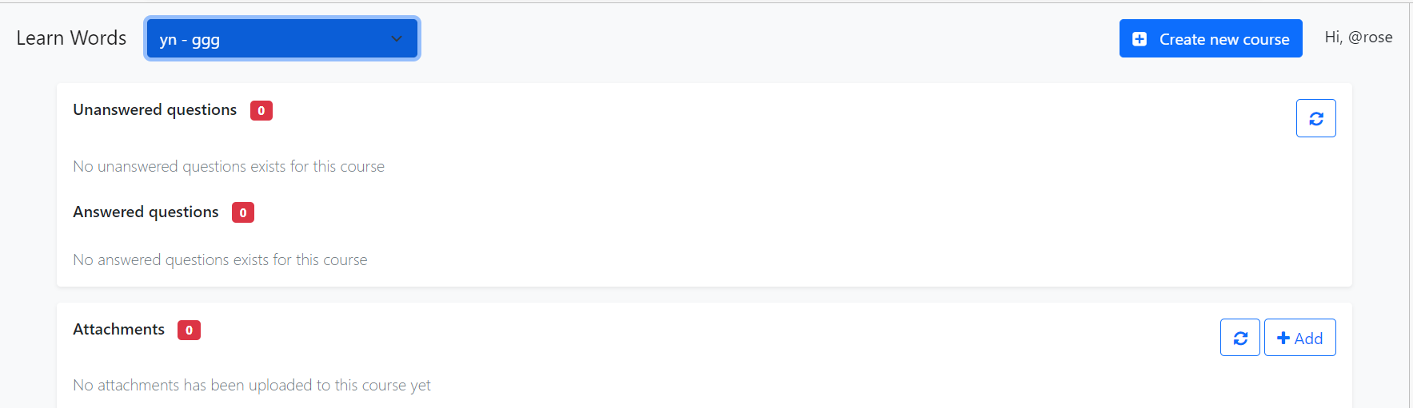

(iii) teacher

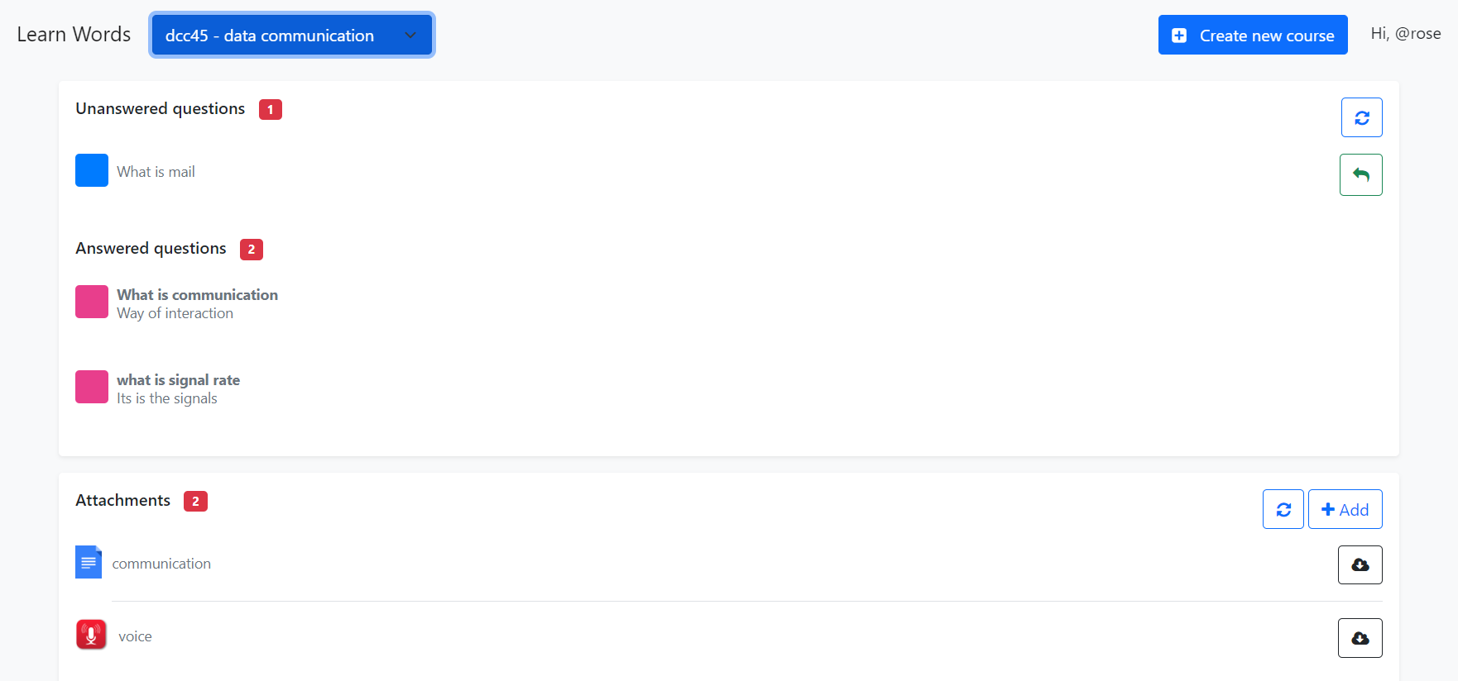

(iv) add question

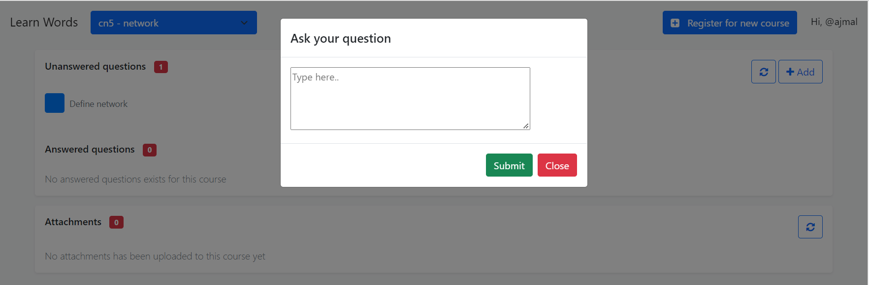

(v) create new course

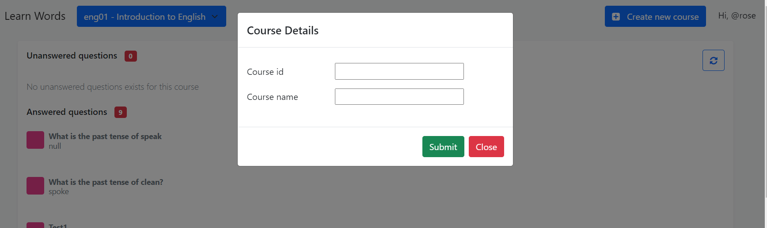

(vi) add attachment

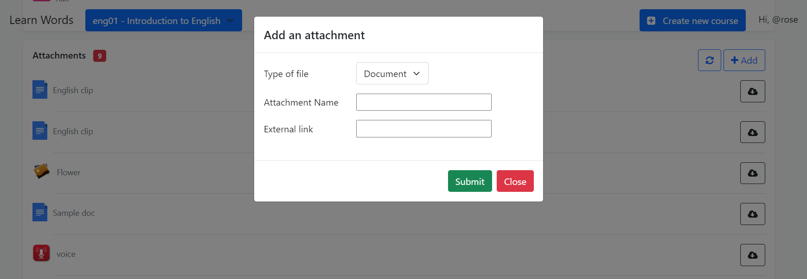

**CHAPTER 8**

**TESTING**

System testing is the key technique to ensure the successful operation of the system been developed in all context. It is very much important to see if the proposed system works properly on the intended delivery platforms and they meet the needs of your client or end user. System testing is a type of software testing that is performed on a complete integrated system to evaluate the compliance of the system with the corresponding requirements. In system testing, integration testing passed components are taken as input. The goal of integration testing to detect any irregularity between the units that are integrated together. System testing detects defects within both the integrated units and the whole system. The result of system testing is tested. System testing is carried out on the whole system in the context of either system requirement specifications or in the context of both.

**8.1. LEVELS OF TESTING**

• Unit testing.

• Integration testing.

• Acceptance testing.

**8.1.1 Unit testing**

Unit testing focuses efforts on the smallest unit of software design. This is known as module testing. The modules are tested separately. The test is carried out during programming stage itself. In this step, each module is found to be working satisfactory as regards to the expected output from the module.

**8.1.2 Integration testing**

Data can be lost across an interface. One module can have an adverse effect on another, sub functions, when combined, may not be linked in desired manner in major functions. Integration testing is a systematic approach for constructing the program 38 structure, while at the same time conducting test to uncover errors associated within the interface. The objective is to take unit tested modules and builds program structure. All the modules are combined and tested as a whole.

**8.1.3 Acceptance testing**

User acceptance of a system is the key factor for the success of any system. The system under consideration is tested for the user acceptance by constantly keeping in touch with the prospective system users at the time of developing and making changes whenever required.

**8.2 TEST CASE ANALYSIS**

Test cases are the key to the process because they identify and communicate the conditions that will be implemented in test and are necessary to verify successful and acceptable implementation of the product requirement. They are all about making sure that the product fulfils the requirements of the system.

**Table 6: Testcase Analysis**

|  |  |  |  |
| --- | --- | --- | --- |
| **Testcase** | **Test Procedure** | **Condition** | **Passed/Failed** |
| Login Page | To check whether the  control from the login  screen goes to the main  menu. | Enter a valid  user name and  password on  the login screens  The control  should go to the  home page | Pass |
| Add new course | Teacher adds a new course | A new course gets created when clicked submit | Yes |
| Add new question | Student can add question to the respective course | A new question created when clicked submit | Yes |
| Add any attachments | Teacher can add attachments (docx, voice, img, video) | Attachment with name, URL can be submitted and goes to the respective link. | Yes |

**8.3 TRACEABILITY MATRIX**

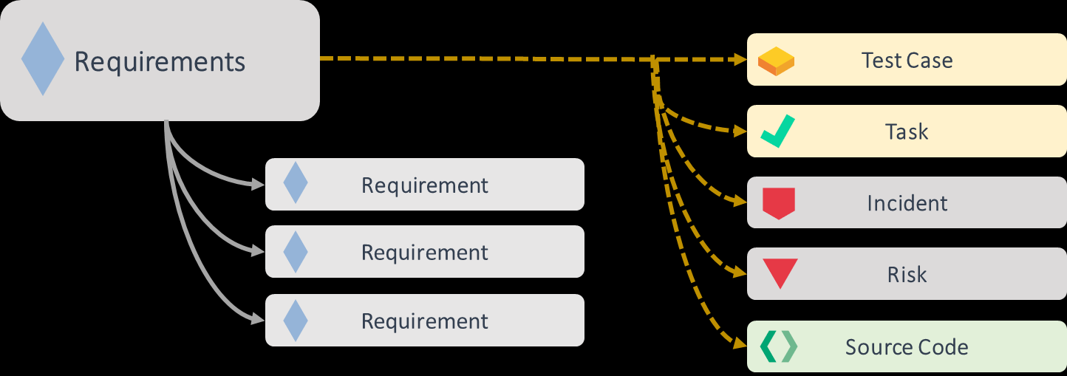

**8.4 TEST PLAN**

Cocomo (Constructive Cost Model) is a regression model based on LOC, i.e. **number of Lines of Code**. It is a procedural cost estimate model for software projects and is often used as a process of reliably predicting the various parameters associated with making a project such as size, effort, cost, time, and quality.

The key parameters which define the quality of any software products, which are also an outcome of the Cocomo are primarily Effort & Schedule:

* **Effort:** Amount of labour that will be required to complete a task. It is measured in person-months units.
* **Schedule:** Simply means the amount of time required for the completion of the job, which is, of course, proportional to the effort put in. It is measured in the units of time such as weeks, months.

Quick glance at the formulae:

**Effort**: a * (Size)b person-month

**Time for development**: 2.5 * (Effort)c month

|  |  |  |  |
| --- | --- | --- | --- |
| Project Type | A | B | c |
| Organic | 2.4 | 1.05 | 0.38 |
| Project Size | 2 |  |  |
| Effort | 4.141 |  |  |
| Time | 2.430 |  |  |
| # of developers | 4 |  |  |

**CHAPTER 9**

**RESULT ANALYSIS & FUTURE SCOPE**

Future Enhancement means adding, modifying or developing the code to support the changes in the specification. Every module in the system is being developed carefully such that the future enhancements do not affect the basic performance of the system. In traditional classroom the subject to be studied is given, the time table for its study is made available, the teachers for each topic is allotted, a classroom with four walls is provided, the time for each teacher is allotted, the time for students are also fixed, in some cases along with black board projectors and smart TV is provided, there are also time when students hunt for their teachers to get a query solved, or some time teachers are made to wait for all students to arrive. In virtual classroom it’s the choice of student to take synchronous form of learning or asynchronous form, if synchronous is selected the online teaching is scheduled which is led by a teacher and students can interact at same time and can get their queries solved at the same time. This is done with the help of internet at any type of device.

The students who learn through virtual classroom is seem to have more knowledge and good performance as they study with their own interest and not by force which normally occurs in traditional classrooms. Even if learner forgets any concepts, they can review the recorded videos and get them revised. In this application, both the tutor and the learner is benefited in training and learning. One of the important goals of this application is to improve collaboration among teachers and students. The physical barriers between classroom and student have been minimized due to virtual classroom. Future scope of this field is to make application that will help the user in many platforms and would be more useful and more user-friendly on the basis of the user’s experience.

**CHAPTER 10**

**CONCLUSION**

The project was successfully completed within the time span allotted every effort has been made to present the system in more user-friendly manner. The new system has overcome most of the limitations of the existing system and works according to the design specification given. The developed systems dispense the problem and meet the needs of by providing reliable and comprehensive information. All the requirements projected by the user have been met by the system. The newly developed system consumes less processing time and all the details are updated and processed immediately.

The implementation phase is less creative than system design. A system project may be dropped at any time prior to the implementation, although it becomes more difficult when it goes to the design phase. The implementation stage is a system project in its own right. It involves careful planning, investigation of the current system and its constraints on the implementation, design methods to achieve the changeover procedures, and evaluation of change over methods.

**REFERENCES**

[1][Frontiers | The Influence of Virtual Education on Classroom Culture (frontiersin.org)](https://www.frontiersin.org/articles/10.3389/fcomm.2021.641214/full)

[2] [(PDF) The effects of “live virtual classroom” on students’ achievement and students’ opinions about “live virtual classroom” at distance education (researchgate.net)](https://www.researchgate.net/publication/282889631_The_effects_of_live_virtual_classroom_on_students'_achievement_and_students'_opinions_about_live_virtual_classroom_at_distance_education)

[3] [Who’s There? Characterizing Interaction in Virtual Classrooms - Sara Willermark, 2021 (sagepub.com)](https://journals.sagepub.com/doi/10.1177/0735633120988530)

[4] [Virtual Classroom: To Create A Digital Education System in Bangladesh | Chowdhury | International Journal of Higher Education (sciedu.ca)](https://www.sciedu.ca/journal/index.php/ijhe/article/view/17172/0)

<https://fdocuments.in/document/srs-for-virtual-eucation.html>

<http://en.wikipedia.org/wiki/History_of_virtual_learning_environments/>

<https://www.slideshare.net/susheel2658/srs-for-virtual-eucation>

[5] [A framework of virtual classroom model on the Internet | IEEE Conference Publication | IEEE Xplore](https://ieeexplore.ieee.org/document/6476574/authors#authors)

[6] [Virtual classroom for multimedia teaching on WWW | IEEE Conference Publication | IEEE Xplore](https://ieeexplore.ieee.org/abstract/document/1158195)

[7] [A Review on Virtual Classroom | Indian Journal of Pharmaceutical Education and Research (ijper.org)](https://www.ijper.org/article/1280)

IBM Software - IBM Lotus Virtual Classroom www.ibm.com/lotus/virtualclassroom

Virtual Classroom—Instructor-led web-based training http://www.cadence.com/support/virtual-classroom.aspx

Designing for the Virtual Interactive Classroom http://www.campus-technology.com/article.asp?id=11046

Virtual Teaching in Higher Education http://www.csun.edu/sociology/virexp.htm

Live eLearning Solution &amp; Collaboration Solution Software <https://www.elluminate.com>

[8] Kimberly C. Harper, Kuanchin Chen, David C. Yen. Distance learning, virtual classrooms, and teaching pedagogy in the Internet environment. Elsevier. Technology in Society 26 (2004) 585– 598.

[9] Cervino, J. (2007), The Virtual Classroom available online.

[10] Ssekakubo, G., Suleman, H., and Marsden, G. (2011). Issues of Adoption: Have E-Learning Management Systems Fulfilled their Potential in Developing Countries? Retrieved September 19 2013, from: http://pubs.cs.uct.ac.za/archive/00000712/01/p231-ssekakubo.pdf

[12] Dr. Nayereh Shahmohammadi. Learning with Virtual Classroom Module, how Effective Research and Educational Planning Organization, Ministry of Education. Journal of Applied Science and Agriculture, 8(3): 269-274, 2013 ISSN 1816-9112.

[13] Birgit Rognebakke KROGSTIE Introducing a Virtual Classroom in a Master Course: Lessons Learned. The work was conducted as part of the Socrates Minerva project "Virtual Classrooms in European Provision" (http://learning.ericsson.net/virtual/products.shtml) which aims to develop best practice-founded guidelines for the use of virtual classrooms in European organizations, public and corporate.

[14] Mohammad Hassan Falakmasir, Jafar Habibi Using Educational Data Mining Methods to Study the Impact of Virtual Classroom in E-Learning. Internal Educational Data Mining Society (2010).

Books:

[1] Using IBM Lotus Virtual Classroom: A Best Practices Guide to e-Learning <http://www.redbooks.ibm.com/abstracts/sg246842.html>

[2] Software Engineering – A Practitioner’s Approach [5/e (2001) – Pressman]

[3] Designing Flexible Object-Oriented Systems with UML [Charles Richter]

**APPENDIX A**

**SOFTWARE REQUIREMENT SPECIFICATION**

**TABLE OF CONTENTS**

**1.0 Introduction:**

This Software Requirements Specification provides a complete description of all the functions and specifications of VIRTUAL CLASSROOM WEB APPICATION.

**1.1 Purpose:**

The purpose of the virtual classroom system is to integrate the benefits of a physical classroom with the convenience of a “no-physical-bar” virtual learning environment. It will usher in the immense flexibility and sophistication in the existing learning platform structures, with the perfect blend of synchronous and asynchronous interaction. It provides a means of collaborative learning for the students.

**1.2 Scope:**

This project has a lot of scope for future development. Developing a virtual classroom system to promote a greater count of students to splurge into the field of Education.

**1.3 Definitions, Acronyms, and Abbreviations:**

* HTML (Hyper Text Markup Language): It is used to create static web pages.
* JavaScript: It is used for programming language.
* HTTP (Hyper Text Transfer Protocol): It is a transaction-oriented client/ server protocol between a web browser and a web server.
* My Sql: It is a database management system that provides a flexible and efficient database platform to raise a strong "on demand" business applications.

**1.4 References:**

<https://fdocuments.in/document/srs-for-virtual-eucation.html>

<http://en.wikipedia.org/wiki/History_of_virtual_learning_environments/>

<https://www.slideshare.net/susheel2658/srs-for-virtual-eucation>

**1.5 Technologies to be used:**

* JavaScript: Application Architecture
* My Sql: It is a database management system that provides a flexible and efficient database platform to raise a strong "on demand" business applications.

**1.6 Overview:**

**Overall Description:**

Developing a virtual classroom system to promote a greater count of students to splurge into the field of Education. It integrates the benefits of a physical classroom with the convenience of a ‘no-physical-bar’ virtual learning environment, minus the commuting hazards and expenses. It will usher in the immense flexibility and sophistication in the existing learning platform structures, with the perfect blend of synchronous and asynchronous interaction. It provides a means of collaborative learning for the students.

**Users of the System:**

1. Students

Students can view the courses and join in the respective courses. They can view the lectures and ask any questions in need.

1. Faculties

Faculties can take lectures, attach documents, attach voice clips and also respond to the queries asked by a student.

**Layout:**

Login: The user can login to the platform using username and password given.

Student: He/she can enrol in the course by clicking on the course list. She can hear the lectures, ask any queries.

Faculty: Faculty can attach the documents, videos and voice clips for the respective student course.

**2.0 OVERALL DESCRIPTION**

**2.1 Product Perspective:**

The virtual classroom system promotes a greater count of students and minus the communicating hazards and expenses.

**2.2 Product Function:**

Only Registered users can access the courses. Users must have valid User id and Password to access the system. In this system students can choose their courses and view their Attendance Record and assignments. Faculty can upload the syllabus, lesson plan, session plan, class notes and question bank for the courses.

**2.3 User class and Characteristics:**

Each User has a valid passwd, User id, which department he/she belongs etc.

**2.4 Operating Environment:**

It should be possible for e-learning tool to be implemented in both Windows and Linux.

**2.5 Design and Implementation Constraints:**

Hardware Constraints:

The system requires a database in order to store persistent data. The database should have backup capabilities.

Software Constraints:

The development of the system will be constrained by the availability of required software such as web servers, database and development tools.

**2.6 Assumptions and Dependencies:**

Although basic password authentication and role-based security mechanisms will be used to protect OPMS from unauthorised access; functionality such as email notifications are assumed to be sufficiently protected under the existing security policies applied by the University network team. Redundant Database is setup as the role of backup Database Server when primary database is failure.

**3. EXTERNAL INTERFACE REQUIREMENTS**

**3.1 User Interface**

Virtual classroom software enables instructors to moderate student participation display learning materials in the form of documents, slide decks, or multimedia files.

**3.2 Software interface:**

It should be possible for E-learning tool to be implemented in both Windows and Linux Operating System environments. The GUI and other parts of the E-learning tool software are to be done in JAVA and J2EE.The output of this software will need a web browser for viewing it.

**3.3 Hardware Interface:**

* Monitor screen – the software shall display information to the user via the monitor screen
* Mouse – the software shall interact with the movement of the mouse and the mouse buttons. The mouse shall activate areas for data input, command buttons and select options from menus.
* Keyboard – the software shall interact with the keystrokes of the keyboard. The keyboard will input data into the active area of the database.

**4.0 SYSTEM FEATURES**

**Students:**

* Students can choose courses, attend lectures, view their attendance records, as per their convenience.
* There can be forums to discuss various queries and to put up suggestions posted both by students and teachers.

**Faculties:**

* Faculties can take lectures, upload assignments, announcements, evaluate answer sheets and also can upload lectures and other discussions in various formats as in videos, power point presentation etc.
* There can be forums to discuss various queries and to put up suggestions posted both by students and teachers.

**5.0 REQUIREMENTS**

**5.1 Performance Requirements**

It requires an internet access, 256 MB of memory, and the system requires a google chrome or Firefox. System may require users to download updates to become compatible and compliant with the system.

**5.2 Safety&SecurityRequirements**  
The user is responsible for content uploaded. Users may not use the system to upload or post data which is discriminatory in regards to race, caste or religion.

**5.3 Software Quality attributes**

The performance depends on the availability of the bandwidth. The portal may be periodically unavailable due to maintains upgrades.

**6.0 OTHER REQUIREMENTS**

**6.1 Glossary**

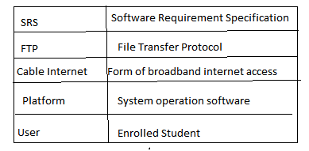

Fig 10: Glossary

**APPENDIX B**

**SYSTEM DESIGN DOCUMENT**

**1.0 Introduction**

Virtual education is an emerging concept. Here the classes are not taken face-to-face in a classroom but through an electronic medium as a substitute. Taking up these virtual classes through an electronic medium is termed as E-Learning. E-Learning is proving itself as a boon for students especially for the disabled who are not able to go and attend the lectures.

**1.1 Purpose**

Developing a virtual classroom system to promote a greater count of students to splurge into the field of Education. The purpose of this software requirements specification is to verify that all the specifications are correct and are verified. This document also serves to ensure that the software is traceable throughout its software development life cycle.

**1.2 Scope**

This project has a lot of scope for future development. Features like ability to attach voice messages, attach document files as well as video presentations and many more such functionalities can be implemented in the later versions of the software.

**1.3 Major constraints**

For ensuring platform independence of the software, the implementation will be JavaScript so the end users’ system must have a JavaScript run time environment

**1.4 Reference Material**

<https://www.hindawi.com/journals/mpe/2021/9914790/>

<https://thejournal.com/Articles/1999/09/01/How-to-Design-a-Virtual-Classroom-10-Easy-Steps-to-Follow.aspx>

**2.0 SYSTEM OVERVIEW**

**2.1 ARCHITECTURE**

This section describes overall system function and the information domain in which it operates

**2.2 System architecture**

The system uses a B/S architectural pattern, i.e. browser/server pattern.

Design:

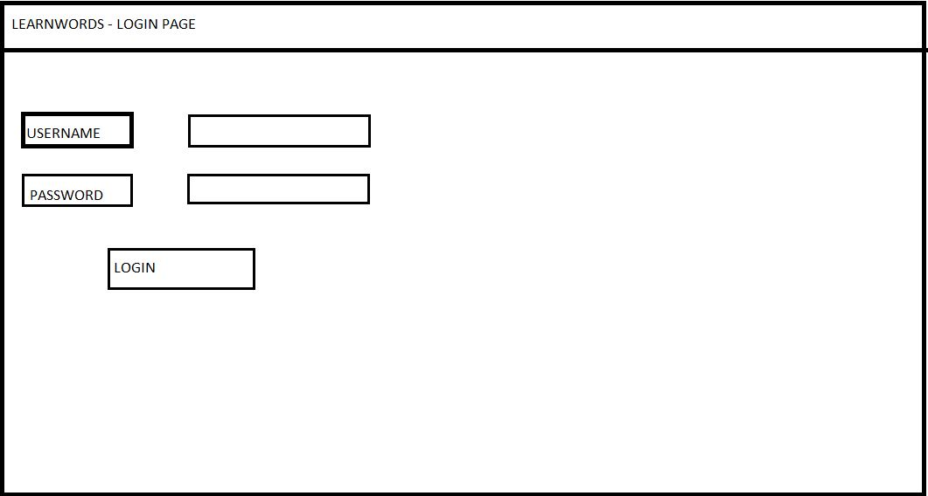

Fig 3: Login Page

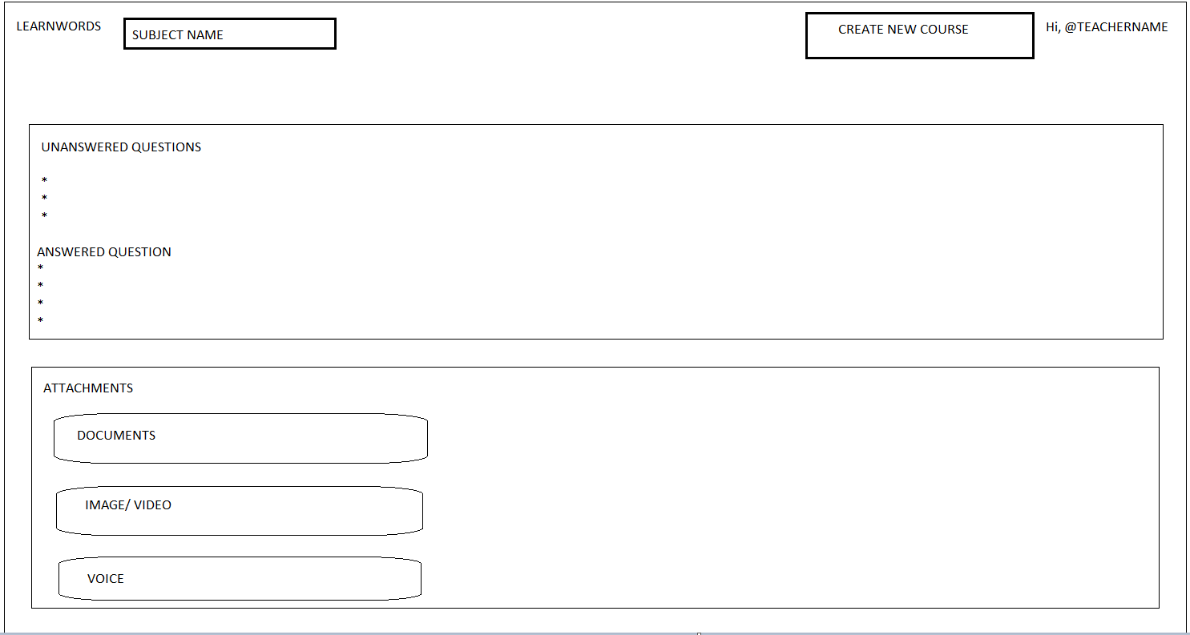

Fig 4: Course Page

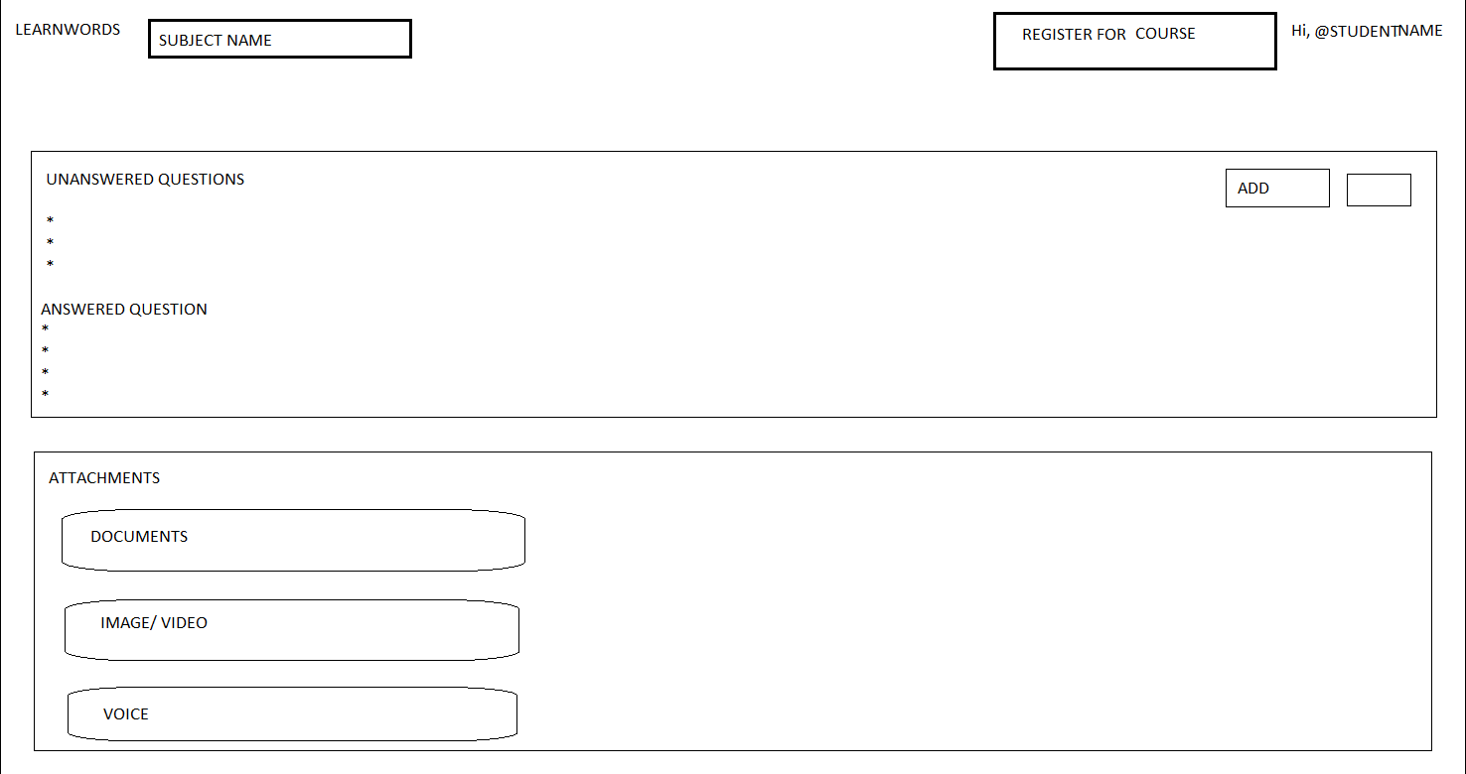

Fig 5 : Student Page

**User Classes and Characteristics:**

A use case diagram, is a visual depiction of the different scenarios of interaction between system actors and use cases. The usefulness of use case diagrams is more as a tool of communication.



Fig 1 : Use case diagram

**2.3 Design Rationale**

The use of collaborative virtual environments in e-learning is one of the most promising uses of virtual reality technology. While much research has been done in the area of networked virtual environments corresponding to the sharing of events, very little research has been done on specific services and functionality.

**2.4 Class diagram Design**



Fig 2 : Class diagram



fig 7 : Interaction Diagram

**2.5 Human Interface Design**

In any virtual learning system design, it is necessary to consider fundamental principles and rules of the user interface design in such system, and in this manner, in this research an adequate user interface is suggested for e-learning Environment in which has been evaluated with regard to these fundamental principles and rules. Evaluations have been done on this interface show its desirable ability to attract users’ satisfaction

**2.6 Requirement Traceability**



Fig 11: Traceability