**Computer Network Lab Exam Exercise**

**Objective:** Create and configure a suitable topology for both LAN and WAN using 10-15

computers, routers, and switches. Simulate the transmission of a message from one network to

a computer in another network.

**Procedure:**

**1. Topology Design:**

○ Design a network topology using Cisco Packet Tracer that includes:

1. LANConfiguration: At least 10 computers connected to switches.

2. WANConfiguration: Connect the LAN network to another network using

routers.

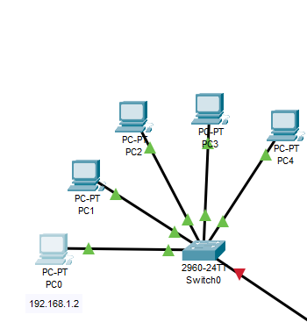 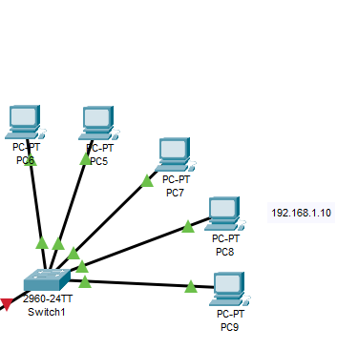

**2. Network Setup in Cisco Packet Tracer:**

○ AddDevices:

1. Place and connect 10-15 computers.

2. Add necessary switches (at least 2 for the LAN setup).

3. Add at least 2 routers for WAN setup.

○ Configure IP Addresses:

1. Assign IP addresses to all computers within the LAN.

2. Configure router interfaces with appropriate IP addresses.

3. Set up routing protocols or static routes as needed for WAN

communication.

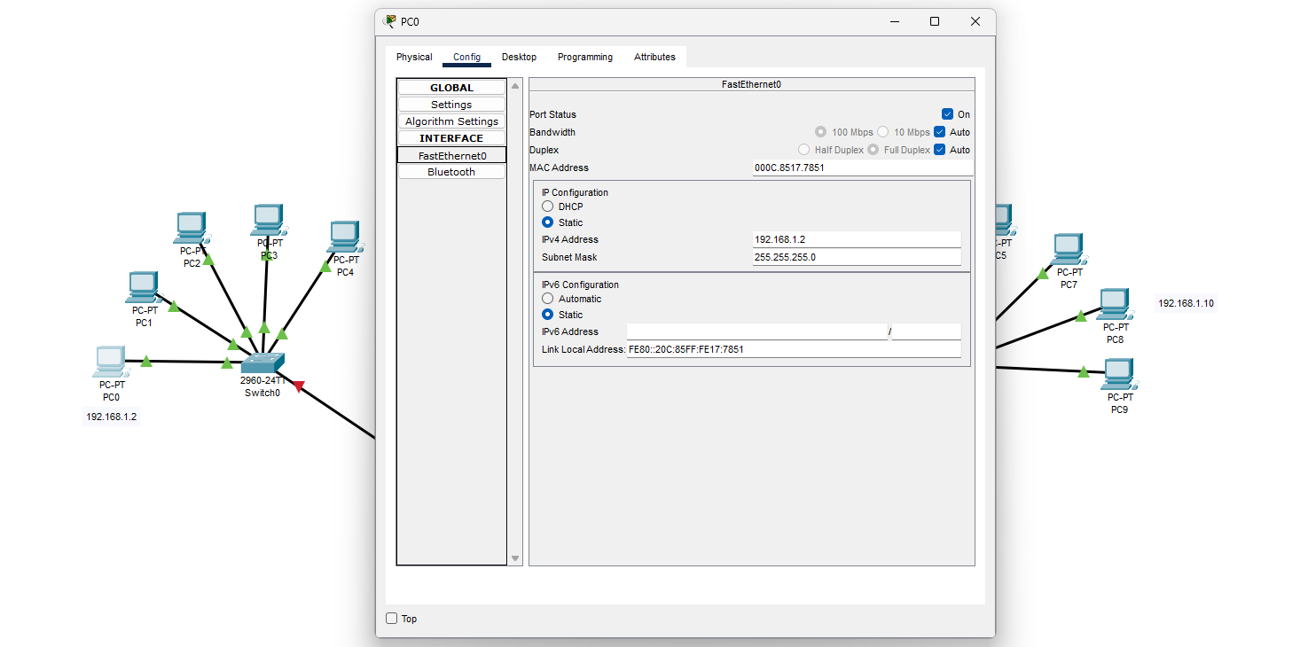

**3. Configuration Steps:**

○ LANConfiguration:

1. Connect computers to the switches.

2. Configure IP addresses on each computer.

3. Connect switches with each other as needed.

○ WANConfiguration:

1. Connect routers to each other.

2. Configure router interfaces with IP addresses.

3. Set up routing (static or dynamic) to ensure connectivity between the

LANs.

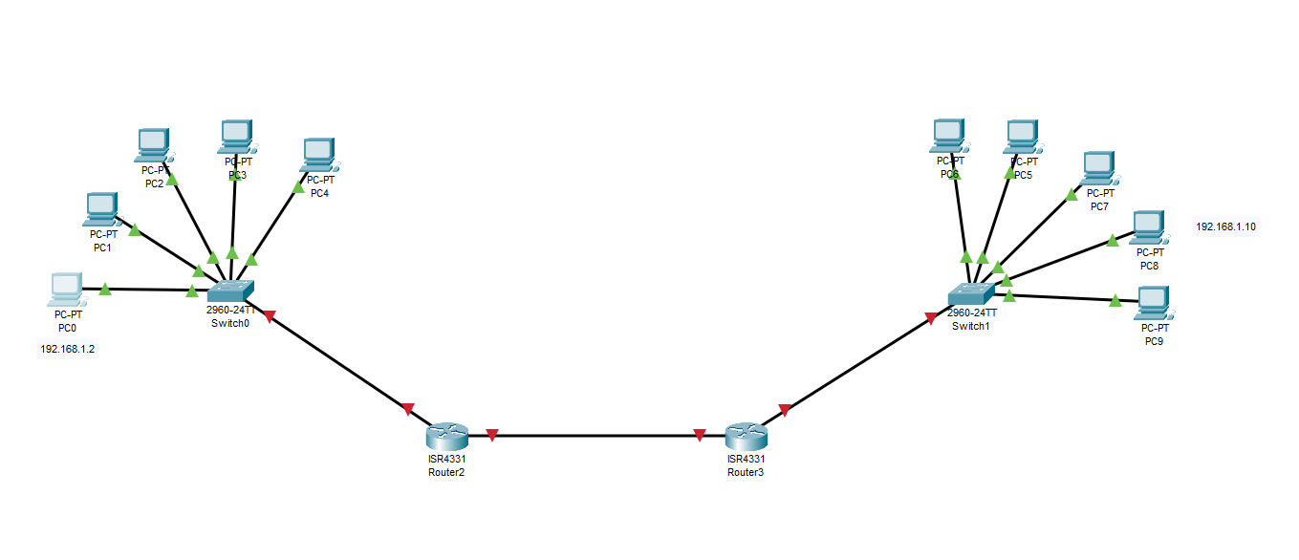

**4. Simulation:**

○ Send a Message:

1. Use the simulation mode in Cisco Packet Tracer.

2. Configure and send a message from a computer in one network to a

computer in another network.

3. Capture and verify the message transmission.

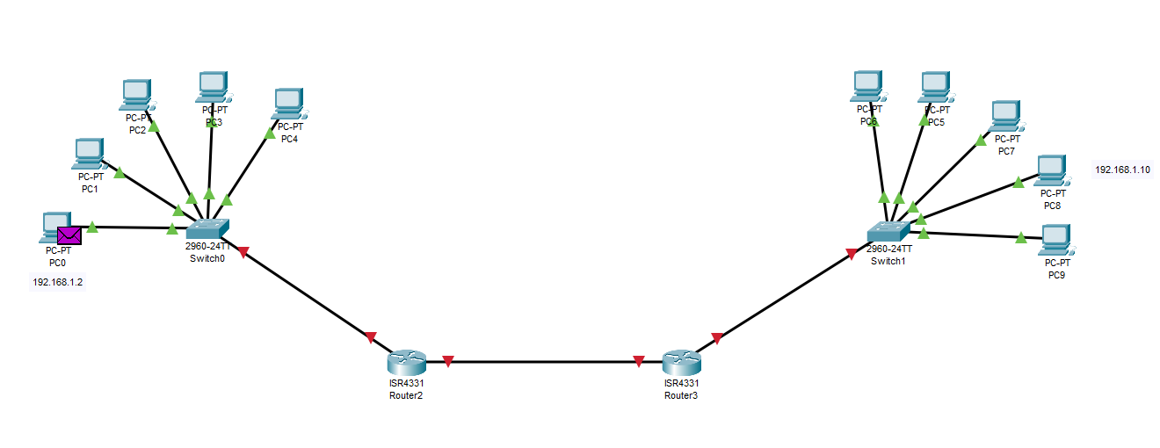

**5. Documentation:**

○ Create aStep-by-Step Procedure Document:

1. Outline each step taken in the network configuration and simulation.

2. Include commands and settings used during the configuration process.

○ TakeScreenshots:

1. Capture screenshots of the network topology.

2. Capture screenshots showing the successful transmission of the

message.

○ SavePacket Tracer File:

1. Save the Packet Tracer file with your completed network configuration

and simulation.

**6. Upload and Submit:**

○ GitHubRepository:

1. Create a GitHub repository with your register number as the repository

name.

2. Upload the following files to the repository:

■ Procedure document (suggested to write in .MD file in github)

■ Screenshots

■ Packet Tracer file (.pkt)

3. Ensure that the repository is public or accessible.

○ Submitthe Repository Link:

1. Copy the URL of your GitHub repository.

2. Submit this URL to Google Classroom as per the submission guidelines.