Universidad Del Valle De Guatemala 10/03/2021

Digital 2 Helder Ovalle Barrios

Sección: 20 18349

**MiniProyecto#2**

**Diagrama de flujo:**

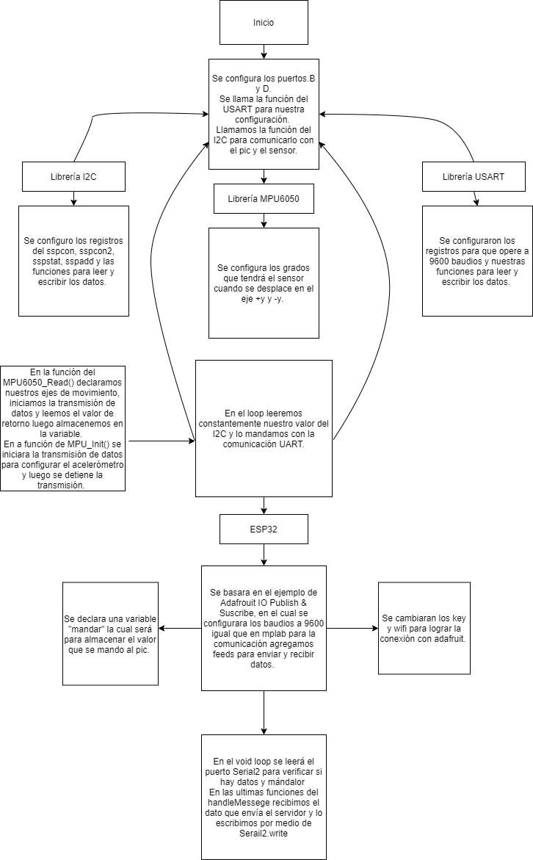

**Esquematico:**

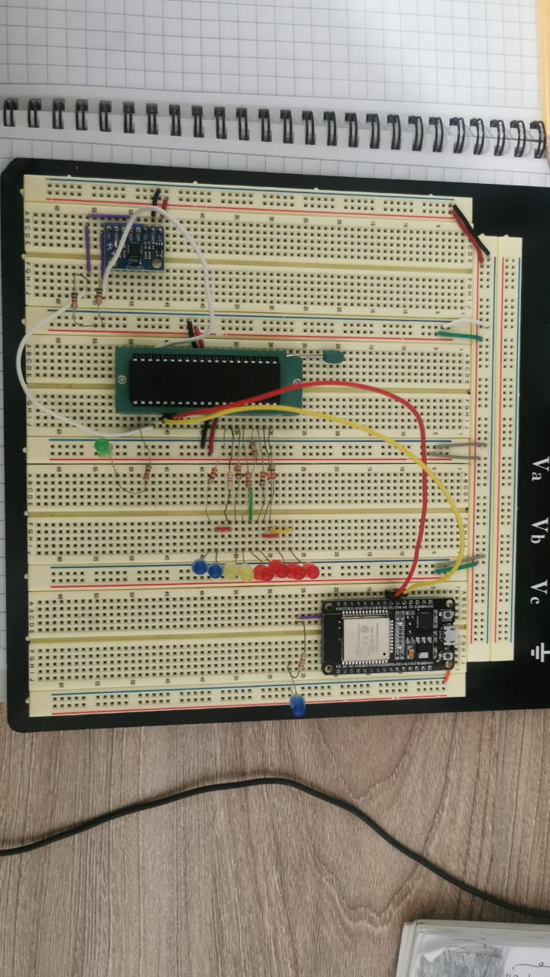

**Link de github:**

<https://github.com/Helder1121/Labsdigitaldos/tree/main/Mini_proyectodos>

**Link de youtube:**

<https://www.youtube.com/watch?v=c1iKabxvNJ0>

**Link de Adafruit:**

<https://io.adafruit.com/Helder1131/dashboards>

**Progra comentada:**

**Principal:**

//******************************************************************************

// Palabra de configuración

//******************************************************************************

// CONFIG1

#pragma config FOSC = INTRC_NOCLKOUT // Oscillator Selection bits (INTOSCIO oscillator: I/O function on RA6/OSC2/CLKOUT pin, I/O function on RA7/OSC1/CLKIN)

#pragma config WDTE = OFF // Watchdog Timer Enable bit (WDT disabled and can be enabled by SWDTEN bit of the WDTCON register)

#pragma config PWRTE = OFF // Power-up Timer Enable bit (PWRT disabled)

#pragma config MCLRE = OFF // RE3/MCLR pin function select bit (RE3/MCLR pin function is MCLR)

#pragma config CP = OFF // Code Protection bit (Program memory code protection is disabled)

#pragma config CPD = OFF // Data Code Protection bit (Data memory code protection is disabled)

#pragma config BOREN = OFF // Brown Out Reset Selection bits (BOR disabled)

#pragma config IESO = ON // Internal External Switchover bit (Internal/External Switchover mode is enabled)

#pragma config FCMEN = ON // Fail-Safe Clock Monitor Enabled bit (Fail-Safe Clock Monitor is enabled)

#pragma config LVP = OFF // Low Voltage Programming Enable bit (RB3 pin has digital I/O, HV on MCLR must be used for programming)

// CONFIG2

#pragma config BOR4V = BOR21V // Brown-out Reset Selection bit (Brown-out Reset set to 2.1V)

#pragma config WRT = OFF // Flash Program Memory Self Write Enable bits (Write protection off)

//******************************************************************************

// Importación de librerías

//******************************************************************************

#include <xc.h>

#include <stdio.h>

//#include "config.h"

#include "USART.h"

#include "MPU.h"

//******************************************************************************

// Variables

//******************************************************************************

#define _XTAL_FREQ 8000000

//******************************************************************************

// Ciclo principal

//******************************************************************************

void main(void){

UART_TX_Init();

TRISD2 = 0; // LED Indicador

TRISB = 0; // Leds conectadas para demostrar la variable ay

ANSELH = 0;

MPU6050_Init();

//**************************************************************************

// Loop principal

//**************************************************************************

while(1)

{

RD2 = ~RD2; // Blink LED verde

MPU6050_Read();

__delay_ms(50);

}

return;

}

//Se hizo con oscilador externo al inicio pero no era tan establa y mejor se

//hizo con uno interno.

**Librerias:**

/*

* File: USART.c

* Author: betov

*

* Created on 22 de febrero de 2021, 07:53 AM

*/

//Extraido de:

//https://deepbluembedded.com/mpu6050-with-microchip-pic-accelerometer-gyroscope-interfacing-with-pic/

//y combinacion del proyecto pasado que tambien era de:

////Extraido de https://electrosome.com/

#include <xc.h>

#include "USART.h"

//---------------[ UART Routines ]------------------

//--------------------------------------------------

void UART_TX_Init(void)

{

BRGH = 0; // Set For High-Speed Baud Rate

SPBRG = 12; // Set The Baud Rate To Be 9600 bps

//--[ Enable The Ascynchronous Serial Port ]--

SYNC = 0;

SPEN = 1;

//--[ Set The RX-TX Pins to be in UART mode (not io) ]--

TX_D = 1;

RX_D = 1;

TXEN = 1; // Enable UART Transmission

}

void UART_Write(unsigned char data)

{

while(!TRMT);

TXREG = data;

}

void UART_Write_String(char* buf)

{

int i=0;

while(buf[i] != '\0')

UART_Write(buf[i++]);

}

/*

* File: MPU.c

* Author: betov

*

* Created on 9 de marzo de 2021, 01:08 AM

*/

//Extrado de: https://deepbluembedded.com/mpu6050-with-microchip-pic-accelerometer-gyroscope-interfacing-with-pic/

#include <xc.h>

#include "I2c.h"

#include "MPU.h"

#include "USART.h" // for debugging serial terminal

#include <stdio.h>

//-------------[ MPU6050 Routines ]------------------

//---------------------------------------------------

void MPU6050_Init()

{

// Power-Up Delay & I2C_Init

__delay_ms(100);

I2C_Master_Init();

// Setting The Sample (Data) Rate

I2C_Start(0xD0);

I2C_Master_Write(SMPLRT_DIV);

I2C_Master_Write(0x07);

I2C_Master_Stop();

// Setting The Clock Source

I2C_Start(0xD0);

I2C_Master_Write(PWR_MGMT_1);

I2C_Master_Write(0x01);

I2C_Master_Stop();

// Configure The DLPF

I2C_Start(0xD0);

I2C_Master_Write(CONFIG);

I2C_Master_Write(0x00);

I2C_Master_Stop();

// Configure The ACCEL (FSR= +-2g)

I2C_Start(0xD0);

I2C_Master_Write(ACCEL_CONFIG);

I2C_Master_Write(0x00);

I2C_Master_Stop();

// Configure The GYRO (FSR= +-2000d/s)

I2C_Start(0xD0);

I2C_Master_Write(GYRO_CONFIG);

I2C_Master_Write(0x18);

I2C_Master_Stop();

// Enable Data Ready Interrupts

I2C_Start(0xD0);

I2C_Master_Write(INT_ENABLE);

I2C_Master_Write(0x01);

I2C_Master_Stop();

}

void MPU6050_Read()

{

char buffer[40];

int Ax,Ay,Az,T,Gx,Gy,Gz;

// Prepare For Reading, Starting From ACCEL_XOUT_H

I2C_Start(0xD0);

I2C_Master_Write(ACCEL_XOUT_H);

I2C_Master_Stop();

I2C_Start(0xD1);

Ax = ((int)I2C_Read(0)<<8) | (int)I2C_Read(0);

Ay = ((int)I2C_Read(0)<<8) | (int)I2C_Read(0);

Az = ((int)I2C_Read(0)<<8) | (int)I2C_Read(0);

T = ((int)I2C_Read(0)<<8) | (int)I2C_Read(0);

Gx = ((int)I2C_Read(0)<<8) | (int)I2C_Read(0);

Gy = ((int)I2C_Read(0)<<8) | (int)I2C_Read(0);

Gz = ((int)I2C_Read(0)<<8) | (int)I2C_Read(1);

I2C_Master_Stop();

PORTB = (Ay+16384)/128;//Conversion para los datos de la variable ay del

//acelerometro

sprintf(buffer," Ay = %d ",Ay);

UART_Write_String(PORTB);

}

/*

* File: I2c.c

* Author: betov

*

* Created on 9 de marzo de 2021, 01:09 AM

*/

//Extraido de: https://deepbluembedded.com/mpu6050-with-microchip-pic-accelerometer-gyroscope-interfacing-with-pic/

#include <xc.h>

#include "I2c.h"

//---------------[ I2C Routines ]-------------------

//--------------------------------------------------

void I2C_Master_Init()

{

SSPCON = 0x28;

SSPCON2 = 0x00;

SSPSTAT = 0x00;

SSPADD = ((_XTAL_FREQ/4)/I2C_BaudRate) - 1;

SCL_D = 1;

SDA_D = 1;

}

void I2C_Master_Wait()

{

while ((SSPSTAT & 0x04) || (SSPCON2 & 0x1F));

}

void I2C_Master_Start()

{

I2C_Master_Wait();

SEN = 1;

}

void I2C_Start(char add)

{

I2C_Master_Wait();

SEN = 1;

I2C_Master_Write(add);

}

void I2C_Master_RepeatedStart()

{

I2C_Master_Wait();

RSEN = 1;

}

void I2C_Master_Stop()

{

I2C_Master_Wait();

PEN = 1;

}

void I2C_ACK(void)

{

ACKDT = 0; // 0 -> ACK

ACKEN = 1; // Send ACK

while(ACKEN);

}

void I2C_NACK(void)

{

ACKDT = 1; // 1 -> NACK

ACKEN = 1; // Send NACK

while(ACKEN);

}

unsigned char I2C_Master_Write(unsigned char data)

{

I2C_Master_Wait();

SSPBUF = data;

while(!SSPIF); // Wait Until Completion

SSPIF = 0;

return ACKSTAT;

}

unsigned char I2C_Read_Byte(void)

{

//---[ Receive & Return A Byte ]---

I2C_Master_Wait();

RCEN = 1; // Enable & Start Reception

while(!SSPIF); // Wait Until Completion

SSPIF = 0; // Clear The Interrupt Flag Bit

I2C_Master_Wait();

return SSPBUF; // Return The Received Byte

}

unsigned char I2C_Read(unsigned char ACK_NACK)

{

//---[ Receive & Return A Byte & Send ACK or NACK ]---

unsigned char Data;

RCEN = 1;

while(!BF);

Data = SSPBUF;

if(ACK_NACK==0)

I2C_ACK();

else

I2C_NACK();

while(!SSPIF);

SSPIF=0;

return Data;

}

**Porgra de arduino:**

// Adafruit IO Publish & Subscribe Example

//

// Adafruit invests time and resources providing this open source code.

// Please support Adafruit and open source hardware by purchasing

// products from Adafruit!

//

// Written by Todd Treece for Adafruit Industries

// Copyright (c) 2016 Adafruit Industries

// Licensed under the MIT license.

//

// All text above must be included in any redistribution.

/********* Configuration ************/

// edit the config.h tab and enter your Adafruit IO credentials

// and any additional configuration needed for WiFi, cellular,

// or ethernet clients.

#include "config.h"

/******** Example Starts Here ***********/

// this int will hold the current count for our sketch

int mandar = 0;

int LED2 = 0;

#define LED_PIN 2

#define RXD2 16

#define TXD2 17

// Track time of last published messages and limit feed->save events to once

// every IO_LOOP_DELAY milliseconds.

//

// Because this sketch is publishing AND subscribing, we can't use a long

// delay() function call in the main loop since that would prevent io.run()

// from being called often enough to receive all incoming messages.

//

// Instead, we can use the millis() function to get the current time in

// milliseconds and avoid publishing until IO_LOOP_DELAY milliseconds have

// passed.

#define IO_LOOP_DELAY 5000

unsigned long lastUpdate = 0;

// set up the 'counter' feed

AdafruitIO_Feed *mandarFeed = io.feed("mandar");

AdafruitIO_Feed *recibirFeed = io.feed("recibir");

AdafruitIO_Feed *LEDREDFeed = io.feed("LEDRED");

void setup() {

pinMode(LED_PIN, OUTPUT);

pinMode(22, OUTPUT);

pinMode(23, OUTPUT);

// start the serial connection

Serial.begin(9600);

Serial2.begin(9600, SERIAL_8N1, RXD2, TXD2);

delay(1000);

// wait for serial monitor to open

while (! Serial);

Serial.print("Connecting to Adafruit IO");

// connect to io.adafruit.com

io.connect();

// set up a message handler for the count feed.

// the handleMessage function (defined below)

// will be called whenever a message is

// received from adafruit io.

recibirFeed->onMessage(handleMessage);

LEDREDFeed->onMessage(handleMessage2);

// wait for a connection

while (io.status() < AIO_CONNECTED) {

Serial.print(".");

delay(500);

}

// we are connected

Serial.println();

Serial.println(io.statusText());

recibirFeed->get();

LEDREDFeed->get();

}

void loop() {

if(Serial.available()){

Serial.write("-");

Serial2.write(Serial.read());

//LED

}

if(Serial2.available()> 0){

//Serial.write(Serial2.read());

mandar = Serial2.read();

Serial.println(Serial2.read());

}

// io.run(); is required for all sketches.

// it should always be present at the top of your loop

// function. it keeps the client connected to

// io.adafruit.com, and processes any incoming data.

io.run();

//enviar=random(0,100);

if (millis() > (lastUpdate + IO_LOOP_DELAY)) {

// save count to the 'counter' feed on Adafruit IO

Serial.print("Valor de PIC -> ");

Serial.println(mandar);//Valor que se manda del pic

mandarFeed->save(mandar);

// increment the count by 1

//count++;

// after publishing, store the current time

lastUpdate = millis();

}

delay(3000);

}

// this function is called whenever a 'counter' message

// is received from Adafruit IO. it was attached to

// the counter feed in the setup() function above.

void handleMessage(AdafruitIO_Data *data) {

Serial.print("received <- ");

Serial.println(data->value());

if (data->toString() == "ON") { //enciende el LED azul

digitalWrite(LED_PIN, HIGH);

}

if (data->toString() == "OFF") { //apaga el LED azul

digitalWrite(LED_PIN, LOW);

}

}

void handleMessage2(AdafruitIO_Data *data) {

Serial.print("received <- ");

Serial.println(data->value());

if(data->toString() == "ON"){ //enciende el LED azul

digitalWrite(22, HIGH);

Serial.print("LEDRED");

}

if(data->toString() == "OFF"){ //apaga el LED azul

digitalWrite(22, LOW);

Serial.print("LEDRED");

}

}