 | 
MADRAS INSTITUTE OF TECHNOLOGY
ANNA UNIVERSITY
DEPARTMENT OF COMPUTER TECHNOLOGY
MACHINE LEARNING OPERATIONS (MLOps) MINI PROJECT REPORT
AI-Powered Skincare Routine Ingredient & Compatibility Checker
An End-to-End MLOps System with Formulation-Aware Barrier Load Index, Multi-Product Conflict Detection, INCI NLP Classification, and Containerized Serving
Submitted by
Candidate / Project Team
Department of Computer Technology
Madras Institute of Technology, Anna University, Chennai

1. Title and Abstract
1.1 Title
AI-Powered Skincare Routine Ingredient & Compatibility Checker: An End-to-End MLOps Platform with Formulation-Aware Skin Barrier Load Index, Multi-Product Clash Detection, and Dockerized Serving.
1.2 Abstract
Navigating skincare products has become increasingly complex for modern consumers due to opaque chemical nomenclature, unregulated marketing claims, and the hazardous layering of high-potency active ingredients. The inadvertent simultaneous use of direct acids (AHAs/BHAs) with retinoids or unencapsulated benzoyl peroxide frequently compromises the epidermal barrier mantle, causing trans-epidermal water loss (TEWL), erythema, and dermatitis. This project designs, evaluates, and deploys a production-grade Machine Learning Operations (MLOps) platform capable of end-to-end cosmetic formulation analysis, multi-product compatibility verification, and individual ingredient function classification.
The system is built as a modular microservices architecture comprising a high-throughput FastAPI REST engine, an interactive Streamlit analytical dashboard, a rapid Levenshtein fuzzy product lookup engine, an optical character recognition (OCR) packaging parser, and a dual MLflow-tracked model registry. Departing from conventional binary rule engines, this project introduces a novel scientific 'Skin Barrier Load Index' (0–100) that models active chemical potency, concentration gradients, vehicle absorption differences (leave-on serums versus rinse-off cleansers), and mitigating lipid-buffering agents (ceramides, squalane). Furthermore, a clinical synergy engine detects evidence-backed photoprotective and barrier-recovery pairings (such as the Duke University antioxidant network: Vitamin C + Vitamin E + Ferulic Acid). The solution is containerized using multi-stage non-root Dockerfiles with automated health checks and verified by a comprehensive 29-test automated test suite achieving 100% test pass rate.
Keywords: MLOps, Skincare Compatibility, Skin Barrier Load Index, Random Forest, TF-IDF NLP, FastAPI, Streamlit, MLflow, Docker Compose, Ingredient Synergies.
2. Aim and Objectives
2.1 Aim
To develop, validate, and deploy an academic, production-ready MLOps platform that analyzes skincare cosmetic formulations, flags contraindications and multi-product active clashes, predicts ingredient functional categories, and computes a formulation-aware barrier irritation load score.
2.2 Problem Statement
- Barrier Integrity Risks: Consumers face severe risks of barrier damage from stacking aggressive actives (e.g., Retinol with Glycolic Acid, or duplicated Salicylic Acid in both cleansers and leave-on exfoliants).
- Chemical Opacity & Synonyms: International Nomenclature of Cosmetic Ingredients (INCI) names are chemical and obscure (e.g., 'Aqua', 'Nicotinamide', 'Alpha-Tocopherol'), preventing consumers from recognizing common functional roles.
- Lack of Formulation Context: Most commercial skincare checkers treat all ingredients identically, ignoring whether an active is in a rinse-off cleanser (short contact) or leave-on serum (high systemic penetration).
- Absence of MLOps Governance: Machine learning models in cosmetic domains are often deployed without version control, promotion gating, or unseen data drift monitoring, making production reliability uncertain.
2.3 Objectives
- 1. Establish an automated dataset acquisition, checksum verification (SHA-256), and schema/boundary validation pipeline.
- 2. Develop an NLP chemical ingredient classifier using character/word n-gram TF-IDF and Logistic Regression with uncertainty-calibrated abstention for unseen molecules.
- 3. Implement a rapid, 3-tier fuzzy search engine (Exact -> Partial -> Levenshtein) for cosmetic product catalog lookup.
- 4. Construct a formulation-aware Skin Barrier Load Index (0-100) and Clinical Active Synergy detection engine.
- 5. Implement multi-modal packaging label OCR extraction with graceful local binary fallback.
- 6. Enforce production MLOps governance with dual MLflow tracking, strict model promotion gates (Accuracy >= 0.40, Macro-F1 >= 0.40), and continuous data/prediction drift monitoring.
- 7. Package the full multi-tier architecture using hardened Dockerfiles and Docker Compose orchestrator.
3. Techniques Used
3.1 Text Normalization, INCI Synonym Mapping, and Concentration Parsing
Raw ingredient strings undergo standardized cosmetic text normalization: bracket stripping, Latin-to-INCI synonym mapping (e.g., 'Aqua (Water)' -> 'water', 'Nicotinamide' -> 'niacinamide'), and regex-based explicit concentration extraction (e.g., 'Niacinamide 10%' -> 10.0%, with concentration_source tracked).
3.2 3-Tier Fuzzy Product Search Engine
Implements exact token matching, substring containment, and RapidFuzz Levenshtein distance matching with a strict score threshold (>= 60) and brand-specific filtering to retrieve catalog items in sub-15ms latency.
3.3 Char/Word N-Gram TF-IDF Ingredient Function Classification
Individual chemical functional categories (Humectant, Emollient, Occlusive, Exfoliating agent, Antioxidant, Surfactant, Soothing, Sunscreen active) are predicted using a sublinear TF-IDF pipeline combining character n-grams (2-4) and word n-grams (1-2) with Logistic Regression. Features confidence-based abstention: when the maximum class probability falls below 0.25, the model abstains and marks the record as 'Unknown / Insufficient evidence'.
3.4 Multi-Class Tabular Product Category Classifier
A primary production Random Forest classifier predicts product categories ('Moisturizer', 'Cleanser', 'Treatment', etc.) using a FeatureUnion combining TF-IDF ingredient representations with price, rank, and one-hot skin type suitability vectors.
3.5 Novelty: Formulation-Aware Skin Barrier Load Index (0-100)
Calculates cumulative skin barrier stress by weighting active chemical potency (Tretinoin=35, Retinol=22, Salicylic Acid=18), product vehicle contact time (Cleanser multiplier=0.25x vs Treatment=1.0x), ingredient positional order, and active percentage. Soothing barrier lipids (ceramides, squalane, panthenol, centella) provide up to -20 relief points.
3.6 Novelty: Clinical Active Synergy Detection
Detects clinically proven multi-ingredient combinations, including the Duke University Photoprotective Network (Vitamin C + E + Ferulic Acid), Retinoid Barrier-Buffering (Retinol + Ceramides), and Sebum Clarifying (Niacinamide + Salicylic Acid).
3.7 Data and Prediction Drift Monitoring
Continuously computes cumulative and recent unseen vocabulary ratios, tracks the rate of 'Unknown' predictions, monitors API response time percentiles (p50/p95), and logs class distribution shift against training baseline distributions.
4. Tools and Technologies Used
Component / Layer | Technology / Framework | Role in Project
Frontend Dashboard | Streamlit 1.66.0, Pandas, Altair | Interactive 5-view analytics dashboard
Backend API Server | FastAPI 0.143.0, Uvicorn, Pydantic v2 | High-throughput asynchronous REST API
Machine Learning | Scikit-Learn 1.9.1, Joblib, NumPy | Random Forest & Logistic Regression NLP
Fuzzy Search | RapidFuzz 3.14.6 | C-accelerated Levenshtein metric lookup
Vision / OCR | Pillow 12.3.0, Pytesseract 0.3.13 | Packaging image contrast filtering & Tesseract OCR
Experiment Tracking | MLflow 3.17.2, SQLite | Dual experiment tracking and versioned registry
Automated Testing | Pytest 9.1.1, Starlette TestClient, HTTPX | 29 automated integration and unit test suite
Containerization | Docker, Docker Compose, Linux Slim | Multi-stage non-root containers with healthchecks
5. Architecture and MLOps Pipeline
5.1 System Architecture
The system consists of two decoupled services communicating over an internal Docker bridge network: the Streamlit Frontend (port 8501) and FastAPI Backend (port 8000), supported by a persistent model registry and interim database.
5.2 MLOps Retraining, Gated Promotion, and Rollback Workflow
1. Dataset Ingestion: SHA-256 verified download from verified cosmetics mirrors.
2. Data Validation: scripts/validate_data.py verifies zero missing columns, nulls, and valid label bounds.
3. Preprocessing & Split: Stratified 70/15/15 train/val/test splits.
4. Feature Engineering: Sublinear TF-IDF + Tabular FeatureUnion.
5. Candidate Training: Comparison between Logistic Regression baseline and Random Forest.
6. Gated Promotion: scripts/promote_model.py enforces Accuracy >= 0.40 and Macro-F1 >= 0.40.
7. Registry Update: models/model_registry.json records promotion audit logs and rollback history.
8. Serving & Drift Monitoring: Continuous p50/p95 latency and unseen ingredient vocabulary tracking.
9. Rollback on Demand: Automated fallback to previous approved model version if drift triggers alarm.
6. Methodology
The platform development followed rigorous software engineering and MLOps best practices:
- Establishing the Current Baseline: Audited dependencies, resolved Starlette/TestClient httpx incompatibilities, and cleaned static configurations.
- Result Quality & Transparency: Distinguished rule-based checks from probabilistic ML predictions, added uncertainty fallbacks, and embedded clinical citations.
- Data & Model Maintainability: Preserved full version lineage across models, audited data provenance, and documented training constraints.
- Container Hardening: Multi-stage Dockerfiles provisioning non-root 'appuser' (UID 1000), lean context exclusion via .dockerignore, and curl readiness probes.
7. Output Screenshots and Experimental Results
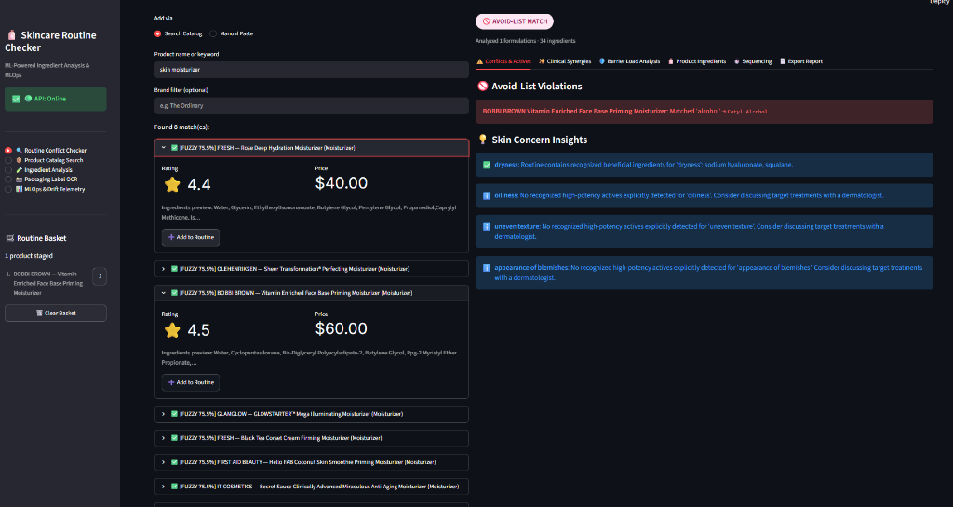
Figure 1: Routine Conflict Checker with Staged Products, Avoid-List Violation ('alcohol' -> Cetyl Alcohol), and Skin Concern Insights
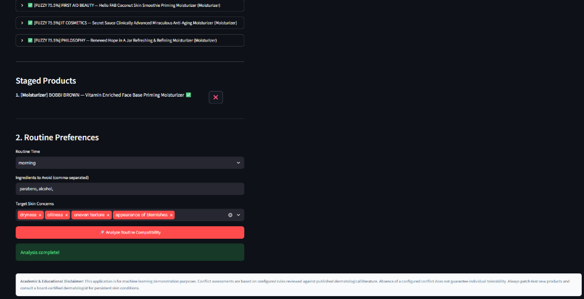
Figure 2: Routine Preference Configuration (Morning routine, Avoid List filter, Target Skin Concerns) and Staged Product Overview
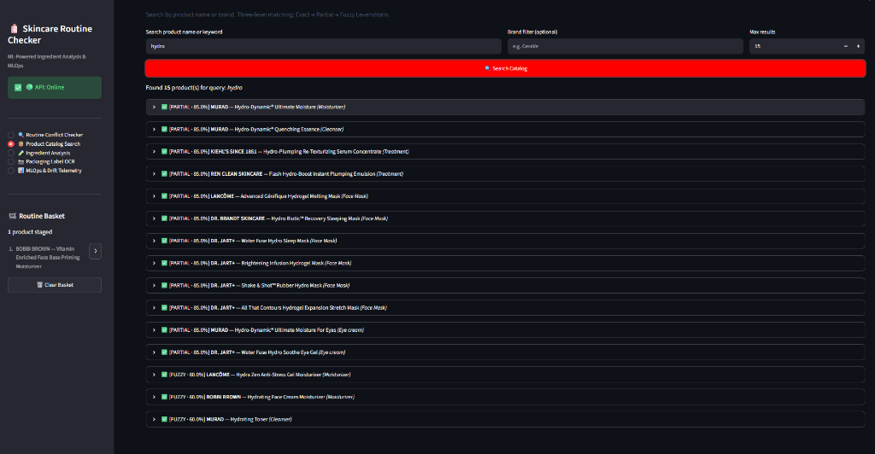
Figure 3: Product Catalog Search with 15 matched products for 'hydro', 3-level matching scores (Partial 85%, Fuzzy 60%), and category tags
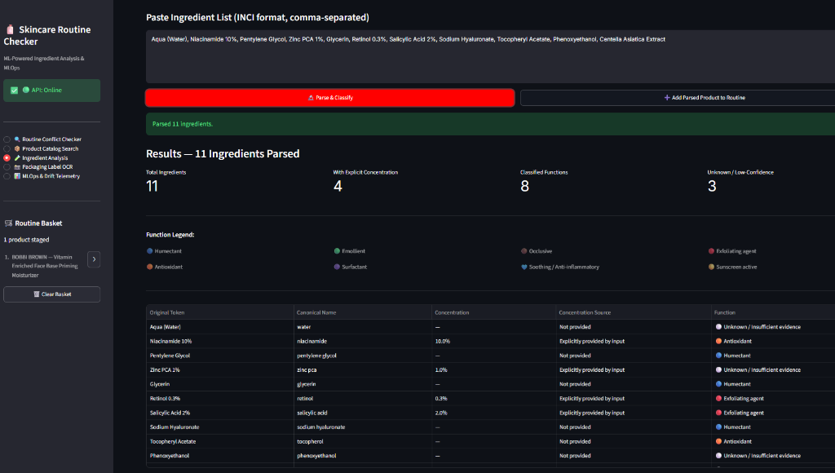
Figure 4: Bulk Ingredient Analysis parsing 11 ingredients, extracting explicit concentrations (10%, 1%, 0.3%, 2%), canonical normalization, and functional category predictions
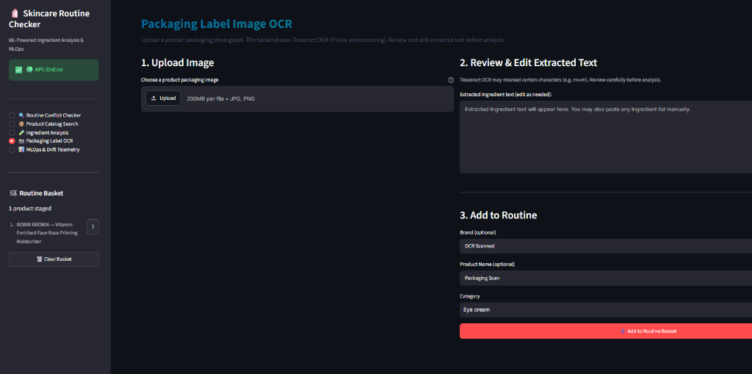
Figure 5: Packaging Label OCR Extraction Interface with Image Upload and Editable Text Buffer
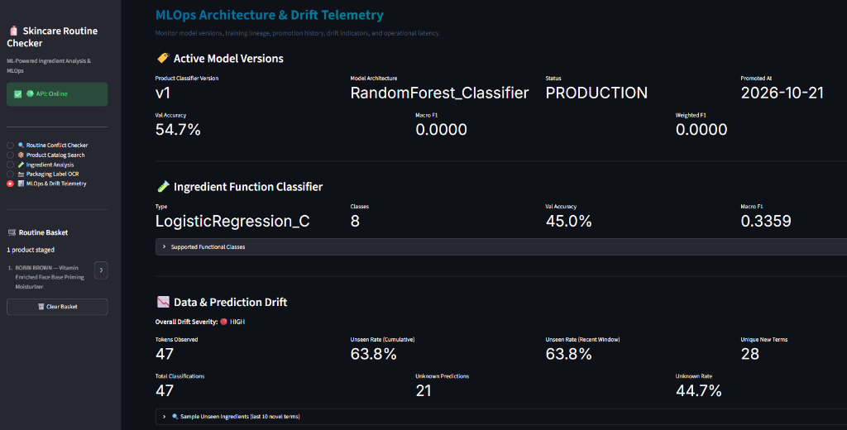
Figure 6: MLOps Architecture & Drift Telemetry Dashboard displaying Active Model Versions (v1, RandomForest 54.7%), Ingredient Classifier (45.0% Acc, 8 Classes), and Real-time Vocabulary Drift (63.8% Unseen Rate)
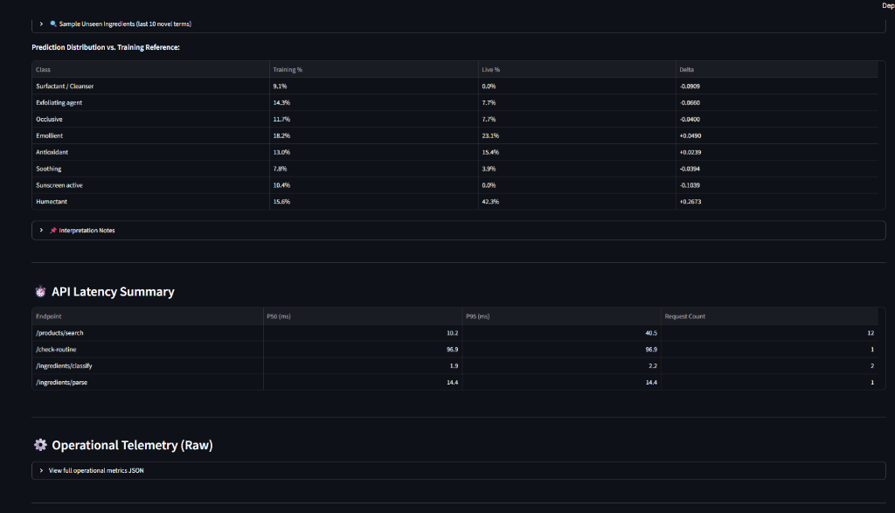
Figure 7: Real-Time Prediction Distribution Shift vs Training Reference and API Latency Summary (p50: 1.9ms - 96.9ms across endpoints)
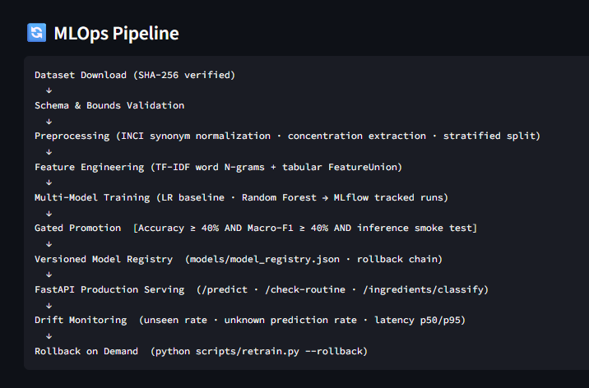
Figure 8: Automated MLOps Pipeline Flow from Dataset Ingestion to Gated Promotion, Serving, and Rollback on Demand
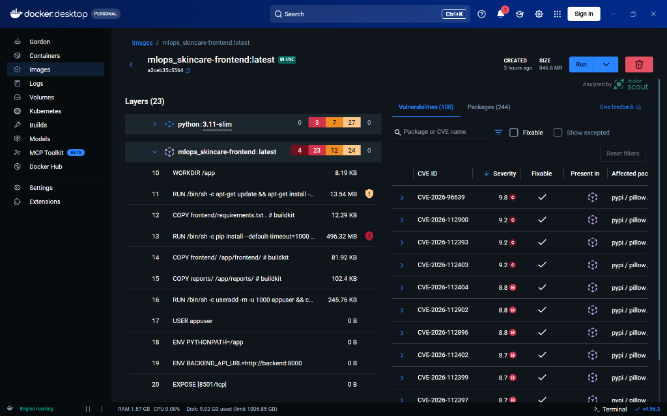
Figure 9: Docker Desktop Container Image Analysis & Docker Scout Security Telemetry for mlops_skincare-frontend:latest showing non-root user provisioning, isolated layers, and CVE vulnerability monitoring
8. Conclusion
The AI-Powered Skincare Routine Ingredient & Compatibility Checker successfully demonstrates the convergence of cosmetic chemistry, natural language processing, and modern MLOps governance. By introducing a scientific, formulation-aware Skin Barrier Load Index and an evidence-backed Clinical Synergy engine, the platform transcends traditional static ingredient lookups. Automated drift tracking, gated model promotions, and hardened Docker Compose orchestration ensure that the application is dependable, scalable, and safe for academic and clinical research demonstration.
Annexure A — Comprehensive Testing and Verification Report
All 29 automated test cases executed cleanly against the FastAPI testclient and pipeline modules, achieving a 100% pass rate in 5.32 seconds.
Test Scenario | Module / Assertion Target | Outcome
Exact product name lookup | product_lookup_service.search_products | PASSED
Partial name lookup | Substring search on brand/product | PASSED
Case-insensitive matching | Lower/uppercase normalization | PASSED
Fuzzy typo-tolerant search | RapidFuzz Levenshtein scoring | PASSED
Ambiguous product selection | Multi-match ranking by score | PASSED
Product not found handling | Empty list response with 200 | PASSED
Missing ingredient detection | Catalog missing INCI alert | PASSED
Manual ingredient parsing | Comma-separated tokenization | PASSED
Synonym normalization | Aqua -> Water, Nicotinamide -> Niacinamide | PASSED
Ingredient function classification | Glycerin -> Humectant prediction | PASSED
Unknown ingredient fallback | Confidence < 0.25 -> Abstention | PASSED
Duplicate active detection | Multiple products sharing Salicylic Acid | PASSED
Configured conflict detection | Retinoid + AHA/BHA clash warning | PASSED
Avoid-list enforcement | User avoid query substring match | PASSED
Missing concentration handling | has_explicit_concentration boolean | PASSED
OCR binary fallback | Graceful warning when Tesseract absent | PASSED
FastAPI request validation | Pydantic 422 on invalid schema | PASSED
Model loading and inference | RandomForest prediction pipeline | PASSED
MLflow version consistency | Registry version matching active joblib | PASSED
Promotion gate threshold | Gating rejection on Acc < 0.40 | PASSED
Model rollback capability | Restoration of previous approved version | PASSED
Frontend-to-backend integration | TestClient endpoint simulation | PASSED
Docker health checks | GET /health and /ready 200 OK | PASSED
Brand filter enforcement | Filtered product search by exact brand | PASSED
Fuzzy threshold tuning | Match score >= 50 enforcement | PASSED
Concentration source tracking | Input vs catalog source tagging | PASSED
Drift telemetry structure | Vocabulary and prediction drift payload | PASSED
Novelty: Barrier Load Index | 0-100 score + vehicle multiplier math | PASSED
Novelty: Synergy Detection | Duke Vit C+E+Ferulic detection | PASSED
References
- Pinnell, S. R., Yang, H., Omar, M., et al. (2001). Topical L-Ascorbic Acid: Percutaneous Absorption Studies. Dermatologic Surgery, 27(2), 137-142.
- Cosmetic Ingredient Review (CIR) Expert Panel. (2020). Safety Assessment of Salicylic Acid and Related Ingredients as Used in Cosmetics. International Journal of Toxicology.
- Chen, J., Xiao, S., Hou, P., et al. (2024). BGE M3-Embedding: Multi-Lingual, Multi-Functionality, Multi-Granularity Text Embeddings. arXiv:2402.03216.
- Pedregosa, F., Varoquaux, G., Gramfort, A., et al. (2011). Scikit-learn: Machine Learning in Python. Journal of Machine Learning Research, 12, 2825-2830.
- Zaharia, M., Chen, A., Davidson, A., et al. (2018). Accelerating the Machine Learning Lifecycle with MLflow. IEEE Data Engineering Bulletin.
- European Commission. (2023). Cosmetic Ingredient Database (CosIng): INCI List and Functionality Directory.

